Report

Yuchen Zhang

Estimate of each time:

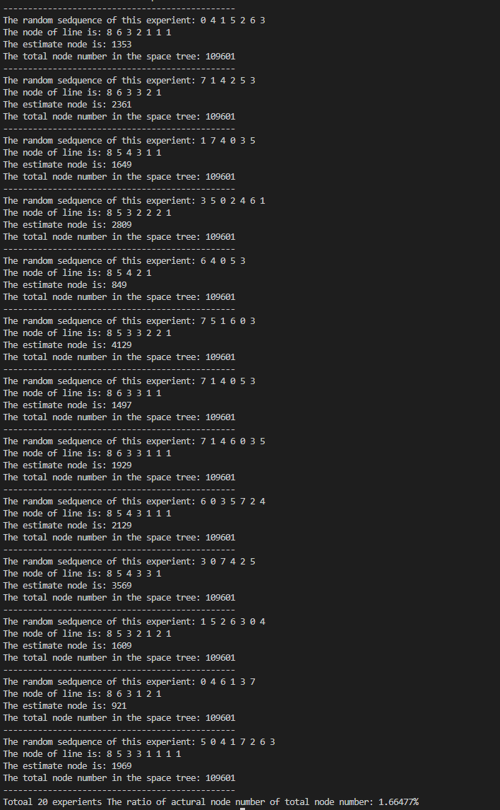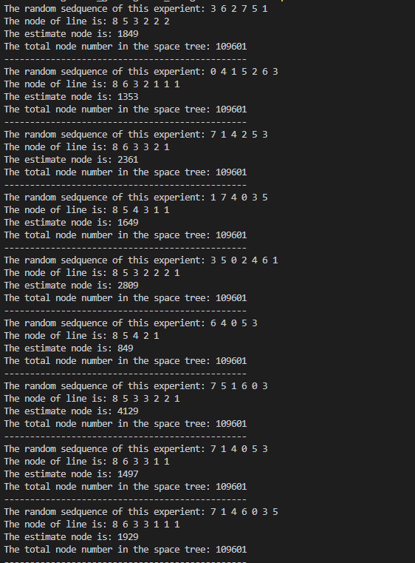

The estimate of each run is 1849, 1353, 2361, 1649, 2809, 849, 4129, 1497, 1929, 1353, 2361, 1649, 1009, 4129, 1929, 2129, 3569, 1609, 921, 1969

The average node is 2052 (2052.6)