Event Calendar System

Made by:

Pakhomov Pavel

Stepanov Egor

Software Requirements Specification

1. **Introduction**
   1. Purpose
   2. Intended Audience and Reading Suggestions
   3. Project Scope
2. **Overall Description**
   1. Product Perspective
   2. Product Features
   3. User Classes and Characteristics
   4. Limitations of the System

Introduction

1. **Purpose**

The purpose of this application is to create a web application that will function as a calendar for events for students. The idea is to create a calendar where anyone can create an event with the description when and where exactly event will take place. Anyone can plan to attend a party in the calendar.

1. **Intended Audience and Reading Suggestions**

This project is a prototype for the event management. This project is useful for the students that live at the Strahov dormitories and as well as to the other people, who would like to participate.

1. **Project Scope**

The purpose of the event calendar is to ease party management and to create a convenient and easy-to-use application for students, trying to find a party. The system is based on a relational database with its event management and attendance functions. We will have a database server supporting various parties around the Strahov dormitory as well as various amount of users, that are going to attend them.

Overall description

1. **Product perspective**

A distributed calendar database system holds the following information.

* Event details:

It includes the name and location of the event, along with the start time and approximate end time, and also list of all the people attending this event.

* User description:

It includes the first name, the last name and the username, as well as the friend list of the given user.

1. **Product features**

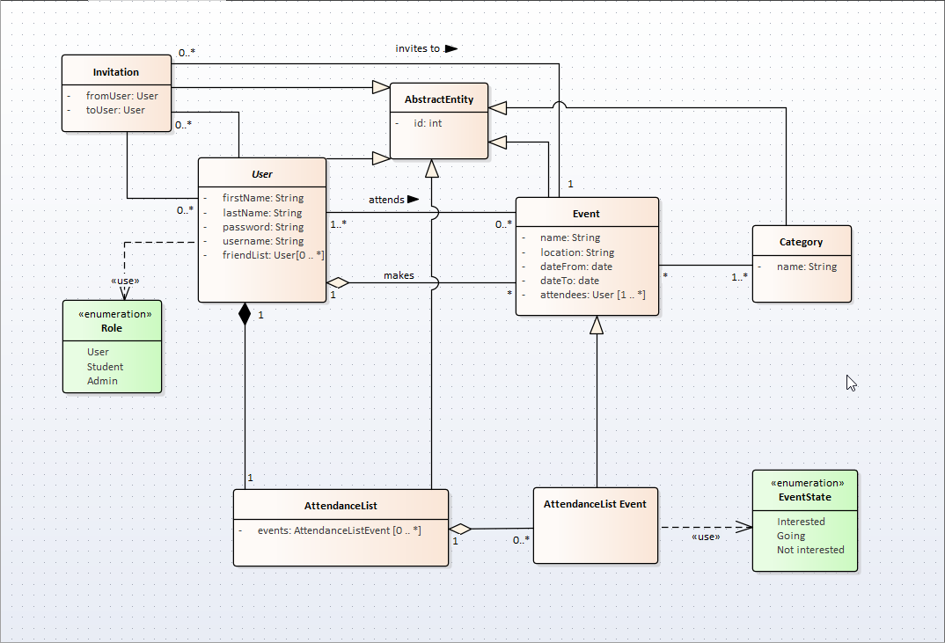

1. **User classes and characteristics**

Users of the system should be able to retrieve information about an event with the given location and date/time of event from the database. The system will support three types of user privileges, User(default), Student, and Admin. Default users will have access to user functions, students will have access to a little bit more functions, and the admins will have access to calendar management functions.

The default user should be able to do the following functions:

* Invite other users to an event
* Cancel a sent invite
* Attend an event
* Manage his own friend list
* Manage his own attendance list

The student should be able to do the following functions:

* All functions of the user
* Create an event
* Add event to a category and remove event from the category
* Cancel an event

The admin should have following management functionalities:

* Cancel a sent invite
* Cancel an event
* Ban a user
* Add/remove the category

1. **Limitations of the System**

The system won’t support following functions:

* Reservation of the location when creating an event
* Creation of an event outside of Strahov dormitories