Project Overview
We are building a web-based application for managing an art gallery. The main features of this system are focusing on guests and employees entering and leaving the gallery and rooms.
Users, being guests and employees, are allowed to enter/leave the gallery and explore connected rooms if the user is authorized to enter an adjacent room. With this being a web-based application, we will be running the front-end and back-end on a Docker Container. Containers allow protection from intrusions by containing a threat without exposing the hosting server on top of containing the threat as a low-privileged user.

Security Requirements
For Authentication users will use a username and password system, passwords will be securely hashed and stored on the database and for user-safety we will employ password requirements such as requiring a specific length and including various characters from numbers to symbols. We could implement an MFA through possibly Google Authenticator or replace the username password schema with an OAuth system, which would mitigate leaking password hashes.
Authorization will be simply role-based and stored on the database. Users are the lowest privileged and cannot access restricted areas, employees are the administrative privileged and can access these restricted areas. All roles must abide by the rules of moving around rooms, they can only move between adjacent rooms.
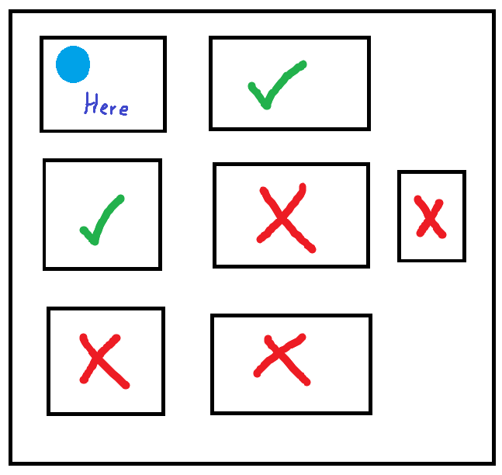
Figure 1, Depicts movement rules for moving between adjacent rooms based on a given position, shown by the blue circle.
Data Protection will be carried out through secure protocols such as HTTPS; HTTP is natively insecure and attackers listening to transmitted packets can intercept and view request information in plain text which violates confidentiality.
Input Validation will be handled on the Server-Side, natively the system will not trust user-provided information and must be thoroughly sanitized and tested. Text displayed from the database will not be rendered as HTML, it will be rendered as text to mitigate XSS, for database protections we are utilizing Drizzle-ORM which natively employs placeholder logic when performing queries, making SQLI extremely difficult.
Logging and Monitoring will be assisted through NGINX, we can configure the webserver to track request attributes like; IP, User-Agent, Resource, Method, Status, Request-Size, etc. NGINX will log these requests in its native log file and a user with the Administrator role can use a simple to use interface that can filter these logs and display them conveniently, we can also embed logging within the server-side application and allow these to be viewed and filtered as well.

Non-Functional Requirements
NGINX natively offers load-balancing which allows the server to handle large amounts of traffic without overwhelming a specific load section. We can configure the database to backup information on a given delay, provided that this class project is not handling critical information we do not need a rigorous backup routine, a daily backup will suffice. In the case of a database leak it really depends on our system we chose when developing; if we use a username and password schema then we will need to provide a special reset link via email to notify about the leak and suggest the user reset their password, or we can do the same email approach but perform a system-wide reset where the backend server sets a random password and we will send this to the user. Both systems run the risk of failing if the attacker has access to their emails. If we use an OAuth system where the users sign-in through services like Google, Microsoft, Discord, etc., this puts less stress on us as we are not storing their credentials, if a session is compromised, we can simply delete it from the database.

