Project Overview 2
We are constructing a secure art gallery where authenticated guests are allowed to navigate between adjacent rooms to view displayed art images. We also have a role-system of guest, employee, and admin where between each authorization level a user can perform a set of actions. We also have a basic logging mechanism to track user movement around the gallery to assist employees and admins with management.
Our architecture is comprised of a docker-compose which allows for a consistent reliable build environment. Our front-end is comprised of React with an Express backend that is communicated through a NGINX Reverse Proxy. We utilize web request handling with NGINX because it is a reliable service with load-balancing capabilities and a wide variety of useful features. Finally, we manage and store data using Drizzle-ORM that connects to a Postgres database, this is shown in Figure 1.

Assets
- Username, Email, and Password hashes
- Images stored in restricted areas
- JWT Secret
- Postgres Database
- NGINX
- Login/Registration Panels
- Employee Panel
- Admin Panel

Threat-Actors
- External attackers
  - Unauthenticated/Authenticated
- Internal attackers
  - Employees/Admins

Decomposition
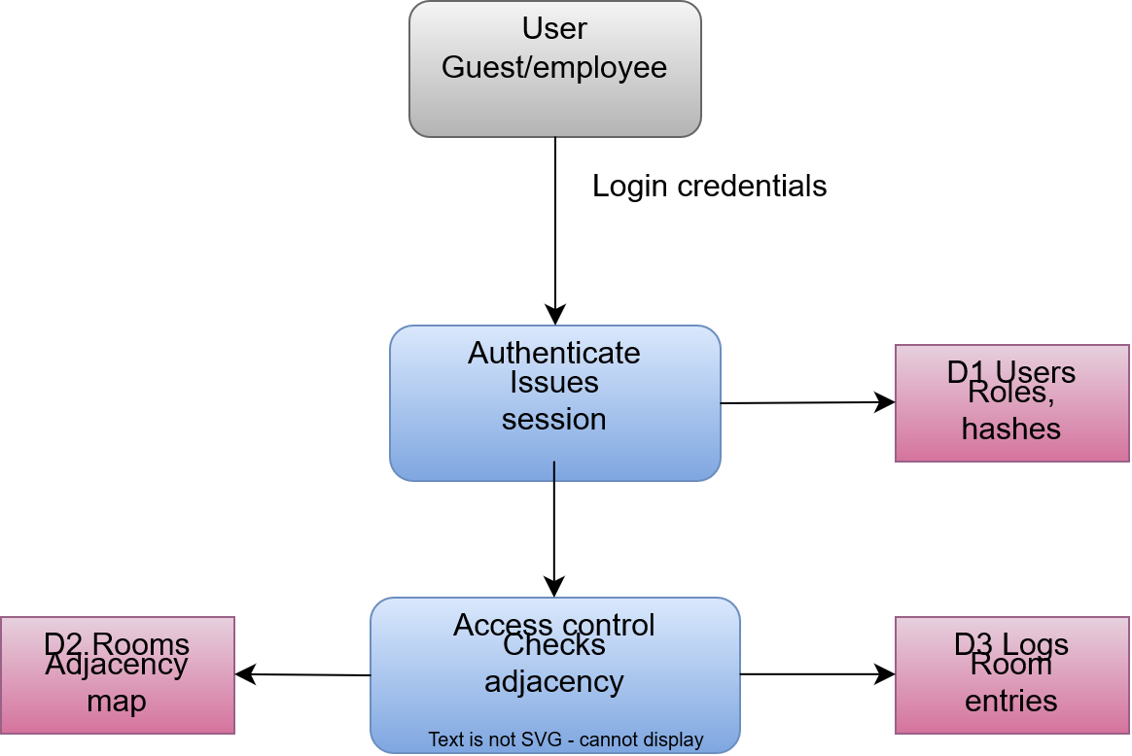

STRIDE-Threats
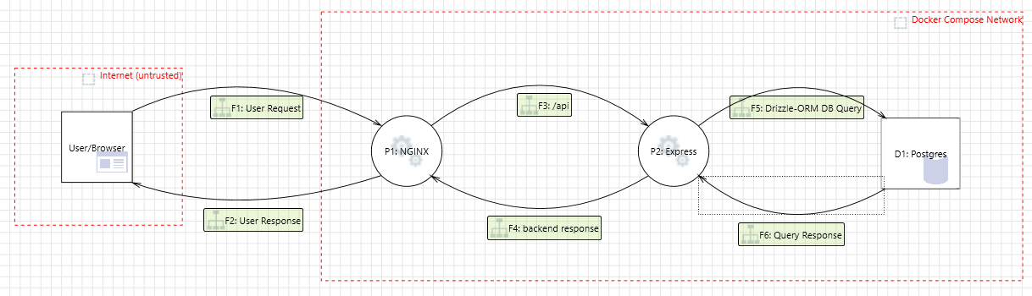
Figure 1: STRIDE diagram of System Architecture
Category | Description | Mitigation(s) | Severity
Elevation of Privileges | A user within P2 may be able to pivot to D1 | Firewall configuration | High
Elevation of Privileges | DB Access should be based on least-privilege | Accounts of least-privilege are used to connect to the DB | High
Information Disclosure | An attacker might have access to high-value PII or HBI data | Add additional protection mechanisms, encrypt data, hash passwords, encrypted backups | High
Information Disclosure | An attacker might be able to disclose information through SQLI | Database auditing, SQLI mitigations like placeholder queries, etc | High
Repudiation | Without auditing and logging it would be impossible to implement accountability in the system | Enable logging and auditing | Medium
Tampering | An attacker can possibly tamper database items and deny it | Utilize signatures to critical database items | High
Tampering | An attacker can take advantage of a lack of intrusion detection and prevention | Enable threat detection and prevention mechanisms | High

This system only enabled a user to access the system from one point, NGINX. From NGINX a user can access the backend through the reverse proxy “/api”. For a user to compromise this system they would need to find some way to get into the system itself. Using the Drizzle-ORM we mitigate SQLI where unless there is a vulnerability an attacker can use to bypass security the chances of a SQLI attack succeeding are very low.
The backend can serve images stored locally on the server, an attacker can try to attack these endpoints to exfil sensitive files from the server, we mitigate this by taking the file-name as a component of the URL, “/image/file.png”, rather than some URL parameter like “?file=”. Despite this in the backend we validate all user-defined input because a user should never be natively trusted. With file-access we resolve that path and check if the resource being accessed is outside the allowed directory and deny it. An attacker with system access could insert sensitive files in the allowed directory and directly access this but this requires system access which is difficult to achieve.
Users can upload their own images; file upload can allow an attacker to achieve potential RCE or even stored-XSS by uploading a malicious file that can be accessed from the site. We handle this by checking the file extension and mime type, we only accept valid images and while these can be bypassed through magic-bytes and so forth. Despite a potential “successful” upload the backend will always view these files as images thus any malicious JS, PHP, will not execute. There are systems that help mitigate these actions but you run the risk of how they parse user-defined image files to be flawed and result in an exploit itself.
With internal compromise handling it would require a potential shutdown to investigate the cause of internal breach along with a required rotation of all credentials, assume the attacker has leaked stored hashes and alert users of potential breach so they can update their credentials. It is difficult to fully prevent a lateral traversal between backend and the database because the backend requires some form of DB credentials to perform queries with Drizzle. We can employ encryption, but when an attacker is inside, they can exfil the decryption logic and decrypt off-site.
In compromise of the database, assuming an attacker can achieve successful SQLI, Postgres does contain ways to both read/write/execute files and programs, thus to mitigate against these operations is by creating a low-privilege database user who has restrictions on symbols they can use, Postgres accepts custom-configuration which can be used to log activities and handle prevention to some extent.
The main goal of this system to ensure protection is to mitigate attackers from gaining internal system access through RCE, ACE, File Upload, etc. Easiest way for handling this is handling user-input.

