

By: Cameron Schaff
Configuring Multi-hop iBGP over OSPF

Purpose
The purpose of this lab was to connect across a simulated ISP through IBGP, we used OSPF however any underlying protocols will work. This process enables route sharing across network edge routers over a hop or multi hop router in the middle. All while using OSPF to redistribute internal network information to IBGP’s routing to get across the network.
Background Information
BGP
Border Gateway Protocol (BGP) was created in 1989 to address the need for more efficient and scalable methods of routing between different isolated provider networks otherwise known as Autonomous Systems (ASes) on the internet. Autonomous systems are a collection of IP networks and routers under the control of single entity or organization that presents a common route to the internet. Before BGP, there was a protocol named Exterior Gateway Protocol (EGP) that was used, however it was not suitable for the scale and complexity of the rapidly developing internet. As the internet made many leaps in succession during the 1980s, there was a need for a protocol that could be scalable; the internet was growing rapidly, and the number of networks (autonomous systems) was increasing, necessitating a more scalable routing solution that could calculate on a international scale. As well as including policy-based routing as organizations wanted more control over how traffic is routed between ASes and on their own internal network, not just based on the shortest path or best link, but also on business, administrative, and policy considerations. It was also required to be stable as the internet needed a protocol that could adapt to changes (such as link failures) and prevent routing loops or instabilities that could cause major outages. Finally, its greatest challenge needed interdomain routing, as the internet expanded to continental connection, routing had to be done between different ASes (interdomain), not just within a single AS (intradomain). This is the core trait of BGP a program designed for expansion. Thus, BGP was introduced in 1989 with the release of BGP-1 by Yakov Rekhter and many others, later enhanced into BGP-4 (the version in use today) with the inclusion of support for Classless Inter-Domain Routing (CIDR) and other improvements.
BGP functions
BGP functions off a path vector protocol designed to mediate exchanges of routing information between different ASes. It is the backbone protocol used by all major ISP’s (ISPs and large enterprises) to decide the best path for data to travel across local and global internet. Some key features of BGP include, but are not limited to: Inter-AS routing, path vector routing policy, and loop prevention.
Inter-AS Routing allows routers in one AS to exchange routing information with routers in other ASes. Each AS is identified by a unique Autonomous System Number (ASN). BGP uses a path vector algorithm, meaning it keeps track of the full path of ASes that routing information has passed through. Each route advertised by BGP includes a list of ASes that the packet will traverse to reach the destination, also known as the AS path. Routing Policies allows network administrators to define rules and limitations based on various attributes (such as AS path, prefix length, or other metrics) unlike other protocols. As BGP uses the AS path as a loop prevention mechanism. If a router receives a route advertisement that contains its own AS number in the AS path, it will reject that route to avoid network loops.
BGP Path Selection Algorithm
When BGP routers need to select the best route to a destination, they use a set of rules or attributes to determine which path to choose, the BGP rules and attributes are as follow: To prefer the path with the highest local preference; local preference is a BGP attribute used to influence routing decisions within an AS. It is manually configured by network administrators and can be used to prefer one exit connection over another. Or, to prefer the path with the shortest AS path; the AS path is a list of ASes the route has passed through. A shorter AS path is preferred as it indicates fewer hops and, in theory, a more direct route. To prefer the path with the lowest origin type: BGP assigns an origin code to each route, indicating whether the route was learned from an Interior Gateway Protocol (IGP), an Exterior Gateway Protocol (EGP), or manually configured. Routes originating from an IGP are preferred over EGP, and EGP is preferred over manually configured routes. To prefer the path with the lowest MED (Multi-Exit Discriminator): The MED is an attribute used to influence routing decisions between two ASes. It’s used to suggest to a neighboring AS which of several possible entry points to choose, and the path with the lowest MED value is preferred. To prefer eBGP over iBGP: If a route is learned from an eBGP (external BGP) peer (a peer in another AS), it is preferred over a route learned from an iBGP (internal BGP) peer (a peer within the same AS). To prefer the path with the lowest IGP metric: The next step involves checking the IGP metric (such as OSPF or IS-IS) to the next hop. The path with the lowest IGP metric to the next hop is preferred. Tie-breaking: If all the previous steps result in ties, BGP will choose the path that was received first (i.e., the earliest in time).
eBGP
eBGP (External Border Gateway Protocol) is a path-vector routing protocol that exchanges routing information between different autonomous systems (ASes) linked through the Internet. A program developed to address the growing need for scalable, flexible, and policy-driven inter-domain routing, eBGP enables communication between independent networks under different administrative control, such as Internet Service Providers (ISPs). eBGP routers share routing information through BGP's protocol update messages, which include important attributes such as the AS path, prefix, next-hop IP, and various efficiency/speed-based metrics that influence routing decisions. The AS path attribute plays a critical role in preventing routing loops by ensuring that routes are only accepted if they do not traverse the AS that is advertising them. eBGP allows network operators to define routing policies using attributes like local preference, MED (Multi-Exit Discriminator), and AS path before controlling the flow of traffic between ASes based on business needs, such as optimizing performance, increasing redundancy, or decreasing costs. It is fundamental to the global Internet infrastructure, supporting everything from large-scale ISP backbone routing to multi-homing for enterprises, and enabling precision control over how traffic is routed across diverse networks. This is important to note that eBGP is not for local use and is used majorly as an interconnecting bridge between internet suppliers and companies. Other much faster much more detailed protocols like OSPF, EIGRP, or IS-IS should be used on small home and company networks for increased speeds as the BGP’s bandwidth is not needed.
BGP was created to address challenges of routing between different ASes and to provide a flexible, scalable, and policy-driven approach to internet routing. It uses a path vector protocol and a rich set of attributes and decision-making rules to select the best route for traffic. As one of the backbone protocols for interdomain routing, the protocol plays a crucial role in maintaining stability, scalability, and flexibility of the internet.
iBGP
Internal Border Gateway Protocol (iBGP) is a protocol designed to enable routers within the same autonomous system (AS) to exchange routing information. Unlike external BGP (eBGP), which is used to exchange routes between different ASes, iBGP ensures that all routers within an AS have access to the same routing information. This creates a consistent view of the network for all routers, enabling them to make informed routing decisions to maintain efficiency and speed.
The creation of iBGP was driven by the need for scalable and efficient routing within large autonomous systems. In the early days of BGP, without iBGP, each router within an AS would rely only on eBGP sessions with external ASes, leading to incomplete or inconsistent routing information. This could result in suboptimal routing decisions, especially in large networks with multiple routers.
To address this challenge, iBGP was developed to allow routers within the same AS to share information with each other, creating a fully meshed network of BGP sessions within the AS. With iBGP, every router in the AS learns about all available routes, improving routing accuracy and enabling features like load balancing, redundancy, and more granular traffic control effectively combining into one router running eBGP. Additionally, iBGP provides a method for enforcing routing policies, such as filtering routes or implementing security measures within the AS.
However, iBGP also introduces complexities. To ensure a consistent network view and prevent routing loops, iBGP imposes restrictions, such as the split-horizon rule, where a router does not advertise routes learned from one iBGP peer to another. This restriction can be overcome by using route reflectors or next-hop-self configurations to reduce the number of iBGP sessions and ensure the smooth flow of information across the network. The creation of iBGP was a critical advancement in the evolution of BGP, enabling scalable and efficient routing within large, complex networks while maintaining control over traffic flow and routing policies.
OSPF
Open Shortest Path First (OSPF) is a widely used interior gateway protocol (IGP) designed to manage the routing of data efficiently and dynamically within an autonomous system (AS). Initially developed in the late 1980s and standardized by the Internet Engineering Task Force (IETF) in RFC 2328, OSPF has become a cornerstone of modern networking, providing a scalable, reliable, and flexible solution for routing in large and complex networks as well as small home office configurations. OSPF operates based on the link-state routing algorithm, which allows routers to build an up-to-date, complete map of the entire network topology and make routing decisions based on this map’s metrics.

Development and Creation of OSPF (OSPF 1, OSPF v2, Dijkstra’s Algorithm, Ipv6 OSPF v3)
The development of OSPF can be traced back to the late 1980s when the need for a more efficient, scalable, and flexible routing protocol for IP networks became evident. The first version of OSPF, OSPFv1, was developed under the IETF's Routing Area Working Group in response to the limitations of the Routing Information Protocol (RIP), which had significant issues in larger networks, such as slow convergence times, limited scalability, and reliance on hop counts as the sole metric for determining optimal path leading to network congestion and inefficiency that could have been otherwise avoided.

OSPF was designed to address these limitations, using a more sophisticated link-state routing algorithm, which allowed routers to share information about the state of their links (for instance, their interfaces and connections to other routers). This was a significant improvement over RIP, which only communicated hop counts and could not effectively represent more complex network topologies.

The development of OSPF v2 (Standard ipv4 OSPF), the version that is widely used today, was formally completed in 1991 and standardized in RFC 2328. This version introduced numerous improvements, such as support for large networks, the ability to scale better in both large-scale enterprise networks and service provider environments, and a more detailed approach to managing route metrics, including the introduction of the Dijkstra algorithm to calculate the shortest path from the recorded link states and metrics.

Dijkstra Algorithm:
Dijkstra's algorithm is an algorithm for finding the shortest paths between nodes in a weighted graph, which may represent, for example, road networks. It was conceived by computer scientist Edsger W. Dijkstra in 1956 and published three years later.

Dijkstra's algorithm finds the shortest path from a given source node to every other node.: 196–206 It can also be used to find the shortest path to a specific destination node, by terminating the algorithm once the shortest path to the destination node is known. For example, if the nodes of the graph represent cities, and the costs of edges represent the average distances between pairs of cities connected by a direct road, then Dijkstra's algorithm can be used to find the shortest route between one city and all other cities. A common application of shortest path algorithms is network routing protocols, most notably IS-IS (Intermediate System to Intermediate System) and OSPF (Open Shortest Path First). It is also employed as a subroutine in other algorithms such as Johnson's algorithm.

As networking technologies and requirements continued to evolve, the need for IPv6 support grew, leading to the creation of OSPFv3. This version, standardized in RFC 5340, incorporated improvements and adjustments for IPv6, allowing OSPF to operate in modern IP-based networks supporting both IPv4 and IPv6 protocols.

OSPF Usage

OSPF is used in a variety of networking environments, from small office networks to large enterprise data centers, campus networks, and even service provider backbones. Its primary function is to dynamically calculate the best path for data packets between routers based on real-time topology data. OSPF routers continuously share link-state advertisements (LSAs) with each other, enabling them to keep an up-to-date map of the network. This enables quick adaptation to network topology changes, such as the addition or removal of routers and links.

OSPF is used in both single-area and multi-area configurations. In a single-area configuration, all routers in the AS are part of the same OSPF area, and routing information is exchanged freely between all routers. In multi-area OSPF configurations, networks are divided into smaller, more manageable areas to improve scalability and reduce overhead. Routers that belong to different areas exchange summarized routing information, keeping the routing table sizes smaller and more manageable.

Topology
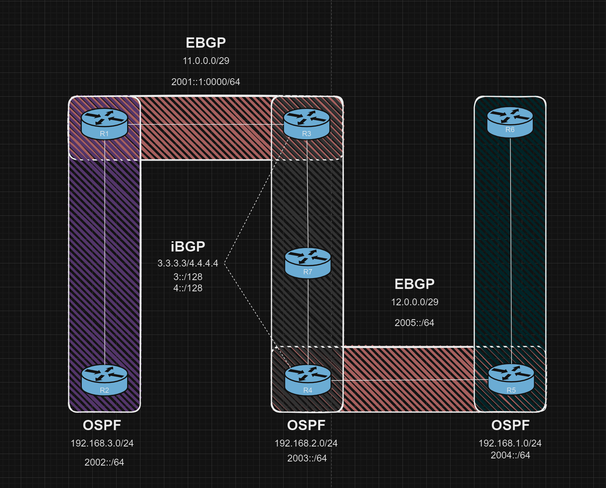
Lab Commands
R1
Current configuration : 4585 bytes
Last configuration change at 22:07:49 UTC Mon Dec 9 2024
version 16.9
service timestamps debug datetime msec
service timestamps log datetime msec
platform qfp utilization monitor load 80
platform punt-keepalive disable-kernel-core
hostname R1
boot-start-marker
boot-end-marker
vrf definition Mgmt-intf
address-family ipv4
exit-address-family
address-family ipv6
exit-address-family
no aaa new-model
login on-success log
subscriber templating
vtp domain cisco
vtp mode transparent
ipv6 unicast-routing
multilink bundle-name authenticated
crypto pki trustpoint TP-self-signed-2189345785
enrollment selfsigned
subject-name cn=IOS-Self-Signed-Certificate-2189345785
revocation-check none
rsakeypair TP-self-signed-2189345785
crypto pki certificate chain TP-self-signed-2189345785
certificate self-signed 01
30820330 30820218 A0030201 02020101 300D0609 2A864886 F70D0101 05050030
31312F30 2D060355 04031326 494F532D 53656C66 2D536967 6E65642D 43657274
69666963 6174652D 32313839 33343537 3835301E 170D3234 31323039 32313333
34305A17 0D333030 31303130 30303030 305A3031 312F302D 06035504 03132649
4F532D53 656C662D 5369676E 65642D43 65727469 66696361 74652D32 31383933
34353738 35308201 22300D06 092A8648 86F70D01 01010500 0382010F 00308201
0A028201 01009C53 7EBC08B6 8113DE14 81DD9EDC BA892D12 8271EBED AAA8A2C1
B5C957CA 805B4635 93A5D7DC F01AD7FD C87DB7C4 0938383F 9AD314EC 626C36BF
E55E6274 044F33F3 7B1376A7 B063588C 6CF317B7 8C5E136B 40CC546E 9EEFAFF0
4F1A3BAA 33AF46F9 CF3DF07B 871466CB DC8F9E23 9F65C8C9 710EBD11 B4763098
6851B821 4286EDA3 A2BEAD5E E1370402 82E2AC9D D7611215 05C85EC5 8D07F582
B23E242F 0B6FC327 4A591921 B5D147A2 F7F15617 F5145B0F 2C9E170B 37C4984A
84DF6F0B 1A85046E 6BAC449D 208C680D C4CDFD97 B0C5182E 820C34D9 FB1893F6
45849E0B 77238700 16389606 4C265FE5 89BFF0FB F6EC3300 B279D868 CEEC0CB6
F81BB954 B7D30203 010001A3 53305130 0F060355 1D130101 FF040530 030101FF
301F0603 551D2304 18301680 14A4700A 315CC5FF 4E705745 8721FFEA F324BAB0
FD301D06 03551D0E 04160414 A4700A31 5CC5FF4E 70574587 21FFEAF3 24BAB0FD
300D0609 2A864886 F70D0101 05050003 82010100 7EAA33ED E23D4B5B 162179D1
31ACCD09 0FAA40B4 8EF9BEF7 CE0F3F6C 941B63CE 9CA72436 6B1722B3 C6F1791D
D930D9AA 0A0B861C ACF00B26 B95954B0 150BF617 A7F583F6 E4A80A03 DA9FCEDD
62C425CB FCBFB477 030F3E15 7566F848 E5D60087 F3D50163 D54B2F96 60450B15
27972813 E47087E2 37B6CAFB 81847649 451AA42A DC9598CE 34418A73 CA34DC57
9C6FBD66 3E77EEC0 373006BE D968328D 0875CD76 9024C003 BDE6AF6E F0D02169
0C6C0E5D 5694B2CA 9617CD6E 56287788 BDC370B8 76C7B93D 51E9B529 5792E9C5
1DD95F84 5761A221 DC2792DE 3BD5F118 812A2023 F44678FC 298C58AC 01AFEADC
FB24BBBE 19A2F74F AD6820D0 54965C60 ABC0309C
quit
license udi pid ISR4321/K9 sn FDO21482DXE
license boot level appxk9
no license smart enable
diagnostic bootup level minimal
spanning-tree extend system-id
redundancy
mode none
interface Loopback0
ip address 1.1.1.1 255.255.255.255
interface GigabitEthernet0/0/0
ip address 11.0.0.1 255.255.255.248
negotiation auto
ipv6 address 2001::1:1/64
interface GigabitEthernet0/0/1
ip address 192.168.3.1 255.255.255.0
negotiation auto
ipv6 address 2002::1/64
ipv6 ospf 1 area 1
ipv6 ospf hello-interval 20
ipv6 ospf dead-interval 60
interface Serial0/1/0
interface Serial0/1/1
interface GigabitEthernet0/2/0
no ip address
shutdown
negotiation auto
interface GigabitEthernet0/2/1
no ip address
shutdown
negotiation auto
interface GigabitEthernet0
vrf forwarding Mgmt-intf
no ip address
shutdown
negotiation auto
router ospf 1
router-id 1.1.1.1
redistribute connected subnets
redistribute bgp 1 subnets
network 192.168.3.0 0.0.0.255 area 1
router bgp 1
bgp router-id 1.1.1.1
bgp log-neighbor-changes
neighbor 11.0.0.3 remote-as 4
neighbor 2001::1:3 remote-as 4
address-family ipv4
redistribute connected
redistribute ospf 1
neighbor 11.0.0.3 activate
no neighbor 2001::1:3 activate
exit-address-family
address-family ipv6
redistribute connected
redistribute ospf 1
neighbor 2001::1:3 activate
exit-address-family
ip forward-protocol nd
ip http server
ip http authentication local
ip http secure-server
ip tftp source-interface GigabitEthernet0
ipv6 router ospf 1
router-id 1.1.1.1
redistribute connected
redistribute bgp 1
control-plane
line con 0
transport input none
stopbits 1
line aux 0
stopbits 1
line vty 0 4
login
end

R2
Current configuration : 4021 bytes
Last configuration change at 21:23:21 UTC Mon Dec 9 2024
version 16.9
service timestamps debug datetime msec
service timestamps log datetime msec
platform qfp utilization monitor load 80
platform punt-keepalive disable-kernel-core
hostname R2
boot-start-marker
boot-end-marker
vrf definition Mgmt-intf
address-family ipv4
exit-address-family
address-family ipv6
exit-address-family
no aaa new-model
login on-success log
subscriber templating
vtp domain cisco
vtp mode transparent
ipv6 unicast-routing
multilink bundle-name authenticated
crypto pki trustpoint TP-self-signed-2557841031
enrollment selfsigned
subject-name cn=IOS-Self-Signed-Certificate-2557841031
revocation-check none
rsakeypair TP-self-signed-2557841031
crypto pki certificate chain TP-self-signed-2557841031
certificate self-signed 01
30820330 30820218 A0030201 02020101 300D0609 2A864886 F70D0101 05050030
31312F30 2D060355 04031326 494F532D 53656C66 2D536967 6E65642D 43657274
69666963 6174652D 32353537 38343130 3331301E 170D3234 31323039 32313131
30385A17 0D333030 31303130 30303030 305A3031 312F302D 06035504 03132649
4F532D53 656C662D 5369676E 65642D43 65727469 66696361 74652D32 35353738
34313033 31308201 22300D06 092A8648 86F70D01 01010500 0382010F 00308201
0A028201 01009643 43B84234 C9BB51F5 CE7CDC0C 874AB996 540192D7 6DF6CED5
6724B2E5 55EAB675 C2512888 14B72C23 F7D408B8 888E0C94 9BFD2458 98A09A0A
0DD40919 B3247D0A BC6AD24E 0991CE28 8619FEE3 57E91F42 36DC5CFF 2B3753B4
C54AC9ED 567A2BFA A7E02FE7 D2B8830C F6B688DF 25BAF552 62757F93 5B80284D
2A94FF49 E187A178 A1A44012 EDEE8649 C27D4ACF D4604F8D F67E442A 11D10B7A
207E722C 39A418E7 3EBAFE1E 5D1E6DA5 CAFD7C44 54B1C316 3B0A5E83 140CE599
8EDAF4A0 26BF935B C80CFF53 4E31F458 DFCB2C1F 6D6E910C A1580E78 97273FA1
2A635F11 13F7A00B 92B94B4B 0CDA6239 2FACFAEC 795BC525 8B410CD6 BB55C04C
CFEDAD09 EAD30203 010001A3 53305130 0F060355 1D130101 FF040530 030101FF
301F0603 551D2304 18301680 142C3FA7 FCA0DCC9 8EE39A16 22C37B53 0A8DC5DE
FE301D06 03551D0E 04160414 2C3FA7FC A0DCC98E E39A1622 C37B530A 8DC5DEFE
300D0609 2A864886 F70D0101 05050003 82010100 4DC4EFC4 B885CBC9 55EE0032
25B09713 B9E3F6A1 04F01DE1 EDB686D9 8B89B584 7E400C8A CC43DCB7 CA8CE3D7
F46D0E83 0064264D 37D93A47 CAB56B04 437E8940 5157C660 69F009C7 146D8A0E
BCA18D07 E2F8BFDC 1B5B5483 6170763F DD6C3081 6F7CFE7B 94B7E612 08DFE16C
376D13C5 DA7974B3 24E2DC58 E4243BCA 5902BE8E 1FE00D6B F69FA467 E09931BD
417308A4 8E461CE8 9B37CEEC 9FC8A3F1 4E83F10B 548D27EC C9F8585C E360540D
6BDC51B3 06C59A8D B712BE7B 738AA670 12D26108 E948FDA5 4775B8CA 846977D7
C9B56075 ADA9AD32 36BB77A4 78CB473E 7E4D0B14 B4F61D63 904C8D52 AF8C3016
807A86D9 1D7B6B62 93B2F6EE 7D792068 B62E5EEA
quit
license udi pid ISR4321/K9 sn FDO21500G1N
license boot level appxk9
no license smart enable
diagnostic bootup level minimal
spanning-tree extend system-id
redundancy
mode none
interface GigabitEthernet0/0/0
no ip address
negotiation auto
interface GigabitEthernet0/0/1
ip address 192.168.3.2 255.255.255.0
negotiation auto
ipv6 address 2002::2/64
ipv6 ospf 1 area 1
ipv6 ospf hello-interval 20
ipv6 ospf dead-interval 60
interface Serial0/1/0
no ip address
shutdown
interface Serial0/1/1
no ip address
shutdown
interface GigabitEthernet0/2/0
no ip address
shutdown
negotiation auto
interface GigabitEthernet0/2/1
no ip address
shutdown
negotiation auto
interface GigabitEthernet0
vrf forwarding Mgmt-intf
no ip address
shutdown
negotiation auto
router ospf 1
router-id 2.2.2.2
network 192.168.3.0 0.0.0.255 area 1
ip forward-protocol nd
ip http server
ip http authentication local
ip http secure-server
ip tftp source-interface GigabitEthernet0
ipv6 router ospf 1
router-id 2.2.2.2
control-plane
line con 0
transport input none
stopbits 1
line aux 0
stopbits 1
line vty 0 4
login
end

R3
Current configuration : 4881 bytes
Last configuration change at 23:20:25 UTC Tue Dec 10 2024
version 16.9
service timestamps debug datetime msec
service timestamps log datetime msec
platform qfp utilization monitor load 80
platform punt-keepalive disable-kernel-core
hostname R3
boot-start-marker
boot-end-marker
vrf definition Mgmt-intf
address-family ipv4
exit-address-family
address-family ipv6
exit-address-family
no aaa new-model
login on-success log
subscriber templating
vtp domain cisco
vtp mode transparent
ipv6 unicast-routing
multilink bundle-name authenticated
crypto pki trustpoint TP-self-signed-318861592
enrollment selfsigned
subject-name cn=IOS-Self-Signed-Certificate-318861592
revocation-check none
rsakeypair TP-self-signed-318861592
crypto pki certificate chain TP-self-signed-318861592
certificate self-signed 01
3082032E 30820216 A0030201 02020101 300D0609 2A864886 F70D0101 05050030
30312E30 2C060355 04031325 494F532D 53656C66 2D536967 6E65642D 43657274
69666963 6174652D 33313838 36313539 32301E17 0D323431 32303932 33313430
395A170D 33303031 30313030 30303030 5A303031 2E302C06 03550403 1325494F
532D5365 6C662D53 69676E65 642D4365 72746966 69636174 652D3331 38383631
35393230 82012230 0D06092A 864886F7 0D010101 05000382 010F0030 82010A02
82010100 D4783572 ACF4C6FE E6F11D3B 4A72067C 26390753 2E72CD94 3EC0AB1B
96E707E0 C6977ED3 E4AE719D F16270D4 030D694C 0433FA40 DE0CA53E 61AFF285
74F28288 33E3A4CA 5F6A4509 F3A56D8E 2CB3CFD7 EBE43B0E 07376A8C DCCF833C
E6FF0A9D 58AA40F0 813636A2 46D0272D 45FB901D 85E4D594 BD6A89C5 F98548F0
A1DD0087 14C07E2B DF3BEBC7 91D8A72E 743BB245 83A63042 6CBAE441 DA6F37B6
4603303A E07560C3 12E0D26B D208B702 002846A1 F3ACBDCA 67918F1D E721E1B5
663EFEFC D9B9616F 2C1AF372 29AB008A 786A5155 242F3A28 FB81670C 40A1E926
962D68C3 260D855B F2650EDE 5F2DF41E EA90CD56 287B4ECD 740E8872 9D3A7881
3C02E7D7 02030100 01A35330 51300F06 03551D13 0101FF04 05300301 01FF301F
0603551D 23041830 16801401 CD626BA5 BC3C7314 ADB2DB2E 840125A2 440DEE30
1D060355 1D0E0416 041401CD 626BA5BC 3C7314AD B2DB2E84 0125A244 0DEE300D
06092A86 4886F70D 01010505 00038201 01006B0A 2DD1DB0A 88D8DC71 1226BD6A
EE9BCE48 70543AC4 40BF6B9B 4C2847CC DC4930C0 93955A4F 2702C19F 42307B02
4D5A5856 77326260 1258EEA0 B10A58FD E6535046 53587816 25F26912 3A0231CE
20D0428D AFE3BF36 5D38D035 AA73973B FB7CBF5E 02839457 0DD69307 F1D517CF
5D53989E 460DD52A F918B36F A245A2EB 83F4DF13 DB9160BD D554584B 262B2C64
6057322E 1CB749F5 444A81DD CAC6B5E7 9529E50D 480F0BC7 A1566C0A 87F52783
6BEC7B47 40D82AB0 AFD80352 2E495237 25000A30 A0E59EE6 4981D43B A4B8E1BF
61C837C7 CCD84B81 F609A1D3 4FA38BD1 13275E55 2F9AC7D3 34961BAE D8D3619A
12577751 AFA7575D 64D201FC C0B0ADC8 CC01
quit
license udi pid ISR4321/K9 sn FDO214420HM
no license smart enable
diagnostic bootup level minimal
spanning-tree extend system-id
redundancy
mode none
interface Loopback0
ip address 3.3.3.3 255.255.255.255
ipv6 address 3::/128
ipv6 enable
ipv6 ospf 4 area 0
interface GigabitEthernet0/0/0
ip address 11.0.0.3 255.255.255.248
negotiation auto
ipv6 address 2001::1:3/64
interface GigabitEthernet0/0/1
ip address 192.168.12.1 255.255.255.0
negotiation auto
ipv6 address 2003::1/64
ipv6 enable
ipv6 ospf 3 area 0
ipv6 ospf hello-interval 20
ipv6 ospf dead-interval 60
interface Serial0/1/0
interface Serial0/1/1
interface GigabitEthernet0/2/0
no ip address
shutdown
negotiation auto
interface GigabitEthernet0/2/1
no ip address
shutdown
negotiation auto
interface GigabitEthernet0
vrf forwarding Mgmt-intf
no ip address
shutdown
negotiation auto
router ospf 4
router-id 3.3.3.3
redistribute connected subnets
redistribute bgp 4 subnets
network 192.168.12.0 0.0.0.255 area 0
router bgp 4
bgp router-id 3.3.3.3
bgp log-neighbor-changes
neighbor 4:: remote-as 4
neighbor 4:: update-source Loopback0
neighbor 4.4.4.4 remote-as 4
neighbor 4.4.4.4 update-source Loopback0
neighbor 4.4.4.4 timers 120 360
neighbor 11.0.0.1 remote-as 1
neighbor 2001::1:1 remote-as 1
address-family ipv4
redistribute connected
no neighbor 4:: activate
neighbor 4.4.4.4 activate
neighbor 11.0.0.1 activate
no neighbor 2001::1:1 activate
distance bgp 220 5 1
exit-address-family
address-family ipv6
redistribute connected
redistribute ospf 3
distance bgp 220 5 1
neighbor 4:: activate
neighbor 2001::1:1 activate
exit-address-family
ip forward-protocol nd
ip http server
ip http authentication local
ip http secure-server
ip tftp source-interface GigabitEthernet0
ipv6 router ospf 3
router-id 3.3.3.3
redistribute connected
redistribute bgp 4
ipv6 router ospf 4
control-plane
line con 0
transport input none
stopbits 1
line aux 0
stopbits 1
line vty 0 4
login
end

R4
Current configuration : 4758 bytes
Last configuration change at 23:19:57 UTC Tue Dec 10 2024
version 16.9
service timestamps debug datetime msec
service timestamps log datetime msec
platform qfp utilization monitor load 80
platform punt-keepalive disable-kernel-core
hostname R4
boot-start-marker
boot-end-marker
vrf definition Mgmt-intf
address-family ipv4
exit-address-family
address-family ipv6
exit-address-family
no aaa new-model
login on-success log
subscriber templating
vtp domain cisco
vtp mode transparent
ipv6 unicast-routing
multilink bundle-name authenticated
crypto pki trustpoint TP-self-signed-2240717686
enrollment selfsigned
subject-name cn=IOS-Self-Signed-Certificate-2240717686
revocation-check none
rsakeypair TP-self-signed-2240717686
crypto pki certificate chain TP-self-signed-2240717686
certificate self-signed 01
30820330 30820218 A0030201 02020101 300D0609 2A864886 F70D0101 05050030
31312F30 2D060355 04031326 494F532D 53656C66 2D536967 6E65642D 43657274
69666963 6174652D 32323430 37313736 3836301E 170D3234 31313034 32313235
30325A17 0D333030 31303130 30303030 305A3031 312F302D 06035504 03132649
4F532D53 656C662D 5369676E 65642D43 65727469 66696361 74652D32 32343037
31373638 36308201 22300D06 092A8648 86F70D01 01010500 0382010F 00308201
0A028201 0100E608 04ED6277 53AFB217 7E7A1875 2BF73578 32EB33E6 6469055F
1D6644BA 7CFBA89C BDFB96B2 F595B6CC CD2DF7E0 5A4364A7 C74F08F0 EEDE99AB
280C2191 FEC81788 BADD4EF3 6905C5C3 7FF09557 82440BB6 8E37EACD 61C5B3AE
58D89B1B 959C0716 F922AE7A A06BA18A 3BA76957 E03E34D9 34AA10C2 2F2B5FA2
F4621917 8C90F5D9 52520897 CB330C73 28F7FA5B 8D880563 BF5C5C6E 7E99E0E0
F5E7D543 F9E7FBE5 66B03D84 894C030E 71A660E9 A0C47C99 F82A6820 55F8DBFD
0F1579BC 47ECB381 453B3D67 1D11ADF3 58A9723E EF8469B9 87F10ADE 7BEBD744
B933FF96 9A487E34 14905E87 C7237F57 5EEF8215 D0487AA8 0D43B27A 2557F104
8905A260 E5A10203 010001A3 53305130 0F060355 1D130101 FF040530 030101FF
301F0603 551D2304 18301680 14EAD6DA CB179878 175C8B6A 1F2E95E5 97EB470E
C5301D06 03551D0E 04160414 EAD6DACB 17987817 5C8B6A1F 2E95E597 EB470EC5
300D0609 2A864886 F70D0101 05050003 82010100 C44B2A82 71CC8CFE 181BBAB9
FAA66ADC 3C10896C 71E330CB 176B517F EF33C108 7C6ED8D7 B5C1D219 3C371D89
C95AE00E 0B47607A 5C0A4713 700C1258 923A730A 08E8400B 3F051BB2 18694B05
65C09607 8B41E4FD 3041689F 23411AA0 5E72803A 7BD3AC9F F1DC3594 F5EAB919
2EA80811 42045E95 79F62CD4 FF8A08C4 75688FC1 E08EA7EE 4592C7F4 309141A1
78FED3F2 21AED6B4 194E484D FC13E69C 9C1FD9D4 BD19D2E5 80CFF51B 29779CDE
06C6E317 EE0B2274 A1F7CAE2 DE62A9F5 9B708DB6 743EF3E5 533ECC5E E6A951C7
6DA5F515 D15FC3CE CE91D958 C53FBDB0 F439DFE5 E2886730 8D56C9A6 D8E49A6F
611256C0 6DD82CED 6ED741CD 8232A944 7F20BD12
quit
license udi pid ISR4321/K9 sn FDO214414DZ
no license smart enable
diagnostic bootup level minimal
spanning-tree extend system-id
redundancy
mode none
interface Loopback0
ip address 4.4.4.4 255.255.255.0
ipv6 address 4::/128
ipv6 enable
ipv6 ospf 4 area 0
interface GigabitEthernet0/0/0
ip address 12.0.0.1 255.255.255.248
negotiation auto
ipv6 address 2005::1/64
interface GigabitEthernet0/0/1
ip address 192.168.2.2 255.255.255.0
negotiation auto
ipv6 address 2003::2/64
ipv6 ospf 4 area 0
ipv6 ospf hello-interval 20
ipv6 ospf dead-interval 60
interface Serial0/1/0
no ip address
shutdown
interface Serial0/1/1
no ip address
shutdown
interface GigabitEthernet0
vrf forwarding Mgmt-intf
no ip address
shutdown
negotiation auto
router ospf 4
router-id 4.4.4.4
redistribute connected subnets
redistribute bgp 4 subnets
network 192.168.2.0 0.0.0.255 area 0
router bgp 4
bgp router-id 4.4.4.4
bgp log-neighbor-changes
neighbor 3:: remote-as 4
neighbor 3:: update-source Loopback0
neighbor 3.3.3.3 remote-as 4
neighbor 3.3.3.3 update-source Loopback0
neighbor 3.3.3.3 timers 120 360
neighbor 12.0.0.2 remote-as 3
neighbor 2005::2 remote-as 3
address-family ipv4
redistribute connected
redistribute ospf 4
no neighbor 3:: activate
neighbor 3.3.3.3 activate
neighbor 12.0.0.2 activate
no neighbor 2005::2 activate
exit-address-family
address-family ipv6
redistribute connected
redistribute ospf 4
neighbor 3:: activate
neighbor 2005::2 activate
exit-address-family
ip forward-protocol nd
ip http server
ip http authentication local
ip http secure-server
ip tftp source-interface GigabitEthernet0
ipv6 router ospf 4
router-id 4.4.4.4
redistribute connected
redistribute bgp 4
ipv6 router ospf 3
redistribute bgp 4
control-plane
line con 0
transport input none
stopbits 1
line aux 0
stopbits 1
line vty 0 4
login
end

R5
Current configuration : 4467 bytes
Last configuration change at 22:44:55 UTC Tue Dec 10 2024
version 16.9
service timestamps debug datetime msec
service timestamps log datetime msec
platform qfp utilization monitor load 80
platform punt-keepalive disable-kernel-core
hostname R5
boot-start-marker
boot-end-marker
vrf definition Mgmt-intf
address-family ipv4
exit-address-family
address-family ipv6
exit-address-family
no aaa new-model
login on-success log
subscriber templating
vtp domain cisco
vtp mode transparent
ipv6 unicast-routing
multilink bundle-name authenticated
crypto pki trustpoint TP-self-signed-4153289585
enrollment selfsigned
subject-name cn=IOS-Self-Signed-Certificate-4153289585
revocation-check none
rsakeypair TP-self-signed-4153289585
crypto pki certificate chain TP-self-signed-4153289585
certificate self-signed 01
30820330 30820218 A0030201 02020101 300D0609 2A864886 F70D0101 05050030
31312F30 2D060355 04031326 494F532D 53656C66 2D536967 6E65642D 43657274
69666963 6174652D 34313533 32383935 3835301E 170D3234 31323039 32313331
33305A17 0D333030 31303130 30303030 305A3031 312F302D 06035504 03132649
4F532D53 656C662D 5369676E 65642D43 65727469 66696361 74652D34 31353332
38393538 35308201 22300D06 092A8648 86F70D01 01010500 0382010F 00308201
0A028201 01009794 7ECAA3F9 4E9F6B74 1BD73530 775507C4 CE94E618 EF6171DD
5D17619F E29D8014 BA4847A2 34415356 9AC4A1FC B33AD03B C114B68C 68371B85
008ED989 25E105A1 BF30CEC1 321B36B9 4A5D0C52 5726FF3C 4EBECC7E D38EFCC3
0FEB8280 C7002895 8C9ACBC3 69684711 552CDB3C BA022A17 1E8EEF62 C92E01ED
9358EE59 6F4273F6 3B7021DC 63A56785 97FB9946 72C7FDCE 6ADCE669 20588F27
3122B777 C9131E2D 4E494B6C FE0F46B5 87C24184 589F0CCA 63992B68 8CBDCA61
07311E0F FEB1697A FDBBD22F 8AFEBC08 12D351D5 BB22A6C7 D2D5E1C5 AAD26DD5
B732B205 C56EA341 D78D5FE6 BC4E3B43 263436CE 752BC320 DA581818 99AFA152
065262DD 628F0203 010001A3 53305130 0F060355 1D130101 FF040530 030101FF
301F0603 551D2304 18301680 14E3DA23 DDC17C2D 253E2D7C BF43F976 37830E9F
DE301D06 03551D0E 04160414 E3DA23DD C17C2D25 3E2D7CBF 43F97637 830E9FDE
300D0609 2A864886 F70D0101 05050003 82010100 34E01AF9 47C9A8A1 73C79E23
C8A35CC3 253DC739 C75981F9 BDFAFCC3 E933B445 55EC105E 8FC05F41 6CF831D6
DA588C8C 628D9088 7218B62E B0DC10F6 A9310465 064F7AC2 58E2F434 05F5748C
B15E4194 ADE50323 3EF5E7CD 1CF2A4B7 58BCA194 C27307A9 DA1B83EF BFE0EB9A
C89DFF3F 344278CB 1B2ABF76 4B79AD16 46C3A529 3C7434DF 8C4F2B71 5162B177
FD223A05 A2B3A529 D9CBCC3F 9F485B32 F7F5DB0C 7F227AB5 077CECDA 756FFCE6
0CCA1D78 30D41069 CE995472 24282719 3966B64D 72519C88 76529B1A AE635CC4
6E25B6A6 1347B162 F2A3D43C 9A6996A8 00EA8C2F 9FAA9272 C1E0B3BA 57E1C8E7
5305C3D4 E0B7EF6A 21F9F843 53A1976F 15F36BD1
quit
license udi pid ISR4321/K9 sn FDO214417Q4
no license smart enable
diagnostic bootup level minimal
spanning-tree extend system-id
redundancy
mode none

interface Loopback0
ip address 5.5.5.5 255.255.255.0
ip ospf 1 area 1
interface GigabitEthernet0/0/0
ip address 12.0.0.2 255.255.255.248
negotiation auto
ipv6 address 2005::2/64
interface GigabitEthernet0/0/1
ip address 192.168.1.1 255.255.255.0
negotiation auto
ipv6 address FE80::127 link-local
ipv6 address 2004::1/64
ipv6 ospf 1 area 1
ipv6 ospf hello-interval 20
ipv6 ospf dead-interval 60
interface Serial0/1/0
no ip address
shutdown
interface Serial0/1/1
no ip address
shutdown
interface GigabitEthernet0
vrf forwarding Mgmt-intf
no ip address
shutdown
negotiation auto
router ospf 1
router-id 1.1.1.1
redistribute connected subnets
redistribute bgp 3 subnets
network 192.168.1.0 0.0.0.255 area 1
router bgp 3
bgp router-id 5.5.5.5
bgp log-neighbor-changes
neighbor 12.0.0.1 remote-as 4
neighbor 2005::1 remote-as 4
address-family ipv4
redistribute connected
redistribute ospf 1
neighbor 12.0.0.1 activate
no neighbor 2005::1 activate
exit-address-family
address-family ipv6
redistribute connected
redistribute ospf 1
neighbor 2005::1 activate
exit-address-family
ip forward-protocol nd
ip http server
ip http authentication local
ip http secure-server
ip tftp source-interface GigabitEthernet0
ipv6 router ospf 1
router-id 5.5.5.5
redistribute connected
redistribute bgp 3
control-plane
line con 0
transport input none
stopbits 1
line aux 0
stopbits 1
line vty 0 4
login
end

R6
Current configuration : 1939 bytes
Last configuration change at 22:45:12 UTC Tue Dec 10 2024
version 16.9
service timestamps debug datetime msec
service timestamps log datetime msec
platform qfp utilization monitor load 80
platform punt-keepalive disable-kernel-core
hostname R6
boot-start-marker
boot-end-marker
vrf definition Mgmt-intf
address-family ipv4
exit-address-family
address-family ipv6
exit-address-family
no aaa new-model
login on-success log
subscriber templating
vtp domain cisco
vtp mode transparent
ipv6 unicast-routing
multilink bundle-name authenticated
crypto pki trustpoint TP-self-signed-2054344109
enrollment selfsigned
subject-name cn=IOS-Self-Signed-Certificate-2054344109
revocation-check none
rsakeypair TP-self-signed-2054344109
crypto pki certificate chain TP-self-signed-2054344109
license udi pid ISR4321/K9 sn FDO215009QY
no license smart enable
diagnostic bootup level minimal
spanning-tree extend system-id
redundancy
mode none
interface Loopback0
ip address 6.6.6.6 255.255.255.0
ip ospf 1 area 0
interface GigabitEthernet0/0/0
no ip address
negotiation auto
interface GigabitEthernet0/0/1
ip address 192.168.1.2 255.255.255.0
negotiation auto
ipv6 address 2004::2/64
ipv6 enable
ipv6 ospf 1 area 1
ipv6 ospf hello-interval 20
ipv6 ospf dead-interval 60
interface Serial0/1/0
no ip address
interface Serial0/1/1
no ip address
interface GigabitEthernet0
vrf forwarding Mgmt-intf
no ip address
negotiation auto
router ospf 1
router-id 2.2.2.2
redistribute connected subnets
network 192.168.1.0 0.0.0.255 area 1
ip forward-protocol nd
no ip http server
ip http secure-server
ip tftp source-interface GigabitEthernet0
ipv6 router ospf 1
router-id 2.2.2.2
redistribute connected
control-plane
line con 0
transport input none
stopbits 1
line aux 0
stopbits 1
line vty 0 4
login
end

R7
Current configuration : 4139 bytes
Last configuration change at 21:54:09 UTC Tue Dec 10 2024
version 16.9
service timestamps debug datetime msec
service timestamps log datetime msec
platform qfp utilization monitor load 80
platform punt-keepalive disable-kernel-core
hostname R7
boot-start-marker
boot-end-marker
vrf definition Mgmt-intf
address-family ipv4
exit-address-family
address-family ipv6
exit-address-family
no aaa new-model
login on-success log
subscriber templating
vtp domain cisco
vtp mode transparent
ipv6 unicast-routing
multilink bundle-name authenticated
crypto pki trustpoint TP-self-signed-1457377718
enrollment selfsigned
subject-name cn=IOS-Self-Signed-Certificate-1457377718
revocation-check none
rsakeypair TP-self-signed-1457377718
crypto pki certificate chain TP-self-signed-1457377718
certificate self-signed 01
30820330 30820218 A0030201 02020101 300D0609 2A864886 F70D0101 05050030
31312F30 2D060355 04031326 494F532D 53656C66 2D536967 6E65642D 43657274
69666963 6174652D 31343537 33373737 3138301E 170D3234 31323039 32313333
33305A17 0D333030 31303130 30303030 305A3031 312F302D 06035504 03132649
4F532D53 656C662D 5369676E 65642D43 65727469 66696361 74652D31 34353733
37373731 38308201 22300D06 092A8648 86F70D01 01010500 0382010F 00308201
0A028201 01009EB7 D59D2E12 7D9BDA7B 1F910060 08F2D828 2073E98E 538235E8
BC703A2E DF73E1C0 0B5D6E02 47519A53 15F8D0A1 C47FB8A3 F180D9C1 88BCBAF4
584F733F 7EE27C60 923C0063 DECF79C7 DA9B4036 30B069B3 94AB9BDB 439D0FF9
67F77AEC 322EF1BF 84717AEB 27CC4D0B CBEE69B7 EB856603 1D2106A6 D5B6B2A6
E9A5679B B41492D4 39471638 3269D49F E847BDE4 BDB634A0 C8BF6218 1289FCFF
2727C641 488DFFCE DC09E8D3 F41FD765 58E63F3E 53C851FA 7218FE89 C976CE8E
DC4BEFE3 9628A935 9A300552 539017FB 14F06653 61542266 7B9FA91B 2C69E91F
7BED4721 9084BC8E AF4BDE8A B035FF3C BC2283F4 D85C5898 AF37FE1C 3E36F334
B3A21CCD D1790203 010001A3 53305130 0F060355 1D130101 FF040530 030101FF
301F0603 551D2304 18301680 14373550 4A1C08CA EF084490 E32F251E 2F67B9C8
BE301D06 03551D0E 04160414 3735504A 1C08CAEF 084490E3 2F251E2F 67B9C8BE
300D0609 2A864886 F70D0101 05050003 82010100 529C2552 005651E9 1E894264
2A3BFBD4 F0999DFF BF810E7C 3AB9E8F3 6867C8EE CE4568BF D5AD15DE 9F0107B3
3F9BEB51 173AECAD 3E70531D FE11B632 C9E684D6 ED669674 717EC677 A725FA7F
2336C726 E439F962 B8EAD363 D3C46960 283F9CE8 69DAC983 551CE1C4 4839EFED
E8E03BE9 9A5B627E D5296B32 B0CF1F35 199E6E0E F459606F CA198A37 96015069
959E91BB F983651E 226EBCFC 34F25DB7 C0703021 035B6419 7FB47614 278B559F
5E00729C 13FE371D EAFBDEAC 748163E7 318C43BB B7608226 F85993E1 A44D4F0E
2D239816 115D426A CD396B95 629407C9 B5949EBA 14E6BBFC D40D74A7 C0693625
7981721C 2323B5A0 BC3F1344 B85C0A34 E48CD54E
quit
license udi pid ISR4321/K9 sn FDO21441WDF
no license smart enable
diagnostic bootup level minimal
spanning-tree extend system-id
redundancy
mode none
interface GigabitEthernet0/0/0
ip address 192.168.2.254 255.255.255.0
negotiation auto
ipv6 address 3::1/64
ipv6 ospf 7 area 0
ipv6 ospf hello-interval 20
ipv6 ospf dead-interval 60
interface GigabitEthernet0/0/1
ip address 192.168.12.254 255.255.255.0
negotiation auto
ipv6 address 4::1/64
ipv6 ospf 7 area 0
ipv6 ospf hello-interval 20
ipv6 ospf dead-interval 60
interface Serial0/1/0
no ip address
shutdown
interface Serial0/1/1
no ip address
shutdown
interface GigabitEthernet0
vrf forwarding Mgmt-intf
no ip address
shutdown
negotiation auto
router ospf 7
router-id 7.7.7.7
redistribute connected subnets
network 192.168.2.0 0.0.0.255 area 0
network 192.168.12.0 0.0.0.255 area 0
router bgp 5
bgp log-neighbor-changes
neighbor 192.168.2.2 remote-as 4
neighbor 192.168.12.1 remote-as 4
ip forward-protocol nd
ip http server
ip http authentication local
ip http secure-server
ip tftp source-interface GigabitEthernet0
ipv6 router ospf 7
router-id 7.7.7.7
redistribute connected
control-plane
line con 0
transport input none
stopbits 1
line aux 0
stopbits 1
line vty 0 4
login
end

Lab
R7

For Router 7 begin with configuring each interface that act as connections between R3 and R4.
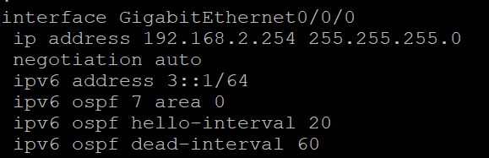
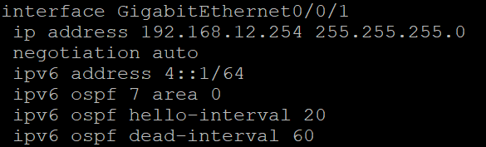
Router 7 is only an intermediary router that will share a routing protocol with both routers with iBGP interfaces. Proceed to configure the routing protocol that is used on R3 and R4 to establish a connection between them.
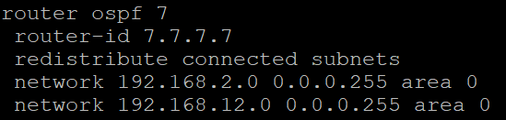
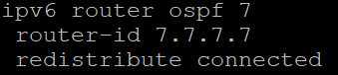

R3
- This will be building off the eBGP lab topology.
To route over iBGP the presence of loopback interfaces in the topology is essential, this is because OSPF is instructed to redistribute routes to BGP. Effectively, virtually linking the interfaces without a physical connection (a condition required by iBGP).

Configure loopback interfaces.
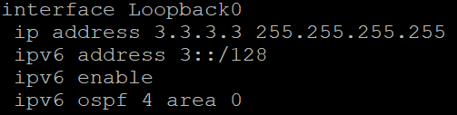
Once loopback has been set up in the router BGP configure the loopback as a neighbor. Then writing the [update-source] command to let BGP know where to look for a BGP neighbor in what port.
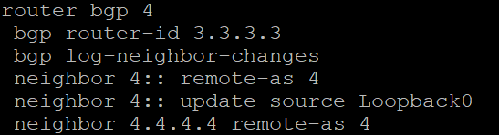

R4
Similarly to R3 begin the configuration of loopback address. Remembering to make it discoverable over the backbone routing protocol.
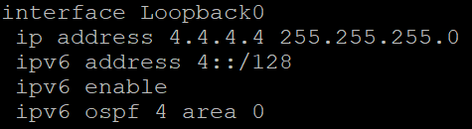
Just like R4 begin to configure router 3’s loopback as a neighbor to allow for BGP to discover the IP over loopback.
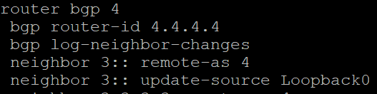

Finalizing
The routing table on Router 4 should look like below.
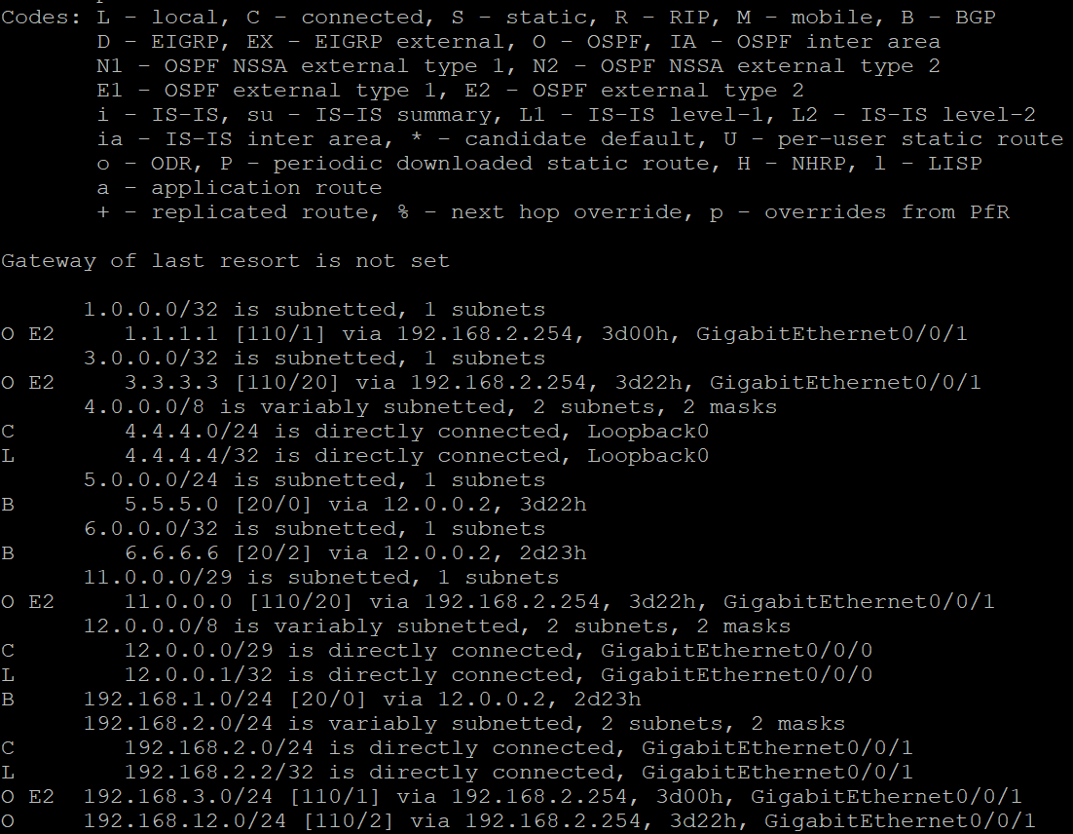
The routes over iBGP should be learned over the routing protocol of the backbone. This topology uses OSPF so as shown the O routes.
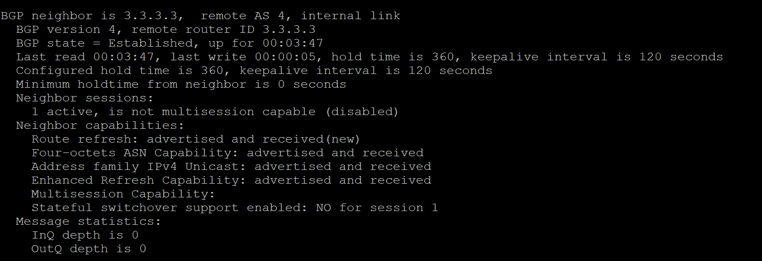
When looking at BGP neighbors, the hop router should show the internal link is working.

When using [show ipv4 bgp] it will also show the iBGP routes that were learned.
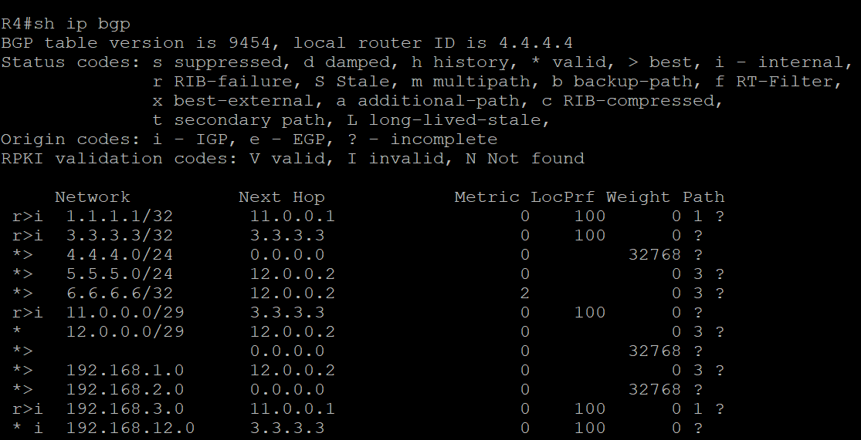

Problems
Common issues that may arise when configuring this lab would most likely be regarding the routing protocol used to share the iBGP routes. During the initial configuration the BGP routes would not be shared the reason being OSPF was not fully distributing the loopback routes. Be sure to [redistribute] routes across each router when neccesary.

Other common issues were missing simple configurations such as ipv6 Unicast-routing for older routers and making sure subnets aren’t overlapping and Ip’s are in the same subnet!

Conclusion
Internal border gateway protocol allows for routers in a local network to route and communicate with each other much like its counterpart, external border gateway protocol (eBGP). iBGP is a subsidiary of BGP and functions internally on network service providers to distribute routes over point to point or hop/multi-hop configurations. It allows for effective and efficient routing on internal networks over a single AS number. Although like eBGP in configuration through neighbors, differences can be found in communication of internal routes as iBGP works over another routing protocol such as IS-IS or OSPF. It only shares BGP and external routes to inside routers while topology and internal routing is through the internal routing protocol.

Sign-off


