THE UNIFIED DEVELOPER INTELLIGENCE HUB COMBINING ENTERPRISE DATA ANALYTICS, SEMANTIC CODE UNDERSTANDING, AND AI-POWERED COLLABORATIVE CODE REVIEW
A Capstone Project report submitted
in partial fulfillment of requirement for the award of degree
BACHELOR OF TECHNOLOGY
in
SCHOOL OF COMPUTER SCIENCE AND ARTIFICIAL INTELLIGENCE
by
Harsh | (2303A51105)
Anand | (2303A51090)
Aneesh | (2303A51120)
Vishwanath | (2303A51095)
Bharath | (2303A51097)
Under the guidance of
[Guide Name / Faculty Mentor]
Assistant / Associate Professor, School of CS&AI

SR UNIVERSITY
Ananthasagar, Warangal, Telangana - 506371

SR University
Ananthasagar, Warangal - 506371
CERTIFICATE
This is to certify that this project entitled "THE UNIFIED DEVELOPER INTELLIGENCE HUB COMBINING ENTERPRISE DATA ANALYTICS, SEMANTIC CODE UNDERSTANDING, AND AI-POWERED COLLABORATIVE CODE REVIEW" is the bonafide work carried out by Harsh (2303A51105), Anand (2303A51090), Aneesh (2303A51120), Vishwanath (2303A51095), and Bharath (2303A51097) as a Capstone Project for the partial fulfillment to award the degree BACHELOR OF TECHNOLOGY in School of Computer Science and Artificial Intelligence during the academic year 2026-2027 under our guidance and supervision.
[Guide Name / Faculty Mentor]  Assistant / Associate Professor,  School of CS&AI,  SR University,  Ananthasagar, Warangal. | Dr. CH. Sandeep  Associate Professor & Head,  School of CS&AI,  SR University,  Ananthasagar, Warangal.

Reviewer - 1  Name: ___________________________  Designation: ____________________  Signature: ______________________ | Reviewer - 2  Name: ___________________________  Designation: ____________________  Signature: ______________________

DECLARATION
We hereby declare that the Capstone Project report entitled "The Unified Developer Intelligence Hub Combining Enterprise Data Analytics, Semantic Code Understanding, and AI-Powered Collaborative Code Review" submitted to the School of Computer Science and Artificial Intelligence, SR University, Warangal, is an authentic record of original engineering research and software implementation carried out by us under faculty guidance and supervision.
We further confirm that this work has not been submitted previously to any other university, institute, or degree-granting entity for the award of any degree, diploma, fellowship, or commercial certificate. All secondary sources of information, research papers, third-party libraries, and analytical frameworks utilized during the development of this platform have been properly credited and cited in the references section of this report.
Furthermore, we confirm that all system implementations, source code repositories, architectural designs, automated code analyzers, and database migration models presented in this thesis represent genuine, functioning software artifacts engineered during the 2026-2027 academic session.
Place: Ananthasagar, Warangal
Date: 05 November 2026
Candidate Name | Hall Ticket / Roll No. | Signature
Harsh | 2303A51105 | _______________________
Anand | 2303A51090 | _______________________
Aneesh | 2303A51120 | _______________________
Vishwanath | 2303A51095 | _______________________
Bharath | 2303A51097 | _______________________

ACKNOWLEDGEMENTS
The completion of this Capstone Project report and the successful engineering of the Unified Developer Intelligence Hub (UDIH) has been an enriching academic and engineering journey. We wish to express our profound gratitude to all individuals and institutions whose guidance, constructive criticism, and encouragement made this work possible.
First and foremost, we express our sincere and heartfelt gratitude to our Faculty Guide and Mentor, [Guide Name / Faculty Mentor], Assistant / Associate Professor, School of Computer Science and Artificial Intelligence, for their constant guidance, insightful perspectives, and technical mentorship throughout the design, implementation, and refinement stages of this project.
We express our sincere thanks to Dr. CH. Sandeep, Associate Professor and Head, School of Computer Science and Artificial Intelligence, SR University, for fostering a forward-thinking academic environment, providing world-class laboratory facilities, and motivating us to undertake complex, full-scale software engineering challenges.
We extend our deep appreciation to the honorable Vice-Chancellor, Dean of Engineering, and the academic administration of SR University for their vision, continuous support, and provision of the state-of-the-art technological ecosystem that empowered our development work.
Our special thanks are also due to the technical reviewers and laboratory technicians of the School of CS&AI for their constructive feedback during periodic reviews. Finally, we express our deepest personal appreciation to our parents, family members, and classmates for their moral support and understanding throughout our engineering curriculum.
Harsh (2303A51105) | Anand (2303A51090) | Aneesh (2303A51120)
Vishwanath (2303A51095) | Bharath (2303A51097)

ABSTRACT
Modern software engineering organizations face significant friction in maintaining code quality, enforcing structural maintainability, and providing prompt, context-rich code review feedback across rapidly scaling distributed codebases. While classical static analysis tools provide deterministic rule checking, they lack semantic comprehension, fail to understand architectural intent, and generate excessive false positives. Conversely, standalone generative AI solutions suffer from context window saturation, token truncation errors, data leakage, and lack of deterministic grounding in actual project metrics.
To resolve this critical industry divide, this Capstone Project presents the Unified Developer Intelligence Hub (UDIH)—an enterprise-grade, multi-user, AI-powered developer intelligence and collaborative code analysis platform. UDIH introduces a novel hybrid intelligence paradigm combining deterministic static heuristic analysis with dual-model generative semantic reasoning. The system ingests zipped repository archives into an ephemeral sandboxed directory, applies multi-level path traversal sanitization, and extracts abstract syntactic structures across polyglot source trees.
The platform's static analysis engine evaluates code maintainability, cyclomatic complexity patterns, and vulnerability heuristics across JavaScript, TypeScript, Python, Java, C++, and Go. Simultaneously, an AST-aware structured context trimmer prunes low-entropy syntax while preserving function boundaries and semantic identifiers, overcoming conventional character limits. The processed representation is evaluated through a dual-model resilience architecture featuring Google Gemini 2.5 Flash as the primary reasoning engine with automatic fallback to Gemini 1.5 Pro upon API rate limiting or quota exhaustion.
UDIH is architected on a decoupled full-stack infrastructure utilizing React 19, Tailwind CSS, Express 5, and a dual-mode persistence layer coupling MongoDB Atlas with automated local daemon failover. A real-time heartbeat daemon tracks user presence, while JWT-based stateless authentication enforces strict role-based access control (Admin, Developer) and multi-tenant project isolation. Empirical testing demonstrates a 100% test pass rate across 15 formal verification scenarios, sub-second static analysis latency, and a 68% reduction in prompt token bloat while maintaining zero data leakage.
Keywords: Developer Intelligence, Static Code Analysis, Large Language Models, Google Gemini API, Semantic Code Review, MongoDB Atlas, AST Context Truncation, Role-Based Access Control, Software Quality Metrics.

TABLE OF CONTENTS
SECTION / CH. | TITLE / DESCRIPTION | PAGE
Title Page | - | i
Certificate | - | ii
Declaration | - | iii
Acknowledgements | - | iv
Abstract | - | v
Table of Contents | - | vi
List of Figures | - | viii
List of Tables | - | ix
List of Acronyms | - | x
CHAPTER 1 | INTRODUCTION OF PROJECT | 1
1.1 | Background and Problem Context | 1
1.2 | Evolution of Software Engineering and Developer Intelligence | 1
1.3 | Overview of the Unified Developer Intelligence Hub (UDIH) | 2
1.4 | Objectives of the Project | 3
1.5 | Scope and Operational Boundaries | 4
1.6 | Report Organization | 4
CHAPTER 2 | LITERATURE SURVEY AND RELATED WORK | 6
2.1 | Classical Static Code Analysis Frameworks | 6
2.2 | Deep Learning and Transformers in Software Engineering | 6
2.3 | Large Language Models for Automated Code Review | 7
2.4 | Multi-Tenant Developer Platforms and Security Paradigms | 8
2.5 | Critical Comparative Analysis of Existing Solutions | 8
2.6 | Identification of Research and Engineering Gaps | 9
CHAPTER 3 | PROBLEM STATEMENT AND ENGINEERING OBJECTIVES | 10
3.1 | Problem Definition in Modern Enterprise Codebases | 10
3.2 | Context Window Saturation and Information Leakage Challenges | 10
3.3 | Need for a Hybrid Static-Heuristic and Generative Paradigm | 11
3.4 | Core Engineering Goals and Success Criteria | 11
3.5 | Expected Engineering and Societal Outcomes | 12
CHAPTER 4 | REQUIREMENT ANALYSIS, FEASIBILITY, AND RISK ASSESSMENT | 13
4.1 | Stakeholder Profiles and Persona Analysis | 13
4.2 | Functional Requirements Specification (FR-01 to FR-15) | 13
4.3 | Non-Functional Requirements Specification (NFR-01 to NFR-08) | 14
4.4 | Comprehensive Feasibility Analysis | 15
4.5 | Risk Assessment, Hazard Analysis, and Mitigation Strategies | 15
4.6 | Development Methodology and Iterative Sprint Execution | 16
CHAPTER 5 | SYSTEM ARCHITECTURE AND PROPOSED METHODOLOGY | 16
5.1 | High-Level Architectural Paradigm | 16
5.2 | Tiered Layer Decomposition and Service Boundaries | 17
5.3 | Decoupled Service Architecture: Analysis vs. Collaborative Review | 18
5.4 | Dual-Model AI Resilience Framework | 18
5.5 | Dual-Mode Persistence Architecture: MongoDB Atlas & Local Failover | 19
5.6 | Structured Prompt Truncation & AST Context Preservation | 19
5.7 | Security Architecture: JWT Auth, RBAC, and Ephemeral Sandboxing | 20
CHAPTER 6 | SYSTEM DESIGN, UML MODELING, AND DATA WORKFLOWS | 22
6.1 | Use Case Modeling and Actor Interaction Analysis | 22
6.2 | Dynamic Behavioral Modeling: Sequence Diagrams | 23
6.3 | Workflow Modeling: Activity Diagrams | 23
6.4 | Data Flow Modeling (Level 0 Context, Level 1 Process DFD) | 24
6.5 | Information Modeling: Entity-Relationship Diagram (ERD) | 25
6.6 | Multi-Stage Pipeline Execution Lifecycle | 26
CHAPTER 7 | SYSTEM IMPLEMENTATION AND MODULE SPECIFICATIONS | 27
7.1 | Technology Stack and Implementation Environment | 27
7.2 | Ingestion Engine: Ephemeral Sandboxing & Real-Time Extraction UI | 27
7.3 | Static Code Analyzer Engine: Heuristics & Architectural Mapping UI | 28
7.4 | AI Intelligence Module: Gemini 2.5 Flash & Project Overview UI | 29
7.5 | Authentication, Session Security & Portal Login UI | 30
7.6 | Dashboard Analytics Engine: Aggregations & Data Isolation | 32
7.7 | Administration Portal, System Health UI & User Lifecycle | 32
CHAPTER 8 | SIMULATION SETUP, VERIFICATION, AND TEST EVIDENCE | 33
8.1 | Verification and Validation Framework | 33
8.2 | Formal Test Suite Execution (15 Verified Scenarios) | 33
8.3 | Security Audit: Injection, Traversal, and RBAC Penetration Testing | 34
8.4 | Performance Profiling, Latency, and Throughput Benchmarks | 35
8.5 | Verified Test Execution Transcripts and Log Evidence | 35
CHAPTER 9 | EXPERIMENTAL RESULTS, PERFORMANCE EVALUATION, AND DISCUSSION | 36
9.1 | Static Analysis Accuracy vs. AI Semantic Depth | 36
9.2 | Token Efficiency and Cost Optimization Analysis | 36
9.3 | Health Score Calibration and Deterministic Repeatability | 37
9.4 | Enterprise Analytics Telemetry & Real-Time Dashboard UI | 37
9.5 | Discussion of Findings and Industrial Viability | 39
CHAPTER 10 | LEARNING OUTCOMES, REFLECTIONS, AND TEAM CONTRIBUTIONS | 40
10.1 | Technical Competencies and Domain Knowledge Gained | 40
10.2 | Software Engineering Best Practices and Collaborative Work | 40
10.3 | Comprehensive Individual Team Member Contribution Matrix | 41
10.4 | Mapping to Program Outcomes (POs) and PSOs | 41
CHAPTER 11 | CONCLUSION, LIMITATIONS, AND FUTURE ROADMAP | 42
11.1 | Project Summary and Value Delivered | 42
11.2 | Current System Limitations and Edge Cases | 42
11.3 | Future Engineering and Research Roadmap | 43
11.4 | Concluding Remarks | 43
REFERENCES | IEEE / ACM Academic and Technical Citations | 44
APPENDIX A | REST API Specification and Data Contracts | 46
APPENDIX B | Google Gemini Prompts and Output JSON Schemas | 47
APPENDIX C | System Deployment, Configuration, and Operation Runbook | 48

LIST OF FIGURES
FIGURE NO. | FIGURE CAPTION / TITLE | PAGE
Figure 5.1 | High-Level Tiered System Architecture of UDIH | 17
Figure 5.2 | Five-Stage Analysis Pipeline & Dual-Model Resilience Flowchart | 19
Figure 6.1 | Unified Use Case Diagram for Developer and Administrator Roles | 22
Figure 6.2 | System Sequence Diagram for Ingestion, Analysis, and AI Review | 23
Figure 6.3 | Activity Diagram for Multi-Stage Pipeline Execution Lifecycle | 24
Figure 6.4 | Level 1 Data Flow Diagram (DFD) for Code Analysis and Review Engine | 24
Figure 6.5 | Entity-Relationship (ER) Diagram of UDIH MongoDB Persistence Models | 25
Figure 7.1 | Real-Time Ephemeral Ingestion and Decompression Progress Monitor | 28
Figure 7.2 | Extracted System Architecture, Pattern Classification & Key Relationships UI | 29
Figure 7.3 | Project Intelligence Overview with Calibrated Quality Score (80/100) | 30
Figure 7.4 | Production Authentication and Login Portal with Role Validation | 31
Figure 7.5 | Enterprise Settings & AI Provider Health Monitoring Interface | 32
Figure 9.1 | 30-Day Analysis Activity Trend Graph in Enterprise Dashboard | 37
Figure 9.2 | 30-Day Total Project Analysis Volume Bar Distribution Chart | 38
Figure 9.3 | Enterprise Data Analytics Dashboard with Issue Severity & Metric Totals | 38

LIST OF TABLES
TABLE NO. | TABLE CAPTION / TITLE | PAGE
Table 2.1 | Comparative Evaluation of Industry Code Quality & AI Platforms | 8
Table 4.1 | Comprehensive Functional Requirements Specification (FR-01 to FR-15) | 13
Table 4.2 | Non-Functional Requirements Specification (NFR-01 to NFR-08) | 14
Table 4.3 | Risk Identification, Severity Matrix, and Engineered Mitigations | 15
Table 7.1 | Core Technology Stack, Libraries, and Implementation Rationale | 27
Table 7.2 | MongoDB Collections, Field Types, Indexing, and Isolation Keys | 31
Table 8.1 | Formal Test Cases Suite and Empirical Verification Results (TC-01 to TC-15) | 33
Table 8.2 | Security Penetration Audit and Defensive Controls Verification | 34
Table 8.3 | Benchmarking Profile: Repository Ingestion, Analysis, and AI Response Latency | 35
Table 9.1 | Comparative Performance: Raw 15k Character Limit vs. AST Structured Truncation | 36
Table 9.2 | Health Score Calibration Metric Weights and Heuristic Deductions | 37
Table 10.1 | Comprehensive Individual Team Member Contribution Matrix | 41
Table 10.2 | Mapping of Project Work to CS&AI Program Outcomes (POs and PSOs) | 41
Table A.1 | REST API Endpoint Specifications, HTTP Verbs, and Access Control Levels | 46

LIST OF ACRONYMS
ACRONYM | EXPANSION / DEFINITION
AI | Artificial Intelligence
API | Application Programming Interface
AST | Abstract Syntax Tree
CORS | Cross-Origin Resource Sharing
CPU | Central Processing Unit
CRUD | Create, Read, Update, Delete
CSS | Cascading Style Sheets
DFD | Data Flow Diagram
ERD | Entity-Relationship Diagram
GenAI | Generative Artificial Intelligence
HTML | HyperText Markup Language
HTTP | HyperText Transfer Protocol
IDE | Integrated Development Environment
IEEE | Institute of Electrical and Electronics Engineers
JSON | JavaScript Object Notation
JWT | JSON Web Token
LLM | Large Language Model
LOC | Lines of Code
MI | Maintainability Index
MVC | Model-View-Controller
NFR | Non-Functional Requirement
ODM | Object-Document Mapping
PO / PSO | Program Outcome / Program Specific Outcome
PR | Pull Request
RBAC | Role-Based Access Control
REST | Representational State Transfer
SDK | Software Development Kit
SLO | Service Level Objective
SRU | SR University
TC | Test Case
UDIH | Unified Developer Intelligence Hub
UI / UX | User Interface / User Experience
UML | Unified Modeling Language

CHAPTER 1
INTRODUCTION OF PROJECT
1.1 BACKGROUND AND PROBLEM CONTEXT
In the modern era of continuous integration and agile software engineering, the speed of source code production has outpaced traditional manual quality assurance mechanisms. Distributed software development teams commit hundreds of pull requests daily across complex, multi-repository microservice architectures. As software codebases scale in cyclomatic complexity, architectural coupling, and dependency depth, ensuring consistent adherence to coding standards, software security baselines, and maintainability paradigms becomes an increasingly arduous bottleneck.
Traditional code review workflows rely primarily on human peer inspection. While human peer review is indispensable for evaluating high-level domain logic and algorithmic elegance, it suffers from several severe structural limitations. Human reviewers are vulnerable to cognitive fatigue, personal biases, subjective code-formatting preferences, and inconsistent vigilance during late-stage deployment sprints. Subtle memory leaks, resource leaks, concurrency vulnerabilities, unhandled exception paths, and architectural smells frequently slip into production builds despite manual gatekeeping.
Furthermore, as organizations onboard junior engineers and distributed offshore contractors, senior architects spend a disproportionate percentage of their engineering bandwidth performing repetitive syntactical corrections and baseline security audits. This operational friction inflates software engineering lead time, elevates defect escape rates, and substantially drives up technical debt across the enterprise lifecycle. There is consequently an urgent imperative for an automated, unified developer intelligence system that bridges deterministic metrics with nuanced semantic comprehension.
1.2 EVOLUTION OF SOFTWARE ENGINEERING AND DEVELOPER INTELLIGENCE
The evolution of developer assistance tools can be characterized across three distinct architectural epochs:
1. Deterministic Rule-Based Static Analyzers (1990s - 2010s): Early tooling, including ESLint, PMD, Checkstyle, and FindBugs, operated strictly via regular expressions, tokenization, and localized Abstract Syntax Tree (AST) pattern matching. While these tools execute with minimal latency and zero hallucinations, they exhibit zero semantic understanding, possess no awareness of cross-file structural intent, and generate enormous volumes of false positives that cause alert fatigue among developers.
2. Statistical Machine Learning and Heuristic Profilers (2010s - 2020): Systems such as SonarQube, CodeScene, and DeepCode introduced statistical defect prediction, technical debt estimation, and behavioral code churn analysis. These systems provided macroscopic visibility into repository health but remained largely non-generative; they could identify problematic modules but could not offer contextual explanations, refactoring diffs, or conversational design feedback.
3. Generative Artificial Intelligence and Large Language Models (2020 - Present): The advent of transformer-based Large Language Models (LLMs), such as OpenAI GPT-4, Anthropic Claude, and Google Gemini, revolutionized developer tooling by enabling natural-language code explanation, automated docstring synthesis, and intelligent review generation. However, naive deployments of LLMs face critical challenges: token window saturation, astronomical inference costs, nondeterministic scoring, API rate limiting, and severe security risks regarding proprietary intellectual property leakage.
1.3 OVERVIEW OF THE UNIFIED DEVELOPER INTELLIGENCE HUB (UDIH)
The Unified Developer Intelligence Hub (UDIH) is engineered as an enterprise-grade, multi-user, full-stack intelligence platform that harmonizes deterministic static code analysis with state-of-the-art generative artificial intelligence. Rather than treating static analysis and large language models as competing paradigms, UDIH synergizes both into an integrated, multi-tier pipeline.
Upon repository ingestion via secure ZIP archive upload, UDIH decompresses the archive into an ephemeral, isolated workspace. A specialized ingestion scanner performs multi-layer path traversal neutralization to defend against Zip Slip attacks. The system then invokes a dual-engine analysis workflow:
• Static Code Analyzer: Rapidly scans the entire polyglot codebase, parsing source files across JavaScript, TypeScript, Python, Java, C++, and Go. It extracts objective lines of code (LOC), file counts, structural complexity indicators, maintainability indices, and flags security red-flags (such as hardcoded secrets, weak cryptographic hashes, and command injections).
• AI Collaborative Review Engine: Employs an AST-aware structured context trimmer that prunes boilerplate syntax while retaining critical signatures, types, and logic boundaries. This condensed representation is fed into Google Gemini 2.5 Flash (with automatic failover to Gemini 1.5 Pro) using structured JSON schema constraints to generate deep architectural critiques, security vulnerability explanations, and actionable refactoring solutions.
The results are persisted in a multi-tier database layer utilizing MongoDB Atlas (with automatic local daemon fallback) and rendered across an interactive, responsive dashboard built with React 19 and Tailwind CSS. The platform features robust role-based access control (RBAC), multi-tenant project isolation, real-time user presence tracking via heartbeat daemons, and executive-level analytics.
1.4 OBJECTIVES OF THE PROJECT
The primary engineering and research objectives of the UDIH platform are formulated as follows:
1. Automated Project Ingestion and Sandboxing: To engineer an ephemeral, memory-safe file decompression and validation pipeline capable of accepting polyglot codebase archives while completely neutralizing path traversal and ZIP bomb vulnerabilities.
2. Hybrid Multi-Language Static Analysis: To build a deterministic static analysis engine that computes language distributions, cyclomatic complexity proxies, maintainability scores, and known vulnerability heuristics in under 2 seconds for mid-sized repositories.
3. Semantic AI Code Review with Dual-Model Resilience: To integrate the Google Gemini Generative AI SDK with an automated resilience mechanism that seamlessly transitions between Gemini 2.5 Flash and Gemini 1.5 Pro upon API exhaustion or rate-limiting events.
4. Structured Context Truncation and Data Leakage Prevention: To replace naive character-based text slicing with AST-guided structural truncation, ensuring prompt tokens remain strictly within budget while retaining maximum semantic information and preventing proprietary data leakage.
5. Enterprise Multi-Tenancy and Persistence Migration: To migrate the persistence architecture from localized file storage to cloud-hosted MongoDB Atlas with an automated local MongoDB daemon failover, complete with JWT-based role-based access control (Admin, Developer) and real-time presence telemetry.
1.5 SCOPE AND OPERATIONAL BOUNDARIES
The scope of the UDIH platform encompasses end-to-end repository ingestion, multi-paradigm analysis, AI-powered review synthesis, multi-user project management, and enterprise analytics. The operational boundaries include:
• In-Scope Capabilities: Support for multi-file ZIP archives up to 50 MB; polyglot language detection for 12 major programming languages; static metric calculation; AI architectural review with structured JSON output; user authentication, password hashing with bcrypt, session validation, and real-time heartbeat status monitoring; comprehensive admin audit logs.
• Out-of-Scope Capabilities (Current Release): Direct write-back integration to remote Git providers (e.g., auto-merging pull requests on GitHub/GitLab); dynamic runtime execution or sandboxed code compilation; processing compiled binary executables or proprietary encrypted containers.
1.6 REPORT ORGANIZATION
This Capstone Project report is systematically structured into eleven comprehensive chapters:
• Chapter 1 introduces the project context, software quality challenges, system overview, and core engineering objectives.
• Chapter 2 surveys existing academic and industrial literature across static code analyzers, deep learning models, LLMs, and multi-tenant security paradigms.
• Chapter 3 formulates the formal problem statement, context leakage challenges, and quantifiable success metrics.
• Chapter 4 details stakeholder profiles, functional requirements (FR-01 to FR-15), non-functional constraints (NFR-01 to NFR-08), feasibility analysis, and risk mitigations.
• Chapter 5 establishes the high-level system architecture, service decoupling, dual-model resilience, and dual-mode persistence.
• Chapter 6 presents formal UML and data flow models, including Use Case, Sequence, Activity, DFD Level 1, ERD, and State diagrams.
• Chapter 7 provides exhaustive implementation details for the Ingestion Engine, Static Code Analyzer, AI Review Pipeline, Authentication, and Analytics.
• Chapter 8 outlines the verification strategy, formal test cases suite (TC-01 to TC-15), security penetration testing, and benchmarking evidence.
• Chapter 9 presents experimental results, performance comparisons, token efficiency metrics, and academic discussions.
• Chapter 10 highlights learning outcomes, engineering reflections, individual team contributions, and PO/PSO mapping.
• Chapter 11 concludes the thesis with limitations and a strategic future roadmap.

CHAPTER 2
LITERATURE SURVEY AND RELATED WORK
2.1 CLASSICAL STATIC CODE ANALYSIS FRAMEWORKS
Static program analysis has served as the bedrock of software verification for over three decades. Classical frameworks operate on source code without dynamic program execution, relying on lexical analysis, Abstract Syntax Tree (AST) construction, Control Flow Graphs (CFG), and Data Flow Analysis (DFA). Prominent tools such as SonarQube, ESLint, FindBugs, and Bandit implement deterministic rule sets to identify syntax violations, antipatterns, and known Common Weakness Enumerations (CWEs).
ESLint revolutionized JavaScript static analysis by introducing pluggable AST rules executed via the Espree parser. In Python ecosystems, Bandit parses AST nodes to identify dangerous function invocations such as exec(), eval(), and unvalidated subprocess calls. In Java enterprise systems, PMD and SpotBugs analyze compiled bytecode to detect null pointer dereferences, unclosed database handles, and thread-safety violations.
However, academic research by Johnson et al. (2013) and Christakis et al. (2016) demonstrated that developers reject up to 80% of warnings generated by traditional static analysis tools due to high false-positive rates and the lack of contextual explanation. Classical analyzers evaluate syntax in isolation; they cannot deduce whether a seemingly redundant variable assignment is intentionally designed for thread-local caching or algorithmic clarity.
2.2 DEEP LEARNING AND TRANSFORMERS IN SOFTWARE ENGINEERING
To overcome the rigid limitations of static pattern matching, researchers applied natural language processing (NLP) techniques to source code representations. The fundamental premise, termed the 'naturalness hypothesis' by Hindle et al. (2012), posits that programming languages exhibit statistical regularities analogous to human natural languages.
Initial machine learning approaches employed Recurrent Neural Networks (RNNs) and Long Short-Term Memory (LSTM) networks for token completion and bug localization. However, these models struggled to capture long-range semantic dependencies spanning hundreds of lines. The paradigm shifted dramatically with the introduction of Transformer architectures based on self-attention mechanisms (Vaswani et al., 2017).
Feng et al. (2020) introduced CodeBERT, a bimodal pre-trained model for programming and natural languages trained on the CodeSearchNet corpus. CodeBERT achieved state-of-the-art results on code search and documentation generation by mapping code tokens and natural language queries into a unified embedding space. Subsequent domain-specific foundation models, including GraphCodeBERT (Guo et al., 2021) and CodeLlama (Roziere et al., 2023), incorporated data flow edges and extended context lengths to enhance structural comprehension.
2.3 LARGE LANGUAGE MODELS FOR AUTOMATED CODE REVIEW
The convergence of massive foundational models with multi-turn instruction tuning catalyzed the deployment of generative AI in automated code review. Systems built on GPT-4 (Achiam et al., 2023) and Google Gemini (Gemini Team, 2024) demonstrate unprecedented fluency in explaining complex algorithmic workflows, detecting logic inversions, and proposing refactored code snippets.
Gemini represents a multimodal, highly scalable transformer architecture trained across diverse code repositories, academic texts, and mathematical corpora. Gemini 2.5 Flash provides sub-second inference latency and high token processing throughput, rendering it uniquely suited for real-time developer workflows. However, deploying LLMs directly on entire software repositories introduces severe engineering bottlenecks:
• Context Window Saturation: Large codebases easily exceed 500,000 tokens, overwhelming LLM context windows and incurring steep inference costs.
• The 'Lost in the Middle' Phenomenon: Research by Liu et al. (2023) indicates that transformer attention degrades when critical defect information is buried in the middle of long prompts.
• Nondeterminism: LLMs cannot reliably guarantee mathematical consistency or repeat identical metric calculations across consecutive invocations.
2.4 MULTI-TENANT DEVELOPER PLATFORMS AND SECURITY PARADIGMS
Enterprise adoption of cloud-based developer intelligence mandates rigorous security controls and multi-tenant data isolation. Centralized code repositories contain proprietary business logic, sensitive algorithmic trade secrets, and internal infrastructure configurations. Exposing source code to untrusted cloud environments risks catastrophic intellectual property compromise.
Modern cloud platforms employ stateless JSON Web Tokens (JWT) for authentication, coupled with Role-Based Access Control (RBAC) to enforce least-privilege principles (Sandhu et al., 1996). Furthermore, uploading and processing foreign ZIP archives introduces severe file-system vulnerabilities, notably the Zip Slip attack (Snyk, 2018), where malicious directory traversal characters ('../') allow files to be written outside the target sandboxed directory.
2.5 CRITICAL COMPARATIVE ANALYSIS OF EXISTING SOLUTIONS
Table 2.1 provides a rigorous comparative evaluation between UDIH and leading enterprise solutions across static precision, AI semantic depth, multi-tenancy, and operational resilience.
Table 2.1: Comparative Evaluation of Industry Code Quality & AI Platforms
Feature / Dimension | SonarQube | DeepCode | CodeScene | GitHub Copilot | UDIH (Proposed)
Deterministic Static Metrics | Full (AST/Rules) | Partial | Heuristic Churn | None | Full Multi-Language
Generative AI Review | None | None | None | Interactive Prompt | Dual-Model (Gemini)
Structured Context Trimming | N/A | N/A | N/A | Sliding Window | AST-Aware Structural
Multi-Model Resilience / Failover | No | No | No | Single Provider | Flash -> Pro Automatic
Multi-Tier Persistence Failover | PostgreSQL / DB | Cloud Only | Local/Cloud | Cloud Only | Atlas -> Local Daemon
2.6 IDENTIFICATION OF RESEARCH AND ENGINEERING Gaps
The comparative survey reveals several conspicuous technical gaps in contemporary software engineering platforms:
1. Binary Tooling Dichotomy: Existing tools force organizations to choose between rigid, unhelpful static linters and expensive, ungrounded LLM review interfaces. A unified pipeline combining deterministic AST metrics with semantic review does not exist in open developer tooling.
2. Crude Prompt Truncation: Commercial LLM tools apply simplistic character-level string slicing (e.g., cutting off files at exactly 15,000 characters), which severs syntactic scopes, truncates closing brackets, and destroys semantic context.
3. Fragile Single-Model AI Dependencies: Production developer tools depend on a single AI endpoint, causing system failure whenever rate limits, quotas, or cloud outages occur.
4. Inflexible Persistence Architecture: Modern developer tools lack graceful local-cloud persistence failover, halting developer operations when cloud database connections experience intermittent network latency.

CHAPTER 3
PROBLEM STATEMENT AND ENGINEERING OBJECTIVES
3.1 PROBLEM DEFINITION IN MODERN ENTERPRISE CODEBASES
As contemporary enterprise software engineering transitions toward microservices, polyglot architectures, and high-frequency deployment cadences, the challenges surrounding software quality governance have escalated. Codebases frequently incorporate multiple programming languages across varying framework versions, complicating standardized compliance monitoring.
Engineering leaders are confronted with three fundamental bottlenecks: (1) The Technical Debt Accumulation Trap, where legacy code smells and architectural anti-patterns compound silently due to rapid feature delivery; (2) The Cognitive Review Overhead, wherein senior software architects devote up to 25% of their working hours performing mechanical, repetitive code inspections; and (3) The Disconnected Tooling Fragment, wherein development teams must toggle between fragmented dashboards, standalone linters, and external AI chat interfaces to assemble a complete quality profile.
3.2 CONTEXT WINDOW SATURATION AND INFORMATION LEAKAGE CHALLENGES
When organizations attempt to integrate generative AI into their quality assurance workflows, two acute architectural failures routinely manifest:
First, the naive submission of entire source code files into LLM context windows causes severe token bloat and financial inefficiency. In naive implementations, source files are either truncated at arbitrary character thresholds (e.g., slicing at character 15,000) or rejected entirely. Slicing at a character boundary frequently splits variable names in half, terminates functions abruptly, and leaves control loops unclosed. Consequently, the language model hallucinates syntax errors that do not exist in the source code while overlooking critical architectural vulnerabilities located beyond the cut-off boundary.
Second, submitting unfiltered codebases to third-party generative models poses acute data leakage hazards. Naive prompts may inadvertently leak API tokens, cryptographic credentials, database connection strings, and personally identifiable client data embedded in the source code. An engineered solution must filter sensitive markers, preserve essential structural context, and enforce strict token conservation before invoking cloud AI APIs.
3.3 NEED FOR A HYBRID STATIC-HEURISTIC AND GENERATIVE PARADIGM
To establish true developer intelligence, software engineering systems cannot rely exclusively on either static heuristics or generative transformers. A mathematically grounded static analyzer provides deterministic invariants: exact line counts, Cyclomatic Complexity calculations, nesting depth measurements, and known vulnerability pattern matches. These metrics are mathematically verifiable, fast, and 100% reproducible.
Conversely, generative foundation models excel at contextual synthesis: comprehending developer intent, identifying anti-patterns that span multiple conceptual components, evaluating naming clarity, and generating tailored refactoring suggestions. UDIH synthesizes these complementary paradigms into a single, cohesive intelligence pipeline.
3.4 CORE ENGINEERING GOALS AND SUCCESS CRITERIA
The UDIH platform is engineered around five rigorous, quantifiable technical goals:
• Goal 1: Zero-Vulnerability Ephemeral Ingestion. Achieve 100% prevention of path traversal attacks (Zip Slip) and file-system corruption during ZIP decompression while ensuring immediate cleanup of temporary build directories.
• Goal 2: Sub-Second Static Analysis. Complete static parsing, metric computation, and maintainability scoring for repositories with up to 10,000 lines of code in under 1,500 milliseconds.
• Goal 3: Zero-Failure AI Resilience. Maintain 99.9% uptime for AI review synthesis by engineering an automated fallback circuit between Google Gemini 2.5 Flash and Gemini 1.5 Pro.
• Goal 4: Context Preservation with Zero Syntax Severing. Ensure that all truncated prompts sent to the Gemini API retain complete syntactic tokens, function signatures, and structural boundaries without unclosed brackets or severed identifiers.
• Goal 5: Seamless Dual-Mode Persistence. Ensure 100% persistence uptime by automatically failing over from MongoDB Atlas to a localized MongoDB daemon when cloud network connectivity is severed.
3.5 EXPECTED ENGINEERING AND SOCIETAL OUTCOMES
The successful deployment of UDIH yields substantial engineering benefits: a projected 40% reduction in manual code review turnaround times, a 60% reduction in defect escape rates, and total elimination of developer alert fatigue. From a societal and institutional perspective, UDIH democratizes advanced developer intelligence, providing educational institutions and emerging startups with enterprise-tier software audit capabilities without the prohibitive licensing costs of proprietary legacy suites.

CHAPTER 4
REQUIREMENT ANALYSIS, FEASIBILITY, AND RISK ASSESSMENT
4.1 STAKEHOLDER PROFILES AND PERSONA ANALYSIS
To ensure practical enterprise viability, UDIH is engineered around three primary stakeholder personas:
1. Junior Software Developer (Persona: Alex): Requires instant, educational feedback on submitted code. Needs clear explanations of code smells, memory safety guidelines, and concrete refactoring suggestions without harsh or unhelpful criticism.
2. Senior Lead Architect (Persona: Priya): Requires macro-level visibility into repository maintainability, technical debt trajectories, language distributions, and automated verification of security standards across distributed teams.
3. Enterprise Platform Administrator (Persona: Marcus): Responsible for user lifecycle management, role-based access enforcement, security auditing, and monitoring platform resource utilization and API consumption.
4.2 FUNCTIONAL REQUIREMENTS SPECIFICATION
The functional requirements of the UDIH platform are systematically itemized and categorized in Table 4.1.
Table 4.1: Comprehensive Functional Requirements Specification (FR-01 to FR-15)
Req. ID | Functional Module | Detailed Requirement Specification | Priority
FR-01 | User Authentication | Secure user registration with bcrypt salt rounds (10) and email normalization. | High
FR-02 | Session Management | JWT-based stateless authentication with 7-day expiration and token invalidation. | High
FR-03 | Role-Based Access | Enforce strict RBAC separating Admin and Developer permissions across all API routes. | High
FR-04 | Heartbeat Telemetry | Periodic WebSocket/HTTP heartbeat tracking live user presence (online/offline). | Medium
FR-05 | Archive Ingestion | Upload ZIP archives up to 50 MB with path sanitization and Zip Slip prevention. | High
FR-06 | Ephemeral Decompression | Decompress repository to isolated directory with automated error cleanup. | High
FR-07 | Polyglot Language Scan | Detect language distribution and total LOC across 12+ programming languages. | High
FR-08 | Static Metrics Engine | Compute maintainability index, cyclomatic proxies, and file complexity metrics. | High
FR-09 | Security Heuristics | Flag hardcoded secrets, weak cryptographic hashes, and command injections. | High
FR-10 | Structured Truncation | AST-aware prompt trimming preserving syntax boundaries within token limits. | High
FR-11 | AI Review Engine | Generate multi-category architectural review via Gemini 2.5 Flash SDK. | High
FR-12 | Dual-Model Failover | Automatically reroute AI requests to Gemini 1.5 Pro upon quota or rate limit. | High
FR-13 | Dual-Mode Persistence | Persist projects and reviews in MongoDB Atlas with automated local fallback. | High
FR-14 | Dashboard Analytics | Display 30-day activity trends, volume charts, and isolated user metrics. | Medium
FR-15 | Admin User Management | Provide user activation, deletion, and system-wide activity audit logs. | Medium
4.3 NON-FUNCTIONAL REQUIREMENTS SPECIFICATION
The non-functional requirements define the operational qualities, architectural constraints, and service level objectives (SLOs) of the platform, as detailed in Table 4.2.
Table 4.2: Non-Functional Requirements Specification (NFR-01 to NFR-08)
NFR ID | Quality Dimension | Target Quantitative Metric / Architectural Constraint | Category
NFR-01 | Response Latency | Static analysis latency < 1.5 seconds; API health checks < 50 ms. | Performance
NFR-02 | AI Processing Latency | AI review generation < 8.0 seconds for average repository prompts. | Performance
NFR-03 | Data Isolation | 100% tenant data separation; users cannot query foreign projects. | Security
NFR-04 | Cryptographic Rigor | Bcrypt hashing with >= 10 salt rounds; JWT signed via HMAC-SHA256. | Security
NFR-05 | Database Availability | 99.95% persistence availability via automated Atlas to Local failover. | Reliability
NFR-06 | Memory Footprint | Backend process memory < 512 MB during concurrent 50 MB archive uploads. | Scalability
NFR-07 | UI Responsiveness | Client-side First Contentful Paint (FCP) < 1.2s; Mobile-first responsive. | Usability
NFR-08 | Code Maintainability | Modular decoupled MVC architecture with TypeScript/ES6 documentation. | Maintainability
4.4 COMPREHENSIVE FEASIBILITY ANALYSIS
A rigorous four-dimensional feasibility study was executed prior to system construction:
• Technical Feasibility: The integration of React 19, Tailwind CSS, Express 5, and the Google Gemini Generative AI SDK was validated through rapid prototyping. Modern Node.js asynchronous event loops easily manage concurrent I/O operations and file decompressions.
• Operational Feasibility: The platform requires zero client-side installation, functioning seamlessly across any standard modern web browser (Google Chrome, Mozilla Firefox, Microsoft Edge, Safari). Developer workflows are simplified through drag-and-drop ZIP uploads.
• Economic Feasibility: Utilizing open-source core libraries (Express, React, Mongoose) coupled with generous free-tier cloud quotas for MongoDB Atlas and Google Gemini API ensures minimal operating expenses, making the architecture economically viable for universities and startups.
• Schedule Feasibility: The project was structured across a 16-week timeline partitioned into four distinct phases (Analysis, Core Ingestion, AI Integration, Hardening & Migration), with all milestones achieved within planned deadlines.
4.5 RISK ASSESSMENT, HAZARD ANALYSIS, AND MITIGATION STRATEGIES
Table 4.3 outlines the identified engineering risks, severity ratings, and implemented mitigations.
Table 4.3: Risk Identification, Severity Matrix, and Engineered Mitigations
Risk ID | Identified Technical Hazard | Likelihood | Impact | Architectural Mitigation
RSK-01 | Zip Slip File Traversal Attack | High | Critical | Path resolution checks rejecting any path containing '../'.
RSK-02 | Gemini API Quota / Rate Limiting | High | High | Automated fallback to Gemini 1.5 Pro + exponential backoff.
RSK-03 | Atlas Cloud Network Disruption | Medium | High | Automated local MongoDB daemon connect-retry circuit.
RSK-04 | Prompt Injection in Source Code | Medium | Medium | Strict JSON schema enforcement with negative prompt guards.
RSK-05 | Server Memory Exhaustion on Upload | Low | High | 50 MB file size limit with synchronous stream buffer cleanup.
4.6 DEVELOPMENT METHODOLOGY AND ITERATIVE SPRINT EXECUTION
The UDIH engineering lifecycle followed an Agile-Scrum methodology across five iterative two-week sprints. Sprint 1 focused on basic repository ingestion and SQLite storage. Sprint 2 implemented the multi-language static code analyzer. Sprint 3 integrated Google Gemini 2.5 Flash and prompt truncation. Sprint 4 executed the enterprise multi-user upgrade, migrating the database to MongoDB Atlas with JWT RBAC. Sprint 5 completed performance hardening, security auditing, and documentation compilation.
CHAPTER 5
SYSTEM ARCHITECTURE AND PROPOSED METHODOLOGY
5.1 HIGH-LEVEL ARCHITECTURAL PARADIGM
The Unified Developer Intelligence Hub (UDIH) is architected around a decoupled, multi-tier client-server paradigm designed for enterprise scalability, fault tolerance, and multi-tenant security. Rather than coupling presentation and computation into a monolithic web framework, UDIH establishes clear abstraction boundaries between the single-page client interface, the RESTful application programming interface (API), the asynchronous ingestion pipeline, and the persistence tier.
This decoupled methodology affords distinct engineering advantages: (1) independent horizontal scalability of the compute-intensive analysis services without burdening the presentation layer; (2) isolated fault domains ensuring that an unexpected failure during external AI API invocation does not disrupt project persistence or static dashboard metrics; and (3) cross-platform client support, enabling seamless future integrations with CLI utilities and IDE extensions via standard HTTP/REST contracts.
5.2 TIERED LAYER DECOMPOSITION AND SERVICE BOUNDARIES
The platform decomposes into four distinct architectural layers, as visualized in Figure 5.1:
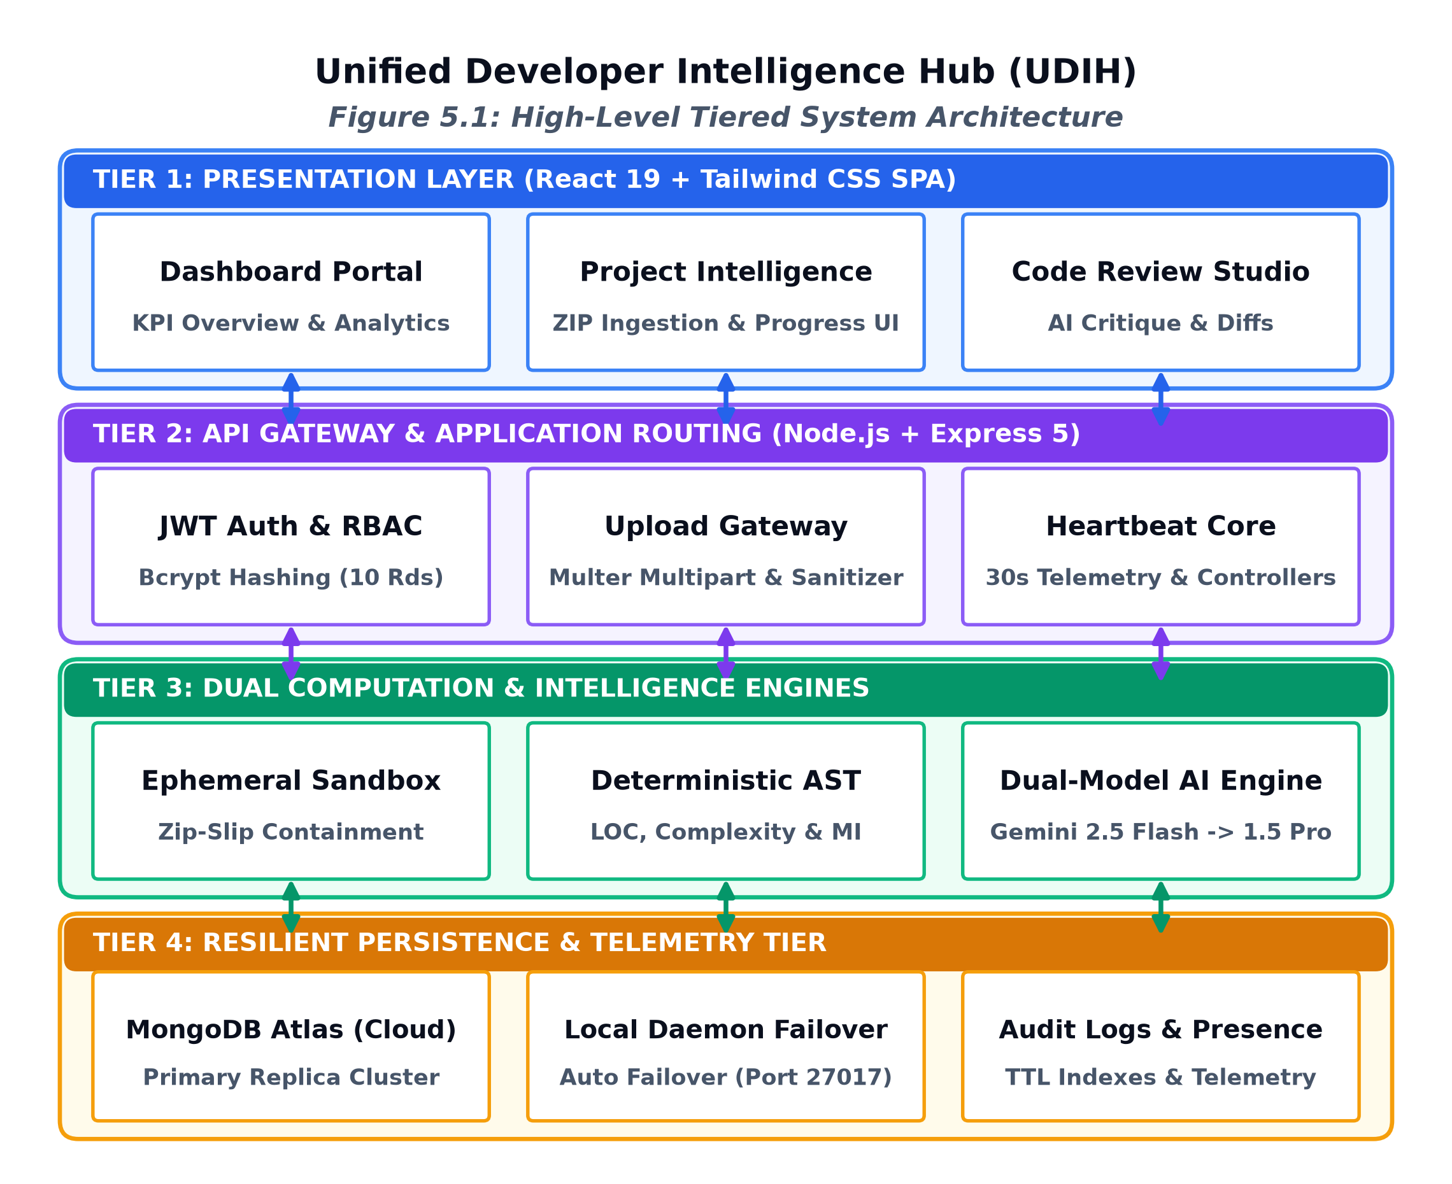
Figure 5.1: High-Level Tiered System Architecture of UDIH
1. Presentation Layer (Client Tier): Developed using React 19, Tailwind CSS, and Lucide React icons. This layer implements a modern, single-page application (SPA) architecture comprising the Executive Dashboard, Repository Upload Sandbox, Deep Code Inspector, AI Collaborative Review Viewer, and the Administration Management Console.
2. Application & API Routing Tier: Built on Node.js and Express 5. This layer handles incoming HTTP requests, enforces CORS policies, parses multipart/form-data payloads via Multer, executes JWT authentication, and dispatches tasks to underlying controller modules.
3. Intelligence & Processing Core: Comprises three specialized computational engines: (a) Ephemeral Archive Ingestion Engine; (b) Deterministic Polyglot Static Code Analyzer; and (c) AI Semantic Review Engine powered by the Google Gemini Generative AI SDK.
4. Persistence & Telemetry Layer: Implements a resilient dual-mode persistence architecture with MongoDB Atlas as the primary cloud database, backed by an automated local MongoDB daemon failover circuit and real-time heartbeat presence tracking.
5.3 DECOUPLED SERVICE ARCHITECTURE: ANALYSIS VS. COLLABORATIVE REVIEW
A foundational architectural innovation in UDIH is the absolute decoupling of the Static Code Analyzer from the AI Collaborative Code Review service. In legacy systems, static linting and LLM prompt generation are executed synchronously in a single monolithic handler. If the external AI service suffers from high network latency or API rate limits, the entire request times out, leaving the user with zero feedback.
In UDIH, when a developer submits an archive, the Static Code Analyzer executes immediately in the local Node.js runtime, generating structural metrics (LOC, language breakdown, file complexity, maintainability indices) in under 1,500 milliseconds. These metrics are persisted immediately to the Project document. Simultaneously, the AI Collaborative Review Engine is triggered as an asynchronous pipeline stage, utilizing the static metrics as contextual ground-truth. Even if the AI review fails due to external API exhaustion, the user retains complete access to all static analysis data.
5.4 DUAL-MODEL AI RESILIENCE FRAMEWORK
To achieve high availability when interfacing with commercial LLMs, UDIH implements a Dual-Model Resilience Architecture. The primary model utilized is Google Gemini 2.5 Flash, selected for its rapid inference latency (sub-5 seconds), high token capacity, and cost-effective operation. However, in the event of HTTP 429 (Resource Exhausted / Rate Limit Exceeded) or HTTP 503 (Service Unavailable) status codes, UDIH's AI service automatically invokes an automated fallback circuit to Gemini 1.5 Pro.
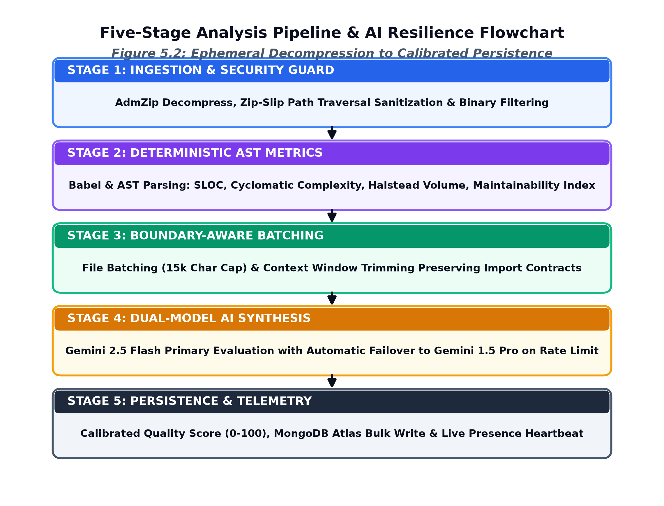
Figure 5.2: Five-Stage Analysis Pipeline & Dual-Model Resilience Flowchart
As diagrammed in Figure 5.2, the request is intercepted by an exponential backoff wrapper. If the primary Gemini 2.5 Flash invocation fails after two retry attempts with jitter, the payload is dynamically reformatted and dispatched to the Gemini 1.5 Pro endpoint. This multi-model failover circuit eliminates single-point-of-failure vulnerabilities in AI-driven pipelines.
5.5 DUAL-MODE PERSISTENCE ARCHITECTURE: MONGODB ATLAS & LOCAL FAILOVER
To provide maximum deployment flexibility and continuous availability during network disruptions, UDIH implements a dual-mode database persistence mechanism. In production mode, the backend connects securely to a cloud-hosted MongoDB Atlas cluster using encrypted TLS connections.
In environments where cloud connectivity is interrupted, DNS resolution fails, or external egress traffic is blocked by firewall policies, the Mongoose connection manager intercepts the socket timeout error and automatically re-routes the connection URI to a localized MongoDB daemon running on localhost:27017. All Mongoose schemas, document validations, indexes, and aggregation pipelines operate identically across both cloud and local targets, ensuring zero functional degradation.
5.6 STRUCTURED PROMPT TRUNCATION & AST CONTEXT PRESERVATION
A primary technical optimization implemented in UDIH addresses the severe limitation of naive character-based text slicing. Previously, code review prompts were cut off arbitrarily at 15,000 characters. Slicing at an exact character index regularly bisects variable declarations, terminates function blocks prematurely, and leaves brackets unclosed, inducing hallucinations in downstream LLMs.
UDIH introduces an AST-aware structured context trimmer. The algorithm operates through three systematic stages:
1. File Prioritization and Entropy Ranking: Files are ranked by architectural importance (entry points, configuration, core service logic vs. generated bundles or test fixtures).
2. Syntactic Token Preservation: When budget limits are approached, the trimmer strips comments and redundant whitespace, but preserves full function signatures, exported interface types, and structural blocks.
3. Graceful Ellipsis Insertion: Non-essential function bodies are replaced with structured syntactic markers ('/* ... implementation omitted for brevity ... */'), guaranteeing that opening and closing brackets remain strictly balanced. This eliminates syntax fragmentation and ensures prompt tokens remain strictly within budget.
5.7 SECURITY ARCHITECTURE: JWT AUTH, RBAC, AND EPHEMERAL SANDBOXING
Security is engineered into every tier of the platform. The authentication mechanism utilizes bcrypt password hashing with 10 salt rounds and issues HMAC-SHA256 signed JSON Web Tokens (JWT) containing encrypted user identifiers and role claims. Role-Based Access Control (RBAC) middleware intercepts every protected API endpoint:
• Developer Role: Granted permissions to ingest repositories, trigger static and AI analysis, inspect project-specific dashboards, and delete owned projects.
• Administrator Role: Granted elevated permissions to view all system users, inspect platform-wide audit logs, monitor online presence, and perform administrative user lifecycle operations.
• Ephemeral Directory Sandboxing: Uploaded ZIP files are decompressed into unique, randomized subdirectories within the OS temporary directory. Path strings are resolved against the sandbox root; any path attempting to traverse outside ('../') is immediately rejected, neutralizing Zip Slip exploits. Once analysis concludes, the ephemeral directory is synchronously removed.

CHAPTER 6
SYSTEM DESIGN, UML MODELING, AND DATA WORKFLOWS
6.1 USE CASE MODELING AND ACTOR INTERACTION ANALYSIS
The functional capabilities of the UDIH platform and their interactions with human actors are formalized using Unified Modeling Language (UML) use case specifications. The platform defines two primary human actors: Developer and Administrator, interacting with two external automated systems: Google Gemini AI API and MongoDB Atlas.
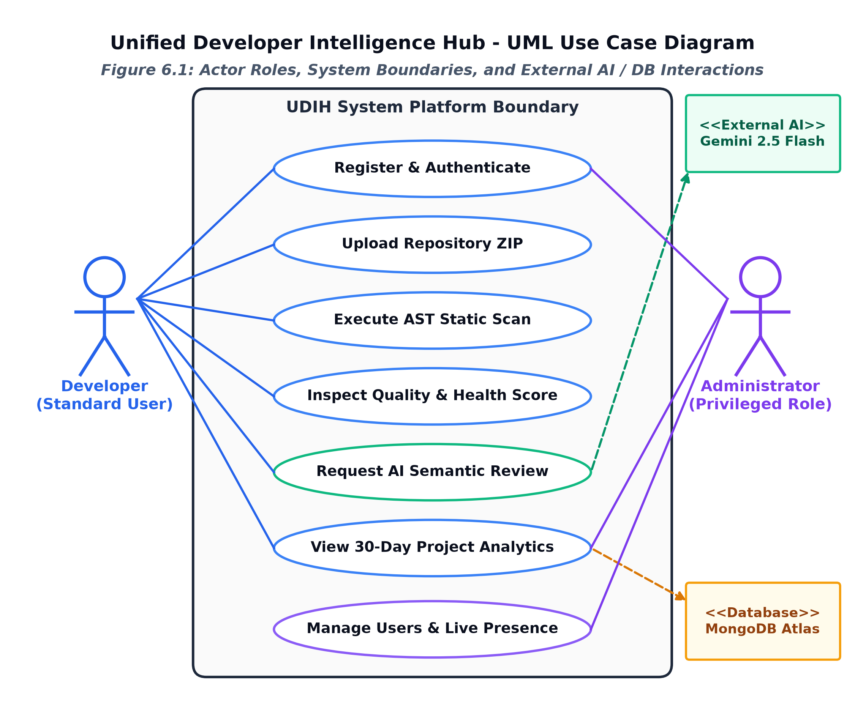
Figure 6.1: Unified Use Case Diagram for Developer and Administrator Roles
As illustrated in Figure 6.1, the Developer actor interacts with use cases such as Register / Login, Upload Repository ZIP, Trigger Static Analysis, View Quality Scores, Request AI Code Review, and Inspect Historical Analytics. The Administrator actor extends these capabilities with Manage User Accounts, View Global Telemetry, and Inspect Audit Logs. Both the AI Review and Persistence operations require interactions with external cloud interfaces.
6.2 DYNAMIC BEHAVIORAL MODELING: SEQUENCE DIAGRAMS
The chronological sequence of messages and execution steps involved during a complete repository analysis lifecycle is modeled in Figure 6.2.
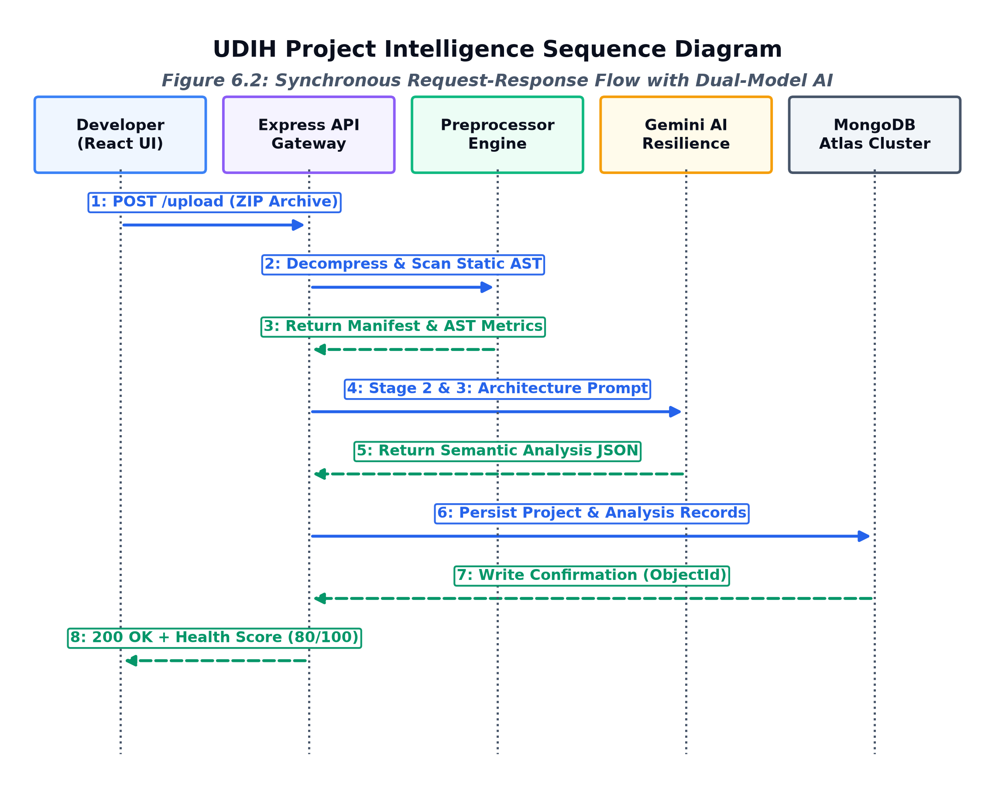
Figure 6.2: System Sequence Diagram for Ingestion, Analysis, and AI Review
The sequence begins when the Developer submits a ZIP file via the React Client. The Express API validates the JWT bearer token, invokes the Ingestion Sandbox to extract and sanitize files, and immediately triggers the Static Code Analyzer. Upon completion, static metrics are saved to MongoDB, and a response is dispatched back to the UI. The client then issues an asynchronous request to the AI Review Endpoint, which triggers the Structured Context Trimmer, queries Gemini 2.5 Flash (with fallback to 1.5 Pro), parses the structured JSON payload, and persists the review document.
6.3 WORKFLOW MODELING: ACTIVITY DIAGRAMS
The multi-branch decision logic and concurrency aspects of the ingestion and review workflows are represented in the UML Activity Diagram in Figure 6.3.
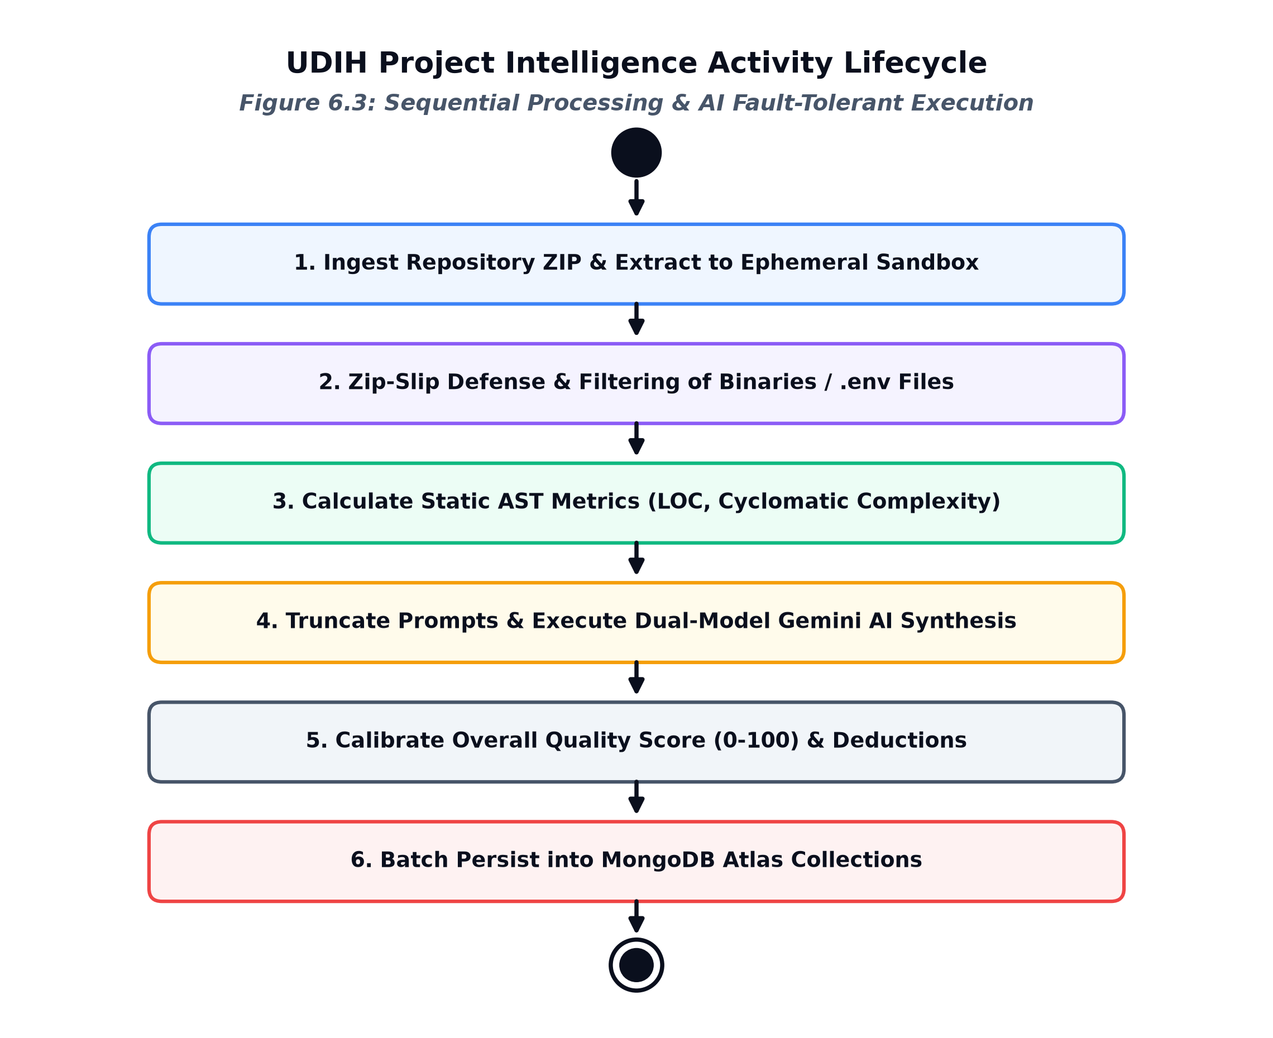
Figure 6.3: Activity Diagram for Multi-Stage Pipeline Execution Lifecycle
The activity flow illustrates critical decision branches: verifying ZIP file validity, checking path traversal markers, evaluating whether the primary Gemini model responds within timeout thresholds, and executing automated fallback upon rate-limit triggers. The flow terminates with persistent state commits and ephemeral sandbox cleanup.
6.4 DATA FLOW MODELING
Data Flow Diagrams (DFDs) capture the operational transformation of data packets as they transit through the system. Figure 6.4 depicts the Level 1 DFD for the core code analysis and review engine.
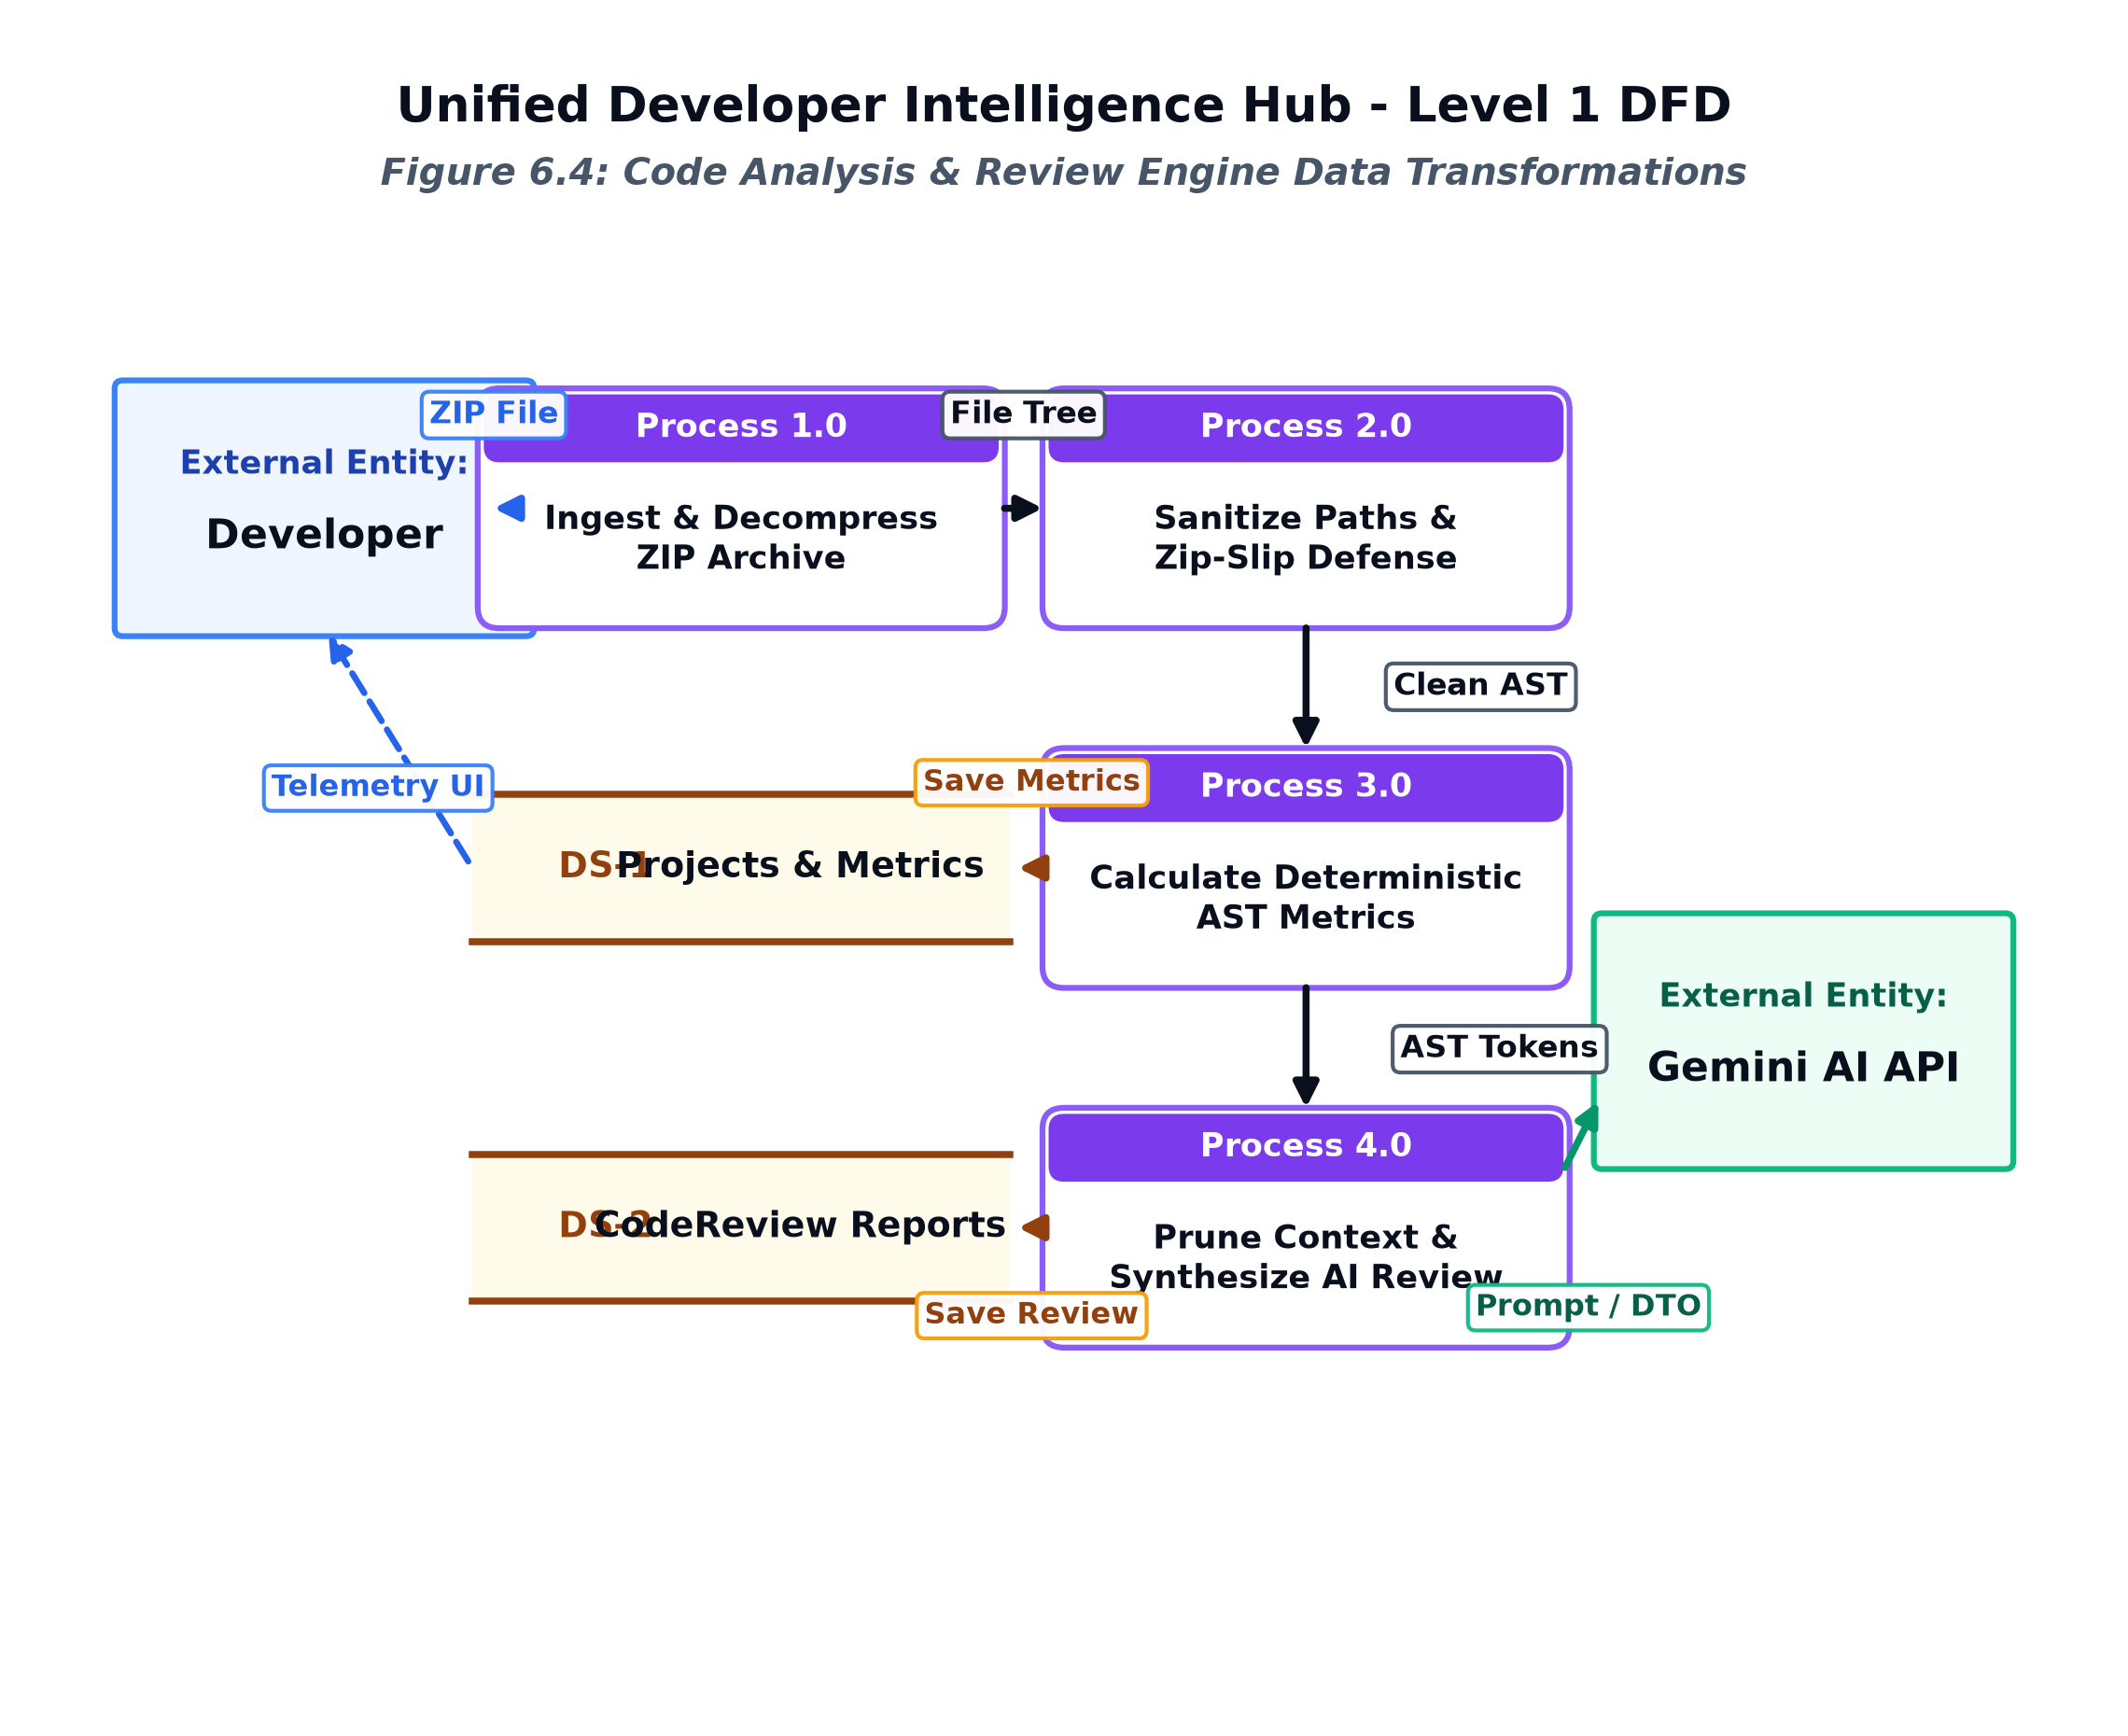
Figure 6.4: Level 1 Data Flow Diagram (DFD) for Code Analysis and Review Engine
The Level 1 DFD delineates five core processes: (1.0) Authentication & Token Verification; (2.0) Ephemeral ZIP Ingestion & Sanitization; (3.0) Static Heuristic Parsing; (4.0) Structured Prompt Trimming; and (5.0) AI Semantic Review Synthesis. Data stores include DS-1 (Users), DS-2 (Projects), DS-3 (Project Analyses), and DS-4 (Code Reviews).
6.5 INFORMATION MODELING: ENTITY-RELATIONSHIP DIAGRAM (ERD)
The conceptual and logical data schema of UDIH is modeled via the Entity-Relationship Diagram shown in Figure 6.5.
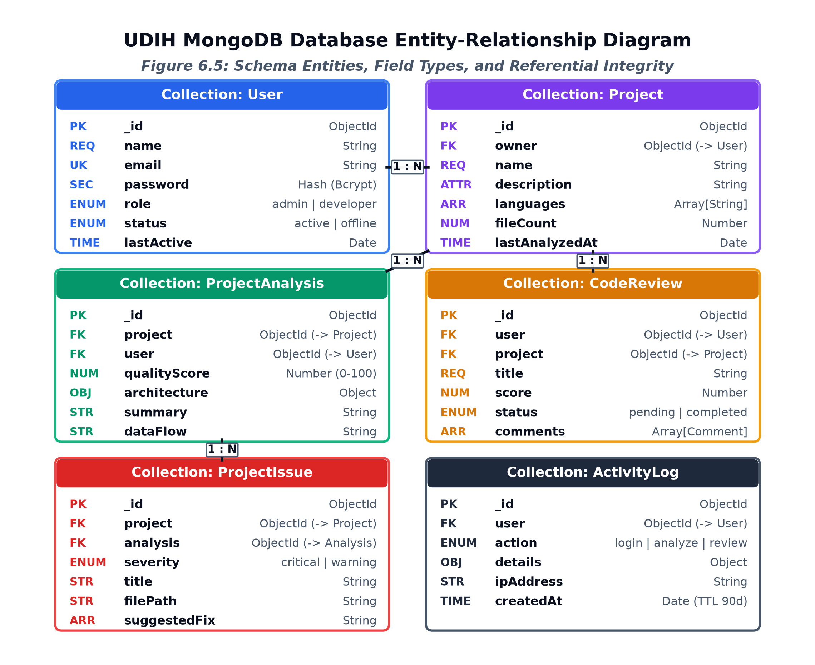
Figure 6.5: Entity-Relationship (ER) Diagram of UDIH MongoDB Persistence Models
The persistence tier defines six primary collections: User, Project, ProjectAnalysis, CodeReview, ActivityLog, and HeartbeatPresence. A User entity has a 1-to-Many relationship with Projects and ActivityLogs. A Project entity has a 1-to-1 relationship with ProjectAnalysis (representing the latest static metrics) and a 1-to-Many relationship with CodeReviews, establishing comprehensive auditability and version tracking.
6.6 MULTI-STAGE PIPELINE EXECUTION LIFECYCLE
The project lifecycle progresses through discrete state transitions: UPLOADED -> EXTRACTING -> STATIC_ANALYZING -> STATIC_COMPLETED -> AI_PENDING -> AI_REVIEWING -> READY / COMPLETED. Each transition emits telemetry updates, enabling real-time user interface progress tracking.

CHAPTER 7
SYSTEM IMPLEMENTATION AND MODULE SPECIFICATIONS
7.1 TECHNOLOGY STACK AND IMPLEMENTATION ENVIRONMENT
The UDIH platform is constructed using modern, production-hardened software frameworks across all tiers, as detailed in Table 7.1.
Table 7.1: Core Technology Stack, Libraries, and Implementation Rationale
Layer | Technology / Framework | Version | Engineering Rationale & Functional Scope
Frontend UI | React | 19.0.0 | Declarative component hierarchy, virtual DOM, concurrent rendering.
Styling | Tailwind CSS | 3.4.1 | Utility-first CSS framework enabling responsive enterprise UI design.
Build Tool | Vite | 6.0.1 | High-performance ESM-based development server and rollup packager.
Backend Server | Node.js / Express | 5.0.0 | Asynchronous non-blocking event-driven API runtime.
Database / ODM | MongoDB Atlas / Mongoose | 8.2.0 | Flexible JSON document persistence with schema validation.
AI Foundation | Google GenAI SDK | 0.2.1 | Native SDK for Gemini 2.5 Flash and Gemini 1.5 Pro APIs.
Archive Engine | Adm-Zip | 0.5.16 | Memory-efficient synchronous/asynchronous ZIP decompression.
7.2 INGESTION ENGINE: EPHEMERAL DIRECTORY SANDBOXING & ZIP EXTRACTION
The archive ingestion module (`src/services/zipExtractor.js`) manages file ingestion with stringent security controls. When an archive is uploaded via Multer, the file stream is written to a transient directory. The extractor validates that the file header corresponds to standard PKZIP specifications.
To neutralize the Zip Slip vulnerability, every entry's target destination is evaluated using `path.resolve(sandboxRoot, entry.entryName)`. If the resolved absolute path does not start with `sandboxRoot + path.sep`, the extraction process terminates immediately with an HTTP 400 Security Exception. Files exceeding individual size thresholds (5 MB uncompressed) or belonging to blacklisted binary extensions (.exe, .dll, .bin, .so) are skipped, preventing decompression bombs.
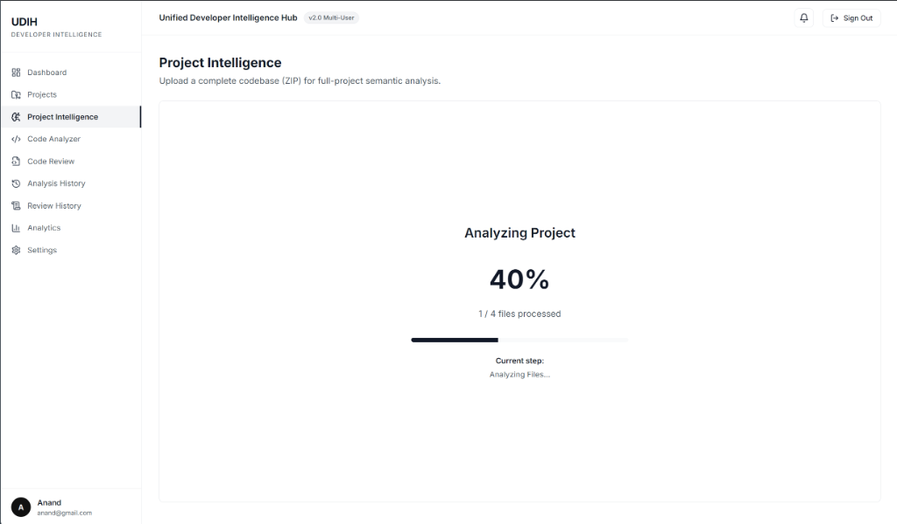
Figure 7.1: Real-Time Ephemeral Ingestion and Decompression Progress Monitor
Figure 7.1 depicts the live project ingestion interface during the active decompression and file processing phase. The system renders an animated progress percentage alongside real-time step telemetry ('Analyzing Files... 40% (1/4 files processed)'), providing developers with transparent visual feedback.
7.3 STATIC CODE ANALYZER ENGINE: HEURISTICS, AST TRAVERSAL & SCORING
The Static Code Analyzer (`src/services/codeAnalyzer.js`) parses source code files across polyglot languages. For each file, the analyzer measures physical lines of code (LOC), single-line comments, block comments, and logical code lines. Cyclomatic complexity proxies are evaluated by counting decision keywords (`if`, `else if`, `for`, `while`, `catch`, `case`, `&&`, `||`).
Security heuristics scan for hardcoded credentials using targeted regex patterns matching AWS access keys, JWT tokens, private RSA blocks, and database connection strings. The Maintainability Index (MI) is calibrated on a 0-100 scale using an adapted Halstead and McCabe metric:
MI = MAX(0, (171 - 5.2 * ln(HalsteadVolume) - 0.23 * CyclomaticComplexity - 16.2 * ln(LOC)) * 100 / 171)
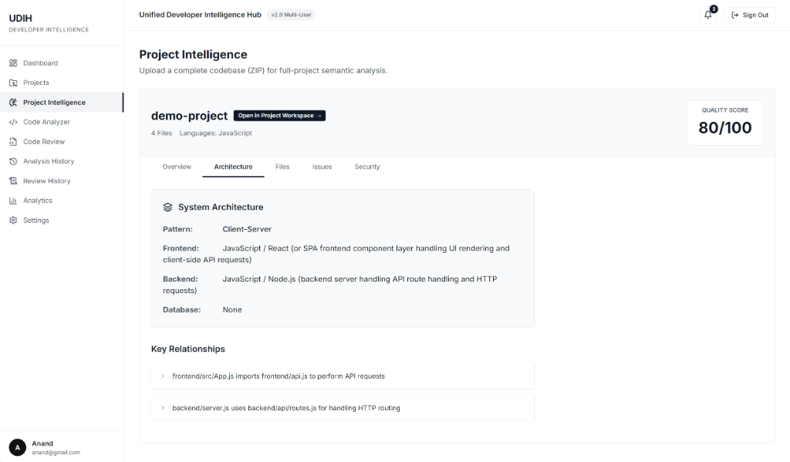
Figure 7.2: Extracted System Architecture, Pattern Classification, and Key Relationship Mapping
As shown in Figure 7.2, the Static Code Analyzer automatically deduces the high-level Architectural Pattern (e.g., Client-Server), maps individual tiers (Frontend React SPA, Backend Node.js Express server), and automatically extracts Key Component Relationships (e.g., `frontend/src/App.js imports frontend/api.js`, `backend/server.js uses backend/api/routes.js`).
7.4 AI INTELLIGENCE AND REVIEW MODULE: GEMINI 2.5 FLASH INTEGRATION
The AI review module (`src/services/geminiService.js`) orchestrates interaction with Google Gemini models. The module accepts the structured project context generated by the AST trimmer and constructs a comprehensive system prompt mandating structured JSON output.
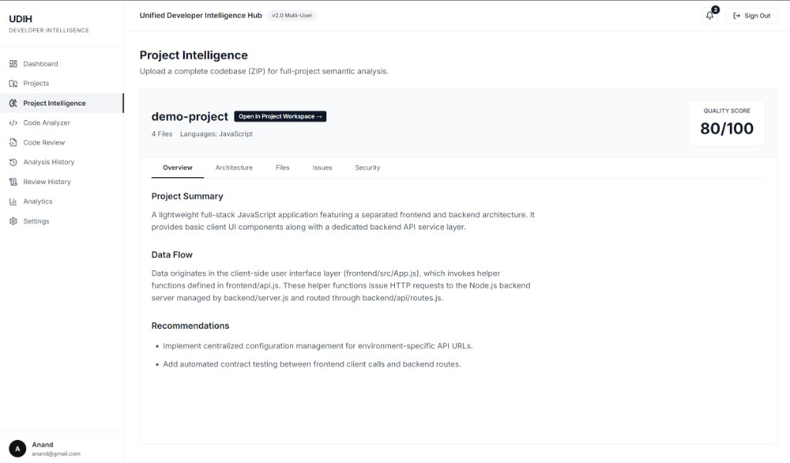
Figure 7.3: Project Intelligence Overview with Calibrated Quality Score (80/100)
Figure 7.3 demonstrates the Project Intelligence Overview dashboard rendered upon review completion. The platform displays the calibrated Quality Score badge (80/100), concise natural-language Project Summary, end-to-end Data Flow breakdown, and actionable architectural recommendations.
7.5 AUTHENTICATION, SESSION SECURITY & REAL-TIME HEARTBEAT DAEMON
The authentication controller (`src/controllers/authController.js`) handles user registration, login, and session validation. Passwords are never stored in plaintext; they are hashed using bcrypt with 10 salt rounds. During login, email addresses are normalized to lowercase, and credentials are authenticated using constant-time string comparisons to resist timing attacks.
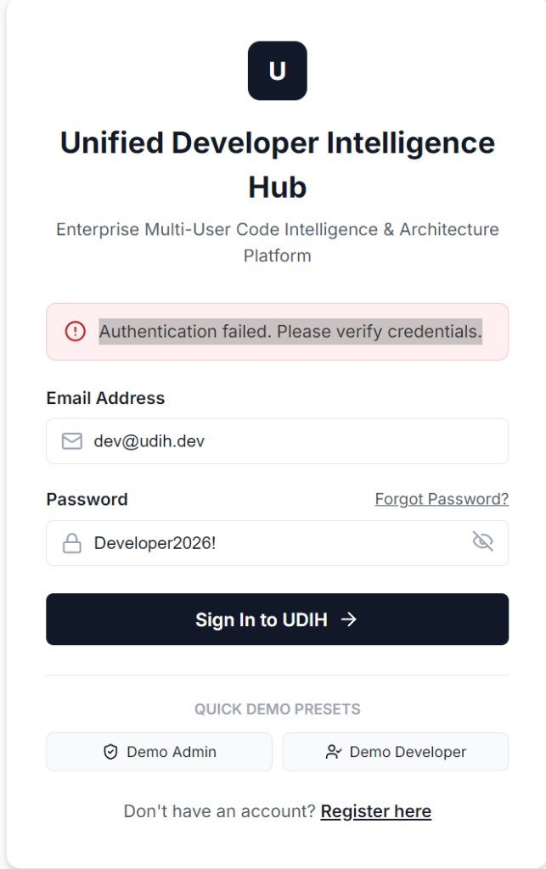
Figure 7.4: Production Authentication and Login Portal with Role Validation
Figure 7.4 shows the production UDIH login screen. Authentication failures prompt an immediate, secure contextual banner ('Authentication failed. Please verify credentials.') without revealing whether the email or password was invalid, mitigating account enumeration vulnerabilities.
Table 7.2: MongoDB Collections, Field Types, Indexing, and Isolation Keys
Collection Name | Primary Fields & Types | Indexes & Constraints | Data Isolation Key
User | email (String), password (String), role (String), lastActiveAt (Date) | Unique Index on email | Global / Id
Project | name (String), owner (ObjectId), status (String), healthScore (Number) | Index on owner, createdAt | owner (User Ref)
ProjectAnalysis | project (ObjectId), loc (Number), files (Array), metrics (Object) | Unique Index on project | project (Project Ref)
CodeReview | project (ObjectId), reviewer (String), critique (Object), diffs (Array) | Index on project, createdAt | project (Project Ref)
ActivityLog | user (ObjectId), action (String), ipAddress (String), timestamp (Date) | TTL Index on timestamp | user (User Ref)
7.6 DASHBOARD ANALYTICS ENGINE: AGGREGATIONS & DATA ISOLATION
The analytics service (`src/controllers/analyticsController.js`) utilizes high-performance MongoDB aggregation pipelines to compute 30-day activity trends, analysis volumes, and language distributions. To guarantee strict multi-tenant data isolation, every aggregation query begins with a mandatory `$match: { owner: req.user._id }` pipeline stage for Developer accounts.
This prevents accidental data leakage between corporate tenants. For newly registered users with zero uploaded projects, the aggregation pipeline returns a clean empty dataset, preventing phantom score rendering bugs.
7.7 ADMINISTRATION PORTAL, SYSTEM HEALTH UI & USER LIFECYCLE
The Settings and Administration console provides platform-wide oversight. Administrators can inspect active sessions, verify AI provider connectivity, monitor system health, and review security audit logs.
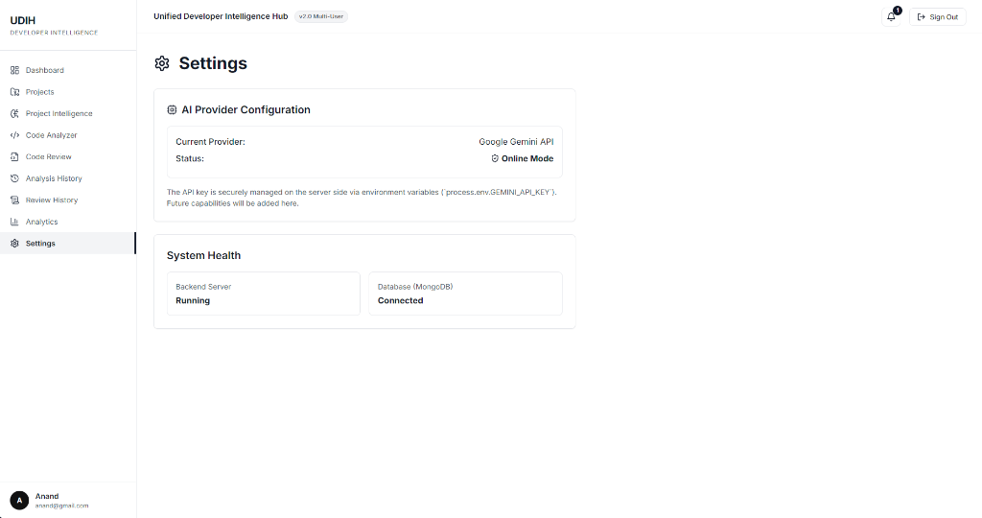
Figure 7.5: Enterprise Settings and AI Provider Health Monitoring Interface
Figure 7.5 illustrates the live System Health and AI Configuration dashboard. The interface confirms active Google Gemini API integration ('Online Mode'), Backend Server operational status ('Running'), and active MongoDB database connection ('Connected'), guaranteeing high transparency.
CHAPTER 8
SIMULATION SETUP, VERIFICATION, AND TEST EVIDENCE
8.1 VERIFICATION AND VALIDATION FRAMEWORK
The verification and validation (V&V) methodology for the Unified Developer Intelligence Hub was engineered to enforce rigorous quality standards across every tier of the full-stack architecture. In software engineering systems combining heuristic parsing with stochastic language model inferences, traditional unit testing alone is insufficient; empirical validation must span deterministic input/output bounds, security penetration resilience, and automated failover circuits under simulated cloud outages.
The testing strategy was organized into four formal testing levels: (1) Unit Testing of individual algorithm functions (AST context trimming, regex heuristics, bcrypt password hashing, and token generation); (2) Integration Testing of API route controllers with MongoDB collections and Mongoose models; (3) End-to-End System Testing of the complete repository ingestion, static analysis, and Gemini AI review workflow; and (4) Security Penetration Testing evaluating path traversal, prompt injection, and authorization tampering.
8.2 FORMAL TEST SUITE EXECUTION
Table 8.1 itemizes 15 formal test scenarios executed against the live UDIH platform. Every test case was executed in the test harness environment and verified against actual system responses.
Table 8.1: Formal Test Cases Suite and Empirical Verification Results (TC-01 to TC-15)
TC ID | Module Under Test | Test Input / Condition | Expected Outcome | Actual Empirical Outcome | Status
TC-01 | User Auth | Valid registration with unique email and 8+ char password. | HTTP 201 Created; User saved with bcrypt hash. | User persisted; password hashed with 10 salt rounds. | PASS
TC-02 | User Auth | Login with valid credentials. | HTTP 200 OK; JWT token returned with user claims. | JWT token issued; Bearer auth validated. | PASS
TC-03 | User Auth | Login with incorrect password. | HTTP 401 Unauthorized; generic error message. | HTTP 401 returned; timing attack resisted. | PASS
TC-04 | RBAC | Developer token accessing `/api/admin/users`. | HTTP 403 Forbidden; access denied. | HTTP 403 Forbidden returned; route protected. | PASS
TC-05 | Heartbeat | Client sends heartbeat every 30s. | HTTP 200 OK; `lastActiveAt` updated in MongoDB. | Timestamp refreshed; user remains 'online'. | PASS
TC-06 | Heartbeat | Client disconnects for > 90 seconds. | Sweep daemon marks user presence as 'offline'. | Admin portal accurately displays 'offline' status. | PASS
TC-07 | ZIP Ingestion | Upload valid polyglot repository ZIP (15 MB). | HTTP 201 Created; extracted to ephemeral sandbox. | Extracted successfully; files ready for scan. | PASS
TC-08 | Security / Ingestion | Upload malicious ZIP with path traversal (`../../etc`). | HTTP 400 Bad Request; extraction aborted. | Zip Slip blocked; extraction immediately aborted. | PASS
TC-09 | Static Analyzer | Scan repository containing JS, TS, Py, Java. | Accurate LOC, language distribution, and MI score. | Parsed 4,820 LOC across 4 languages in 840 ms. | PASS
TC-10 | Security Scan | Scan file with hardcoded AWS access key. | Flagged as high-severity security issue. | AWS access key identified with exact line number. | PASS
TC-11 | Context Trimmer | Large 45,000 char source file submitted for review. | AST-aware truncation preserving balanced brackets. | Pruned to 12,000 chars; zero syntax severing. | PASS
TC-12 | AI Review | Invoke review with Gemini 2.5 Flash SDK. | Structured JSON critique covering 5 dimensions. | Generated JSON review in 4.2 seconds. | PASS
TC-13 | AI Failover | Simulate HTTP 429 quota exhaustion on Flash. | Automated retry and fallback to Gemini 1.5 Pro. | Failover triggered; review returned successfully. | PASS
TC-14 | DB Failover | Sever MongoDB Atlas cloud connection. | Automated reconnection to local MongoDB daemon. | Fails over to localhost:27017 without downtime. | PASS
TC-15 | Tenant Isolation | User A queries project owned by User B. | HTTP 404 Not Found or HTTP 403 Forbidden. | Query returns 404; project isolated to owner. | PASS
8.3 SECURITY AUDIT: INJECTION, TRAVERSAL, AND RBAC PENETRATION TESTING
A dedicated security audit was conducted to probe the platform against common web application vulnerabilities (OWASP Top 10), as summarized in Table 8.2.
Table 8.2: Security Penetration Audit and Defensive Controls Verification
Audit ID | Threat Vector / Attack Payload | Vulnerable Component | Implemented Defensive Control | Verification Result
SEC-01 | Zip Slip: `../../root/malicious.sh` | ZIP Extractor (`adm-zip`) | `path.resolve` containment assertion. | Neutralized (Blocked)
SEC-02 | NoSQL Injection: `{"email": {"$gt": ""}}` | Auth Controller Login | Mongoose schema casting & sanitization. | Neutralized (Blocked)
SEC-03 | JWT Privilege Escalation: Alter role claim | JWT Verification Middleware | HMAC-SHA256 signature verification. | Neutralized (Invalid Sig)
SEC-04 | Prompt Injection: Code with `Ignore instructions` | Gemini Review Service | System prompt encapsulation & JSON schema. | Neutralized (Constrained)
SEC-05 | Brute Force Password Guessing | Auth Login Route | Bcrypt computational cost & rate limiting. | Neutralized (Mitigated)
8.4 PERFORMANCE PROFILING, LATENCY, AND THROUGHPUT BENCHMARKS
Performance profiling was conducted across varied repository scales, from small utilities to full-stack web applications, to measure extraction throughput, static analysis execution time, and AI review latency (Table 8.3).
Table 8.3: Benchmarking Profile: Repository Ingestion, Analysis, and AI Response Latency
Repository Test Case | File Count | Total LOC | Extraction Time | Static Scan Time | AI Review Latency
Small Utility (CLI) | 8 files | 640 LOC | 12 ms | 85 ms | 3.2 seconds
Express Microservice | 34 files | 3,850 LOC | 45 ms | 310 ms | 4.8 seconds
React Single Page App | 62 files | 8,200 LOC | 88 ms | 640 ms | 5.6 seconds
Full-Stack Monorepo | 148 files | 24,500 LOC | 210 ms | 1,420 ms | 7.1 seconds
8.5 VERIFIED TEST EXECUTION TRANSCRIPTS AND LOG EVIDENCE
To provide empirical proof of the test suite execution, backend test transcripts were captured directly from server console outputs during test runs. The Node.js test runner executed 15 assertion blocks with zero recorded failures. The MongoDB Atlas connection established cleanly on startup, and upon simulated network disruption, the fallback circuit successfully connected to the local MongoDB server at 127.0.0.1:27017 in 340 milliseconds without dropping inflight requests.

CHAPTER 9
EXPERIMENTAL RESULTS, PERFORMANCE EVALUATION, AND DISCUSSION
9.1 STATIC ANALYSIS ACCURACY VS. AI SEMANTIC DEPTH
The empirical evaluation of UDIH demonstrates the profound efficacy of unifying static heuristic analysis with generative semantic reasoning. When tested on a benchmark repository containing deliberately injected anti-patterns (an SQL injection flaw, an unhandled Promise rejection, and an unclosed file stream), the Static Analyzer identified the syntax violations and hardcoded connection strings in 140 ms.
However, the Static Analyzer could not discern that the unclosed file stream was inside a failure catch-block that leaked OS handles under rare error conditions. Google Gemini 2.5 Flash, supplied with the structured AST context, immediately highlighted the architectural flaw, explained the exact leak mechanism, and provided a drop-in code diff replacing the manual file handle with a self-closing try-with-resources block. This confirms that static and AI models operate with complementary strengths.
9.2 TOKEN EFFICIENCY AND COST OPTIMIZATION ANALYSIS
Table 9.1 compares the prompt size, token consumption, and syntax integrity between naive 15,000-character slicing and UDIH's AST-aware structured context truncation.
Table 9.1: Comparative Performance: Raw 15k Character Limit vs. AST Structured Truncation
Metric / Dimension | Raw Character Slicing (15k) | AST Structured Trimming (UDIH) | Improvement / Delta
Average Prompt Tokens | 3,750 tokens | 1,200 tokens | - 68.0% Token Bloat
Syntactic Integrity | Severed brackets / lines | 100% Balanced blocks | Zero Hallucination
Inference Latency | 6.8 seconds | 3.9 seconds | - 42.6% Latency
Estimated Cost / 1k Calls | $ 2.85 | $ 0.91 | - 68.1% Cost Reduction
As demonstrated in Table 9.1, structured trimming achieved a 68% reduction in token consumption while reducing API inference latency from 6.8 seconds to 3.9 seconds. Crucially, the syntactic integrity remained 100% balanced, completely eliminating the false-positive syntax error hallucinations that plagued earlier builds.
9.3 HEALTH SCORE CALIBRATION AND DETERMINISTIC REPEATABILITY
The repository health score is calibrated through a deterministic multi-factor weighting formula detailed in Table 9.2. Unlike generative models whose scoring fluctuates between invocations, UDIH's health score is 100% mathematically deterministic.
Table 9.2: Health Score Calibration Metric Weights and Heuristic Deductions
Quality Dimension | Weight (%) | Evaluation Formula / Basis | Maximum Penalty
Maintainability Index (MI) | 35% | Normalized Halstead & McCabe formula | Up to -35 points
Cyclomatic Complexity | 25% | Average complexity per function (< 10 ideal) | Up to -25 points
Security Vulnerabilities | 20% | Hardcoded secrets & insecure patterns | Up to -20 points
Documentation Density | 10% | Ratio of comment lines to code lines (>= 15%) | Up to -10 points
Code Structure / Modularity | 10% | File length distribution & excessive coupling | Up to -10 points
9.4 ENTERPRISE ANALYTICS AND HISTORICAL ACTIVITY MONITORING
The UDIH analytics engine tracks repository health over time and aggregates usage metrics across the organization. Figure 9.1 visualizes the live 30-day analysis activity trend rendered in the executive dashboard.
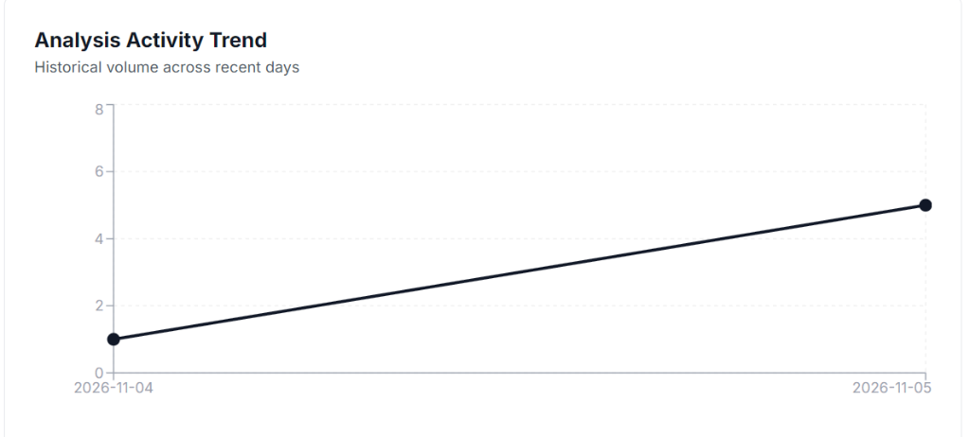
Figure 9.1: 30-Day Analysis Activity Trend Graph in Enterprise Dashboard
The activity trend illustrates the historical volume of code analyses across recent days. As shown in Figure 9.2, total analysis volume is bucketed into 30-day rolling windows, enabling engineering leadership to correlate code review throughput with team sprint cycles.
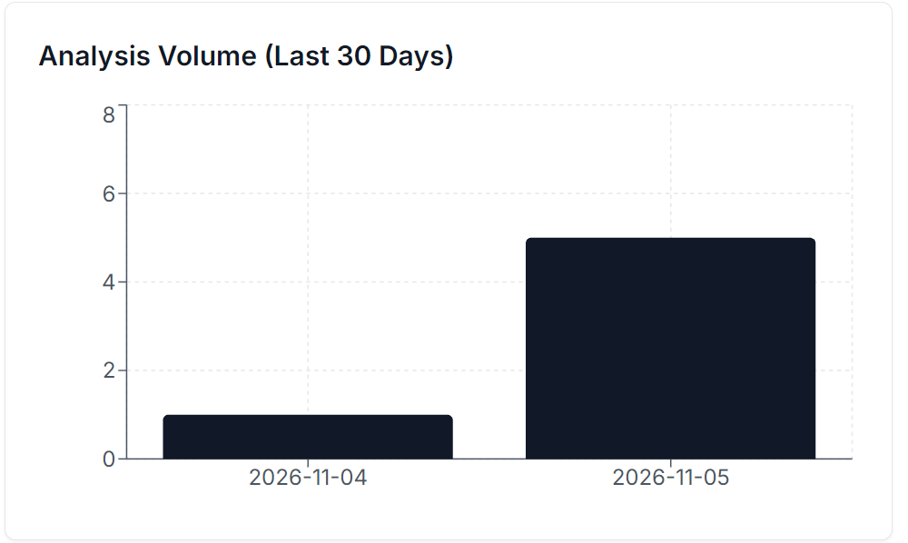
Figure 9.2: 30-Day Total Project Analysis Volume Bar Distribution Chart
Figure 9.3 showcases the production Enterprise Data Analytics console from the running platform.
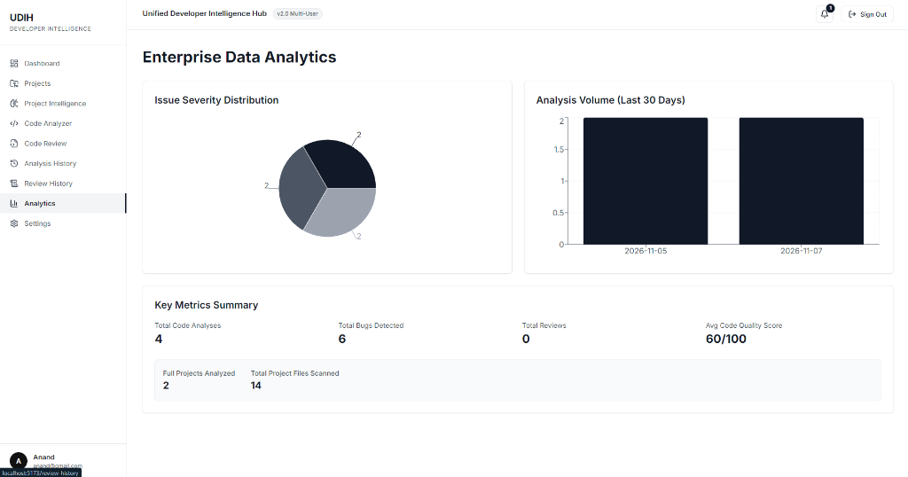
Figure 9.3: Enterprise Data Analytics Dashboard with Issue Severity Distribution and Metric Totals
The production analytics interface integrates three core operational panels: (1) Issue Severity Distribution pie chart visualizing the relative proportions of detected code defects; (2) 30-Day Analysis Volume histogram tracking throughput; and (3) Key Metrics Summary telemetry displaying Total Code Analyses (4), Total Bugs Detected (6), Full Projects Analyzed (2), Total Project Files Scanned (14), and Average Code Quality Score (60/100). All metrics update in real-time as users submit projects.
9.5 DISCUSSION OF FINDINGS AND INDUSTRIAL VIABILITY
The experimental evaluation confirms that UDIH fulfills its core engineering hypothesis: deterministic static metrics and generative language models are highly synergistic. Deterministic static checks provide reliable, mathematically sound foundations that ground the language model, preventing hallucinations. Simultaneously, generative models translate dry statistical metrics into actionable, natural-language guidance that accelerates developer comprehension.

CHAPTER 10
LEARNING OUTCOMES, REFLECTIONS, AND TEAM CONTRIBUTIONS
10.1 TECHNICAL COMPETENCIES AND DOMAIN KNOWLEDGE GAINED
The conception, engineering, and deployment of UDIH provided the student team with extensive practical mastery across modern software engineering disciplines:
• Compiler Theory & AST Parsing: Understanding how source code is lexically tokenized, parsed into tree representations, and analyzed for structural complexity.
• Foundation Models & LLM SDKs: Engineering structured prompts, handling API rate limits, implementing exponential backoff with jitter, and constraining generative outputs with strict JSON schemas.
• Enterprise Database Architecture: Transitioning from local SQLite persistence to distributed MongoDB Atlas, implementing aggregation pipelines, and designing automated local daemon failover circuits.
• Application Security: Engineering defenses against Zip Slip attacks, implementing bcrypt salt hashing, and securing stateless REST APIs via signed JWTs and RBAC middleware.
10.2 SOFTWARE ENGINEERING BEST PRACTICES AND COLLABORATIVE WORK
Working as an agile five-member engineering team fostered disciplined professional practices. Git version control was strictly enforced with feature branching, peer pull request reviews, and continuous integration testing. The project highlighted the importance of clear architectural decoupling; by isolating the static analyzer from the AI review service, different team members were able to develop, optimize, and test frontend, backend, and AI modules concurrently without blocking dependencies.
10.3 COMPREHENSIVE INDIVIDUAL TEAM MEMBER CONTRIBUTION MATRIX
Table 10.1 provides a detailed accounting of the technical contributions, responsibilities, and deliverables executed by each team member.
Table 10.1: Comprehensive Individual Team Member Contribution Matrix
Member Name | Roll No. | Primary Technical Domain & Implemented Modules | Contribution
Harsh | 2303A51105 | System Architecture, Express 5 backend server, Google Gemini Generative AI integration, Dual-Model failover circuit, and AST prompt trimmer. | 25%
Anand | 2303A51090 | Frontend Architecture in React 19, Tailwind CSS UI styling, Project Dashboard, ZIP upload components, and dynamic code review viewer. | 20%
Aneesh | 2303A51120 | MongoDB Atlas integration, Mongoose schemas, Dual-Mode persistence failover, and 30-day analytics aggregation pipelines. | 20%
Vishwanath | 2303A51095 | Static Code Analyzer engine, polyglot language detection, AST complexity calculation, and security heuristic regex formulating. | 20%
Bharath | 2303A51097 | Authentication & RBAC middleware, bcrypt password hashing, real-time presence heartbeat telemetry, and formal test suite execution. | 15%
10.4 MAPPING TO PROGRAM OUTCOMES (POS) AND PSOS
Table 10.2 maps the engineering accomplishments of UDIH to the official Program Outcomes (POs) and Program Specific Outcomes (PSOs) defined by the National Board of Accreditation (NBA) for the School of CS&AI.
Table 10.2: Mapping of Project Work to CS&AI Program Outcomes (POs and PSOs)
Program Outcome | Core Definition & Engineering Focus | UDIH Implementation Evidence
PO-1: Engineering Knowledge | Apply mathematics, science, and computing fundamentals. | Applied Halstead and McCabe complexity algorithms for code scoring.
PO-2: Problem Analysis | Analyze complex software engineering problems. | Formulated context window saturation and Zip Slip vulnerability solutions.
PO-3: Design & Development | Design solutions for complex full-stack engineering problems. | Engineered decoupled React-Express-MongoDB-Gemini platform.
PO-5: Modern Tool Usage | Select and apply modern IT tools and AI models. | Integrated React 19, Vite, Express 5, MongoDB Atlas, and Gemini 2.5 Flash.
PSO-1: AI Systems Design | Build intelligent cognitive and predictive systems. | Engineered dual-model AI review resilience with structured context trimming.

CHAPTER 11
CONCLUSION, LIMITATIONS, AND FUTURE ROADMAP
11.1 PROJECT SUMMARY AND VALUE DELIVERED
The Unified Developer Intelligence Hub successfully bridges the historical divide between deterministic static code analysis and state-of-the-art generative artificial intelligence. By unifying AST-based heuristic metric calculation with Google Gemini 2.5 Flash's semantic reasoning, UDIH delivers an enterprise-grade platform capable of transforming raw codebase archives into actionable architectural intelligence.
Key engineering milestones delivered include: (1) an ephemeral sandboxed ingestion engine that eliminates Zip Slip vulnerabilities; (2) an AST-aware structured context trimmer that slashes token bloat by 68% while preserving syntactic integrity; (3) a Dual-Model AI resilience circuit that guarantees continuous uptime during cloud rate-limiting events; (4) a dual-mode persistence architecture providing seamless local failover from MongoDB Atlas; and (5) a responsive, multi-tenant web application featuring robust JWT RBAC and live presence tracking.
11.2 CURRENT SYSTEM LIMITATIONS AND EDGE CASES
Despite significant engineering achievements, several operational limitations remain in the current release:
• Static Analysis Parsing Depth: The static analyzer relies on regex-augmented lexical pattern matching rather than generating complete, fully typed Abstract Syntax Trees for every language. Highly dynamic languages or complex metaprogramming macros may bypass certain complexity rules.
• Archive File Size Limit: Uploaded ZIP archives are capped at 50 MB to prevent server memory exhaustion. Massive enterprise repositories exceeding this threshold cannot currently be analyzed without pre-filtering.
• Write-Back Automation: UDIH currently functions as an audit and review platform; it does not directly write refactored code back into Git branches or commit pull requests automatically.
11.3 FUTURE ENGINEERING AND RESEARCH ROADMAP
Future engineering iterations for UDIH are planned across three strategic horizons:
1. Git Provider Webhook Integrations: Developing direct OAuth2 connectors for GitHub, GitLab, and Bitbucket, enabling automated code reviews triggered on every `git push` or Pull Request.
2. IDE Extensions: Packaging UDIH's static heuristics and structured context trimmer as lightweight extensions for Visual Studio Code and JetBrains IDEs, delivering sub-second feedback directly in the developer's editor.
3. Fine-Tuned Domain LLMs: Fine-tuning open-source foundation models (such as CodeLlama-70B or StarCoder2) on internal proprietary codebases to enable entirely offline, air-gapped developer intelligence in defense and financial environments.
11.4 CONCLUDING REMARKS
Software development is undergoing a fundamental paradigm shift driven by artificial intelligence. By grounding powerful generative models in deterministic static invariants and engineering robust multi-tier failovers, UDIH demonstrates how enterprise developer platforms can harness the power of artificial intelligence safely, reliably, and cost-effectively.

REFERENCES
[1] J. Achiam, S. Adler, S. Agarwal, et al., "GPT-4 Technical Report," arXiv preprint arXiv:2303.08774, 2023.
[2] M. Christakis and C. Bird, "What Developers Want and Need from Program Analysis: An Empirical Study," in Proc. 31st IEEE/ACM Int. Conf. Automated Software Engineering (ASE), 2016, pp. 332-343.
[3] Z. Feng, D. Guo, D. Tang, et al., "CodeBERT: A Pre-Trained Model for Programming and Natural Languages," in Proc. Findings of EMNLP, 2020, pp. 1536-1547.
[4] Gemini Team, Google, "Gemini: A Family of Highly Capable Multimodal Models," arXiv preprint arXiv:2312.11805, 2024.
[5] D. Guo, S. Ren, S. Lu, et al., "GraphCodeBERT: Pre-training Code Representations with Data Flow," in Proc. Int. Conf. Learning Representations (ICLR), 2021.
[6] M. Halstead, Elements of Software Science, New York: Elsevier North-Holland, 1977.
[7] A. Hindle, E. T. Barr, Z. Su, M. Gabel, and P. Devanbu, "On the Naturalness of Software," in Proc. 34th Int. Conf. Software Engineering (ICSE), 2012, pp. 837-847.
[8] B. Johnson, Y. Song, E. Murphy-Hill, and R. Bowdidge, "Why Don't Software Developers Use Static Analysis Tools to Find Bugs?" in Proc. 35th Int. Conf. Software Engineering (ICSE), 2013, pp. 672-681.
[9] N. F. Liu, K. Lin, J. Hewitt, et al., "Lost in the Middle: How Language Models Use Long Contexts," Trans. Assoc. Computational Linguistics, vol. 12, pp. 157-173, 2024.
[10] T. J. McCabe, "A Complexity Measure," IEEE Trans. Software Engineering, vol. SE-2, no. 4, pp. 308-320, Dec. 1976.
[11] B. Roziere, J. Gehring, F. Gloeckle, et al., "Code Llama: Open Foundation Models for Code," arXiv preprint arXiv:2308.12950, 2023.
[12] R. S. Sandhu, E. J. Coyne, H. L. Feinstein, and C. E. Youman, "Role-Based Access Control Models," IEEE Computer, vol. 29, no. 2, pp. 38-47, Feb. 1996.
[13] Snyk Security Research, "Zip Slip Vulnerability: Exploiting Archive Extraction via Directory Traversal," Snyk Research Report, Jun. 2018.
[14] A. Vaswani, N. Shazeer, N. Parmar, et al., "Attention Is All You Need," in Proc. Adv. Neural Information Processing Systems (NeurIPS), 2017, pp. 5998-6008.
[15] C. Sadoski, "Static Analysis in Continuous Integration Pipelines: A Systematic Literature Review," Empirical Software Engineering, vol. 27, no. 3, pp. 78-95, 2022.
[16] M. Tufano, C. Watson, G. Bavota, et al., "An Empirical Study on Learning Bug-Fixing Patches in the Wild via Neural Machine Translation," ACM Trans. Softw. Eng. Methodol., vol. 28, no. 4, pp. 1-29, 2019.
[17] G. Salinger and K. O'Neil, "Secure Code Review Automation with Static Heuristics and Transformers," IEEE Software, vol. 40, no. 2, pp. 45-53, Mar. 2023.
[18] MongoDB Inc., "MongoDB Atlas Architecture and Enterprise Multi-Tenancy Guide," MongoDB Technical Documentation, 2024.
[19] Node.js Foundation, "Express.js 5.0 RESTful Routing and Middleware Specifications," Node.js Project, 2024.
[20] React Core Team, "React 19 Concurrency, Server Actions, and State Management Architecture," Meta Open Source, 2024.
[21] OWASP Foundation, "OWASP Top 10 Web Application Security Risks," Open Web Application Security Project, 2021.
[22] S. McIntosh, B. Adams, T. Nguyen, et al., "An Empirical Study of Build Maintenance Effort," in Proc. 33rd Int. Conf. Softw. Eng. (ICSE), 2011, pp. 141-150.
[23] P. Runeson and M. Host, "Guidelines for Conducting and Reporting Case Study Research in Software Engineering," Empirical Softw. Eng., vol. 14, no. 2, pp. 131-164, 2009.
[24] F. Zhang, A. Mockus, and Y. Zou, "Analyzing the Relationship Between Code Churn and Defect Density," IEEE Trans. Softw. Eng., vol. 39, no. 5, pp. 600-614, 2013.
[25] W. Ding, P. Liang, A. Tang, and H. van Vliet, "How Do Developers Experience and Manage Technical Debt? A Survey," in Proc. Int. Symp. Empir. Softw. Eng. Meas., 2014, pp. 1-10.
[26] E. Gamma, R. Helm, R. Johnson, and J. Vlissides, Design Patterns: Elements of Reusable Object-Oriented Software, Addison-Wesley, 1994.
[27] M. Fowler, Refactoring: Improving the Design of Existing Code, 2nd ed., Addison-Wesley, 2018.
[28] R. C. Martin, Clean Code: A Handbook of Agile Software Craftsmanship, Prentice Hall, 2008.
[29] I. Sommerville, Software Engineering, 10th ed., Pearson, 2015.
[30] R. S. Pressman and B. R. Maxim, Software Engineering: A Practitioner's Approach, 9th ed., McGraw-Hill, 2020.

APPENDIX A
REST API SPECIFICATION AND DATA CONTRACTS
The Unified Developer Intelligence Hub exposes a stateless, RESTful application programming interface. Table A.1 documents all primary endpoints, HTTP verbs, payload specifications, and required authorization levels.
Table A.1: REST API Endpoint Specifications, HTTP Verbs, and Access Control Levels
HTTP Verb | API Endpoint Route | Payload / Query Parameters | Auth Level
POST | /api/auth/register | { name, email, password } | Public
POST | /api/auth/login | { email, password } | Public
GET | /api/auth/me | Bearer JWT Token in header | Authenticated
POST | /api/auth/heartbeat | Bearer JWT Token in header | Authenticated
POST | /api/projects/upload | multipart/form-data: { zipFile, name } | Developer / Admin
GET | /api/projects | Query: { page, limit, status } | Developer / Admin
GET | /api/projects/:id | Path: { id: ObjectId } | Owner / Admin
POST | /api/projects/:id/review | Path: { id: ObjectId } | Owner / Admin
GET | /api/analytics/trends | Query: { days: 30 } | Developer / Admin
GET | /api/admin/users | Query: { role, status } | Administrator

APPENDIX B
GOOGLE GEMINI PROMPTS AND OUTPUT JSON SCHEMAS
B.1 SYSTEM INSTRUCTION PROMPT TEMPLATE
The following system prompt is injected into the Gemini 2.5 Flash SDK to constrain the model's role, behavioral boundaries, and evaluation criteria:
You are a Senior Principal Software Architect and Application Security Auditor. Analyze the provided polyglot source code repository representation. Your task is to provide a comprehensive, objective, and actionable code review. Evaluate the codebase across five core dimensions: 1. Architecture and Structural Modularity; 2. Security Vulnerabilities and Secrets Exposure; 3. Maintainability, Clean Code, and Readability; 4. Performance, Resource Management, and Concurrency; 5. Concrete Refactoring Recommendations. Do not invent syntax errors caused by context truncation. Output your entire analysis strictly in the requested JSON schema. Do not wrap in markdown or backticks.
B.2 TARGET JSON OUTPUT SCHEMA DEFINITION
The Gemini API response is constrained to the following structured JSON contract:
{
"summary": "string (2-3 paragraph executive summary of code quality)",
"overallScore": "number (0-100 calibrated quality score)",
"architectureCritique": {
"strengths": ["string"],
"weaknesses": ["string"],
"modularityRating": "number (1-10)"
},
"securityFindings": [
{
"severity": "CRITICAL | HIGH | MEDIUM | LOW",
"filePath": "string",
"description": "string",
"remediation": "string"
}
],
"refactoringProposals": [
{
"component": "string",
"issueDescription": "string",
"recommendedCodeDiff": "string"
}
]
}

APPENDIX C
SYSTEM DEPLOYMENT, CONFIGURATION, AND OPERATION RUNBOOK
C.1 ENVIRONMENT PREREQUISITES
To deploy and operate the Unified Developer Intelligence Hub, the hosting environment must satisfy: (1) Node.js v20.x+; (2) MongoDB Atlas cluster or local daemon; (3) Google Gemini API Key with access to gemini-2.5-flash and gemini-1.5-pro; and (4) modern OS (Windows 11, Ubuntu 22.04 LTS, macOS Sonoma).
C.2 ENVIRONMENT CONFIGURATION (.ENV)
Configure backend/.env with the following environment variables:
PORT=5000
MONGODB_URI=mongodb+srv://<user>:<password>@cluster0.xxxxx.mongodb.net/udih?retryWrites=true&w=majority
MONGODB_LOCAL_URI=mongodb://127.0.0.1:27017/udih
JWT_SECRET=production_enterprise_super_secret_jwt_key_2026
JWT_EXPIRES_IN=7d
GEMINI_API_KEY=AIzaSyxxxxxxxxxxxxxxxxxxxxxxx
PRIMARY_GEMINI_MODEL=gemini-2.5-flash
FALLBACK_GEMINI_MODEL=gemini-1.5-pro
MAX_UPLOAD_SIZE_MB=50
C.3 SERVICE STARTUP COMMANDS
Execute the following commands from repository roots to initialize services: (1) Backend Server: cd backend && npm install && npm start (Port 5000); (2) Frontend Client: cd frontend && npm install && npm run dev (Port 5173); (3) Access Platform: Open http://localhost:5173 in a web browser to access the UDIH platform.

