Group Project

Advanced Software Engineering

Smart Tolling System
  - Msc Software Engineering 1st year
Students: Endere Shabanaj, Alesia Gode, Ervin Hysa, Albulena Liko, Enrik Zaimi
2-06-2025

Table of Contents
Abstract 4
Main Objectives 4
Project Benefits 4
Functional Requirements 4
Non-Functional Requirements 5
Stakeholders 5
Use scenarios / Use Cases 6
Diagrams 12
Activity Diagrams 12
1. Vehicle Detection and Toll Recording 12
2. Payment Processing 14
3. User Account Management (Add Funds) 16
4. Log Management (Error Handling) 18
5. Camera Status Monitoring 19
The sequence diagram 20
Participants and System Components: 20
Component diagram 21
Data Flow Diagram – DFD 24
Deployment Diagram 25
General Description 25
Component Descriptions 25
Camera Device 25
AI/OCR Module 25
Toll System Server 25
Vehicle & Toll DB 25
Payment Gateway 26
Log & Audit Server 26
Notification Server 26
Admin Interface 26
User Mobile App 26
ER Diagram 27
Created with ERDPlus 27
Relacional Scheme Created with ERDPlus 27
Database 28
Design Patterns : Observer Pattern 29
What is the Observer Pattern? 29
Why Observer Pattern for Smart Tolling? 29
Event Descriptions 30
Example in the System 30
Jira platform 31
Division of labor 32
Gantt Diagram 32
Computer Vision 32
Conclusion 34

Abstract
This project aims to develop an intelligent system that automatically detects vehicle license plates using cameras and artificial intelligence and generates toll payments in an automated manner. The system is designed to minimize human intervention, enhance efficiency and transparency in the payment process, and facilitate smoother traffic flow on toll roads.

Main Objectives
- High-accuracy license plate detection using cameras and OCR algorithms.
- Identification of the vehicle owner and relevant information.
- Automatic toll calculation based on the road segment used.
- Generation and processing of toll payments.
- Integration with databases and payment platforms (e.g., bank APIs, PayPal, Stripe).
- Ensuring data privacy and maintaining logs for auditing purposes.

Project Benefits
- For users: Fast and uninterrupted access through toll roads.
- For authorities: More efficient traffic management and automated revenue collection.
- For public safety: Valuable data for identifying suspicious or wanted vehicles.
- For the system as a whole: Increased transparency and reduced human error.

Functional Requirements
The system must be able to:
- Detect vehicle license plates using cameras and OCR/YOLO algorithms.
- Verify plates against the registered vehicle database.
- Automatically calculate the toll based on vehicle category and distance traveled.
- Process the payment automatically if a linked account is available.
- Record the transaction in the system.
- Store all travel data (for auditing and statistical analysis).
- Notify the driver if the payment is not processed automatically.
- Handle exceptional cases (e.g., unreadable plates, failed payment, camera malfunction).
- Provide an admin interface to review and resolve pending cases.
- Generate reports for users and administrators, including transactions, revenue, and incidents.
- Update and maintain the vehicle and user database.

Non-Functional Requirements
The system must meet the following quality attributes:
- Performance – Plate detection and payment processing must occur within 2 seconds.
- Availability – The system must be operational 24/7.
- Security – User and admin authentication is required; payment data must be encrypted.
- Scalability – Must support an increasing number of vehicles and cameras.
- Compliance – Must comply with data privacy regulations (e.g., GDPR or equivalents).
- Reliability – Must include regular backups and recovery mechanisms for unexpected failures.
- Maintainability – Code should be modular and well-documented for easy maintenance.
- Auditability – All actions must be logged for tracking and inspection.
- Interoperability – Must be able to communicate with payment APIs (e.g., PayPal, Stripe, or local banks).
- Usability – The user and admin interfaces should be simple and intuitive.

Stakeholders
Stakeholder | Role/Responsibility | Importance | Influence | Interests / Positive Impacts | Concerns
Drivers (End Users) | End users – travel on toll roads and are charged automatically | High | Medium | Time-saving, no queues, more transparent and fair payment process | Fear of license plate recognition errors, unfair pricing, privacy protection
Road Authority / Government | Oversees system operation, collects toll revenue | High | High | Automated revenue collection, increased transparency, improved traffic control | High maintenance costs, system errors causing public dissatisfaction
Software Developers | Design and implement the system | High | High | Professional growth, application of technical skills, building a functional system | Technical complexity, demanding requirements, pressure from deadlines, lack of quality data
Toll System Operator | Monitors the system in real-time, handles support tasks | Medium | Medium | Work automation, fewer manual interventions | System outages, challenges in complaint handling
Police / Security Institutions | May use license plate data for security and law enforcement | Medium | Medium | Fast access to data for legal investigations | Potential data misuse, legal concerns over information usage
Payment Providers / Banks | Automatically process transactions | Medium | Low–Medium | Revenue from transactions, increased usage of their services | Technical mismatches, failed transactions, financial data security
Regulatory / Legal Institutions | Ensure legal compliance with data privacy and traffic regulations | Medium | High | Increased public trust through law-compliant systems | Privacy violations, vulnerability to misuse of personal data

Use scenarios / Use Cases
Use case name: | License plate detection and payment generation
Scenario: | A vehicle passes a toll road, the system detects the license plate and automatically calculates the payment fee.
Triggering event: | The vehicle passes in front of the camera on the toll road.
Brief description: | The system uses cameras and algorithms for license plate recognition (OCR/YOLO). After correct detection, the payment fee is displayed and automatically processed or a notification is sent to the user for payment.
Actors: | Driver (User), Camera (System Sensor), Toll System, Admin
Related use cases: | Automatic payment, User notification, Admin reporting
Stakeholders: | Driver, Road Administration, System developer, Fiscal authorities
Preconditions: | System is active, camera is working, vehicle is registered in the database.
Postconditions: | Payment is registered, user is notified, data is stored in the system.
Flow of activities: | Actor | System
 | - Driver passes through the toll road. | 1.1 Camera captures the vehicle's license plate.  1.2 System uses OCR to read the license plate.  1.3 System verifies if the vehicle is in the database.  1.4 System calculates the fare based on vehicle category and distance.  1.5 System processes payment automatically or records as "pending".  1.6 Sends notification to driver for confirmation or payment details.  1.7 Logging for statistics and auditing.
Exception conditions: | If the camera does not clearly capture the license plate, the system records an incident and notifies the admin for manual verification.  If the license plate is not found in the database, the system marks it as an unidentified vehicle and adds it to the list for investigation.  If the payment fails (problems with the user's account or banking system), the system marks the payment as "pending" and sends a notification to the user to take action.  If there is a connection failure with the payment API, the attempt is recorded and retried later.  If the camera is not working, a maintenance alarm is raised.
Fully developed use case description for “Toll System”

Use case name: | Verification of the vehicle in the database
Scenario: | After capturing the license plate from the camera, the system verifies whether the vehicle is registered in the system database.
Triggering event: | Detection of the license plate by the camera and sending it for verification.
Brief description: | The system searches for the license plate in the database to confirm the existence of the vehicle and its account to continue processing the payment.
Actors: | Camera (sensor), System, Driver, Admin (only in special cases).
Related use cases: | Detection of the license plate, Generation of payment, Account management, Notification of the administrator.
Stakeholders: | Driver, Admin, System developer, Road management institution.
Preconditions: | The license plate is detected and OCR has extracted the data, the database is active.
Postconditions: | The vehicle is registered and the payment process continues, or the vehicle is marked as unidentified and the admin is notified.
Flow of activities: | Actor | System
 | 1. The camera sends the read license plate. | 1. The system searches for the license plate in the database.  2. If it exists, it retrieves the account and vehicle details  3. If it does not exist, it marks it as an unidentified vehicle and notifies the admin.
Exception conditions: | 1. If the database is not active, it saves the license plate for later verification and raises an alarm for the system.  2. If the license plate is read incorrectly (OCR with inaccuracy), it records it as an incident and notifies for manual verification.  3. If the vehicle is not found, it sets the status to "under investigation" and temporarily blocks payment processing.

Use case name: | Automatic toll calculation
Scenario: | After the license plate is successfully verified, the system automatically calculates the toll based on established rules such as distance, vehicle type, time of day, etc.
Triggering event: | The identified vehicle passes into the toll zone and is ready for toll processing.
Brief description: | The system selects the toll rules and automatically calculates the amount to be paid by the driver.
Actors: | Toll System, Driver, Admin (for monitoring).
Related use cases: | Vehicle Verification, Automatic Payment, Logging, User Notification.
Stakeholders: | Driver, Road Administration, Fiscal Authorities, Developers.
Preconditions: | The vehicle has been verified and the data exists in the system.
Postconditions: | The toll is calculated and sent for payment or notification.
Flow of activities: | Actor | System
1. The system verifies the vehicle category (car, truck, bus, etc.).
2. The system identifies the distance traveled in the toll zone.
3. Checks the schedule (if a higher fee applies at certain times).
4. Calculates the final fee based on the rules.
5. The fee is sent for processing to the payment system or stored as "pending".
Exception conditions: | 1. If the vehicle category is missing, a standard fare is set and marked for review by the admin.  2. If the distance cannot be calculated (e.g., lack of data), the system sets the maximum fare or records it as an incident.  3. If there is an error in the fare rules (updates not applied), the system notifies the admin and suspends the payment.

Use case name: | Recording data in the system
Scenario: | After identifying the license plate and processing the payment, the system records all data for the specific case in the database.
Triggering event: | Finalizing the processing of a vehicle passage on the toll road.
Brief description: | The system automatically saves data such as: license plate, date, time, location, calculated fare, payment status and the ID of the camera that made the identification.
Actors: | Toll System, Admin
Related use cases: | License plate detection, Fare calculation, Payment, Admin Audit
Stakeholders: | Road Administration, Fiscal Authorities, Drivers, Technical Admin
Preconditions: | The passage data has been successfully processed and there are no errors in the basic information.
Postconditions: | The data is stored in the database and is ready for auditing, analysis and reporting.
Flow of activities: | Actor | System
1. The system prepares the data package for registration (vehicle, camera, time, fare, payment).
2. Verify the structure and integrity of the data.
3. Record the data in the database with a unique ID for each pass.
4. Notify the admin if there is any incident during registration.
Exception conditions: | 1. If any field is empty or invalid, the system stores the data in a temporary table for manual verification.  2. If there is a failure in connecting to the database, an alarm is raised and the data is stored for later sending (buffering).  3. If the data is successfully recorded, but is not immediately accessible for auditing, the system labels the event as “for verification”.

Use case name: | Log storage for audit
Scenario: | Every time a key action occurs in the system (such as license plate detection, payment processing, data verification), a log is created and recorded for later auditing.
Triggering event: | Execution of any important process in the system (automatic or manual).
Brief description: | The system records logs with detailed information for each important step: action, actor, time, success/failure, system message. The logs are stored in a separate structure for auditing.
Actors: | Toll System, Admin
Related use cases: | License plate detection, Toll calculation, Payment recording, Reporting
Stakeholders: | Technical Admin, Developers, Supervisory Institutions, Fiscal Authorities
Preconditions: | The system is functional and the log module is active.
Postconditions: | Information is stored in the log for each action and is available for auditing.
Flow of activities: | Actor | System
1. Identifies which actions are logable (payment processing, license plate verification).
2. Creates a log entry with ID, timestamp, user/sensor, status, and short description.
3. Stored in a specific log table (accessible only by admins).
4. If there is an incident, the log is categorized as "critical" and a signal is sent to the Admin.
Exception conditions: | 1. If the log database is full or offline, the log is temporarily stored on the local system and sent later.  2. In case of attempts to manipulate the logs, the system raises a security alarm and blocks access to the suspicious user.  3. If a log is not created for a key action, it is recorded as an “irresponsible action” and a report is sent to the admin.

Use case name: | Automatic payment processing
Scenario: | The system automatically processes a vehicle payment after the license plate is detected and the fee is calculated.
Triggering event: | Fee calculation after the system detects the license plate.
Brief description: | After the fee is calculated, the system checks the user account and processes the payment automatically, recording the transaction and notifying the user.
Actors: | Toll System, Driver, Bank
Related use cases: | License plate detection, Fee calculation, User notification, Log storage
Stakeholders: | Driver, Road Administration, Bank, Fiscal Authorities
Preconditions: | The vehicle is registered and has an active payment account. The system is connected to the payment service.
Postconditions: | Payment is recorded, the user is notified, the data is stored in the log.
Flow of activities: | Actor | System
1. Checks if the vehicle has an active payment account.
2. Verifies account balance and available funds.
3. Processes payment via payment API or user account.
4. Records transaction in database.
5. Notifies user via email/SMS or app of payment status.
6. Logs entry for audit.
Exception conditions: | 1. If the account does not have sufficient funds, the system places the payment as “pending” and notifies the user.  2. If the payment API is down, the system saves the request and retries it later.  3. If there is a discrepancy in the transaction data, a notification is sent to the admin for manual intervention.  4. If the user has chosen to pay manually, it is not executed automatically, but is notified of the action.

Diagrams

Activity Diagrams
Based on the Entity-Relationship Diagram (ERD) for a tolling system, showing entities like TOLLRECORD, USER, VEHICLE, ACCOUNT, PAYMENT, CAMERA, and LOG, along with their relationships and attributes we have created the necessary Activity Diagrams for this system. To create activity diagrams for this tolling system, we need to identify the key processes or workflows that occur within the system We’ll outline the main processes that likely occur, such as vehicle detection, toll recording, payment processing, user account management, and logging activities. We’ll describe the activity diagrams also in a textual format. Each activity diagram will focus on a specific process within the tolling system.

1. Vehicle Detection and Toll Recording
This process involves a vehicle passing through a toll booth, being detected by a camera, and having a toll record created.
- Start: Vehicle approaches the toll booth.
- Action: Camera captures the vehicle’s plate number.
  - Decision: Is the plate number readable?
    - Yes: Proceed.
    - No: Log an error (e.g., "Unreadable Plate") and end process.
- Action: System retrieves VEHICLE details using PlateNumber.
  - Decision: Is the vehicle registered in the system?
    - Yes: Proceed.
    - No: Log an error (e.g., "Unregistered Vehicle") and end process.
- Action: System creates a new TOLLRECORD entry.
  - Attributes: TimeStamp, CameraID, VehicleID.
- Action: Update TOLLRECORD with Status (e.g., "Pending Payment").
- Action: Log the event in the LOG table (e.g., LogType = "Toll Recorded", Message = "Vehicle Passed").
- End: Toll record created successfully.

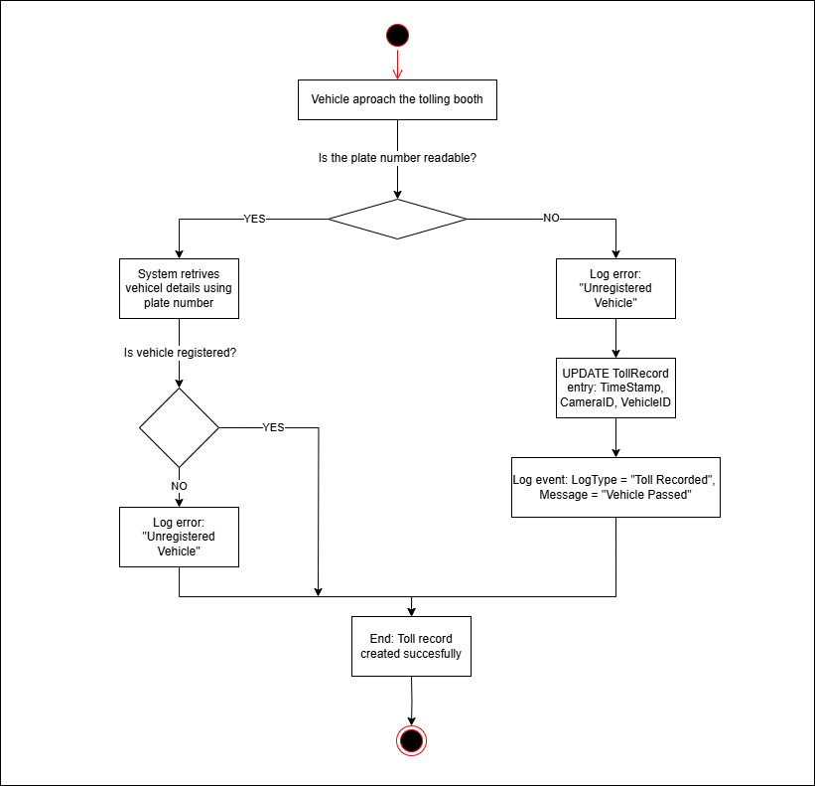

2. Payment Processing
This process handles how a toll payment is processed after a toll record is created.
- Start: System identifies a TOLLRECORD with Status = "Pending Payment".
- Action: Retrieve associated VEHICLE and linked USER via USERID.
- Action: Retrieve USER’s ACCOUNT details.
  - Decision: Does the account have sufficient BALANCE?
    - Yes: Proceed.
    - No: Notify user (via Email) to add funds and end process.
- Action: Calculate TollAmount for the TOLLRECORD.
- Action: Deduct TollAmount from ACCOUNT.BALANCE.
- Action: Create a new PAYMENT record.
  - Attributes: PaymentID, Method (e.g., "Account Deduction"), Amount, Date, Status (e.g., "Completed").
- Action: Update TOLLRECORD.Status to "Paid".
- Action: Log the event in the LOG table (e.g., LogType = "Payment Processed", Message = "Toll Paid").
- End: Payment processed successfully.
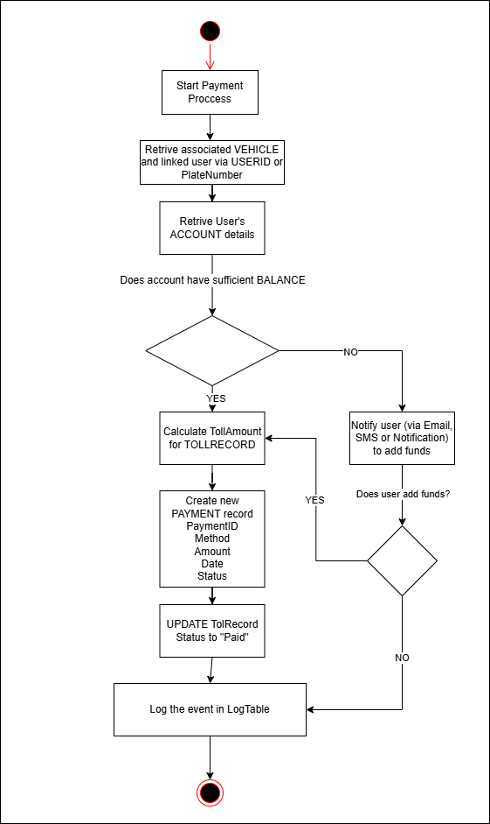

3. User Account Management (Add Funds)
This process describes how a user adds funds to their account.
- Start: User logs into the system.
- Action: System verifies USER credentials (e.g., Email, Role).
  - Decision: Is the user authenticated?
    - Yes: Proceed.
    - No: Log an error (e.g., "Authentication Failed") and end process.
- Action: User selects "Add Funds" option.
- Action: User enters the amount to add.
- Action: System creates a new PAYMENT record.
  - Attributes: Method (e.g., "Credit Card"), Amount, Date, Status (e.g., "Pending").
- Action: Process payment via external payment gateway.
  - Decision: Is the payment successful?
    - Yes: Proceed.
    - No: Update PAYMENT.Status to "Failed", log error, and end process.
- Action: Update ACCOUNT.BALANCE by adding the amount.
- Action: Update PAYMENT.Status to "Completed".
- Action: Log the event in the LOG table (e.g., LogType = "Funds Added", Message = "Account Funded").
- End: Funds added successfully.
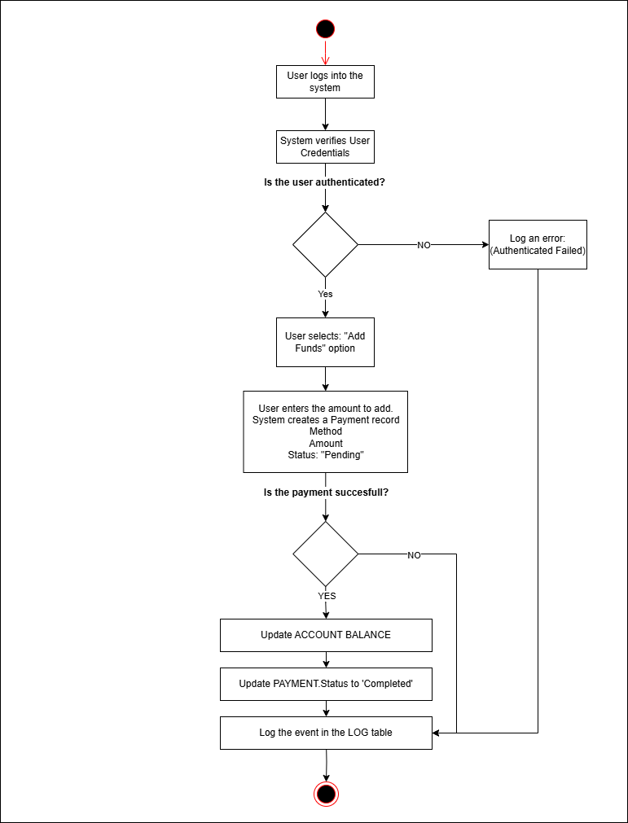

4. Log Management (Error Handling)
This process describes how the system logs events or errors.
- Start: An event or error occurs in the system (e.g., unreadable plate, payment failure).
- Action: System identifies the event type.
- Action: Create a new LOG entry.
  - Attributes: LogID, LogType (e.g., "Error", "Info"), Message (e.g., "Unreadable Plate"), TimeStamp.
- Action: Store the LOG entry in the database.
- End: Event logged successfully.
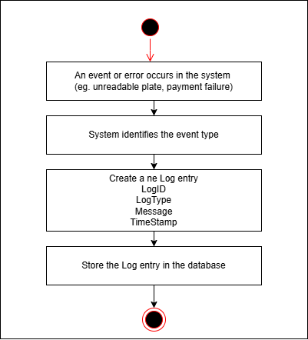

5. Camera Status Monitoring
This process monitors the status of cameras in the tolling system.
- Start: System initiates a status check for all CAMERA entities.
- Action: Loop through each CAMERA in the system.
- Action: Check CAMERA.Status.
  - Decision: Is the camera active?
    - Yes: Proceed to next camera.
    - No: Log an error in the LOG table (e.g., LogType = "Camera Failure", Message = "Camera Offline").
- Action: Notify admin (via Email) if any camera is offline.
- End: Camera status check completed.
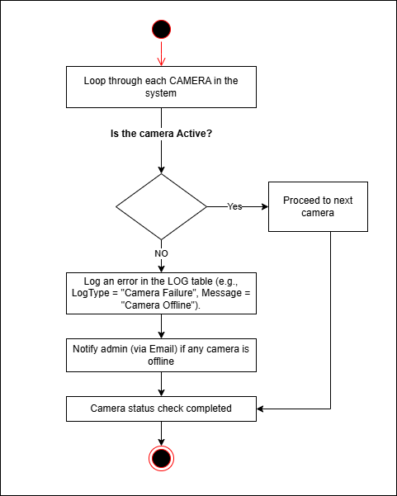

The sequence diagram
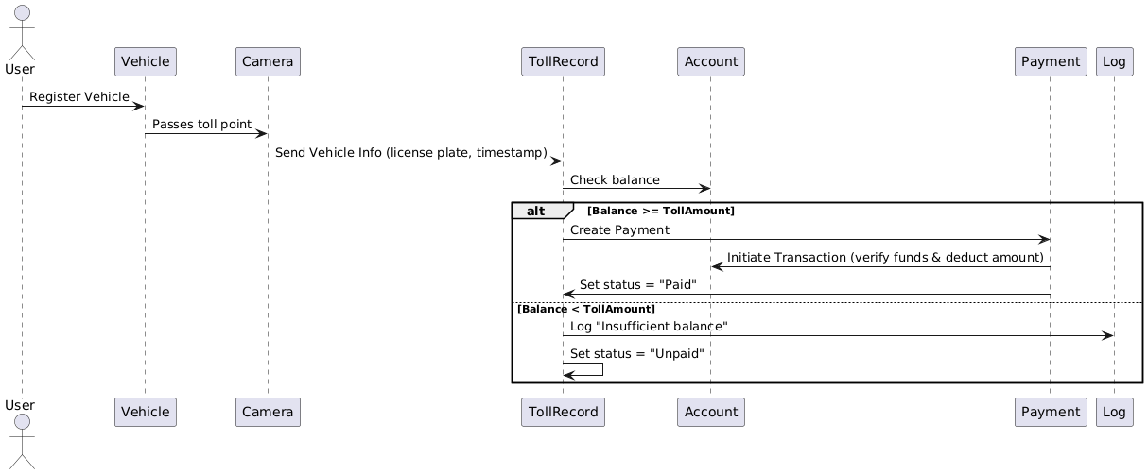

Participants and System Components:
1. User
- Represents the vehicle owner or driver.
- Initiates the process by registering their vehicle with the toll system.
2. Vehicle
- Represents the physical car or transport unit.
- Associated with the User's account.
- Automatically interacts with the system when passing a toll point.
3. Camera
- Installed at the toll point.
- Automatically detects and captures vehicle information (e.g., license plate number and timestamp) as the vehicle passes.
4. TollRecord
- A central service that creates and manages toll transactions.
- Receives vehicle information from the Camera and initiates the process of charging the vehicle’s account.
- Responsible for determining payment status (Paid or Unpaid).
5. Account
- Manages financial data associated with registered users.
- Provides the current balance for a specific vehicle or user.
- Deducts toll amount during the payment transaction.
6. Payment
- Processes monetary transactions.
- Acts as an intermediary between TollRecord and Account to execute a secure deduction.
- Communicates the success or failure of the payment to TollRecord.
7. Log
- Stores events or errors for auditing and system health monitoring.
- Records issues like "Insufficient balance" for future reference or notification.

Component diagram
This component diagram models a Toll Management System and illustrates how different functional modules (subsystems) interact with each other. The diagram is divided into several key subsystems, each responsible for specific features in the system. These components are visualized as rectangular boxes containing smaller component symbols (interfaces), and arrows denote dependencies and interactions between them.
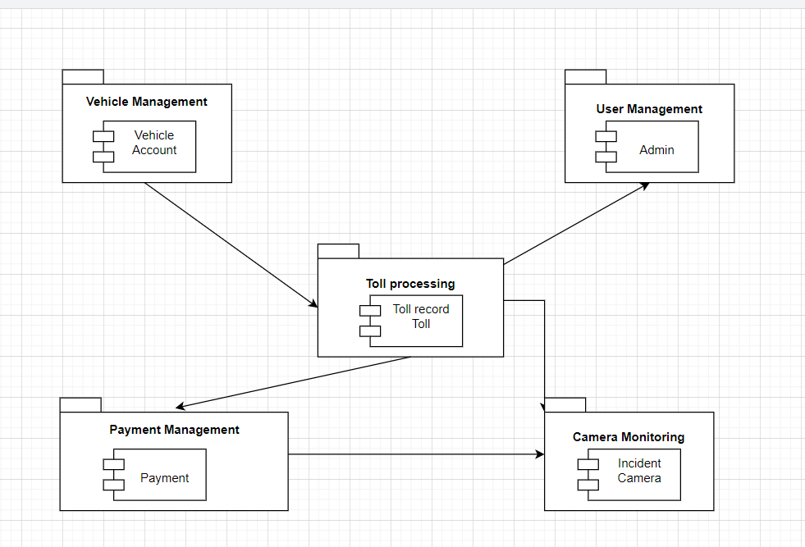

Subsystems and Components:
- Vehicle Management System
Component: Vehicle,
This component handles all information related to vehicles using the toll system. It manages vehicle registration, license plate details, and links vehicles to user accounts.
- User Management System
Component: Admin
Responsible for managing administrative users of the system. This component includes admin roles, authentication, and access control for managing other subsystems.
- Toll Processing Subsystem
Components: TollRecord, Toll
The core module of the system. It records vehicle passages through tolls, generates toll records, calculates toll fees, and determines the toll location and time. It receives data from vehicle and camera systems and forwards information to payment and monitoring subsystems.
- Payment Management Subsystem
Components: Payment, Camera
This component handles all payment operations including toll fee calculation, payment processing, and integration with external payment systems. It also processes camera data (used for violations, license plate capture, etc.) and links payments to toll records.
- Camera Monitoring Subsystem
Component: Incident
Manages monitoring through cameras installed at toll gates. It detects and logs incidents such as unpaid tolls or rule violations. It integrates with the payment and toll processing systems to take necessary action based on the incident data. It also processes camera data (used for violations, license plate capture, etc.) and links payments to toll records.

Interactions Between Components:
- The Vehicle Management subsystem provides vehicle data to Toll Processing so that tolls can be linked to specific vehicles.
- The User Management subsystem interacts with Toll Processing to allow admins to access and manage toll records and operations.
- The Toll Processing subsystem sends toll information to the Payment Management system for billing and transaction purposes.
- Camera Monitoring receives incident and toll data from Toll Processing, and also interacts with Payment Management for violation payments.
- The Payment Management system also utilizes Camera components to verify license plates or violations linked to payments.

Data Flow Diagram – DFD
Krijuar me ClickUp Whiteboard
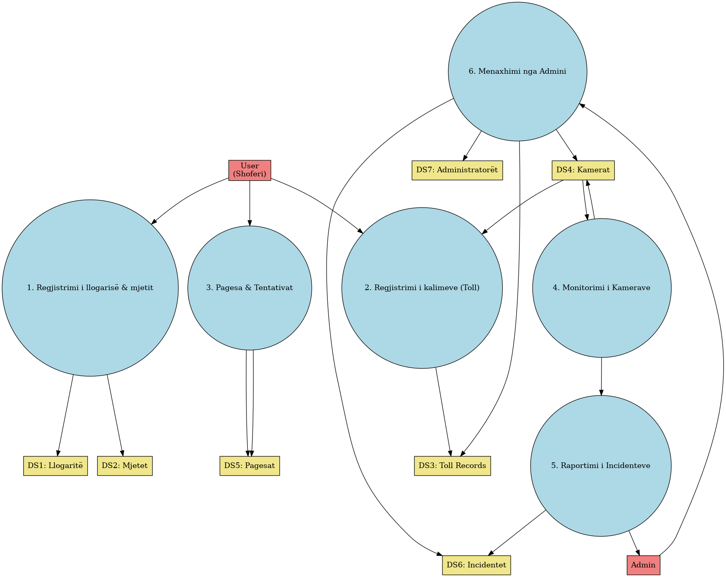

Deployment Diagram
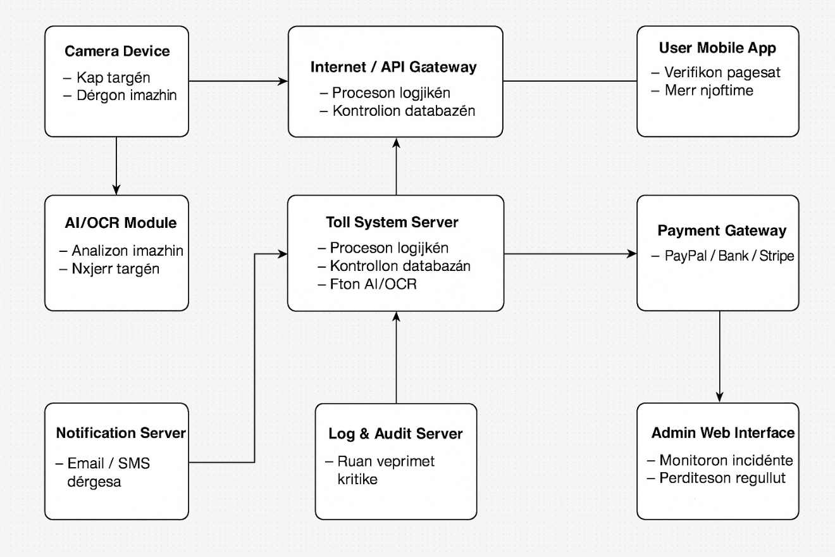

General Description

This document describes the deployment diagram for an automated system that detects vehicle license plates using cameras and artificial intelligence technology, and automatically processes toll payments. The system includes a number of physical and software components that interact in real-time to ensure the efficient and secure operation of the system.

Component Descriptions

Camera Device
Captures vehicle images and sends them for processing.

AI/OCR Module
Uses computer vision (YOLO/OCR) to extract license plate numbers.

Toll System Server
Core system logic: verification, toll calculation, and orchestration.

Vehicle & Toll DB
Stores vehicle registrations, toll rules, passage data.

Payment Gateway
Handles automatic transactions (via Stripe, PayPal, or bank APIs).

Log & Audit Server
Stores critical operations for traceability and legal compliance.

Notification Server
Sends SMS/Email alerts to users or admins.

Admin Interface
Allows toll authority to review, edit, and monitor system events.

User Mobile App
Lets users view their toll payments and receive notifications.

ER Diagram

Created with ERDPlus
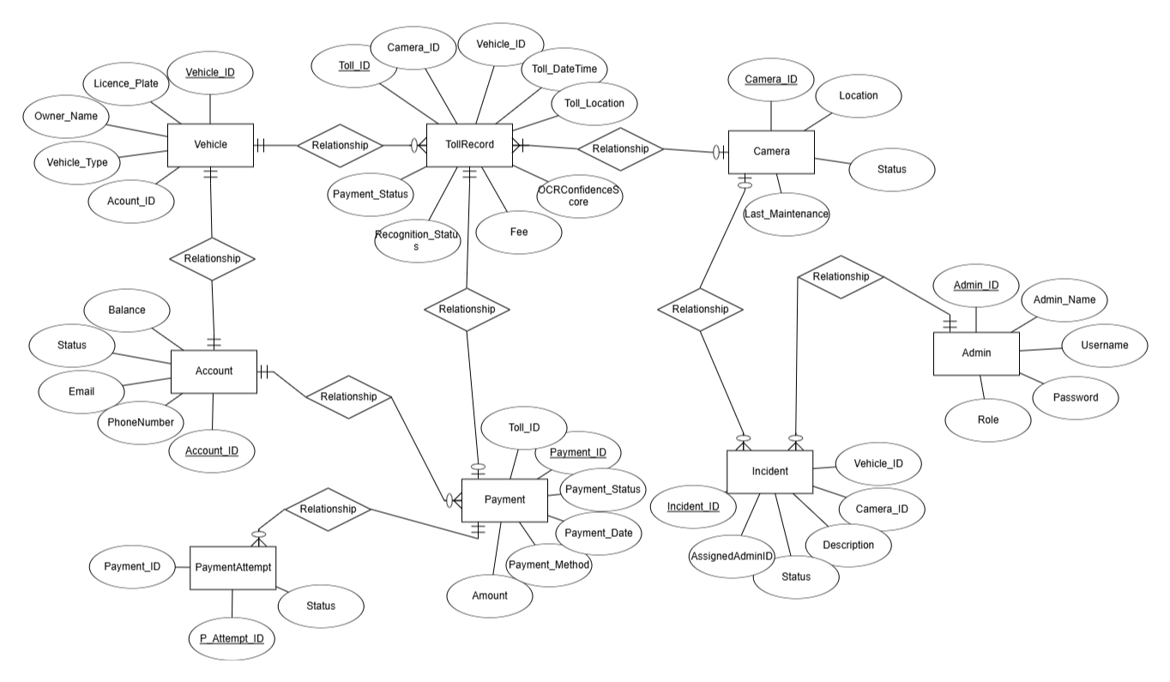

Relacional Scheme
Created with ERDPlus

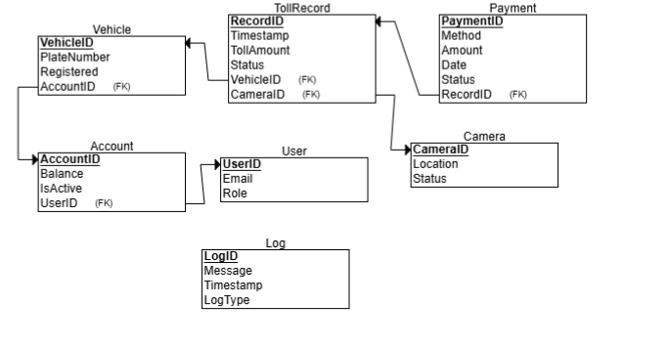

Database
CREATE TABLE User
(
UserID INT NOT NULL,
Email INT NOT NULL,
Role INT NOT NULL,
PRIMARY KEY (UserID)
);

CREATE TABLE Camera
(
CameraID INT NOT NULL,
Location INT NOT NULL,
Status INT NOT NULL,
PRIMARY KEY (CameraID)
);

CREATE TABLE Log
(
LogID INT NOT NULL,
Message INT NOT NULL,
Timestamp INT NOT NULL,
LogType INT NOT NULL,
PRIMARY KEY (LogID)
);

CREATE TABLE Account
(
AccountID INT NOT NULL,
Balance INT NOT NULL,
IsActive INT NOT NULL,
UserID INT NOT NULL,
PRIMARY KEY (AccountID),
FOREIGN KEY (UserID) REFERENCES User(UserID)
);

CREATE TABLE Vehicle
(
VehicleID INT NOT NULL,
PlateNumber INT NOT NULL,
Registered INT NOT NULL,
AccountID INT NOT NULL,
PRIMARY KEY (VehicleID),
FOREIGN KEY (AccountID) REFERENCES Account(AccountID)
);

CREATE TABLE TollRecord
(
RecordID INT NOT NULL,
Timestamp INT NOT NULL,
TollAmount_ INT NOT NULL,
Status INT NOT NULL,
VehicleID INT NOT NULL,
CameraID INT NOT NULL,
PRIMARY KEY (RecordID),
FOREIGN KEY (VehicleID) REFERENCES Vehicle(VehicleID),
FOREIGN KEY (CameraID) REFERENCES Camera(CameraID)
);

CREATE TABLE Payment
(
PaymentID INT NOT NULL,
Method INT NOT NULL,
Amount INT NOT NULL,
Date INT NOT NULL,
Status INT NOT NULL,
RecordID INT NOT NULL,
PRIMARY KEY (PaymentID),
FOREIGN KEY (RecordID) REFERENCES TollRecord(RecordID)
);

Design Patterns : Observer Pattern

What is the Observer Pattern?
The Observer Pattern is a behavioral design pattern where an object, known as the subject, maintains a list of its dependents, called observers, and notifies them automatically of any state changes, typically by calling one of their methods.

Why Observer Pattern for Smart Tolling?
Your system has multiple components that need to respond to state changes or events, such as:
Event | Observers
Vehicle detected | Logger, Payment module, Notifier
Payment failed | Logger, Notification system, Admin dashboard
Camera offline | Admin alert system, Logging module
OCR failed | Admin dashboard, Logger, Manual Verification queue

Event Descriptions
- When a vehicle is detected, the system notifies several observers: the Logger to record the event, the Payment module to initiate automatic toll payment, and the Notifier to alert the driver if necessary.
- When a payment fails, the system triggers the Logger to log the failed transaction, the Notification system to inform the user, and the Admin dashboard to display the incident for manual review.
- When a camera goes offline, the system alerts the Admin alert system to notify the maintenance team and also updates the Logging module to register the downtime incident.
- When OCR fails to read a license plate, the system notifies the Admin dashboard for manual intervention, logs the failure using the Logger, and adds the case to the Manual Verification queue for further processing.

Using the Observer Pattern:
- You can decouple the components that detect and trigger events (e.g., the OCR engine or toll detector) from those that respond to them (e.g., Logger, EmailNotifier, PaymentHandler).
- You ensure real-time updates across modules (e.g., Admin panel updates when a failure log is recorded).
- It simplifies maintenance and extensibility. You can add new observers like SMS alerts or external APIs without changing the core detection logic.

Example in the System
- Subject: TollEventDetector
- Observers:
  - PaymentProcessor
  - AdminNotifier
  - AuditLogger
  - UserNotifier
When a vehicle is detected:
TollEventDetector → notifies all observers:
→ PaymentProcessor deducts amount
→ AuditLogger records the event
→ UserNotifier sends SMS if needed
→ AdminNotifier logs failure if any

Jira platform

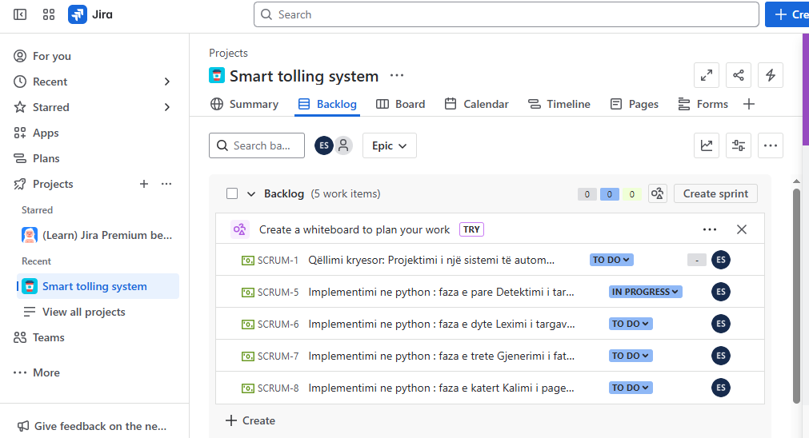

Division of labor
(including setting a deadline)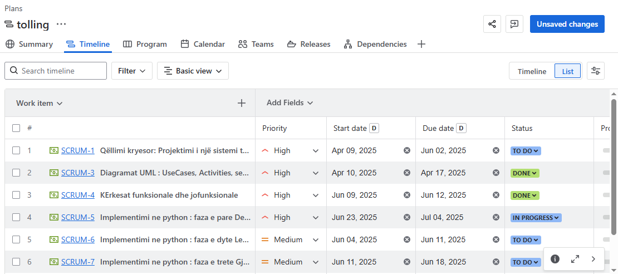

Gantt Diagram

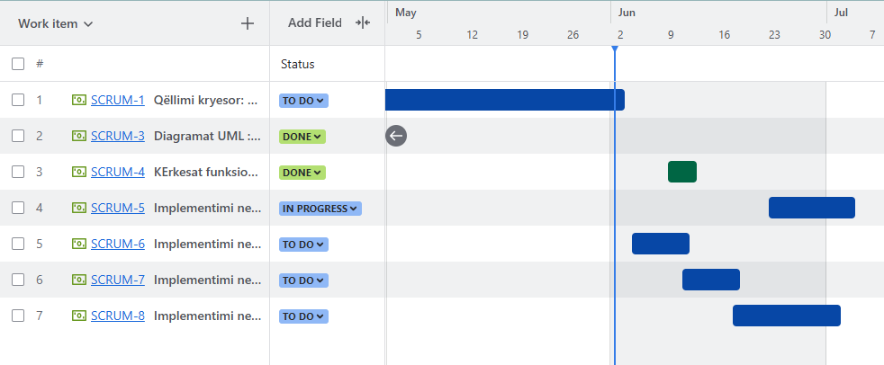

Computer Vision
Created with cvat.ai
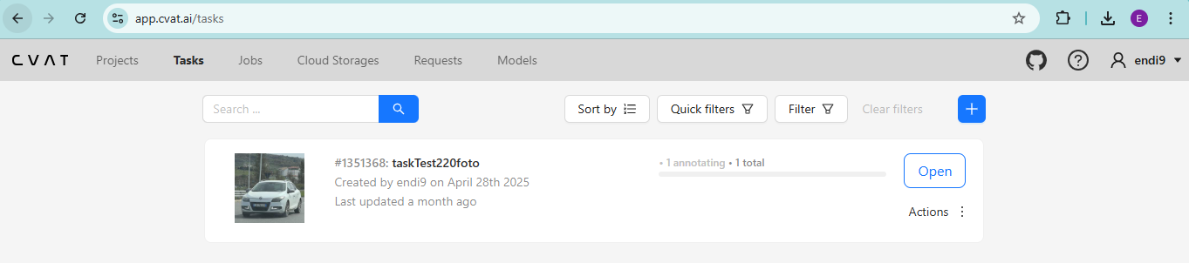
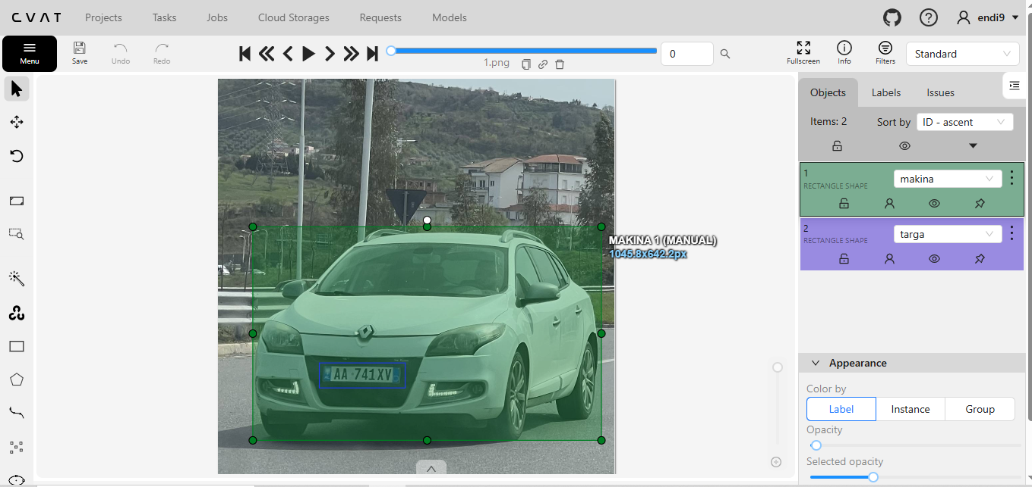
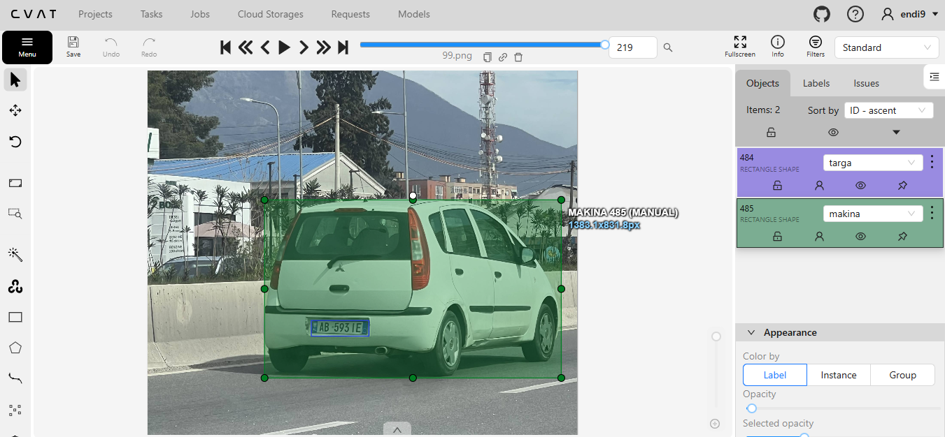

Conclusion

This project offers a modern and efficient solution for toll management on toll roads using artificial intelligence and advanced technology (we have not chosen it yet). The benefits are numerous: for users it offers convenience and speed, for authorities efficiency and transparency, for developers challenges and opportunities for innovation. With the implementation of appropriate security and privacy measures, this system can be a model for many other roads in the future.

During this project, our group has worked closely in all the main stages of the system development, starting from the analysis of requirements, modeling of processes and data, to the design of the system architecture and prototyping. Each member has contributed responsibly to the division of tasks, documentation, and technical development of the main components of the project.

We have managed to create a functional structure for an intelligent system that automatically detects vehicle license plates at toll points and processes the corresponding fees in an automated manner. At this point, we have completed most of the analysis and design, and have successfully implemented the functionality of license plate detection and its display in the system.

Currently, the project is in the implementation and active development phase, where the payment logic and interaction with the database and cameras are being worked out. We appreciate the progress achieved so far and are committed to delivering a sustainable and efficient solution for modern toll system management.

