实验2 2016302580242 刘瑞康

(1)

#### Student

INSERT INTO Student(STUDENTNUM, STUDENTNAME, SEX, CLASS, PASSWORD, IDCARD)

VALUES('200101', 'Stephen Curry', 'm', 1, 'sk', '429001199212140000');

INSERT INTO Student(STUDENTNUM, STUDENTNAME, SEX, CLASS, PASSWORD, IDCARD)

VALUES('200102', 'Diana Taurasi', 'f', 1, 'dt', '429001199305110000');

INSERT INTO Student(STUDENTNUM, STUDENTNAME, SEX, CLASS, PASSWORD, IDCARD)

VALUES('200103', 'John Wall', 'm', 1, 'jw', '429003199201170000');

INSERT INTO Student(STUDENTNUM, STUDENTNAME, SEX, CLASS, PASSWORD, IDCARD)

VALUES('200201', 'Brittney Griner', 'f', 2, 'bg', '421003199212140000');

INSERT INTO Student(STUDENTNUM, STUDENTNAME, SEX, CLASS, PASSWORD, IDCARD)

VALUES('200202', 'Derrick Rose', 'm', 2, 'dr', '439001199105060000');

INSERT INTO Student(STUDENTNUM, STUDENTNAME, SEX, CLASS, PASSWORD, IDCARD)

VALUES('200203', 'Damiam Lillard', 'm', 2, 'dl', '429001199203110000');

INSERT INTO Student(STUDENTNUM, STUDENTNAME, SEX, CLASS, PASSWORD, IDCARD)

VALUES('200301', 'Anthony Davis', 'm', 3, 'ad', '424551199104010000');

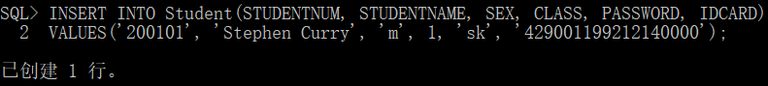

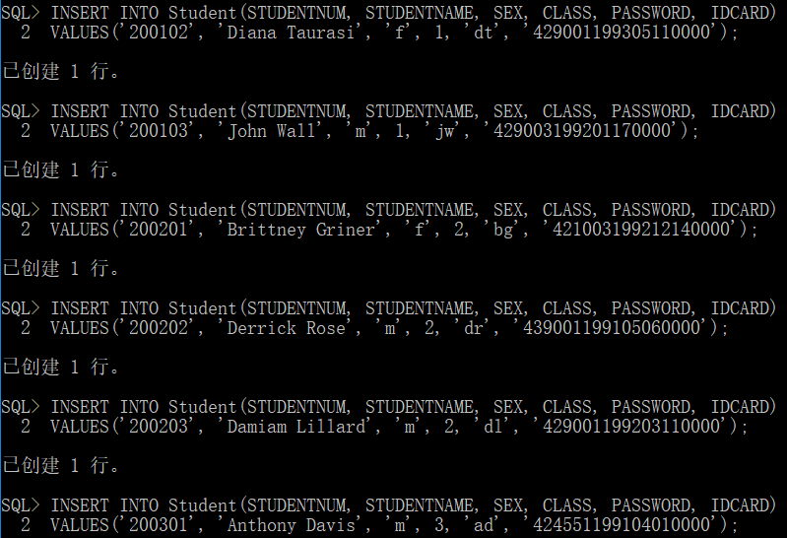

#### Teacher

INSERT INTO Teacher(teacherNum, teacherName, sex, title, password)

VALUES('1', 'Kobe Bryant', 'm', 'Prof', 'kbbm');

INSERT INTO Teacher(teacherNum, teacherName, sex, title, password)

VALUES('2', 'Kevin Garnett', 'm', 'Assistant Prof', 'kgwk');

INSERT INTO Teacher(teacherNum, teacherName, sex, title, password)

VALUES('3', 'Maya Moore', 'f', 'Lecturer', 'mm@1987');

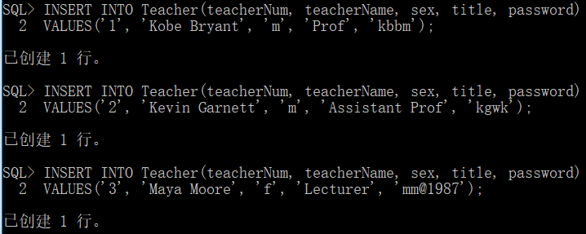

#### Lesson

INSERT INTO Lesson(lessonNum, lessonName, year, term, credit, teacherNum, beforeLessonNum)

VALUES('1', 'C programming language', '2013', 'one', 4, '1', NULL);

INSERT INTO Lesson(lessonNum, lessonName, year, term, credit, teacherNum, beforeLessonNum)

VALUES('2', 'C++ programming', '2013', 'one', 2, NULL, '1');

INSERT INTO Lesson(lessonNum, lessonName, year, term, credit, teacherNum, beforeLessonNum)

VALUES('3', 'algorithm design', '2013', 'one', 3, NULL, '2');

INSERT INTO Lesson(lessonNum, lessonName, year, term, credit, teacherNum, beforeLessonNum)

VALUES('4', 'architecture and music', '2012', 'two', 2, '3', NULL);



插入第一条时出现错误，因为创建表时term类型为CHAR(2)

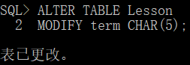

考虑到合理值中最长为seven5个字符，修改为CHAR(5)



插入第二条时又出现错误，由于创建时不允许TeacherNum为NULL

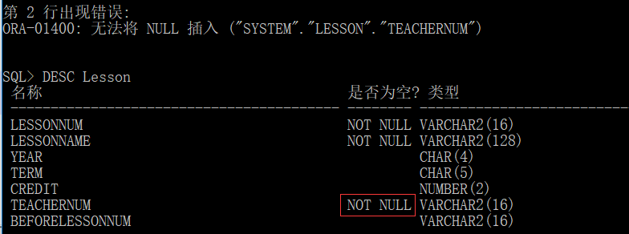

重新设置使其可以为NULL

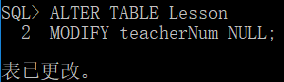

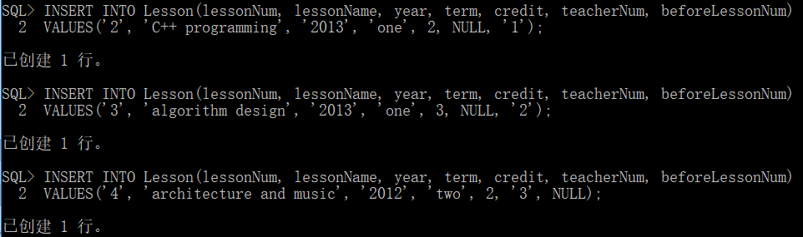

#### Stu_choose_lesson

INSERT INTO Stu_choose_lesson

VALUES('200101', '1');

INSERT INTO Stu_choose_lesson

VALUES('200102', '1');

INSERT INTO Stu_choose_lesson

VALUES('200103', '1');

INSERT INTO Stu_choose_lesson

VALUES('200201', '2');

INSERT INTO Stu_choose_lesson

VALUES('200202', '2');

INSERT INTO Stu_choose_lesson

VALUES('200203', '2');

INSERT INTO Stu_choose_lesson

VALUES('200301', '2');

INSERT INTO Stu_choose_lesson

VALUES('200101', '3');

INSERT INTO Stu_choose_lesson

VALUES('200102', '3');

INSERT INTO Stu_choose_lesson

VALUES('200103', '3');

INSERT INTO Stu_choose_lesson

VALUES('200201', '3');

INSERT INTO Stu_choose_lesson

VALUES('200202', '3');

INSERT INTO Stu_choose_lesson

VALUES('200101', '4');

INSERT INTO Stu_choose_lesson

VALUES('200102', '4');

INSERT INTO Stu_choose_lesson

VALUES('200201', '4');

INSERT INTO Stu_choose_lesson

VALUES('200202', '4');

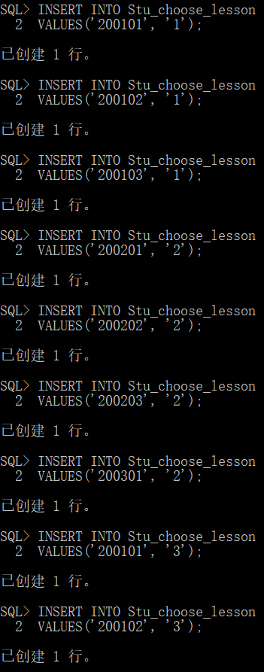

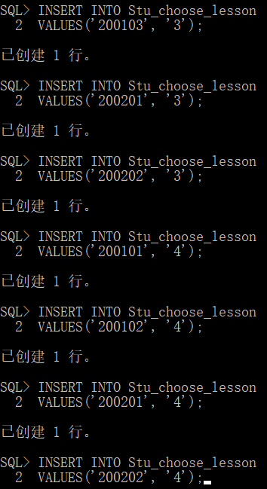

#### Leave_apply

INSERT INTO Leave_apply

VALUES(1, Date'2013-8-29', 'personal leave', 'failed', '200101', '1', '1');

INSERT INTO Leave_apply

VALUES(2, Date'2013-8-30', 'sick leave', 'failed', '200102', '1', '1');

INSERT INTO Leave_apply

VALUES(3, Date'2013-8-31', 'sick leave', 'failed', '200103', '1', '1');

INSERT INTO Leave_apply

VALUES(4, Date'2013-9-1', 'family visit', 'failed', '200201', '2', '2');

INSERT INTO Leave_apply

VALUES(5, Date'2013-9-2', 'emergency leave', 'failed', '200202', '2', '2');

INSERT INTO Leave_apply

VALUES(6, Date'2013-9-3', 'personal leave', 'unchecked', '200203', '3', '3');

INSERT INTO Leave_apply

VALUES(7, Date'2013-9-4', 'sick leave', 'unchecked', '200301', '3', '3');

INSERT INTO Leave_apply

VALUES(8, Date'2013-9-5', 'sick leave', 'passed', '200201', '3', '3');

INSERT INTO Leave_apply

VALUES(9, Date'2013-9-6', 'sick leave', 'failed', '200202', '4', '3');

INSERT INTO Leave_apply

VALUES(10, Date'2013-9-7', 'personal leave', 'unchecked', '200203', '4', '3');

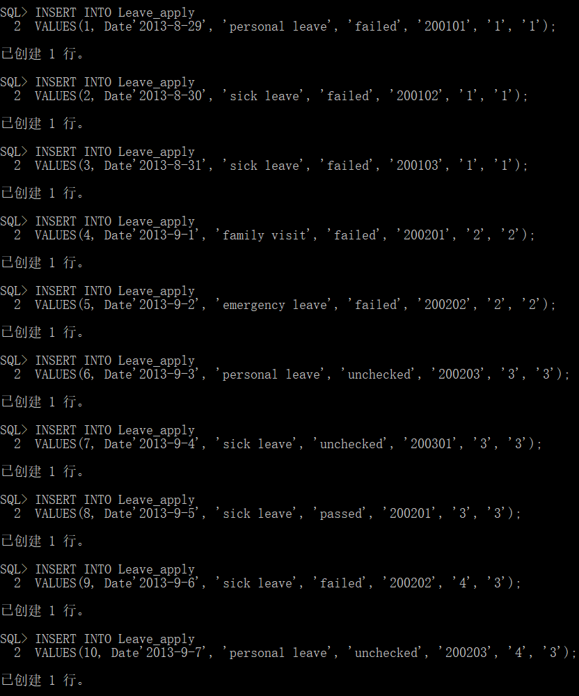

#### Message

INSERT INTO Message

VALUES(1, 'Your leave apply has been rejected.', '1', '200101', to_date('2013-8-31 10:10:10','yyyy-mm-dd hh24:mi:ss'));

INSERT INTO Message

VALUES(2, 'Your leave apply has been rejected.', '2', '200102', to_date('2013-9-1 19:22:38','yyyy-mm-dd hh24:mi:ss'));

INSERT INTO Message

VALUES(3, 'Your leave apply has been passed.', '3', '200103', to_date('2013-9-2 14:05:30','yyyy-mm-dd hh24:mi:ss'));

INSERT INTO Message

VALUES(4, 'Your leave apply has been passed.', '4', '200201', to_date('2013-9-3 08:30:27','yyyy-mm-dd hh24:mi:ss'));

INSERT INTO Message

VALUES(5, 'Your leave apply has been passed.', '5', '200202', to_date('2013-9-4 20:26:05','yyyy-mm-dd hh24:mi:ss'));

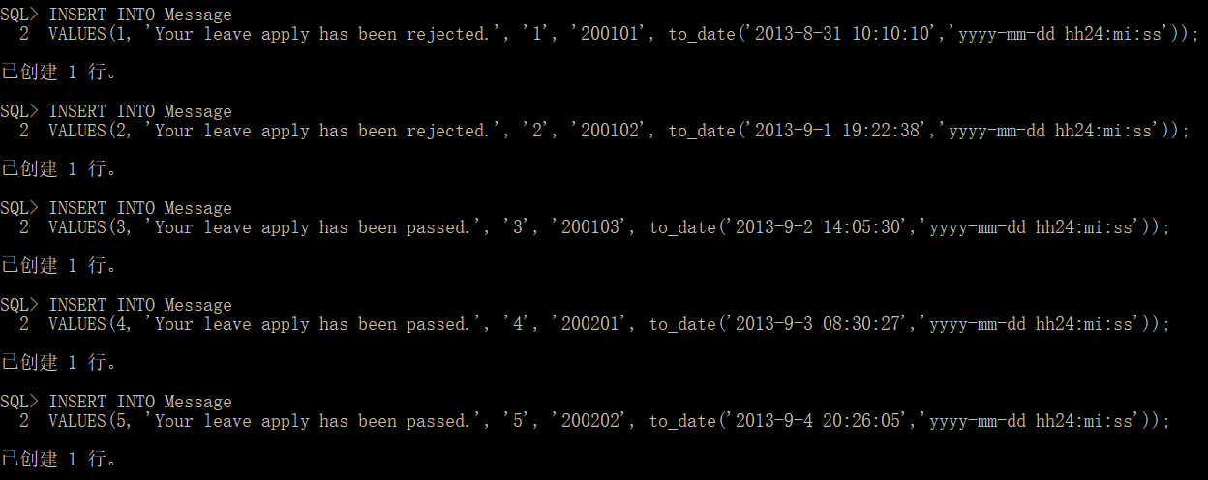

(2)

DELETE FROM Student

WHERE studentNum = ‘200101’;

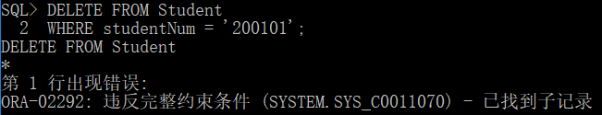

不能成功删除，因为该记录已经被其他表通过外键引用。

(3)

UPDATE Lesson

SET credit = 4

WHERE lessonNum = ‘3’;

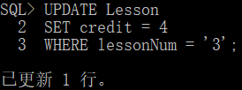

UPDATE Lesson

SET credit = 1

WHERE lessonNum = ‘4’;

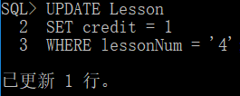

UPDATE Lesson

SET lessonName = ‘高级语言程序设计’

WHERE lessonNum = ‘1’;

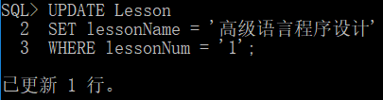

(4)

CREATE VIEW V_stu_lesson (studentNum, studentName, lessonNum, lessonName, credit, teacherNum, teacherName)

AS SELECT s.studentNum, s.studentName, l.lessonNum, l.lessonName, l.credit, t.teacherNum, t.teacherName

FROM Student s, Stu_choose_lesson scl, Lesson l, Teacher t

WHERE s.studentNum = scl.studentNum AND scl.lessonNum = l.lessonNum AND l.teacherNum = t.teacherNum;

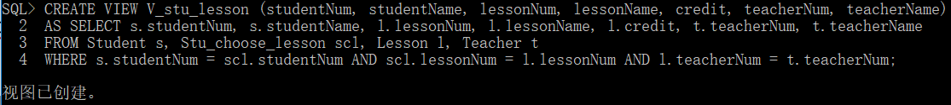

(5)

SELECT *

FROM V_stu_lesson

WHERE teacherNum = ‘3’;

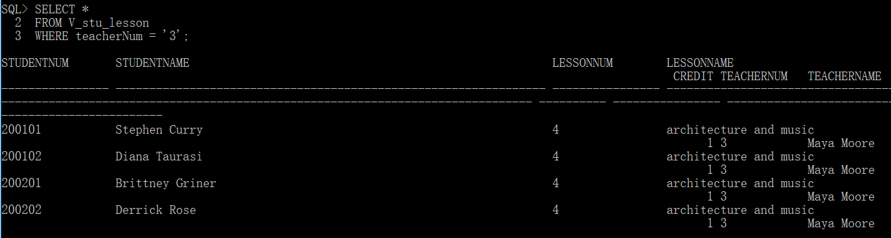

(6)

SELECT studentNum, studentName, lessonNum, lessonName, teacherNum, teacherName

FROM V_stu_lesson

WHERE teacherNum = ‘3’;

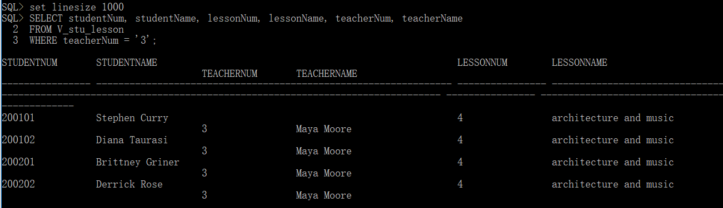

(7)

UPDATE V_stu_lesson

SET credit = 3

WHERE lessonNum = ‘4’;

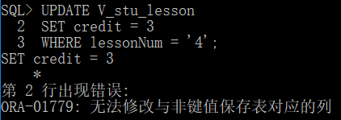

视图可更新的充要条件要求FROM子句最多只能指定一个表，显然该视图不符合可更新性要求。

(8)

UPDATE Student

SET studentNum = ‘200130’

WHERE studentNum = ‘200103’;

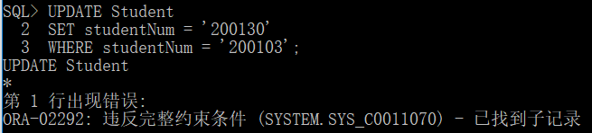

不能成功修改，因为该记录已经被其他表通过外键引用。