实验1 2016302580242 刘瑞康

(1)

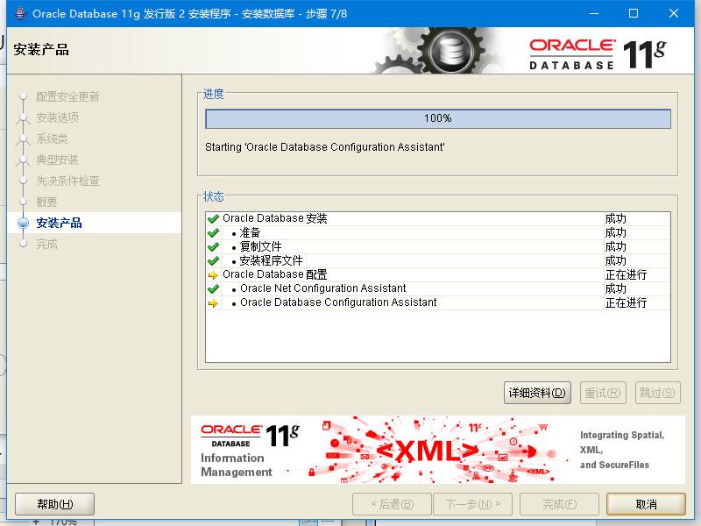

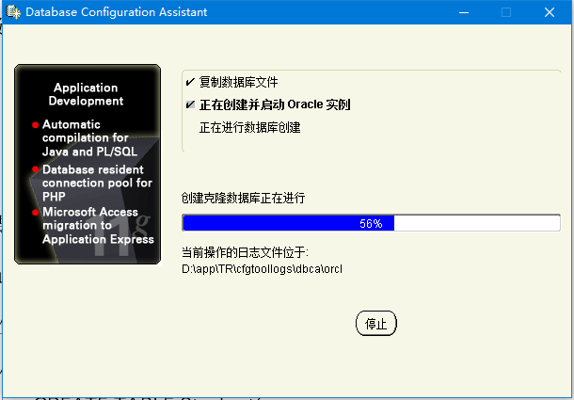

(2)

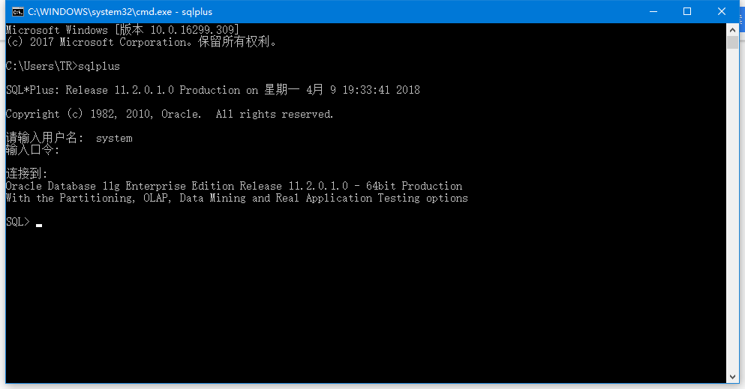

(3)学生选课表中studentNum、lessonNum均为外键

(4)

CREATE TABLE Student(

studentNum VARCHAR2(16) NOT NULL,

studentName VARCHAR2(64) NOT NULL,

sex VARCHAR2(2) NOT NULL,

class NUMBER(2) NOT NULL,

password VARCHAR2(50),

PRIMARY KEY(studentNum)

);

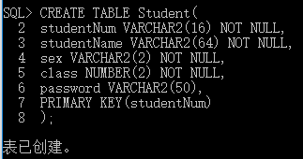

CREATE TABLE Teacher(

teacherNum VARCHAR2(16) NOT NULL,

teacherName VARCHAR2(64) NOT NULL,

sex CHAR(2) NOT NULL,

title VARCHAR2(32),

password VARCHAR2(50),

PRIMARY KEY(teacherNum)

);

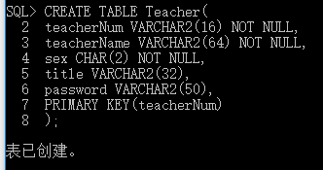

CREATE TABLE Lesson(

lessonNum VARCHAR2(16) NOT NULL,

lessonName VARCHAR2(128) NOT NULL,

year CHAR(4),

term CHAR(2),

credit NUMBER(2),

teacherNum VARCHAR2(16) NOT NULL,

beforeLessonNum VARCHAR2(16),

PRIMARY KEY(lessonNum),

FOREIGN KEY(teacherNum) REFERENCES Teacher(teacherNum)

);

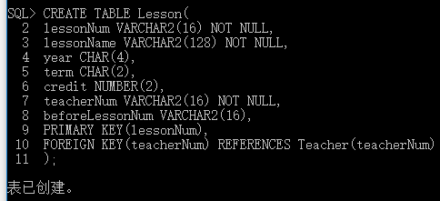

CREATE TABLE Stu_choose_lesson(

studentNum VARCHAR2(16) NOT NULL,

lessonNum VARCHAR2(16) NOT NULL,

PRIMARY KEY(studentNum, lessonNum),

FOREIGN KEY(studentNum) REFERENCES Student(studentNum),

FOREIGN KEY(lessonNum) REFERENCES Lesson(lessonNum)

);

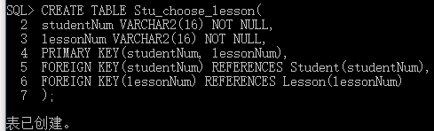

CREATE TABLE Leave_apply(

applyNum VARCHAR(16) NOT NULL,

applyTime DATE NOT NULL,

reason VARCHAR2(128) NOT NULL,

state VARCHAR2(16) DEFAULT ’unchecked’ NOT NULL,

studentNum VARCHAR2(16) NOT NULL,

lessonNum VARCHAR2(16) NOT NULL,

teacherNum VARCHAR2(16) NOT NULL,

PRIMARY KEY(applyNum),

FOREIGN KEY(studentNum) REFERENCES Student(studentNum),

FOREIGN KEY(lessonNum) REFERENCES Lesson(lessonNum),

FOREIGN KEY(teacherNum) REFERENCES Teacher(teacherNum),

CHECK(state in (’unchecked’, ’passed’, ’failed’))

);

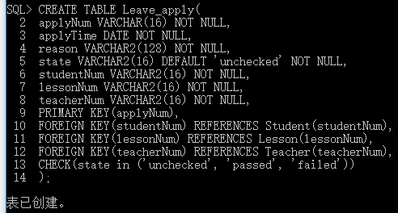

CREATE TABLE Message(

messageNum NUMBER(16) NOT NULL,

content VARCHAR2(128) NOT NULL,

applyNum VARCHAR2(16) NOT NULL,

studentNum VARCHAR2(16) NOT NULL,

time DATE NOT NULL,

PRIMARY KEY(messageNum),

FOREIGN KEY(studentNum) REFERENCES Student(studentNum),

FOREIGN KEY(applyNum) REFERENCES Leave_apply(applyNum)

);

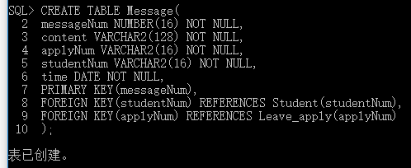

(5)

ALTER TABLE Teacher

DROP COLUMN title;

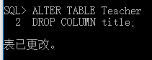

ALTER TABLE Teacher

ADD title VARCHAR2(32);

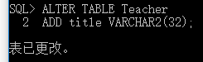

ALTER TABLE Student

MODIFY sex CHAR(2);

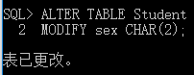

(6)

INSERT INTO Teacher

VALUES(‘1’, ‘Kobe Bryant’, ‘m’, ‘Prof’, ‘kbbm’);

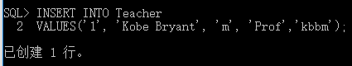

ALTER TABLE Teacher

ADD sex CHAR(2) NOT NULL DEFAULT ‘m’;

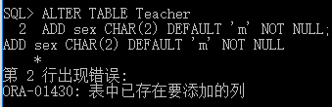

//失败原因，已经有同名列，而关系列表中不允许有同名的列出现

//解决方法：

DELETE FROM Teacher;

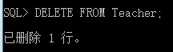

ALTER TABLE Teacher

DROP COLUMN sex;

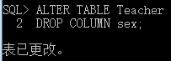

ALTER TABLE Teacher

ADD sex CHAR(2) NOT NULL DEFAULT ‘m’;

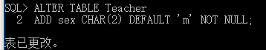

(7)

ALTER TABLE Student

ADD IDcard VARCHAR2(18) UNIQUE

CHECK( LENGTH(IDcard)=18 AND IDcard LIKE ‘%[0-9]’);

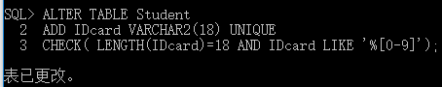

(8)

ALTER TABLE Lesson

ADD CONSTRAINT more_than_0 CHECK(credit>0);

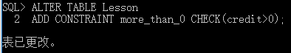

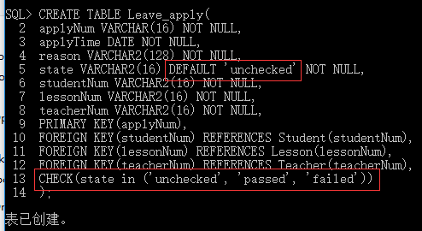

(9)

CREATE INDEX LessonNumInd ON Leave_apply(lessonNum);



CREATE INDEX Stu_LessonInd ON Stu_choose_lesson(studentNum, lessonNum);

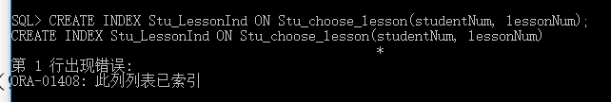

//因为已经把(studentNum,lessonNum)设为了主键，已经创建了默认的引索

(10)

DESCRIBE Student;

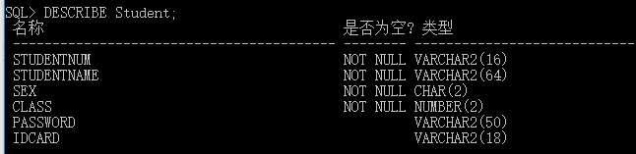

DESCRIBE Teacher;

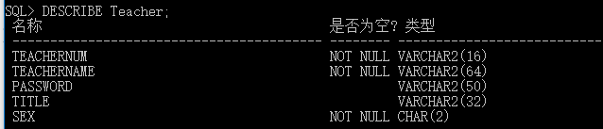

DESCRIBE Lesson;

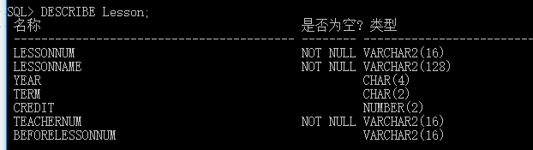

DESCRIBE Stu_choose_lesson;

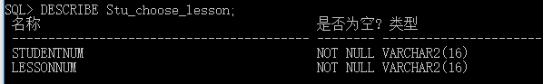

DESCRIBE Leave_apply;

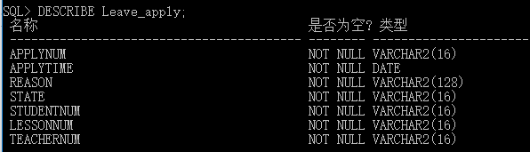

DESCRIBE Message;

