3.5

将训练样本进行规范化处理

***X*1**=[0,0,0,1]T, ***X*2**=[1,0,0,1]T, ***X*3**=[1,0,1,1]T,***X*4**=[1,1,0,1]T

***X*5**=[0,0,-1,-1]T, ***X*6**=[0,-1,-1,-1]T, ***X*7**=[0,-1,0,-1]T, ***X*8**=[-1,-1,-1,-1]T

取*W*(1) = (0, 0, 0, 0) T,c = 1。迭代过程如下。

第一轮：

*W*T(1)*X*1 = [-1,-2,-2,0][0,0,0,1]T = 0, *W*(2) = *W*(1) + *X*1 = [-1,-2,-2,1]T

*W*T(2)*X*2 = [-1,-2,-2,1][1,0,0,1]T = 0, *W*(3) = *W*(2) + *X*2 = [0,-2,-2,2]T

*W*T(3)*X*3 = [0,-2,-2,2][1,0,1,1]T = 0, *W*(4) = *W*(3) + *X*3 = [1,-2,-1,3]T

*W*T(4)*X*4 = [1,-2,-1,3][1,1,0,1]T = 2 > 0, *W*(5) = *W*(4)

*W*T(5)*X*5 = [1,-2,-1,3][0,0,-1,-1]T = -2 < 0, *W*(6) = *W*(5) + *X*5 = [1,-2,-2,2]T

*W*T(6)*X*6 = [1,-2,-2,2][0,-1,-1,-1]T = 2 > 0, *W*(7) = *W*(6)

*W*T(7)*X*7 = [1,-2,-2,2][0,-1,0,-1]T = 0, *W*(8) = *W*(7) + *X*7 = [1,-3,-2,1]T

*W*T(8)*X*8 = [1,-3,-2,1][-1,-1,-1,-1]T = 3 > 0, *W*(9) = *W*(8)

第二轮：

*W*T(9)*X*1 = [1,-3,-2,1][0,0,0,1]T = 1 > 0, *W*(10) = *W*(9)

*W*T(10)*X*2 = [1,-3,-2,1][1,0,0,1]T = 2 > 0, *W*(11) = *W*(9)

*W*T(11)*X*3 = [1,-3,-2,1][1,0,1,1]T = 0, *W*(12) = *W*(11) + *X*3 = [2,-3,-1,2]T

*W*T(12)*X*4 = [2,-3,-1,2][1,1,0,1]T = 1 > 0, *W*(13) = *W*(12)

*W*T(13)*X*5 = [2,-3,-1,2][0,0,-1,-1]T = -1 < 0, *W*(14) = *W*(13) + *X*5 = [2,-3,-2,1]T

*W*T(14)*X*6 = [2,-3,-2,1][0,-1,-1,-1]T = 4 > 0, *W*(15) = *W*(14)

*W*T(15)*X*7 = [2,-3,-2,1][0,-1,0,-1]T = 2 > 0, *W*(16) = *W*(15)

*W*T(16)*X*8 = [2,-3,-2,1][-1,-1,-1,-1]T = 2 > 0, *W*(17) = *W*(16)

第三轮：

*W*T(17)*X*1 = [2,-3,-2,1][0,0,0,1]T = 1 > 0, *W*(18) = *W*(17)

*W*T(18)*X*2 = [2,-3,-2,1][1,0,0,1]T = 3 > 0, *W*(19) = *W*(18)

*W*T(19)*X*3 = [2,-3,-2,1][1,0,1,1]T = 1 > 0, *W*(20) = *W*(19)

*W*T(20)*X*4 = [2,-3,-2,1][1,1,0,1]T = 0, *W*(21) = *W*(20) + *X*4 = [3,-2,-2,2]T

*W*T(21)*X*5 = [3,-2,-2,2][0,0,-1,-1]T = 0, *W*(22) = *W*(21) + *X*5 = [3,-2,-3,1]T

*W*T(22)*X*6 = [3,-2,-3,1][0,-1,-1,-1]T = 4 > 0, *W*(23) = *W*(22)

*W*T(23)*X*7 = [3,-2,-3,1][0,-1,0,-1]T = 1 > 0, *W*(24) = *W*(23)

*W*T(24)*X*8 = [3,-2,-3,1][-1,-1,-1,-1]T = 1 > 0, *W*(25) = *W*(24)

第四轮：

*W*T(25)*X*1 = [3,-2,-3,1[0,0,0,1]T = 1 > 0, *W*(26) = *W*(25)

*W*T(26)*X*2 = [3,-2,-3,1][1,0,0,1]T = 4 > 0, *W*(27) = *W*(26)

*W*T(27)*X*3 = [3,-2,-3,1][1,0,1,1]T = 1 > 0, *W*(28) = *W*(27)

*W*T(28)*X*4 = [3,-2,-3,1][1,1,0,1]T = 2 > 0, *W*(29) = *W*(28)

*W*T(29)*X*5 = [3,-2,-3,1][0,0,-1,-1]T = 2 > 0, *W*(30) = *W*(29)

*W*T(30)*X*6 = [3,-2,-3,1][0,-1,-1,-1]T = 4 > 0, *W*(31) = *W*(30)

*W*T(31)*X*7 = [3,-2,-3,1][0,-1,0,-1]T = 1 > 0, *W*(32) = *W*(31)

*W*T(32)*X*8 = [3,-2,-3,1][-1,-1,-1,-1]T = 1 > 0, *W*(33) = *W*(32)

该轮迭代分类结果全部正确，故解向量为*W* = [3,-2,-3,1]T

则判别函数为d(X) = 3x1 – 2x2 – 3x3 + 1

判别界面如下：

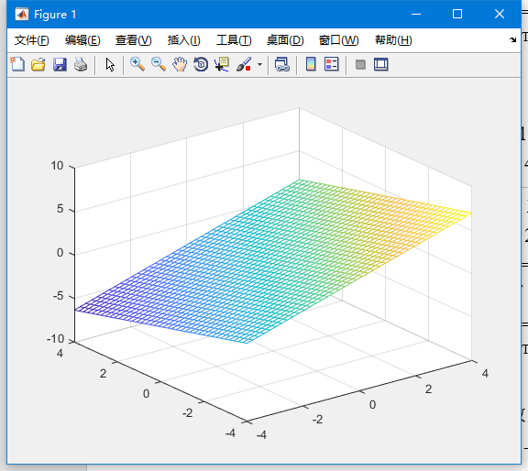

3.9

*X*1 = [0,1]T , *X*1

则K1 (*X*) = K0(*X*) + *K*(*X , X1*) = 8x22-8x12+1

*X*2 = [0,-1]T , *X*2, *K*1(*X*2) =9 > 0 , 分类正确

则K2 (*X*) = K1(*X*)

*X*3 = [1,0]T , *X*3, *K*2(*X*3) =-7 < 0 , 分类正确

则K3 (*X*) = K2(*X*)

*X*4 = [-1,0]T , *X*4, *K*3(*X*4) =-7 < 0 , 分类正确

则K4 (*X*) = K3(*X*)

*X*1 = [0,1]T , *X*1, *K*4(*X*1) =9 > 0 , 分类正确

则K5 (*X*) = K4(*X*)

全部训练样本分类正确，故算法收敛

判别函数为d(X) = 8x22-8x12+1