**邮寄地址:云南省昆明市呈贡区云南师范大学西区 电话：17300092393 李舒羽 收**

**The New Feminism in *No Signposts in the Sea* from the Perspective of Psychoanalysis**

Shuyu Li

(Yunnan Normal University, Yunnan Kunming 650000)

## Abstract: Vita Sackville-West is an English poet and novelist. Her feminist views are mainly reflected in her descriptions of the relationships among the characters and the psychological activities of the characters. Some critics have studied Vita Sackville-West’s works, however their researches mainly focus on her love affair with Virginia Woolf or the influence of the stream-of-consciousness theory, there has been little analysis of the psychology of the protagonist--Edmund Carr in *NO Signposts in the Sea*. This thesis discusses the new feminist ideas in this novel and the relationship between it and the author. By analyzing the psychological conditions of Edmund Carr, we can not only come to know Vita Sackville-West and *NO Signposts in the Sea* but also understand more about the new feminism conceptions better.

**Key Words**: *NO Signposts in the Sea,* New feminism, Psychology

**精神分析法视角下《海上无航标》的新女性主义思想解读**

李舒羽

(云南师范大学，云南 昆明 650000)

## 摘要

薇塔·萨克维尔－维斯特是20世纪英国有名的女性诗人和小说家。她一生中创作了很多作品，受到了业界的极大认可。其作品的主题都与爱情和婚姻有关。她擅长通过对人物的内心活动和人物间的关系的描写来展现她的女性主义观点。

国内学者对薇塔•萨克维尔－维斯特的作品研究并不多，对《海上无航标》的研究也多集中于她与伍尔夫的同性恋关系，她的恋爱观以及意识流写作手法上，很少有人对小说主人公埃德蒙·卡尔的人格和心理状态进行讨论分析。本文主要通过对埃德蒙的人格变化来探讨小说的情节，分析小说与作者的联系以及其中所体现的新女性主义观点，希望通过对人物的精神分析让读者对《海上无航标》的内容和其蕴含的新女性主义思想有更深刻的解读，同时也对作者本人和其作品有进一步的了解。

**关键字**：《海上无航标》；新女性主义；精神分析

*No Signposts in the Sea* (1961) is the last novel of Vita Sackville-West, just before her death in 1962, and it is highly regarded as the last words to love. Edmund Carr sets sail on his first and last cruise. The novel is divided into small fragments of text, which could be seen as the scenes’ fading in and fading out. *No Signposts in the Sea* is the reflection and the enlightenment of the author’s life. In the tongue of Edmund Carr, Vita released the emotion and suppressed inclination which was always latent.

The new feminism, distinguished from the traditional suffragist one, emphasizes the creed of gender equality--the integral complement of different genders rather than the superiority of one gender against another. And such conceptions are indicated in many of Vita’s works as well as *No Signposts in the Sea*. This thesis analyzes the main character, Edmund Carr in *No Signposts in the Sea,* to explore the new feminist thoughts that Vita Sackville-West reveals to help the readers know more about she and her works. The thesis consists of three parts. The first part is an introduction about Vita Sackville-West andher works; this part will introduce the writing style and the main plots of *No Signposts in the Sea*. The second part is the analysis of Edmund Carr’s self-finding process from the perspectives of Freud’s psychoanalysis theories and Jung’s analytical psychology; it will analyze Edmund’s behaviors and mental activities, unscrambling the cause and effect, and how he healed then. The last part is the conclusion; this part will explain the relationship between the novel and Vita Sackville-West, and the new feminism ideas that are indicated in *No Signposts in the Sea*.

## 1.The Journey of Self-perception

## 1.1 Personality disorder

Edmund Carr, the main character in *No Signposts in the Sea*, used to be an absolute materialist. Dismissive as Pharisee, he was a cold fish and looked down upon other people, as he said: “I regarded as moon lings all those whose life was lived on a less practical plane.” He also asserted that he totally believed in the progress of human civilization, and spared no regrets for the beauty of nature such as a lake was dammed into hydraulic use to benefit the industrial city. Materialism was his creed and he accepted as a law of human progress. In addition, he had no faith in the existence of the greatest love, and any one’s ascription of disinterested motives would arouse not only his suspicion but his scorn. Besides, the middle-aged bachelor has never joined in a love relationship. He was devoted to his career, having little time to entertain himself, let alone fall in love with anyone or enjoy a family life. In a word, Edmund had cut down the connection from not only the outside world but also his emotional world. And then, he met his loved one when he was diagnosed serious illness.

### 1.2 Edmund’s Symptoms of Personality Conflict

According to Freud’s personality theory, the ego of a mental healthy person is the strongest so that it can satisfy the needs of the id and the superego. At the same time the ego still needs to take the reality into consideration. If the superego becomes too strong, the personality would be driven by rigid morals, being judgmental and unbending in his or her association with the world. When conflicts occur between the goals of the id and the superego, the superego will make a person feel guilty and will act as a referee to mediate the conflicts. If anxiety develops to the degree where the conflict cannot be kept unconscious, the ego will deploy various defense mechanisms (Freud, 1894) which include repression, denial, and rationalization, from being dived mad by the overwhelming moods. Up until now, it is a signal that the underwater desire is beginning to surface.

As for Edmund, the destruction of personality brought about the inability of self-identification. His love to Laura was deepened, however he told himself that she must be unattainable for him, which shatters the felicity. At the same time, the existence of the Colonel formed a three-some with them. When he observed that the Colonel’ s admiration to Laura and they seemed got along pretty well with each other, Edmund was actually uncomfortable deep within, being filled with jealousy, despair, meanness, and outbursts of disappointment, whereas he “rationally” deluded himself that they were so matched each other ，for both of them are elegant and highly privileged.

He also thought that he was inferior compared with the Colonel—not only in appearance but also in the occupation and the social status. Edmund was green with envy, but he deceived himself that he did not care it at all. The feigned calmness had been clawing his heart, making him miserable and depressed. At the same time the destructive self-repressing distorted his mind. In the cockles of the heart, he even imagined to destroy Laura’s life and her class. Edmund had been confused with overwhelming ambivalence, so much in confusion, and so much in love. The inner conflict led to his anxiety and nervousness, which drove him paranoid. He suspected that the Colonel and Laura disliked him, being intentionally unattainable for him. For instance when Laura, with whom he had dinner together the other day, sitting some way off with a married couple, Edmund deemed that he must be designedly substituted by them. Self-deceiving as he was, however time and time again when his beloved Laura hinted of her affection to him, he choose to sidestep the signals, consoling himself that he would be satisfied as long as Laura’s keeping company and the Platonic love would make no difference.

All in all, Edmund was always refusing to recognize the real feelings which he regarded as a lack of nobleness. In other words, he was unable to accept his original self. He was always violating his own will. The deep demands were seldom met so that the mental system could hardly maintain its balance of psychic power. As a result he was trapped in a vicious circle. “Is there no escape from suffering and sin?” Yes, there is no escape but facing the reality.

## 2. Mental Healing

## Self-perception has been an urgent demand to Edmund, and for God’s sake he has already realized he has to bring the unconsciousness (where the id is related) to the surface and then figure out who he really is; he is supposed to draw himself in the parts of him that once has always been denied, to gain insight to certain emotion signals, break through the barrier between the mind and feelings, and stop resisting his true emotions and call them out.

## 

### 2.1 The Psychology Analysis of Human Mind

Firstly, according to Sigmund Freud, human personality is complex and has more than a single component. In his famous psychoanalytic theory of personality, personality is composed of three elements. These three elements of personality, known as the id, the ego, and the superego , work together to create complex human behaviors, and each component adds its own unique contribution to personality and all three elements work together to form complex human behaviors.

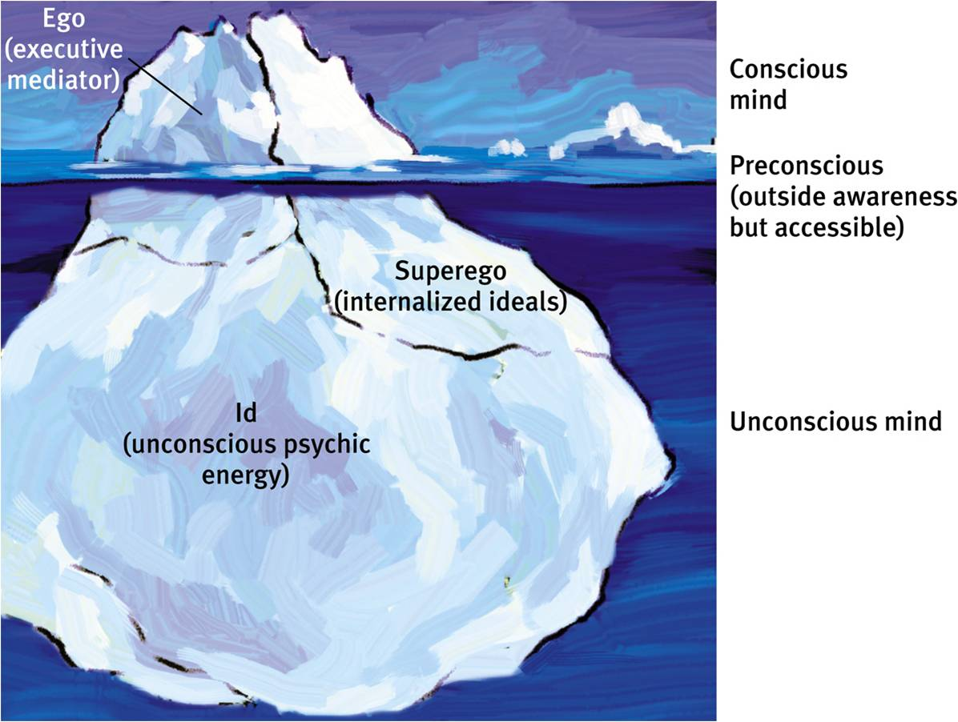

Freud believed that when we explain our own behavior to ourselves or others (conscious mental activity) we rarely give a true account of our motivation. This is not because we are deliberately lying. While human beings are great deceivers of others, they are even more adept at self-deception. Our rationalizations of our conduct are therefore disguising the real reasons. On the surface is consciousness, which consists of those thoughts that are the focus of our attention now, and this is seen as the tip of the iceberg. The preconscious consists of all which can be retrieved from memory. The conscious mind includes all the things we are aware of or can easily bring into awareness. This can happen through the process of repression. Freud emphasized the importance of the unconscious mind, and a primary assumption of Freudian theory is that the unconscious mind governs behavior to a greater degree than people suspect. Indeed, the goal of psychoanalysis is to make the unconscious conscious, and to get the feelings moving and expressing in their most natural way.

Then the students of Freud, Carl Gustav Jung, founded the theory of analytical psychology. Analytical psychology has a more general approach, compared with the Freudian psychoanalysis which assumes that the repressed material hidden in the unconscious is given by repressed sexual instincts. The unconscious, for Jungian analysts, may contain repressed sexual drives, but also aspirations, fears, etc. Jung proposes that the ultimate goal of the collective unconscious and self-realization is to pull us to the highest experience. He emphasizes the importance of the individual psyche and the personal quest for wholeness, embarked upon a deep, extensive process of self-analysis that he called “a confrontation with the unconscious” (Jung, 1961, chap. 6, pp. 170-99). As the carrier of the individual's consciousness, it is the task of the ego to become aware of its own limitations, to see its existence as only a small island though an essential one in the much greater ocean of the personal and collective unconscious.

And in ordinary human experience, the experience of being taken over by a complex is what we point to with language such as “I was beside myself” or “I don't know what got into me.” Jung saw the persona as a vital sector of the personality which provides the individual with a container, a protective covering for his or her inner self. A well-developed individual may have several personae appropriate to business and social situations. The problem comes not in having a persona but in identifying with persona to the ignorance of the person's inner motions, which occurred to Edmund, in his words: “They are as inexplicable to me as the emotions which rock my own heart. I do not let them appear on the surface but am terribly aware of them beneath. Sometimes, churned by a gale, the waters grow angry and the blue expanse turns black and white, tossing us remorselessly, the waves crashing with a sound as of breaking biscuits, the rain hissing as it obliterates all vision, and again I draw the parallel between the elements and the surprising violence I have discovered in myself.”

### 2.2 The New Edmund Carr with a Vengeance

As significant events take place below in the unconscious mind, in order to bring the hidden messages to consciousness, we need observe backwards to our sensation and accept all of the motions within. When Edmund turns his eyes back to the very bottom of his inner world, he finds his true self and feels alive. Acknowledging the upcoming death, Edmund decides to leave his jobs behind and follows the beautiful and intelligent Laura, whose qualities, intelligence and warmth stiffened by a deep reserve, have struck him as uncommon. It is the first time that he allows himself to follow the voice of his heart, to follow the deep wills. This is actually a milestone of the first step on his self-searching journey.

The indolence of the days at sea gives Edmund an unfamiliar peace and a profound change in perspectives and values. The release from work pressure; getting away from a hectic life in London; the lackadaisical rhythms of ship life; the shifting panorama of magnificent skies, sea, shores, islands, etc. and these combine to make him refresh. Edmund is no longer what he used to be, in his words: “no longer what people believed me to be, a middle-aged journalist taking a holiday on an ocean-going liner, but a liberated being, bathed in mythological waters, an Endymion young and strong, with a god for his father and a vision of the world inspired from Olympus. All weight is lifted from my limbs; 1 am one with the night; I understand the meaning of pantheism.”

Edmund has turned from a materialist to a mentalist. He releases the suppressed inclination which was always ignored. Now He feels quite amused as he watches his dramatic changes. Once he was completely absorbed in the political events of the world, hardly allowing himself a little rest by reading poetry or listening to music. At presence these world problems no longer interest but bore him. Once he firmly believed in uncompromising materialism which in his opinion represented the law of human progress, now he finds himself sentimental and sensitive.

In addition, he is able to appreciate the beauty of the nature. He is pleased by the breeze, the sky, the water, the fish and the bird; he is totally captured in the joy of watching the flashing green steak right after sunset, the moon lying on her back and the scattered stars. Once he believed in progress and felt reasonable about the damage of the beauty of nature, he now starts being concerned about the pollution problems—“the wireless told us today that there is fog all over England.” He has also learned to take care of others’ feeling, being friendly to the neighbors instead of taking advantage over others; he even gets along well with even his rival in love.

His affection to Laura is no more to possess her, for he has understood the unconditional love. He completely accepts who she really is. Furthermore, he has acknowledged his desire without regarding it as guilty or shame. So he no longer feels awkward when he thinks about Laura. He imagines over the recesses of Laura's character, enjoying the fantasy of the eternal youth of the Moon and Endymion, and their abilities of giving birth to babies; he imagines about the fisherman whose wife is waiting him home, and in their small cottage, there is nothing but health and love. Edmund at last understand the essence of love, and he does love Laura, body and soul. Now Edmund is no longer a self-centered odd fish--Considering that Laura likes the Colonel, Edmund does not resent when the man expressed his admiration to Laura. When the Colonel talks about public affairs, Edmund does not tease him by saying the views which would make the Colonel puzzled. Moreover, he no longer judges others with prejudice, in contract he is capable of finding that there is a trace of poetic quality in the Colonel’s character, so that Edmund sincerely expresses the appreciation towards his enemy in love.

*This is the unexpected kind of remark that makes me like the Colonel; there is a touch of rough poetry about him. I like also the out-of-the-way information which he imparts from time to time without insistence. He has traveled much, and has used his eyes and kept his ears open. I have discovered also that he knows quite a lot about sea-birds; he puts me right about the different sorts of gull, and tells me very nicely that that couldn't possibly be an albatross, not in these waters.*

There was a time when he suspected people with contempt and scorn, laughing at their unselfish motive. Now he completely learns what great love is—it is pure, sincere and unconditional and has no boundary. In short, Edmund has been able to be in contact with his internal self. He entirely accepts the reality of his human nature as well as the upcoming death, which help him releases all the confusions and sorrows so that the hurts can be ultimately healed. In the end, Edmund gets back his real personality and obtains the eternal inner peace.

## 3.Conclusion

In *No Signposts in the Sea*, the author shares the same setting with the hero— on voyage and dying. Undoubtedly, this novel reflects the author's life experience and her feminist thoughts. In the era of Vita Sackville-West’s (the 1920s), women’s voices were marginalized by the male-dominated society. Women were required to be obedient, not allowed to announce their opinions. In this situation they longed to declare themselves and to get rid of the discrimination and oppression of the patriarchy. Such new feminism thoughts are shown in *No Signposts in the Sea*, especially in the descriptions of the characters’ internal activities and their interpersonal relationships.

In the beginning of the novel, Edmund was confused for his distorted emotions and was losing control. The reason is that the detachment between his feminine personality (sentimental and sensitive) and the social expectation (to be ambitious and emotionally suppressed) made him feel himself abnormal, which led to his self-contempt. During the days on board, the gentleness and kindness of Laura changed Edmund. He started to get in touch with his deeper emotion, which offers self-perception to him. The femininity in Laura’s character helps the hero call out his suppressed feelings and gain a deeper insight into his own nature. This provided him a healthier mental condition and reduced his sense of distortion. With the guidance of women, the materialist at last becomes a moralist. In a word, women are not just household wives or the tools of delivering babies but play significant roles in male’s growth to ripeness. Last but not least, in such give-and-take relationships, each gender can learn to respect the otherness and make up the absent part in their partners’ character.

Males and females are born equal. with the tongue of Edmund Carr, the author criticizes the discrimination and oppression of the patriarchy and proposes that both of the two genders are supposed to keep their hearts open and express their feelings to each other. On the one hand we women should strengthen our inner power, dare declare ourselves and unchain ourselves from the prejudices of the patriarchy; we should be spiritually independent and bravely voice our demands for equal social status, especially for equal position in certain relationships. On the other hand men are likewise oppressed by patriarchy. They are brought up suppressing their emotions, which lead to their tendency of mood disorder. In new feminist view, men do not have to be too ambitious and competitive as the society expects them to be; they can also live their lives more enjoyably such like listening to music and reading poetry rather than struggle for material achievement. Men do not have to be that strong and unmoved, they can also be sentimental and sensitive; in fact they will be completely accepted if their sorrows, weakness and tenderness could be unaffectedly expressed. New feminism proposes the creed of gender equality, aiming at clearing up the misunderstanding between males and females instead of one gender being superior to the other one.

All in all, by analyzing the behaviors and internal activities of Edmund Carr, we can have a better understanding of *No Signposts in the Sea,* which is a mirror of Vita Sackville-West’s life. By studying it, we can not only learn more about the new feminist thoughts but also understand the author better. Moreover, we are capable of obtaining a deeper insight into our internal personalities and strengthening our sense of self-perception.

## References

1. Freud, Sigmund. Group Psychology and the Analysis of the Ego. Vienna: International Psychoanalytic Publishing House, 1921.
2. Jung, C.G. The Collected Works of C.G. Jung. Princeton: Princeton University Press, 1979.
3. 简丽丽.弗吉尼亚•伍尔夫的“双性同体观”[J]. 文学教育(中), 2011(09).
4. 孙立恒.爱的遗言:性别研究视角下的《海上无路标》[J]. 外国文学, 2012(02): 142-148.
5. 王昌玲, 韦虹. 超越两性二元对立——《海上无航标》的女性主义解读[J]. 天津外国语大学学报, 2012(03): 68-70.
6. 王旭霞. 生态批评视域下的《海上无路标》解读[J]. 长江大学学报(社会科学版), 2012(05): 27-29.
7. 王昌玲.《海上无航标》的多重剥夺主题——生态女性主义视角[J]. 西安外国语大学学报, 2014(01).
8. 黎清群. 孤寂•焦虑•迷茫:主人公卡尔的心灵之旅——《海上无航标》的叙事意蕴分析[J]. 中北大学学报(社会科学版), 2015(03).

**作者简介：**李舒羽（1995.04——），女，云南昆明人，昆明市呈贡区云南师范大学英语口译专业研究生