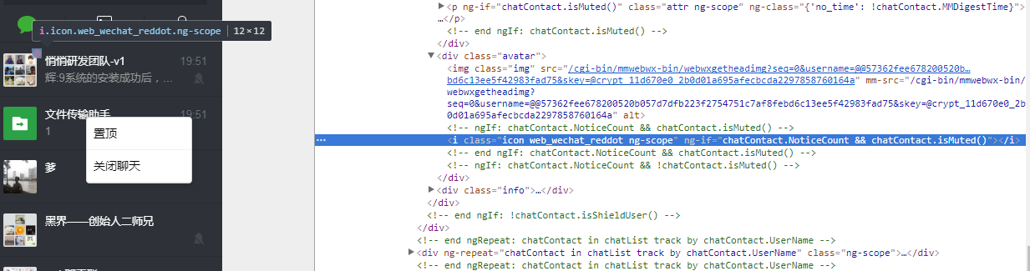

1.web_wechat_reddot

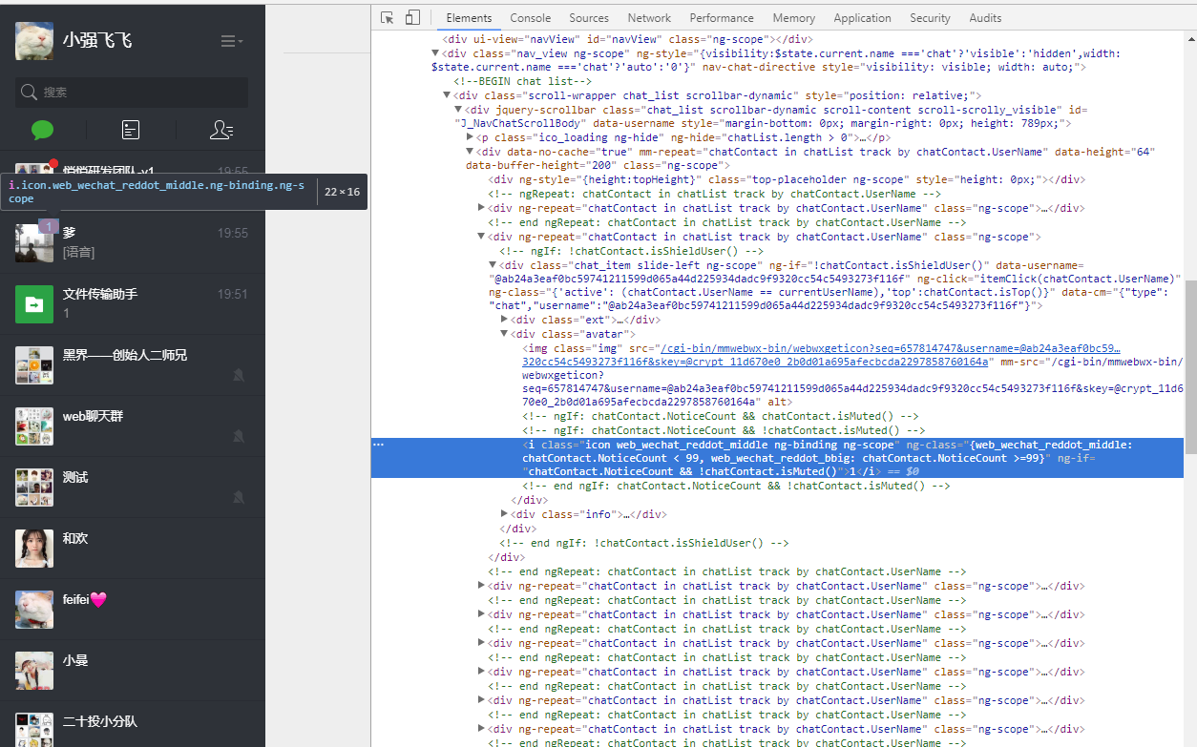

1. web_wechat_reddot_middle

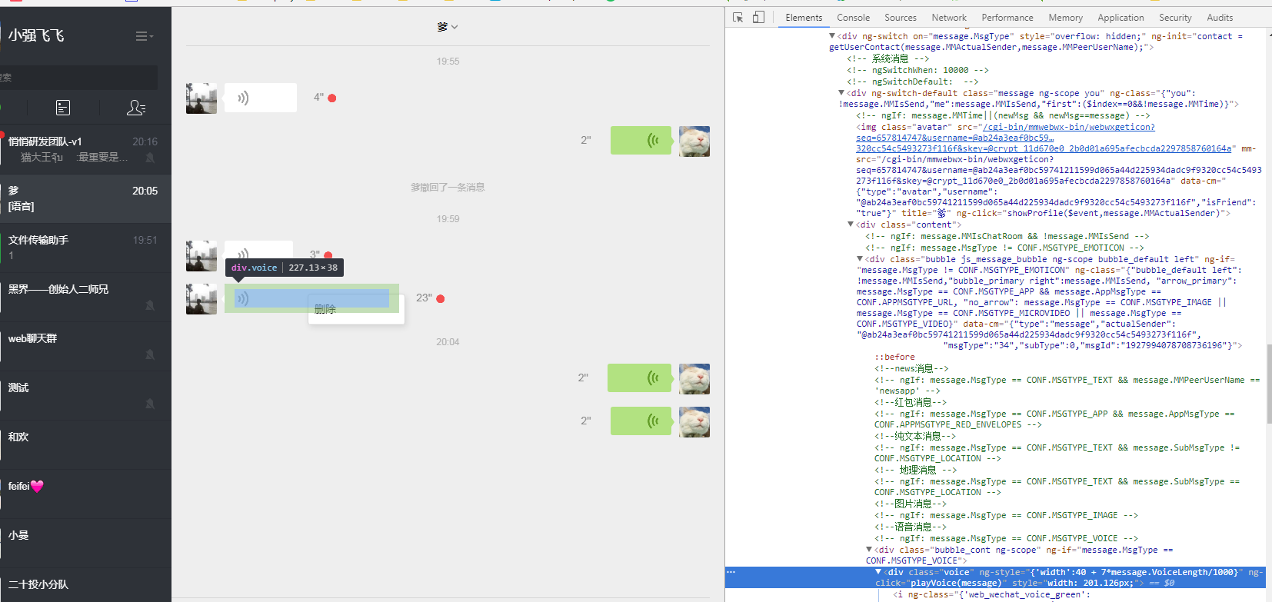

1. Voice

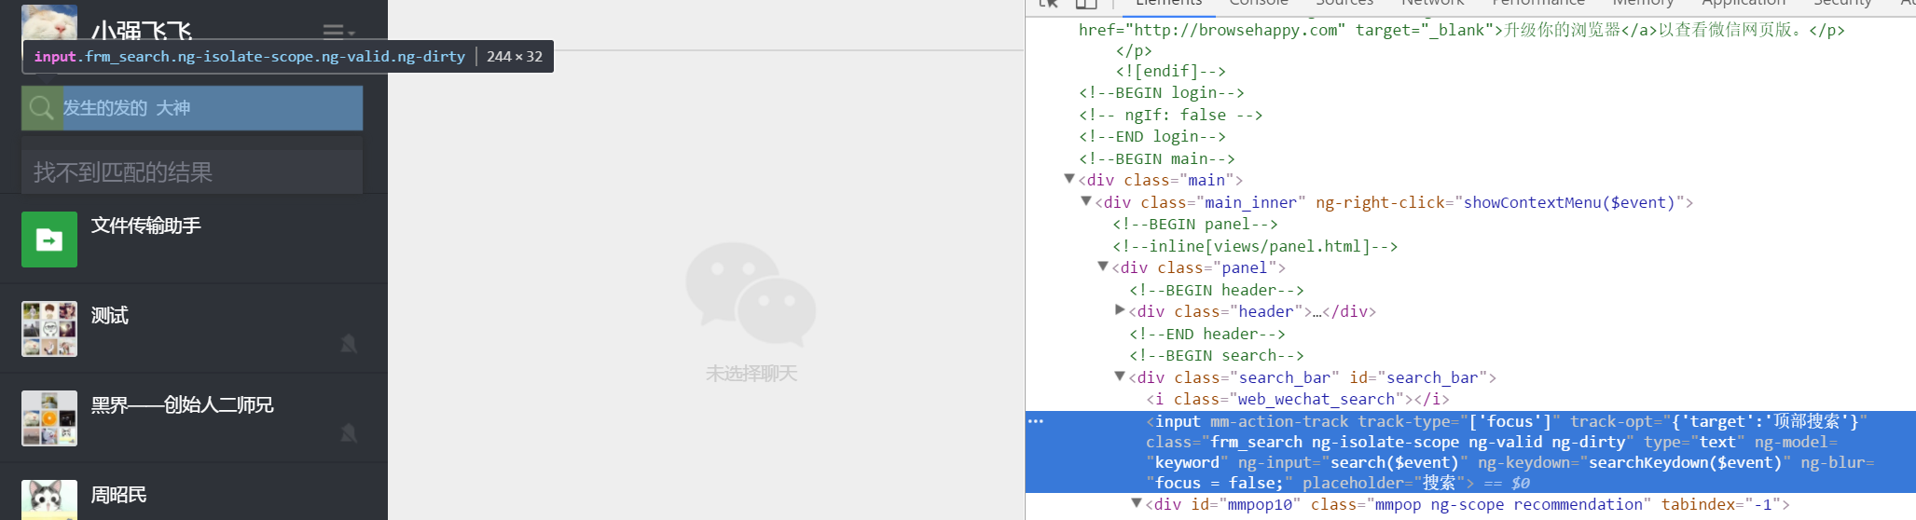4. .frm_search

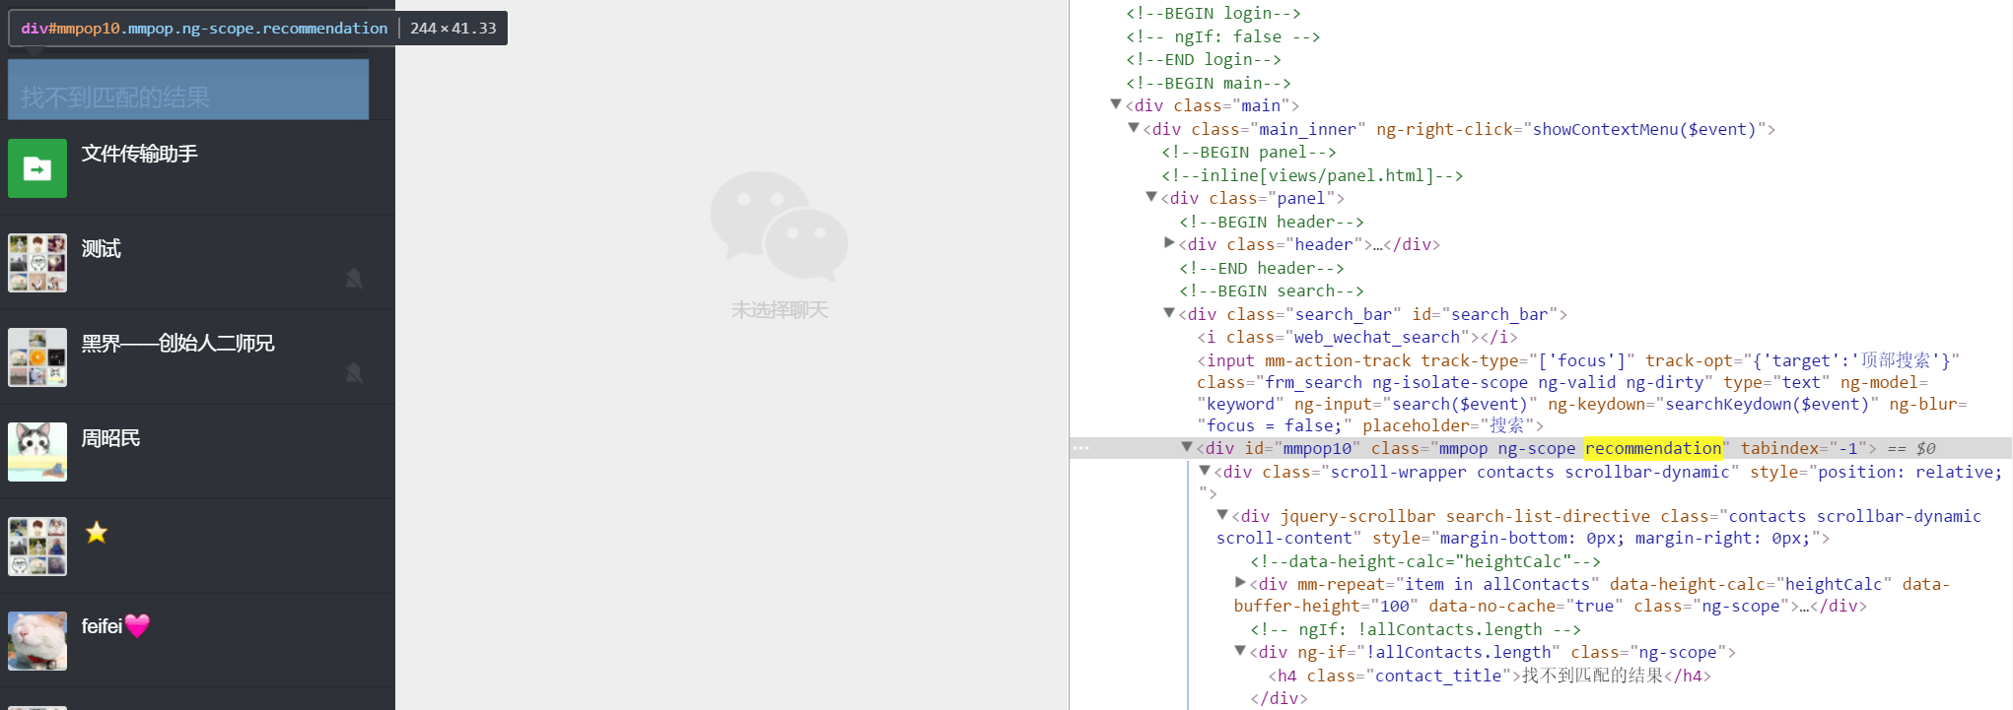  
5.搜索结果框：.recommendation

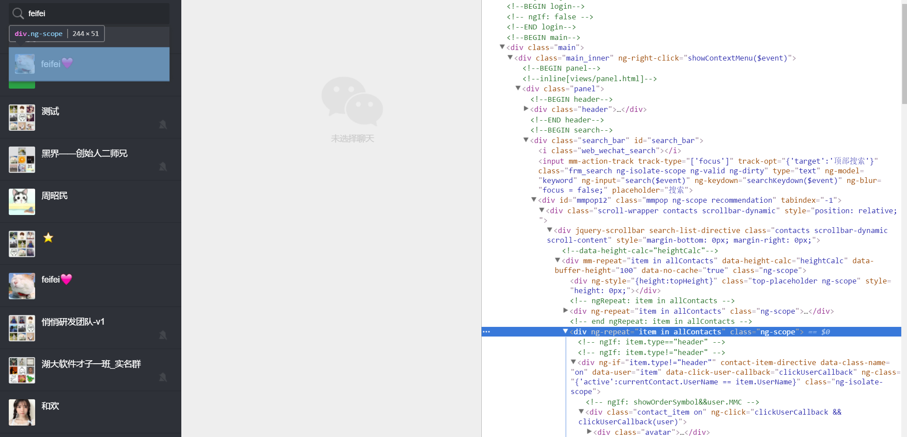

1. 搜索结果集: .recommendation .contact_item.on'’

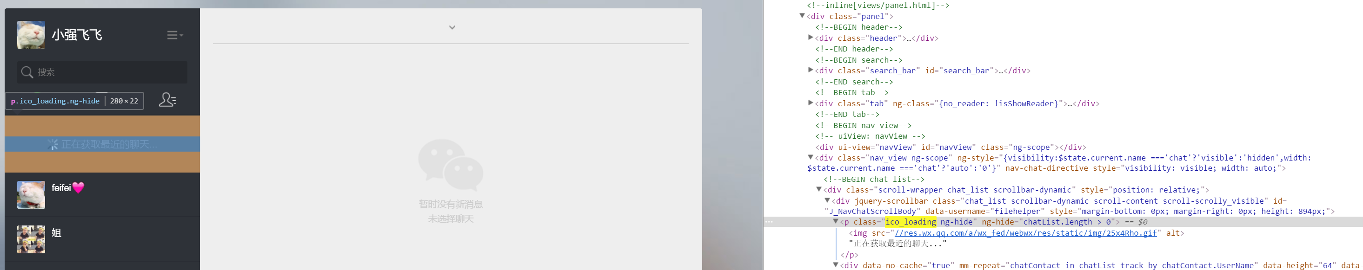

.chat_list .chat_list .ico_loading

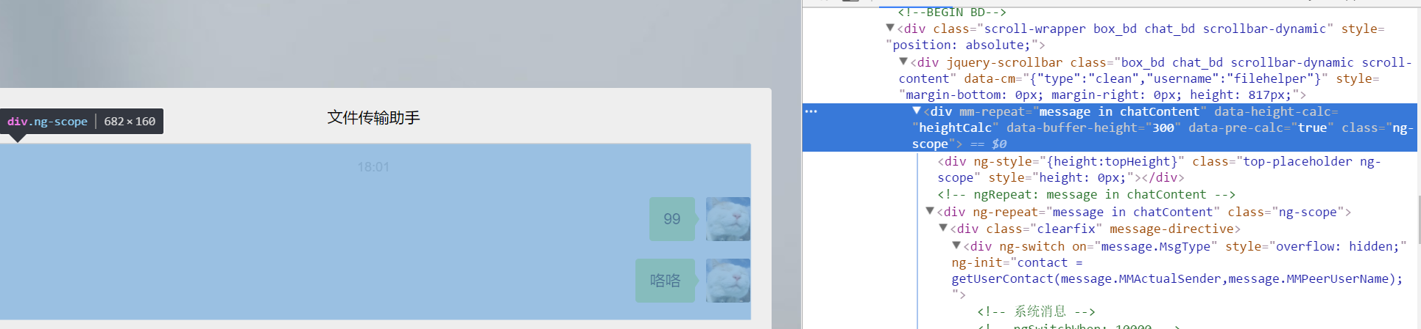

1. [mm-repeat]="message in chatContent"

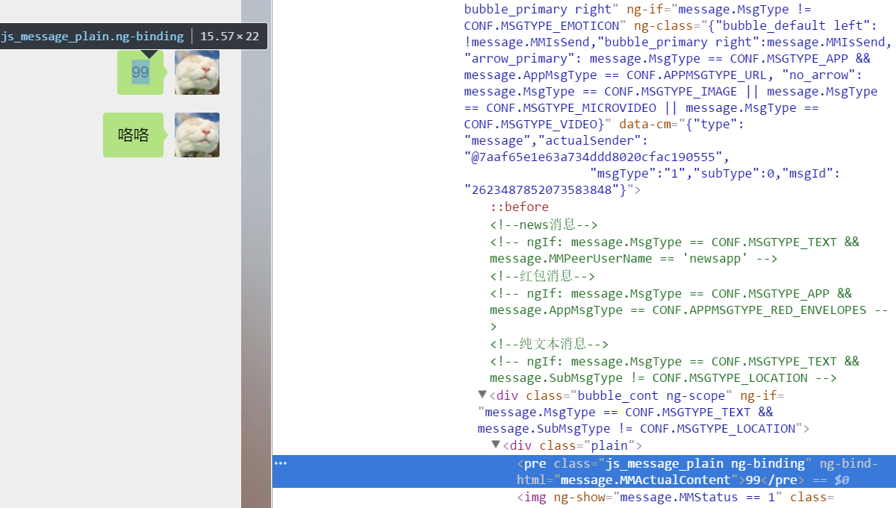  
8 . .you .js_message_plain  
  
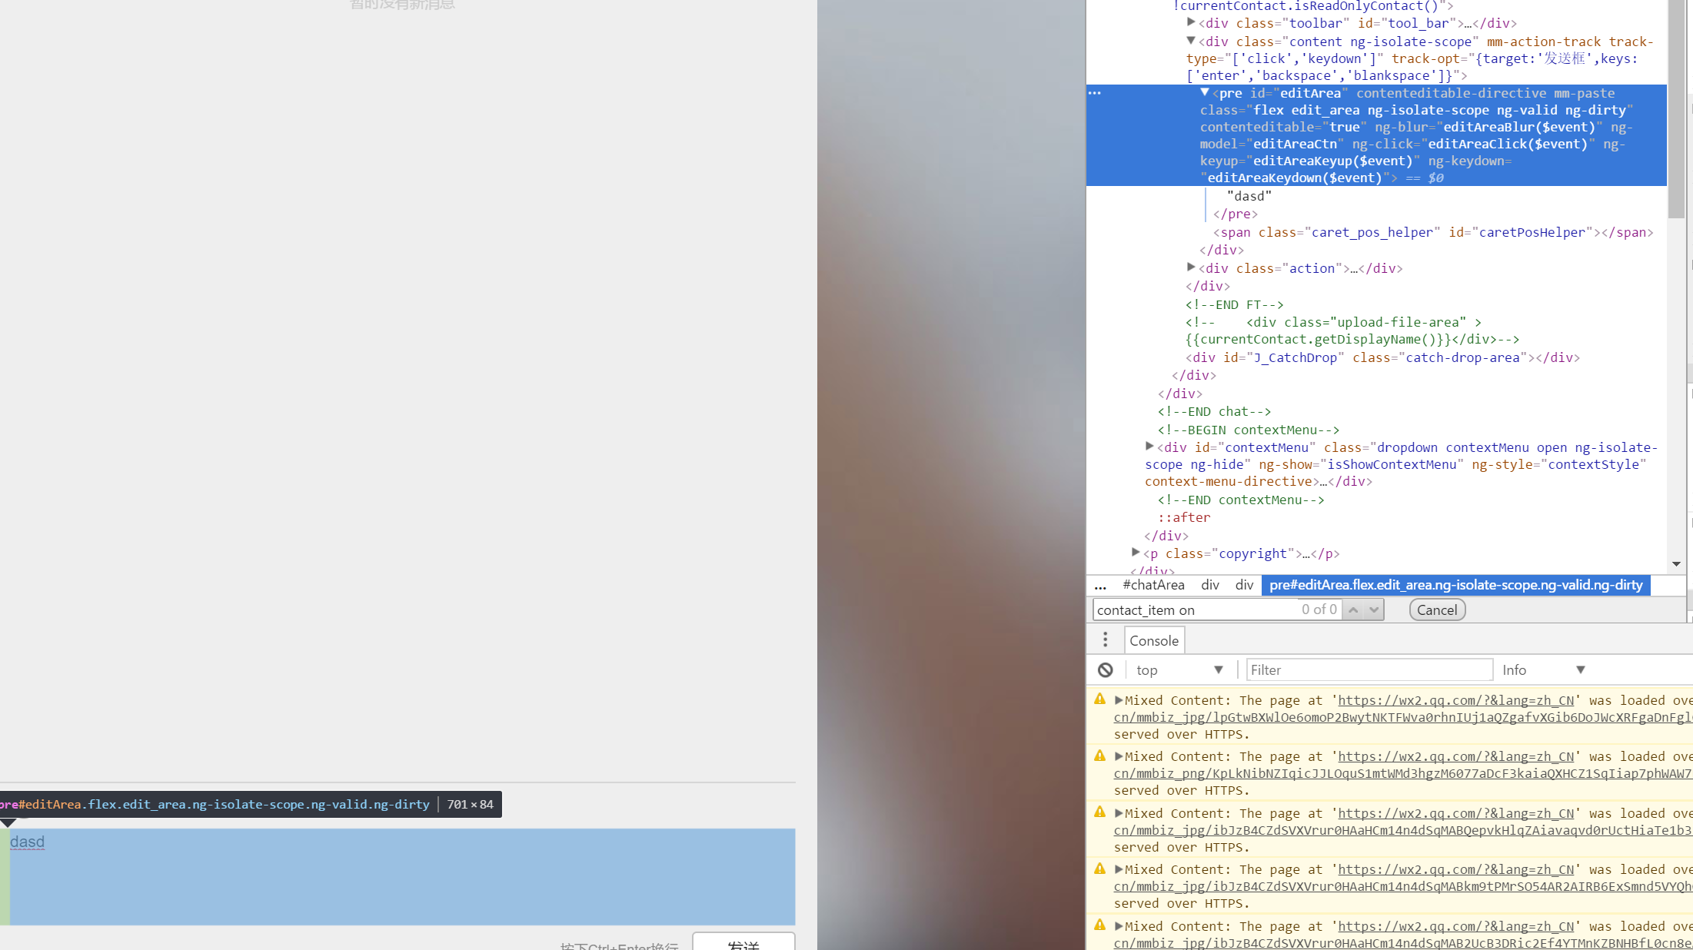

#editArea