**Terna Engineering College**

**Computer Engineering Department**

**Program: Sem V**

**Course: Web Technology Laboratory (CSL504)**

**Faculty: Nayana Vaity**

LAB Manual

PART A

(PART A : TO BE REFFERED BY STUDENTS)

**Experiment No.06**

**A.1 Aim:**

Design your mark sheet using Extensible Mark-up Language (XML) and Extensible style sheet language (XSL).

**A.2 Prerequisite:**

1. Knowledge of World Wide Web (WWW)

2. Knowledge of core concepts of web technology.

3. Knowledge of XML and XSL.

**A.3 Outcome:**

**After successful completion of this experiment students will be able to**

* Design static web page using XML and XSL.
* Understand concepts of web page and web browser.

**A.4 Theory:**

* **XML:**

· stands for Extensible Markup Language

· is a markup language much like HTML

· designed to describe data, not to display data

· tags are not predefined. You must define your own tags

· designed to be self-descriptive

* **XML and HTML:**

XML is not a replacement for HTML.

* XML and HTML were designed with different goals:
* XML was designed to describe data, with focus on what data is
* HTML was designed to display data, with focus on how data looks
* HTML is about displaying information, while XML is about carrying information.

XML documents form a tree structure that starts at "the root" and branches to "the leaves".

* **XML Syntax Rules are:**
* All XML elements must have a closing tag.
* Tags are case sensitive
* Elements must be properly nested
* Documents must have a root element
* Attributes values must be quoted.
* Xml document should be well formed
* **XML Naming Rules:**
* Names can contain letters, numbers, and other characters
* Names cannot start with a number or punctuation character
* Names cannot start with the letters xml (or XML, or Xml, etc)
* Names cannot contain spaces
* Any name can be used, no words are reserved.
* **Display XML Data**
* **HTML Page:**

The XMLHttpRequest object is used to exchange data with a server

The XMLHttpRequest object is:

* Update a web page without reloading the page
* Request data from a server after the page has loaded
* Receive data from a server after the page has loaded
* Send data to a server in the background

**Syntax**: for creating an XMLHttpRequest object:

xmlhttp=new XMLHttpRequest();

HTML web page used this object with script to exchange data.

* **XPATH and XSLT (XML Technology):**

**XPATH:**

* is a syntax for defining parts of an XML document
* uses path expressions to navigate in XML documents
* contains a library of standard functions
* is a major element in XSLT
* Uses path expressions to select nodes or node-sets in an XML document.

**XSLT:**

* With XSLT you can transform an XML document into HTML.
* XSLT (extensible Style sheet Language Transformations) is the recommended style sheet language for XML.
* XSLT is far more sophisticated than CSS. With XSLT you can add/remove elements and attributes to or from the output file. You can also rearrange and sort elements, perform tests and make decisions about which elements to hide and display, and a lot more.
* XSLT uses XPath to find information in an XML document.
* Reference of XSL need to specify in XML file to retrieve XML data.

**Example:**<?xml-stylesheet type="text/xsl" href="simple.xsl" ?>

**Example: mark sheet designing using XML.**

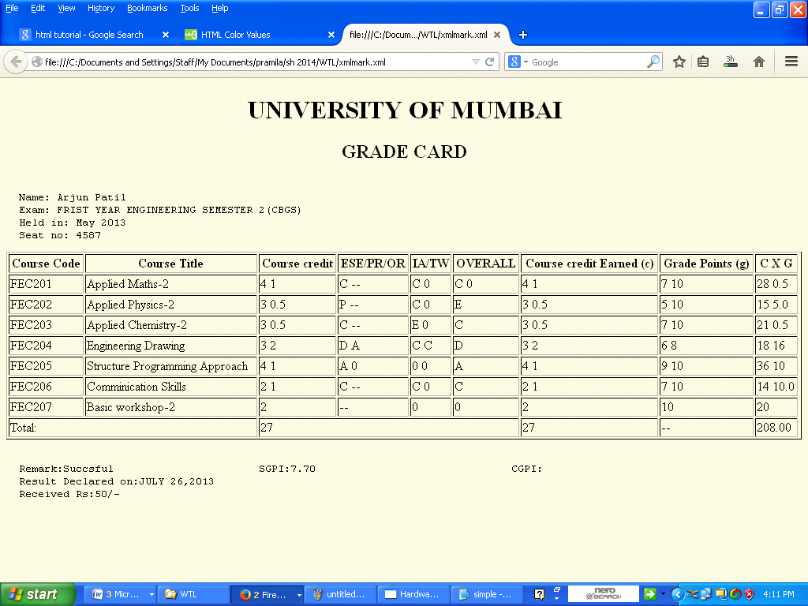

**Example Source Code:**

**Marksheet.xml**

<?xml version="1.0" encoding="UTF-8"?>

<?xml-stylesheet type="text/xsl" href="simple.xsl" ?>

<GRADE_CARD>

<grade>

<Name>Arjun Patil</Name>

<Examination>FRIST YEAR ENGINEERING SEMESTER 2(CBGS)</Examination>

<Held_in>May 2013</Held_in>

<Seat_no>4587</Seat_no>

<Course>

<Code>FEC201</Code><Title>Applied Maths-2</Title><c_Credit>4 1</c_Credit>

<PR_OR>C --</PR_OR><TW>C 0</TW><Overall>C 0</Overall><Gp>7 10</Gp><c>4 1</c><cxg>28 0.5</cxg>

</Course>

**Simple.xsl**

<?xml version="1.0" encoding="ISO-8859-1"?>

<xsl:stylesheet version="1.0" xmlns:xsl="http://www.w3.org/1999/XSL/Transform">

<xsl:template match="/">

<html>

<body bgcolor="#F5F5DC">

<center><h1>UNIVERSITY OF MUMBAI</h1></center>

<center><h2>GRADE CARD</h2></center>

<pre>

<xsl:for-each select="GRADE_CARD/grade">

Name: <xsl:value-of select="Name"/>

Exam: <xsl:value-of select="Examination"/>

Held in: <xsl:value-of select="Held_in"/>

Seat no: <xsl:value-of select="Seat_no"/>

</xsl:for-each>

**PART B**

(PART B : TO BE COMPLETED BY STUDENTS)

***(Students must submit the soft copy as per following segments within two hours of the practical. The soft copy must be uploaded on the Blackboard or emailed to the concerned lab in charge faculties at the end of the practical in case the there is no Black board access available)***

|  |  |
| --- | --- |
| Roll No. 18 | Name: Shreyas Patil |
| Class : C | Batch : C1 |
| Date of Experiment: | Date of Submission |
| Grade : |  |

|  |  |
| --- | --- |
| **B.1** | **Web page Snapshot:** |
|  |  |
|  |  |
| **B.2.** | **Web page source code:** |
|  | **Xml code:**  <?xml version="1.0" encoding="UTF-8"?>  <?xml-stylesheet type="text/xsl" href="marksheet.xsl"?>  <Marksheet>  <Subject>  <SubjectCode>CSC 301</SubjectCode>  <SubjectName>APPLIED MATHS III</SubjectName>  <Theory>60</Theory>  <TW>22</TW>  <PracticalAndOral>20</PracticalAndOral>  <Total>102</Total>  </Subject>  <Subject>  <SubjectCode>CSC 302</SubjectCode>  <SubjectName>DLDA</SubjectName>  <Theory>60</Theory>  <TW>22</TW>  <PracticalAndOral>20</PracticalAndOral>  <Total>102</Total>  </Subject>  <Subject>  <SubjectCode>CSC 303</SubjectCode>  <SubjectName>ECCF</SubjectName>  <Theory>60</Theory>  <TW>22</TW>  <PracticalAndOral>20</PracticalAndOral>  <Total>102</Total>  </Subject>  <Subject>  <SubjectCode>CSC 304</SubjectCode>  <SubjectName>DS</SubjectName>  <Theory>60</Theory>  <TW>22</TW>  <PracticalAndOral>20</PracticalAndOral>  <Total>102</Total>  </Subject>  <TotalMarks>  <Marks>408</Marks>  </TotalMarks>  </Marksheet>  **Xsl code:**  <?xml version="1.0" encoding="UTF-8"?>  <xsl:stylesheet version="1.0" xmlns:xsl="http://www.w3.org/1999/XSL/Transform">  <xsl:template match="/">  <html>  <body>  <table border="1" width="100%">  <tr>  <td colspan="6"><h1><center> Mumbai University</center></h1></td>  </tr>    <tr><td colspan="6"><h4> Name:David B<br /> Examination:SECOND YEAR COMPUTER ENGINEERING SEM III[CHOICE BASED]<br />Roll No:1<br /> Exam Seat No:31019060</h4></td>  </tr>  <tr>  <th> SubjectCode</th>  <th> SubjectName</th>  <th> Theory</th>  <th> TW</th>  <th> PracticalAndOral</th>  <th> Total</th>  </tr>  <xsl:for-each select="Marksheet/Subject">  <tr>  <td><xsl:value-of select="SubjectCode"/></td>  <td><xsl:value-of select="SubjectName"/></td>  <td><xsl:value-of select="Theory"/></td>  <td><xsl:value-of select="TW"/></td>  <td><xsl:value-of select="PracticalAndOral"/></td>  <td><xsl:value-of select="Total"/></td>  </tr>  </xsl:for-each>  <tr>  <td colspan="5">Total</td>  <xsl:for-each select="Marksheet/TotalMarks">  <td><xsl:value-of select="Marks"/></td>  </xsl:for-each>  </tr>  </table>  </body>  </html>  </xsl:template>  </xsl:stylesheet> |
|  |  |
| **B.3** | **Question of Curiosity:**  1.What are the features of XML?  Ans:   * Excellent for handling data with a complex structure or atypical data • Data described using markup language * Text data description * Human- and computer-friendly format * Handles data in a tree structure having one-and only one-root element * Excellent for long-term data storage and data reusability   2.Differentiate between XML and HTML.  Ans:  HTML was designed for data display to focus the data look while XML was designed for storing and transporting data. HTML is used for displaying web pages while XML does not used for displaying web pages. HTML was invented in 1990 while XML was invented in 1996. HTML is static type while MXL is dynamic type. In XML author can create custom tags but in HTML custom tags are predefined. XML can preserve white spaces while XML can’t preserve white spaces. HTML is presentation type language while XML is neither a presentation type language not programming type. HTML don’t have strict rules of processing while XML has to follow strict rule otherwise processing file will be terminated.  3.Explain XSL in detail.  Ans:  XSL is a language for expressing style sheets. An XSL style sheet is, like with CSS, a file that describes how to display an XML document of a given type. XSL shares the functionality and is compatible with CSS2 (although it uses a different syntax). It also adds:   * A transformation language for XML documents: XSLT. Originally intended to perform complex styling operations, like the generation of tables of contents and indexes, it is now used as a general-purpose XML processing language. XSLT is thus widely used for purposes other than XSL, like generating HTML web pages from XML data. * Advanced styling features, expressed by an XML document type which defines a set of elements called Formatting Objects, and attributes (in part borrowed from CSS2 properties and adding more complex ones. |
|  |  |
| **B.4** | **Conclusion:**  **(**Write appropriate conclusion.)  Using Extensible Mark-up Language (XML) and Extensible style sheet language (XSL) marksheet has been created. |