When a .net application runs, four sections of memory (heaps) are created to be used for starage :

1. The Code heap – stores the actual native code instructions after they have been JustIn Time compiled (JITed)
2. Small Object Heap (SOH) stores allocated objects that are less than 85K in size.
3. Large Object Heap (LOH) stores allocated objects greater than 85 K, some exceptions
4. Process Heap

Everything on Heap > has an address.

* To keep track of everything, .net maintains a stack data structure, which it uses to track the state of an execution thread and all the method calls made.

Stack -> used to keep track of a method’s data from every other method call.

When a method is called, the .net creates a container (a stack frame) that contains all of the data necessary to complete the call.

Primitive Data Type (CTS)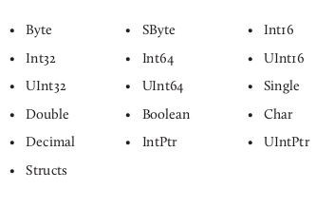

* When an instance of the object is created, only an object reference is stored on the stack. Actual instance is located on the heap, and its address is held on the stack.