**Differences >**

1. % operator in C# -> // (double slash here)

Basics >

Guido van Rossum – Python creator

To use the imaginary number use the module – cmath

Python’s Implementation -> CPython

**Frozen Binaries –** These bundle together the byte code of your program files, along with the PVM and any python support files that your program may need.

Unix Script - > #!path_to_python_interpreter

**Importing Modules**

Using the keywords – from, import and reload

*If a module is imported, it gets executed first*

dir function to get list of available attributes of a filein python.

**To Run**

Can Us exec(open(code.py).read())

If u want to use py file from another path, use PYTHONPATH setting

**Frozen Binary Executables**

**Built in Object Types**

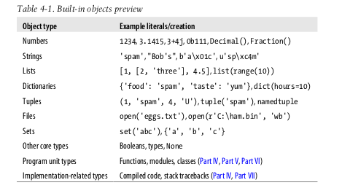

**Python has imaginary numbers**

**In Python we can also index backward – negative indexes count from the left**

* **Strings are immutatble :** Can not change the string character value .

**e.**g S =’spam’; s[0]= ‘z’ (will throw an error)