Lab 1 report

Summary
The final model is a logistic stack over four models. On the full official test (17,623 posts) it scores macro-F1 0.6683, QWK 0.6134 and accuracy 0.7070. The official baseline scores 0.5410, so the gain is +12.7 pp. The 0.70 target was not reached.
In a grouped ablation on a separate CatBoost model without native text, removing author-history features costs 12–14 pp and removing post-structure features costs 2–3 pp. The weakest class is below, with F1 0.55.

Data and validation
Train has 71,395 labelled posts from 3,295 authors. Test has 17,623 posts from 824 other authors. Classes split 20 / 60 / 20 (below / typical / above).
- Validation uses train authors only. Two author-disjoint splits (seeds 42 and 137) each have a fitting part, a calibration part for the stack and class weights, and a scoring part.
- A change was kept only if it helped on both splits. The final recipe was also checked with three-fold author cross-validation.
- Features use only strictly earlier posts of the author. Current-post reactions, labels and IDs never enter the model.
- Post age at crawl time (age_days) is used. Reactions are a crawl-time snapshot, so older posts had more time to collect them. Removing the whole crawl-time group changes dev macro-F1 by only 0.2–0.4 pp.
- Text and images were encoded locally. No dataset content was sent to external services.

Method
Four models each predict the three class probabilities. A logistic regression (C = 0.1) combines their log-odds with the author's level, history size, spread and the reshare flag. Class decision multipliers are then tuned on calibration authors to maximise macro-F1, since otherwise the model leans towards typical (60% of posts).
Component | What it adds | Dev macro-F1, seed 42 / 137
CatBoost | Post structure (type, length, hashtags, mentions, links, attachments), posting time, author history aggregates, post text as a native text feature, CLIP image features | 0.663 / 0.659
E5-base MLP | Frozen multilingual-e5-base vectors of the post and its context, similarity to the author's earlier posts, metadata | 0.668 / 0.660
History model | Current post text, context and metadata, plus text vectors and outcomes of up to 20 earlier posts by the same author | 0.668 / 0.673
Outcome-share MLP | Current text and context vectors, tabular and visual features, plus nine shares: how many of the author's earlier posts would fall below or above the cutoffs relative to the author's current level, or got zero reactions, over the last 5, last 20 and all posts | 0.667 / 0.666
Stack of the four |  | 0.686 / 0.685
The outcome shares describe how stable an author is. The median gives the usual level; the shares show how often the author lands far from it.

What else I tried
None of these improved the stack on both dev splits, so all were dropped.
Approach | Change in stack dev macro-F1, seed 42 / 137
Fine-tuning all 12 Transformer layers of E5-small, token embeddings frozen | +0.12 / −0.28 pp
Residual correction on frozen text | +0.07 / −0.26 pp
Count-model prior for authors with few reactions | −0.10 / −0.06 pp
Text graph as a fifth stack component | −0.26 / −0.20 pp
Averaging several initialisations | about −0.18 / −0.13 pp
Meta-model trained on full out-of-fold predictions | +0.03 / −0.32 pp
The fine-tuned text branch improved on its own (0.656 → 0.662), but the stack gained nothing stable. Its predictions correlate strongly with the frozen E5-base branch, which suggests the two overlap. A graph of mentions between authors could not be built: other people are pseudonymised per author (PERSON_k), so cross-author links cannot be recovered. An organisation graph improved one branch by about 0.2 pp in CV but not the full stack.

Results
Full official test | Macro-F1 | QWK | Accuracy
Official baseline | 0.5410 | 0.4576 | 0.5465
My stack | 0.6683 | 0.6134 | 0.7070
Dev macro-F1 was 0.686 / 0.685 and three-fold author CV gave 0.676. The dev splits and CV folds were reused in many experiments, so dev and CV scores may be optimistic.
True \ predicted | below | typical | above | F1
below (3,541) | 1,861 | 1,649 | 31 | 0.551
typical (10,491) | 1,314 | 8,114 | 1,063 | 0.761
above (3,591) | 42 | 1,065 | 2,484 | 0.693
The model almost never mixes up below and above: 73 of 7,132 such posts. Most errors are between typical and either extreme class. Below is the hardest class, and almost half of below posts are predicted as typical.

Why it works: grouped ablation
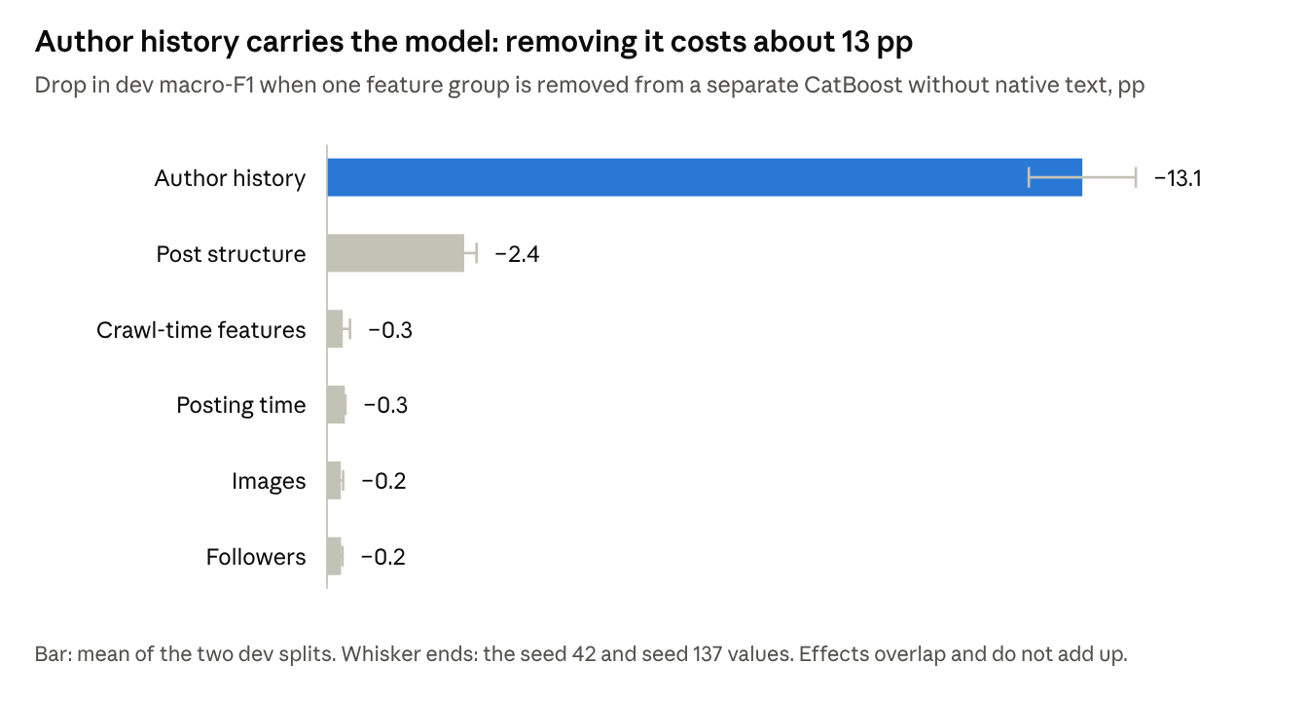
lab1_submission/analysis.json · grouped ablation, dev splits seed 42 and 137
Each bar removes one feature group from a separate CatBoost model without native text, not the final stack, and refits the decision multipliers. Effects overlap and do not add up. Post structure is the only other group worth more than 0.5 pp.

