Endrit Huruglica  
 Mail:endrithuruglica@gmail.com  
 Phone number: +38345370145  
 Addres: Gjilan/Kosovo  
   
 -------------------------------------------------------------------------------------  
   
 Experience  
 Fluidi Company – 15.01.2020- 15.02.2020  
 Practice  
 Natura Company 01.07.2019- 15.07.2019  
 Practice  
   
 Milk Company KABI 20.06.2018- 20.07.2018  
 Practice  
  
 -----------------------------------------------------------------------------------------  
 Education  
  
 University of Tetovo  
   
 Food Technology Engineer  
   
 BACHELOR

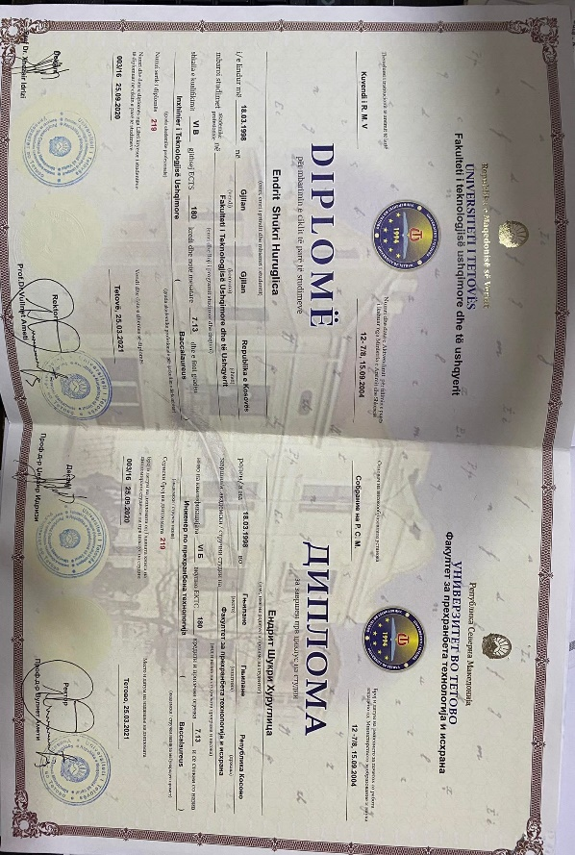  
 Skills  
 -------------------------------------------------------------  
 English Language B1 German Language A1