EMPIRICAL COMPARISON OF LEARNING ALGORITHMS FOR BREAST CANCER DIAGNOSIS

Problem P1 — Breast Cancer Wisconsin (Diagnostic)
Course: CPE 513 — Artificial Neural Network
Group: Group 1
Group members:
• Abah Emmanuel Enemaku (2021/1/79515CP)
• Agbana Boluwatife Odunayo (2021/1/79727CP)
• Abbas Adamu (2021/1/79612CP)
• Abdulhamid Taofeek Opeyemi (2021/1/79530CP)
• Abduljelil Musa (2021/1/81454CP)
• Abdulsalam Abdulkadir (2021/1/79556CP)
• Abubakar Rayyanu Ango (2021/1/82351CP)
• Adamu Mohammed (2021/1/80362CP)
• Adamu Okpanachi Hayatuddeen (2022/2/88071CP)
• Adewuyi Oluwaseyi David (2021/1/81631CP)
Department: Computer Engineering
Institution: Federal University of Technology, Minna
Dataset: UCI Breast Cancer Wisconsin (Diagnostic), dataset 17; file: wdbc.data
Dataset DOI: 10.24432/C5DW2B
Date: 18 September 2026
Repository: github.com/Enemaku/cpe513_breast_cancer_comparison

Abstract
Classifying breast masses from fine-needle aspirate measurements is a small-sample diagnostic support task where false negatives carry real clinical weight. We compared four common algorithm families — Logistic Regression, k-nearest neighbours, Random Forest and RBF SVM — on the UCI Breast Cancer Wisconsin (Diagnostic) dataset of 569 cases and 30 numeric predictors. Every model saw the same repeated stratified 5-fold cross-validation protocol with three repeats, nested 3-fold tuning, and an identical six-configuration search budget. Under this controlled comparison, RBF SVM produced the strongest operating-point numbers: 97.38 ± 1.42% balanced accuracy, 99.58 ± 0.54% ROC-AUC and 98.28 ± 2.57% sensitivity at 95% specificity. Logistic Regression was essentially tied in balanced accuracy (97.19 ± 1.43%; Holm-adjusted paired p = 1.00), while the two top models clearly outperformed Random Forest and k-NN. The ablation was stark: removing fold-wise scaling cost SVM 6.56 percentage points and k-NN 4.04 points. For screening support we would provisionally deploy the SVM at a malignancy-probability threshold near 0.291, but only after external clinical validation.

Keywords
breast cancer diagnosis; repeated cross-validation; support vector machine; logistic regression; random forest; k-nearest neighbours; ROC-AUC; model comparison

Introduction
The decision supported by this model is whether a breast mass sampled by fine-needle aspiration should be classified as malignant or benign from quantitative characteristics of cell nuclei. The output is best viewed as diagnostic decision support for a clinician rather than an autonomous clinical decision. In this study malignant disease is the positive class, so the main practical concern is preserving sensitivity while constraining false-positive referrals.
Formally, the input is x in R^30 and the target y is binary (malignant = 1, benign = 0). The comparison question is: under identical outer folds, preprocessing, tuning budget and metric definitions, are differences in balanced accuracy among Logistic Regression, k-NN, Random Forest and RBF SVM larger than fold-to-fold variation, and what sensitivity is available when specificity is constrained to approximately 95%?
The anchor study by Aamir et al. [2] compared Random Forest, Gradient Boosting, SVM, an artificial neural network and a multilayer perceptron on WDBC after correlation-based feature elimination and recursive feature elimination reduced the representation to 11 attributes. Their best reported 80:20 result was 99.12% accuracy for the MLP; Random Forest and SVM were reported at 98.07% and 97.76%, respectively. The study also describes a 5-fold framework, but the feature-selection procedure, use of several split ratios and emphasis on accuracy make the headline numbers different in protocol from the present experiment.
The contribution here is not a new classifier. It is a protocol-controlled comparison using the same 30-feature representation for every algorithm, preprocessing fitted only within folds, an equal six-configuration tuning budget per model, repeated paired outer folds, multiple clinically relevant metrics, a paired statistical comparison, timing, calibration and an explicit scaling ablation.

Related work
Recent WDBC studies typically report high scores, but their conclusions are difficult to compare directly because feature selection, tuning effort, train/test splits and headline metrics vary. Aamir et al. [2] combine feature selection with model comparison. Rasool et al. [3] also combine exploratory feature elimination and hyperparameter optimization, reporting particularly strong polynomial-SVM results. Dhahri et al. [4] automate preprocessing, feature selection and classifier optimization using genetic programming. These studies establish that the dataset is highly learnable, while also motivating a comparison in which the algorithm family is the main controlled variable.

Table 1. Prior work on the Wisconsin diagnostic breast-cancer classification problem.
Study | Dataset / representation | Algorithms | Validation | Tuning budget | Headline result
Aamir et al. [2] | WDBC; reduced to 11 features | RF, GB, SVM, ANN, MLP | 5-fold framework; 60:40, 70:30 and 80:20 results | Not fully specified per model | MLP 99.12% accuracy; RF 98.07%; SVM 97.76% (80:20 column)
Rasool et al. [3] | WDBC; feature analysis/elimination | Polynomial/linear SVM, LR, k-NN, voting | Train/test evaluation plus k-fold CV | Hyperparameters optimized; equal budget not stated | Polynomial SVM 98.25% test accuracy; CV headline 99.03%; LR 98.06%
Dhahri et al. [4] | Wisconsin diagnostic data | LR, k-NN, RF, GB, SVM, trees, Bayes, LDA, ensembles | 10-fold CV; 5-fold used for ROC plots | Genetic-programming search across pipelines | Automated pipeline validation accuracy 98.24%; RF/GB/ET strong by log-loss

The gap addressed here is therefore experimental rather than algorithmic: the cited studies do not settle whether small differences among common model families remain after folds, representation, search budget and metrics are controlled and after fold-level uncertainty is made visible. The present design keeps those quantities fixed and treats the fold scores as paired observations.

Problem and data
The Breast Cancer Wisconsin (Diagnostic) dataset was obtained from the UCI Machine Learning Repository [1]. It contains measurements computed from digitized images of fine-needle aspirates. Ten nuclear characteristics (including radius, texture, perimeter, area, compactness, concavity and concave points) are each represented by mean, standard-error and worst-value summaries, producing 30 real-valued predictors. The raw file also contains an identifier and the diagnosis label; the identifier is excluded before modelling.

Table 2. Dataset summary and audit.
Item | Finding
Source | UCI Machine Learning Repository, dataset 17
File / DOI | wdbc.data / 10.24432/C5DW2B
License | CC BY 4.0
Size | 569 cases; 30 numeric predictors after ID removal
Target | Malignant: 212 (37.3%); Benign: 357 (62.7%)
Missing / sentinel values | 0 missing values; no documented sentinel values in the 30 predictors
Duplicates | 0 duplicate predictor rows
Leakage control | Identifier removed; all scaling fitted within training folds

The audit found no missing values and no duplicated predictor rows. Dependence among predictors was substantial: 21 feature pairs had absolute Pearson correlation at least 0.90. The strongest pair was mean radius versus mean perimeter (|r| = 0.998); mean radius, mean perimeter and mean area, and their worst-value counterparts, formed the expected highly correlated groups. This collinearity is relevant to coefficient stability, so individual Logistic Regression coefficients are not interpreted as independent biological effects.
The evaluation uses repeated stratified 5-fold cross-validation with three repeats (15 paired outer test scores per algorithm) and fixed seed 513. Each outer training partition contains its own inner 3-fold search. No model choice, hyperparameter or preprocessing statistic is selected from an outer test fold. There is no separate final test set; the outer folds are the untouched evaluation folds. The dataset is de-identified, but its age, small size and lack of demographic variables prevent any claim of subgroup fairness or prospective clinical validity.

Methods
Logistic Regression with L2 regularization is included as the high-bias linear/probabilistic baseline [5]. k-NN supplies an instance-based method whose Euclidean neighbourhoods make feature scale directly visible [6]. Random Forest represents a nonlinear ensemble of decorrelated decision trees [7]. RBF SVM supplies a kernel method capable of nonlinear decision boundaries through a radial basis similarity function [8]. Implementations use scikit-learn [10].
For the main experiment the pipeline is: outer split -> fit StandardScaler on the outer-training data only -> inner grid search on the scaled training folds -> refit the selected configuration on the complete outer-training partition -> evaluate once on the untouched outer test fold. The same outer fold indices are reused for all four algorithms. Scaling is applied to all four pipelines to keep the numerical representation identical; for trees this monotonic transformation does not change the ordering used by splits, while for k-NN and SVM it prevents large-magnitude features from dominating distance calculations.

Table 3. Hyperparameter tuning protocol. Each algorithm receives six candidate configurations.
Algorithm | Search space | Method | Configs | Inner CV | Selection
Logistic Regression | C = {0.01, 0.1, 1, 10, 100, 300} | Grid | 6 | 3-fold stratified | ROC-AUC
k-NN | k = {3, 7, 15}; weights = {uniform, distance} | Grid | 6 | 3-fold stratified | ROC-AUC
Random Forest | trees = {30, 80}; max depth = {None, 8, 16}; leaf = 1 | Grid | 6 | 3-fold stratified | ROC-AUC
RBF SVM | C = {0.1, 1, 10}; gamma = {scale, 0.01} | Grid | 6 | 3-fold stratified | ROC-AUC

Four headline metrics are reported. Balanced accuracy is the mean of sensitivity and specificity, giving both classes equal weight. ROC-AUC measures ranking discrimination across thresholds [11]. Sensitivity at 95% specificity is the largest test-fold sensitivity available at a ROC operating point with specificity at least 0.95; it is an evaluation metric and is not reused as a deployment threshold. Matthews correlation coefficient (MCC) summarizes all four cells of the confusion matrix on a −1 to +1 scale [12]. Brier score is additionally used for calibration comparison. Every headline value is the mean ± sample standard deviation across the 15 outer scores.
The inferential comparison uses a Friedman test on paired balanced-accuracy scores across the four algorithms, followed by pairwise Wilcoxon signed-rank tests with Holm correction when the omnibus null is rejected [9]. Effect size r is reported from the normal approximation as |Z|/sqrt(15). A secondary ablation repeats the complete nested evaluation for k-NN and RBF SVM with StandardScaler removed; this is deliberately separate from the main comparison.
The reference run used Python 3.13.5, scikit-learn 1.8.0, NumPy 2.3.5, pandas 2.2.3, SciPy 1.17.0 and Matplotlib 3.10.8 on a Linux cloud CPU runtime (AMD EPYC 9V74 80-Core Processor, 5 logical CPUs allocated, approximately 5.81 GB RAM). A GPU is not used by these scikit-learn estimators. Training time is the wall time for the inner search plus refit on each outer fold; prediction latency is measured on the corresponding outer test fold.

Results
Table 4 reports the repeated outer-fold results. RBF SVM had the highest mean balanced accuracy, ROC-AUC and sensitivity at the 95%-specificity operating point. Logistic Regression was very close on all four headline metrics. Random Forest had the largest tuning-and-fit time in this implementation.

Table 4. Main results over 15 paired outer folds (mean ± SD). Best mean is bold in each column (higher is better for performance; lower is better for time).
Algorithm | Rank | Balanced acc. | ROC-AUC | Sens. @95% spec. | MCC | Train (s) | Pred. (ms/sample)
RBF SVM | 1 | 97.38 ± 1.42% | 99.58 ± 0.54% | 98.28 ± 2.57% | 0.952 ± 0.024 | 0.199 ± 0.004 | 0.0094 ± 0.0012
Logistic Regression | 2 | 97.19 ± 1.43% | 99.50 ± 0.60% | 97.64 ± 2.82% | 0.952 ± 0.022 | 0.144 ± 0.015 | 0.0056 ± 0.0007
k-NN | 3 | 95.81 ± 1.78% | 98.91 ± 1.03% | 96.54 ± 3.44% | 0.929 ± 0.026 | 0.093 ± 0.022 | 0.0121 ± 0.0010
Random Forest | 4 | 95.69 ± 1.34% | 99.05 ± 1.01% | 96.39 ± 3.32% | 0.915 ± 0.023 | 1.166 ± 0.032 | 0.0325 ± 0.0059

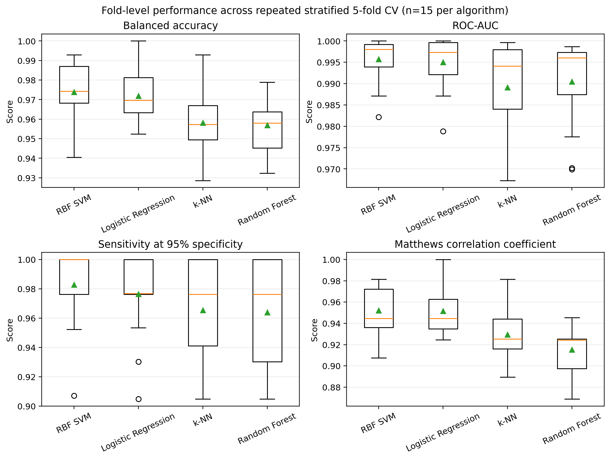
Figure 1. Fold-level dispersion for the four required metrics under repeated stratified 5-fold cross-validation (15 scores per algorithm). Triangles denote means.

At the default probability threshold, Figure 2 shows pooled outer-fold confusion matrices for all four compared algorithm families. Each case appears once as test data in each repeat, giving 1,707 pooled decisions per algorithm. The two highest-ranked models made different trade-offs: RBF SVM produced 25 false-negative and 14 false-positive decisions, while Logistic Regression produced 31 false negatives and 8 false positives.
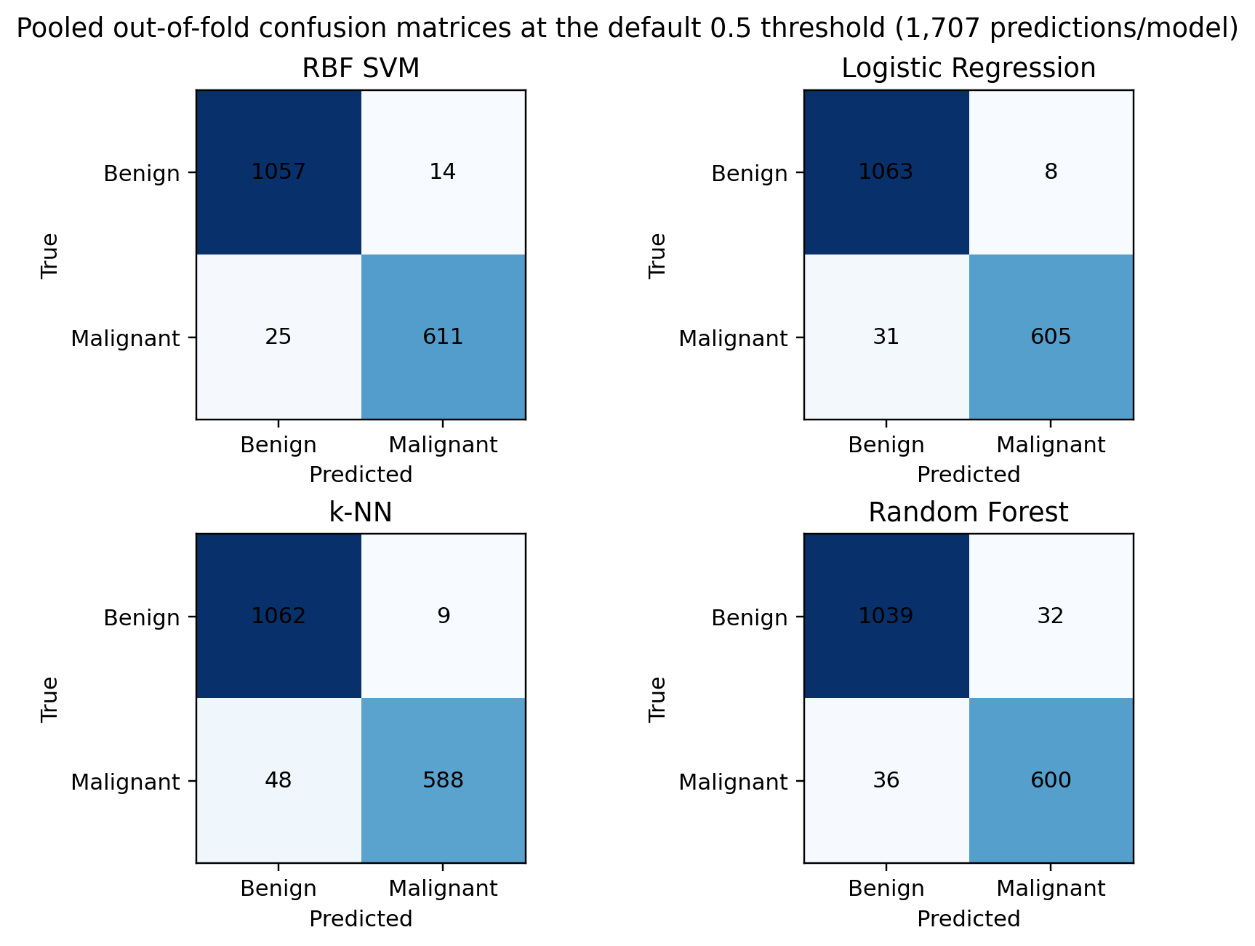
Figure 2. Pooled outer-fold confusion matrices for all four compared algorithm families at the default 0.5 threshold. Counts sum to 1,707 per algorithm because the 569 cases are tested in three repeats.

The Friedman test rejected equality of balanced-accuracy ranks (chi-square = 21.42, p = 8.61e-05). Pairwise results are shown in Table 5. The 0.19-percentage-point difference between RBF SVM and Logistic Regression did not survive the paired test, whereas both models exceeded Random Forest and k-NN after Holm correction.

Table 5. Paired statistical comparison of balanced accuracy. Effect size r = |Z|/sqrt(15); Holm-adjusted p-values control the six post-hoc comparisons.
Test / pair | Statistic / difference | Raw p | Holm p | Effect r | Interpretation
Friedman (4 alg.) | chi2=21.42 | 8.61e-05 | — | — | Reject equal ranks
RBF SVM vs Random Forest | W=0; Δ=+1.70 pp | 6.53e-04 | 0.004 | 0.880 | Significant
Logistic Regression vs Random Forest | W=5; Δ=+1.50 pp | 0.003 | 0.012 | 0.770 | Significant
RBF SVM vs k-NN | W=6.5; Δ=+1.57 pp | 0.002 | 0.012 | 0.785 | Significant
Logistic Regression vs k-NN | W=6; Δ=+1.38 pp | 0.006 | 0.017 | 0.713 | Significant
Logistic Regression vs RBF SVM | W=44; Δ=−0.19 pp | 0.916 | 1.000 | 0.036 | Not significant
Random Forest vs k-NN | W=41; Δ=−0.12 pp | 0.753 | 1.000 | 0.081 | Not significant

Figure 3 shows calibration from pooled outer-fold probabilities for RBF SVM and Logistic Regression. Their mean outer-fold Brier scores were 0.0191 ± 0.0084 and 0.0218 ± 0.0070, respectively.
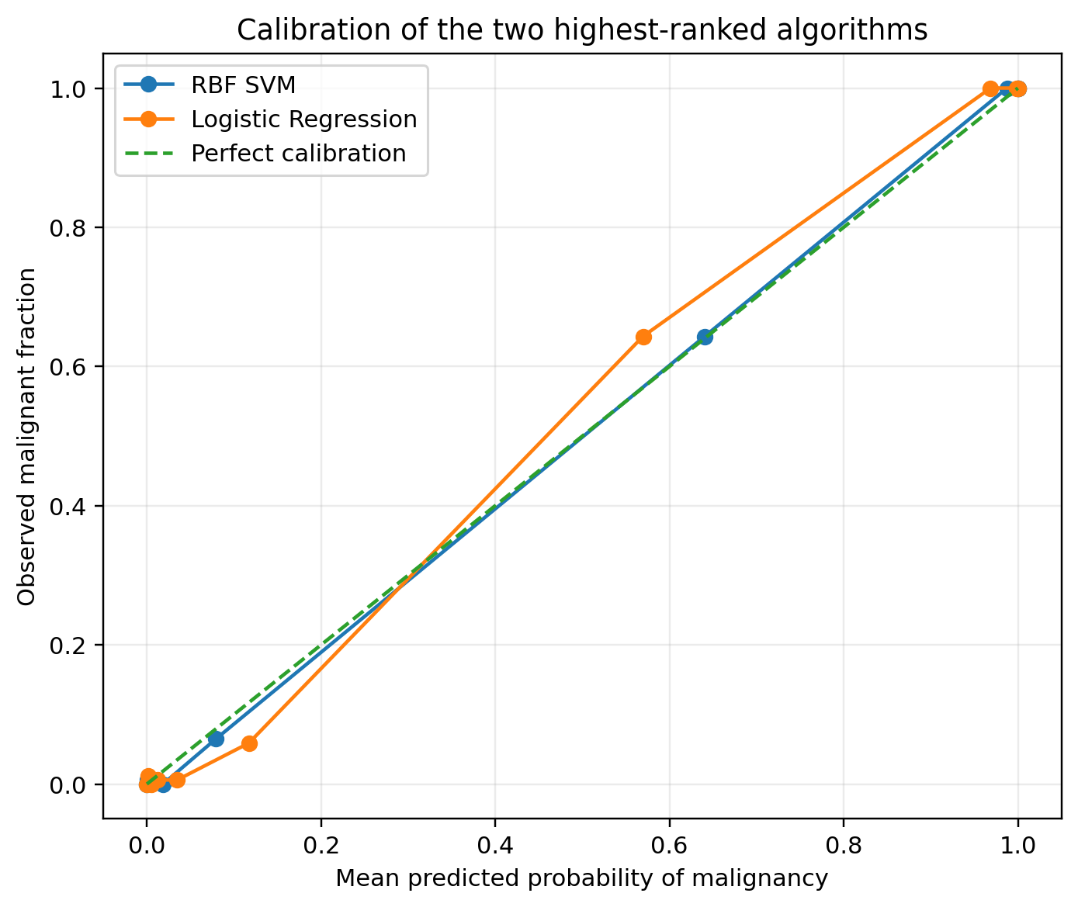
Figure 3. Calibration curves for RBF SVM and Logistic Regression from pooled outer-fold probabilities; the dashed line denotes perfect calibration.

Table 6. Candidate operating thresholds for the two highest-ranked algorithms. Thresholds are derived from 5-fold out-of-fold predictions on the full development dataset after tuning and therefore require external validation before clinical use.

Algorithm | Candidate threshold | OOF sensitivity | OOF specificity | Outer sens. @95% spec. | Brier
RBF SVM | 0.291 | 98.11% | 96.64% | 98.28 ± 2.57% | 0.0191 ± 0.0084
Logistic Regression | 0.259 | 97.17% | 95.80% | 97.64 ± 2.82% | 0.0218 ± 0.0070

The scaling ablation produced the summary in Table 7. Removing StandardScaler lowered mean balanced accuracy for both scale-sensitive methods under the same outer folds and tuning-budget size.

Table 7. Scaling ablation (balanced accuracy, mean ± SD over 15 outer folds).
Algorithm | Scaled inside fold | No scaling | Difference
k-NN | 95.81 ± 1.78% | 91.77 ± 2.21% | +4.04 pp
RBF SVM | 97.38 ± 1.42% | 90.83 ± 1.86% | +6.56 pp

Discussion
The main takeaway is straightforward: RBF SVM and Logistic Regression are effectively tied at the top. The raw difference is just 0.19 percentage points in balanced accuracy (97.38% versus 97.19%), but each model's fold-to-fold standard deviation is around 1.4 points, so the gap is well inside the noise. The paired Wilcoxon test returns Holm-adjusted p = 1.00 with r = 0.036, which means the data give no basis for calling one the accuracy winner. Against Random Forest and k-NN, however, the gap widens to roughly 1.4–1.7 points and survives Holm correction with large effect sizes across the 15 paired folds.
This ranking partly agrees with Aamir et al. [2]: both SVM and Random Forest were competitive in their study too. Their strongest model, however, was an MLP, and their accuracy figures cannot be compared point-for-point with our balanced-accuracy numbers. The reasons are protocol differences — they reduced features to 11 through correlation and RFE selection, used several train-test ratios, and reported accuracy as the headline metric. We keep all 30 predictors, nest the search inside repeated outer folds, and use the same six-configuration budget for every algorithm. So the lower Random Forest balanced accuracy here does not contradict their 98.07% accuracy; the experiments are measuring different things.
The data geometry explains the near-tie. Many of the 30 predictors are strongly correlated transformations of the same underlying size and contour features, so a regularised linear boundary already does much of the work. The RBF SVM can bend that boundary locally, but the extra flexibility buys only a small average gain smaller than the variation between folds. Random Forest is less sensitive to scaling and can capture nonlinear interactions, yet with only 569 observations its tree partitions also carry their own sampling variance. k-NN suffers most because its neighbourhoods are driven directly by Euclidean distance, so unscaled predictors quickly distort which cases count as neighbours.
The scaling ablation makes that mechanism measurable. Mean balanced accuracy fell from 95.81% to 91.77% for k-NN (a 4.04-point loss) and from 97.38% to 90.83% for RBF SVM (a 6.56-point loss). This is why scaling is kept inside the fold rather than applied once to the full dataset: it is both influential and a fitted transformation.
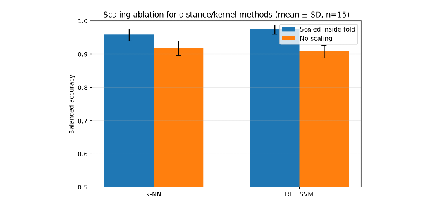
Figure 4. Secondary scaling ablation for k-NN and RBF SVM. Error bars are fold-level standard deviations across the same 15 outer splits.

For a screening-support operating point we would provisionally set the RBF SVM threshold near 0.29 instead of the default 0.50. The full-data out-of-fold analysis gives 98.11% sensitivity and 96.64% specificity at that point; Logistic Regression at 0.26 gives 97.17% sensitivity and 95.80% specificity. We choose the SVM here because of the operating point and its slightly lower Brier score, not because it was statistically better on balanced accuracy. This threshold is still a development-set candidate — any real deployment needs prospective validation, an explicit clinical cost analysis and recalibration if the population shifts.

Threats to validity
Internal validity: We reduced leakage by fitting scaling and model selection inside each training fold and by reusing the same outer splits across every algorithm. The main remaining threats are the finite six-configuration grids and the SVM's Platt-scaled probability estimates, which are implementation-specific. We should also remember that the 15 fold scores come from repeated cross-validation, so they are paired but not independent draws of new patients.
External validity: WDBC is a small historical dataset from a single diagnostic setting, with no demographic covariates. It cannot represent changes in imaging technology, sampling protocols, clinical workflow or population mix that a modern deployment would face. The scores therefore support a benchmark comparison rather than a clinical-effectiveness claim.
Construct validity: Balanced accuracy, ROC-AUC, MCC and sensitivity at 95% specificity capture different performance aspects, but none of them encode the real clinical cost of a missed malignancy versus an unnecessary referral. The 95% specificity target is an assignment-defined constraint, not a validated policy.
Conclusion validity: With only one dataset and N = 15 paired fold scores, generalisation is limited. Holm correction controls the six post-hoc balanced-accuracy comparisons, and we treated differences smaller than the fold-level dispersion as inconclusive rather than ranking them. The candidate threshold is estimated from development-data out-of-fold predictions, so it remains optimistic until externally tested.

Conclusion
Under repeated stratified 5-fold cross-validation with nested equal-budget tuning, RBF SVM and Logistic Regression were the strongest models for WDBC, with balanced accuracy of 97.38 ± 1.42% and 97.19 ± 1.43%, respectively. Their 0.19-point difference was not reliable after paired testing, while both exceeded Random Forest and k-NN on balanced accuracy. For screening support, the RBF SVM provides the stronger operating-point result, with 98.28 ± 2.57% sensitivity at 95% specificity and a provisional threshold near 0.29. The strongest caveat is that these are internal benchmark results on 569 historical cases; external prospective validation is required before any clinical use.

References
[1] W. Wolberg, O. Mangasarian, N. Street, and W. Street, "Breast Cancer Wisconsin (Diagnostic) [Dataset]," UCI Machine Learning Repository, 1993. doi: 10.24432/C5DW2B.
[2] S. Aamir, A. Rahim, Z. Aamir, et al., "Predicting Breast Cancer Leveraging Supervised Machine Learning Techniques," Computational and Mathematical Methods in Medicine, vol. 2022, Art. no. 5869529, 2022. doi: 10.1155/2022/5869529.
[3] A. Rasool, C. Bunterngchit, L. Tiejian, M. R. Islam, Q. Qu, and Q. Jiang, "Improved Machine Learning-Based Predictive Models for Breast Cancer Diagnosis," International Journal of Environmental Research and Public Health, vol. 19, no. 6, Art. no. 3211, 2022. doi: 10.3390/ijerph19063211.
[4] H. Dhahri, E. Al Maghayreh, A. Mahmood, W. Elkilani, and M. F. Nagi, "Automated Breast Cancer Diagnosis Based on Machine Learning Algorithms," Journal of Healthcare Engineering, vol. 2019, Art. no. 4253641, 2019. doi: 10.1155/2019/4253641.
[5] D. R. Cox, "The Regression Analysis of Binary Sequences," Journal of the Royal Statistical Society: Series B, vol. 20, no. 2, pp. 215-242, 1958.
[6] T. Cover and P. Hart, "Nearest Neighbor Pattern Classification," IEEE Transactions on Information Theory, vol. 13, no. 1, pp. 21-27, 1967. doi: 10.1109/TIT.1967.1053964.
[7] L. Breiman, "Random Forests," Machine Learning, vol. 45, pp. 5-32, 2001. doi: 10.1023/A:1010933404324.
[8] C. Cortes and V. Vapnik, "Support-Vector Networks," Machine Learning, vol. 20, pp. 273-297, 1995. doi: 10.1007/BF00994018.
[9] J. Demsar, "Statistical Comparisons of Classifiers over Multiple Data Sets," Journal of Machine Learning Research, vol. 7, pp. 1-30, 2006.
[10] F. Pedregosa et al., "Scikit-learn: Machine Learning in Python," Journal of Machine Learning Research, vol. 12, pp. 2825-2830, 2011.
[11] T. Fawcett, "An Introduction to ROC Analysis," Pattern Recognition Letters, vol. 27, no. 8, pp. 861-874, 2006. doi: 10.1016/j.patrec.2005.10.010.
[12] B. W. Matthews, "Comparison of the Predicted and Observed Secondary Structure of T4 Phage Lysozyme," Biochimica et Biophysica Acta, vol. 405, no. 2, pp. 442-451, 1975. doi: 10.1016/0005-2795(75)90109-9.

Appendix A — Reproducibility
The complete submission package contains the experiment script, a Colab launcher notebook, pinned environment files, raw fold-level CSV files, fold-specific selected hyperparameters, out-of-fold predictions and all figures used in this report. The official UCI wdbc.data URL is requested by the script; an offline fallback uses scikit-learn's packaged copy of the same 569 x 30 predictor matrix.
Table A1. Reproducibility information.
Item | Value / path
Seed | 513
Primary command | python src/run_experiment.py
Environment | requirements.txt and environment.yml
Raw main results | results/fold_results_main.csv
Outer predictions | results/oof_predictions_main.csv
Fold hyperparameters | results/best_hyperparameters_by_fold.csv
Statistical tests | results/friedman_balanced_accuracy.csv; results/wilcoxon_holm_balanced_accuracy_with_r.csv
Ablation results | results/fold_results_no_scaling_ablation.csv
Figures | figures/figure1_... through figure4_...
Repository | github.com/Enemaku/cpe513_breast_cancer_comparison

A marker can regenerate the evidence from a clean environment by installing the pinned dependencies and running the single command above. The script writes raw per-fold results before summary tables are derived. Timing is hardware-dependent; predictive metrics should reproduce within deterministic numerical tolerance under the pinned versions.

Appendix B — AI-use statement
We used ChatGPT (OpenAI) as an AI assistant to help interpret the assignment requirements, design a leakage-safe nested cross-validation workflow, draft and review Python code, organise the statistical analysis, and edit the wording and layout of this report. The assistant was also used to locate the official UCI dataset metadata and the cited anchor/related papers. All numerical results in the report come from executable experiment code and archived CSV outputs; they were not invented or copied from the assistant. We verified the dataset dimensions and class counts, inspected the preprocessing and fold boundaries, checked that each algorithm received the same tuning-budget size, and cross-checked the report values against the generated CSV files. The supplied notebook and script can regenerate the tables and figures. We remain responsible for understanding, explaining and reproducing the submitted work.

Appendix C — Final configurations
The main reported scores use fold-specific configurations selected independently inside each outer-training partition. For a final model fitted after the comparison, a separate 5-fold search on all development data selected the configurations below. These full-data selections are provided for reproducibility; they do not replace the nested estimates in Table 4.
Table C1. Full-development-data selected configurations.
Algorithm | Selected hyperparameters | 5-fold inner ROC-AUC | Pipeline
Logistic Regression | {"model__C": 0.1} | 0.9944 | StandardScaler -> model
k-NN | {"model__n_neighbors": 15, "model__weights": "distance"} | 0.9934 | StandardScaler -> model
Random Forest | {"model__max_depth": null, "model__min_samples_leaf": 1, "model__n_estimators": 30} | 0.9900 | StandardScaler -> model
RBF SVM | {"model__C": 10, "model__gamma": 0.01} | 0.9957 | StandardScaler -> model; probability=True

For threshold-sensitive use, the candidate full-development thresholds are 0.291 for RBF SVM and 0.259 for Logistic Regression. These values must be re-estimated or externally validated if the data distribution or prevalence changes.

