#### 

#### Figure For SA,SB,SC is equal to 1

|  |
| --- |
|  |
|  |
|  |

#### Figure For only one switch is active

#### For each switching time is actually like step response. The current drawn by the DC bus capacitors are different because there are stray inductances and parasitic resistance.

High Frequency Response at switching times

It actullay shows how to share current drawings of phases at switching time from capacitors A, B,C

We observe that capacitors are perfectly shorted to each others and share the currents equal for lower frequecny than 100 kHz

Also, capacitor currrents have some local maxima and minima, it can be observed because of impedance shown by each capacitance

There are 9 situation for each capacitors for each phases .

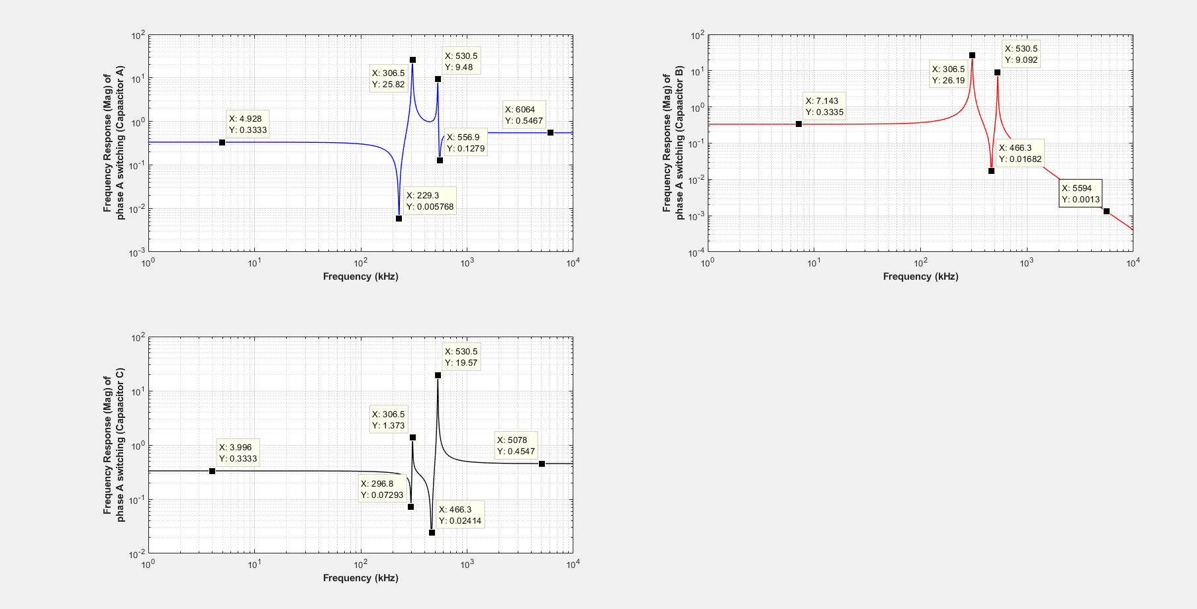





Switching Function

Switching Function can be written in frequency domain.

It is converted in time-domain to validate with simulation results.

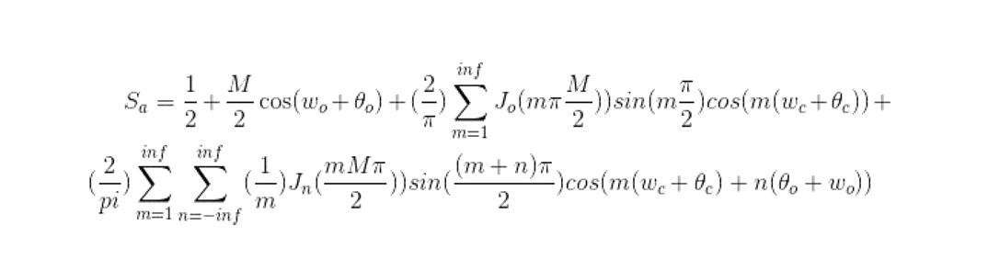

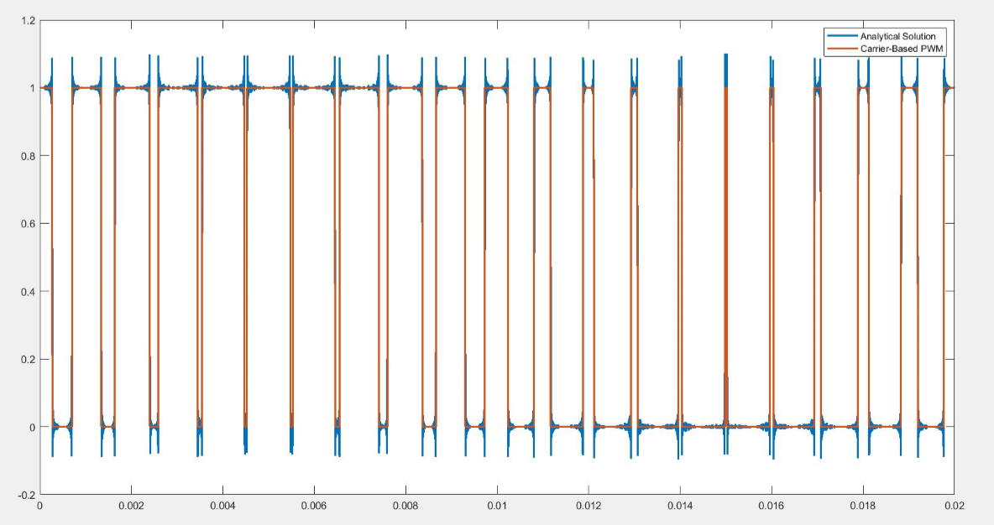

Gibbs Phenomena, discontinuity (turn-on, turn-off)