A ideal model of a single module of a 3-phase VSI is shown at figure X. Although the each phase leg has a metal film capacitor and ceramic capacitors closer to GaNFets, we can model the DC Bus as a single capacitor where the parasitic are ignored.

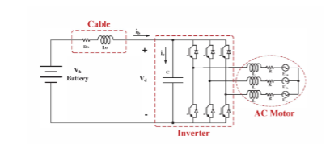

In the simplified model, it is assumed that input current is ideal DC and all ripples are filtered by DC Bus capacitor. Also, each leg has a current that is function of phase current and switch condition. Then, the inverter has a current as in equation and the capacitor current can be derived by the formula.

