**PULSE WİDTH MODULATION**

Pulse Width Modulation (PWM) is used for creating analog signal by digital signal. For this aim, Pulses are created at different high or low time at constant frequency. So, the PWM is consist of two basic part which are Duty Cycle and Frequency. Duty cycle changes the power of signal with high(on) time.

$$D=ton* f$$

$$Vout = DVin$$

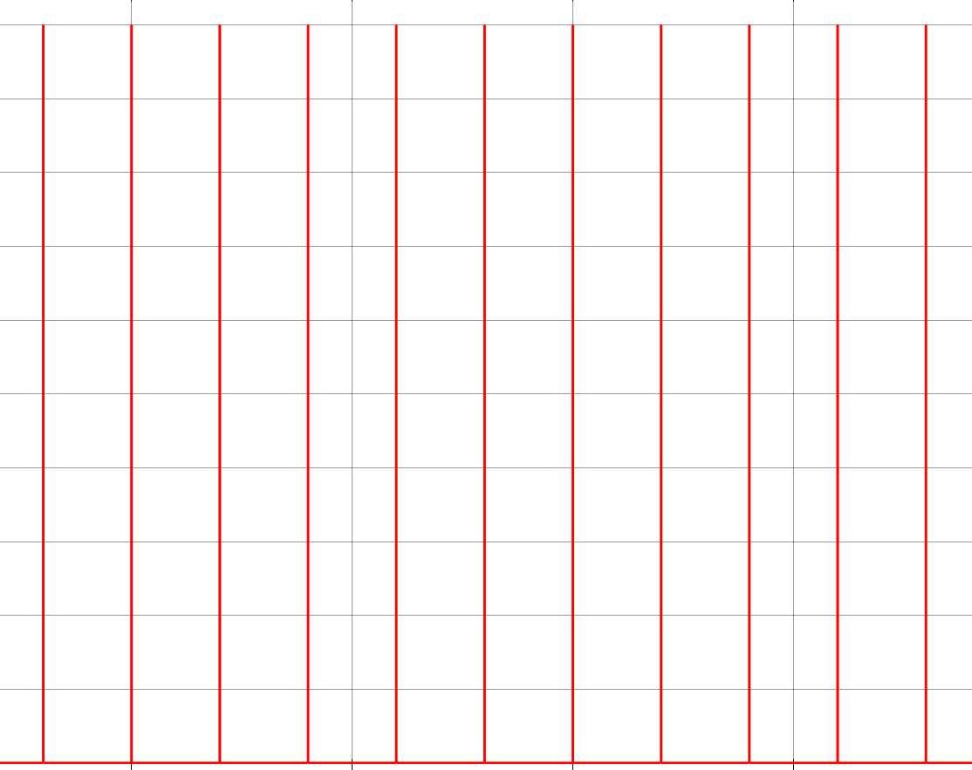 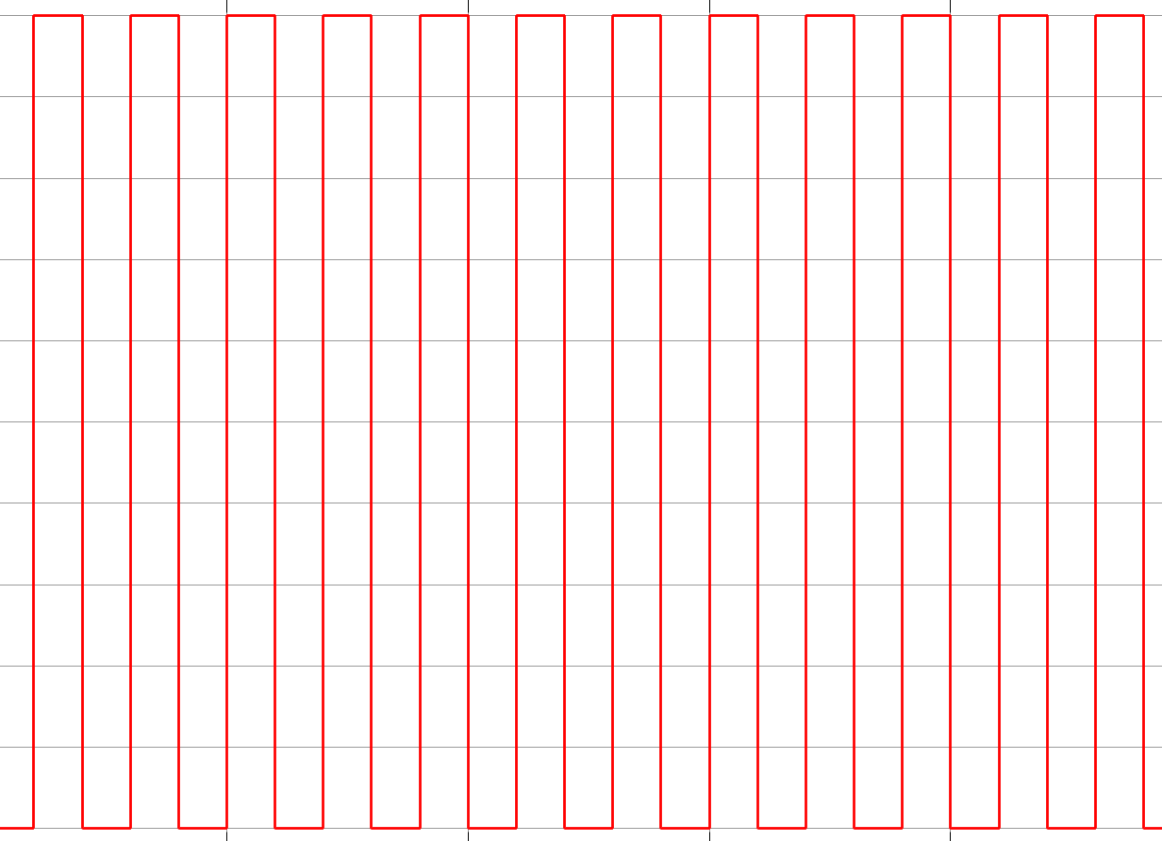

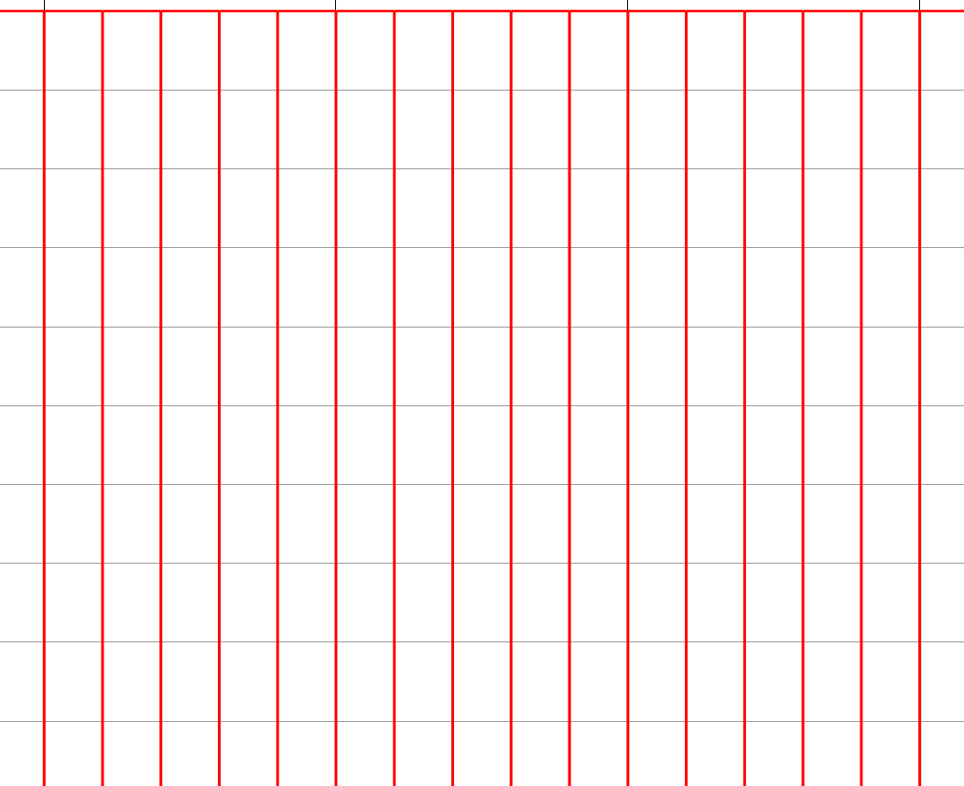

At Figure XXX, There are 1-50-99 duty cycle representation.