

MIDDLE EAST TECHNICAL UNIVERSITY

Electrical & Electronics Engineering

Simulation Project #1

EE 464

Enes Ayaz – 2093318



# Introduction

At this report, the CUK Converter (at figure X) will be investigated in analytical. A converter will be designed for some specification that is tabulated below.

|  |  |
| --- | --- |
| Input Voltage | 9 V |
| Output Voltage | -12 V |
| Output Current | 3 A |
| Switching Frequency | 100 kHz |
| Max. Output Voltage Ripple | %2 |

Also, the Buck-Boost Converter will be designed and compared with CUK converter in aspect of Input currents.

Finally, a closed-loop control system will be established and we will keep the output voltage constant at different situation, different disturbance in input voltage.

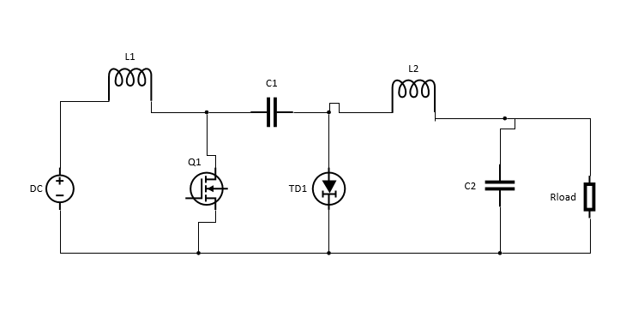

# Question-1)

For the analytical solution, it is required the circuit is investigated for the switch-on and switch-off states.

**On-State (Q1 Transistor conducts)**

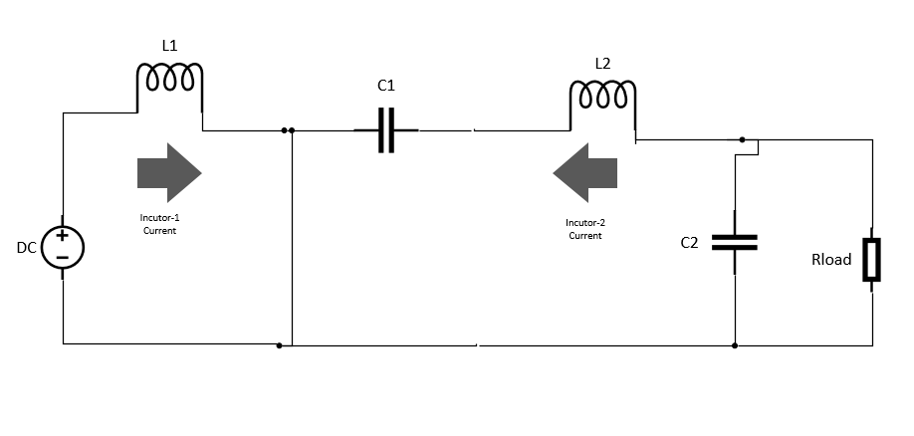

**Off-State (Q1 Transistor does not conduct)**

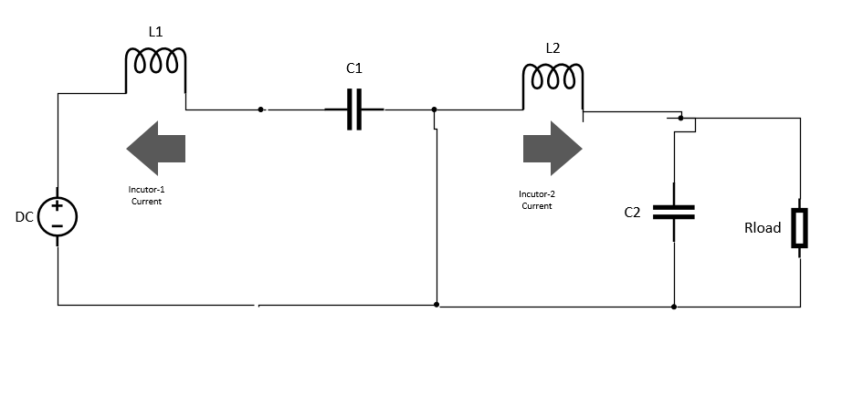

At off state, both inductors discharges and the voltage of inductors are output voltage( negative). At on state, both inductors charges and the voltage of inductors are input voltage( positive). Inductor voltage and current waveforms with respect to time are shown below Figure X.

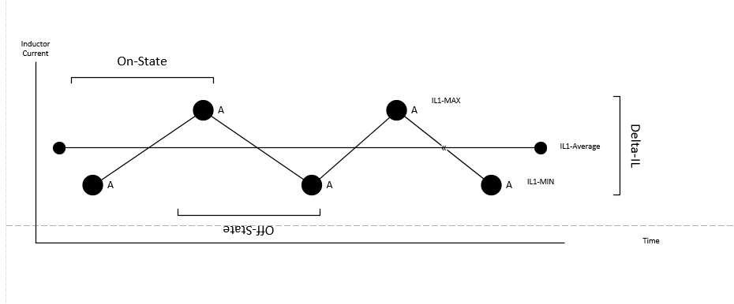

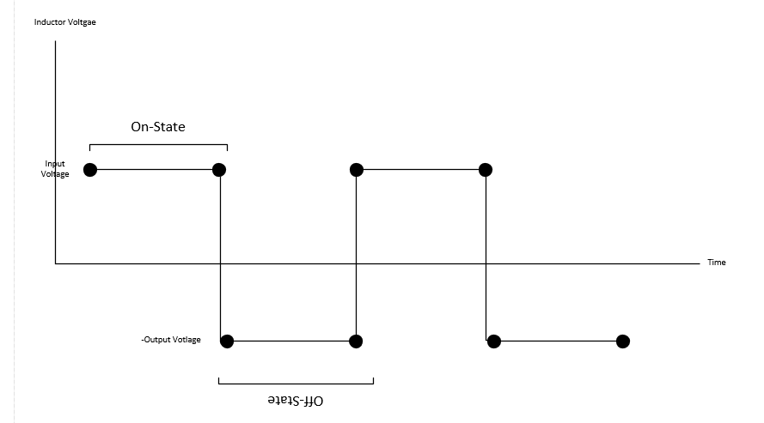

$$V_{d}DT_{s}+\left( V_{d}+V_{o}\right)\left(1-D\right)T_{s}=0$$

From the inductor volt-second balance output voltage is function of duty cycle of transistor and input voltage.

$$\frac{V_{o}}{V_{d}}=\frac{-D}{1-D}$$

The output of CUK converter is like Buck-Boost Converter. For providing the output voltage as 12 Volt during 9 V input.

$$D=\frac{4}{7}$$

Duty cycle is found as formula X.

## a)

Current ripples at inductors can be found by using figure X slope.

$$Δil_{1}=\frac{\left(V_{o}\right)}{L_{1}} \left(1-D\right)T_{s}$$

For the specification, İnductance can be calculated as:

$L_{1}=\frac{Il_{1}}{Δil_{1 }} \left( R_{l}\right) \left(1-D\right)T_{s}$

Also, the voltage ripple can be found by assuming that inductor current is constant.

$$ΔV_{c}=\frac{1}{2C_{2}}\left(1-D\right)T_{s}$$

For the specification , capacitance can be calculated as:

$$C_{2}=\frac{1}{2ΔV_{c}}\left(1-D\right)T_{s}$$

Capacitance and inductance are calculated and chosen as 18 uF and 180 uH.

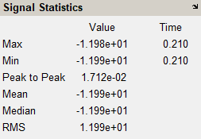

Simulation result shows that output voltage ripple is about **0.14** percentage. It is in safety region.

## b)

### CUK CONVERTER

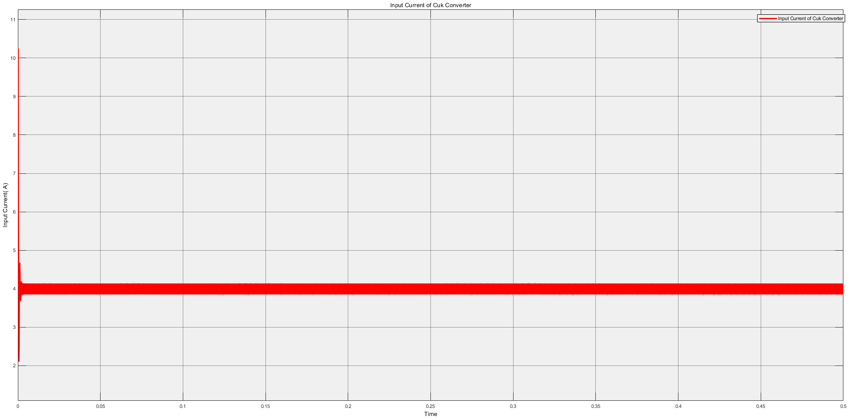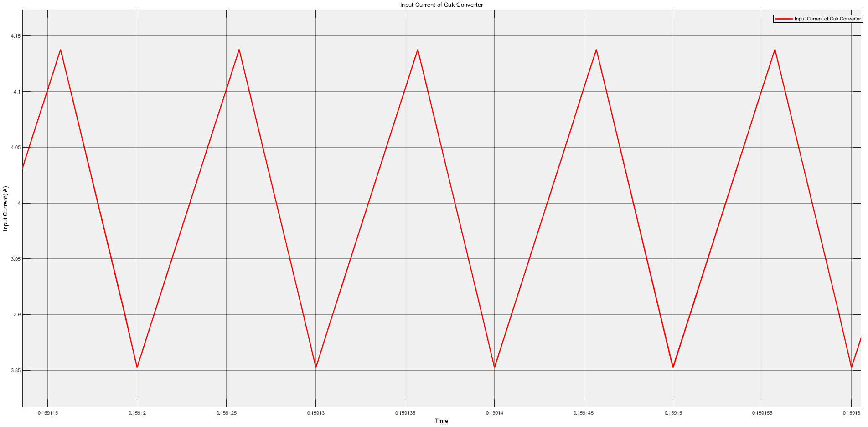

### BUCK-BOOST CONVERTER

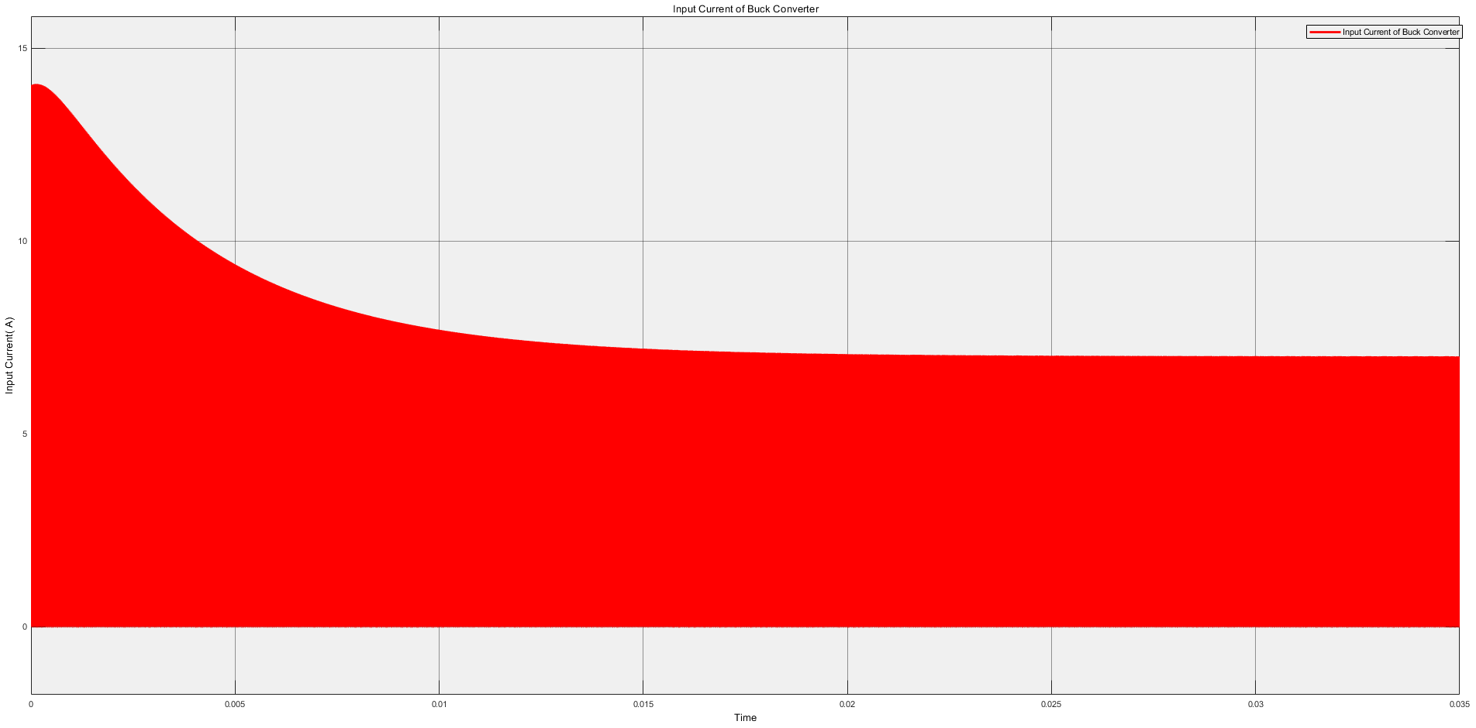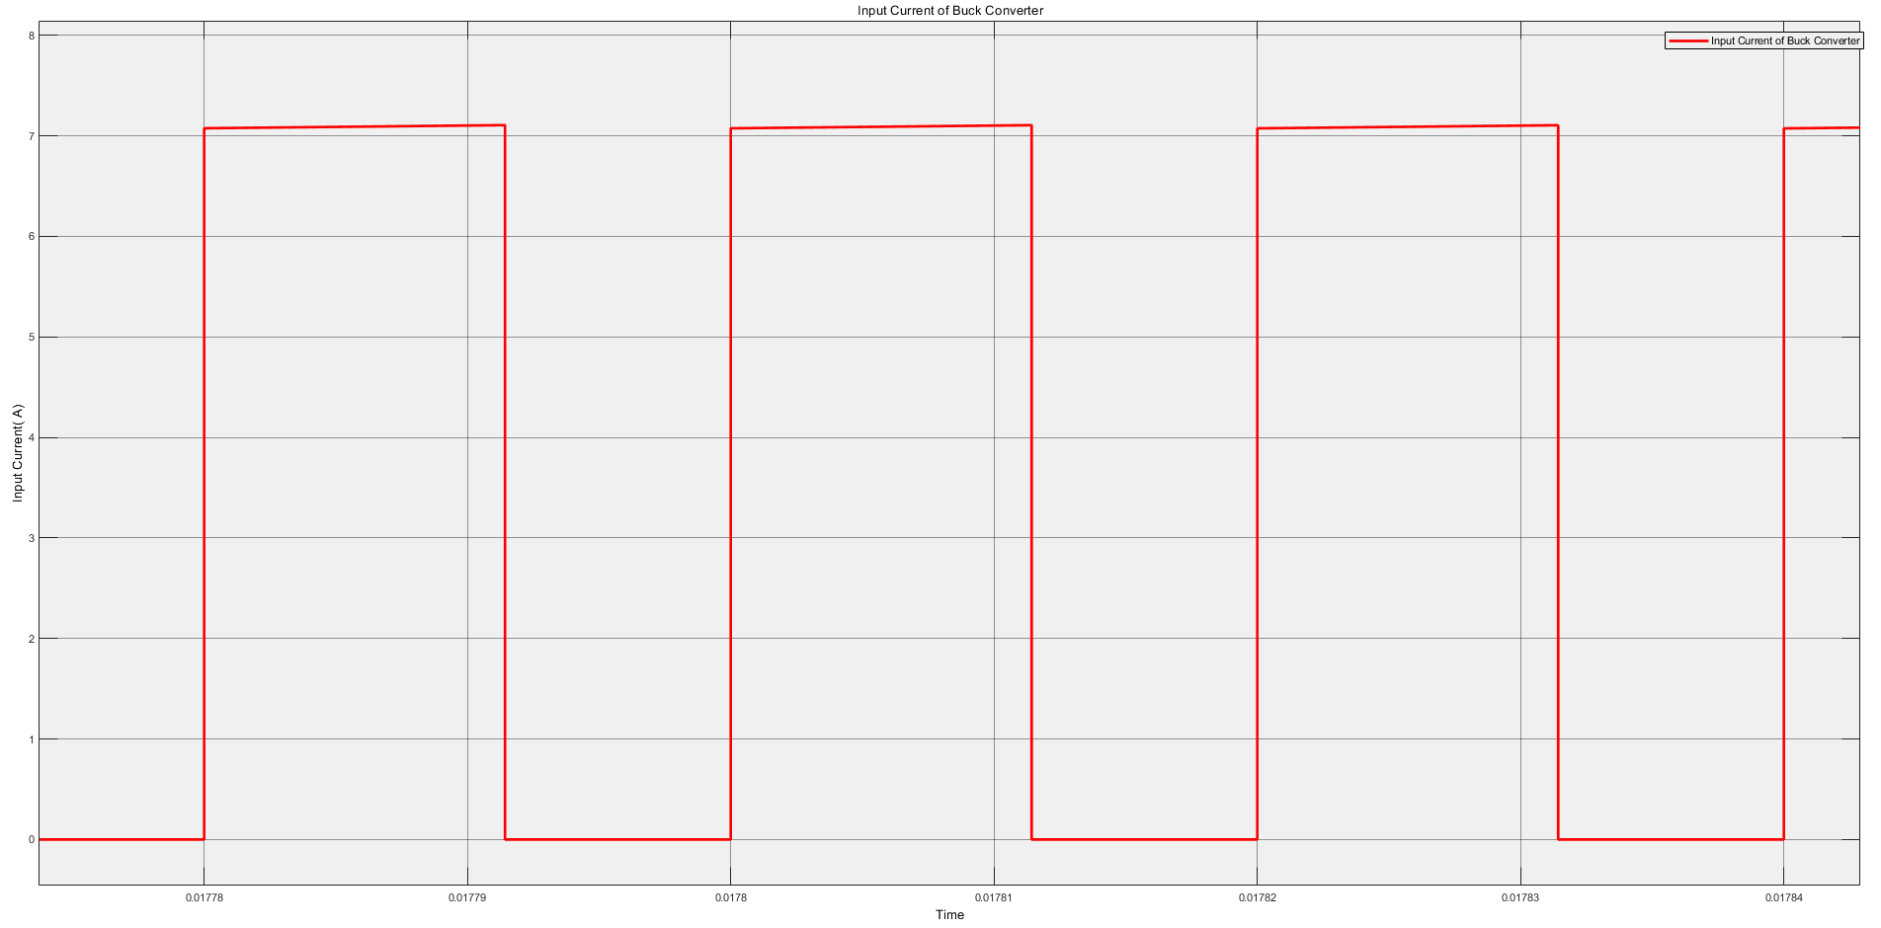

Cuk and Buck-Boost Converter were designed for the same output voltage. Simulation was made at same load. The Cuk converter has small noise at the input thanks to inductor. The input voltage is continuous. The Buck-Boost Converter has noisy input current. The current is square waveform. Although the average currents are the same, Buck-Boost converter has discontinuous input current.

## c)

## d)

Our system was designed open loop. We assumed that the input voltage is constant. At this point, our system will be converted closed loop system that provides constant output voltage.

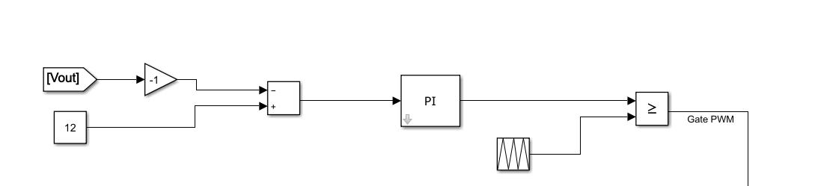

There is a reference output voltage and the duty is adjusted by using output voltage error. Input voltages was given as changing between 8-10 V at periodically.

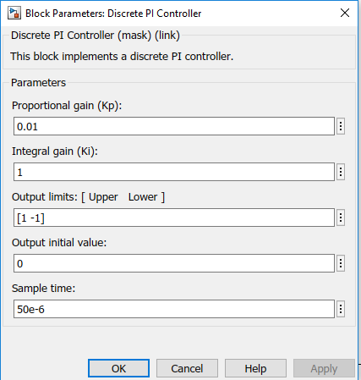

Proportional and Integrated constant can be optimized to minimize error.

The output voltage, input voltage and desired output voltage are shown at Figure X.

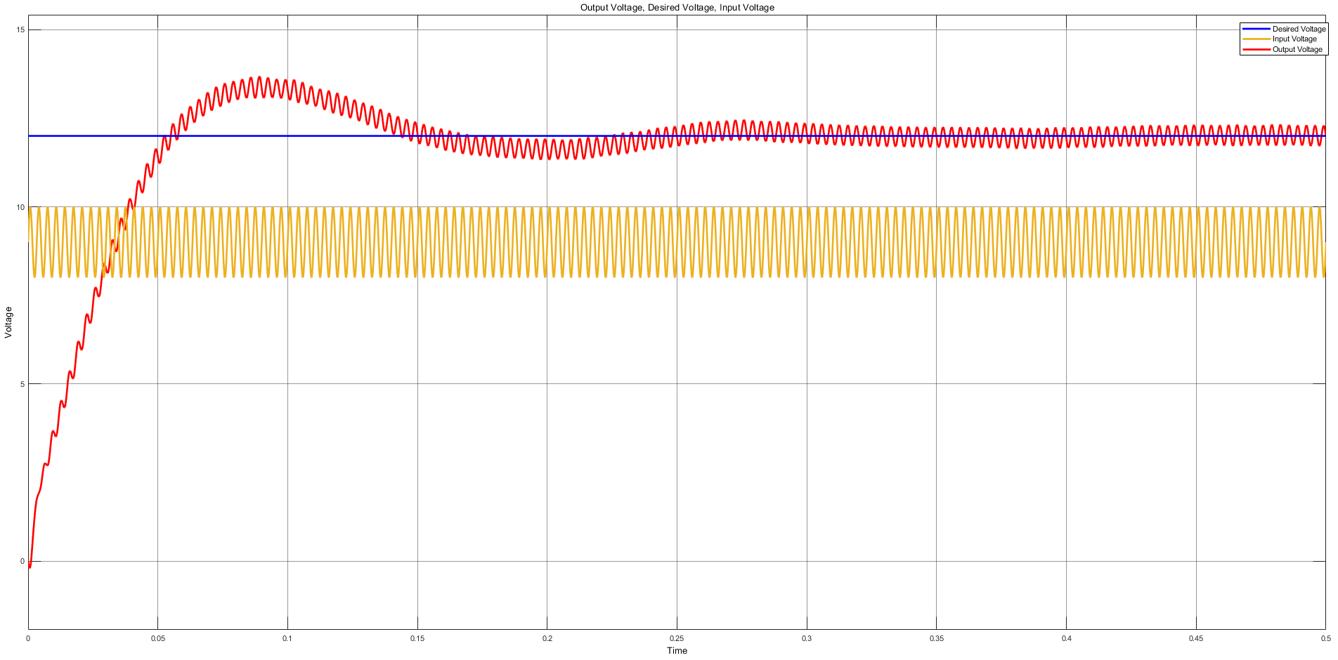

As seen that the output voltage is not constant. There are some ripples at output voltage. The ripple is 5.55 percent as shown Figure X.

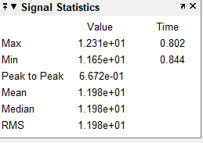

## e)

At this point, the disturbance occurred instantaneously. The input voltage is like step waveform initially 9 V and finally 11 V.

PI controller was used like part D.

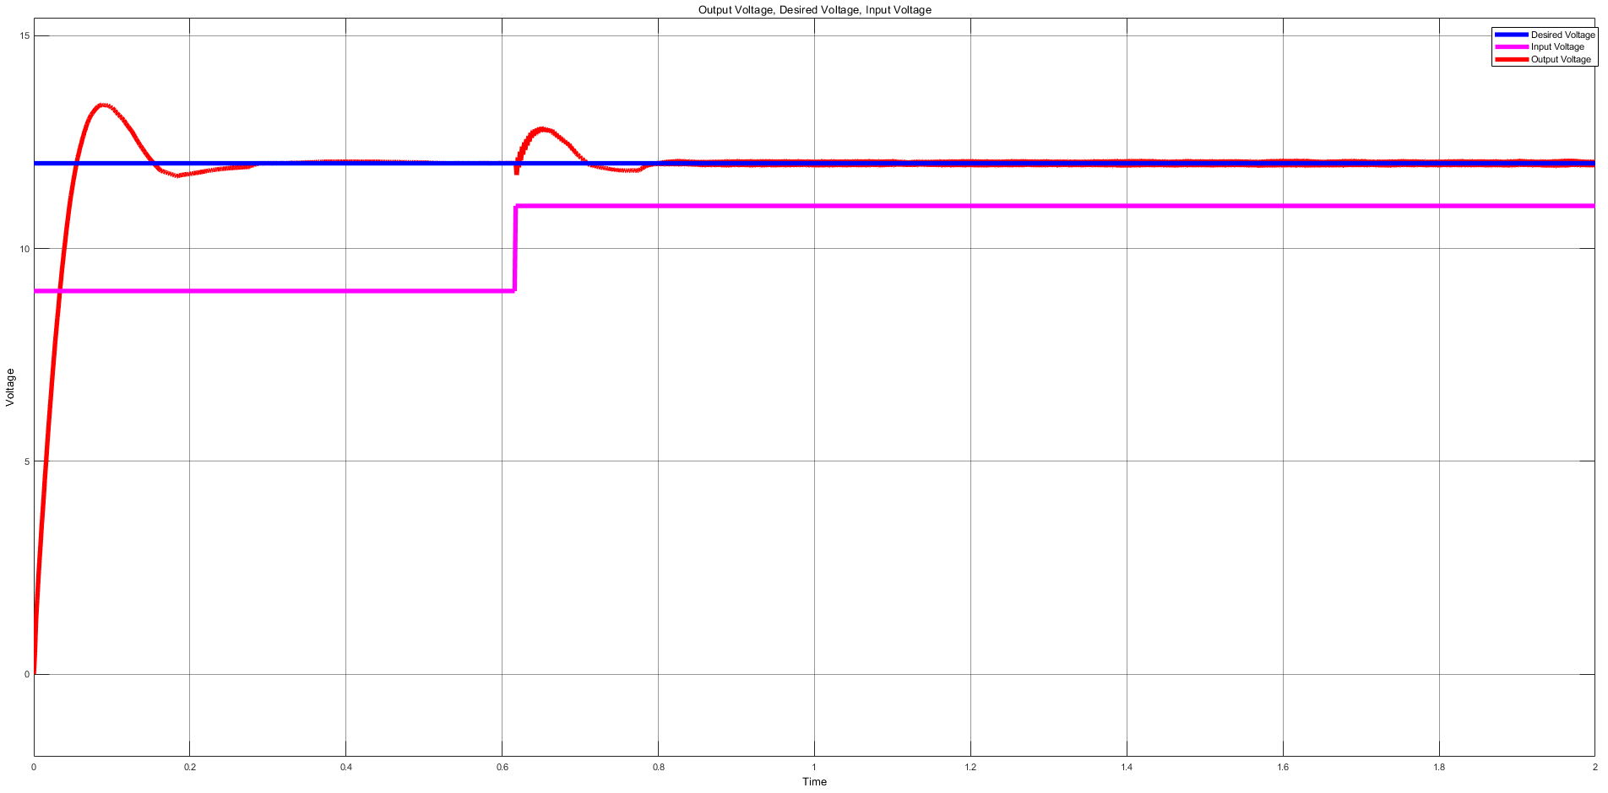

The output voltage is over-shooting characteristic, then it reach the desired output level. There is no steady state error.