

MIDDLE EAST TECHNICAL UNIVERSITY

Electrical & Electronics Engineering

Simulation Project #1

EE 464

Enes Ayaz – 2093318

Ekin Su Saçın – 2031300



# Introduction

At this report, the CUK Converter (at figure 1) will be investigated in analytical. A converter will be designed for some specification that is tabulated below.

|  |  |
| --- | --- |
| Input Voltage | 9 V |
| Output Voltage | -12 V |
| Output Current | 3 A |
| Switching Frequency | 100 kHz |
| Max. Output Voltage Ripple | %2 |

Also, the Buck-Boost Converter will be designed and compared with CUK converter in aspect of Input currents.

Finally, a closed-loop control system will be established and we will keep the output voltage constant at different situation, different disturbance in input voltage.

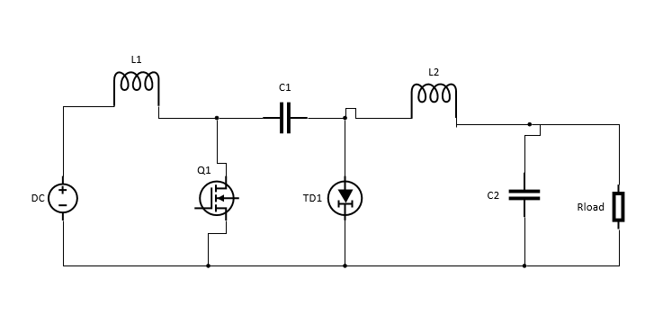

*Figure 1 - The schematic of Cuk Converter*

# Question-1)

For the analytical solution, it is required the circuit is investigated for the switch-on and switch-off states.

**On-State (Q1 Transistor conducts)**

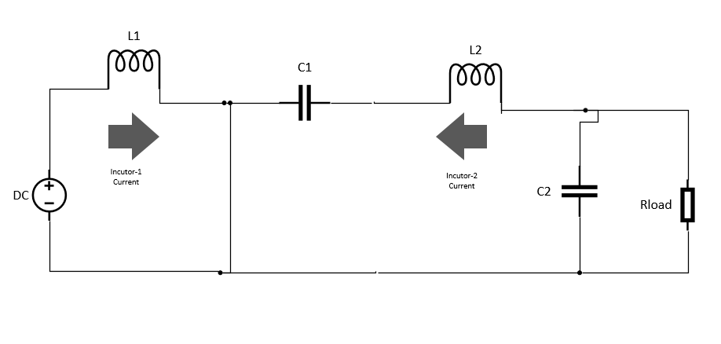

*Figure 2 – The schematic of On-State for Cuk converter*

**Off-State (Q1 Transistor does not conduct)**

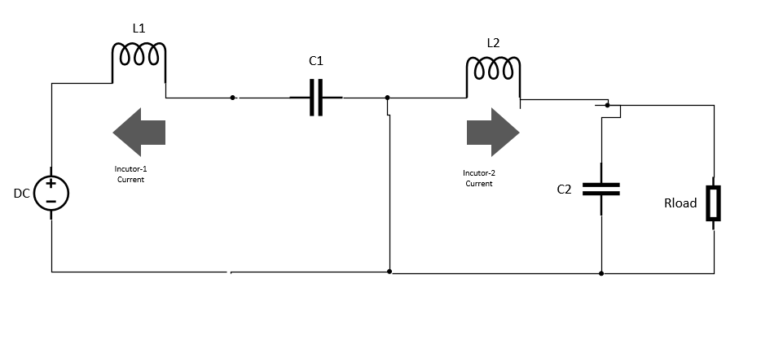

*Figure 3 – The schematic of Off-State for Cuk converter*

At off state, both inductors discharge and the voltage of inductors are output voltage (negative). At on state, both inductors charges and the voltage of inductors are input voltage (positive). Inductor voltage and current waveforms with respect to time are shown below Figure 4.

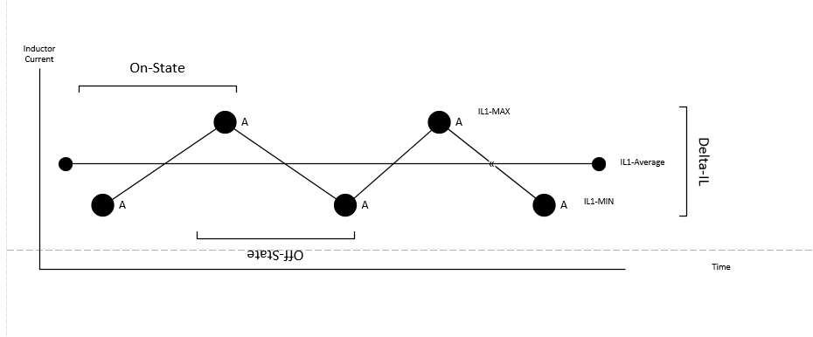

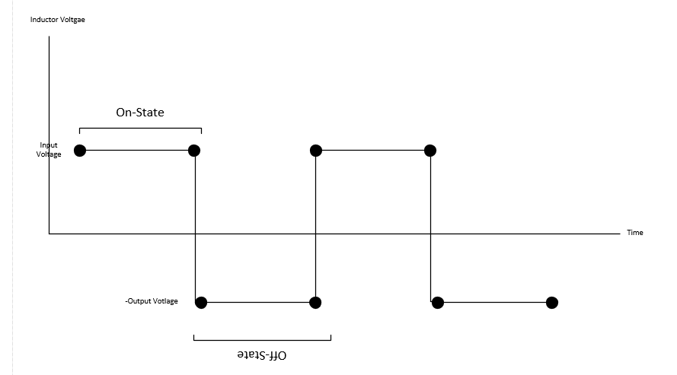

## *Figure 4 – Waveform of inductor voltage and current for Cuk converter*

$V_{d}DT_{s}+\left( V_{d}+V_{o}\right)\left(1-D\right)T_{s}=0$ (1)

From the inductor volt-second balance output voltage is function of duty cycle of transistor and input voltage.

$$\frac{V_{o}}{V_{d}}=\frac{-D}{1-D} (2)$$

The output of CUK converter is like Buck-Boost Converter. For providing the output voltage as 12 Volt during 9 V input.

$$D=\frac{4}{7}$$

Duty cycle is found as formula 2.

## a)

Current ripples at inductors can be found by using figure X slope.

$$Δil_{1}=\frac{\left(V_{o}\right)}{L_{1}} \left(1-D\right)T_{s} (3)$$

For the specification, İnductance can be calculated as:

$L_{1}=\frac{Il_{1}}{Δil_{1 }} \left( R_{l}\right) \left(1-D\right)T_{s} (4)$

Also, the voltage ripple can be found by assuming that inductor current is constant.

$$ΔV_{c}=\frac{1}{2C_{2}}\left(1-D\right)T_{s} (5)$$

For the specification, capacitance can be calculated as:

$$C_{2}=\frac{1}{2ΔV_{c}}\left(1-D\right)T_{s} (6)$$

Capacitance and inductance are calculated and chosen as 18 uF and 180 uH.

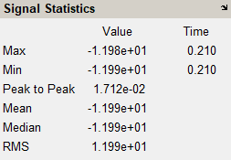

*Figure 5 – Data from Simulink for Output Voltage*

Simulation result shows that output voltage ripple is about **0.14** percentage. It is in safety region.

## b)

### CUK CONVERTER

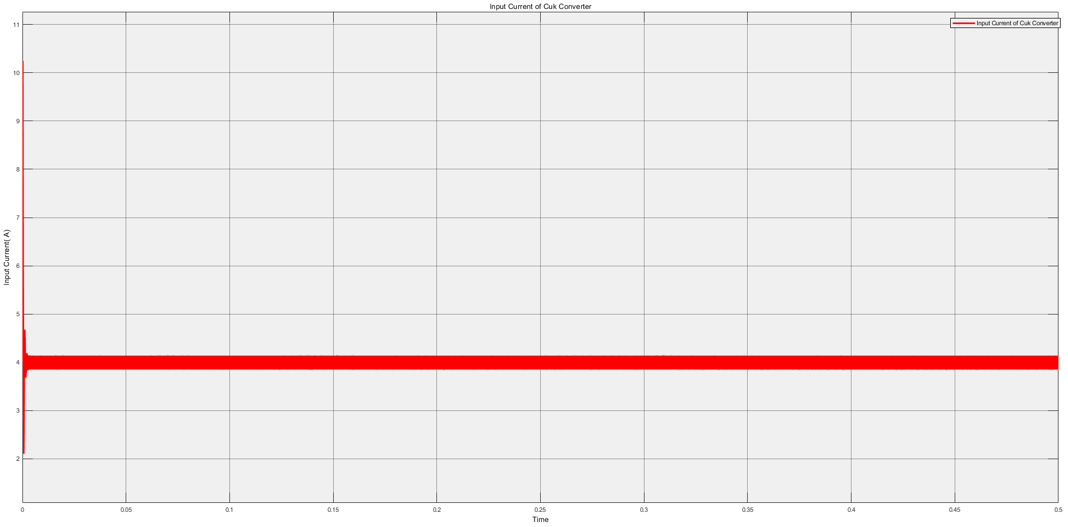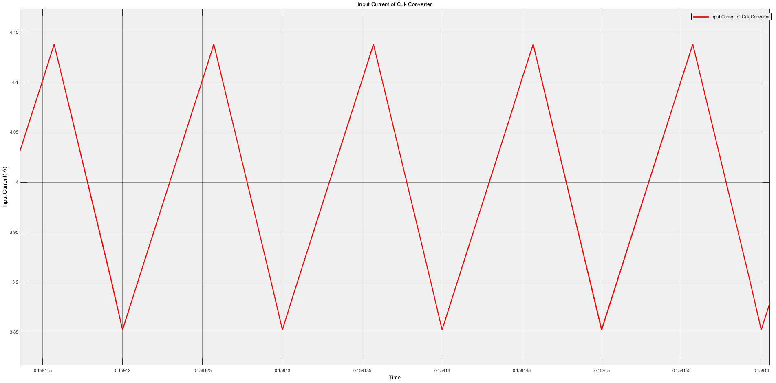

*Figure 6 – Input current waveform of Cuk Converter*

### BUCK-BOOST CONVERTER

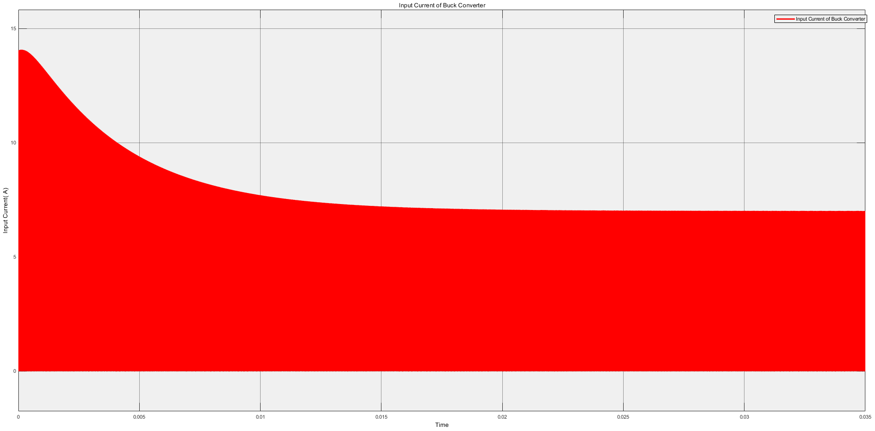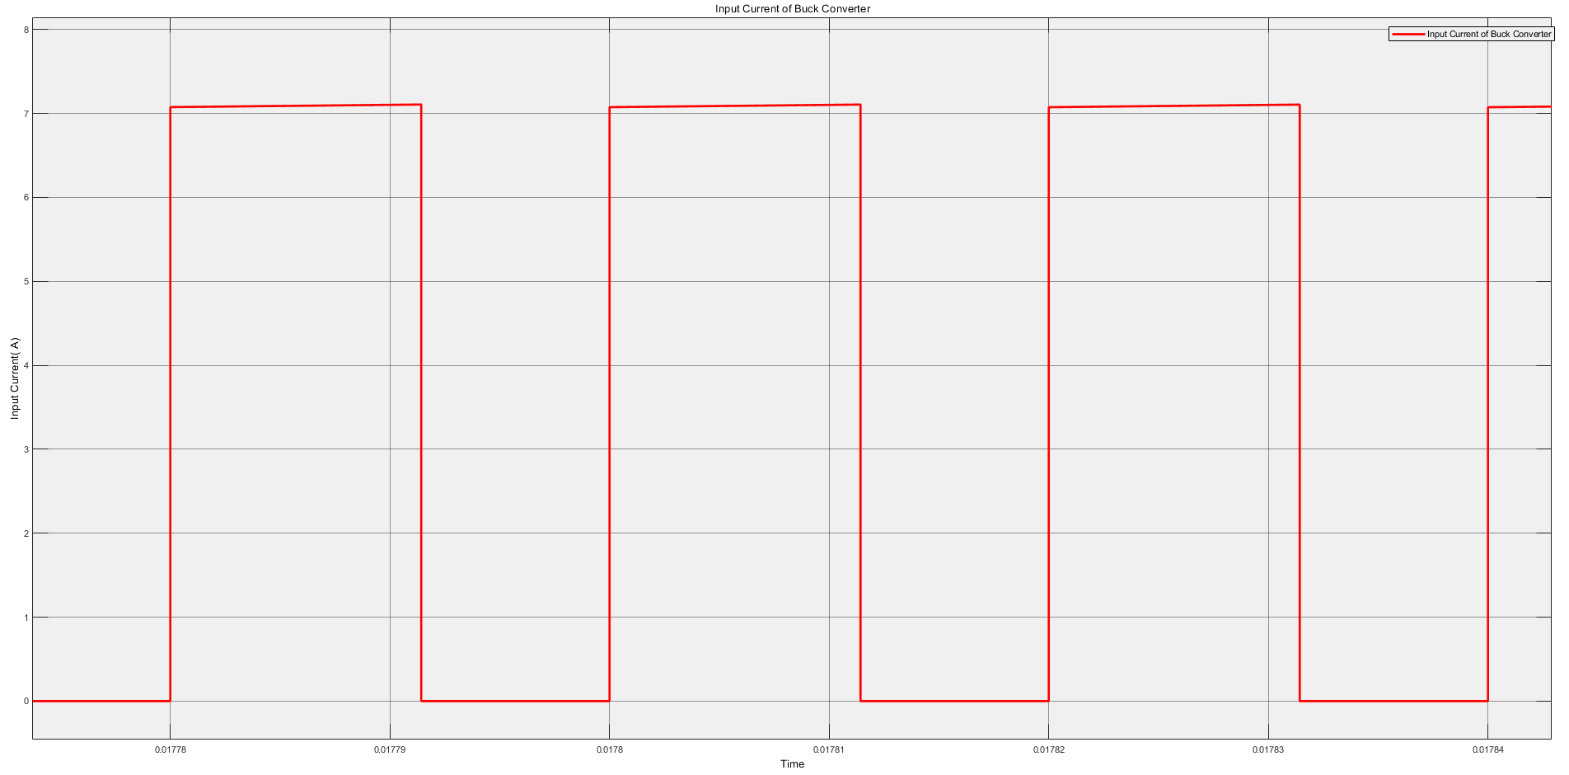

*Figure 7 – Input current waveform of Buck-Boost Converter*

Cuk and Buck-Boost Converter were designed for the same output voltage. Simulation was made at same load. The Cuk converter has small noise at the input thanks to inductor. The input voltage is continuous. The Buck-Boost Converter has noisy input current. The current is square waveform. Although the average currents are the same, Buck-Boost converter has discontinuous input current.

## c)

Inductor current ripples:

$$Δil_{1}=\frac{\left(V_{o}\right)}{L_{1}} \left(1-D\right)T_{s} (7)$$

$$Δil_{1}= \frac{12}{180{*10}^{-6}} \left( 1-\frac{4}{7}\right){10}^{-5} =0.285 A$$

Because of $L_{1}=L_{2}$, $Δil_{1}= Δil_{2}$ = 0.285 A

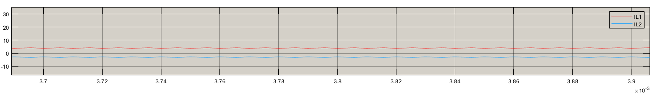

*Figure 8 – Inductor current waveforms of Cuk Converter*

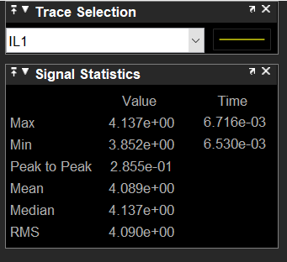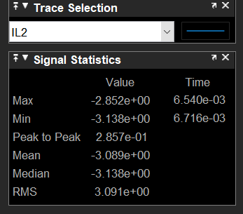

*Figure 9 – Data Statisctics of Inductor current waveforms of Cuk Converter*

Capacitance voltage ripples:

$$ΔV_{c2}=\frac{1}{2C_{2}}\left(1-D\right)T_{s} (8)$$

$$ΔV_{c2}=\frac{1}{2*18*{10}^{-6}}\left(1-4/7\right){10}^{-5}=0.0187 V$$

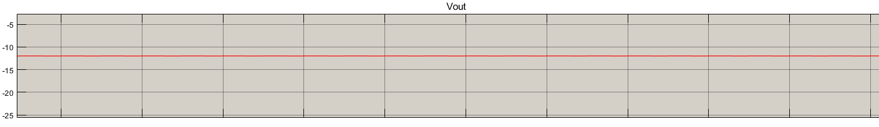

*Figure 10 – Output voltage waveform of Cuk Converter*

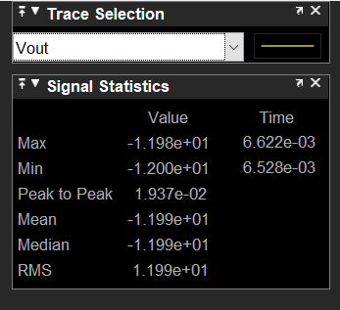

*Figure 11 – Data Statisctics of output voltage waveform of Cuk Converter*

$$ΔV_{c1}=\frac{1}{C_{1}}I_{L1}\left(1-D\right)T_{s} (9)$$

$$ΔV_{c1}=\frac{1}{18*{10}^{-6}}4.08\left(1-4/7\right){10}^{-5}=0.9 V$$

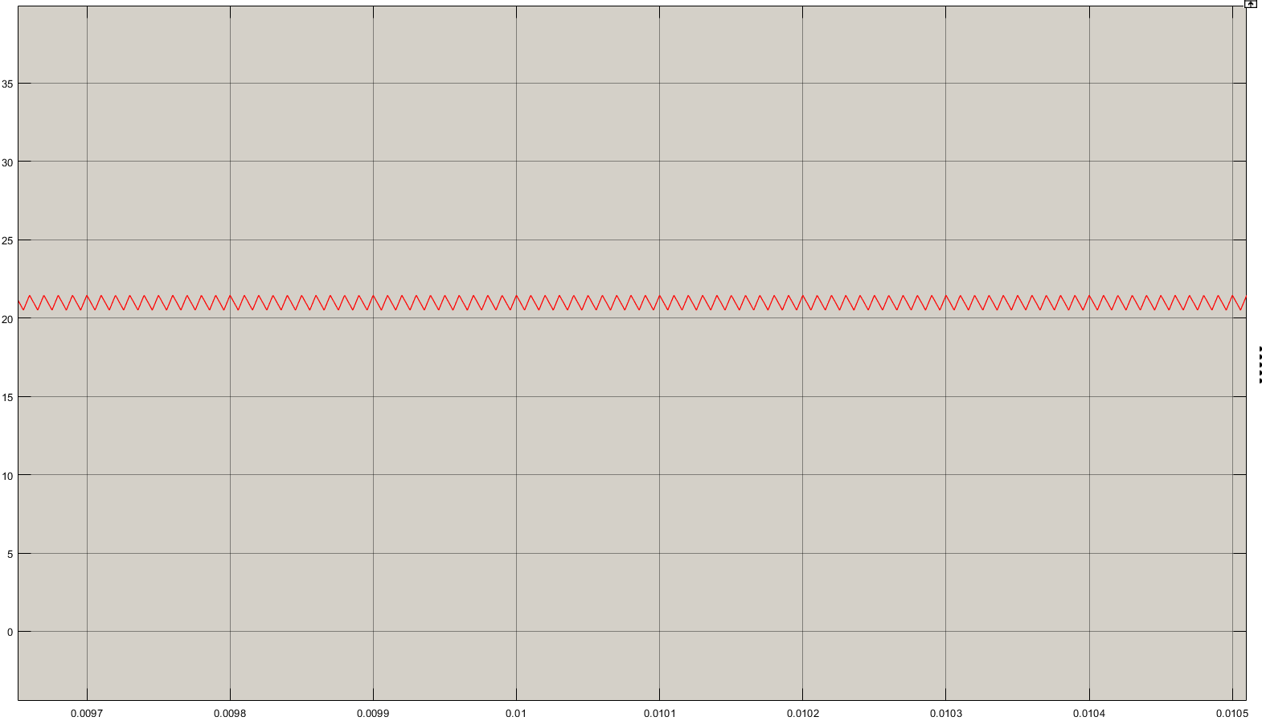

*Figure 12 – Capacitor1 voltage waveform of Cuk Converter*

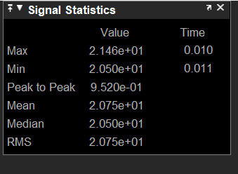

*Figure 13 – Data Statisctics of capacitor1 waveform of Cuk Converter*

## d)

Our system was designed open loop. We assumed that the input voltage is constant. At this point, our system will be converted closed loop system that provides constant output voltage.

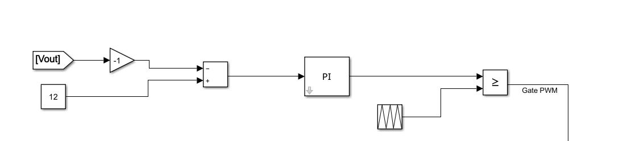

*Figure 14 – Design schematic of Cuk Converter*

There is a reference output voltage and the duty is adjusted by using output voltage error. Input voltages was given as changing between 8-10 V at periodically.

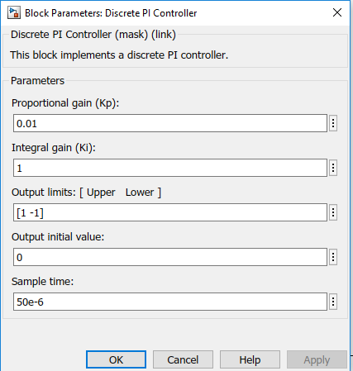

*Figure 15 – PI Controller parameters of Cuk Converter*

Proportional and Integrated constant can be optimized to minimize error.

The output voltage, input voltage and desired output voltage are shown at Figure 16.

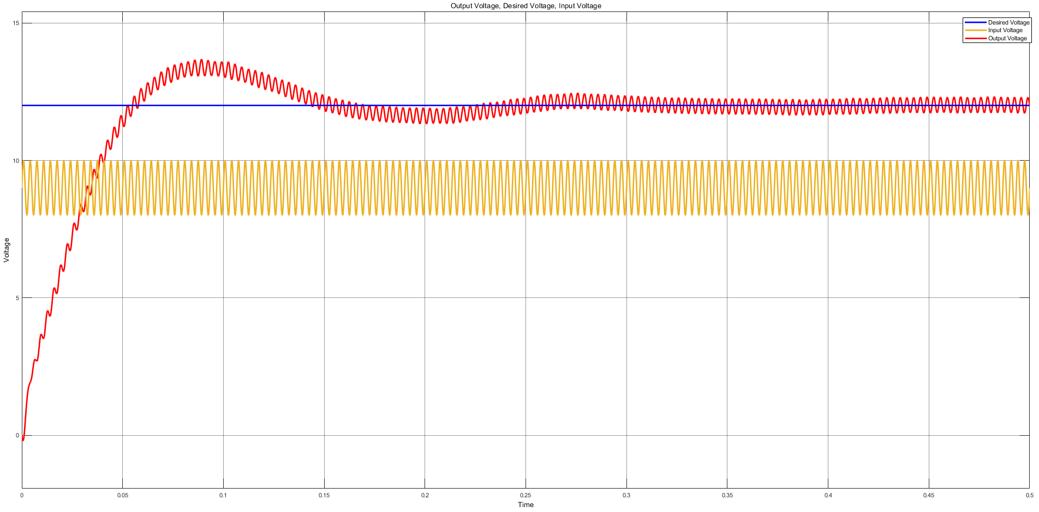

*Figure 16 – Output voltage, input voltage and desired output voltage waveform of Cuk Converter*

As seen that the output voltage is not constant. There are some ripples at output voltage. The ripple is 5.55 percent as shown Figure 16.

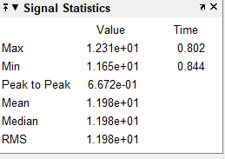

*Figure 17 – Data Statisctics of output voltage waveform of Cuk Converter*

## e)

At this point, the disturbance occurred instantaneously. The input voltage is like step waveform initially 9 V and finally 11 V.

PI controller was used like part D.

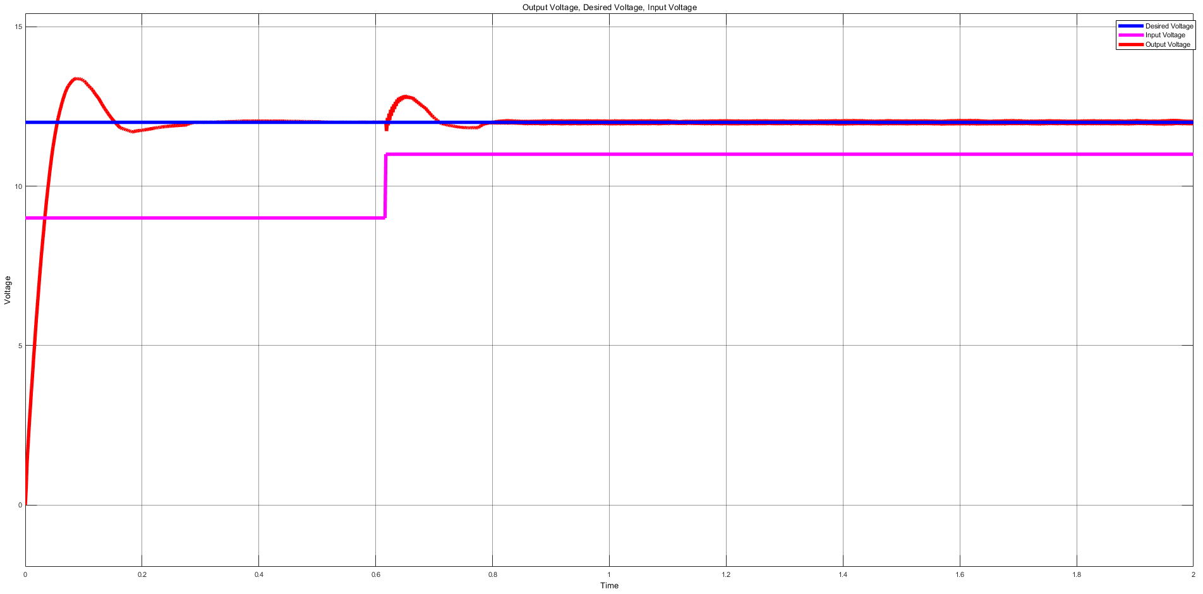

*Figure 18 – Output voltage, input voltage and desired output voltage waveform of Cuk Converter*

The output voltage is over-shooting characteristic, then it reach the desired output level. There is no steady state error.

# Conclusion

In this project, we have worked on Cuk Converter. We designed a Cuk converter according to desired specifications and we observed the input, output current and voltage waveforms for on and off states. We compared waveform results with buck-boost converter. Moreover, we designed a controller loop to provide constant output voltage instead of constant input voltage. In the end of this project, we learned basic working principles of Cuk converters, also we observed the defined advantages and disadvantages about usage of these tools.

As a result, since Cuk converters are preferred DC-DC converters in power-electronic areas, this project let us to encourage our engineering knowledge.