

MIDDLE EAST TECHNICAL UNIVERSITY

Electrical and Electronics Engineering Department

EE568 Selected Topics on Electrical Mahines

PROJECT 1

Enes AYAZ 2093318

# Introduction

In this project, coaxial structured contactless slip ring (CSR), shown in figure 1, will be investigated analytically and by FEA. CSRs are used to energize rotating systems such as robot arms, field excitations of synchronous machines, and radar systems. The system consists of two main part: transmitter (Tx) and receiver (Rx) coils. The system power transfer capability and efficiency are directly affected by the mutual coupling between Tx and Rx. Therefore, in addition to Tx- Rx coil inductance, the mutual inductance should be considered in the design stage. Furthermore, CSRs are mostly mounted over a rotating shaft, which is made up of permeable material such steel, iron. Thus, eddy losses can be generated on this shaft, which also should be considered in the design stage of CSR.

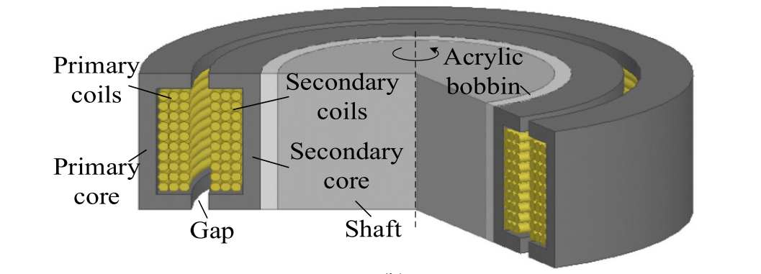

Figure 1 Coaxial Structured Contactless Slip Ring. [1]

In the project, a required inductance values and current ratings are given in Table 1.

Table 1 : Indıuctances of CSR and Current Ratings.

|  |  |
| --- | --- |
|  |  |
|  |  |
|  |  |
|  |  |
|  |  |

In this report, there are three section. Firstly, an analytical model of coaxial CSR is created. Inductance and reluctance of the CSR are formulated. Secondly, 2D finite element analysis with linear material is made by using Ansys Maxwell software. In this part, flux density vectors are plotted. Also, inductances are calculated for different configuration. The analytical model and FEA results are compared. Finally, design methods are investigated to adjust mutual inductances with self-inductances of Tx and Rx.

# Analytical Modelling

2d z-symmetric model of coaxial contactless slip ring and its parametric dimension are given in figure 2.

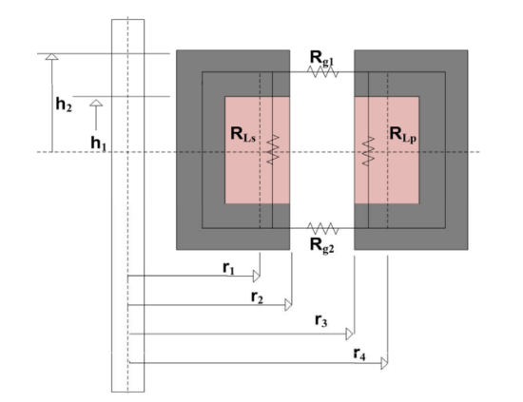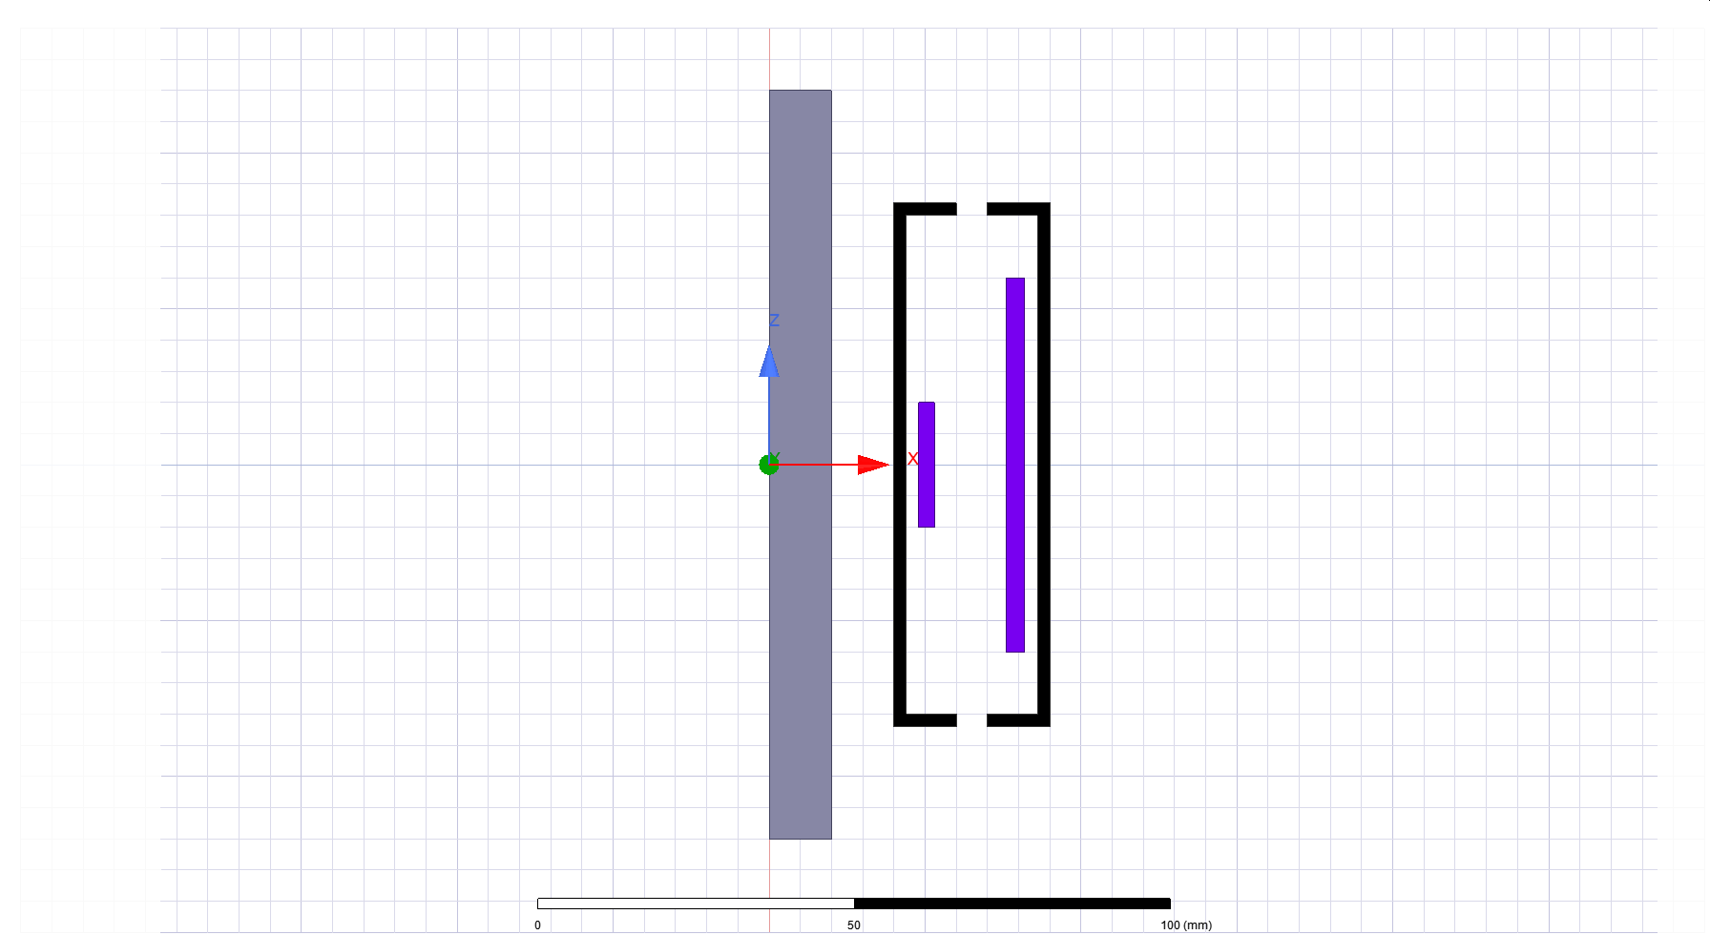

1. (b)

Figure 2 Coaxial contactless slip ring. a) 2d z-symmetric model. b) Parametric dimensions. [2]

Derivation of the reluctance and inductance of the system is calculated by assuming all turns are included to each flux, which can be divided into leakage and mutual fluxes.

|  |  |
| --- | --- |
| **Parameter** | **Coaxial Reluctance** |
|  |  |
|  |  |
|  |  |
|  |  |

The inductances can be calculated using the reluctances and turns ratio as given in

The inductances can be calculated using the reluctances and turns ratio as given in Table 2.

|  |  |
| --- | --- |
| **Inductance** | **Inductance** |
|  |  |
|  |  |
|  |  |

Table Inductances of CSR

# FEA

2d z-symmetrical model of coaxial CSR system is created, shown in X.

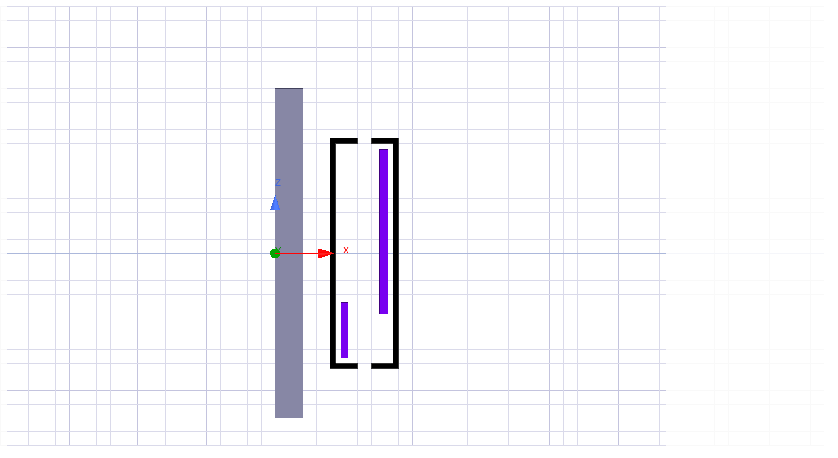

Shaft losses

Shaft 10mm away : 64-24 = 40 W

Shaft 20mm away: 28-27 = 1W

# Conclusion

APPENDIX

* Analytical Model is given at the page.
* FEA-Maxwell is given at the page.
* Bonus part is given in page.