

MIDDLE EAST TECHNICAL UNIVERSITY

Electrical and Electronics Engineering Department

EE568 Selected Topics on Electrical Machines

PROJECT 1

MOTOR Winding Design and Analysis

Enes AYAZ 2093318

# Introduction

In this report, motor winding design is investigated. Firstly, integral slot winding is designed and the effect of distribution factor and pitch angle on the coil voltages. Harmonic elimination by using under-pitch coil is analyzed. Secondly, a fractional slot winding is analyzed for chosen slot and pole number. The voltages of the coils are calculated by using phasors and 3rd and 5th harmonics contribution is calculated. Then, effect of changing slot number at the same pole number is analyzed and the two results are compared. Finally, finite element analysis is made for fractional slot windings. Induced emf and airgap flux distribution will be observed and cogging torque is calculated.

# Integral Slot Winding Design

We have a 20-pole,120 slot, 3-phase machine. For distributed coils, algebraic sum of the coil voltages are not equal to vector sum of the coil voltages. The differences can be formulated with respect to coil numbers electrical angle between two coils and harmonic numbers .

(1)

Also, the voltage of two coils are summed arithmetically, if the electrical angle between two coils are 180°, so full-pitched. Tangle between two coils are bigger than 180°, named as over-pitch coils or smaller than 180°, named as under-pitch coil. It can be formulated with respect to electrical pitch angle between two coils and harmonic numbers . Also, the pitch angle can be used to eliminate the harmonics.

(2)

Design is chosen as 120° pitch angle to eliminate 5th harmonics.

* First of all, number of slots per pole per phase is calculated as

In this part, design is shown for only a pole-pair (2 pole).

|  |  |  |  |  |  |  |  |  |  |  |  |
| --- | --- | --- | --- | --- | --- | --- | --- | --- | --- | --- | --- |
| A1 | A2 | -B1 | -B2 | C1 | C2 | -A3 | -A4 | B3 | B4 | -C3 | -C4 |
| B3 | B4 | C3 | C4 | -A1 | -A2 | -B1 | -B2 | -C1 | -C2 | A3 | A4 |

* By using formula 1 and 2, and taken the variables as:

Winding factor is calculated by multiplying distribution and pitch factor.



0



* Distributed winding causes a small voltage drops due to vector sum of the voltages and it is formulated as distribution factor. The distribution winding factor is smaller if the harmonic number increases. Thus, distribution winding attenuates the harmonics respectively increasing order. Also, coil pitch can be adjusted to eliminate a harmonic. In this part, it is chosen as 120 degree to eliminate harmonic. Thus, there is no voltage contribution from harmonic.

# Fractional Slot Winding Design

In this part, 3-phase permanent-magnet synchronous machine with fractional-slot winding will be analyzed. Firstly, pole number and slot number are chosen by using [Emetor](https://www.emetor.com/windings/). Pole number is chosen as 20 and slot number is chosen as 24 because the configuration brings high winding factor as 0.966.

* slot= 24, pole=20, phase =3 🡺 q=

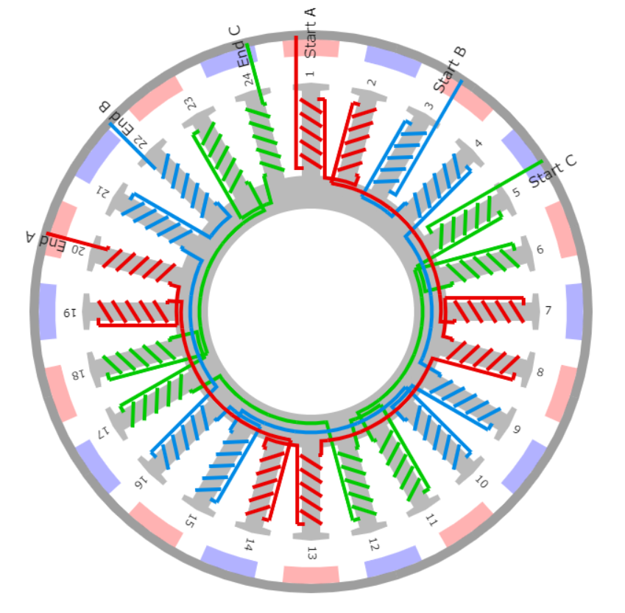

|  |  |  |  |  |  |  |  |  |  |  |  |  |  |  |  |  |  |  |  |  |  |  |  |  |
| --- | --- | --- | --- | --- | --- | --- | --- | --- | --- | --- | --- | --- | --- | --- | --- | --- | --- | --- | --- | --- | --- | --- | --- | --- |
| Slot | 1 | 2 | 3 | 4 | 5 | 6 | 7 | 8 | 9 | 10 | 11 | 12 | 13 | 14 | 15 | 16 | 17 | 18 | 19 | 20 | 21 | 22 | 23 | 24 |
| Degree  (Elec) | 0 | 150 | 300 | 450 | 600 | 750 | 900 | 1050 | 1200 | 1350 | 1500 | 1650 | 1800 | 1950 | 2100 | 2250 | 2400 | 2550 | 2700 | 2850 | 3000 | 3150 | 3300 | 3450 |
| Degree  (Elec) | 0 | 150 | 300 | 90 | 240 | 30 | 180 | 330 | 120 | 270 | 60 | 210 | 0 | 150 | 300 | 90 | 240 | 30 | 180 | 330 | 120 | 270 | 60 | 210 |
| Phase | A1 | -A1 | -B1 | B1 | C1 | -C1 | -A2 | A2 | B2 | -B2 | -C2 | C2 | A3 | -A3 | -B3 | B3 | C3 | +C3 | -A4 | A4 | B4 | -B4 | -C4 | C4 |

* The phasor diagram for only positive coils of phase A is shown figure X.

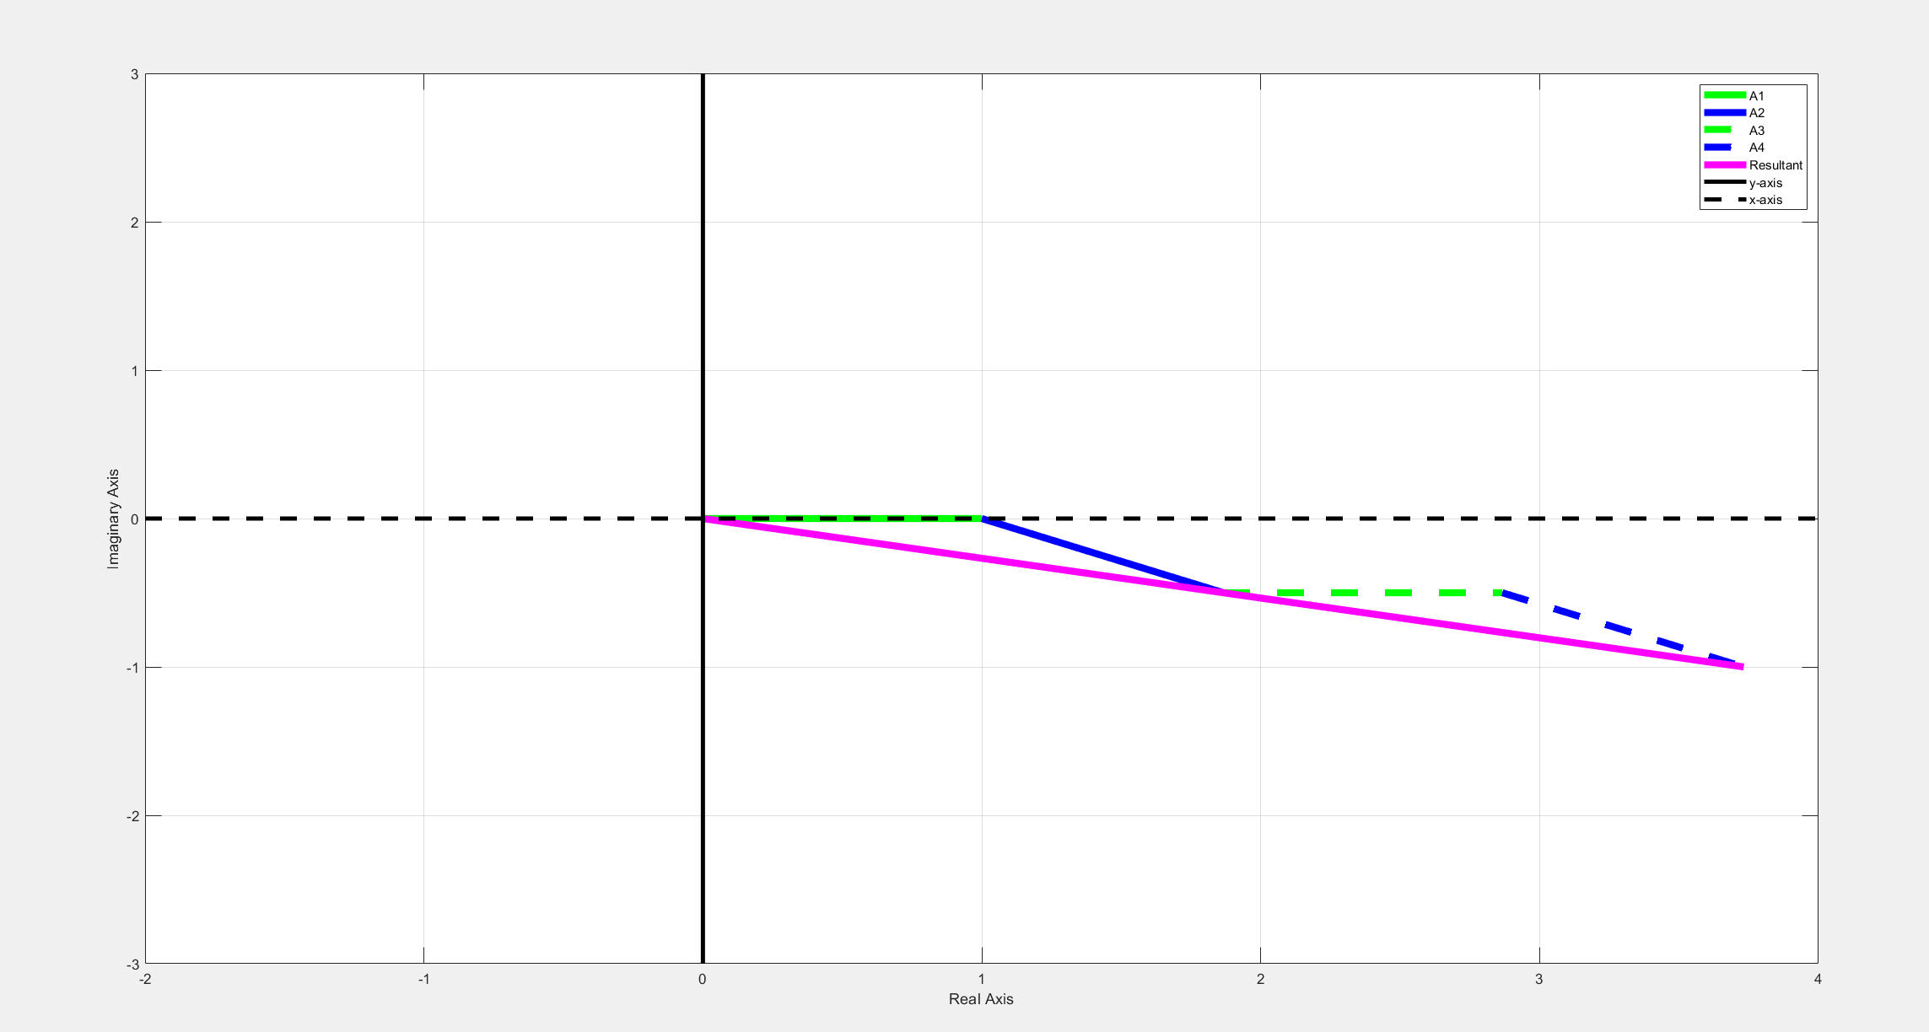

For calculation of winding factor, only for A1 and A2 can be calculated thanks to A3 and A4 the same as A1 and A2. Also, pitch angle is 150 degree.

For 3rd and 5th harmonic winding factor is calculated as:

* Slot number is changing with 21 and pole number is 20.

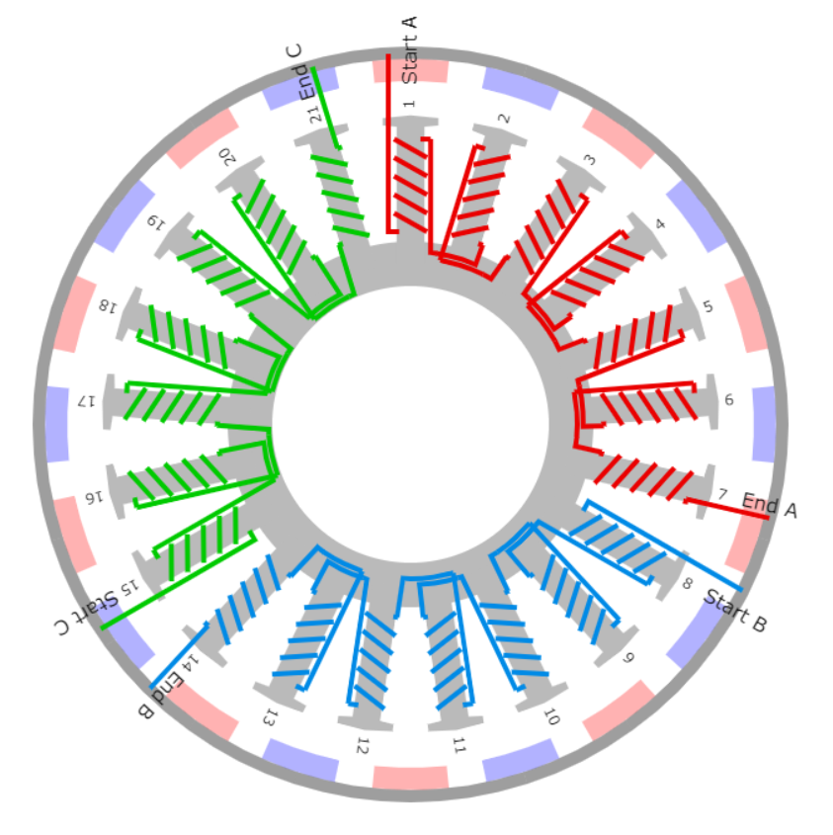

* slot= 21, pole=20, phase =3 🡺 q=0.35

|  |  |  |  |  |  |  |  |  |  |  |  |  |  |  |  |  |  |  |  |  |  |
| --- | --- | --- | --- | --- | --- | --- | --- | --- | --- | --- | --- | --- | --- | --- | --- | --- | --- | --- | --- | --- | --- |
| Slot | 1 | 2 | 3 | 4 | 5 | 6 | 7 | 8 | 9 | 10 | 11 | 12 | 13 | 14 | 15 | 16 | 17 | 18 | 19 | 20 | 21 |
| Degree  (Elec) | 0 | 171 | 342 | 513 | 684 | 855 | 1026 | 1197 | 1368 | 1539 | 1710 | 1881 | 2052 | 2223 | 2394 | 2565 | 2736 | 2907 | 3078 | 3249 | 3420 |
| Degree  (Elec) | 0 | 171 | 342 | 153 | 324 | 135 | 306 | 117 | 288 | 99 | 270 | 81 | 252 | 63 | 234 | 45 | 216 | 27 | 198 | 9 | 180 |
| Phase | A1 | -A1 | A2 | -A2 | A3 | -A3 | A4 | B1 | -B1 | B2 | -B2 | B3 | -B3 | B4 | C1 | -C1 | C2 | -C2 | C3 | -C3 | C4 |

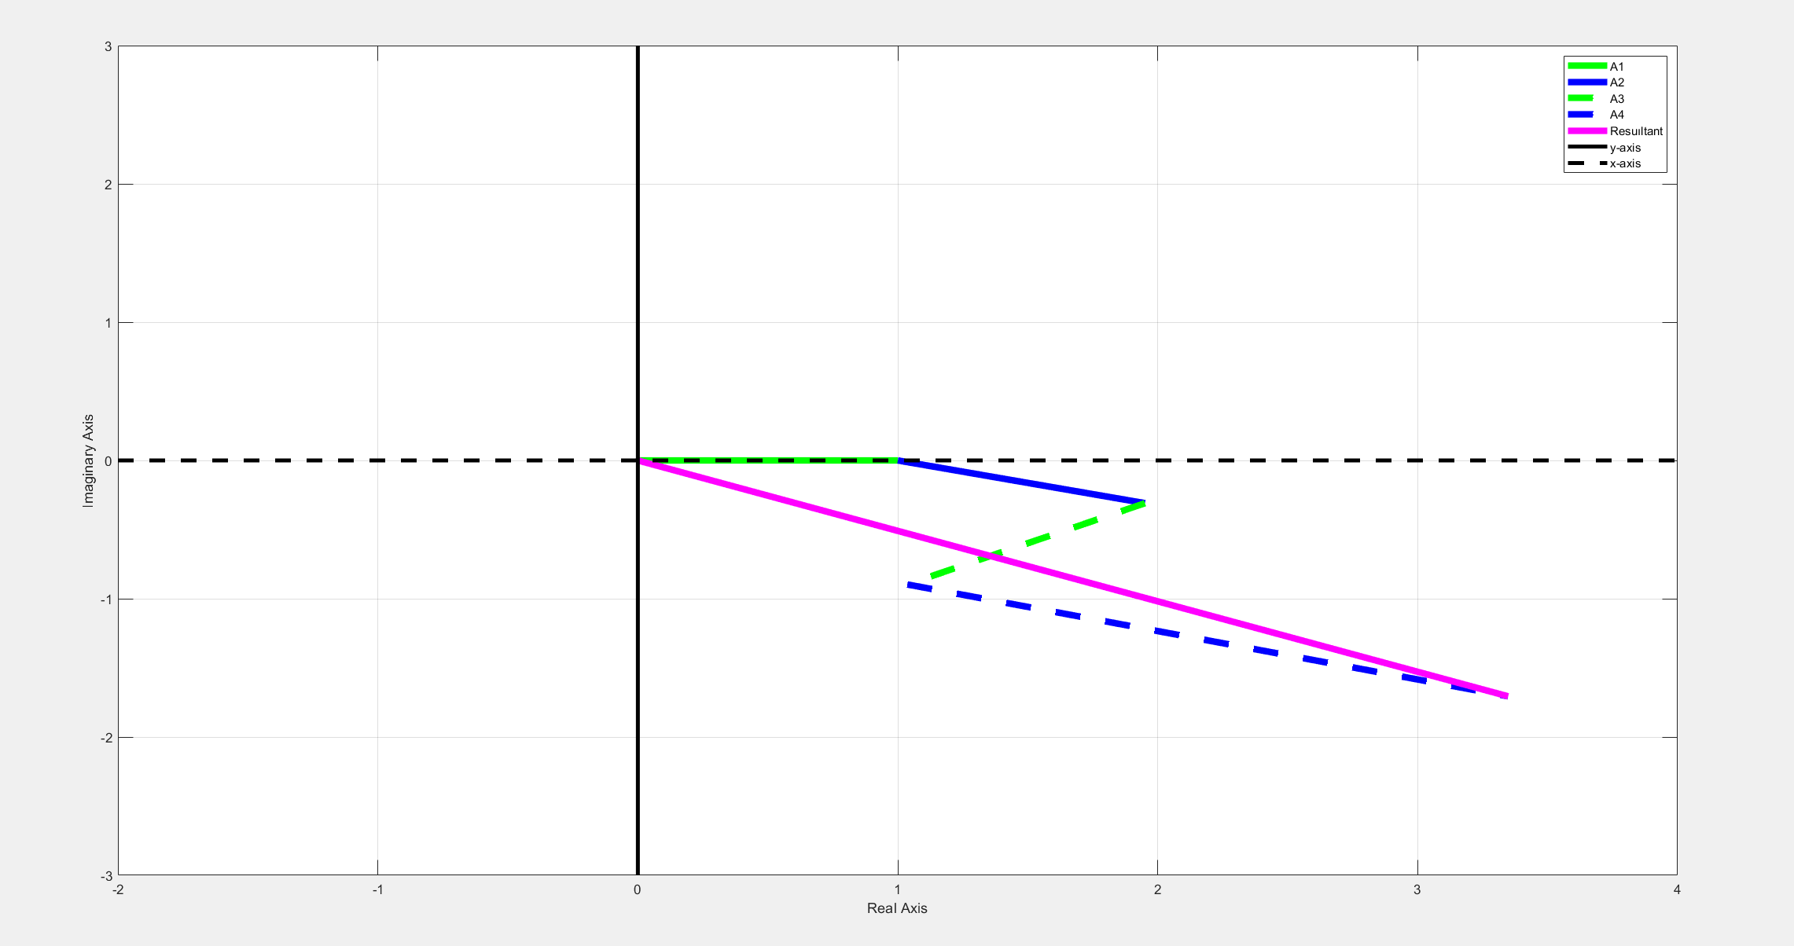

For 3rd and 5th harmonic winding factor is calculated as:

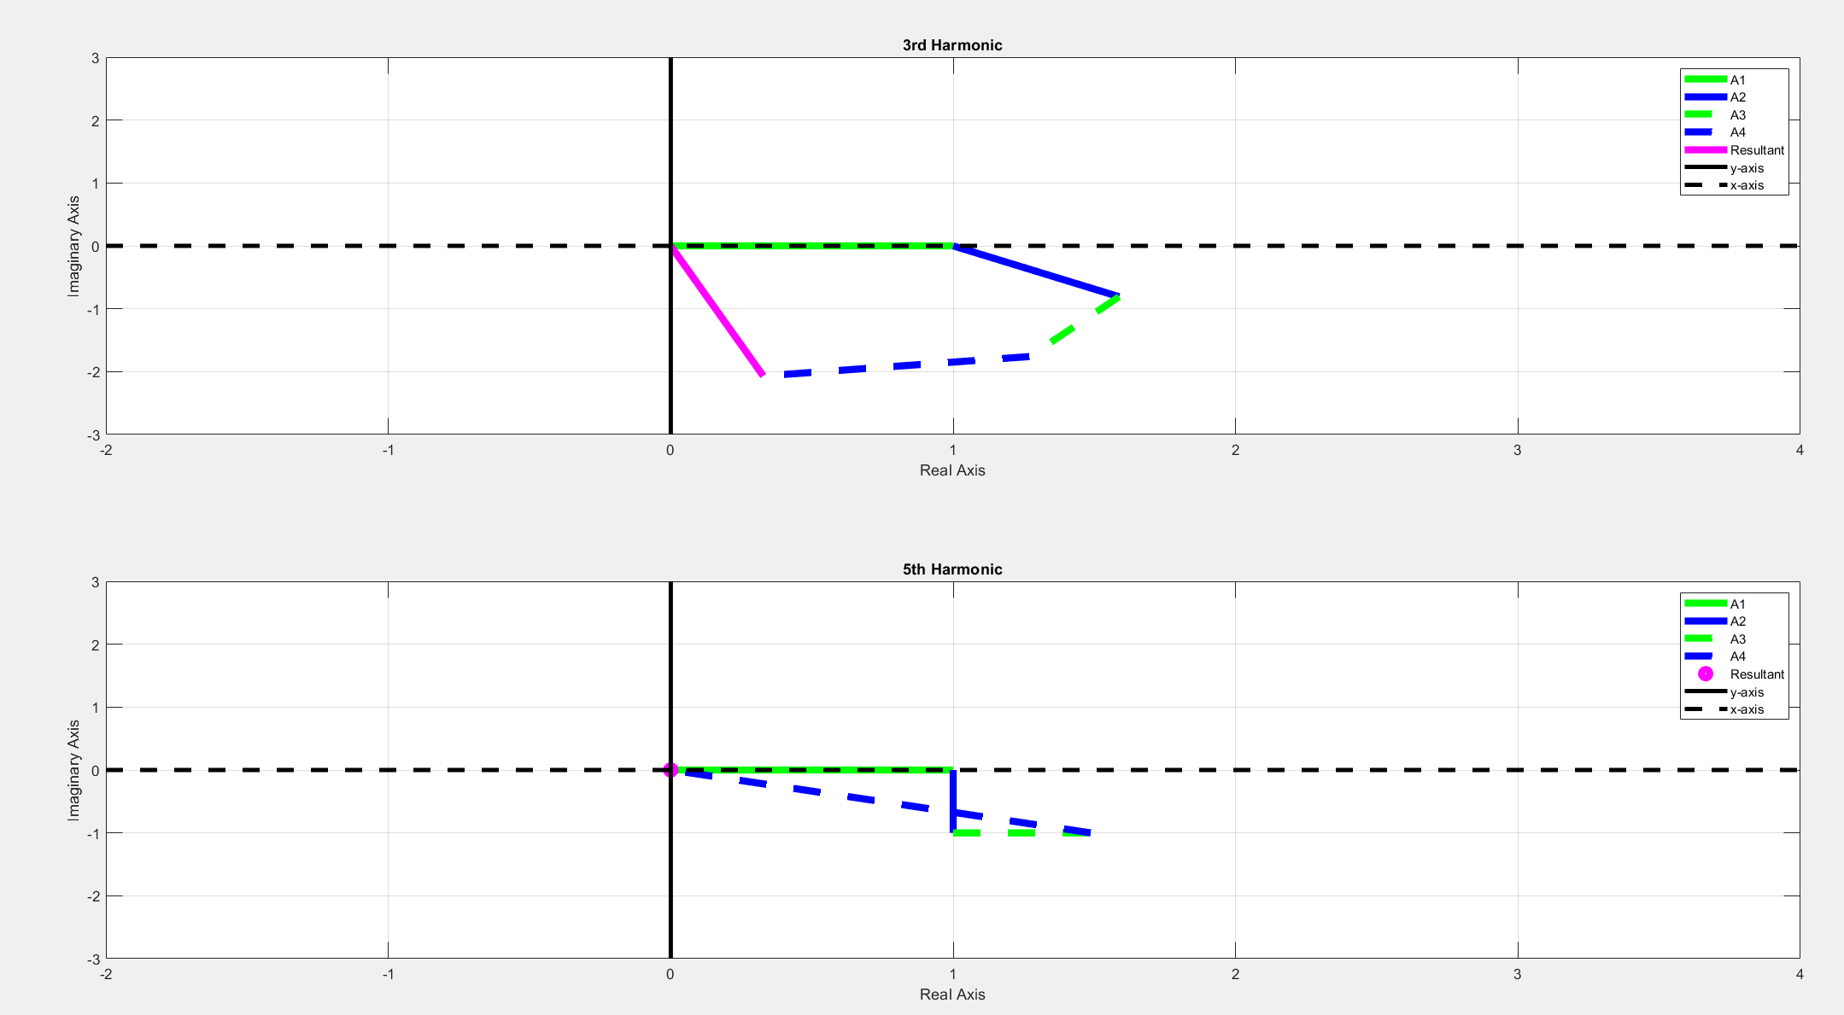

Q3)

24 slot 20 pole 3 phase machine is drawn by Maxwell 2D. Field is fed by DC current to create the magnetic poles. Stator side is 3 phase fractional pitch coil.

A

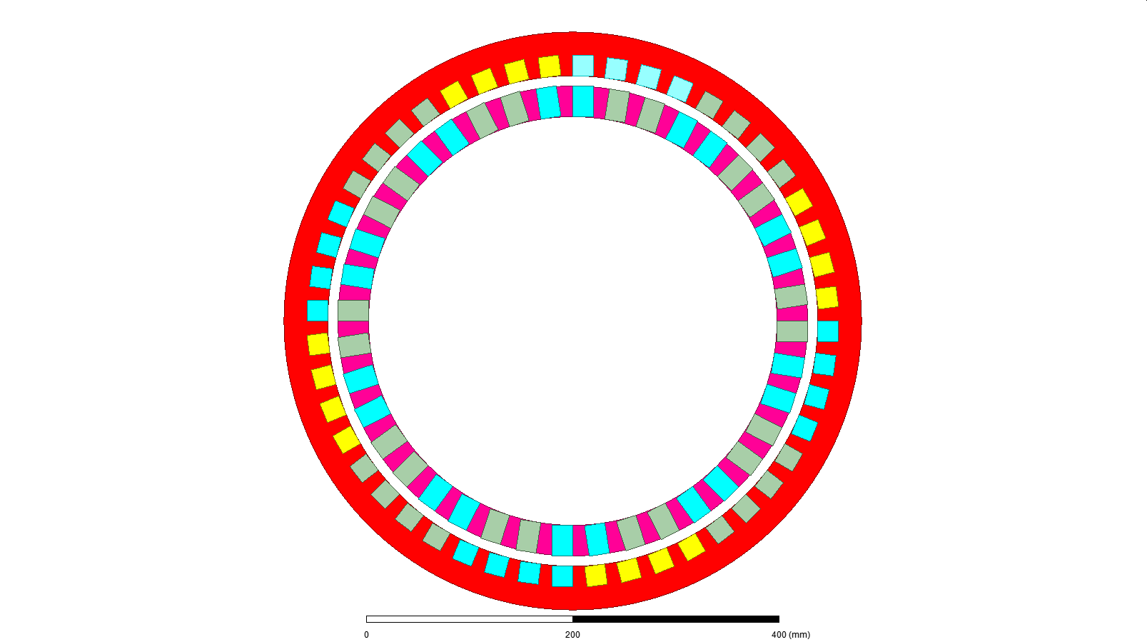

Field Neg

Field Pos

spPos

C

-B

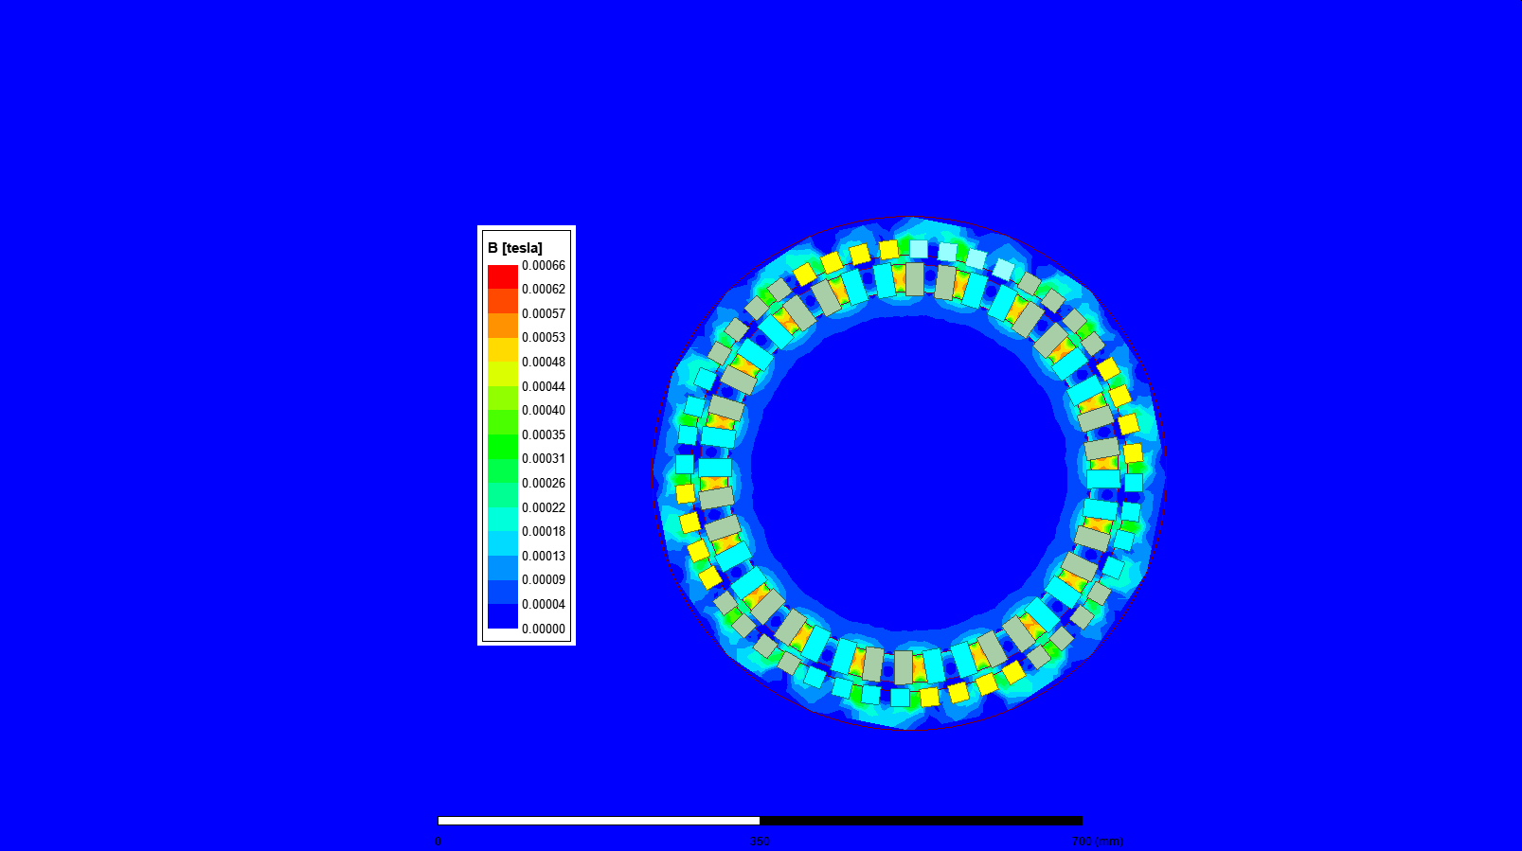

# 

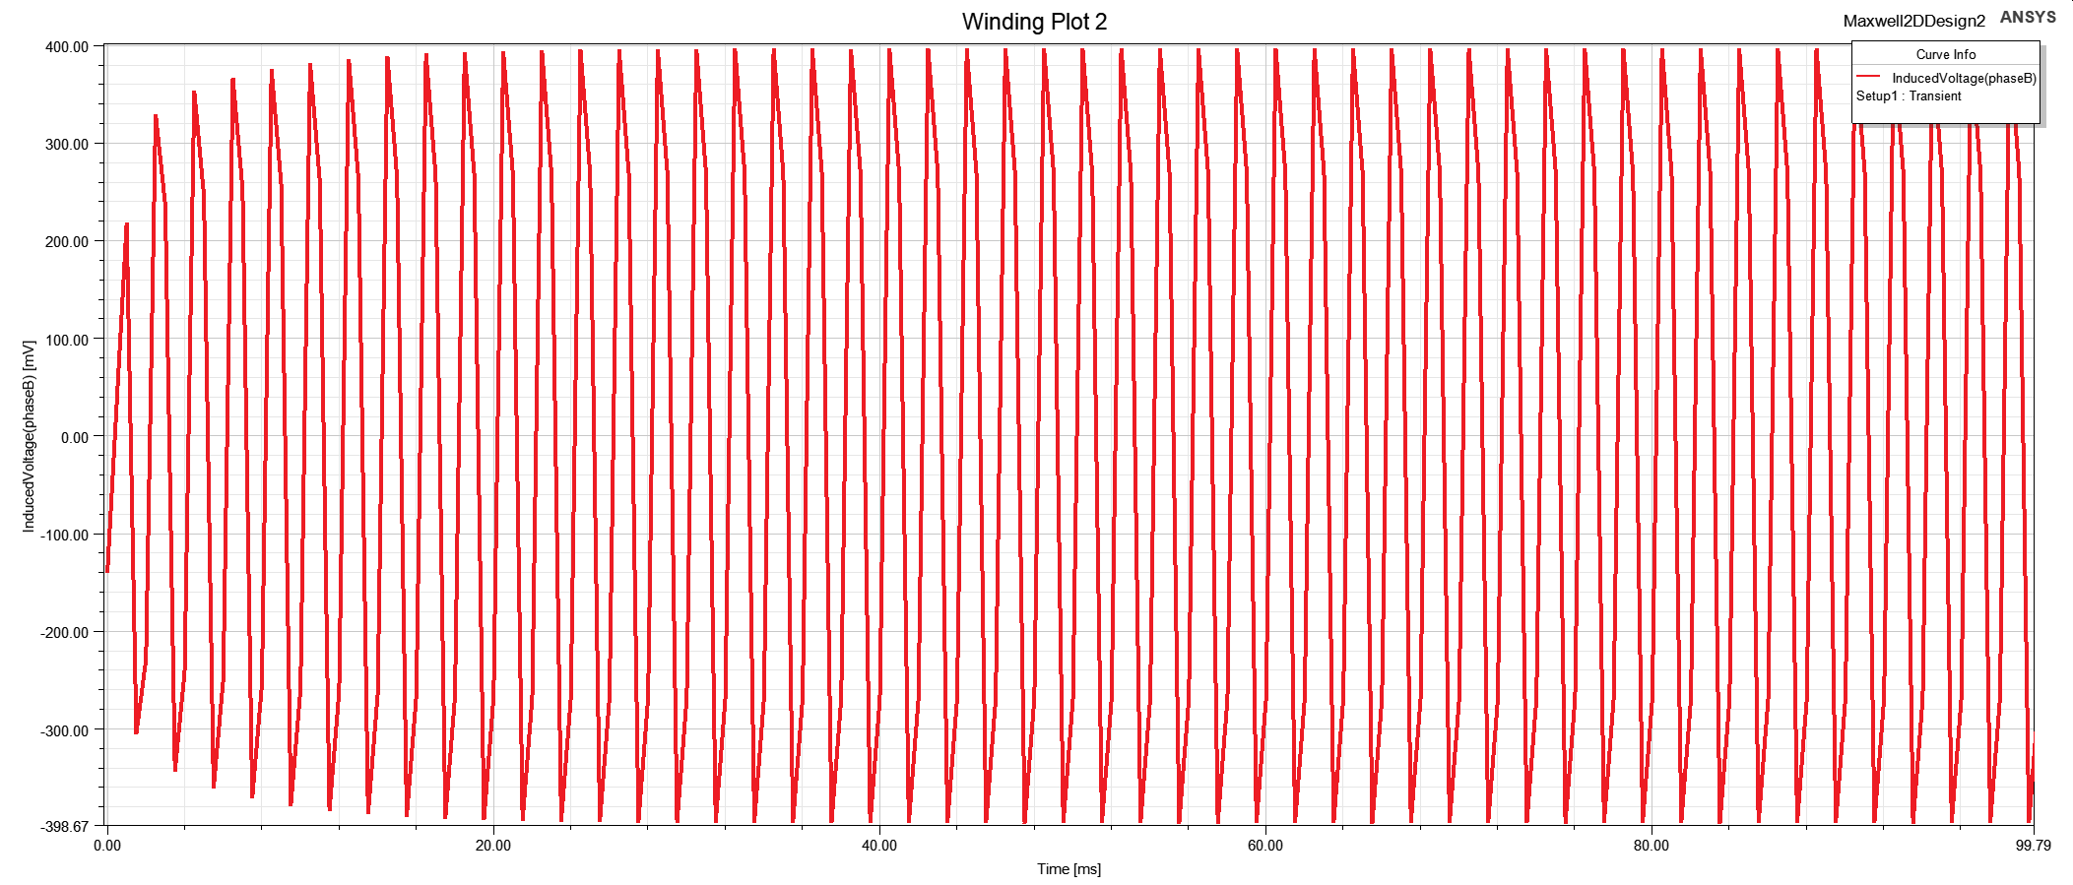

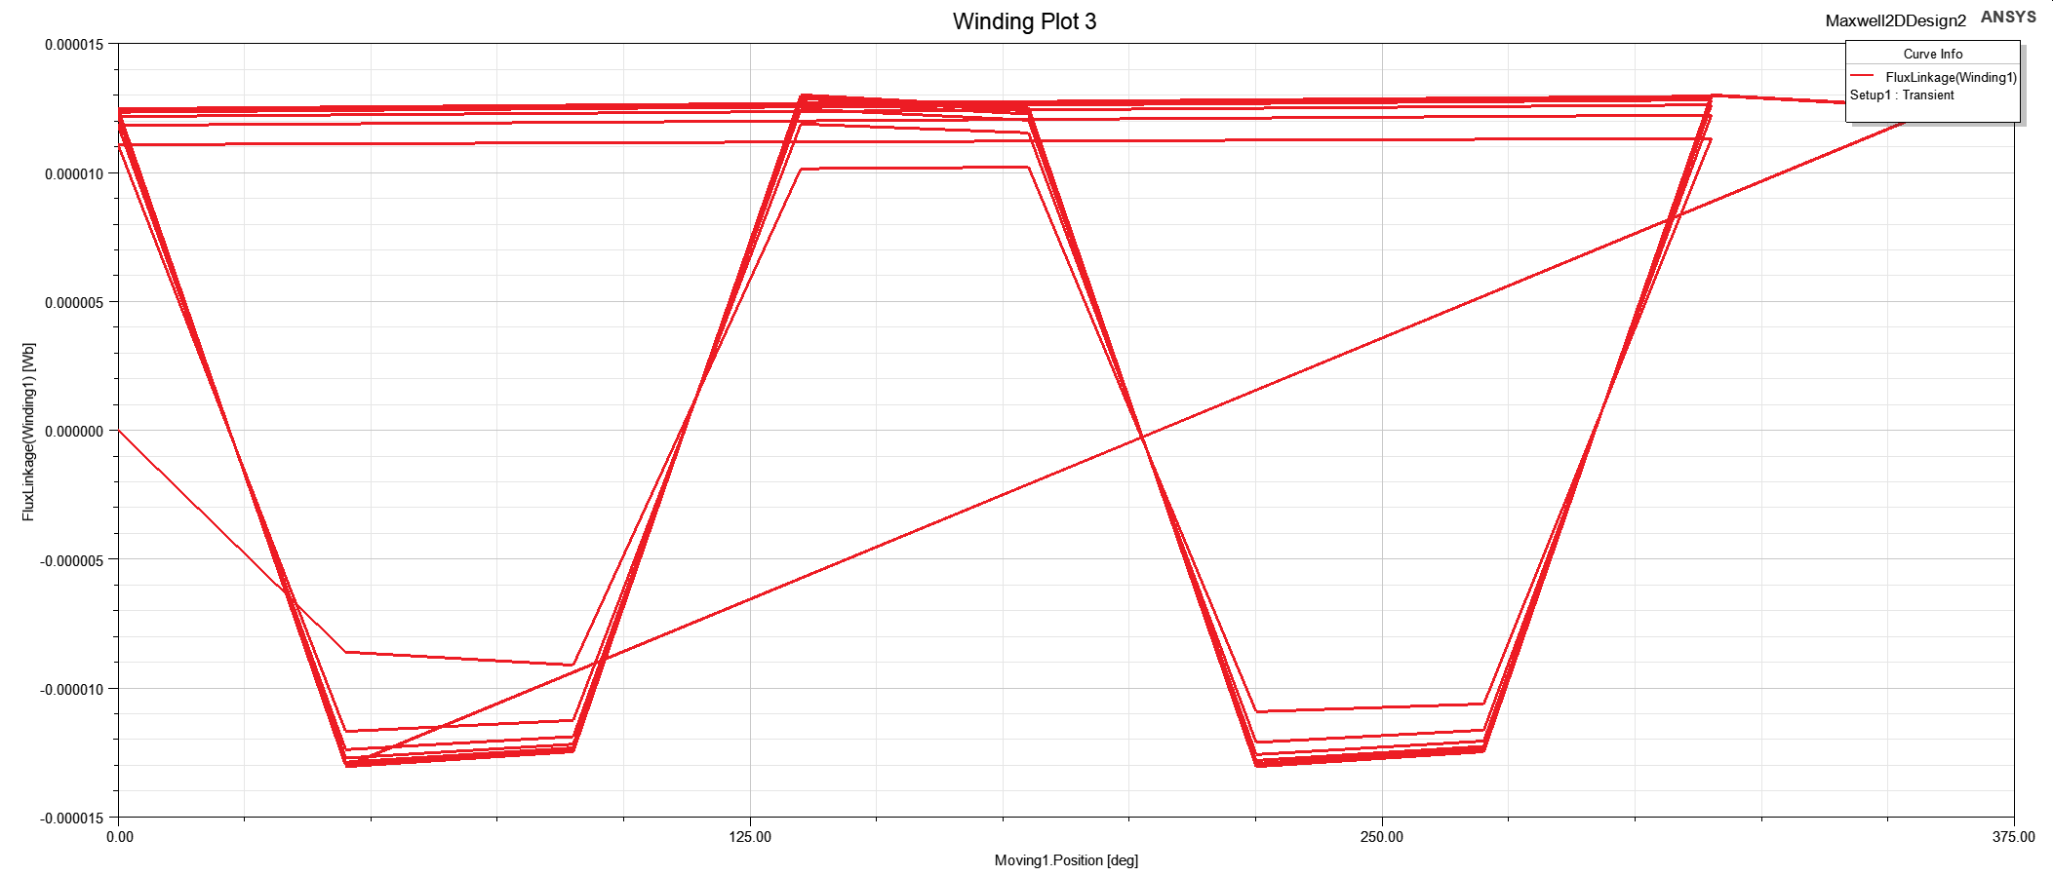

# Conclusion

In this report, different motor winding designs are compared. Firstly, integral slot winding is investigated and we observe that winding factor is attenuated with increasing harmonics. Thus, fundamental induced voltage of coil is dominant. Secondly, different fractional slot winding designs are investigated. It is observed that the fractional slot windings decreases end windings for the same vectors of voltage phasors. Also, it is observed that fractional slot windings can be used to eliminate some harmonics. Finally, finite element analysis for motor design is made and the analytical calculation for a design is validated by finite element analysis.