

MIDDLE EAST TECHNICAL UNIVERSITY

Electrical and Electronics Engineering Department

EE568 Selected Topics on Electrical Machines

PROJECT 3

PM MOTOR COMPARISON ANALYSIS

Enes AYAZ 2093318

# Introduction

In this report surface-mount permanent magnet (SMPM) machines will be investigated. In the first section, magnetic loading of given SMPM machine will be analyzed analytically and the results are validated by FEA tool. In the second section, we design of the stator side of this machine and we will calculate electrical loading analytically and magnetic stress from tangential part of the magnetic field. In addition, the output power will be calculated for rotor speed of 1500 rpm. Third section, we will design a PMSM with rectangular slot-tooth with a 160mm outer diameter. Slot ratio and rotor diameter is estimated for maximum torque. In addition, electrical and magnetic loading will be calculated for the estimations. The results are compared with section 1 and 2 design by using FEA. After design, the magnet NdFeB is replaced by Ferrite magnets and machine with same parameters will be investigated. In addition, the machine will be optimized and compared with previous design.

# Magnetic Loading

In this section, we analyzed the PMSM with constant parameters in table 1.

Table Parameter of the SMPM machine

|  |  |
| --- | --- |
|  |  |
|  |  |
|  |  |
|  |  |
|  |  |
|  |  |
|  |  |
|  |  |

1. Magnetic equivalent circuit for one pole-pair includes the flux sources and reluctances which are belongs to magnets, airgap, stator and rotor material and leakage. The equivalent circuit is shown figure 1 and we can simplify the circuit as figure 2.

|  |  |
| --- | --- |
| Figure The equivalent circuit for one pole-pair | Figure The simplified circuit for one pole-pair |

The magnetic circuit can be solved in two ways. One of them is load-line method. The characteristic of the magnet and airgap are drawn in B-H coordinate system. The load line method is shown in figure 3.

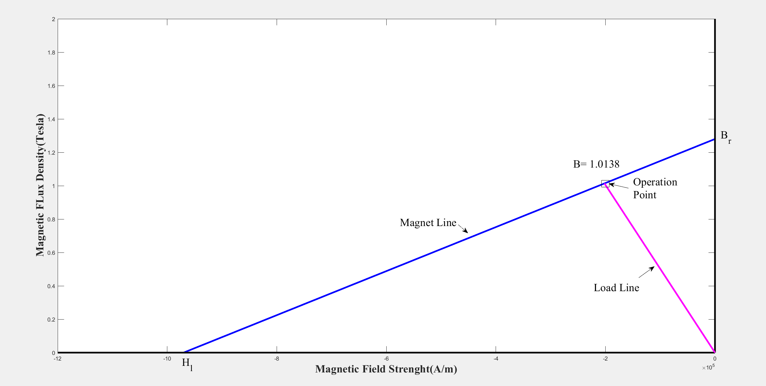

Figure Load-line Method

Also, we can solve the problem with analytically. In figure 2 , we MMF is found with respect to magnet parameters. In addition, the is also written in the kind of .

(1)

(2)

(3)

(4)

We can calculate operation point of magnetic field density in the kind of remanence magnetic field of magnets, magnet length, airgap length and relative permeability of the magnet. We solved the equation and we find that:

(5)

1. Magnetic loading is the total flux in the airgap of a machine. We know that magnet to pole pitch ratio is 0.8 and the total pole area is calculated as:

(6)

Then we know that flux density at airgap is 1.0138 T. Then magnetic loading is :

(7)

1. The airgap flux density is found by using Maxwell 2D model shown in figure 4.

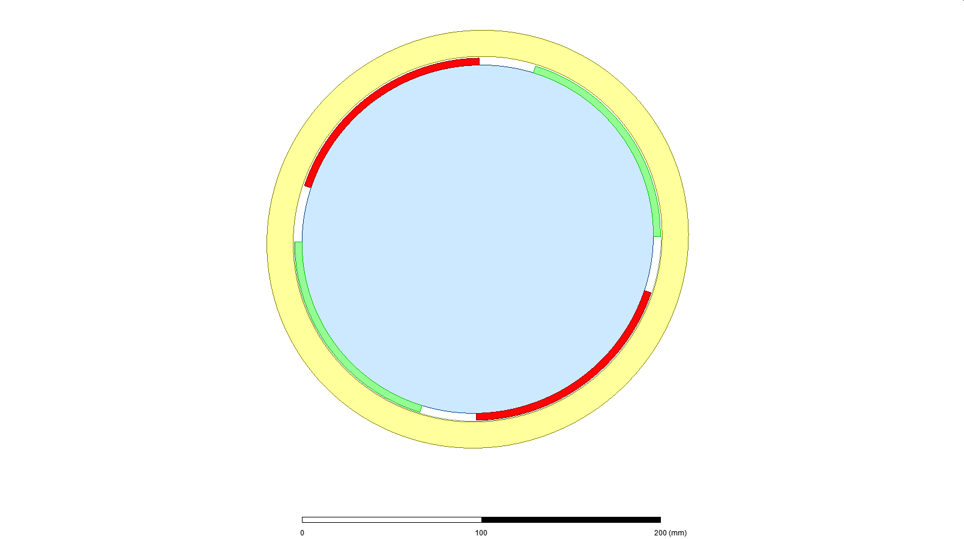

Figure 4-pole PMSM machine with solid stator

(Red: North Poles, Green: South Poles, Yellow: Stator, Blue: Rotor)

The airgap flux density is calculated mid-point airgap. The flux density from FEA distribution are shown at figure 5 and also the data points are drawn by Matlab at figure 6.

|  |
| --- |
| Figure Airgap Flux Distribution from FEA plot |
| Figure Airgap Flux Distribution from Matlab plot |

The FEA results show that at airgap. The difference between analytical and FEA is . FEA result is smaller than analytical result. The stator and rotor permeability are taken as infinite and leakage flux is ignored at analytical calculation. The differences are stem from these assumptions.

# Electrical Loading and Machine Sizing

1. In this section, we choose a slot number for the machine, used at first section. We choose the slot number is 12 by using the [online winding factor calculator](https://www.emetor.com/windings/). Thus, the motor is integral slot and slot per pole per phase is one. Thus, winding factor is 1.
2. By using current and maximum current density, we calculate the required diameter of the cable to provide the current rating.

(8)

(9)

We can choose AWG-20 cable (). The cable is in safe for the rating.

1. We can use rule of thumbs and choose outer diameter is 198 cm (for 4 pole). Also, we know that slot ratio of 0.5 gives the maximum torque. However, the outer diameter restricts the slot ratio. We choose the slot ratio is 0.75 which gives 35 mm slot height with inner diameter 105 mm and outer diameter 140 mm.

Also, we have 12 slots and total slot-tooth length is which give a per slot-tooth. We choose the half of them is slot and other is tooth. It gives space for cables. The winding factor is given as 0.6 and we use AWG-20 cable.

1. Electrical loading is the total turn ratio of the cables for unit length of the airgap.

In the lecture, the desired electrical loading of the PMSM machine between 35-65 A/m. Thus, we say that our electrical loading is proper.

1. Average tangential stress depends on electrical loading and magnetic loading. taken as 90 for PMSM machines.

Force depends on torque and radius of the machine. Torque is calculated by volume of the rotor and tangential stress.

1. We can calculate the power by using Torque and motor speed. Motor speed is given 1500 rpm ().

# COMPARISON and OPTIMIZATION

In this part, we design a 10 pole 12 slot (fractional-slot) PMSM machine with NdFeB magnets and rectangular slot-tooth. Although we use basic rectangular stator slots, there are different types of slot such as open type, semi-closed type, tapered type. The types has some advantageous and disadvantageous. Open slots are easy to assembly but magnetic characteristics is worse than semi-closed slots.

1. We can estimate the rotor diameters and slot ratio by rule-of thumb. Slot ratio is 0.5 for maximum torque. Then, we can design a 10-pole machine with 160 mm outer diameter with 104 mm inner diameter. Thus, the 52 mm is rotor diameter.

Slot height is 50 mm and we can calculate width as 7.85 mm by using . The total slot area is 392.7 mm2. We can take the kw as 0.6 and use AWG-20 cable. We can find the turn ratio.

=472 Turn

Electric loading is calculated as:

We can decrease the our current as 1.9 A to adjust electric loading as .

Average tangential stress depends on electrical loading and magnetic loading. taken as 90 for PMSM machines.

Force depends on torque and radius of the machine. Torque is calculated by volume of the rotor and tangential stress. Length of motor is chosen as 100mm and rotor diameter is 50mm.

The machine is modelled by Maxwell 2D.

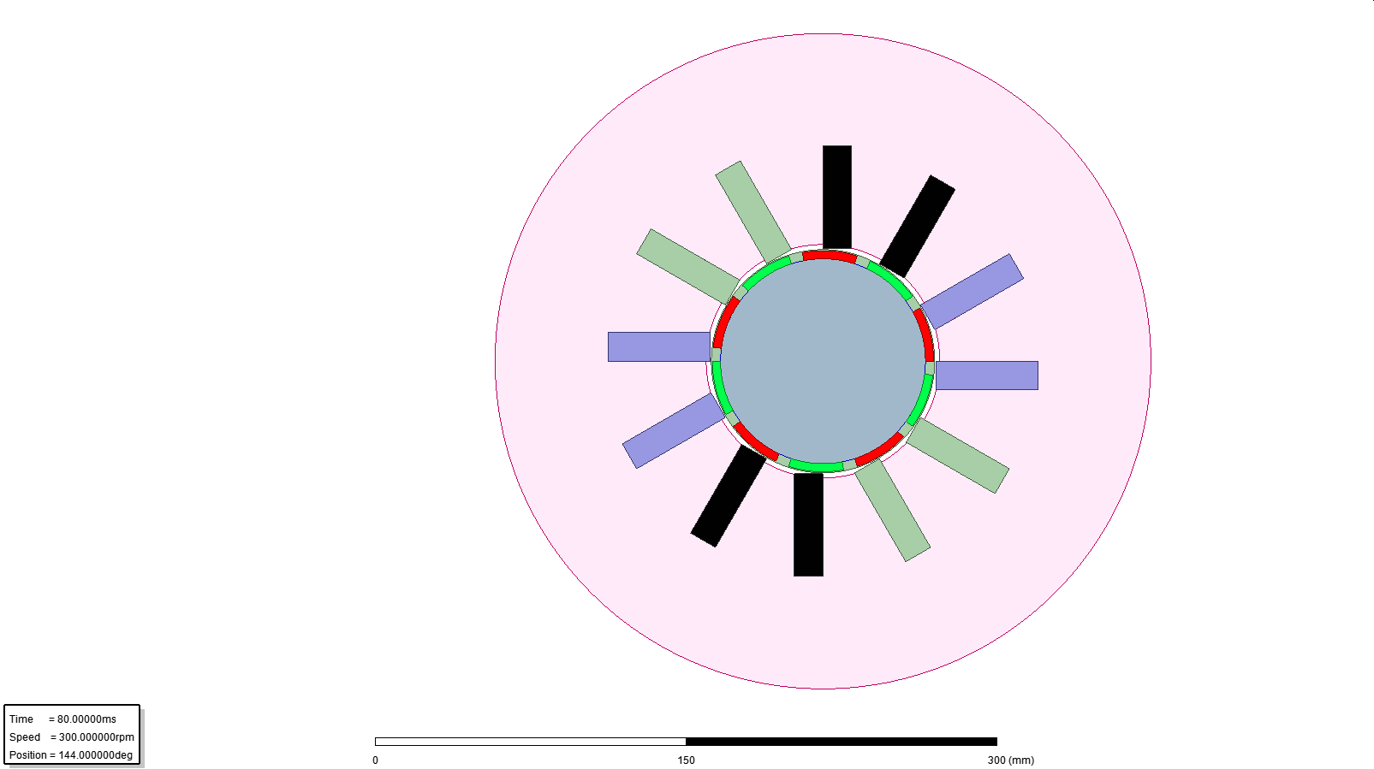

Figure 10 pole 12 slot PMSM Machine

The motor is excited by 1.9A 3phase current and it rotates at 300 rpm (50 Hz Electrical). Torque plot for one phase are shown at figure 8.

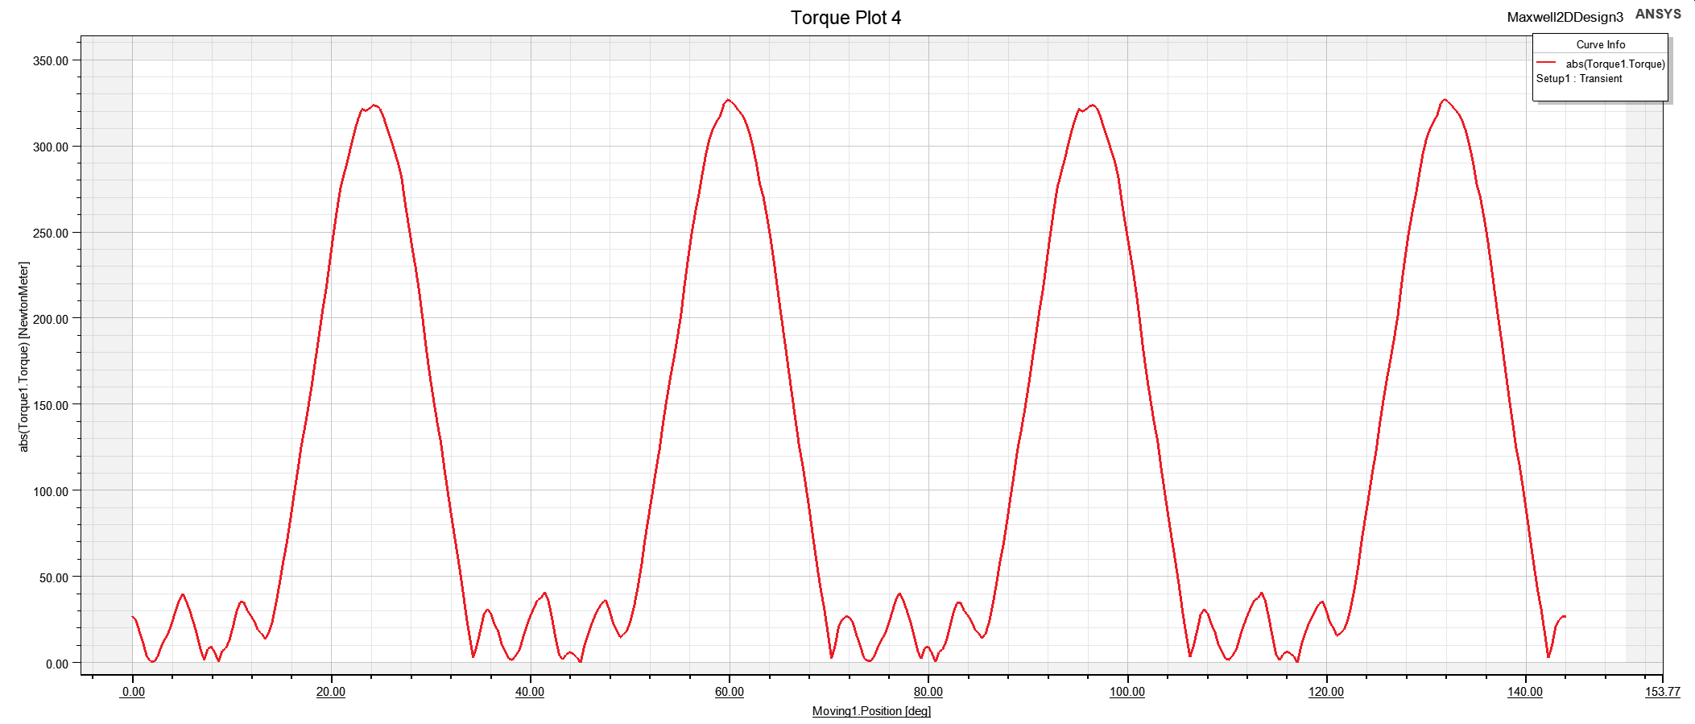

Figure Torque of Machine for 300 rpm

Average torque is calculated as 205 N.m by using Finite element. However, analytically we calculate the 292 N.m. ( My torque calculation at finite element may be failure). Figure 9 shows the current and voltage waveform for the phase A.

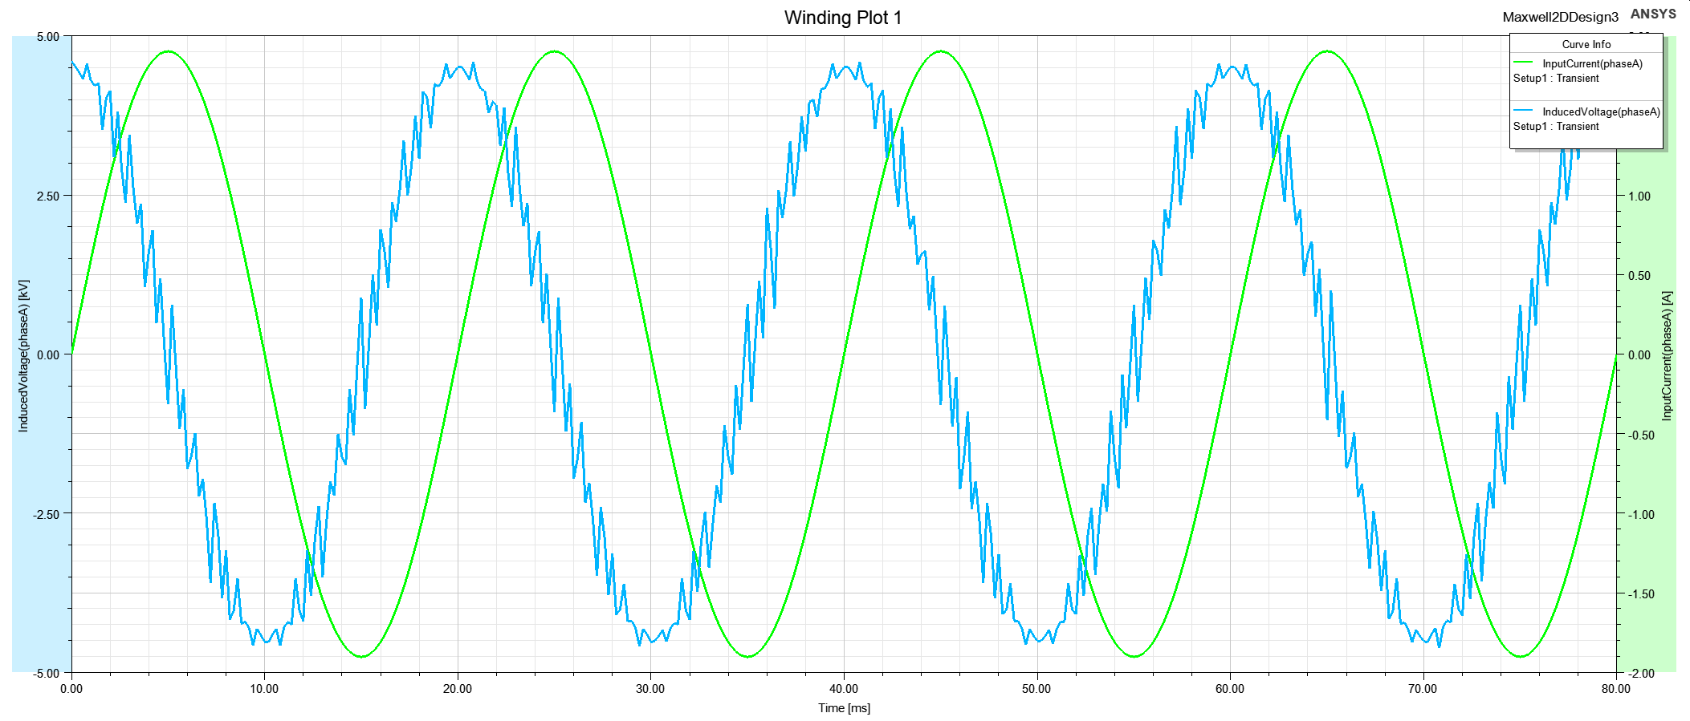

Figure Voltage and Current Waveform of phase

1. We can find operating B by using the formula at below. We take the as 0.4 T and as 16.

= 0.08T

Electrical loading does not change the machine, however magnetic loading is becoming smaller. Then tangential stress and torque become smaller than NdFeB magnets.

The machine rating is diminished drastically because the machine is designed for specific magnetic and electrical loading.

1. We can increase the rotor diameter and slot height with respect to previous design. Thus, the machine saturation point is far away to previous.

Slot height is 70 mm and we can calculate width as 9.81 mm by using . The total slot area is 687.22 mm2. We can take the kw as 0.6 and use AWG-20 cable. We can find the turn ratio.

=824 Turn

Electric loading is calculated as:

Average tangential stress depends on electrical loading and magnetic loading. taken as 90 for PMSM machines.

Force depends on torque and radius of the machine. Torque is calculated by volume of the rotor and tangential stress. Length of motor is chosen as 100mm and rotor diameter is 70mm.

The machine with ferrite has smaller magnetic loading, it led the electrical loading can increases, slot height can increase for same outer diameter. Also, ferrite is more brittle than NdFeB. Thus, the machines are designed by using NdFeB commonly.

# CONCLUSION

In this report, permanent magnet synchronous machines (PMSM) are investigated. The design consideration, electric and magnetic loading of the machines are analyzed. Torque and power of the machines are calculated both analytically and FEA. The results show the electric and magnetic loading of the machines determines the torque and power output with the rotor volume. Also, we observe that changing only the magnets change the motor parameters and we can design a suitable machine by changing slot and rotor parameters for different magnets.