Mendeley – IMMD- device- gan app-

**Applications of Gallium Nitride in Power Electronics**

Abtract

Mistrigggering 🡺 results dV/dt across miller capacitance

Third quadrant 🡺 negative Vgs

Voltage doubler🡺 893 kHz

Three phase 🡺 300 kHz

Introduction

GaN and SiC 🡺 higher operating temperature, faster switching, lower-pn resistance

GaN 🡺 low and medium voltage, POL converters, EV, HEV

HEMT with depletion mode 🡺 high blocking voltage

SI. VS GAN VS. SIC Upon

Larger Bandgap 🡺critical electrical field increases ( direct effected Rds _on )

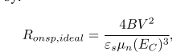

Smaller Dialectric 🡺 smaller gate drain capacitance (faster) (effect switch transition)

Higher Eg 🡺 Hgher Temperature

III. IMPLEMENTATION

1. Overview

Current Collapse phenomenon

1. Mounting EPC

Bare dies packaging 🡺 smaller inductance 🡺 requires reflow oven, hot air gun

1. Gate Drive Detailed

Smaller headroom 🡺 Vgs 4.5 V, maximum 6V

Higher turn-on resistance to avoid overshoot

Lower turn off resistance to avoid mistriggering

1. Layout

FEA 🡺 reduce stray inductance

Di/dt rapid changes

IV. TESTING

Double pulse test

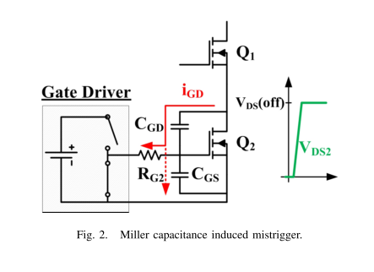

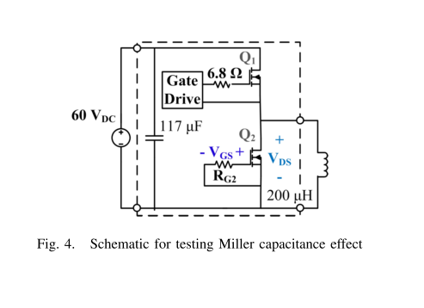

1. Miller Capacitance Influence

Gate resistance ??? RG2

1. Third Quadrant Operation

The ability of GaN HEMTs to conduct reverse current flow

(i.e. source-to-drain) and function as synchronous rectifiers has already been explored

Three level gate driver