**Mendeley- IMMD- device- gan app-**

**99.3% Efficiency of Three-Phase Inverter for Motor Drive Using GaN-based Gate Injection Transistors**

Abstract

Fully reduced on- state resistance in a new normally-off GaN transistor called **Gate Injection Transistor (GIT)** greatly helps to increase the efficiency.

Carrier Frequency 6 kHz

Intro

GaN 🡺 reduces series resistance

IGBT’s 🡺 forward offset voltage limitation for low power and requires Fast Recovery Diodes

GaN 🡺 Lateral Configuration ?? not required diodes

**GaN GATE INJECTION TRANSISTOR (GIT)**

Ron = 66m ohm

e 45A and 650V, respectively. The on-state resistance is as low as 66mΩ, and the specific value RonA is 2.0mΩcm2.

**HIGHLY EFFICIENT INVERTER USING GaN-GITS**

synchronous gate-voltage control ??

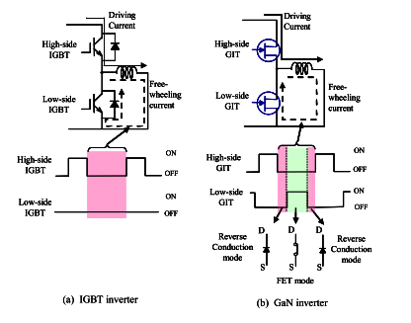

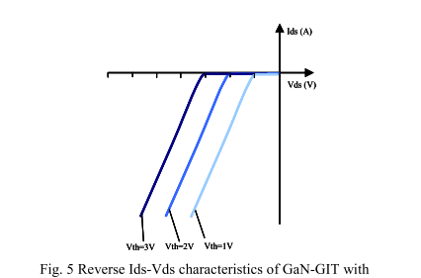

Varying carrier frequency 🡺 to extract conduction and switching loss

**Conclusion**

GIT 🡺 enables low on-state resistance and high breakdown