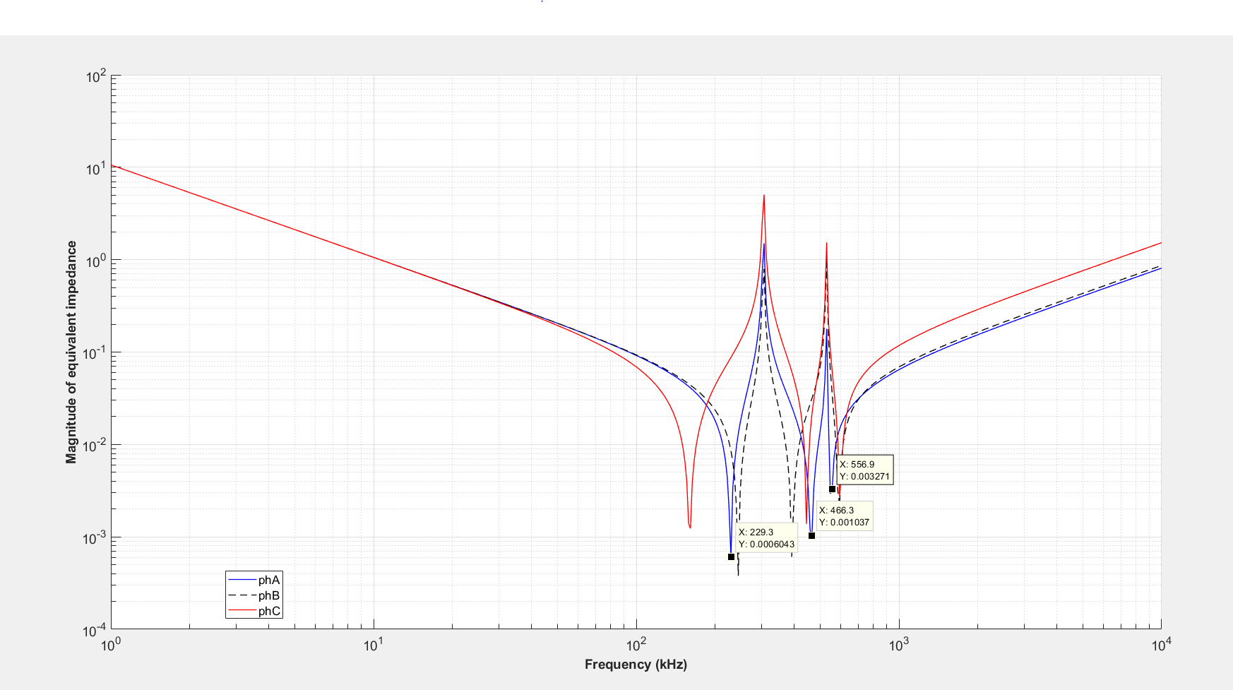

Above, we observe that transfer function at step response at switching time for phase A, phase B and phase C.

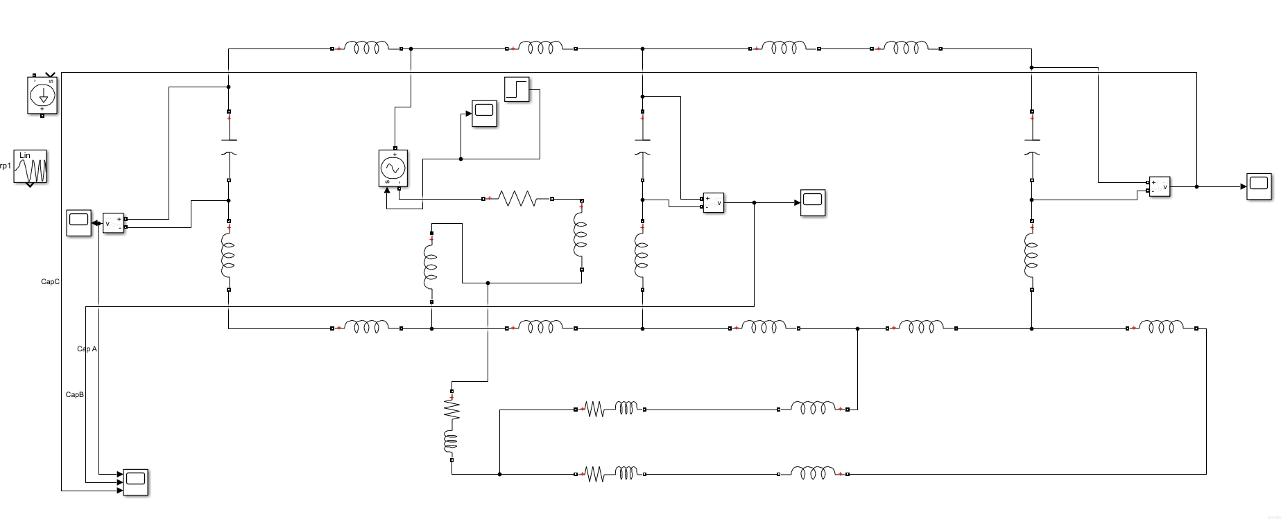

I establish the circuit for high frequency component. (Switching for S=100)

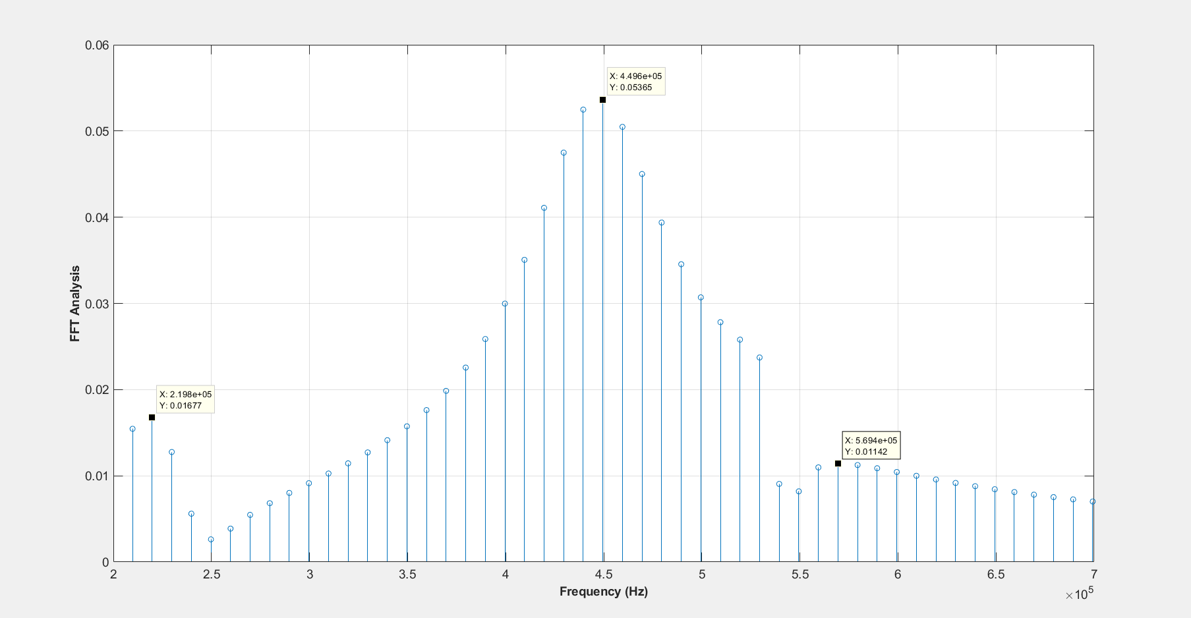

FFT analysis for Simulink model, it is almost the same as calculation of impedance at matlab.

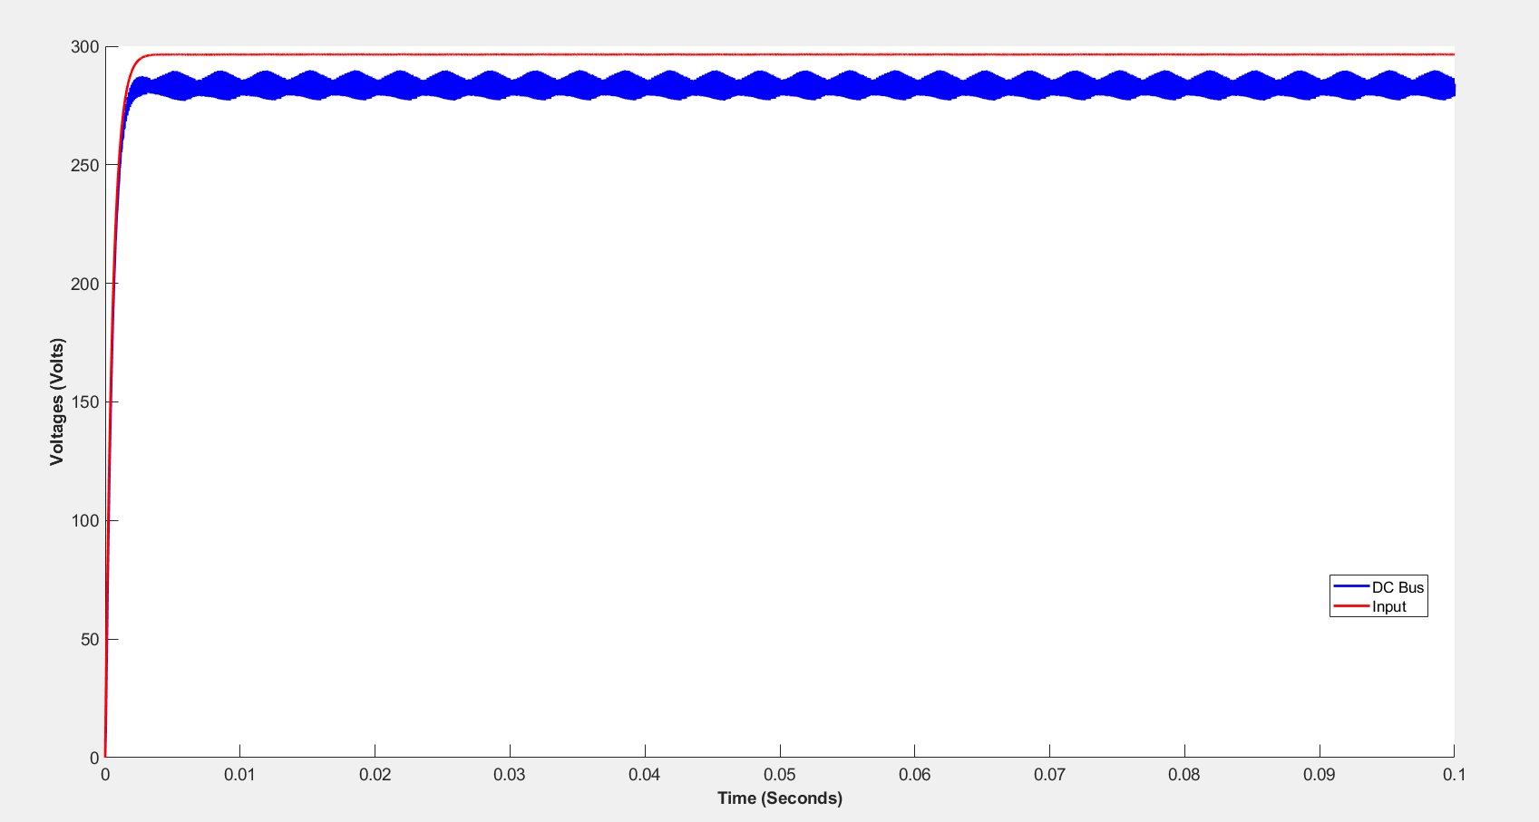

Input is purely DC, we observe DC bus voltage. We can see six pulses at delta=0(reference voltage phase)

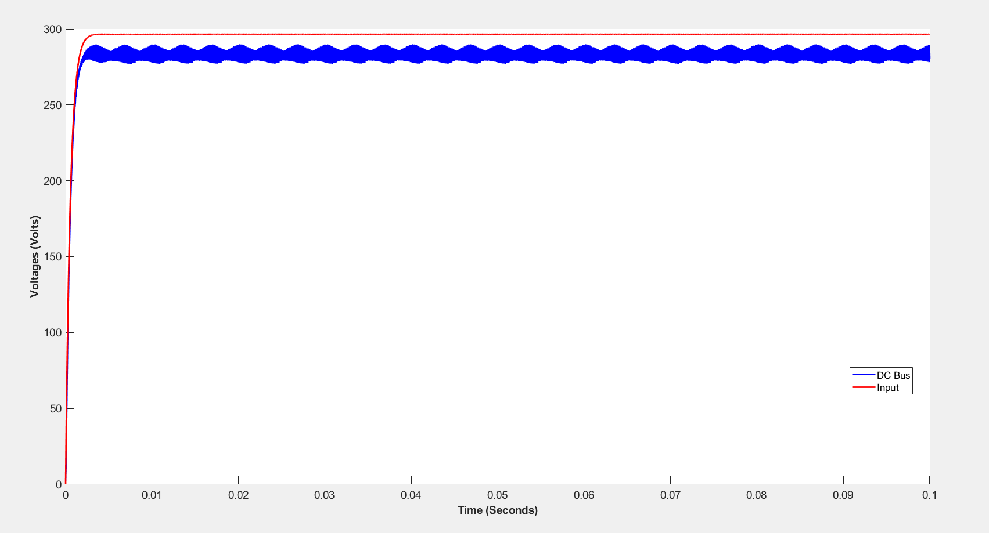

For delta=pi/2

We can easily understand that time at t=0.1, we can observe that phases of six pulse (not 300 Hz harmonic it is envelope, it consist side bands.)

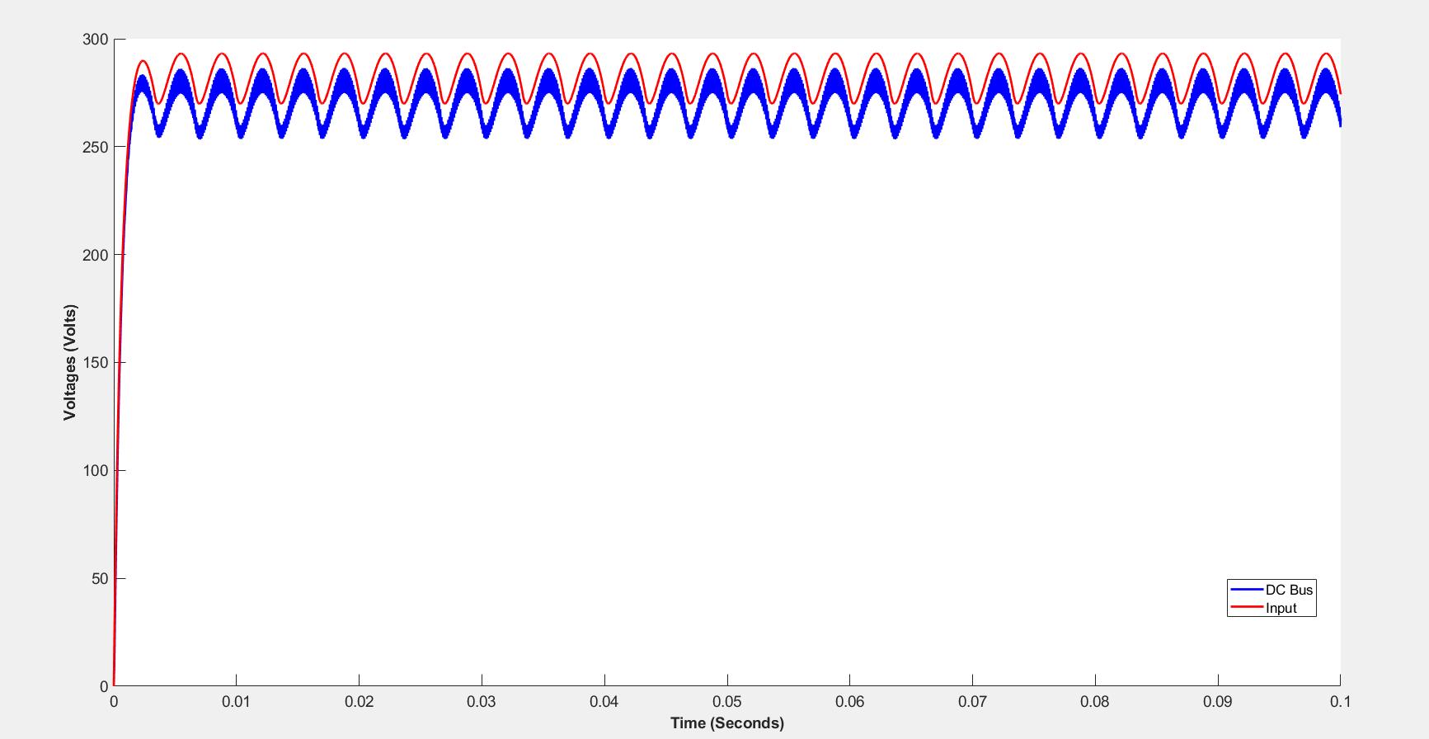

It is with rectifier Cdrec= 1.1mF and Lin=3.4 uH(realistic value) and delta=0

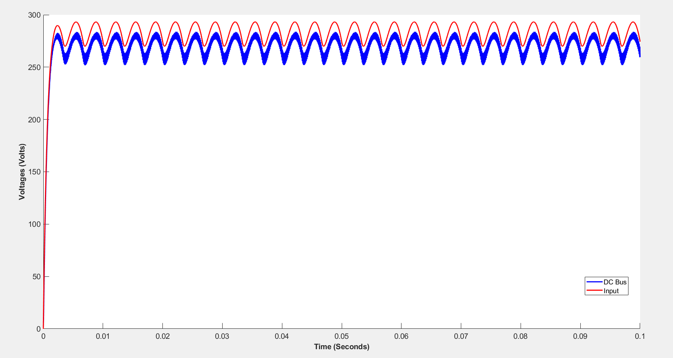

It is with rectifier Cdrec= 1.1mF and Lin=3.4 uH(realistic value) and delta=pi/2

At above 2 figure, rectifier 300 Hz is dominated. So, we can observe 300 Hz component at DC bus not envelope. Also, we can change reference phase, we did not observe phase at DC link because rectifier 300 Hz is observed at DC bus.

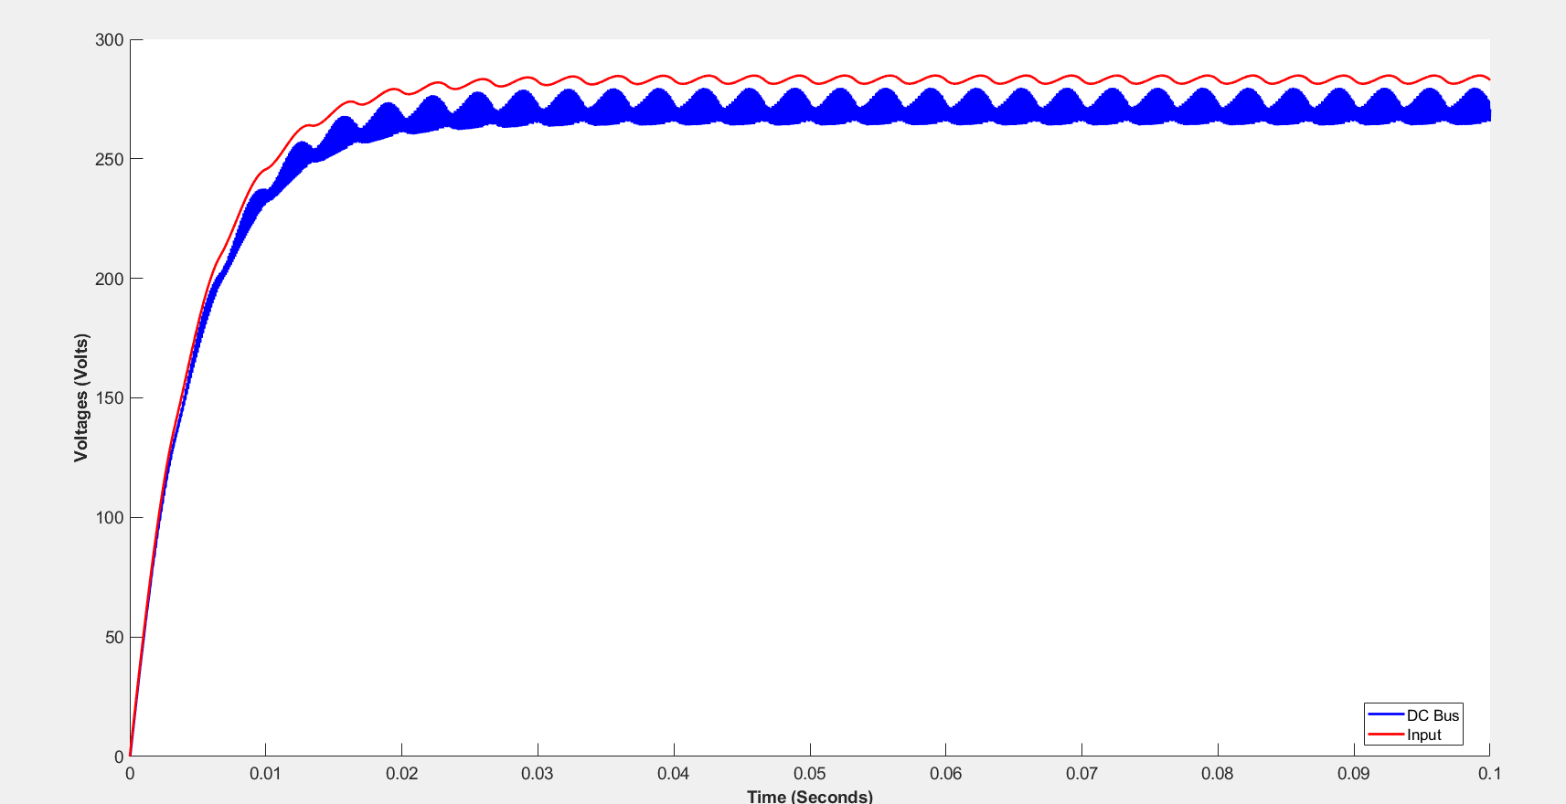

It is with rectifier Cdrec= 10mF and Lin=34 uH(unrealistic value) and delta=0

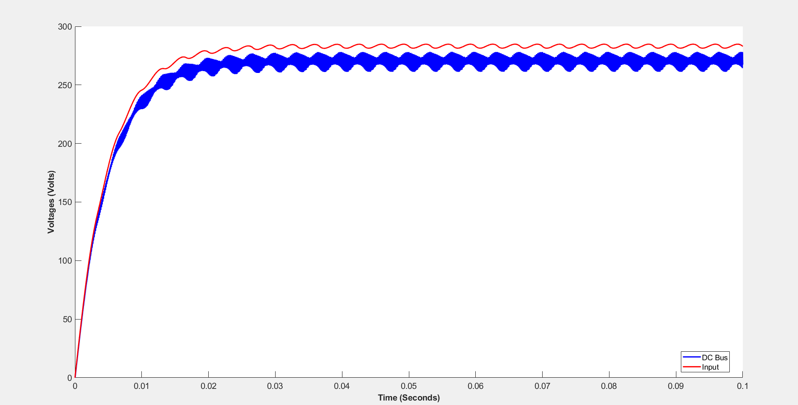

It is with rectifier Cdrec= 10mF and Lin=34 uH(unrealistic value) and delta=pi/2

We observe that rectifier 300 Hz is not dominated at DC bus. Its waveform includes envelope( side band from 150 Hz). Also, phases of DC bus changes with respect to references phase.