* Vdc’s and P’s are made the same (balanced).

**When L’s are the same, R’s are different:**

 



**When R’s are the same, L’s are different:**

 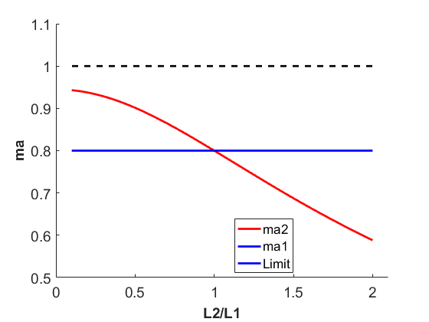

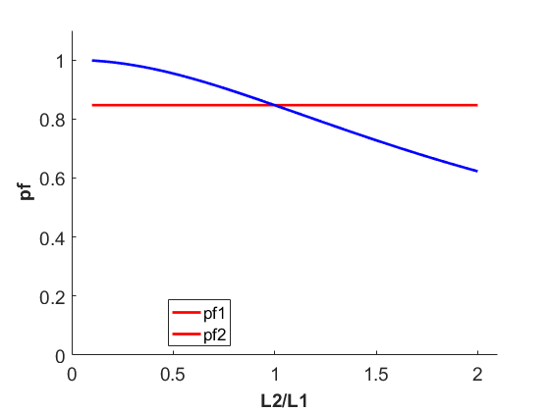

**When R’s and L’s are different (same ratio):**

 

