More electric aircraft applications: Tübitak projesi için incelenmeli

Effect of interleaving on ground voltage

Common mode currents in motor housing (with and without interleaving)

Voltage balancing on series connected modules, PWM mismatch. LC filter for PWM mismatch

3rd harmonic elimination fikri bi yerde dursun

Topology comparison’da number of components, voltage stress, capacitor size ekleyelim

Enteresan fikir: An Integrated 20-kW Motor Drive and Isolated Battery Charger for Plug-In Vehicles

<http://ieeexplore.ieee.org/stamp/stamp.jsp?arnumber=6363611>

İlk olarak bildiğimiz IMMD konsepti 2004 yılında ortaya atıldı.

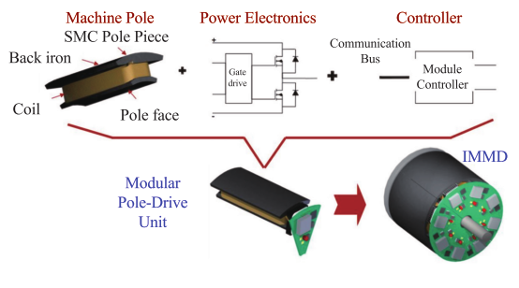Shea 2014

Second generation IMMD (silicon based), Shea 2014, 2015

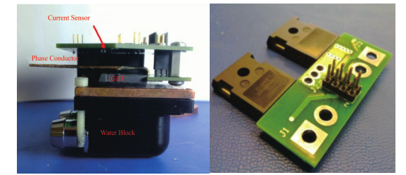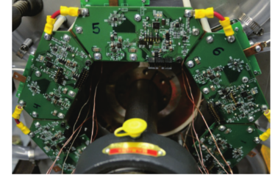

This was the first IMMD prototype unit that included a dedicated controller in each module.

Third generation IMMD (GaN based), Wang (Wisconsin), 2015-2016

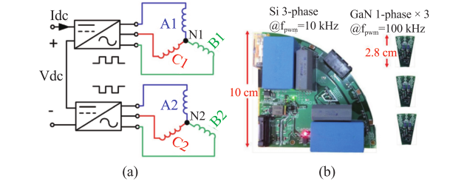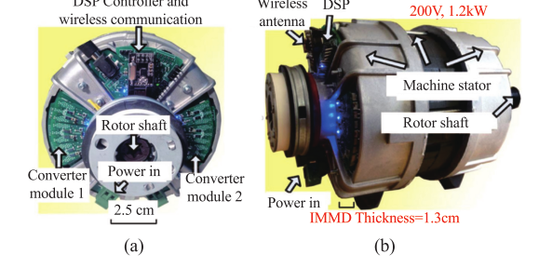

# 2002

**Harris, N. C., Jahns, T. M., & Surong Huang. (2002).** Design of an integrated motor/controller drive for an automotive water pump application. In *Conference Record of the 2002 IEEE Industry Applications Conference. 37th IAS Annual Meeting (Cat. No.02CH37344)* (Vol. 3, pp. 2028–2035). IEEE.

**Shakweh, Y. (2002).** Plug and play integrated motor drives. In *International Conference on Power Electronics Machines and Drives* (Vol. 2002, pp. 655–661). IEE.

**Klumpner, C., Nielsen, P., Boldea, I., & Blaabjerg, F. (2002).** A new matrix converter motor (MCM) for industry applications. *IEEE Transactions on Industrial Electronics*, *49*(2), 325–335. https://doi.org/10.1109/41.993265

# 2003

**Klumper, C., Blaabjerg, F., & Thoegersen, P. (2003).** Evaluation of the Converter Topologies suited for Integrated Motor Drives. *IEEE Industry Applications Magazine*, *12*(2), 71–83.

**Klumpner, C., & Thøgersen, P. (2003).** Converter Topologies with Low Passive Components Usage for the Next Generation of Integrated Motor Drives. *IEEE Power Electronics Specialist Conference (PESC)*, 568–573.

# 2004

**Ranneberg, J., Tadros, Y., & Schäfer, U. (2004**). Motor-Integrated Circular Converter for Hybrid Electric Vehicles. *EPE Journal*, *14*(2), 23–27.

# 2005

**P. W.** **Wheeler** et al., “**An integrated 30kW matrix converter based induction motor drive**,” in 2005 IEEE 36th Power Electronics Specialists Conference, Recife, **2005**, pp. 2390-2395.

Makale bulunamadı: **R. J. White, T.M. Jahns, and T.A Lipo,** “**Fault management techniques for an integrated modular motor drive,**” in Proc. of 2005 CPES Power Electronics Seminar, Blacksburg, VA., Apr. **2005**, pp. 581-588.

**Master tezi: S. I. Mueller, “Model and design of an air-cooled thermal manage- ment system for an integrated motor-controller**,” M.S. thesis, Univer- sity of **Wisconsin**--**Madison**, Madison, USA, **2005**.

**Gerber, M., & Marz, M. (2005).** System integration in automotive power systems. *Power Electronics and Applications*, 1–10.

**Farina, F., Rossi, D., Tenconi, A., Profumo, F., & Bauer, S. E. (2005).** Thermal design of integrated motor drives for traction applications. *2005 European Conference on Power Electronics and Applications*, 1–10.

# 2006

Pickering, S., Thovex, F., Wheeler, P., & Bradley, K. (2006). Thermal Design of an Integrated Motor Drive. *IECON 2006 - 32nd Annual Conference on IEEE Industrial Electronics*, 4794–4799. https://doi.org/10.1109/IECON.2006.348109

# 2007

Brown, N. R., Jahns, T. M., & Lorenz, R. D. (2007). Power Converter Design for an Integrated Modular Motor Drive. *Industry Applications Conference, 2007. 42nd IAS Annual Meeting. Conference Record of the 2007 IEEE*, 1322–1328.

**Bulunamadı** N.R. Brown, T.M. Jahns, R.D. Lorenz, “Development of a converter for an integrated modular motor drive,” Centre for Power Electronics Systems (CPES) 2007 CPES. pp. 419-425.

Mehran Ektesabi, H. F. (2007). Controlling Heat, Vibration and EMI in an Integral Motor. In *Compatibility in Power Electronics*.

Aghili, F., Hollerbach, J. M., & Buehler, M. (2007). A modular and high-precision motion control system with an integrated motor. *IEEE/ASME Transactions on Mechatronics*, *12*(3), 317–329.

Dwari, S., Parsa, L., & Lipo, T. a. (2007). Optimum control of a five-phase integrated modular permanent magnet motor under normal and open-circuit fault conditions. *PESC Record - IEEE Annual Power Electronics Specialists Conference*, 1639–1644.

Ouyang, W., Lemberg, N., Yao, R., & Lipo, T. A. (2007). A novel modular permanent magnet drive system design. *Conference Proceedings - IPEMC 2006: CES/IEEE 5th International Power Electronics and Motion Control Conference*, *2*, 989–994.

# 2008

Bulunamadı B. J. **Sykora**, “**Development of a demonstrator model of an integrated modular motor drive**,” **M.S. thesis**, Dept. of Electr. and Computer Eng., **University** **of** **Wisconsin**- **Madison**, Madison, US, **2008**

**Wolmarans, J. J., Gerber, M. B., Polinder, H., De Haan, S. W. H., Ferreira, J. A., & Clarenbach, D. (2008).** **A 50kW integrated fault tolerant permanent magnet machine and motor drive.** *PESC Record - IEEE Annual Power Electronics Specialists Conference*, 345–351.

**Tenconi, A., Profumo, F., Bauer, S. E., & Hennen, M. D. (2008).** **Temperatures evaluation in an integrated motor drive for traction applications.** *IEEE Transactions on Industrial Electronics*, *55*(10), 3619–3626.

# 2009

# 2010

Marz, M., Schletz, A., Eckardt, B., Egelkraut, S., & Rauh, H. (2010). Power electronics system integration for electric and hybrid vehicles. *Integrated Power Electronics Systems (CIPS), 2010 6th International Conference on*, 16–18.

# 2011

**Choi, G.,** Xu, Z., Li, M., Gupta, S., Jahns, T., Wang, F., … Marlino, L. (**2011**). **Development of Integrated Modular Motor Drive for Traction Applications**. *SAE International Journal of Engines*, *4*(1), 2011-01–0344. https://doi.org/10.4271/2011-01-0344

# 2012

Hennen, M. D., Niessen, M., Heyers, C., Brauer, H. J., & De Doncker, R. W. (2012). Development and control of an integrated and distributed inverter for a fault tolerant five-phase switched reluctance traction drive. *IEEE Transactions on Power Electronics*, *27*(2), 547–554.

Su, G., & Tang, L. (2012). A segmented traction drive system with a small dc bus capacitor. In 2012 IEEE Energy Conversion Congress and Exposition (ECCE) (pp. 2847–2853). IEEE.

# 2013

**Su, G. J., Tang, L., Ayers, C., & Wiles, R.** (**2013**). An inverter packaging scheme for an integrated segmented traction drive system. *2013 IEEE Energy Conversion Congress and Exposition, ECCE 2013*, 2799–2804.

**Wang, J., Li, Y., & Han, Y. (2013).** Evaluation and design for an integrated modular motor drive (IMMD) with GaN devices. *2013 IEEE Energy Conversion Congress and Exposition, ECCE 2013*, (Immd), 4318–4325.

# 2014

**Master tezi, Shea, A.** (**2014**). **Hardware Design of a Integrated Modular Motor Drive (IMMD),** (Immd).

**A. Shea and T. M. Jahns,** “**Hardware integration for an integrated modular motor drive including distributed control,”** in **2014** IEEE Energy Conversion Congress and Exposition (ECCE), Pittsburgh, PA., 2014, pp. 4881-4887.

**Wang, J., & Han, Y. (2014).** A new concept of multilevel converter motor drive with modular design and split winding machine. In *2014 Power and Energy Conference at Illinois (PECI)* (pp. 1–6). IEEE.

**Yehui Han. (2014).** Design, modeling, and control of multilevel converter motor drive with modular design and split winding machine. In *2014 IEEE 15th Workshop on Control and Modeling for Power Electronics (COMPEL)* (Vol. 203, pp. 1–10). IEEE.

# 2015

Abebe, R., Vakil, G., Calzo, G. Lo, Cox, T., Gerada, C., & Johnson, M. (2015). FEA based thermal analysis of various topologies for Integrated Motor Drives (IMD). In *IECON 2015 - 41st Annual Conference of the IEEE Industrial Electronics Society* (pp. 001976–001981). IEEE.

**Engelmann, G.,** Kowal, M., & Doncker, R. W. De. (**2015**). **A Highly Integrated Drive Inverter using DirectFETs and Ceramic DC-Link Capacitors for Open-End Winding Machines in Electric Vehicles,** (1), 290–296.

**Ludwig, F.,** Heidrich, T., & Mockel, A. (**2015**). **Integrated high-speed PMSM drive with IMS PCB-technology for mobile applications.** *Proceedings of the International Conference on Power Electronics and Drive Systems*, *2015*–*Augus*(June), 1070–1073.

**A. Shea and T. M. Jahns**, “**Control challenges and mitigation tech- niques for sensor errors in modular motor drives with weakly-coupled distributed control architectures**,” in **2015** IEEE International Electric Machines & Drives Conference (IEMDC), Coeur d'Alene, ID, 2015, pp. 890-896

**Wang, J., & Han, Y. (2015).** A Class of Modular Multilevel Motor Drives with Design Flexibility and Reduced Components Number. *Applied Power Electronics Conference and Exposition (APEC), 2015 IEEE*, 2387–2393.

**J. Wang, Y. Li, and Y. Han,** "**Integrated modular motor drive design with GaN power FETs," in IEEE Transactions on Industry Applica- tions**, vol. 51, no. 4, Jul.-Aug., **2015**, pp. 3198-3207.

**Doktora tezi.** **Wang, J. (2015).** Design of Multilevel Integrated Modular Motor Drive with Gallium Nitride Power Devices. *Thesis*.

Lambert, S. M., Mecrow, B. C., Abebe, R., Vakil, G., & Johnson, C. M. (2015). Integrated Drives for Transport - A Review of the Enabling Thermal Management Technology. In *2015 IEEE Vehicle Power and Propulsion Conference (VPPC)* (pp. 1–6). IEEE.

Lambert, S. M., Mecrow, B. C., Abebe, R., Vakil, G., & Johnson, C. M. (2015). Integrated Drives for Transport - A Review of the Enabling Electronics Technology. *IEEE Vehicle Power and Propulsion Conference*, 1–6.

**Galassini, A.,** Costabeber, A., Gerada, C., Buticchi, G., & Barater, D. (**2015**). **State space model of a modular speed-drooped system for high reliability integrated modular motor drives.** *Electrical Systems for Aircraft, Railway and Ship Propulsion, ESARS*, *2015*–*May*.

**Galassini,** A., Costabeber, A., & Gerada, C. (**2015**). **Speed droop control of integrated modular motor drives**. In *IECON 2015 - 41st Annual Conference of the IEEE Industrial Electronics Society* (pp. 003271–003276). IEEE.

Jin, L., Norrga, S., Zhang, H., & Wallmark, O. (2015). Evaluation of a multiphase drive system in EV and HEV applications. *Proceedings - 2015 IEEE International Electric Machines and Drives Conference, IEMDC 2015*, 941–945. http://doi.org/10.1109/IEMDC.2015.7409174

# 2016

**Galassini, A.,** Costabeber, A., Gerada, C., Buticchi, G., & Barater, D**. (2016). A Modular Speed-Drooped System for High Reliability Integrated Modular Motor Drives**. *IEEE Transactions on Industry Applications*, *9994*(c), 1–1.

**Doktora tezi, KTH, Jin, Lebing (2016). *Integrated Compact Drives for Electric and Hybrid Electric Vehicles*.**

**Lo Calzo,** G., Vakil, G., Mecrow, B., Lambert, S., Cox, T., Gerada, C., … Abebe, R. (**2016**). **Integrated motor drives: state of the art and future trends**. *IET Electric Power Applications*, *10*(8), 757–771.

**Zhang, H., & Wallmark, O. (2016). Evaluation of winding arrangements in electric machinery for modular electric drives.** *2016 IEEE 8th International Power Electronics and Motion Control Conference, IPEMC-ECCE Asia 2016*, 2820–2825.

# 2017

Thesis, Doctoral. HUI ZHANG , (2017). *On Electric Machinery for Integrated Motor Drives in Automotive Applications*.

Jahns, T. M. (2017). The Past, Present, and Future of Power Electronics Integration Technology in Motor Drives. *CPSS Transactions on Power Electronics and Applications*, *2*(3), 197–216.

Lee, W., Li, S., Han, D., Sarlioglu, B., Minav, T. A., & Pietola, M. (2017). Achieving high-performance electrified actuation system with integrated motor drive and wide bandgap power electronics. In *2017 19th European Conference on Power Electronics and Applications (EPE’17 ECCE Europe)* (p. P.1-P.10). IEEE.

Zhang, H., Member, S., Jin, L., & Member, S. (2017). Evaluation of Modular Integrated Electric Drive Concepts for Automotive Traction Applications.

Gan, C., Wu, J., Hu, Y., Yang, S., Cao, W., & Guerrero, J. M. (2017). New Integrated Multilevel Converter for Switched Reluctance Motor Drives in Plug-in Hybrid Electric Vehicles With Flexible Energy Conversion. *IEEE Transactions on Power Electronics*, *32*(5), 3754–3766.

Galassini, A., Costabeber, A., Gerada, C., & Tessarolo, A. (2017). Distributed Speed Control for Multi-Three Phase Electrical Motors with Improved Power Sharing Capability, 2492–2497.

Galassini, A., Costabeber, A., & Gerada, C. (2017). Speed Control for Multi-Three Phase Synchronous Electrical Motors in Fault Condition, (July), 6–8.

# 2018

**Comparison and Evaluation of Modular Integrated Electric Drives for Automotive Traction Applications**

### Jin, Lebing

KTH, School of Electrical Engineering (EES), Electric power and energy systems. (power electronics)ORCID iD: [0000-0002-6633-8384](http://orcid.org/0000-0002-6633-8384)

### Zhang, Hui

KTH, School of Electrical Engineering (EES), Electric power and energy systems.ORCID iD: [0000-0002-4534-921X](http://orcid.org/0000-0002-4534-921X)

### Wallmark, Oskar

KTH, School of Electrical Engineering (EES), Electric power and energy systems.ORCID iD: [0000-0002-6283-7661](http://orcid.org/0000-0002-6283-7661)

### Norrga, Staffan

KTH, School of Electrical Engineering (EES), Electric power and energy systems. (power electronics)ORCID iD: [0000-0002-8565-4753](http://orcid.org/0000-0002-8565-4753)