**Nathan C. Harris, Thomas M. Jahns, Surong Huang**

University of Wisconsin-Madison

The authors thank Prof. T.A. Lipo at the University of Wisconsin – Madison for his valuable consultations regarding the machine designs

**2002**

Integrated Motor/Controller Drive for Automotive Water Pump Application

No hardware, No modularization

500W, 42VDC, 5000rpm

5 brushless machine topologies are discussed. Interior PM synchronous m/c is selected

Six-switch PWM voltage-source inverter, power MOSFETs, integrated power electronics module (IPEM)

On PE side, physical layout, thermal management and EMI filter design are discussed

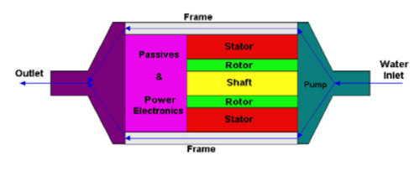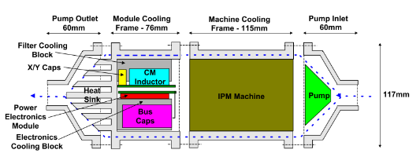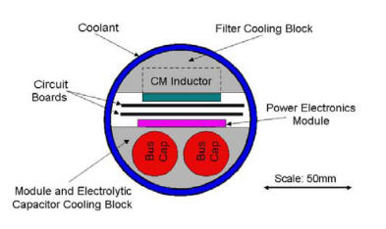

**Christian Klumpner, Peter Nielsen, Ion Boldea, Frede Blaabjerg, Paul Thargersen**

Institute of Energy Technology, Aalborg University, Denmark, Danfoss Drives

**2002**

Matrix Converter Motor (MCM) for Industry Applications

First integrated regenerative frequency converter motor for industry applications, based on a matrix converter topology.

4-kW matrix converter motor prototype

No modularization, IGBT-diode

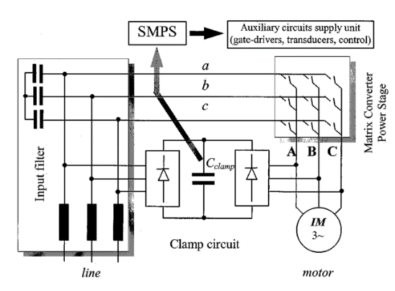 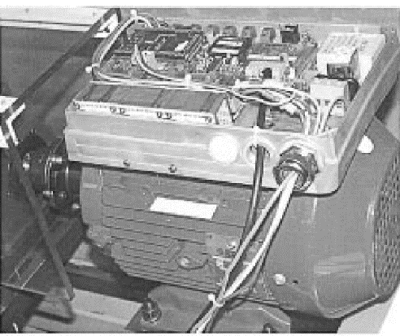

**2003**

*Converter Topologies the Next Generation of Integrated Motor Drives*

ASD converter topologies (inverter is the same, rectifier and dc link/passive sides are different)

No modularity, no hardware

*Evaluation of the Converter Topologies suited for Integrated Motor Drives*

Same with above

**Y Shakweh, G H Owen, D J Hall, H Miller**

FKI Industrial Drives Ltd, UK

**2002**

PLUG AND PLAY INTEGRATED MOTOR DRIVES

IMDs technology, customer’s concerns, market status, future trends as well as technical challenges to increase power ratings.

Today, IMD technology offers power output up to 7.5kW.

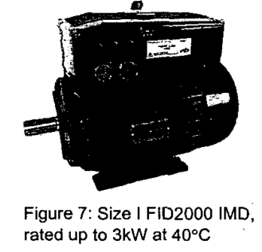

**J. Ranneberg, Y. Tadros, U. Schäfer**

DaimlerChrysler AG, Research and Technology, University of Stuttgart, Germany

**2004**

Motor-Integrated Circular Converter for Hybrid Electric Vehicles

Inserted in the stator housing around the end windings of the induction motor

200-400V, 50kW, IGBT, water cooled, No modularization, toroidal foil capacitor

Prototype 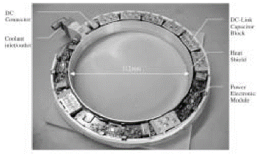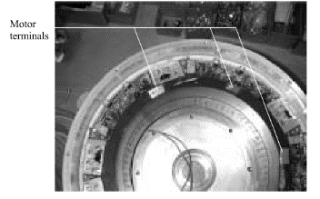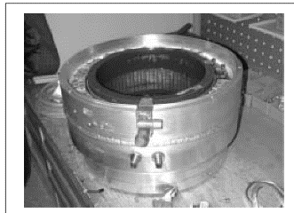

**Francesco Farina, Daniele Rossi, Alberto Tenconi, Francesco Profumo, Stefan E. Bauer**

POLITECNICO DI TORINO, Italy, INSTITUTE FORPOWERELECTRONICS AND ELECTRICAL DRIVES, AACHEN UNIVERSITY, Aachen, Germany

**2005**

Thermal design of integrated motor drives for traction applications

25 kW SRM, water cooled square housing, IGBT based, Comsol simulations (2D FEM)

Integrated Propulsion MOTors (IPMOTs), pre-prototype is under construction

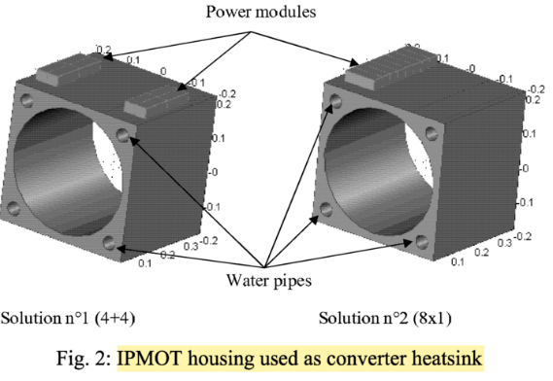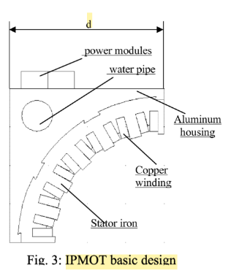

**P W Wheeler, J C Clare, L Empringham, Bradley, S Pickering, D Lampard, K J, M Apap**

University of Nottingham, School of Electrical and Electronic Engineering Nottingham, UK

University of Malta, Department of Electrical Engineering, Malta

**2005**

A Fully Integrated 30kW Motor Drive Using Matrix Converter Technology