# Conventional Motor Drive

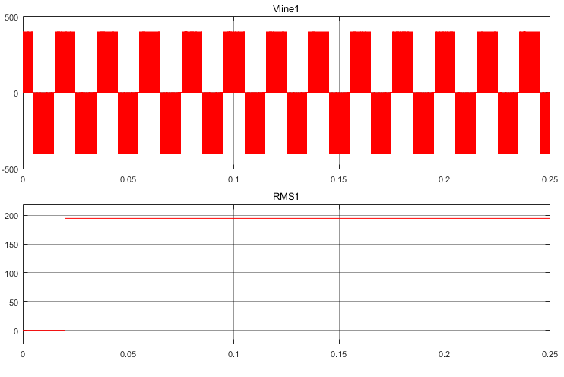

Figure 1: Inverter Output Line to Line Voltage and RMS Value

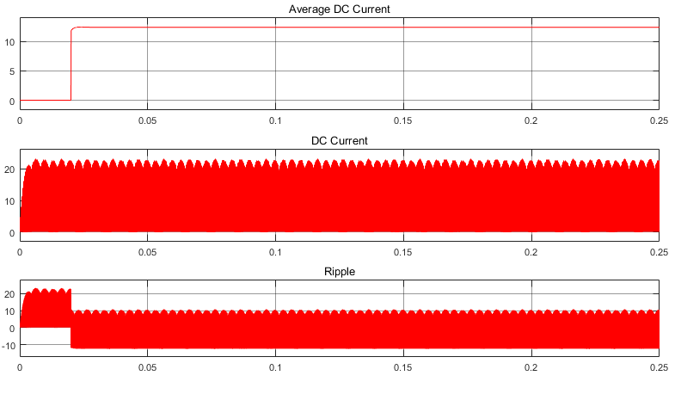

Figure 2: DC Current and Average Current

# Conventional IMMD(Parallel Modules)

## Gate Signals in Phase, DC Voltage Halved

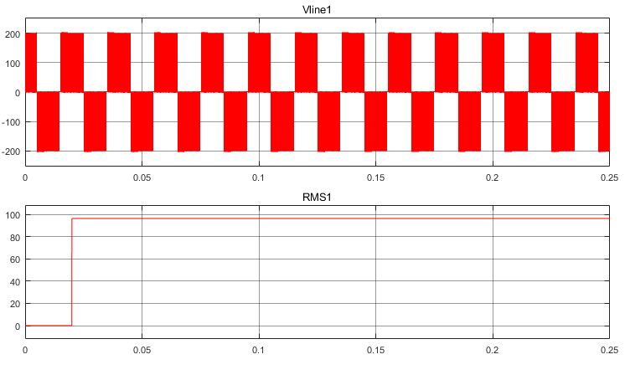

Figure 3: Module 1 Line to Line Voltage

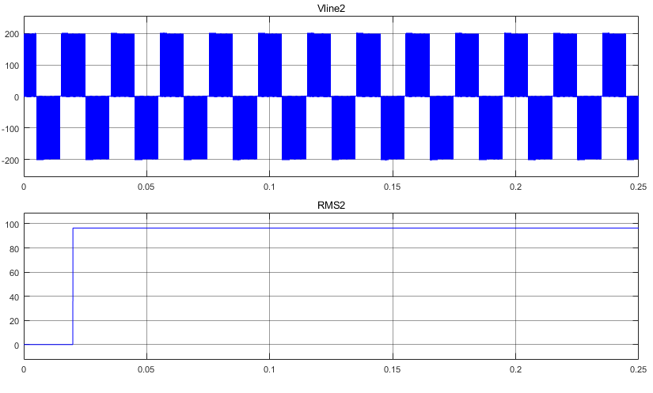

Figure 4: Module 2 Line to Line Voltage

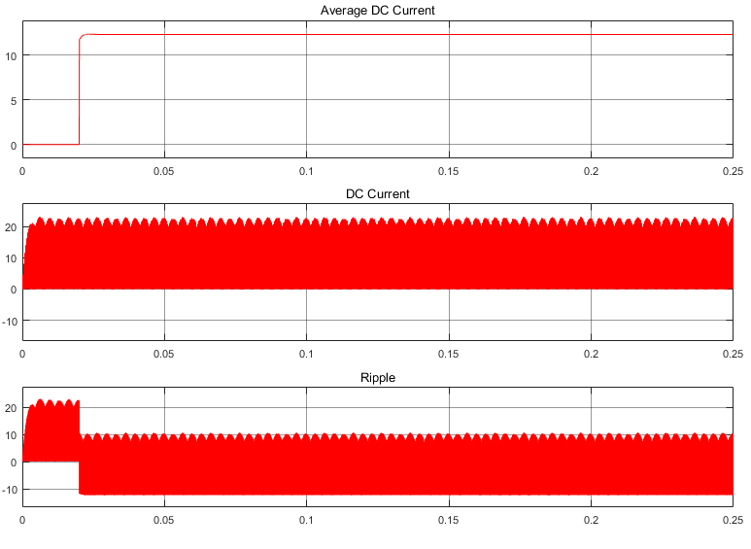

Figure 5: DC Current

## Gate Signals Out of Phase (180), DC Voltage is Halved

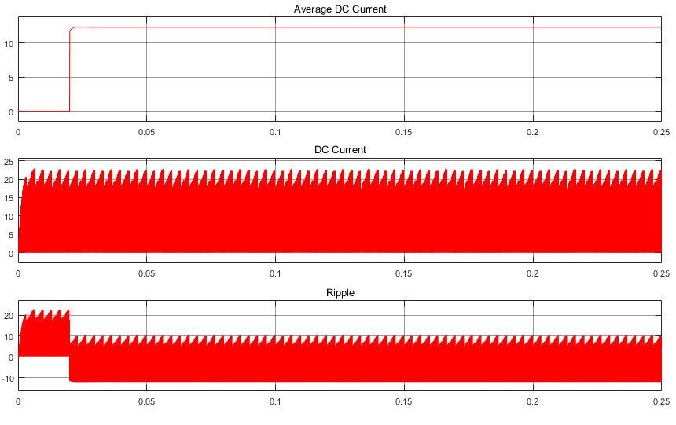

Figure 6: DC Current

Even though the ripple shape is changed with phase, the magnitude didn’t change significantly. These simulations were done to compare DC current ripple to estimate whether it is beneficial. Up to now, a significant result could not be obtained.

# Proposed IMMD (Series Modules)

## Gates Signal in Phase

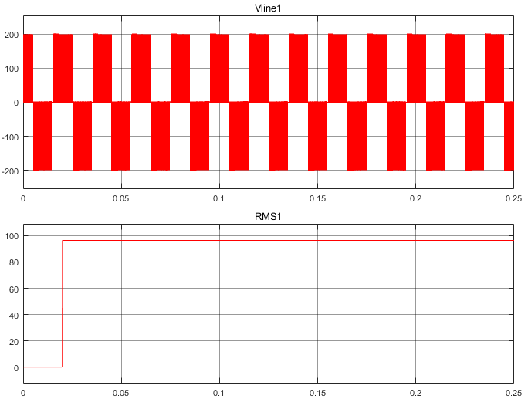

Figure 7: Module 1 Line to Line Voltage

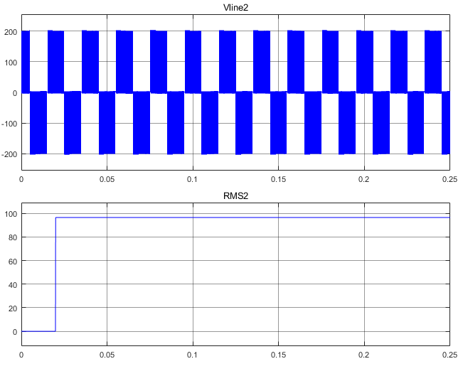

Figure 8: Module 2 Line to Line Voltage

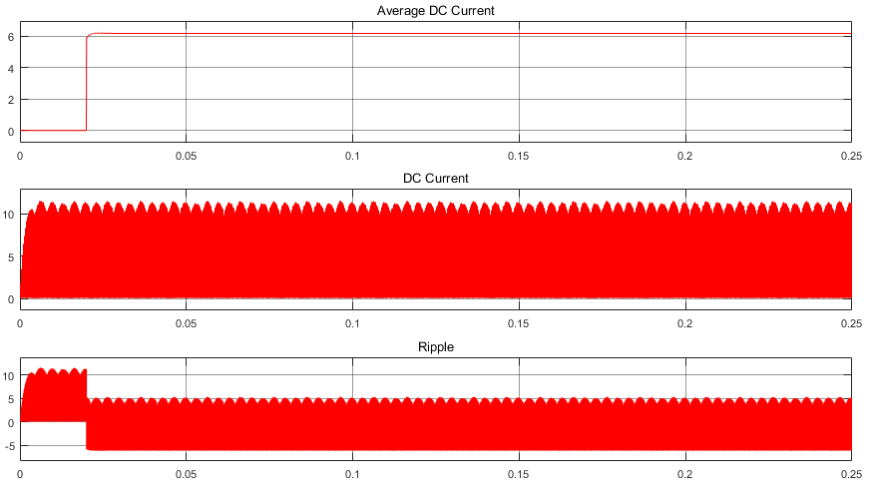

Figure 9: DC Current

## Gate Signals Out of Phase (180)

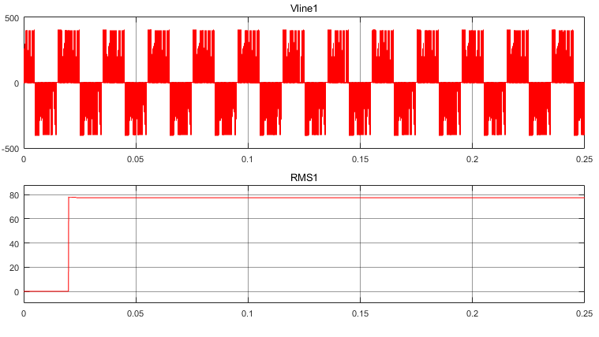

Figure 10: Module 1 Line to Line Voltage

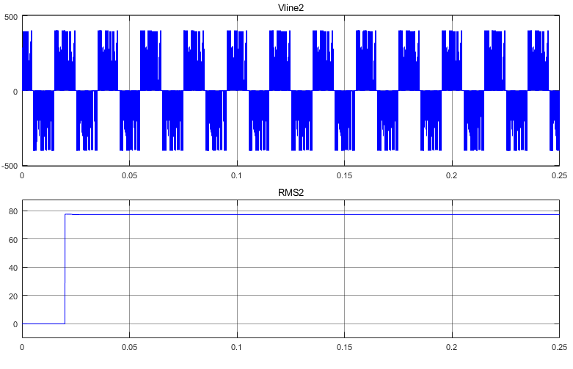

Figure 11: Module 2 Line to Line Voltage

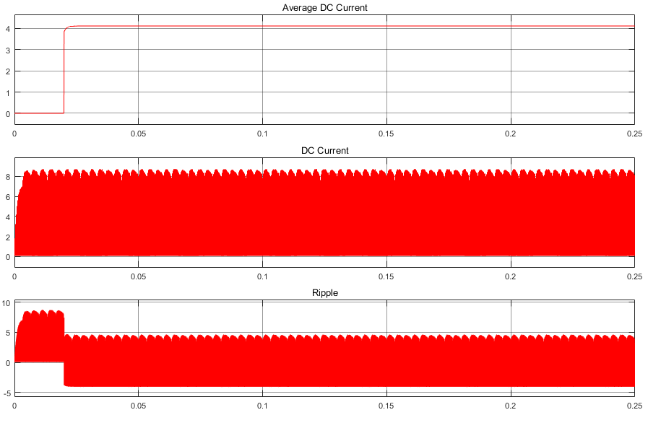

Figure 12: DC Current

Comparison to conventional IMMD, in proposed DC current is lower. That shows, the power consumption of the modules changed. On the other hand, the modules have balanced voltages which is good. Secondly, different phase samples change the results greatly. The average current is decreased and RMS voltage level of the inverter output is decreased also. Probably, the simulation is required to be redone.