Topic 17 — Power Electronics for Transportation Electrification

Parasitic Aware Building Block Design for Stacked Polyphase Bridge Traction Inverters
Abstract—The stacked polyphase bridge (SPB) introduces a voltage-partitioning degree of freedom into high-voltage traction inverters: the number of series-connected submodules determines the required semiconductor voltage class. This paper presents a hardware-constrained design procedure for an SPB phase-leg building block. Single-cell simulations and an electrical and thermal comparison support four parallel transistors per switch position for a candidate arrangement of sixteen submodules. An iterative KiCad–Ansys Q3D–LTspice workflow evaluates the routed power and gate networks. The extracted test-board gate network requires revised drive settings; the evaluated peak drain–source voltage remains approximately 93 V, above the 90 V design target. Experimental double-pulse tests are planned for the full paper.

I. Introduction
Electrification is driving traction and fast-charging power levels toward several hundred kilowatts, while demands for efficiency and power density continue to increase. Raising the dc-link voltage is a key design choice for meeting these requirements, although traction inverters must still deliver substantial phase current. In a conventional two-level traction inverter, each switch must block the full dc-link voltage and conduct the phase current, making semiconductor losses a central design constraint. The stacked polyphase bridge (SPB) introduces an additional design degree of freedom by connecting three-phase bridges in series on the dc side, with each bridge feeding an isolated winding set of a multiphase machine [1], [2].
The benefit of voltage partitioning depends on realizing a practical high-current submodule.
Previous studies establish SPB modulation and loss characteristics [2], dc-link stability [3], and comparisons with alternative GaN converter systems [4]. These studies provide the system-level basis for selecting a submodule voltage. Research on paralleled GaN stages identifies complementary implementation constraints, including commutation-loop inductance, common-source coupling, and unequal gate impedances [5]–[7].
This paper presents a hardware-constrained design procedure for an SPB phase-leg building block. Single-cell switching simulations establish a usable current range per device, and a comparison of losses, junction temperature, and voltage stress supports the selection of the parallel-device count.
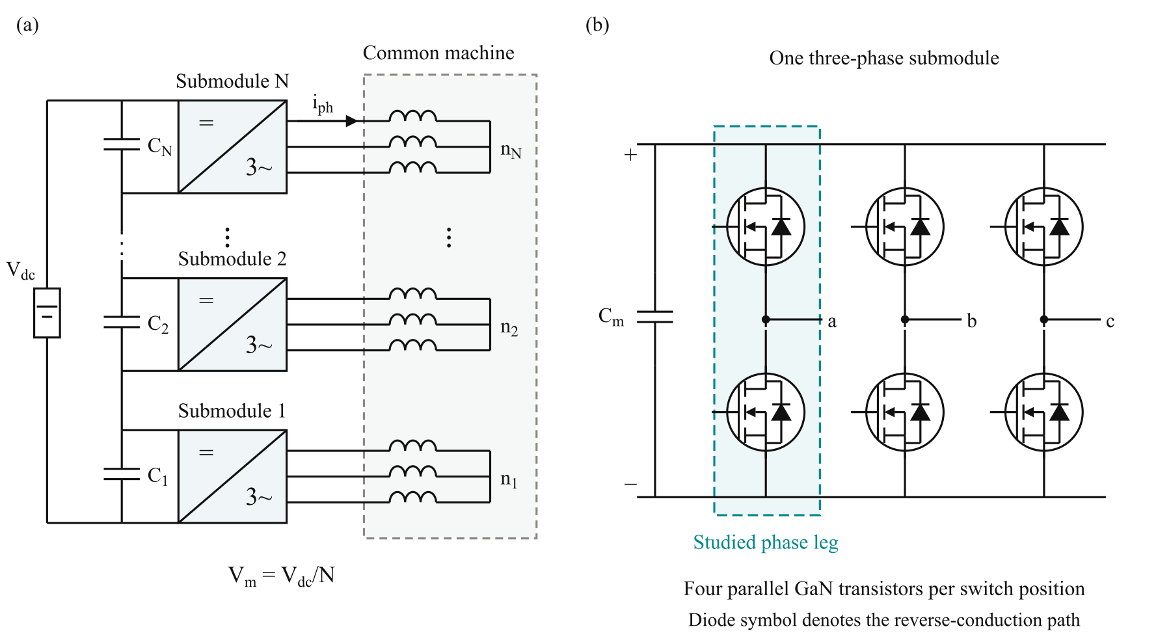
Fig. 1. (a) SPB traction-drive topology with N series-connected submodules, each supplying an isolated three-phase winding set of a common machine. (b) Three-phase submodule with the studied phase leg highlighted. Each switch symbol represents four parallel GaN transistors; the diode denotes the equivalent reverse-conduction path.

II. Traction Requirements and Initial Device Selection

A. Traction Drive Requirements
The building block is designed for a 300-kW traction drive with a total dc-link voltage (V_{dc}) of 1200 V. The initial operating point assumes a modulation index (M) of 1.15, a power factor (cosφ) of 0.9, and a switching frequency (f_{sw}) of 50 kHz. These specifications establish the operating conditions for semiconductor selection and preliminary building-block sizing. A junction-temperature limit of 125 °C is adopted.
A peak drain–source voltage target of 90 V is adopted.
$P = \frac{3 M V_{dc} I_{ph,rms} cos φ}{2\sqrt{2}}$ (1)
Here, V_{dc} is the total dc-link voltage, I_{ph,rms} is the rms phase current, and cosφ is the power factor. The modulation index M is defined such that the fundamental phase-to-neutral voltage peak of each submodule is M V_{m}/2. The specified operating point requires approximately 228 A rms and 322 A peak phase current.

B. Semiconductor Voltage Class Comparison
Voltage partitioning allows the semiconductor voltage class to be selected together with the submodule count. Following the charge-based screening criterion in [8], the device figure of merit is defined as
$D-FOM = \frac{1}{\sqrt{R_{DS(on)} C_{oss,Q}}}$ (2)
Here, C_{oss,Q} = Q_{oss}/V_{test} is the charge-equivalent output capacitance. A higher D-FOM indicates a more favorable combination of conduction resistance and output charge. Among the surveyed devices, EPC2361 has the highest D-FOM and is selected for further investigation [9].
The full paper will provide the device-comparison plot and discuss the respective datasheet test voltages and the limits of this initial screening.

C. Initial Submodule Voltage
A candidate arrangement of sixteen submodules gives a nominal submodule voltage of 75 V, allowing the selected 100 V devices to be considered. The available voltage margin must accommodate submodule-voltage variation and switching overshoot.

III. Single Cell Characterization and Selection of the Parallel Count

A. Single Cell Switching Characterization
The selected EPC2361 is first evaluated in a half-bridge model with one device per switch position. Double-pulse simulations are performed at a submodule voltage of 75 V over a range of device currents. Two assumed commutation-loop inductances, 0.5 nH and 1 nH, represent a compact layout target and a higher-inductance sensitivity case, respectively.
The results identify approximately 80 A as a useful current scale for preliminary sizing, rather than an absolute device-current limit. Dividing the required phase-current peak of 322 A by this value suggests approximately four parallel transistors per switch position.
The full paper will provide the single-cell voltage-stress and switching-energy sweeps used to establish this preliminary current scale.

B. Loss and Thermal Assessment
The single-cell switching-energy data are evaluated over the sinusoidal phase-current waveform to estimate the average switching losses.
The thermal assessment assumes 40 °C ambient, 0.65 K/W heatsink-to-ambient for the complete leg, and 7.6 K/W junction-to-heatsink per transistor. Junction temperature and resistance are solved iteratively.
The full paper will provide the parallel-count loss and voltage-stress plots. The electrical and thermal comparison is retained in Table I.

C. Selection of Four Parallel Devices
Table I summarizes the preliminary comparison. Two devices exceed both the thermal and voltage limits. Three satisfy the thermal constraint but still exceed the voltage target at the compact-loop assumption. Four are the smallest tested count satisfying both constraints in that case.
TABLE I
PRELIMINARY PARALLEL COUNT COMPARISON
Parallel count n | Peak device current (A) | Leg loss (W) | Junction temperature (°C) | Peak V_{DS} at 0.5 nH (V) | Peak V_{DS} at 1 nH (V)
2 | 161 | 39.5 | 141 | 131 | 180
3 | 107 | 23.2 | 84 | 96 | 123
4 | 80.5 | 18.0 | 69 | 83 | 93
5 | 64.4 | 15.8 | 62 | 86 | 85
6 | 53.7 | 14.8 | 59 | 86 | 84
The selected count is not the absolute minimum-loss solution.
The four-device arrangement reaches approximately 93 V when the assumed commutation inductance increases to 1 nH.

IV. Gate Drive Configuration and Cell Arrangement

A. Current Sharing Sensitivity
The full paper will detail the current-sharing sensitivity study. The principal gate-impedance and common-source mismatch cases are summarized in Fig. 2(a).
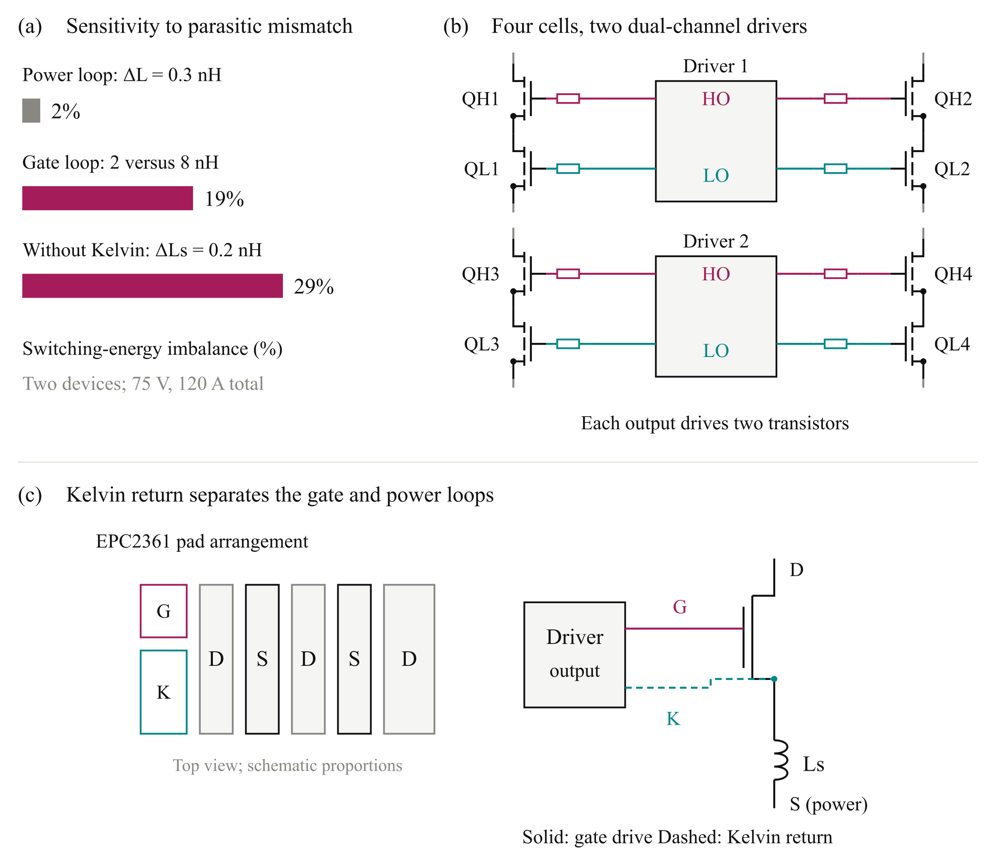
Fig. 2. Gate-drive design considerations: (a) simulated switching-energy imbalance under the investigated parasitic mismatches; (b) four switching cells grouped into two pairs, each served by a dual-channel driver with individual gate resistors; and (c) schematic EPC2361 pad arrangement and Kelvin-source connection, illustrating separation of the gate return from the power-source inductance. Driver supply and return connections are omitted in (b) for clarity. High-side (HS) and low-side (LS) outputs are denoted HO and LO.

B. Paired Gate Drive Configuration
The four-device arrangement is therefore divided into two transistor pairs per switch position. As illustrated in Fig. 2(b), each pair of switching cells is served by one dual-channel 2EDF7275K driver IC. One channel drives the two high-side transistors, while the other drives the two low-side transistors. The complete phase leg consequently uses two driver ICs, with two transistor gates connected to each output channel through individual gate resistors.
The selected driver provides a peak sink-current capability of 8 A per channel [10].
The full paper will expand the gate-loading comparison and the associated peak sink-current and switching-energy requirements.

C. Kelvin Source Connection and Cell Layout
Each local switching cell contains one high-side transistor, one low-side transistor, and local dc-link decoupling capacitors. Four cells form the phase leg and are arranged as two identical pairs.
The full paper will detail the individual gate resistors, star-connected gate branches, and dedicated Kelvin returns illustrated in Fig. 2(c).

D. Verification of the Physical Arrangement
Symmetry within each transistor pair does not eliminate timing differences between the two driver ICs.
The full paper will evaluate inter-driver timing separately from within-pair branch matching and present the corresponding layout iterations.

V. Closing the Design Loop with the Routed Building Block

A. Layout and Parasitic Extraction
The power devices, local decoupling capacitors, and paired gate drivers are placed and routed in KiCad. The conductor geometry is evaluated in Ansys Q3D to obtain resistive and inductive networks, including mutual coupling between branches.
Two board variants are considered: an operating board representing the intended converter building block and an instrumented DPT board.
The full paper will provide the complete iterative workflow diagram and extraction setup, including resistance, self-inductance, mutual coupling, and network boundaries.

B. Extracted Power and Gate Networks
Fig. 3(c) separates the commutation-loop contributions. The operating-board loop is approximately 0.41 nH per cell, supporting the feasibility of the compact-loop assumption used in preliminary sizing.
The DPT gate network departs more substantially from the preliminary assumptions. Fig. 3(d) compares the individual loops with the pair-driven loops, which include the effect of the shared gate path.
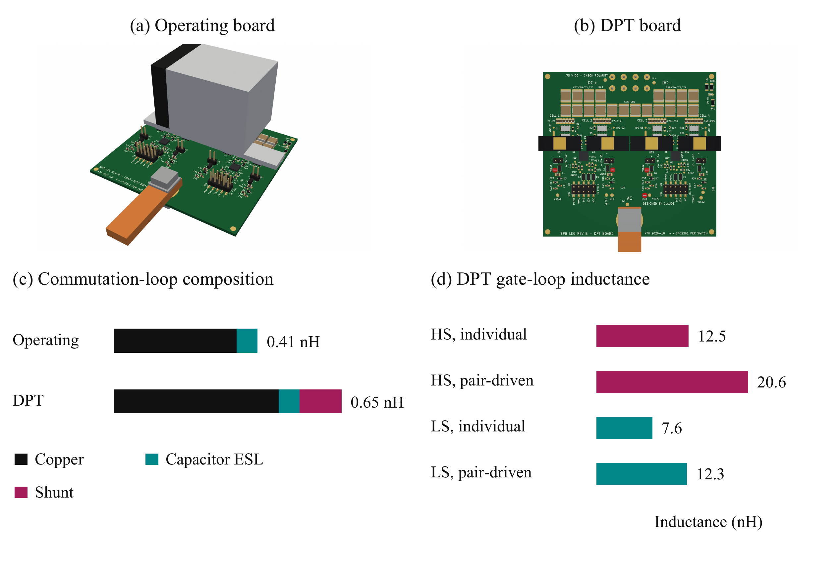
Fig. 3. Building-block variants and evaluated parasitics: (a) operating-board rendering; (b) instrumented DPT-board rendering; (c) commutation-loop inductance including conductor, capacitor ESL, and shunt contributions; and (d) individual and pair-driven DPT gate-loop inductances. Gate-network extraction in this study applies to the DPT board.
Fig. 4 shows the Q3D conductor models underlying the extraction.
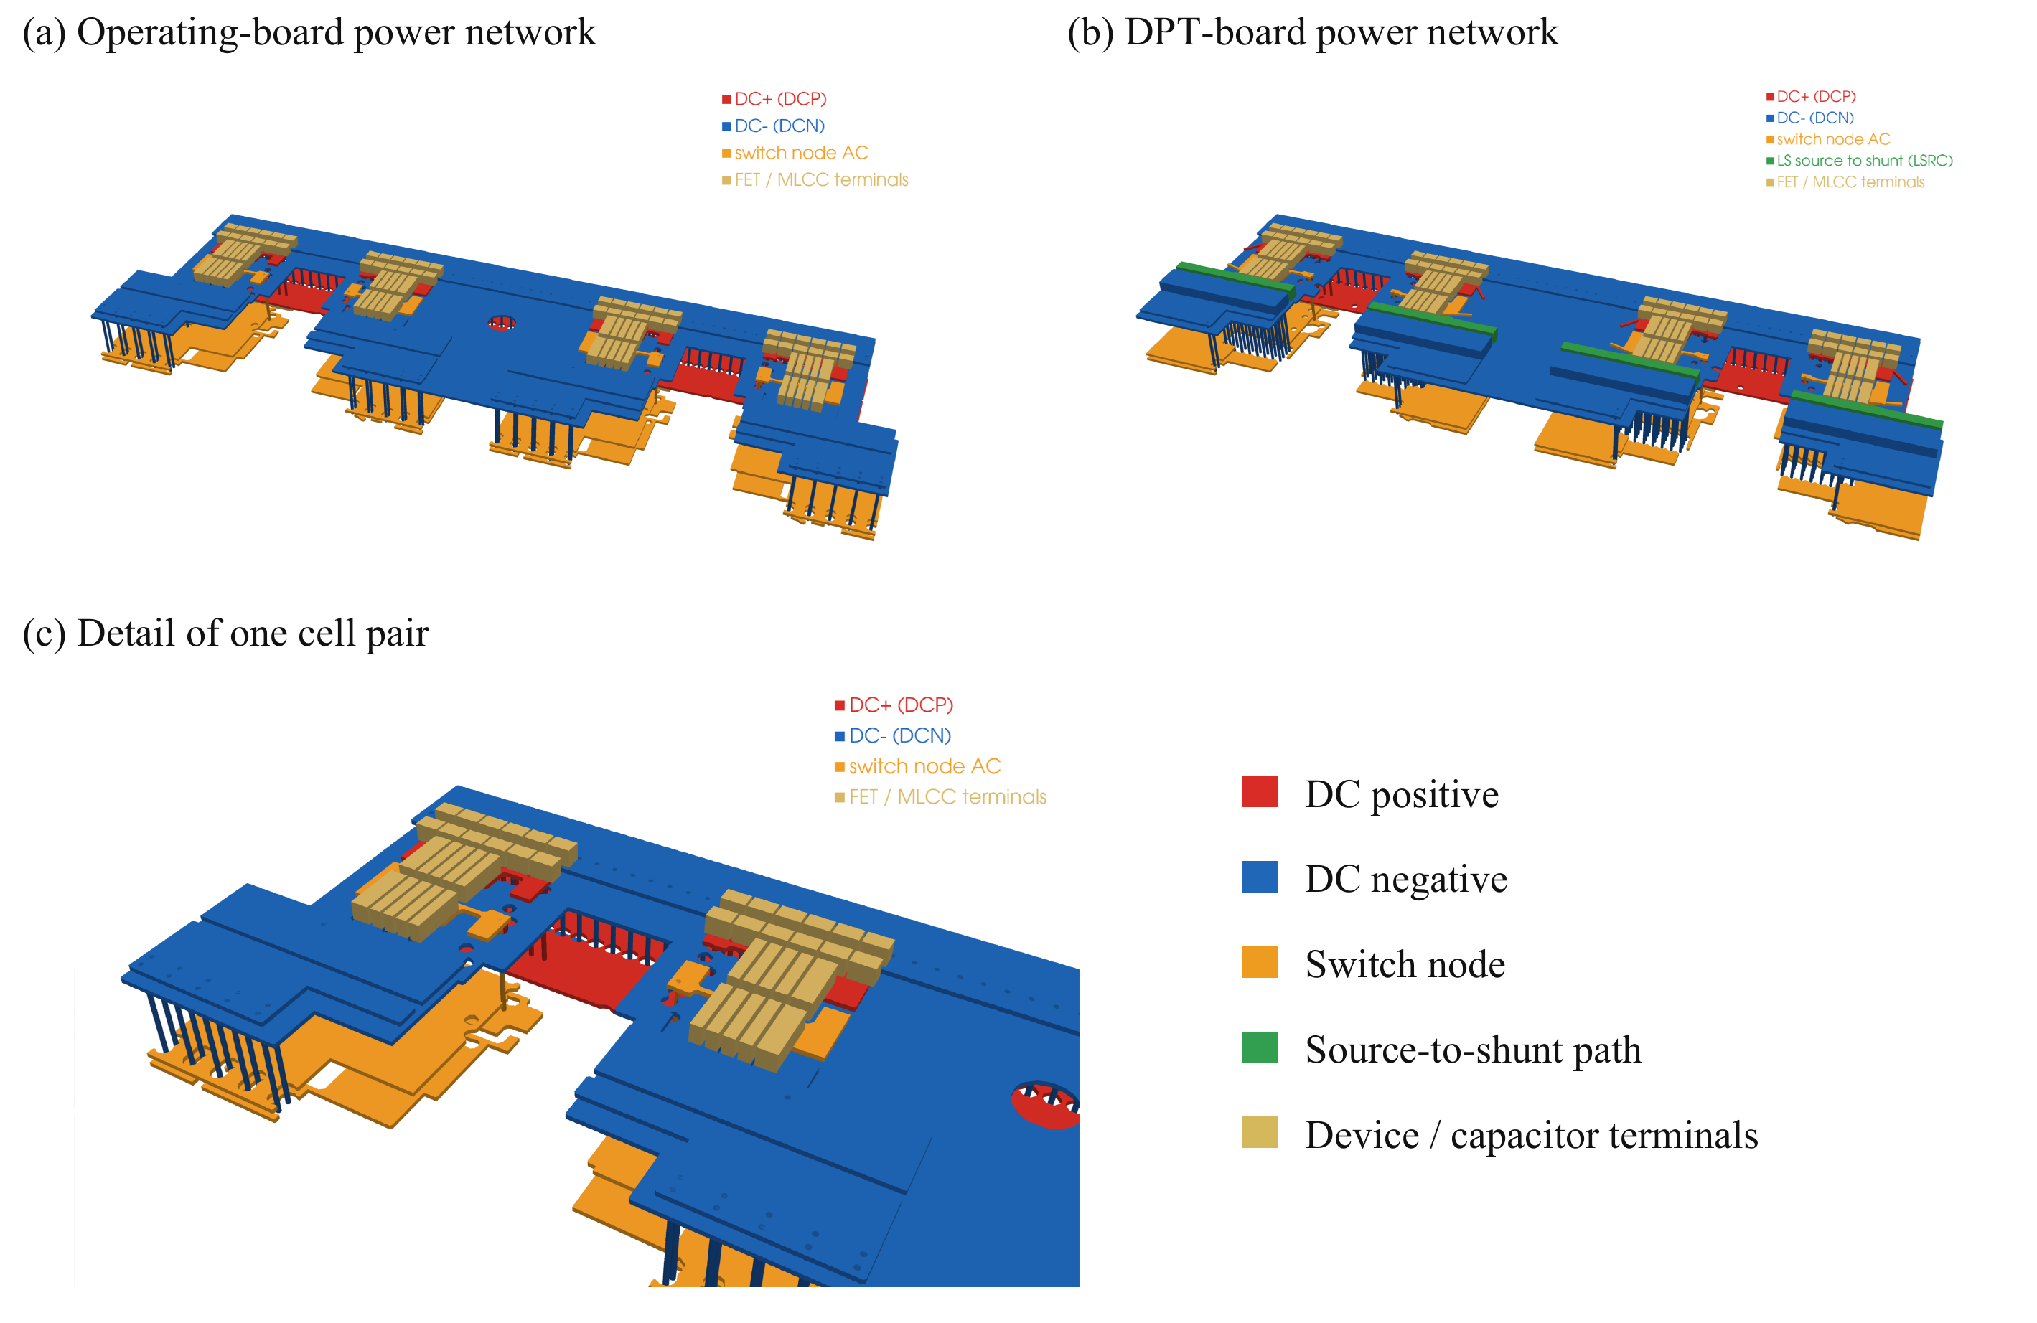
Fig. 4. Ansys Q3D conductor models used for parasitic extraction: (a) operating-board power network; (b) instrumented DPT-board power network, including the additional source-to-shunt conductors; and (c) detail of one cell pair showing the local conductor stack, interlayer connections, and device and capacitor terminals. Colors identify electrical nets and terminals, not field magnitude.

C. Switching Assessment and Design Feedback
Switching simulations are performed near the required phase-current peak, with approximately 316 A achieved in the evaluated DPT cases.
With the extracted DPT gate network, increasing turn-on resistance from 2.5 Ω to 3.5 Ω reduces peak drain–source voltage from approximately 105 V to 93 V, while mean turn-on energy per transistor increases from approximately 24 µJ to 31 µJ.
The full paper will provide the drain-voltage and gate-voltage waveforms, complete simulation comparison table, and corresponding switching-energy assessment.

D. Implications for the Building Block
The power-network results support a compact commutation path, while the gate-network results identify shared routing inductance as a remaining constraint. The evaluated extracted-network DPT case is therefore a candidate requiring refinement rather than a completed validation against all targets.

VI. Experimental Validation and Scope of the Full Paper

A. Planned Double Pulse Measurements
The full paper will provide the planned experimental DPT correlation of voltage overshoot, gate disturbance, current sharing, and switching energy. Experimental results are not available in this manuscript.

B. System Integration Boundary
The full paper will discuss winding and system integration, submodule balancing, auxiliary-power overhead, common-mode behavior, and the insulation boundary of the selected driver.

VII. Conclusion
Experimental DPT correlation is planned for the full paper. The contribution is the traceable connection between SPB voltage choice and the physical switching constraints that determine the usefulness of low-voltage devices at traction-current levels.

References
[1] S. Norrga et al., “A novel inverter topology for compact EV and HEV drive systems,” Proc. IECON, 2013, pp. 6590–6595.
[2] L. Jin et al., “Modulation and power losses of a stacked polyphase bridge converter,” IEEE J. Emerg. Sel. Topics Power Electron., vol. 5, no. 1, pp. 409–418, 2017.
[3] M. Nikouie et al., “DC-link stability analysis and controller design for the stacked polyphase bridges converter,” IEEE Trans. Power Electron., vol. 32, no. 2, pp. 1666–1674, 2017.
[4] G. Rohner et al., “Comparative evaluation of three-phase three-level flying capacitor and stacked polyphase bridge GaN inverter systems for integrated motor drives,” Electronics, vol. 13, Art. 1259, 2024.
[5] J. A. Brothers and T. Beechner, “GaN module design recommendations based on the analysis of a commercial 3-phase GaN module,” Proc. IEEE ECCE, 2019, pp. 4109–4116.
[6] J. Lu and D. Chen, “Paralleling GaN E-HEMTs in 10 kW–100 kW systems,” Proc. IEEE APEC, 2017, pp. 3049–3056.
[7] M. T. Tran et al., “A high-performance GaN power module with parallel packaging for high-current and low-voltage traction inverter applications,” IEEE J. Emerg. Sel. Topics Power Electron., vol. 13, no. 1, pp. 1188–1209, 2025.
[8] J. Azurza Anderson et al., “New figure-of-merit combining semiconductor and multi-level converter properties,” IEEE Open J. Power Electron., vol. 1, pp. 322–338, 2020, doi: 10.1109/OJPEL.2020.3018220.
[9] Efficient Power Conversion, “EPC2361 eGaN FET datasheet,” July 20, 2026.
[10] Infineon Technologies, “2EDF7275K data sheet,” rev. 2.8.

