Topic 17 — Power Electronics for Transportation Electrification

Parasitic Aware Building Block Design for Stacked Polyphase Bridge Traction Inverters
Abstract—The stacked polyphase bridge (SPB) introduces a voltage-partitioning degree of freedom into high-voltage traction inverters: the number of series-connected submodules determines the semiconductor voltage class, while the phase-current requirement remains high. This paper presents a hardware-constrained design procedure for an SPB phase-leg building block. A charge-based device figure of merit identifies the 100 V EPC2361 as the preferred candidate among the surveyed devices. Single-cell simulations use gate-loop inductances of 10 nH and 20 nH and commutation-loop inductances of 0.5 nH and 1 nH. A peak-current voltage screen and electrothermal comparison identify four parallel transistors per switch position as an initial candidate for sixteen submodules. Current-sharing sensitivity motivates symmetric transistor pairs and dedicated Kelvin returns. An iterative KiCad–Ansys Q3D–LTspice workflow replaces the assumed paths with routed networks. The extracted double-pulse test (DPT) network requires a joint assessment of resistance, gate disturbance, and switching energy. Low-current resonance and the remaining gap to the 90 V drain-voltage target require further drive refinement. The contribution is to connect SPB voltage selection to the physical switching constraints governing low-voltage devices at traction-current levels. Experimental double-pulse tests are planned for the full paper.
Index Terms—Gallium nitride, gate drive, parallel transistors, parasitic inductance, stacked polyphase bridge, traction inverter.

I. Introduction
Electrification is driving traction and fast-charging power levels toward several hundred kilowatts, while demands for efficiency and power density continue to increase. Raising the dc-link voltage is a key design choice for meeting these requirements, although traction inverters must still deliver substantial phase current. In a conventional two-level traction inverter, each switch must block the full dc-link voltage and conduct the phase current, making semiconductor losses a central design constraint. The stacked polyphase bridge (SPB) introduces an additional design degree of freedom by connecting three-phase bridges in series on the dc side, with each bridge feeding an isolated winding set of a multiphase machine [1], [2]. Fig. 1 illustrates the SPB topology and the phase-leg building block considered in this work. Distributing the dc-link voltage among submodules allows each bridge to use a lower semiconductor voltage class and apply smaller voltage steps to its winding set. Voltage partitioning therefore becomes an active design choice that links the converter architecture to device selection.
The benefit of voltage partitioning depends on realizing a practical high-current submodule. Increasing the number of submodules reduces the voltage across each bridge but does not reduce the phase current for a given total drive power, dc-link voltage, modulation index, and power factor. Low-voltage gallium nitride (GaN) devices can offer favorable on-state resistance and switching performance, but meeting the traction-current requirement may require several devices in parallel. Current sharing, gate-drive impedance, and commutation-loop parasitics then determine how much of the expected loss benefit can be retained. Increasing the submodule count also increases the number of gate-drive circuits, auxiliary supplies, and interconnections throughout the converter.
Previous studies establish SPB modulation and loss characteristics [2], dc-link stability [3], and comparisons with alternative GaN converter systems [4]. These studies provide the system-level basis for selecting a submodule voltage. Research on paralleled GaN stages identifies complementary implementation constraints, including commutation-loop inductance, common-source coupling, and unequal gate impedances [5]–[7]. Together, these findings motivate a design procedure that considers voltage partitioning and high-current hardware implementation jointly.
The central challenge is the feedback between the selected submodule voltage and the physical building block. A lower device voltage class may offer favorable loss characteristics, but the available voltage margin must accommodate switching overshoot at the required current. Excessive commutation-loop inductance can require slower switching or a lower submodule operating voltage, potentially changing the initial loss comparison or the required submodule count. Gate-loop impedance and symmetry further constrain switching speed by affecting gate-voltage disturbances and dynamic current sharing. The practical benefits of SPB voltage partitioning therefore depend on optimizing the power and gate networks together.
This paper presents a hardware-constrained design procedure for an SPB phase-leg building block. Single-cell switching simulations establish an initial current range using representative gate-loop and commutation-loop inductances. Losses, junction temperature, and the voltage stress of both switches then determine the parallel-count candidate. Current-sharing sensitivity guides the symmetric cell arrangement and paired gate drive. An iterative layout, parasitic-extraction, and circuit-simulation workflow evaluates whether the assumed switching conditions can be maintained in the routed building block. Separate operating and double-pulse test (DPT) boards distinguish the intended converter layout from measurement-related parasitics. The contribution is to connect SPB voltage partitioning and device selection to the physical constraints governing high-current implementation.
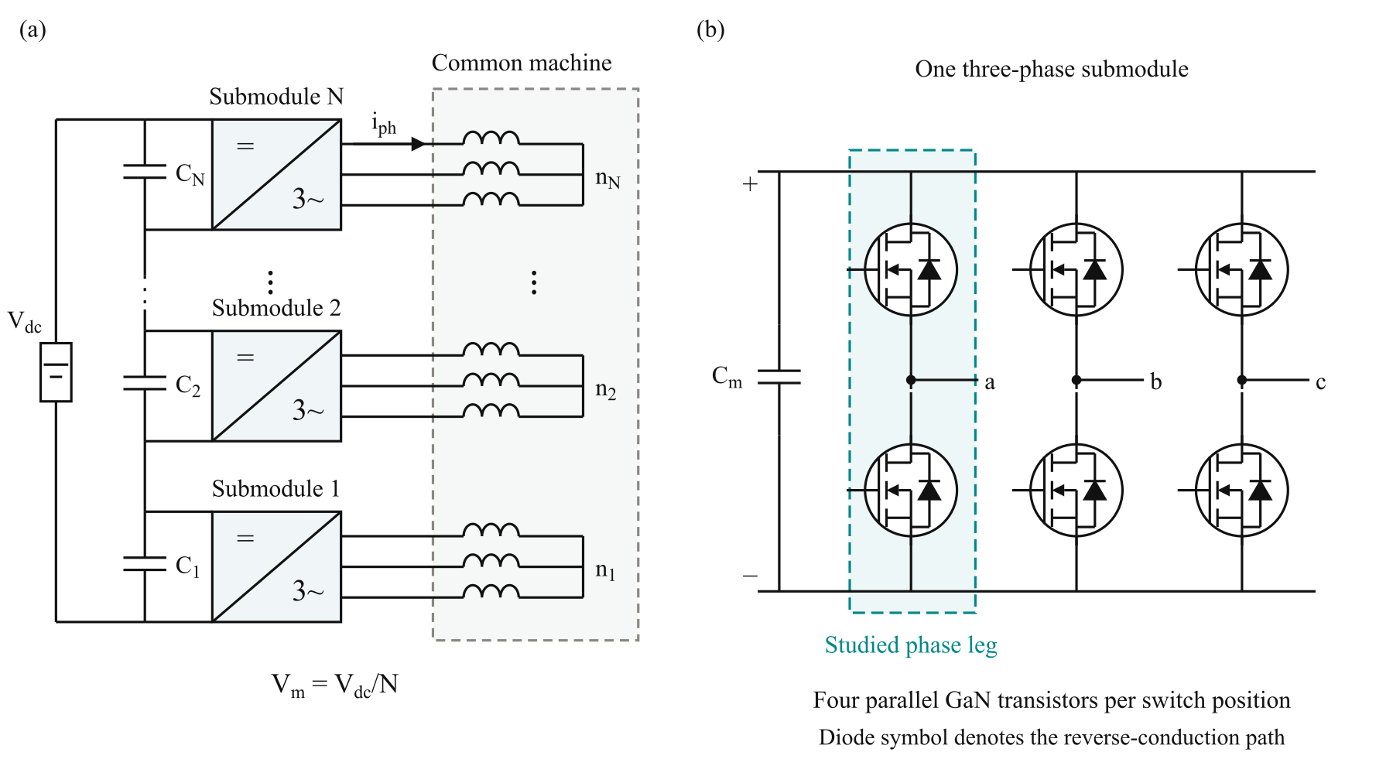
Fig. 1. (a) SPB traction-drive topology with N series-connected submodules, each supplying an isolated three-phase winding set of a common machine. (b) Three-phase submodule with the studied phase leg highlighted. Each switch symbol represents four parallel GaN transistors; the diode denotes the equivalent reverse-conduction path.

II. Traction Requirements and Initial Device Selection

A. Traction Drive Requirements
The building block is designed for the traction operating point and constraints summarized in Table I. For balanced operation with equal submodule voltages, the total active power is expressed as
$P = \frac{3 M V_{dc} I_{ph,rms} cos φ}{2\sqrt{2}}$ (1)
Here, V_{dc} is the total dc-link voltage, I_{ph,rms} is the rms phase current, and cosφ is the power factor. The modulation index M is defined such that the fundamental phase-to-neutral voltage peak of each submodule is M V_{m}/2. The specified operating point requires approximately 228 A rms and 322 A peak phase current.
TABLE I
DESIGN OPERATING POINT AND PRELIMINARY CONSTRAINTS
Quantity | Symbol | Value
Total active power | P | 300 kW
Total dc-link voltage | V_{dc} | 1200 V
Modulation index | M | 1.15
Power factor | cosφ | 0.9
Switching frequency | f_{sw} | 50 kHz
Candidate submodule count | N | 16
Nominal submodule voltage | V_{m} | 75 V
Peak drain–source voltage target | V_{DS,pk} | 90 V
Junction-temperature limit | T_{j,max} | 125 °C
Ambient temperature | T_{a} | 40 °C
The submodule count does not appear explicitly in (1). Increasing the number of series-connected submodules reduces the voltage supplied to each winding set while increasing the number of winding sets contributing to the total power. Consequently, voltage partitioning does not reduce the phase-current requirement under the stated operating conditions. The selected devices must therefore provide both an appropriate blocking-voltage rating and sufficient current-handling capability.

B. Semiconductor Voltage Class Comparison
Voltage partitioning allows the semiconductor voltage class to be selected together with the submodule count. This choice requires a comparison of conduction and switching characteristics rather than on-state resistance alone. Fig. 2 compares the typical on-state resistance R_{DS(on)} at 25 °C and the charge-equivalent output capacitance C_{oss,Q} of the surveyed GaN devices. The latter is calculated as
$C_{oss,Q} = \frac{Q_{oss}}{V_{test}}$ (2)
where Q_{oss} is the output charge at the datasheet test voltage V_{test}. This quantity accounts for the charge accumulated over the voltage excursion, whereas differential output capacitance describes the capacitance at a particular voltage. Following the charge-based screening criterion in [8], the device figure of merit is defined as
$D-FOM = \frac{1}{\sqrt{R_{DS(on)} C_{oss,Q}}}$ (3)
A higher D-FOM indicates a more favorable combination of conduction resistance and output charge. In the simplified hard-switching model underlying this criterion, optimizing semiconductor area gives minimum losses proportional to the square root of the resistance–capacitance product. Fig. 2 therefore uses constant-product contours, with lower τ = R_{DS(on)} C_{oss,Q} corresponding to higher D-FOM.
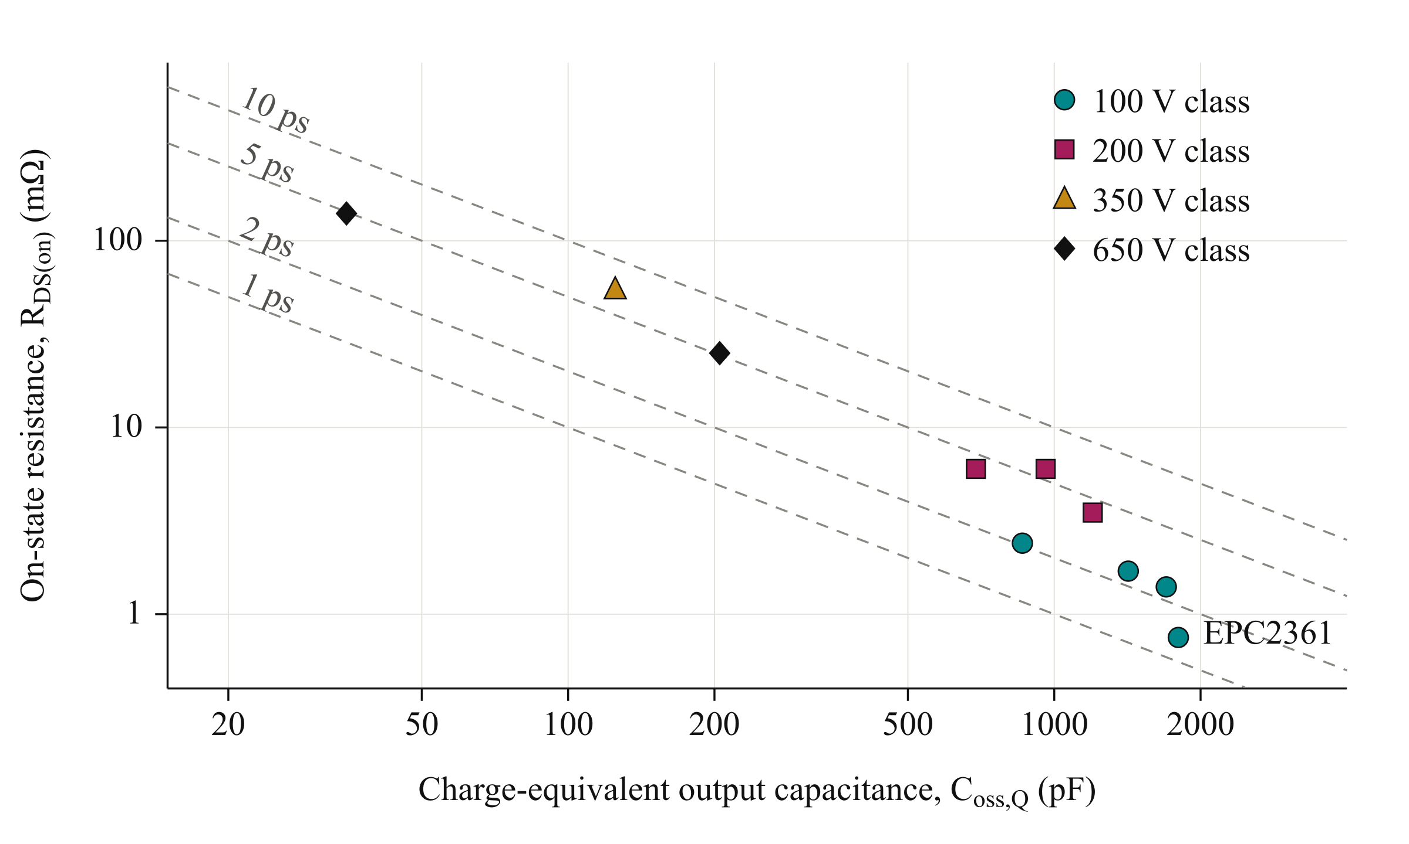
Fig. 2. Typical on-state resistance at 25 °C versus charge-equivalent output capacitance of the surveyed GaN devices, distinguished by voltage class. Dashed lines indicate constant resistance–capacitance products τ = R_{DS(on)} C_{oss,Q}. Lower τ corresponds to higher D-FOM. Charge-equivalent capacitance is calculated at the respective datasheet test voltage.
Among the surveyed devices, EPC2361 has the highest D-FOM and is selected for further investigation. Its typical on-state resistance is 0.75 mΩ [9]. The quotient of the rounded output charge of 90 nC and its 50 V test voltage gives 1800 pF, consistent with the datasheet time-related capacitance of 1796 pF. This is distinct from the differential output capacitance of 1019 pF at the same voltage.
The comparison is an initial screening rather than a direct prediction of converter efficiency. Output-charge values are specified at different test voltages, and the simplified criterion does not capture temperature, gate-drive, parasitic, and current-sharing effects. The candidate is subsequently evaluated at the intended submodule voltage and traction current.

C. Initial Submodule Voltage
For equal voltage partitioning, the nominal submodule voltage is
$V_{m} = \frac{V_{dc}}{N}$ (4)
The candidate arrangement in Table I permits 100 V devices to be considered. The available margin must accommodate submodule-voltage variation and switching overshoot. The peak drain–source voltage target leaves a 15 V allowance above the nominal submodule voltage and a further margin below the device rating. The candidate operating point is therefore assessed through switching simulations and parasitic extraction rather than accepted from the nominal rating alone.

III. Single Cell Characterization and Selection of the Parallel Count

A. Single Cell Switching Characterization
The selected EPC2361 is evaluated in a half-bridge model with one device per switch position. Double-pulse simulations are performed at a submodule voltage of 75 V over a device-current sweep. Gate-loop inductances of 10 nH and 20 nH represent the preliminary range of interest. Commutation-loop inductances of 0.5 nH and 1 nH separately represent a compact power path and a higher-inductance sensitivity case. The lumped gate-loop value includes the outgoing gate path and its return; it is distinct from the power-loop inductance. The gate drive uses +5 V on-state bias, −1 V off-state bias, 3 Ω external turn-on resistance, and 1 Ω external turn-off resistance. The pulsed driver model uses source and sink resistances of 0.85 Ω and 0.35 Ω; driver current limiting and propagation-delay spread are outside this preliminary model. Switching maps are evaluated at the device model’s nominal temperature of 27 °C.
Fig. 3 compares the voltage-stress and turn-on-energy results for the four combinations of power- and gate-loop inductance. Voltage stress is evaluated as the larger of the low-side drain-voltage peak at turn-off and the high-side peak during low-side turn-on. This avoids selecting the device current from only one switching transition. With the compact commutation path, operation near 80 A per device satisfies the drain-voltage target for both gate-loop cases. The larger power-loop case exceeds the target and cannot be accepted solely by increasing the parallel count.
The single-cell results establish approximately 80 A as a preliminary current scale for the compact-loop case, rather than an absolute device-current limit. Dividing the required phase-current peak by this value suggests four parallel transistors per switch position. Neighboring counts are compared on the same drive and thermal basis. This is a peak-current screen: Fig. 3 also shows resonant overshoot at low current, so compliance over the full sinusoidal current range still requires drive refinement. Held-off gate disturbance is checked separately against the minimum threshold; a passing drain-voltage result alone does not establish gate-drive margin.
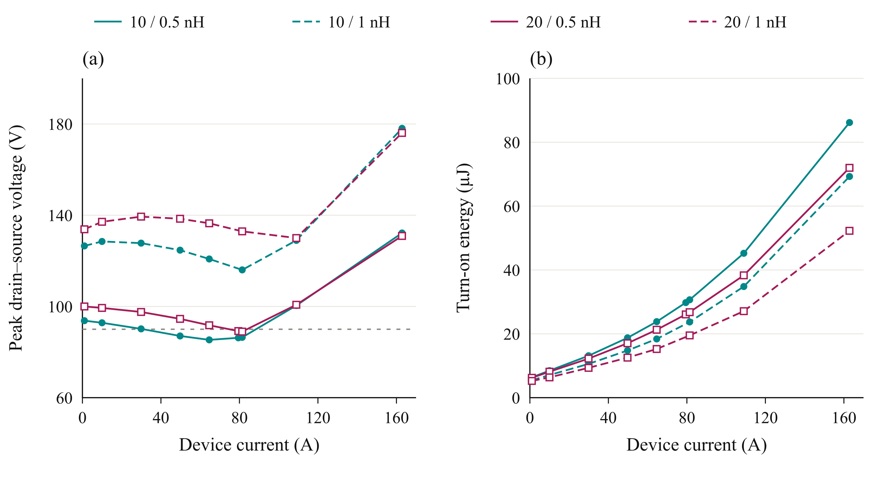
Fig. 3. Simulated single-cell characteristics at 75 V: (a) the larger drain–source voltage peak across the two evaluated switching transitions and (b) turn-on energy. Legend entries give gate-loop / commutation-loop inductance. Teal and wine distinguish the 10 nH and 20 nH gate cases; solid and dashed lines distinguish 0.5 nH and 1 nH power loops. Markers denote simulated operating points, with connecting lines guiding the eye. The dashed grey line denotes the 90 V target. Cases exceeding the constraints are sensitivity results, not recommended operating points.

B. Loss and Thermal Assessment
For n parallel transistors and ideal current sharing, the peak current per device is
$I_{dev,pk} = \frac{I_{ph,pk}}{n}$ (5)
The single-cell switching-energy maps are evaluated over the sinusoidal phase-current waveform to estimate average switching losses. The measured current at the first turn-off, rather than the programmed current parameter, is used for interpolation. Turn-on and turn-off energies are obtained by integrating terminal voltage multiplied by drain current over 150 ns windows, and piecewise-linear interpolation supplies intermediate current points. The phase-leg switching estimate includes the complementary-device output-energy contribution in addition to the hard-switching energy maps. Conduction losses use temperature-dependent on-state resistance, with resistance and junction temperature solved iteratively. Switching-energy temperature dependence is not included in these first-pass thermal estimates.
The thermal assessment assumes an ambient temperature of 40 °C, a heatsink-to-ambient thermal resistance of 0.65 K/W for the complete phase leg, and a junction-to-heatsink thermal resistance of 7.6 K/W per transistor. The same per-device thermal path is used for each parallel-count candidate. The resulting junction temperatures are estimates conditional on these cooling assumptions.
Fig. 4(a) shows the loss distribution for the nominal gate-loop case and compact commutation path. Additional parallel devices reduce conduction loss, while switching charge, gate loading, and layout complexity limit the benefit of further paralleling. The corresponding voltage-stress comparison in Fig. 4(b) shows that overshoot is not necessarily monotonic with parallel count. Gate-network dynamics therefore have to be checked alongside the reduction in current per device.
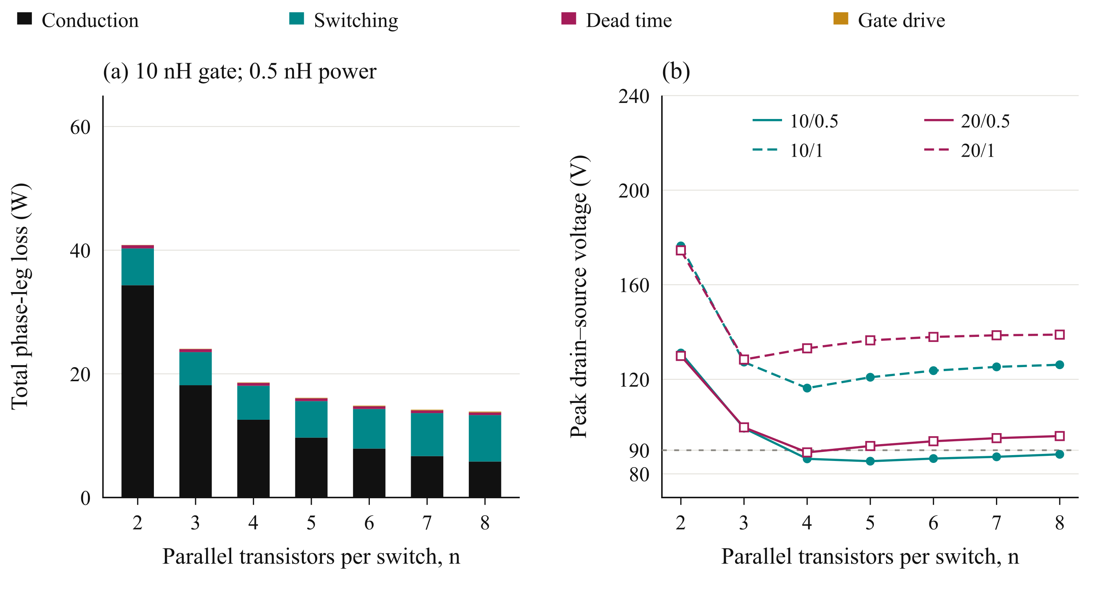
Fig. 4. Parallel-count comparison at 75 V, 228 A rms phase current, and 50 kHz: (a) phase-leg loss distribution for a 10 nH gate loop and 0.5 nH commutation loop; (b) the larger drain-voltage peak across the two switching transitions at the required phase-current peak. Voltage-panel legend entries give gate-loop / commutation-loop inductance in nH, using the encoding of Fig. 3. The grey line denotes the 90 V target. The loss components are identified by the shared legend above the panels.

C. Selection of Four Parallel Devices
Table II compares the candidate parallel counts for both gate-loop cases. Two devices exceed the thermal limit, while three fail the compact-loop drain-voltage target. Four are the smallest tested count passing the peak-current voltage screen and thermal estimate for both gate-loop cases at the compact power-loop assumption. This establishes an implementation candidate; it does not demonstrate voltage compliance over the entire current waveform. The assumed gate bias and resistances are part of the selection.
TABLE II
PRELIMINARY PARALLEL COUNT COMPARISON
Gate loop (nH) | Parallel count n | Leg loss (W) | Junction temperature (°C) | Peak V_{DS} at 0.5 nH (V) | Peak V_{DS} at 1 nH (V)
10 | 2 | 40.8 | 144 | 131 | 176
10 | 3 | 24.0 | 86 | 99 | 127
10 | 4 | 18.6 | 70 | 86 | 116
10 | 5 | 16.1 | 63 | 85 | 121
10 | 6 | 14.9 | 59 | 86 | 124
20 | 2 | 39.8 | 142 | 130 | 175
20 | 3 | 23.4 | 85 | 100 | 128
20 | 4 | 18.2 | 69 | 89 | 133
20 | 5 | 15.7 | 62 | 92 | 136
20 | 6 | 14.5 | 58 | 94 | 138
Loss and junction-temperature estimates in Table II use the 0.5 nH commutation-loop case and the cooling assumptions stated above. The voltage columns show the larger of the evaluated low-side turn-off and high-side turn-on peaks. Values are interpolated at the required peak current per device. Gate-loop inductance is a screening parameter; final acceptance requires the routed network.
Four devices are selected as the implementation candidate and arranged as two identical transistor pairs. This is not the absolute minimum-loss count: further devices can reduce calculated conduction loss but increase the device count and gate-drive burden. Moreover, the higher gate-loop case demonstrates that a lower per-device current does not guarantee a lower drain-voltage peak. The selected arrangement must consequently be verified with the complete power and gate networks.
The higher commutation-inductance cases fail the voltage target, including at the selected parallel count. The design therefore requires a compact power path and controlled gate-drive dynamics; paralleling alone does not recover the available blocking-voltage margin. Current sharing is still assumed equal in the first-pass comparison. The following stage translates the selected count into a symmetric arrangement and evaluates whether the routed geometry preserves those conditions.

IV. Gate Drive Configuration and Cell Arrangement

A. Current Sharing Sensitivity
The preliminary parallel-count selection assumes equal current sharing among the four transistors in each switch position. Maintaining this condition during switching requires control of the gate and power-path impedances. Differences in gate-loop inductance, common-source inductance, and driver timing can produce unequal transient currents and switching energies, even when the devices have similar on-state resistance. Fig. 5(a) summarizes sensitivity simulations for two parallel devices at 75 V and 120 A total current. A power-loop inductance mismatch of 0.3 nH produces approximately 2% switching-energy imbalance in the evaluated case. A gate-loop inductance difference of 2 nH versus 8 nH increases the imbalance to approximately 19%. Without a Kelvin-source return, a common-source inductance mismatch of 0.2 nH produces approximately 29% imbalance. Although these results depend on the investigated operating point and perturbations, they demonstrate that matching the power paths alone is insufficient. The gate branches and source-reference connections must also be considered when translating the selected parallel count into a physical layout. These perturbation cases isolate mismatch mechanisms; their branch values do not replace the 10 nH and 20 nH gate-loop cases used for preliminary sizing. The complete routed network is subsequently used to account for shared paths and coupling.
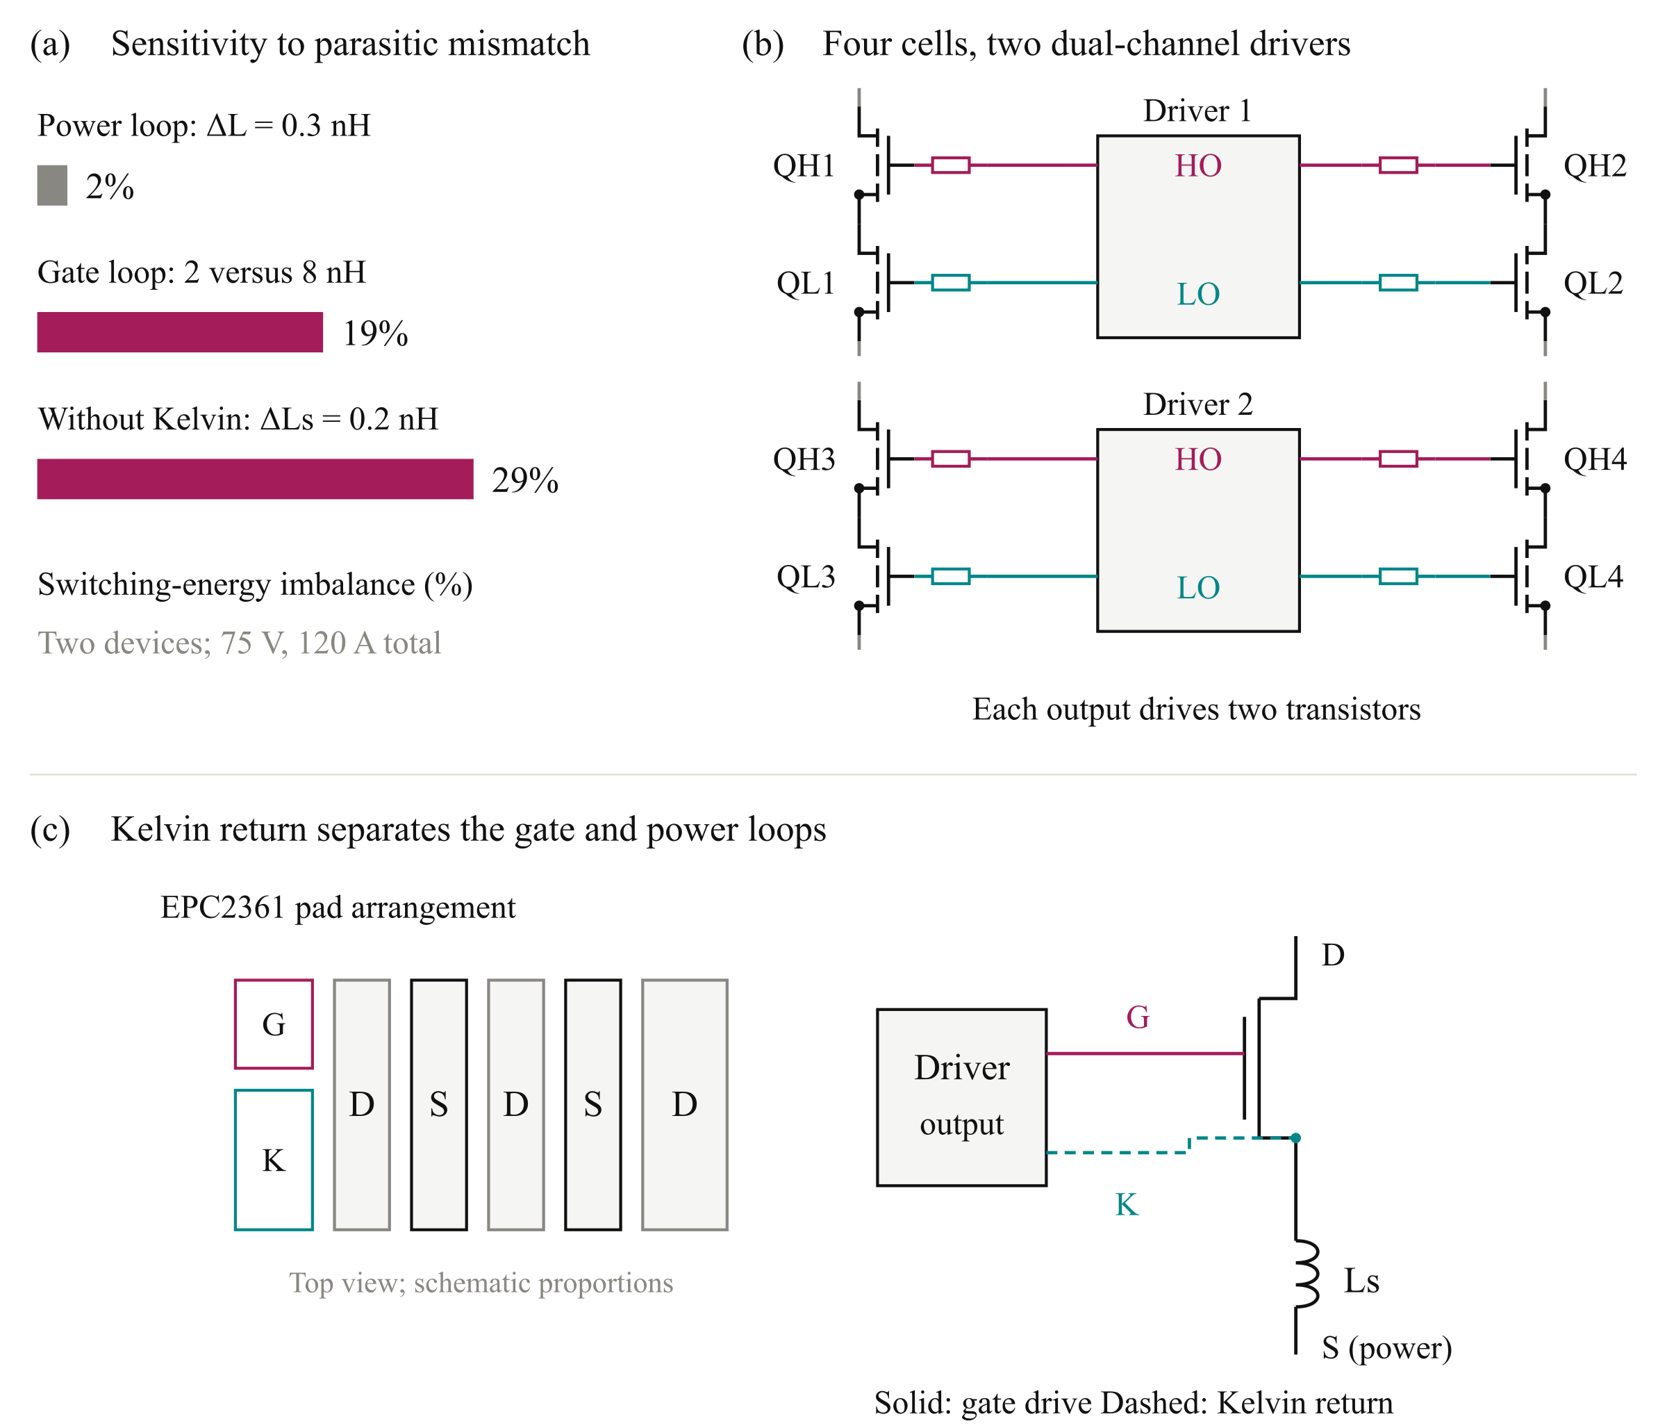
Fig. 5. Gate-drive design considerations: (a) simulated switching-energy imbalance under the investigated parasitic mismatches; (b) four switching cells grouped into two pairs, each served by a dual-channel driver with individual gate resistors; and (c) schematic EPC2361 pad arrangement and Kelvin-source connection, illustrating separation of the gate return from the power-source inductance. Driver supply and return connections are omitted in (b) for clarity. High-side (HS) and low-side (LS) outputs are denoted HO and LO.

B. Paired Gate Drive Configuration
Connecting all four transistors to one gate-driver output increases the total gate charge and the current required to establish the intended switching transition. The turn-off path must also sink the displacement current coupled through the gate–drain capacitance during drain-voltage transients. Excessive impedance in this path can cause a positive gate-voltage disturbance and reduce the margin against unintended turn-on.
The four-device arrangement is therefore divided into two transistor pairs per switch position. As illustrated in Fig. 5(b), each pair of switching cells is served by one dual-channel 2EDF7275K driver IC. One channel drives the two high-side transistors, while the other drives the two low-side transistors. The complete phase leg consequently uses two driver ICs, with two transistor gates connected to each output channel through individual gate resistors.
The selected driver provides a peak sink-current capability of 8 A per channel [10]. Driving two gates from each channel limits the charge handled by one output and permits short, matched branches about the driver. A low-impedance turn-off path is needed to remove displacement current coupled through the gate–drain capacitance, but its damping and bias must also control negative ringing. The nominal current capability alone does not establish gate-voltage margin; both the driven and held-off gate waveforms must be checked with the complete network.

C. Kelvin Source Connection and Cell Layout
Each local switching cell contains one high-side transistor, one low-side transistor, and local dc-link decoupling capacitors. Four cells form the phase leg and are arranged as two identical pairs. Within each pair, symmetric device placement and matched gate branches are used to reduce differences in transient loading. Local decoupling limits the extent of the high-frequency commutation path, while symmetric connections to the shared power terminals reduce differences between the parallel branches.
Fig. 5(c) illustrates the role of the dedicated Kelvin-source connection. The gate-drive return is taken from the Kelvin pad rather than through the power-source conductors. This separates the gate-reference path from the inductance carrying the main source current and reduces the associated inductive feedback into the gate voltage. The Kelvin connection does not eliminate gate-loop inductance; both the outgoing gate branch and its return must remain short and closely coupled.
Individual gate resistors and separate Kelvin-return branches are retained for each transistor. The branches are connected to the corresponding driver channel in a star arrangement, avoiding unnecessary shared impedance between the devices. The layout objective is therefore to minimize both the magnitude and mismatch of the relevant loop impedances.

D. Verification of the Physical Arrangement
Symmetry within each transistor pair does not eliminate timing differences between the two driver ICs. Input routing and inter-driver propagation-delay differences must therefore be assessed separately from the matching of the local gate branches. The paired configuration establishes the intended circuit arrangement, while its current-sharing performance remains subject to verification with the routed geometry.
The paired configuration is translated into a routed board and evaluated through the extraction-based workflow in Section V. The 10 nH and 20 nH lumped gate-loop cases provide an initial design basis. Extraction then replaces them with individual and shared branches, allowing the current capability, switching margin, and loss estimate to be reassessed for the physical building block.

V. Closing the Design Loop with the Routed Building Block

A. Layout and Parasitic Extraction
Initial sizing establishes a candidate voltage and parallel count using the two gate-loop and two commutation-loop cases. The routed building block must then be assessed to determine whether the associated voltage and gate-drive margins can be retained. Fig. 6 connects the KiCad layout, Ansys Q3D parasitic extraction, and LTspice switching assessment. Its feedback is used to revise placement, routing, or drive settings when the complete network changes the switching response.
The power devices, local decoupling capacitors, and paired gate drivers are placed and routed in KiCad. The conductor geometry is evaluated in Ansys Q3D to obtain resistive and inductive networks, including mutual coupling between branches. These networks are incorporated into LTspice to assess voltage overshoot, gate disturbance, transient current sharing, and switching-energy distribution. Placement, routing, or drive settings are revised where necessary.
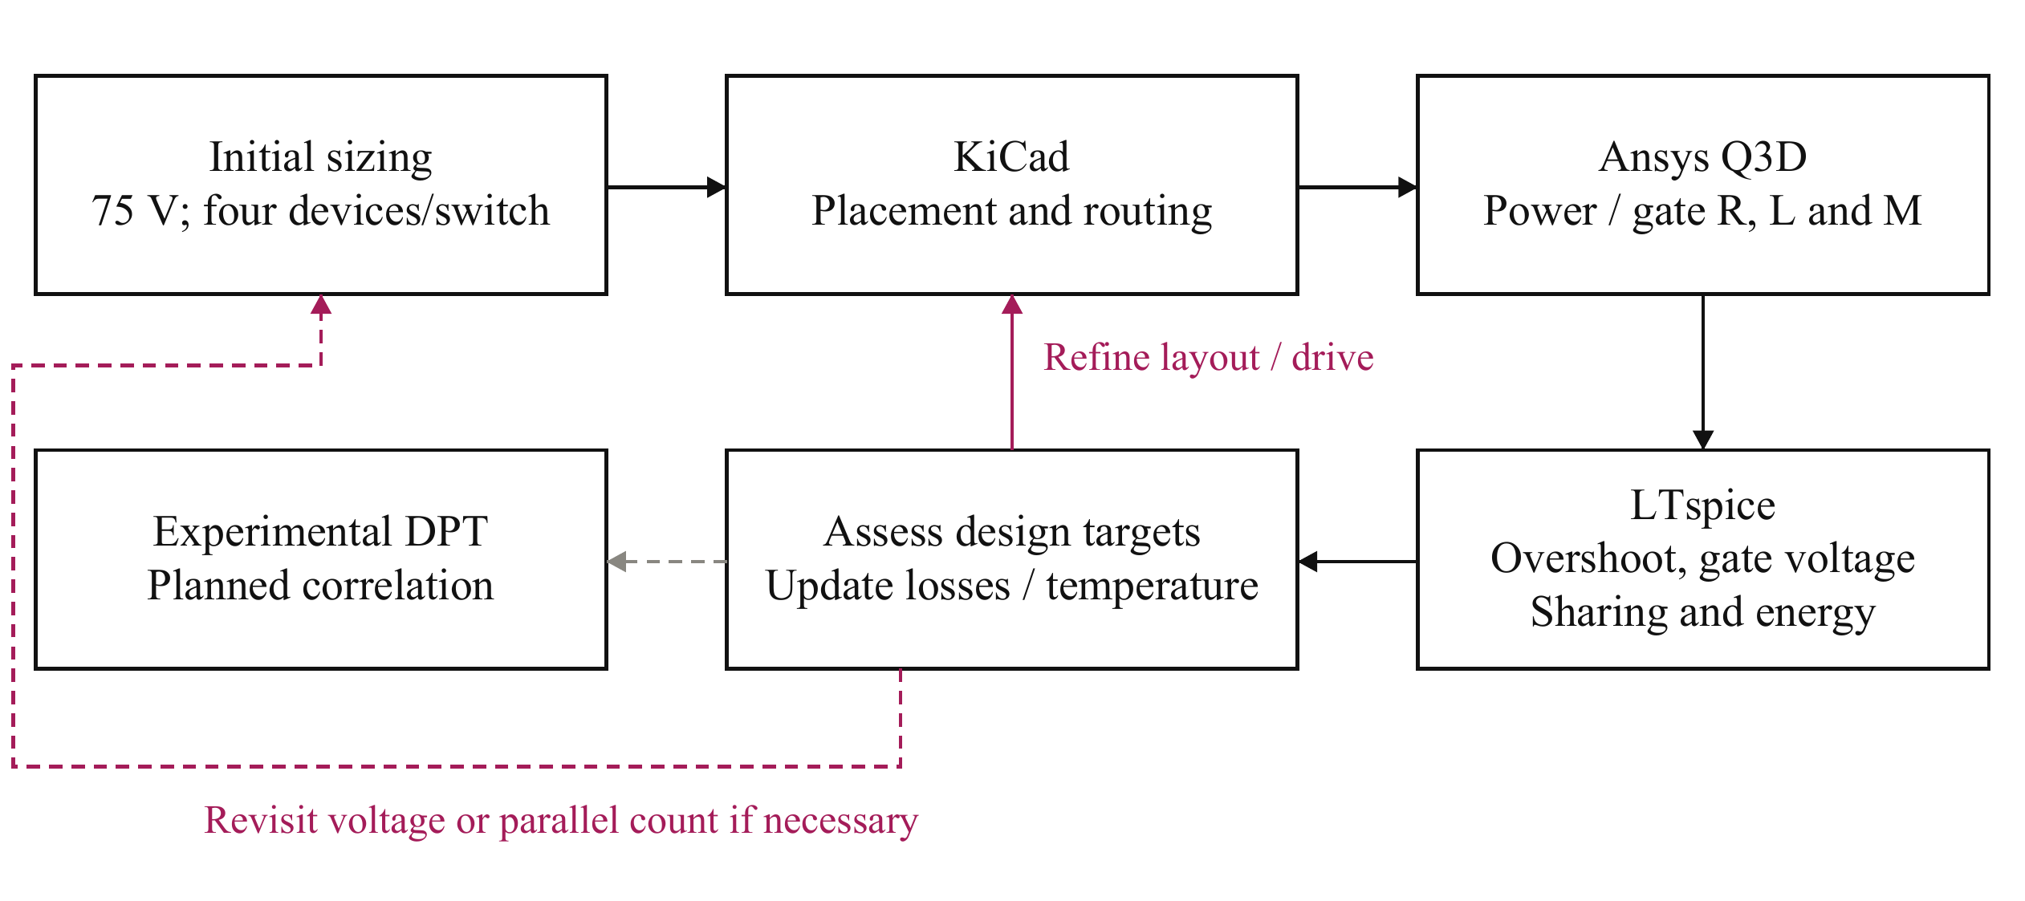
Fig. 6. Iterative design and verification workflow. Extracted power and gate networks connect the routed geometry to switching simulations. The results inform revisions to layout, drive settings, and, where necessary, voltage partition or parallel count. Experimental double-pulse test (DPT) correlation is planned.
Two board variants are considered: an operating board representing the intended converter building block and an instrumented DPT board. The latter includes current-measurement provisions that introduce additional commutation-path parasitics. Figs. 7(a) and 7(b) distinguish these implementations, preventing measurement-related inductance from being treated as an unavoidable feature of the operating converter.

B. Extracted Power and Gate Networks
Fig. 7(c) separates the commutation-loop contributions. The operating-board loop is approximately 0.41 nH per cell, supporting the feasibility of the compact-loop assumption used in preliminary sizing. The additional conductor length and shunt contribution increase the DPT loop to approximately 0.65 nH. The capacitor contribution is included through its equivalent series inductance (ESL).
The DPT gate-network extraction in Fig. 7(d) places the individual and pair-driven paths in the same order of magnitude as the preliminary gate-loop cases. The pair-driven paths include the effect of shared routing, so matching the individual branches does not eliminate common inductance. The 20 nH screening case is representative rather than a guaranteed upper bound. A scalar loop estimate cannot reproduce every shared-path and mutual-coupling effect; the extracted network is therefore used for the final switching assessment.
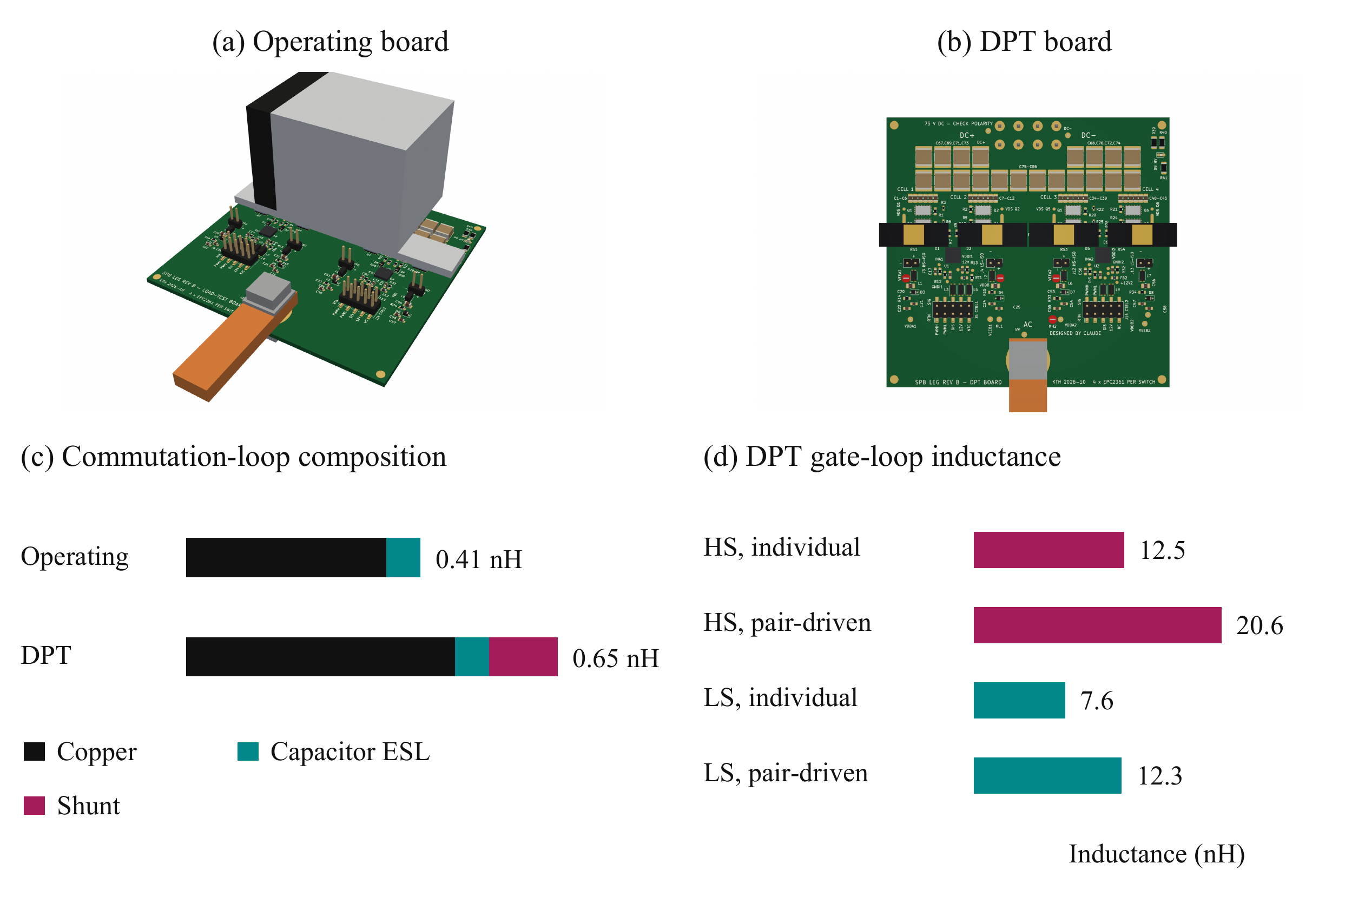
Fig. 7. Building-block variants and evaluated parasitics: (a) operating-board rendering; (b) instrumented DPT-board rendering; (c) commutation-loop inductance including conductor, capacitor ESL, and shunt contributions; and (d) individual and pair-driven DPT gate-loop inductances. Gate-network extraction in this study applies to the DPT board.
Fig. 8 shows the Q3D conductor models underlying the extraction. The operating-board view is compared with the DPT-board network, which includes the additional low-side source-to-shunt path. The cell-pair detail shows the overlapping conductors, interlayer connections, and device and capacitor terminals used to define the local power network. These are geometry views rather than field-distribution plots.
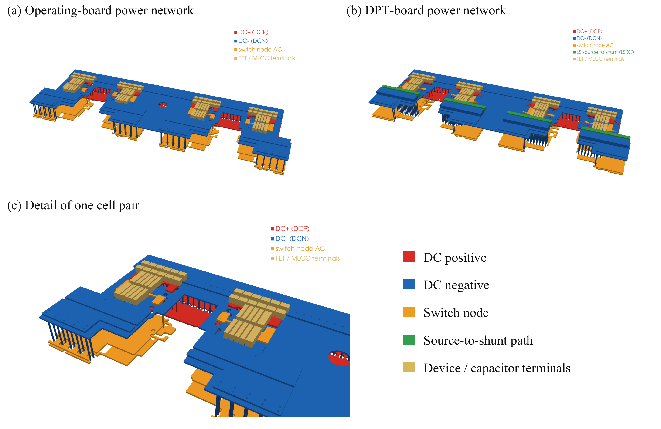
Fig. 8. Ansys Q3D conductor models used for parasitic extraction: (a) operating-board power network; (b) instrumented DPT-board power network, including the additional source-to-shunt conductors; and (c) detail of one cell pair showing the local conductor stack, interlayer connections, and device and capacitor terminals. Colors identify electrical nets and terminals, not field magnitude.

C. Switching Assessment and Design Feedback
Switching simulations near the required phase-current peak compare the routed power paths with the assumed and extracted gate networks. Table III reports the complete drive configurations and their results. For the operating board, the assumed gate and Kelvin-return inductances are split in a fixed 70:30 ratio, with their sum equal to the stated gate-loop value. This split is a modeling assumption, not an extraction result. The 10 nH and 20 nH cases assess sensitivity until the operating-board gate network is extracted. The DPT cases use either the same lumped branch representation or the extracted gate network. Shared paths make these network models more informative than an isolated scalar inductance.
TABLE III
SWITCHING SIMULATION COMPARISON NEAR 316 A
Board / gate model | R_{g,on} / R_{g,off} (Ω) | Off bias (V) | Peak V_{DS} (V) | Mean E_{on} per device (µJ) | Minimum V_{GS} (V)
Operating / 10 nH | 3 / 1 | -1 | 88 | 31.6 | -2.4
Operating / 20 nH | 3 / 1 | -1 | 90 | 29.4 | -2.5
Operating / 20 nH | 3 / 0 | 0 | 89 | 29.7 | -3.0
DPT / 10 nH | 3.5 / 0 | -1.9 | 91 | 32.5 | -4.8
DPT / 20 nH | 3.5 / 0 | -1.9 | 94 | 29.9 | -6.0
DPT / extracted | 2.5 / 0.5 | -1.9 | 105 | 24.3 | -3.5
DPT / extracted | 3.5 / 0.5 | -1.9 | 93 | 31.2 | -3.5
Table III reports the maximum high-side drain–source voltage across the four cells during low-side turn-on and the mean turn-on energy per transistor for that event. These event energies are not fundamental-period average losses. The revised operating-board drive uses the preliminary sizing settings; the zero-bias case shows the gate-disturbance problem. In the extracted DPT gate network, a shared turn-on resistor of 1 Ω or 1.5 Ω feeds two individual 0.5 Ω gate resistors. The listed turn-on values are the corresponding effective per-device resistances under equal pair currents; the individual resistors also remain in the turn-off path. The lumped DPT comparison uses zero external turn-off resistance. Extracted power paths are used in all cases; gate-network extraction applies only to the cases identified in the table.
Fig. 9(a) shows the high-side drain-voltage transients for the revised operating-board drive and two extracted-network DPT resistance settings. Increasing turn-on resistance reduces voltage stress at the cost of greater switching energy. The extracted-network DPT configuration remains above the project drain-voltage target, so additional gate-network or drive optimization is required before accepting it.
Fig. 9(b) compares the held-off high-side gate voltage. On the same operating-board gate model, negative turn-off bias and the revised turn-off resistance suppress the positive disturbance observed with zero bias. The operating-board drain-voltage peak approaches the target in the larger gate-loop case, leaving no useful design margin. The lumped DPT cases also show why negative bias cannot be selected from the positive gate bump alone: their minimum gate voltage violates the negative rating. The extracted DPT trace represents its complete network and separate drive settings. Positive disturbance, negative ringing, and driven-gate overshoot must all be assessed against their respective limits.
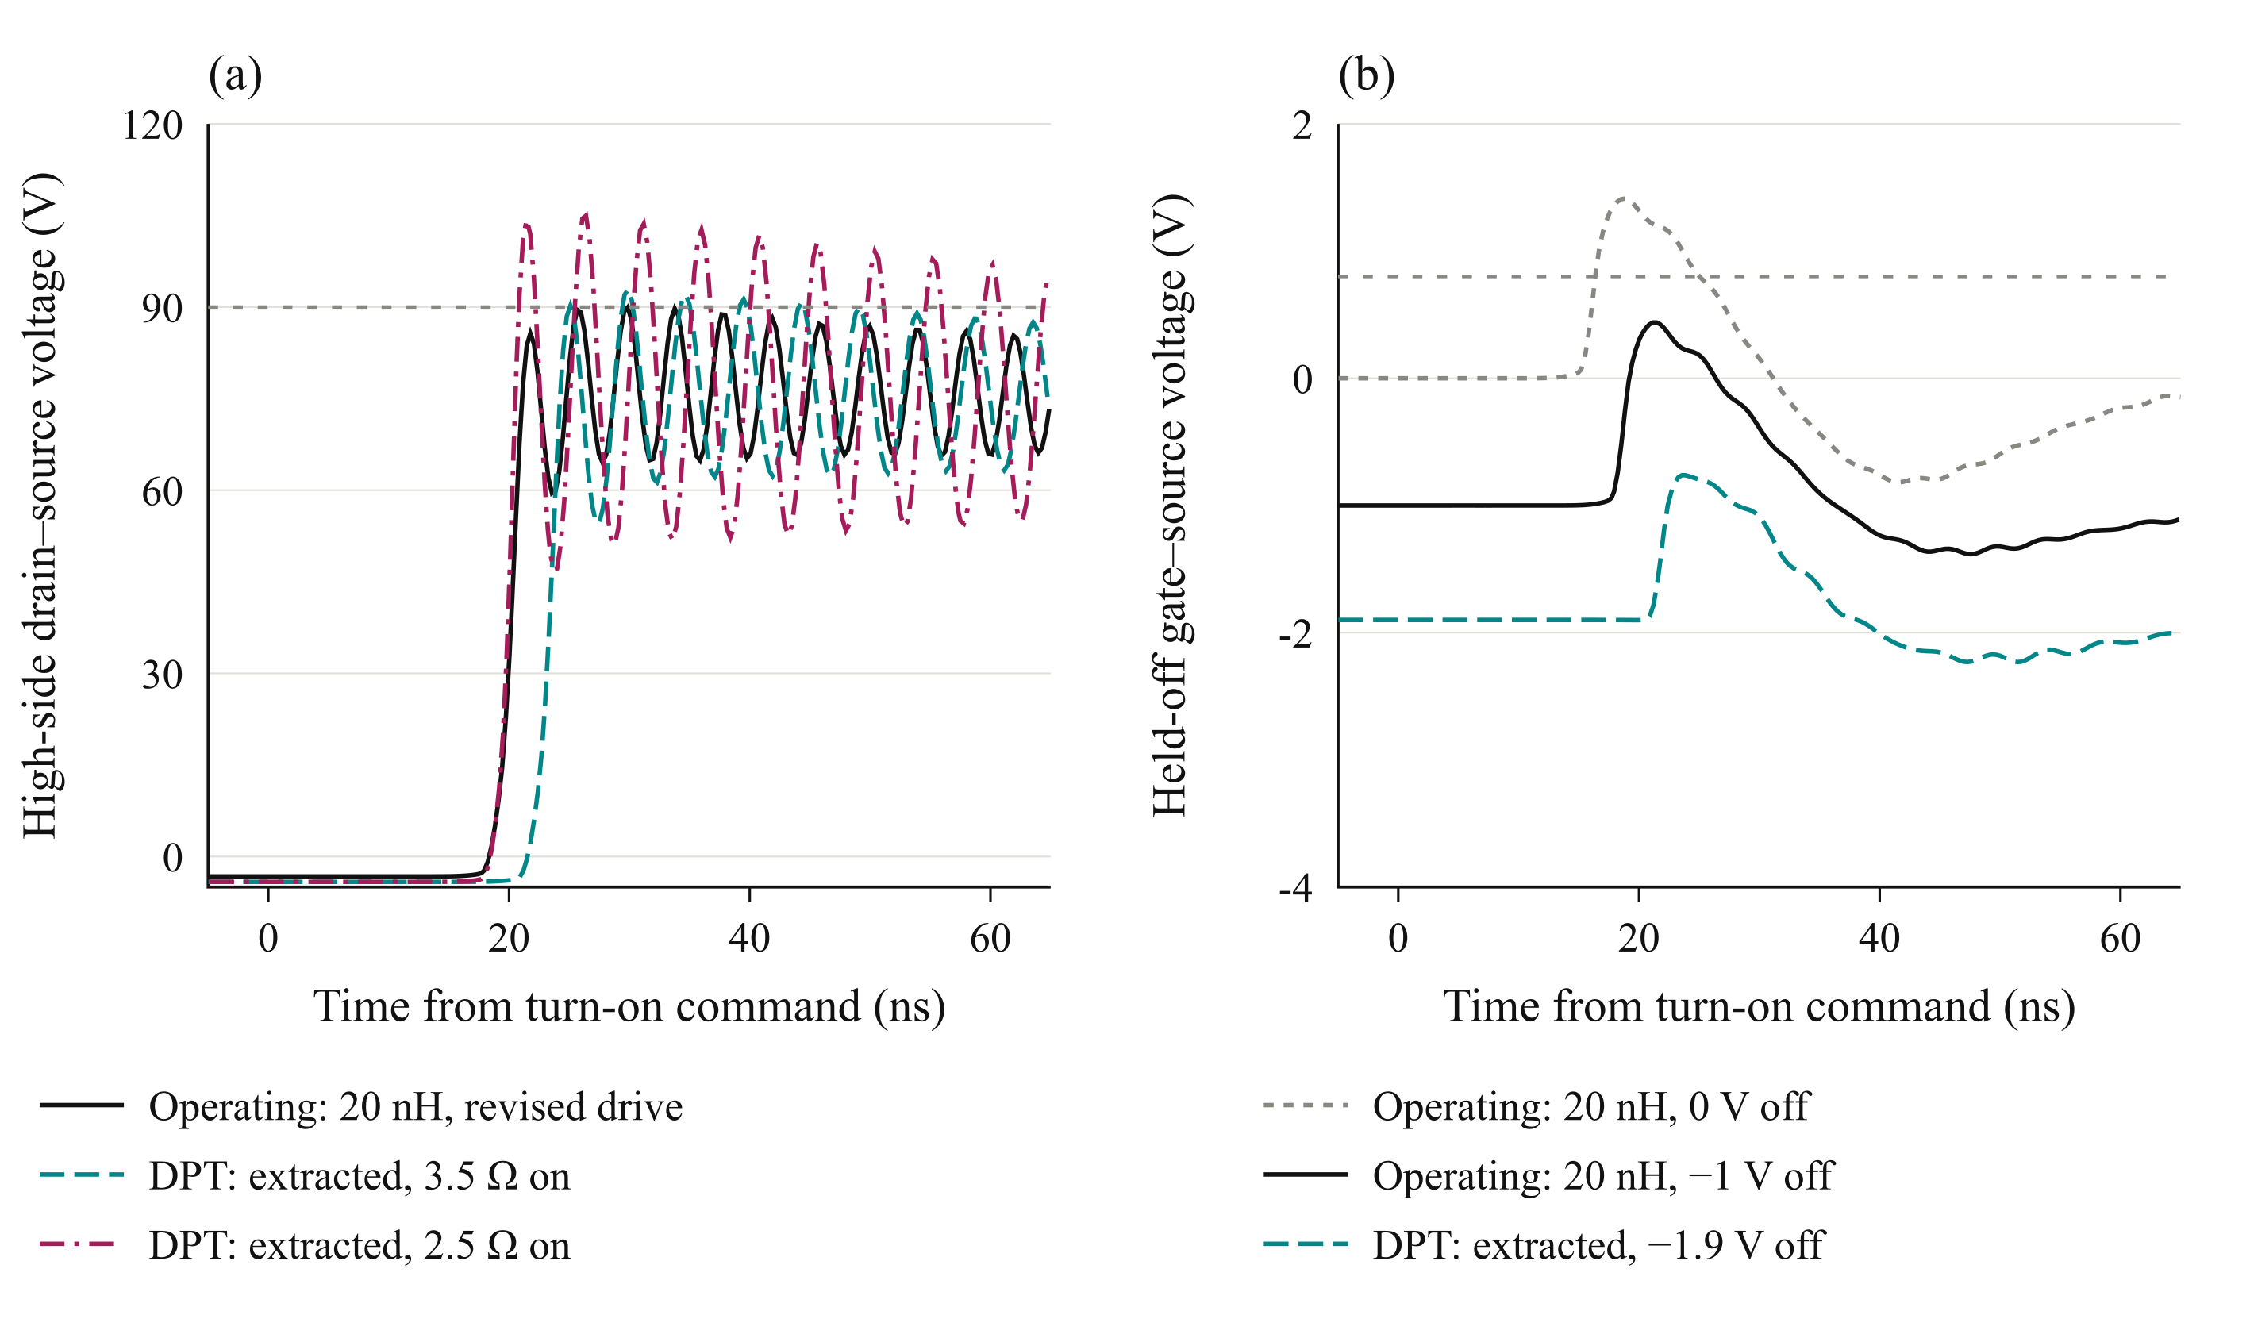
Fig. 9. Switching simulations at 75 V and approximately 316 A: (a) worst-cell high-side drain–source voltage during low-side turn-on and (b) cell-1 held-off high-side gate voltage. The revised operating-board drive uses a 20 nH lumped gate branch, 3 Ω turn-on resistance, 1 Ω turn-off resistance, and −1 V bias. Its zero-bias reference uses zero external turn-off resistance. DPT curves use the extracted gate network with individual 0.5 Ω gate resistors and −1.9 V bias; legend turn-on values are effective per-device resistances. Grey lines denote the 90 V drain-voltage target and the 0.8 V minimum gate threshold.
The extracted-network DPT case with the larger turn-on resistance has a maximum held-off gate excursion of approximately -0.5 V and a minimum gate voltage of approximately -3.5 V across the saved transitions and cells. Both positive and negative gate excursions must be checked against the device ratings of −4 V and +6 V [9]. These waveform checks remain conditional on the modeled network and do not replace experimental correlation.

D. Implications for the Building Block
The routed power-network results support a compact commutation path, while the gate-network results show why that result alone is insufficient. The operating-board gate model remains an assumed network, and the extracted-network DPT case still requires refinement to meet the drain-voltage target. Shorter shared gate paths and driver outputs closer to each pair are the next layout objectives. Symmetry and absolute loop impedance must be addressed together.
The initial gate-loop range makes the loss and voltage assessment realistic before layout, while extraction checks the network topology that those scalar values cannot represent. Updated switching energies from the accepted routed configuration must feed back into the loss and thermal estimates. The operating-board gate network must also be extracted before its final margin is established. This feedback links the physical building block to the SPB voltage choice: the usefulness of low-voltage devices depends on the achievable power and gate paths at the required traction current.

VI. Experimental Validation and Scope of the Full Paper

A. Planned Double Pulse Measurements
The instrumented board provides the basis for experimental DPT correlation. The planned assessment starts at reduced voltage and current before progressing toward the candidate submodule operating point. Measurements will include drain–source voltage, gate–source voltage referenced to the Kelvin terminal, total commutating current, and individual branch currents where the sensing arrangement permits.
The measured voltage and current waveforms will be used to assess overshoot, ringing, transient current sharing, and switching energy. Probe delay and channel skew must be accounted for before voltage–current integration. The effects of the shunts, connections, and probe loading will be considered when comparing measurements with the instrumented-board model. Turn-on resistance and turn-off bias will be varied to examine the voltage-stress and loss tradeoff identified by simulation.
Experimental results are not available in this manuscript. The full paper is intended to report correlation of the DPT model and measurements, including whether the voltage and gate-drive margins predicted by the revised layout are retained in hardware. Operating-board loss and temperature validation will require a subsequent continuous-current assessment under a defined cooling condition.

B. System Integration Boundary
The present study addresses one phase-leg building block. It does not establish a globally optimum SPB submodule count or a complete traction-drive efficiency advantage. Submodule-voltage balancing, winding design, common-mode behavior, auxiliary-power overhead, and insulation across the series stack remain system-level constraints. The voltage-class comparison and preliminary loss model do not replace those evaluations.
Inter-driver timing and the common interconnections between cell pairs must also be evaluated. The gate driver provides functional isolation [10]; it does not by itself establish the insulation architecture required for a submodule positioned within the full dc-link stack. These integration requirements bound the conclusions that can be drawn from the local DPT model.

VII. Conclusion
A hardware-constrained design procedure has been presented for a phase-leg building block of an SPB traction inverter. Charge-based screening selects the 100 V EPC2361. Switching maps with representative gate- and power-loop inductances and an electrothermal comparison identify four parallel devices as the smallest tested count passing the peak-current screen for a compact commutation path. Current-sharing sensitivity motivates symmetric transistor pairs, paired gate drive, and dedicated Kelvin returns. Low-current resonance remains a separate drive-optimization requirement.
The routed-network assessment shows why device selection and voltage partitioning cannot be finalized independently of implementation. A compact power loop is achievable in the evaluated geometry, but gate-network topology and drive settings determine the remaining voltage and gate-disturbance margins. The extracted DPT case remains above the voltage target and requires further refinement, followed by updated loss estimates and experimental correlation. The contribution is the traceable connection between SPB voltage choice and the switching constraints that determine the practical use of low-voltage devices at traction-current levels.

References
[1] S. Norrga et al., “A novel inverter topology for compact EV and HEV drive systems,” Proc. IECON, 2013, pp. 6590–6595.
[2] L. Jin et al., “Modulation and power losses of a stacked polyphase bridge converter,” IEEE J. Emerg. Sel. Topics Power Electron., vol. 5, no. 1, pp. 409–418, 2017.
[3] M. Nikouie et al., “DC-link stability analysis and controller design for the stacked polyphase bridges converter,” IEEE Trans. Power Electron., vol. 32, no. 2, pp. 1666–1674, 2017.
[4] G. Rohner et al., “Comparative evaluation of three-phase three-level flying capacitor and stacked polyphase bridge GaN inverter systems for integrated motor drives,” Electronics, vol. 13, Art. 1259, 2024.
[5] J. A. Brothers and T. Beechner, “GaN module design recommendations based on the analysis of a commercial 3-phase GaN module,” Proc. IEEE ECCE, 2019, pp. 4109–4116.
[6] J. Lu and D. Chen, “Paralleling GaN E-HEMTs in 10 kW–100 kW systems,” Proc. IEEE APEC, 2017, pp. 3049–3056.
[7] M. T. Tran et al., “A high-performance GaN power module with parallel packaging for high-current and low-voltage traction inverter applications,” IEEE J. Emerg. Sel. Topics Power Electron., vol. 13, no. 1, pp. 1188–1209, 2025.
[8] J. Azurza Anderson et al., “New figure-of-merit combining semiconductor and multi-level converter properties,” IEEE Open J. Power Electron., vol. 1, pp. 322–338, 2020, doi: 10.1109/OJPEL.2020.3018220.
[9] Efficient Power Conversion, “EPC2361 eGaN FET datasheet,” July 20, 2026.
[10] Infineon Technologies, “2EDF7275K data sheet,” rev. 2.8.

