Parasitic Aware Building Block Design for Stacked Polyphase Bridge Traction Inverters
17. Power Electronics for Transportation Electrification
Abstract— The stacked polyphase bridge (SPB) introduces a voltage-partitioning degree of freedom into high-voltage traction inverters: the number of series-connected submodules determines the required semiconductor voltage class. However, increasing the number of submodules does not reduce the phase current, making switches paralleling necessary and introducing dynamic current-sharing challenges associated with unequal parasitic impedances. This paper presents a hardware-constrained design procedure for the phase-leg building block of an SPB traction inverter. A device figure of merit based on on-state resistance and output charge identifies the 100 V EPC2361 as the preferred candidate among the surveyed devices. Single-cell switching simulations establish a usable current range per single switch. A subsequent comparison of losses, junction temperature, and drain–source voltage stress supports the selection of four parallel devices per switch position for a candidate configuration with sixteen submodules. Current-sharing sensitivity informs a symmetric cell arrangement with one gate-driver channel per device pair. An iterative KiCad–Ansys Q3D–LTspice workflow then evaluates and refines the routed power and gate networks. The contribution lies in linking SPB voltage partitioning and device selection to the physical constraints of a realizable building block, identifying the conditions required to exploit low-voltage devices in high-voltage traction drives. Experimental double-pulse tests are planned for the full paper to assess the predicted switching losses and parasitic effects.

Introduction
Electrification is driving traction and fast-charging power levels toward several hundred kilowatts, while demands for efficiency and power density continue to increase. Raising the dc-link voltage is a key design choice for meeting these requirements, although traction inverters must still deliver substantial phase current. In a conventional two-level traction inverter, each switch must block the full dc-link voltage and conduct the phase current, making semiconductor losses a central design constraint. The stacked polyphase bridge (SPB) introduces an additional design degree of freedom by connecting three-phase bridges in series on the dc side, with each bridge feeding an isolated winding set of a multiphase machine [1], [2]. Fig. 1 illustrates the SPB topology and the phase-leg building block considered in this work. Distributing the dc-link voltage among submodules allows each bridge to use a lower semiconductor voltage class and apply smaller voltage steps to its winding set. Voltage partitioning therefore becomes an active design choice that links the converter architecture to device selection.

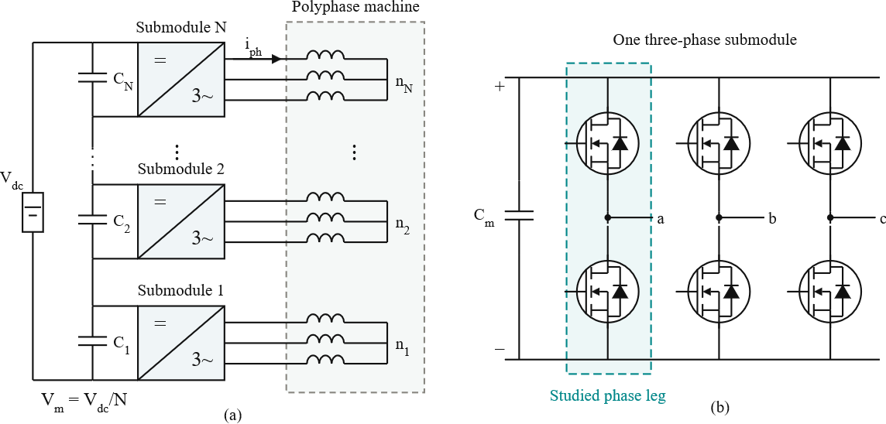
Fig. 1: (a) SPB traction-drive topology with (N) series-connected submodules, each supplying an isolated three-phase winding set of a common machine. (b) Three-phase submodule with the studied phase leg highlighted. Each switch symbol represents four parallel GaN transistors; the diode denotes the equivalent reverse-conduction path.
The benefit of voltage partitioning depends on realizing a practical high-current submodule. Increasing the number of submodules reduces the voltage across each bridge but does not reduce the phase current for a given total drive power, dc-link voltage, modulation index, and power factor. Low-voltage gallium nitride (GaN) devices can offer favorable on-state resistance and switching performance, but meeting the traction-current requirement may require several devices in parallel. Current sharing, gate-drive impedance, and commutation-loop parasitics then determine how much of the expected loss benefit can be retained. Increasing the submodule count also increases the number of gate-drive circuits, auxiliary supplies, and interconnections throughout the converter.

Previous studies establish SPB modulation and loss characteristics [2], [3], dc-link stability [4], and comparisons with alternative GaN converter systems [5]. These studies provide the system-level basis for selecting a submodule voltage. Research on paralleled GaN stages identifies complementary implementation constraints, including commutation-loop inductance, common-source coupling, and unequal gate impedances [6]–[8]. Together, these findings motivate a design procedure that considers voltage partitioning and high-current hardware implementation jointly. The central challenge is the feedback between the selected submodule voltage and the physical building block. A lower device voltage class may offer favorable loss characteristics, but the available voltage margin must accommodate switching overshoot at the required current. Excessive commutation-loop inductance can require slower switching or a lower submodule operating voltage, potentially changing the initial loss comparison or the required submodule count. Gate-loop impedance and symmetry further constrain switching speed by affecting gate-voltage disturbances and dynamic current sharing. The practical benefits of SPB voltage partitioning therefore depend on optimizing the power and gate networks together.

This paper presents a hardware-constrained design procedure for an SPB phase-leg building block. Single-cell switching simulations establish a usable current range per device, and a comparison of losses, junction temperature, and voltage stress supports the selection of the parallel-device count. Current-sharing sensitivity then guides the cell arrangement and paired gate-drive configuration. An iterative layout, parasitic-extraction, and circuit-simulation workflow evaluates the routed power and gate networks and revisits the assumptions used during initial sizing. Separate operating and double-pulse test (DPT) boards distinguish the intended converter layout from the additional parasitics introduced by measurement provisions. The contribution is to connect SPB voltage partitioning and device selection to the physical constraints that determine whether the expected advantages of low-voltage devices can be realized at traction-current levels.

Traction Requirements And The Initial Device And Voltage Choice

Traction-drive requirements
The building block is designed for a 300-kW traction drive with a total dc-link voltage (Vdc) of 1200 V. The initial operating point assumes a modulation index (M) of 1.15, a power factor (cosφ) of 0.9, and a switching frequency (fsw) of 50 kHz. These specifications establish the operating conditions for semiconductor selection and preliminary building-block sizing. A junction-temperature limit of 125 °C is adopted. For balanced operation with equal submodule voltages, the total active power is expressed as

$P = 3\frac{{M V}_{dc}}{2\sqrt{2} } I_{ph,rms} cosφ .$ (1)

Here, Iph,rms denotes the rms phase current, and M is defined such that the fundamental phase-voltage peak of each submodule is M Vm/2, where Vm = Vdc/N. The submodule count, N, does not appear explicitly in (1). Increasing the number of series-connected submodules reduces the voltage supplied to each winding set while increasing the number of winding sets contributing to the total power. Consequently, voltage partitioning does not reduce the phase-current requirement under the stated operating conditions. The specified operating point requires approximately 228 A rms and 322 A peak phase current, irrespective of the submodule count. The selected devices must therefore provide both an appropriate blocking-voltage rating and sufficient current-handling capability.

Semiconductor voltage-class comparison
Voltage partitioning in the SPB allows the semiconductor voltage class to be selected together with the number of series-connected submodules. This choice requires a comparison of conduction and switching characteristics rather than on-state resistance alone. A device with lower resistance may also have greater output charge, increasing the switching-related loss contribution. Fig. 2 compares the typical on-state resistance, RDS(on), at 25 °C and the charge-equivalent output capacitance, Coss,Q, of the surveyed GaN devices.

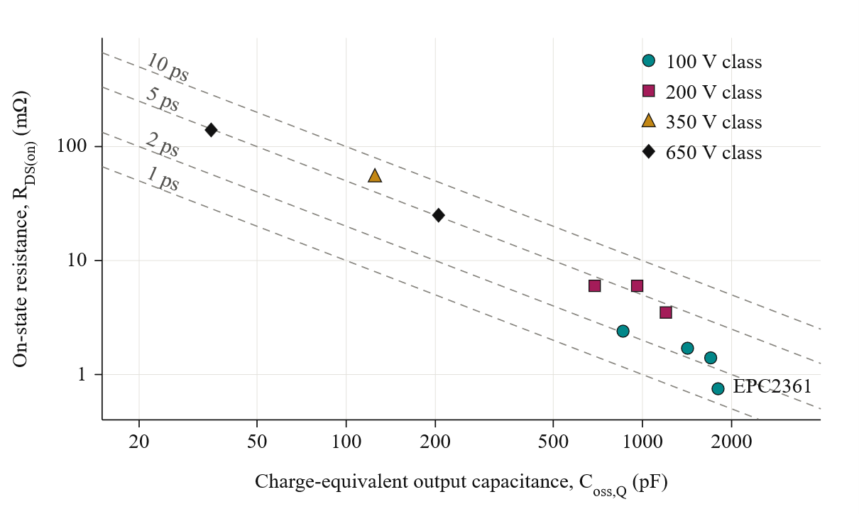
Fig. 2. Typical on-state resistance at 25 °C versus charge-equivalent output capacitance of the surveyed GaN devices, distinguished by voltage class. Dashed lines indicate constant resistance–capacitance products, τ = RDS(on) Coss,Q. Lower τ corresponds to higher D-FOM =$1/\sqrt{RDS(on) Coss,Q)}$ . Charge-equivalent capacitance is calculated from the output charge at the respective datasheet test voltage.

A higher D-FOM indicates a more favorable combination of conduction resistance and output charge. In the simplified hard-switching loss model underlying this criterion, increasing the semiconductor area reduces conduction losses but increases output-charge-related losses.

Among the surveyed devices, the 100 V EPC2361 is selected for further investigation. Its typical on-state resistance is 0.75 mΩ, and its charge-equivalent output capacitance is 1796 pF, calculated from an output charge of 90 nC at 50 V. This comparison serves as an initial screening rather than a direct prediction of converter efficiency. The surveyed output-charge values are specified at different test voltages, and both on-state resistance and switching behavior depend on operating conditions. Furthermore, the simplified criterion does not capture all gate-drive, parasitic, and current-sharing effects. The selected device is therefore evaluated subsequently at the intended submodule voltage and traction current to determine a practical parallel-device count and assess switching-voltage margin.

Initial submodule voltage
For equal voltage partitioning, the nominal submodule voltage is

Vm = Vdc / N, (3)

where N is the number of series-connected three-phase submodules. A candidate arrangement of sixteen submodules gives a nominal submodule voltage of 75 V, allowing the selected 100 V devices to be considered. The available voltage margin must accommodate submodule-voltage variation and switching overshoot. The preliminary peak drain–source voltage target of 90 V provides a 15 V allowance above the nominal operating voltage while retaining a further margin below the device rating. The feasibility of this operating point depends on the commutation-loop inductance and switching speed. Accordingly, the 75 V submodule voltage is treated as an initial design choice to be assessed through switching simulations and parasitic extraction. The next design stage determines the number of parallel devices through single-cell switching simulations and a comparison of losses, junction temperature, and voltage stress. The selected arrangement is then translated into a physical layout, and the extracted power and gate networks are used to reassess the assumptions made during initial sizing.

Single-Cell Characterization And Selection Of The Parallel Count

- Single-cell switching characterization

The selected EPC2361 is first evaluated in a half-bridge model with one device per switch position. Double-pulse simulations are performed at a submodule voltage of 75 V over a range of device currents. Two assumed commutation-loop inductances, 0.5 nH and 1 nH, represent a compact layout target and a higher-inductance sensitivity case, respectively. The preliminary gate-drive model uses an external turn-on resistance of 2 Ω and a low-impedance turn-off path. These lumped assumptions provide an initial basis for sizing before the detailed board geometry is available.

Fig. 3 shows the simulated peak drain–source voltage and turn-on energy. For the 0.5 nH case, operation near 80 A per transistor remains below the 90 V design target. Increasing the device current to approximately 120 A raises the peak voltage above 100 V. The higher-inductance case exceeds the design target already near 80 A, demonstrating the sensitivity of the usable current range to the commutation path.

The results identify approximately 80 A as a useful current scale for preliminary sizing, rather than an absolute device-current limit. Dividing the required phase-current peak of 322 A by this value suggests approximately four parallel transistors per switch position. Neighboring parallel counts are then compared to determine whether this initial estimate satisfies the electrical and thermal requirements.

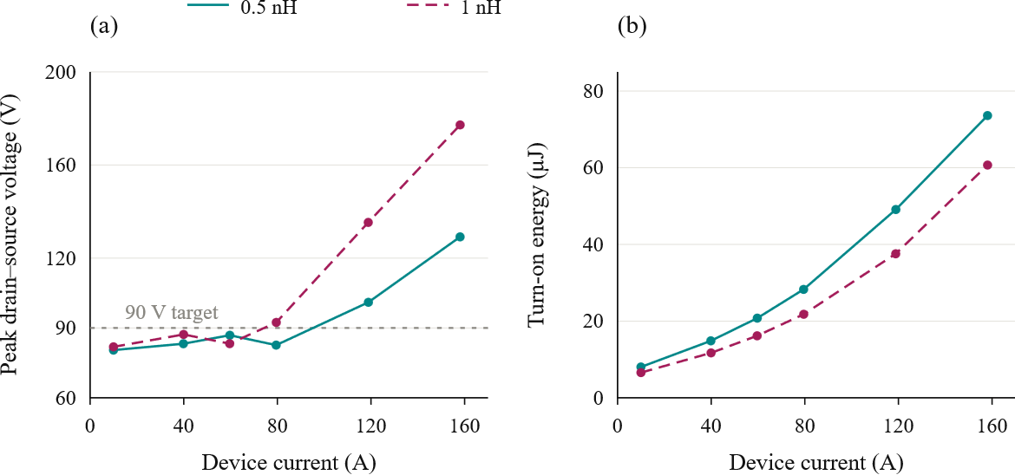
Fig. 3. Simulated single-cell switching characteristics of EPC2361 at a submodule voltage of 75 V: (a) peak drain–source voltage and (b) turn-on energy versus device current for assumed commutation-loop inductances of 0.5 nH and 1 nH. Markers indicate simulated operating points; connecting lines guide the eye. The horizontal dashed line in (a) denotes the 90 V design target.

- Loss and Thermal Assessment

For n parallel transistors and ideal current sharing, the peak current per device is

Idev,pk = Iph,pk/n. (4)

The single-cell switching-energy data are evaluated over the sinusoidal phase-current waveform to estimate the average switching losses. Turn-on energy at the phase-current peak is therefore not applied uniformly throughout the fundamental period. Conduction losses are calculated using temperature-dependent on-state resistance, and the junction temperature and resistance are solved iteratively.
The thermal assessment assumes an ambient temperature of 40 °C, a heatsink-to-ambient thermal resistance of 0.65 K/W for the complete phase leg, and a junction-to-heatsink thermal resistance of 7.6 K/W per transistor. The same per-device thermal path is used for each parallel-count candidate. The resulting junction temperatures are estimates conditional on these cooling assumptions.
Fig. 4(a) shows the phase-leg loss distribution. Increasing the parallel count reduces conduction losses, while the additional devices increase the switching-charge and gate-drive contributions. Four devices provide a substantial reduction in total loss compared with two or three devices. Further paralleling continues to reduce the calculated loss, although the improvement becomes progressively smaller.

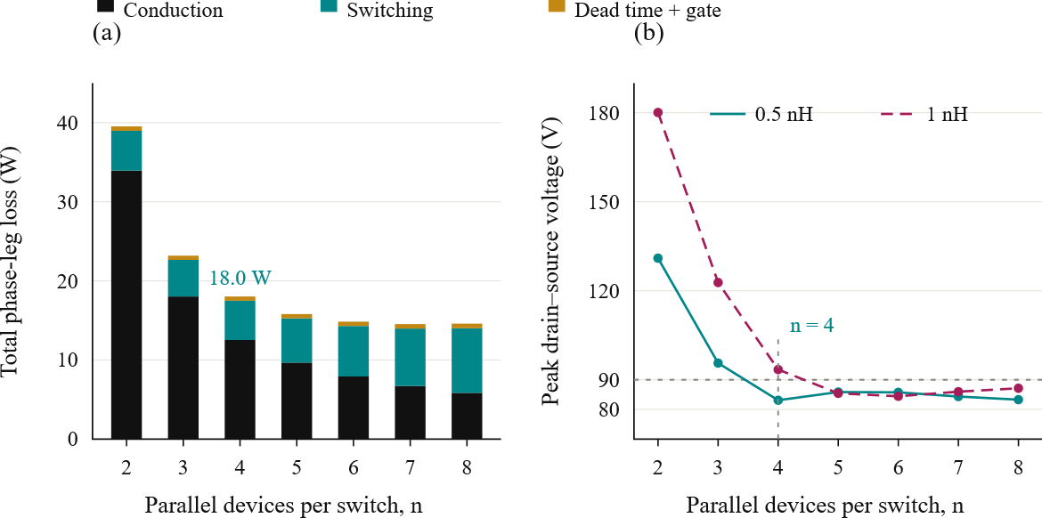
Fig. 4. Preliminary parallel-count comparison at 75 V, 228 A rms phase current, and 50 kHz: (a) calculated phase-leg loss distribution for a commutation-loop inductance of 0.5 nH and (b) predicted peak drain–source voltage for 0.5 nH and 1 nH. The horizontal dashed line denotes the 90 V design target. Four devices are the smallest tested count satisfying the preliminary voltage and thermal constraints at 0.5 nH.

- Selection of Four Parallel Devices

Table I summarizes the preliminary comparison. Two parallel devices exceed both the 125 °C junction-temperature limit and the 90 V peak-voltage target. Three devices satisfy the thermal limit but still exceed the voltage target at 0.5 nH. Four devices are the smallest tested count satisfying both constraints for the compact-loop assumption, with an estimated phase-leg loss of 18.0 W and a junction temperature of approximately 69 °C.
The selected count is not the absolute minimum-loss solution. Additional devices reduce the calculated losses further, but increase the device count and the gate-drive and layout requirements. Four devices are therefore retained as the initial implementation candidate and can subsequently be arranged as two identical transistor pairs.
Fig. 4(b) also shows that the four-device arrangement reaches approximately 93 V when the assumed commutation inductance increases to 1 nH. Consequently, the selection depends on achieving a sufficiently low-inductance commutation path and suitable switching speed. The preliminary calculation also assumes equal current sharing. The following design stage therefore evaluates the cell symmetry, gate-drive arrangement, and extracted power and gate networks to determine whether these assumptions can be maintained in the physical building block.

TABLE I PRELIMINARY PARALLEL-COUNT COMPARISON

Parallel count, n | Peak current per device (A) |  | Phase-leg loss (W) | Junction temperature (°C) | Peak VDS at  0.5 nH (V) | Peak VDS at  1 nH (V)
2 | 161 |  | 39.5 | 141 | 131 | 180
3 | 107 |  | 23.2 | 84 | 96 | 123
4 | 80.5 |  | 18.0 | 69 | 83 | 93
5 | 64.4 |  | 15.8 | 62 | 86 | 85
6 | 53.7 |  | 14.8 | 59 | 86 | 84
Calculated at 75 V and 50 kHz. Loss and junction-temperature estimates use the 0.5 nH commutation-loop case, a 40 °C ambient temperature, and the preliminary gate-drive and cooling assumptions.

GATE-DRIVE CONFIGURATION AND CELL ARRANGEMENT

- Current-Sharing Sensitivity

The preliminary parallel-count selection assumes equal current sharing among the four transistors in each switch position. Maintaining this condition during switching requires control of the gate and power-path impedances. Differences in gate-loop inductance, common-source inductance, and driver timing can produce unequal transient currents and switching energies, even when the devices have similar on-state resistance. Fig. 5(a) summarizes sensitivity simulations for two parallel devices at 75 V and 120 A total current. A power-loop inductance mismatch of 0.3 nH produces approximately 2% switching-energy imbalance in the evaluated case. A gate-loop inductance difference of 2 nH versus 8 nH increases the imbalance to approximately 19%. Without a Kelvin-source return, a common-source inductance mismatch of 0.2 nH produces approximately 29% imbalance. Although these results depend on the investigated operating point and perturbations, they demonstrate that matching the power paths alone is insufficient. The gate branches and source-reference connections must also be considered when translating the selected parallel count into a physical layout.

B. Paired Gate-Drive Configuration

Connecting all four transistors to one gate-driver output increases the total gate charge and the current required to establish the intended switching transition. The turn-off path must also sink the displacement current coupled through the gate–drain capacitance during drain-voltage transients. Excessive impedance in this path can cause a positive gate-voltage disturbance and reduce the margin against unintended turn-on.
The four-device arrangement is therefore divided into two transistor pairs per switch position. As illustrated in Fig. 5(b), each pair of switching cells is served by one dual-channel 2EDF7275K driver IC. One channel drives the two high-side transistors, while the other drives the two low-side transistors. The complete phase leg consequently uses two driver ICs, with two transistor gates connected to each output channel through individual gate resistors.
The selected driver provides a peak sink-current capability of 8 A per channel. In the preliminary gate-drive comparison, connecting four gates to one channel produces an estimated peak sink-current demand of approximately 12–14 A and increases turn-on energy by approximately 31% relative to the two-gate configuration. These results support the paired arrangement as a practical compromise between driver count, gate loading, and routing complexity. The nominal driver-current capability alone, however, does not establish the available gate-voltage margin; the complete gate network must be evaluated during switching.

C. Kelvin-Source Connection and Cell Layout
Each local switching cell contains one high-side transistor, one low-side transistor, and local dc-link decoupling capacitors. Four cells form the phase leg and are arranged as two identical pairs. Within each pair, symmetric device placement and matched gate branches are used to reduce differences in transient loading. Local decoupling limits the extent of the high-frequency commutation path, while symmetric connections to the shared power terminals reduce differences between the parallel branches.
Fig. 5(c) illustrates the role of the dedicated Kelvin-source connection. The gate-drive return is taken from the Kelvin pad rather than through the power-source conductors. This separates the gate-reference path from the inductance carrying the main source current and reduces the associated inductive feedback into the gate voltage. The Kelvin connection does not eliminate gate-loop inductance; both the outgoing gate branch and its return must remain short and closely coupled.
Individual gate resistors and separate Kelvin-return branches are retained for each transistor. The branches are connected to the corresponding driver channel in a star arrangement, avoiding unnecessary shared impedance between the devices. The layout objective is therefore to minimize both the magnitude and mismatch of the relevant loop impedances.
D. Verification of the Physical Arrangement
Symmetry within each transistor pair does not eliminate timing differences between the two driver ICs. Input routing and inter-driver propagation-delay differences must therefore be assessed separately from the matching of the local gate branches. The paired configuration establishes the intended circuit arrangement, while its current-sharing performance remains subject to verification with the routed geometry.
The layout is developed through an iterative KiCad–Ansys Q3D–LTspice workflow. Extracted power and gate networks replace the preliminary lumped assumptions, allowing peak drain–source voltage, gate-voltage disturbance, transient current sharing, and switching-energy distribution to be evaluated together. Component placement, local decoupling, gate routing, and gate resistance are revised where necessary. This assessment determines whether the current capability and switching margin assumed during the initial sizing can be retained in the physical SPB building block.

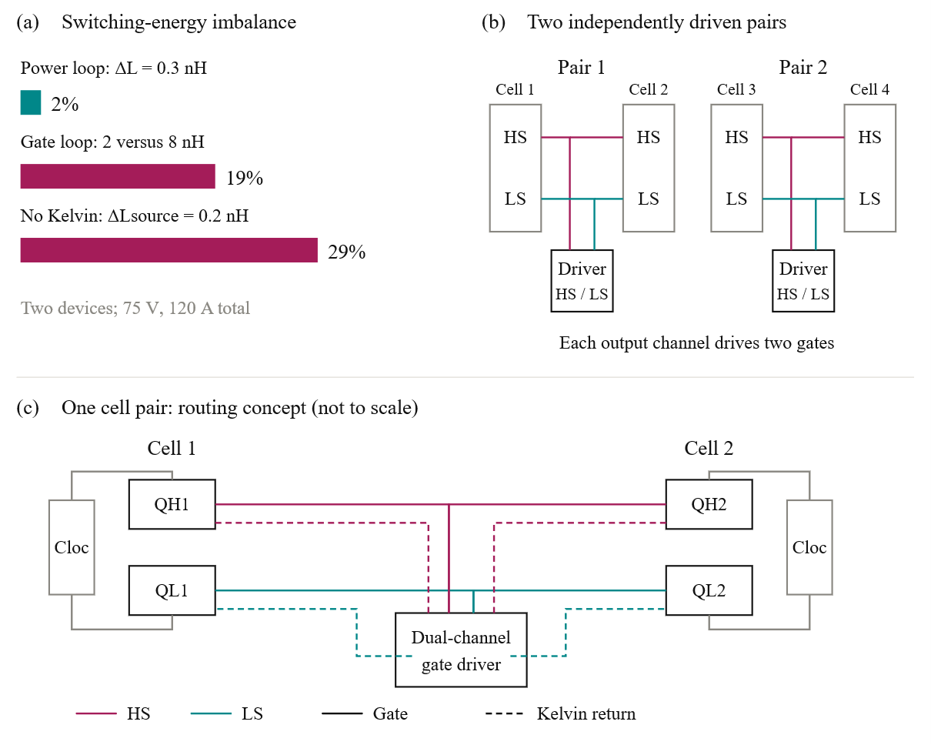

Next Section Text
Next section text. Next section text. Next section text. Next section text. Next section text. Next section text. Next section text. Next section text. Next section text. Next section text. Next section text. Next section text. Next section text. Next section text. Next section text. Next section text. Next section text. Next section text. Next section text. Next section text. Next section text.

A. Your subsection text
Your subsection text. Your subsection text. Your subsection text. Your subsection text. Your subsection text. Your subsection text. Your subsection text. Your subsection text. Your subsection text. Your subsection text. Your subsection text. Your subsection text. Your subsection text. Your subsection text. Your subsection text. Your subsection text. Your subsection text. Your subsection text. Your subsection text. Your subsection text. Your subsection text. Your subsection text.

Next Section Text
Next section text. Next section text. Next section text. Next section text. Next section text. Next section text. Next section text. Next section text. Next section text. Next section text. Next section text. Next section text. Next section text. Next section text. Next section text. Next section text. Next section text. Next section text. Next section text. Next section text. Next section text.

A. Your subsection text
Your subsection text. Your subsection text. Your subsection text. Your subsection text. Your subsection text. Your subsection text. Your subsection text. Your subsection text. Your subsection text. Your subsection text. Your subsection text. Your subsection text. Your subsection text. Your subsection text. Your subsection text. Your subsection text. Your subsection text. Your subsection text. Your subsection text. Your subsection text. Your subsection text. Your subsection text.
(2)
(1)
B. Subsubsection Heading Here
Subsection is here. Subsection is here. Subsection is here. Subsection is here. Subsection is here. Subsection is here. Subsection is here. Subsection is here. Subsection is here. Subsection is here. Subsection is here. Subsection is here. Subsection is here. Subsection is here. Subsection is here. Subsection is here. Subsection is here. Subsection is here. Subsection is here. Subsection is here. Subsection is here. Subsection is here. Subsection is here. Subsection is here. Subsection is here. Subsection is here. Subsection is here. Subsection is here. Subsection is here. Subsection is here. Subsection is here. Subsection is here. Subsection is here. Subsection is here. Subsection is here. Subsection is here. Subsection is here. Subsection is here. Subsection is here

Conclusion
Here goes conclusion. Here goes conclusion. Here goes conclusion. Here goes conclusion. Here goes conclusion. Here goes conclusion. Here goes conclusion. Here goes conclusion. Here goes conclusion. Here goes conclusion. Here goes conclusion. Here goes conclusion. Here goes conclusion. Here goes conclusion. Here goes conclusion. Here goes conclusion. Here goes conclusion. Here goes conclusion. Here goes conclusion. Here goes conclusion. Here goes conclusion. Here goes conclusion. Here goes conclusion. Here goes conclusion. Here goes conclusion. Here goes conclusion. Here goes conclusion. Here goes conclusion. Here goes conclusion. Here goes conclusion. Here goes conclusion. Here goes conclusion. Here goes conclusion. Here goes conclusion. Here goes conclusion. Here goes conclusion. Here goes conclusion. Here goes conclusion. Here goes conclusion. Here goes conclusion. Here goes conclusion. Here goes conclusion. Here goes conclusion. Here goes conclusion. Here goes conclusion. Here goes conclusion. Here goes conclusion.

References
[1] And here is reference. And here is reference. And here is reference. And here is reference. And here is reference. [2] And here is reference. And here is reference. And here is reference. And here is reference. And here is reference. [3] And here is reference. And here is reference. And here is reference. And here is reference. And here is reference. [4] And here is reference. And here is reference. And here is reference. And here is reference. And here is reference.
[5] And here is reference. And here is reference. And here is reference. And here is reference. And here is reference. [6] And here is reference. And here is reference. And here is reference. And here is reference. And here is reference. [7] And here is reference. And here is reference. And here is reference. And here is reference. And here is reference. [8] And here is reference. And here is reference. And here is reference. And here is reference. And here is reference. [9] And here is reference. And here is reference. And here is reference. And here is reference. And here is reference.

Guideline for Digest Submission

- Papers presented at ICPE 2027-ECCE Asia must be original material and must not have been presented or published previously. All digests must comply with the export control laws of the country or countries in which the author(s) reside. A statement of compliance will be required as part of the submission process. All authors should obtain company and governmental clearance prior to submission of Digests. Digests marked or labeled as “Confidential”, “Proprietary” or with similar wording will not be accepted.
- The digest should give a clear and concise statement of the purpose and contribution of the work, specific results and the methods used. Include key equations, figures and tables. ICPE 2027-ECCE Asia reviewers highly value evidence of completed experimental work such as oscillograms and photos of equipment under test.
- Digest should be written in 5 pages or less, single column, and single-space on A4 sized format including figures and tables. Line space can be adjusted upto 1.5. Number all Digest pages. Digests should be submitted as the Adobe Acrobat PDF file (*.pdf).
- Please do not write authors' names and affiliations on the digest for peer review.
- CRITICAL: When submitting the digest, the corresponding author must ensure that the percentage of self-citations in the final paper does not exceed 25%.

