Topic 17 — Power Electronics for Transportation Electrification

Parasitic Aware Building Block Design for Stacked Polyphase Bridge Traction Inverters
Abstract—The stacked polyphase bridge (SPB) introduces a voltage-partitioning degree of freedom into high-voltage traction inverters: the number of series-connected submodules determines the semiconductor voltage class, while the phase-current requirement remains high. This paper presents a hardware-constrained design procedure for an SPB phase-leg building block. A charge-based device figure of merit identifies the 100 V EPC2361 as the preferred candidate among the surveyed devices. A peak-current voltage screen and electrothermal comparison identify four parallel transistors per switch position as an initial candidate for sixteen submodules. Current-sharing sensitivity motivates symmetric transistor pairs and dedicated Kelvin returns. An iterative KiCad–Ansys Q3D–LTspice workflow replaces the assumed paths with routed networks. The extracted double-pulse test (DPT) network requires a joint assessment of resistance, gate disturbance, and switching energy. The main contribution is to connect SPB cell/voltage selection to the physical switching constraints governing low-voltage devices at traction-current levels. Experimental validation via DPT setup is planned for the full paper.
Index Terms—Gallium nitride, gate drive, parallel transistors, parasitic inductance, stacked polyphase bridge, traction inverter.

I. Introduction
Electrification is driving traction and fast-charging power levels toward several hundred kilowatts, while demands for efficiency and power density continue to increase. Raising the dc-link voltage is a key design choice for meeting these requirements; however, in a conventional two-level traction inverter, each switch must block the full dc-link voltage and conduct the phase current, making semiconductor losses a central design constraint.
The stacked polyphase bridge (SPB) introduces an additional design degree of freedom by connecting three-phase bridges in series on the dc side, with each bridge feeding an isolated winding set of a multiphase machine [1], [2]. Fig. 1 illustrates the SPB topology and the phase-leg building block considered in this work. Distributing the dc-link voltage among submodules allows each bridge to use a lower semiconductor voltage class and apply smaller voltage steps to its winding set. Voltage partitioning therefore becomes an active design choice that links the converter architecture to device selection.

Fig. 1. (a) SPB topology and isolated winding sets. (b) Three-phase submodule; each symbol represents four parallel GaN transistors, with the diode indicating reverse conduction.

The benefit of voltage partitioning depends on realizing a practical high-current submodule. Increasing the number of submodules reduces the voltage across each bridge but does not reduce the phase current for a given total drive power and dc-link voltage. Low-voltage gallium nitride (GaN) devices can offer favorable on-state resistance and switching performance, but meeting the traction-current requirement may require several devices in parallel. Current sharing, gate-drive impedance, and commutation-loop parasitics then determine how much of the expected loss benefit can be retained. Increasing the submodule count also increases the number of gate-drive circuits, auxiliary supplies, and interconnections throughout the converter.
Previous studies establish SPB modulation and loss characteristics [2], dc-link stability [3], and comparisons with alternative GaN converter systems [4]. These studies provide the system-level basis for selecting a submodule voltage. Research on paralleled GaN stages identifies complementary implementation constraints, including commutation-loop inductance, common-source coupling, and unequal gate impedances [5]–[7]. Together, these findings motivate a design procedure that considers voltage partitioning and high-current hardware implementation jointly.
The central challenge is the feedback between the selected submodule voltage and the physical building block. A lower device voltage class may offer favorable loss characteristics, but the available voltage margin must accommodate switching overshoot at the required current. Excessive commutation-loop inductance can require slower switching or a lower submodule operating voltage, potentially changing the initial loss comparison or the required submodule count. Gate-loop impedance and symmetry further constrain switching speed by affecting gate-voltage disturbances and dynamic current sharing. The practical benefits of SPB voltage partitioning therefore depend on optimizing the power and gate networks together.
This paper presents a hardware-constrained design procedure for an SPB phase-leg building block. Single-cell switching simulations establish an initial current range using representative gate-loop and commutation-loop inductances. Losses, junction temperature, and the voltage stress of both switches then determine the parallel-count candidate. Current-sharing sensitivity guides the symmetric cell arrangement and paired gate drive. An iterative layout, parasitic extraction, and circuit-simulation workflow evaluates whether the assumed switching conditions can be maintained in the routed building block. Separate operating and double-pulse test (DPT) boards distinguish the intended converter layout from measurement-related parasitics. The contribution is to connect SPB voltage partitioning and device selection to the physical constraints governing high-current implementation.

II. Traction Requirements and Initial Device Selection

A. Traction Drive Requirements
The building block is designed for the traction operating point and constraints summarized in Table I. For balanced operation with equal submodule voltages, the total active power is expressed as
$P = \frac{3 M V_{dc} I_{ph,rms} cos φ}{2\sqrt{2}}$ (1)
Here, V_{dc} is the total dc-link voltage, I_{ph,rms} is the rms phase current, and cosφ is the power factor. The modulation index M is defined such that the fundamental phase-to-neutral voltage peak of each submodule is M V_{m}/2. The specified operating point requires approximately 228 A rms phase current.

TABLE I DESIGN OPERATING POINT AND PRELIMINARY CONSTRAINTS
Quantity | Symbol | Value
Total active power | P | 300 kW
Total dc-link voltage | V_{dc} | 1200 V
Modulation index | M | 1.15
Power factor | cosφ | 0.9
Phase current | I_{ph} | 228 A rms
Switching frequency | f_{sw} | 50 kHz
Candidate submodule count | N | 16
Nominal submodule voltage | V_{m} | 75 V
Peak drain–source voltage target | V_{DS,pk} | 90 V
Junction-temperature limit | T_{j,max} | 125 °C
Ambient temperature | T_{a} | 40 °C
The submodule count does not appear explicitly in (1). The voltage-partition discussion is deferred to the full paper; it is omitted in the digest due to the page limit.

B. Semiconductor Voltage Class Comparison
Voltage partitioning allows the semiconductor voltage class to be selected together with the submodule count. This choice requires a comparison of conduction and switching characteristics rather than on-state resistance alone. Fig. 2 compares the typical on-state resistance R_{DS(on)} at 25 °C and the charge-equivalent output capacitance C_{oss,Q} of the surveyed GaN devices. The capacitance derivation is deferred to the full paper; it is omitted in the digest due to the page limit.
Following the charge-based screening criterion in [8], the device figure of merit is defined as
$D-FOM = \frac{1}{\sqrt{R_{DS(on)} C_{oss,Q}}}$ (2)
A higher D-FOM indicates a more favorable combination of conduction resistance and output charge. In the simplified hard-switching model underlying this criterion, optimizing semiconductor area gives minimum losses proportional to the square root of the resistance–capacitance product. Fig. 2 therefore uses constant-product contours, with lower τ = R_{DS(on)} C_{oss,Q} corresponding to higher D-FOM.
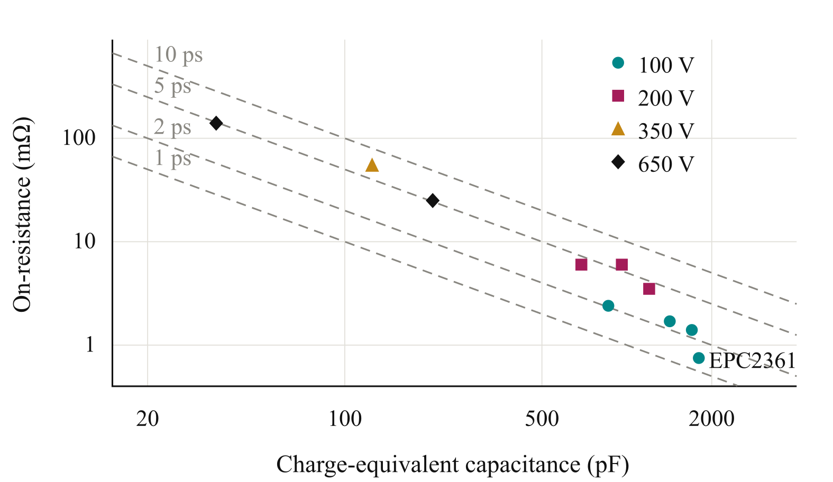
Fig. 2. On-state resistance versus charge-equivalent output capacitance for the surveyed GaN voltage classes.
The device-data normalization and screening limits are deferred to the full paper; it is omitted in the digest due to the page limit.

C. Initial Submodule Voltage
For equal voltage partitioning, the nominal submodule voltage is
$V_{m} = \frac{V_{dc}}{N}$ (3)
The candidate arrangement in Table I permits 100 V devices to be considered. The available margin must accommodate submodule-voltage variation and switching overshoot. The peak drain–source voltage target leaves a 15 V allowance above the nominal submodule voltage and a further margin below the device rating. The candidate operating point is therefore assessed through switching simulations and parasitic extraction rather than accepted from the nominal rating alone.

III. Single Cell Characterization and Selection of the Parallel Count

A. Single Cell Switching Characterization
The selected EPC2361 is evaluated in a half-bridge model with one device per switch position. Double-pulse simulations are performed at a submodule voltage of 75 V over a device-current sweep. Gate-loop inductances of 10 nH and 20 nH represent the preliminary range of interest. Commutation-loop inductances of 0.5 nH and 1 nH separately represent a compact power path and a higher-inductance sensitivity case. Gate-drive and simulation details are deferred to the full paper; it is omitted in the digest due to the page limit.
Fig. 3 compares the voltage-stress and turn-on-energy results for the four combinations of power- and gate-loop inductance. Voltage stress is evaluated as the larger of the low-side drain-voltage peak at turn-off and the high-side peak during low-side turn-on. This avoids selecting the device current from only one switching transition. With the compact commutation path, operation near 80 A per device satisfies the drain-voltage target for both gate-loop cases. The larger power-loop case exceeds the target and cannot be accepted solely by increasing the parallel count.
The full paper will expand the current-range and gate-margin assessment; it is omitted in the digest due to the page limit.
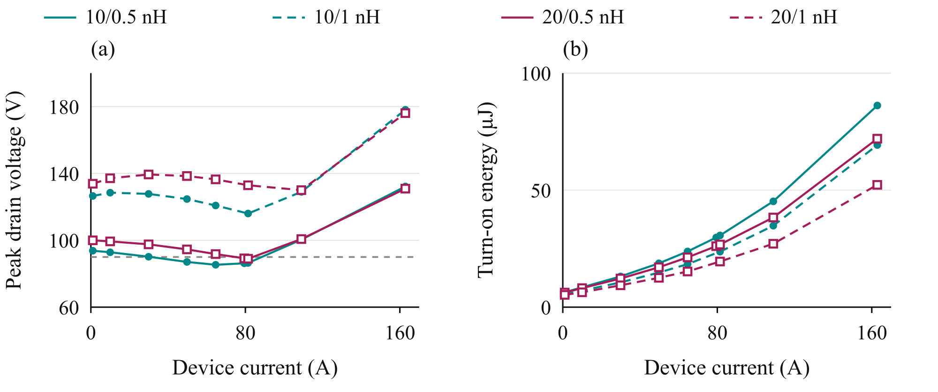
Fig. 3. Single-cell voltage stress and turn-on energy at 75 V. Legend entries specify gate-loop / commutation-loop inductance. Grey line: 90 V target.

B. Loss and Thermal Assessment
For n parallel transistors and ideal current sharing, the peak current per device is
$I_{dev,pk} = \frac{I_{ph,pk}}{n}$ (4)
The single-cell switching-energy maps are evaluated over the sinusoidal phase-current waveform to estimate average switching losses. Energy integration and the thermal model are deferred to the full paper; it is omitted in the digest due to the page limit.
Fig. 4(a) shows the loss distribution for the nominal gate-loop case and compact commutation path. Additional parallel devices reduce conduction loss, while switching charge, gate loading, and layout complexity limit the benefit of further paralleling. The corresponding voltage-stress comparison in Fig. 4(b) shows that overshoot is not necessarily monotonic with parallel count. Gate-network dynamics therefore have to be checked alongside the reduction in current per device.
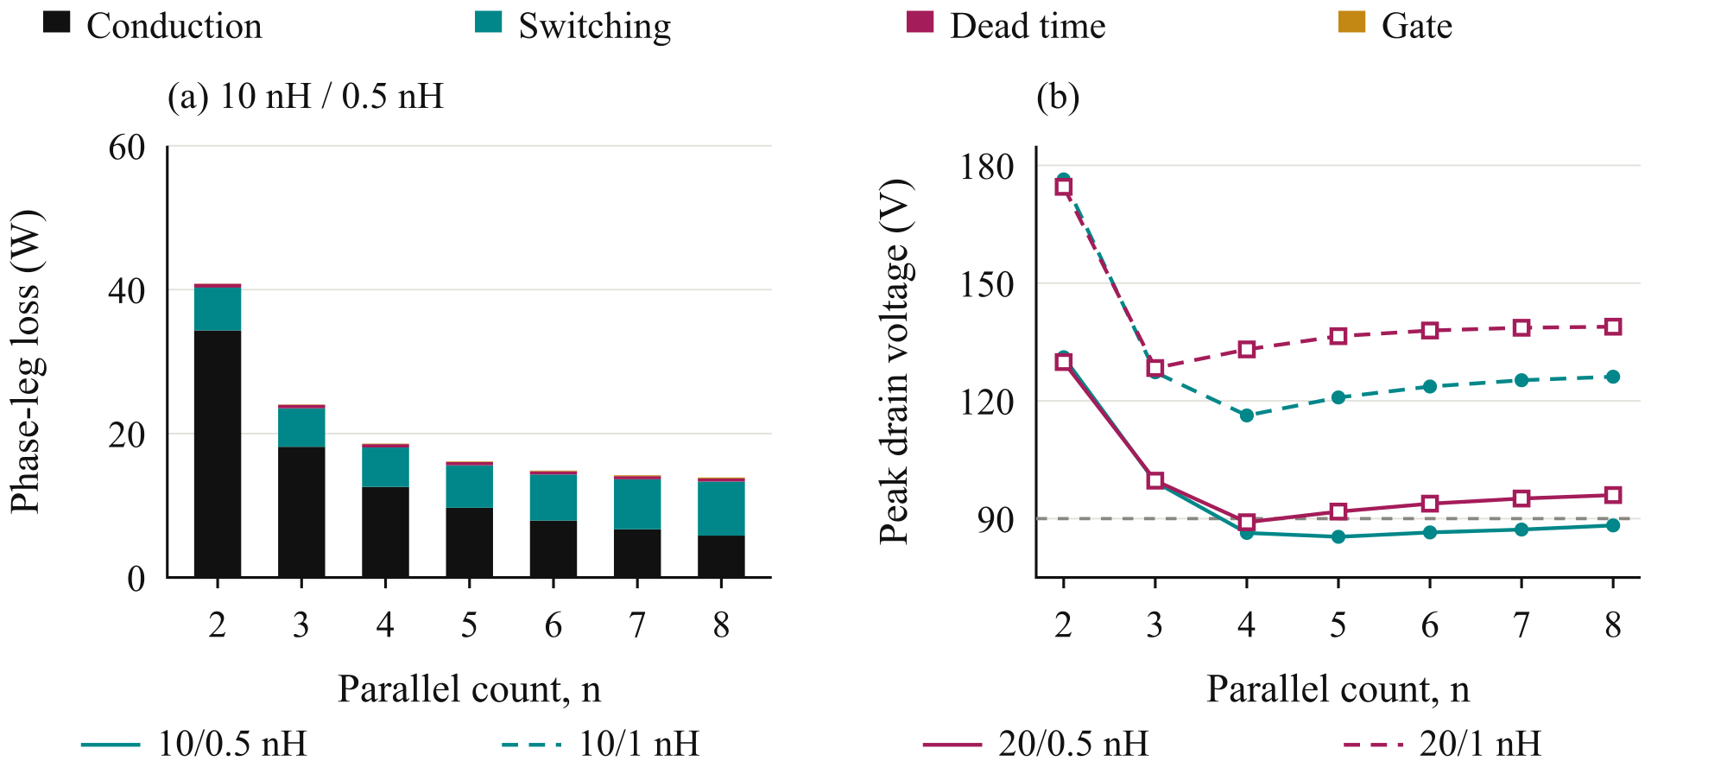
Fig. 4. (a) Phase-leg losses and (b) peak-current voltage stress versus parallel count at 75 V and 50 kHz. Inductance encoding follows Fig. 3.

C. Selection of Four Parallel Devices
The detailed parallel-count comparison is deferred to the full paper; it is omitted in the digest due to the page limit.

IV. Gate Drive Configuration and Cell Arrangement

A. Current Sharing Sensitivity
The preliminary parallel-count selection assumes equal current sharing among the four transistors in each switch position. Maintaining this condition during switching requires control of the gate and power-path impedances. Differences in gate-loop inductance, common-source inductance, and driver timing can produce unequal transient currents and switching energies, even when the devices have similar on-state resistance. Fig. 5(a) summarizes sensitivity simulations for two parallel devices at 75 V and 120 A total current. A power-loop inductance mismatch of 0.3 nH produces approximately 2% switching-energy imbalance in the evaluated case. A gate-loop inductance difference of 2 nH versus 8 nH increases the imbalance to approximately 19%. Without a Kelvin-source return, a common-source inductance mismatch of 0.2 nH produces approximately 29% imbalance. Due to the page limit, the full paper will detail the current-sharing perturbations.
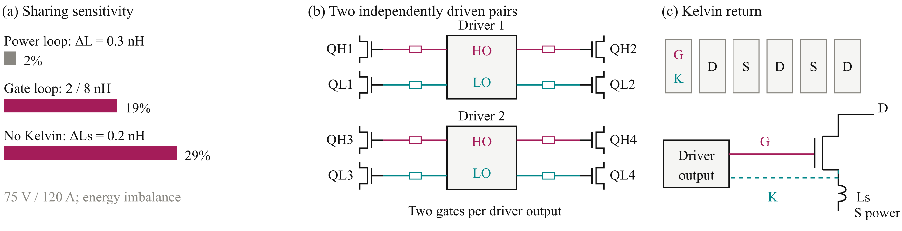
Fig. 5. (a) Sharing sensitivity, (b) paired gate drive, and (c) device pads and Kelvin return. HS/LS denote high/low side; HO/LO identify driver outputs.

B. Paired Gate Drive Configuration
Connecting all four transistors to one gate-driver output increases the total gate charge and the current required to establish the intended switching transition. The turn-off path must also sink the displacement current coupled through the gate–drain capacitance during drain-voltage transients. Excessive impedance in this path can cause a positive gate-voltage disturbance and reduce the margin against unintended turn-on.
The four-device arrangement is therefore divided into two transistor pairs per switch position. As illustrated in Fig. 5(b), each pair of switching cells is served by one dual-channel 2EDF7275K driver IC. One channel drives the two high-side transistors, while the other drives the two low-side transistors. The complete phase leg consequently uses two driver ICs, with two transistor gates connected to each output channel through individual gate resistors. Driver loading and gate-voltage margins are deferred to the full paper; it is omitted in the digest due to the page limit.

C. Kelvin Source Connection and Cell Layout
Layout symmetry and Kelvin-return details are deferred to the full paper; it is omitted in the digest due to the page limit.

D. Verification of the Physical Arrangement
Inter-driver timing and routed-network checks are deferred to the full paper; it is omitted in the digest due to the page limit.

V. Closing the Design Loop with the Routed Building Block

A. Layout and Parasitic Extraction
Initial sizing establishes a candidate voltage and parallel count using the two gate-loop and two commutation-loop cases. The routed building block must then be assessed to determine whether the associated voltage and gate-drive margins can be retained. Fig. 6 connects the KiCad layout, Ansys Q3D parasitic extraction, and LTspice switching assessment. Its feedback is used to revise placement, routing, or drive settings when the complete network changes the switching response.
The power devices, local decoupling capacitors, and paired gate drivers are placed and routed in KiCad. The conductor geometry is evaluated in Ansys Q3D to obtain resistive and inductive networks, including mutual coupling between branches. These networks are incorporated into LTspice to assess voltage overshoot, gate disturbance, transient current sharing, and switching-energy distribution. Placement, routing, or drive settings are revised where necessary.
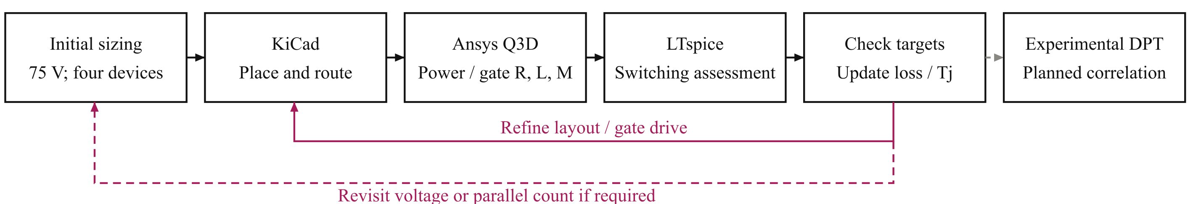
Fig. 6. Iterative design flow linking initial sizing, layout, parasitic extraction, switching assessment, and planned DPT correlation.
Two board variants are considered: an operating board representing the intended converter building block and an instrumented DPT board. The latter includes current-measurement provisions that introduce additional commutation-path parasitics. Figs. 7(a) and 7(b) distinguish these implementations, preventing measurement-related inductance from being treated as an unavoidable feature of the operating converter.

B. Extracted Power and Gate Networks
Fig. 7(c) separates the commutation-loop contributions. The operating-board loop is approximately 0.41 nH per cell, supporting the feasibility of the compact-loop assumption used in preliminary sizing. The additional conductor length and shunt contribution increase the DPT loop to approximately 0.65 nH. The capacitor contribution is included through its equivalent series inductance (ESL). Due to the page limit, shared inductance and mutual coupling are deferred to the full paper.
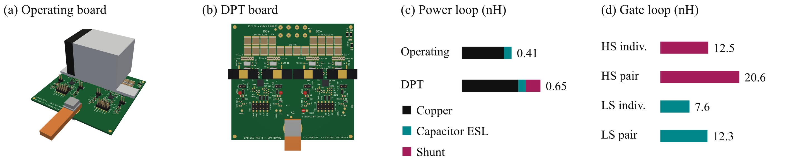
Fig. 7. (a) Operating and (b) DPT boards; (c) commutation-loop composition; (d) individual and pair-driven DPT gate loops.
Fig. 8 shows the Q3D conductor models underlying the extraction. The operating-board view is compared with the DPT-board network, which includes the additional low-side source-to-shunt path. The cell-pair detail shows the overlapping conductors, interlayer connections, and device and capacitor terminals used to define the local power network. These are geometry views rather than field-distribution plots.
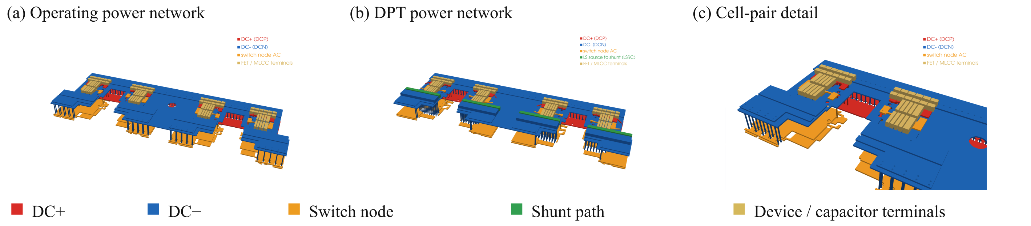
Fig. 8. Q3D conductor models of (a) the operating board, (b) the DPT board, and (c) one cell pair. Colours identify nets.

C. Switching Assessment and Design Feedback
Network-model comparisons and drive optimization are deferred to the full paper ; it is omitted in the digest due to the page limit.
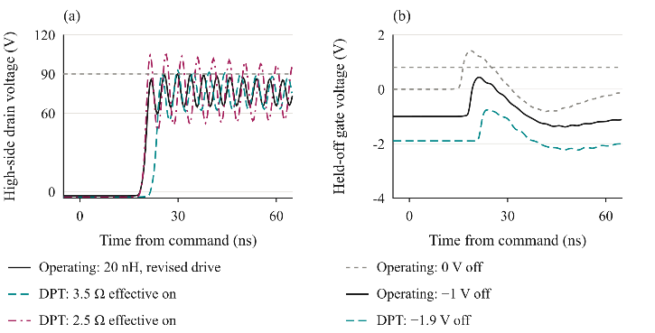
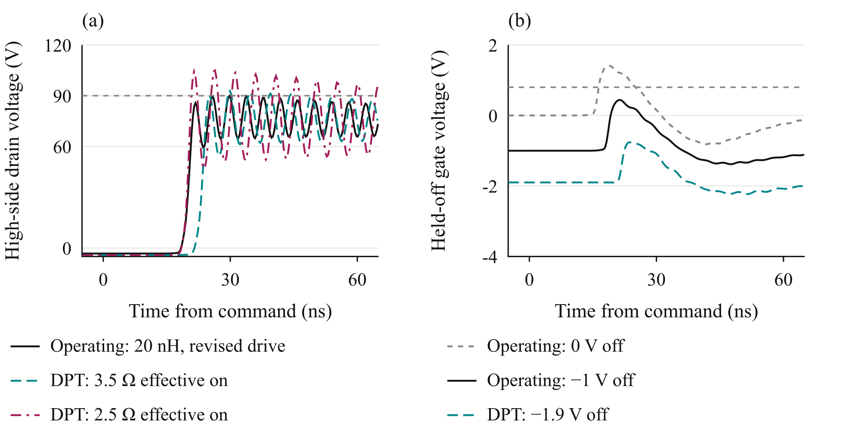

Fig. 9. Waveforms at 75 V and approximately 316 A: (a) worst-cell high-side drain voltage and (b) cell-1 held-off gate voltage. Drive configurations differ in bias and resistance. Grey lines mark 90 V and 0.8 V.
The extracted-network DPT case with the larger turn-on resistance has a maximum held-off gate excursion of approximately -0.5 V and a minimum gate voltage of approximately -3.5 V across the saved transitions and cells. Both positive and negative gate excursions must be checked against the device ratings of −4 V and +6 V [9]. These waveform checks remain conditional on the modeled network and do not replace experimental correlation.

D. Implications for the Building Block
Layout refinement and loss updates are deferred to the full paper; it is omitted in the digest due to the page limit.

VI. Experimental Validation and Scope of the Full Paper

A. Planned Double Pulse Measurements
The experimental DPT procedure is deferred to the full paper.

B. System Integration Boundary
System integration and insulation details are deferred to the full paper; it is omitted in the digest due to the page limit.

VII. Conclusion
Final design conclusions will be presented in the full paper; it is omitted in the digest due to the page limit.

References
[1] S. Norrga et al., “A novel inverter topology for compact EV and HEV drive systems,” Proc. IECON, 2013, pp. 6590–6595.
[2] L. Jin et al., “Modulation and power losses of a stacked polyphase bridge converter,” IEEE J. Emerg. Sel. Topics Power Electron., vol. 5, no. 1, pp. 409–418, 2017.
[3] M. Nikouie et al., “DC-link stability analysis and controller design for the stacked polyphase bridges converter,” IEEE Trans. Power Electron., vol. 32, no. 2, pp. 1666–1674, 2017.
[4] G. Rohner et al., “Comparative evaluation of three-phase three-level flying capacitor and stacked polyphase bridge GaN inverter systems for integrated motor drives,” Electronics, vol. 13, Art. 1259, 2024.
[5] J. A. Brothers and T. Beechner, “GaN module design recommendations based on the analysis of a commercial 3-phase GaN module,” Proc. IEEE ECCE, 2019, pp. 4109–4116.
[6] J. Lu and D. Chen, “Paralleling GaN E-HEMTs in 10 kW–100 kW systems,” Proc. IEEE APEC, 2017, pp. 3049–3056.
[7] M. T. Tran et al., “A high-performance GaN power module with parallel packaging for high-current and low-voltage traction inverter applications,” IEEE J. Emerg. Sel. Topics Power Electron., vol. 13, no. 1, pp. 1188–1209, 2025.
[8] J. Azurza Anderson et al., “New figure-of-merit combining semiconductor and multi-level converter properties,” IEEE Open J. Power Electron., vol. 1, pp. 322–338, 2020, doi: 10.1109/OJPEL.2020.3018220.
[9] Efficient Power Conversion, “EPC2361 eGaN FET datasheet,” July 20, 2026.
[10] Infineon Technologies, “2EDF7275K data sheet,” rev. 2.8.

