Topic 17 — Power Electronics for Transportation Electrification

Low-Voltage GaN Utilization for High-Voltage Stacked Polyphase Bridge Traction Inverters
Abstract—The stacked polyphase bridge (SPB) enables a high-voltage traction drive to use low-voltage gallium nitride (GaN) transistors by partitioning the dc-link voltage among series-connected submodules. Realizing the device-level advantage requires a building block that retains switching margin at high phase current. This paper examines that requirement for a 300-kW, 1200-V drive. A charge-based device comparison motivates the 100-V EPC2361, and a single-cell switching and loss assessment identifies four parallel transistors per switch position as a candidate for sixteen submodules. Current-sharing sensitivity motivates symmetric transistor pairs and dedicated Kelvin returns. The candidate is then assessed through the KiCad–Ansys Q3D–LTspice design loop of the prototype board. Although its estimated local commutation loop is approximately 0.41 nH, the simulated held-off gate peak reaches approximately 1.4 V with zero off-state bias. Revised drive settings reduce this disturbance, while the 20-nH gate-loop case remains near the 90-V drain-voltage target. The study connects low-voltage GaN selection to the joint power- and gate-network constraints that govern its utilization in an SPB traction building block. Testing of a building block is planned for the full paper.
Index Terms—Gallium nitride, gate drive, parallel transistors, parasitic inductance, stacked polyphase bridge, traction inverter.

I. Introduction
High dc-link voltages support traction power levels of several hundred kilowatts, but conventional two-level inverter switches must block the full dc-link voltage while conducting substantial phase current. Multilevel converters enable the use of devices with lower blocking-voltage ratings, although the additional components introduce more potential failure points and do not automatically provide fault tolerance. The stacked polyphase bridge (SPB) connects three-phase bridges in series on the dc side, with each bridge supplying an isolated winding set of a common machine [1], [2]. This arrangement combines voltage partitioning with a modular structure that supports fault-tolerant operation. A faulty submodule can be bypassed while the remaining submodules and winding sets continue operating at reduced capability. Fig. 1 shows the voltage partition and the phase-leg building block considered here.


Fig. 1. (a) SPB topology and isolated winding sets. (b) Three-phase submodule; each symbol represents four parallel GaN transistors, with the diode indicating reverse conduction.

Voltage partitioning enables each SPB submodule to use a lower semiconductor voltage class, creating an opportunity to exploit the favorable on-state resistance and switching characteristics of low-voltage gallium nitride (GaN) devices in high-voltage traction drives. Increasing the submodule count reduces the voltage across each bridge but leaves the phase-current requirement unchanged for fixed total power, dc-link voltage, modulation index, and power factor. Several devices may therefore be required in parallel, making current sharing, gate-drive impedance and commutation paths central to realizing the expected device benefits.
Previous studies address SPB modulation and losses [2], dc-link stability [3], and comparisons with alternative GaN converter systems [4]. Research on paralleled GaN stages identifies complementary implementation constraints, including commutation inductance, source coupling, and unequal gate impedances [5]–[7]. These findings indicate that device-level comparisons must be complemented by an assessment of the routed building block: a favorable device figure of merit alone does not establish sufficient drain- and gate-voltage margins at traction current.
This paper evaluates low-voltage GaN utilization by linking device selection, single-cell characterization and parallel-count selection to a symmetric phase-leg implementation. A KiCad–Ansys Q3D–LTspice workflow connects the prototype layout to its parasitic network and switching response. The contribution is a quantitative assessment of how the power network and gate-drive settings jointly constrain the switching margins of the selected SPB building block.

II. Traction Requirements and Low Voltage Device Selection

A. Traction Drive Requirements
The building block is designed for the traction operating point and constraints summarized in Table I. For balanced operation with equal submodule voltages, the total active power is expressed as
$P = \frac{3 M V_{dc} I_{ph,rms} cos φ}{2\sqrt{2}}$ (1)
Here, V_{dc} is the total dc-link voltage, I_{ph,rms} is the rms phase current, and cosφ is the power factor. The modulation index M is defined such that the fundamental phase-to-neutral voltage peak of each submodule is M V_{m}/2. The specified operating point requires approximately 228 A rms phase current.
TABLE I DESIGN OPERATING POINT AND PRELIMINARY CONSTRAINTS
Quantity | Symbol | Value
Total active power | P | 300 kW
Total dc-link voltage | V_{dc} | 1200 V
Modulation index | M | 1.15
Power factor | cosφ | 0.9
Phase current | I_{ph} | 228 A rms
Switching frequency | f_{sw} | 50 kHz
Candidate submodule count | N | 16
Nominal submodule voltage | V_{m} | 75 V
Peak drain–source voltage target | V_{DS,pk} | 90 V
Junction-temperature limit | T_{j,max} | 125 °C
Ambient temperature | T_{a} | 40 °C

B. Semiconductor Voltage Class Comparison
Voltage partitioning allows the semiconductor voltage class to be selected together with the submodule count. The comparison considers conduction and switching characteristics rather than on-state resistance alone. Fig. 2 compares the typical on-state resistance R_{DS(on)} at 25 °C and charge-equivalent output capacitance C_{oss,Q} of the surveyed GaN devices. Because of the digest page limit, the capacitance derivation will be presented in the full paper.
Following the charge-based screening criterion in [8], the device figure of merit is defined as
$D-FOM = \frac{1}{\sqrt{R_{DS(on)} C_{oss,Q}}}$ (2)
A higher D-FOM indicates a more favorable combination of conduction resistance and output charge. In the simplified hard-switching model underlying this criterion, optimizing semiconductor area gives minimum losses proportional to the square root of the resistance–capacitance product. Fig. 2 therefore uses constant-product contours, with lower τ = R_{DS(on)} C_{oss,Q} corresponding to higher D-FOM.
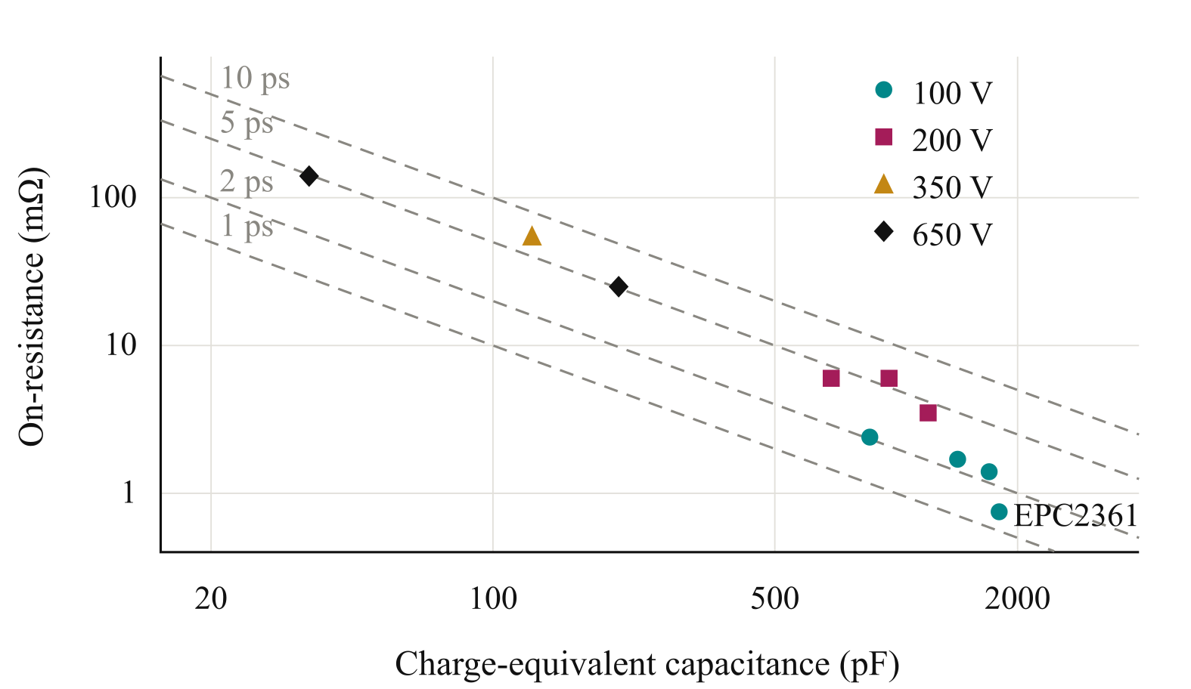
Fig. 2. On-state resistance versus charge-equivalent output capacitance for the surveyed GaN voltage classes.
Because of the digest page limit, device-data normalization and screening limits will be detailed in the full paper.

C. Initial Submodule Voltage
For equal voltage partitioning, the nominal submodule voltage is
$V_{m} = \frac{V_{dc}}{N}$ (3)
For the considered 100 V device, the initial submodule dc-link voltage is set to 75 V to allow for switching overshoot and submodule-voltage variation. This choice requires sixteen series-connected submodules for the specified 1200 V dc link. The feasibility of this operating point is assessed through iterative layout design, parasitic extraction and switching simulations. If adequate voltage margin cannot be achieved, the submodule operating voltage will be revised. However, lowering this voltage increases the required submodule count. The design therefore seeks to use the device-voltage capability effectively while maintaining adequate switching margin.

III. Single Cell Characterization and Selection of the Parallel Count

A. Single Cell Switching Characterization
The selected EPC2361 is evaluated in a half-bridge model with one device per switch position. Inductive-load switching simulations are performed at a submodule voltage of 75 V over a device-current sweep. Gate-loop inductances of 10 nH and 20 nH represent the preliminary range of interest, while commutation-loop inductances of 0.5 nH and 1 nH represent a compact power path and a higher-inductance sensitivity case, respectively. Turn-on and turn-off gate resistances are fixed at 3 Ω and 1 Ω. The aim is to retain fast switching and low switching energy so that the device’s switching capability can be used effectively.
Fig. 3 separates the low-side drain–source voltage peak at turn-off from the high-side peak during low-side turn-on and reports both low-side switching energies. The low-side peak generally rises at higher current, whereas the high-side peak is largest at low current, where rapid capacitive commutation excites ringing. Near 80 A per device, the compact power path meets the drain-voltage target for both events, but the higher-inductance path does not. Increasing gate resistance can slow the relevant transition and reduce overshoot, but generally increases switching energy. Minimizing commutation inductance is therefore important for retaining voltage margin and the device’s switching-loss advantage.
Because of the digest page limit, the full paper will expand the current-range assessment and simulation details.
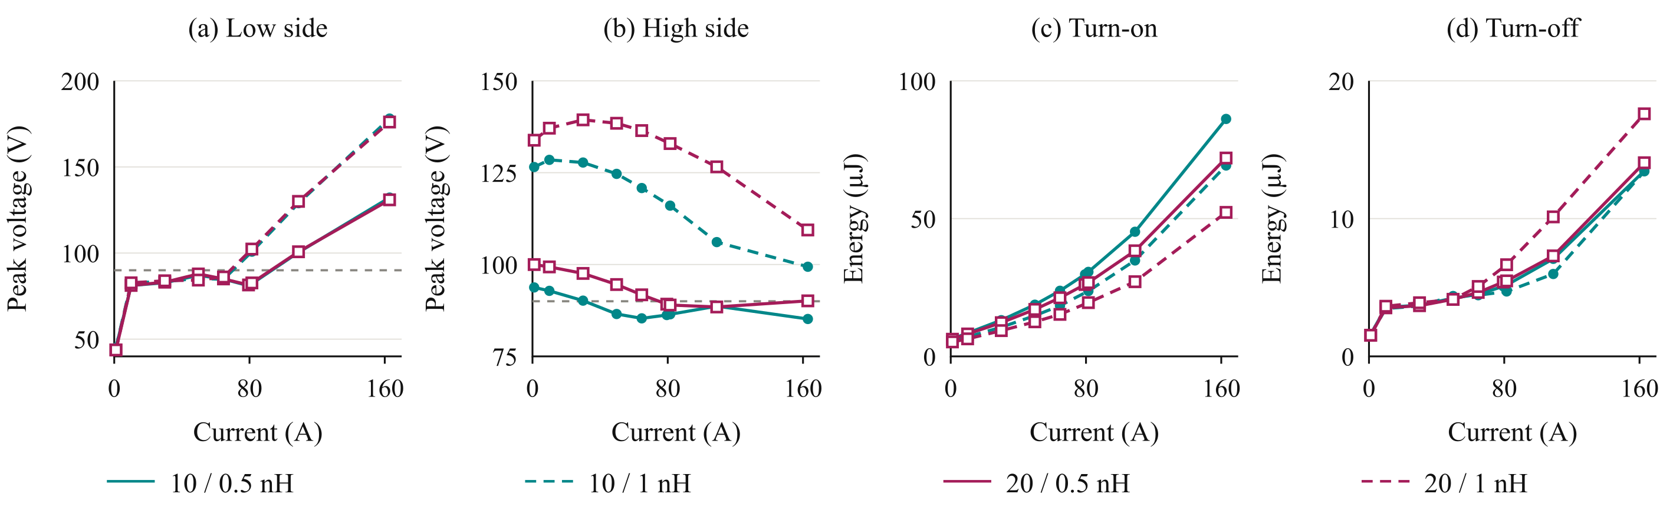
Fig. 3. Single-cell results at 75 V: (a) low-side voltage peak at turn-off; (b) high-side voltage peak during low-side turn-on; (c) low-side turn-on energy; (d) low-side turn-off energy. Legend: gate-loop / commutation-loop inductance. Grey lines: 90 V target.

B. Loss and Thermal Assessment
For n parallel transistors and ideal current sharing, the peak current per device is
$I_{dev,pk} = \frac{I_{ph,pk}}{n}$ (4)
The single-cell switching-energy maps are evaluated over the sinusoidal phase-current waveform to estimate average switching losses. Because of the digest page limit, energy integration and the thermal model will be detailed in the full paper.
Fig. 4(a) shows the loss distribution for the nominal gate-loop case and compact commutation path. Additional parallel devices reduce conduction loss, while switching charge, gate loading and layout complexity limit the benefit of further paralleling. Fig. 4(b) compares only the low-side drain–source voltage peak at turn-off, evaluated at the peak current per device. The high-side peak is assessed separately in Fig. 3(b); both transitions must satisfy the voltage constraint before a parallel count can be accepted.
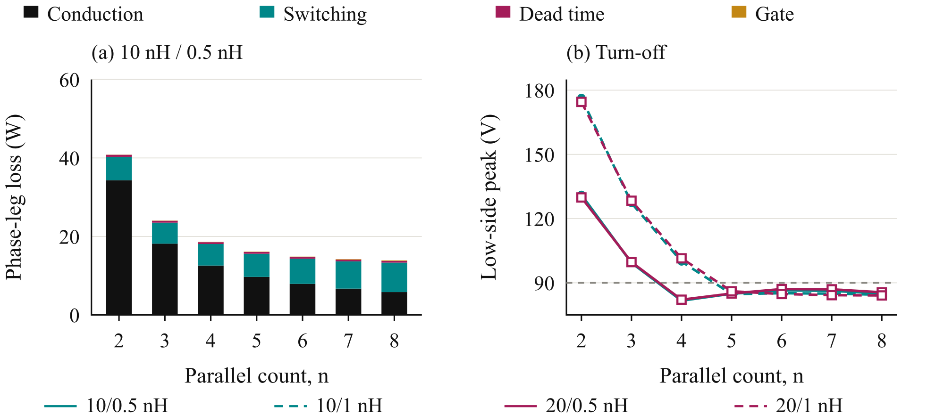
Fig. 4. (a) Phase-leg losses and (b) low-side voltage peak at turn-off versus parallel count at 75 V and 50 kHz. Inductance encoding follows Fig. 3.

C. Selection of Four Parallel Devices
Four parallel transistors are retained as an initial implementation choice: this count meets the preliminary peak-current voltage screen with the compact commutation path and permits two symmetric transistor pairs. It is not the minimum-loss count in the sweep. Its suitability is therefore checked in the routed prototype board rather than inferred from the single-cell model alone. Because of the digest page limit, the selection will be detailed in the full paper.

IV. Gate Drive Configuration and Cell Arrangement

A. Current Sharing Sensitivity
The preliminary parallel-count choice assumes equal current sharing. Fig. 5(a) compares two parallel devices at 75 V and 120 A nominal total current, using 0/5 V gate commands, 2 Ω gate resistors and nominal 10 nH gate loops. A power-loop mismatch of 0.3 nH produces approximately 8% peak-current imbalance; 10/20 nH gate loops produce approximately 56%; and removing the Kelvin return with a 0.2 nH source-inductance mismatch produces approximately 25%. The metric is 100|I_{pk,1} − I_{pk,2}|/(I_{pk,1} + I_{pk,2}), where I_{pk,1} and I_{pk,2} are the individual turn-on peak drain currents. The power- and source-mismatch cases retain 10/10 nH gate loops. The gate-loop mismatch is the most sensitive of these evaluated cases, motivating matched gate paths and dedicated Kelvin returns.
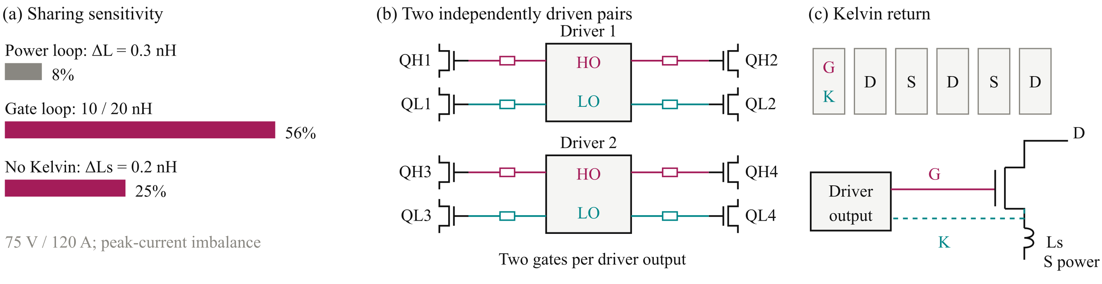
Fig. 5. (a) Peak-current imbalance with a nominal 10 nH gate loop; (b) paired gate drive; (c) device pads and Kelvin return. HO/LO denote high-/low-side driver outputs.

B. Paired Gate Drive Configuration
Connecting all four transistors to one gate-driver output increases the total gate charge and the current required to establish the intended switching transition. The turn-off path must also sink the displacement current coupled through the gate–drain capacitance during drain-voltage transients. Excessive impedance in this path can cause a positive gate-voltage disturbance and reduce the margin against unintended turn-on.
The four-device arrangement is divided into two transistor pairs per switch position. As illustrated in Fig. 5(b), each pair of switching cells is served by one dual-channel 2EDF7275K driver [10]. One channel drives two high-side transistors and the other drives two low-side transistors. The phase leg uses two drivers, with an individual gate resistor for each transistor.

C. Kelvin Source Connection and Cell Layout
Because of the digest page limit, the full paper will detail layout symmetry, Kelvin returns and driver loading.

D. Verification of the Physical Arrangement
Because of the digest page limit, inter-driver timing and additional routed-network checks will be presented in the full paper.

V. Low Voltage GaN Utilization in the Routed Prototype Board

A. Layout and Parasitic Extraction
Initial sizing identifies a voltage class and parallel-count candidate. The prototype board must then show whether this device arrangement can retain sufficient switching margin at traction current. Fig. 6 links KiCad placement and routing to Ansys Q3D extraction and LTspice assessment. Drain stress, gate disturbance and branch behavior guide changes to the layout or drive settings. If sufficient margin cannot be recovered, the submodule voltage or device class must be reconsidered. The workflow thus checks the selected SPB operating point against the intended building-block implementation.
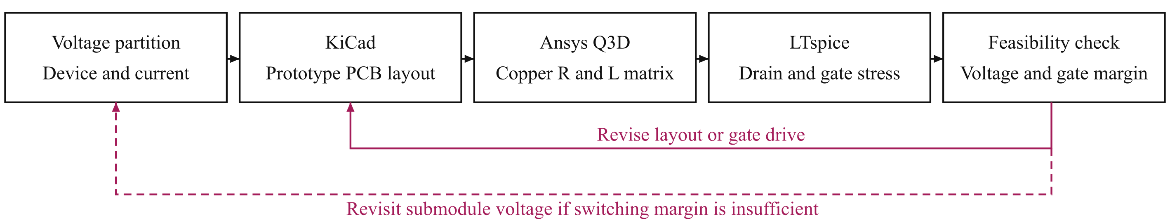
Fig. 6. Prototype board design loop linking voltage choice, routing, parasitic extraction and the joint drain- and gate-voltage assessment.
The following results use only the prototype board representing the intended converter phase leg. Its local capacitors and paired drive arrangement are evaluated together with the routed copper network.

B. Prototype Board Layout and Extracted Network
Fig. 7 shows the KiCad prototype board assembly and the Q3D conductor geometry. The estimated local commutation loop is approximately 0.41 nH per cell, including capacitor equivalent series inductance. This supports the compact-path assumption used for initial sizing. The geometry also shows why the outgoing and return conductors must be considered together, rather than assigning an independent inductance to each visible connection.
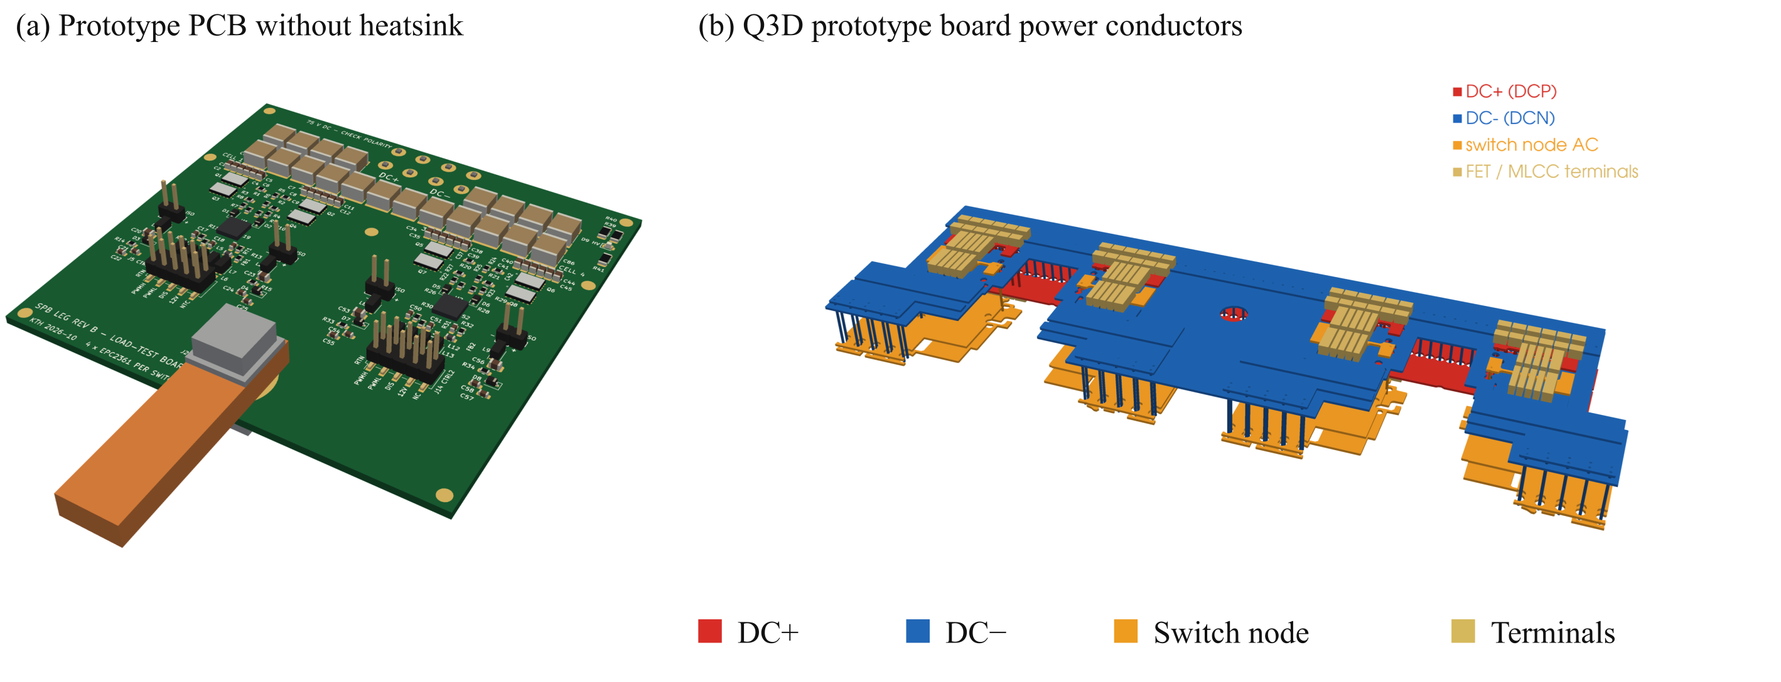
Fig. 7. (a) Prototype PCB without heatsink. (b) Q3D prototype board power conductors; colours identify the dc rails, switch node and device/capacitor terminals.
The LTspice power-network model retains 29 branches, the extracted copper resistance matrix and mutual inductive coupling. It uses dc resistance and partial inductances extracted at 100 MHz. Gate-loop inductances of 10 nH and 20 nH are sensitivity assumptions, distinct from the extracted copper power network. The local loop estimate alone therefore does not describe the complete switching model.

C. Prototype Board Switching Assessment
Fig. 8 compares prototype board responses using the same extracted power network. The local bus is 75 V and the saved inductive-load transition occurs near 316 A total current. The device model temperature is 27 °C. A 5-V on-state command, 1-Ω external turn-off resistance and 0.85-Ω/0.35-Ω driver pull-up/pull-down resistances are used. External turn-on resistance and off-state bias are varied to assess the drain and gate constraints together.
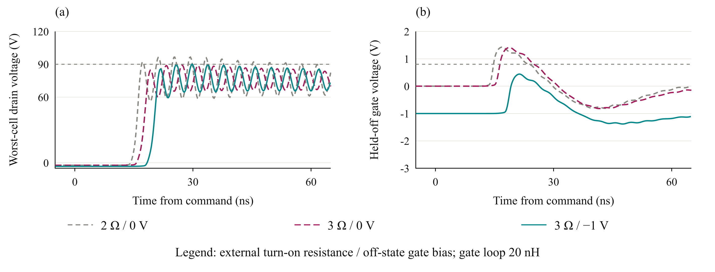
Fig. 8. Prototype board waveforms at 75 V near 316 A: (a) worst-device high-side drain voltage and (b) largest held-off gate response. Grey references mark 90 V and 0.8 V.
Table II reports the maximum drain voltage across the four parallel devices and both assessed commutations, the largest held-off high-side gate peak, and the minimum gate voltage across the saved transitions. With zero off-state bias, increasing turn-on resistance reduces the drain peak but leaves the gate disturbance above the minimum threshold of 0.8 V [9]. This indicates a risk of unintended conduction; it does not quantify a shoot-through current. Negative off-state bias reduces the positive gate excursion, but the 20-nH case remains approximately at the drain-voltage target. The negative gate excursion must also be checked against the −4-V device limit.
TABLE II PROTOTYPE BOARD SIMULATION RESULTS
Gate loop  (nH) | Turn-on R  (Ω) | Off bias  (V) | Drain peak  (V) | Gate peak  (V) | Gate min.  (V)
10 | 3 | -1 | 88.0 | 0.43 | -2.43
20 | 2 | 0 | 96.7 | 1.43 | -3.00
20 | 3 | 0 | 89.2 | 1.41 | -3.00
20 | 3 | -1 | 90.1 | 0.44 | -2.50

D. Implications for Low Voltage GaN Utilization
The prototype board results show that a compact power loop is necessary but does not by itself establish usable switching margin. Parallel count, branch symmetry and gate-drive settings determine whether the selected voltage class remains practical. The higher gate-inductance case leaves no useful drain-voltage margin for tolerances or operating-point variation. If layout and drive changes cannot provide that margin, reducing the submodule voltage feeds back into the SPB series count. The lower gate-inductance case provides more headroom at this operating point, without establishing compliance over a complete traction operating envelope.

VI. Experimental Validation and Scope of the Full Paper

A. Testing of One Building Block
Because of the digest page limit, experimental validation is reserved for the full paper. One prototype board building block will be tested to compare drain and gate transients and switching energy with the simulation predictions. These measurements are planned and have not yet been performed.

B. System Integration Boundary
Because of the digest page limit, system integration and insulation details will be presented in the full paper.

VII. Conclusion
The SPB voltage partition enables low-voltage GaN to be considered for a high-voltage traction drive, but its utilization depends on a realizable high-current building block. The device comparison, single-cell study and parallel-count assessment lead to a symmetric four-device candidate. Prototype board extraction and switching simulations then expose the remaining joint drain- and gate-voltage constraints. These results connect device-level selection to implementation feasibility; they do not establish a final loss optimum or full-drive efficiency. Testing one building block in the full paper will assess the simulation predictions and remaining switching margin.

References
[1] S. Norrga et al., “A novel inverter topology for compact EV and HEV drive systems,” Proc. IECON, 2013, pp. 6590–6595.
[2] L. Jin et al., “Modulation and power losses of a stacked polyphase bridge converter,” IEEE J. Emerg. Sel. Topics Power Electron., vol. 5, no. 1, pp. 409–418, 2017.
[3] M. Nikouie et al., “DC-link stability analysis and controller design for the stacked polyphase bridges converter,” IEEE Trans. Power Electron., vol. 32, no. 2, pp. 1666–1674, 2017.
[4] G. Rohner et al., “Comparative evaluation of three-phase three-level flying capacitor and stacked polyphase bridge GaN inverter systems for integrated motor drives,” Electronics, vol. 13, Art. 1259, 2024.
[5] J. A. Brothers and T. Beechner, “GaN module design recommendations based on the analysis of a commercial 3-phase GaN module,” Proc. IEEE ECCE, 2019, pp. 4109–4116.
[6] J. Lu and D. Chen, “Paralleling GaN E-HEMTs in 10 kW–100 kW systems,” Proc. IEEE APEC, 2017, pp. 3049–3056.
[7] M. T. Tran et al., “A high-performance GaN power module with parallel packaging for high-current and low-voltage traction inverter applications,” IEEE J. Emerg. Sel. Topics Power Electron., vol. 13, no. 1, pp. 1188–1209, 2025.
[8] J. Azurza Anderson et al., “New figure-of-merit combining semiconductor and multi-level converter properties,” IEEE Open J. Power Electron., vol. 1, pp. 322–338, 2020, doi: 10.1109/OJPEL.2020.3018220.
[9] Efficient Power Conversion, “EPC2361 eGaN FET datasheet,” July 20, 2026.
[10] Infineon Technologies, “2EDF7275K data sheet,” rev. 2.8.

