Low-Voltage GaN Utilization in High-Voltage Stacked Polyphase Bridge Inverters for Truck Propulsion

Topic 17 — Power Electronics for Transportation Electrification
Abstract— The stacked polyphase bridge (SPB) partitions the dc-link voltage among series-connected submodules, enabling low-voltage gallium nitride (GaN) switches to be used in high-voltage truck propulsion systems. With suitable bypass hardware and winding control, its isolated machine winding sets also support continued operation following submodule bypass, unlike multilevel implementations without provisions for fault-tolerant operation. Realizing the favorable on-state resistance and switching characteristics of low-voltage GaN at the required phase-current levels, however, requires coordinated parasitic-aware design. This paper presents a phase-leg building block for a 300-kW, 1200-V SPB inverter for truck propulsion. A charge-based device comparison motivates the selection of the 100-V EPC2361, while single-cell switching and loss assessments identify four parallel devices per switch position as a candidate for a sixteen-submodule configuration. Current-sharing sensitivity guides a symmetric arrangement of device pairs. An iterative KiCad–Ansys Q3D–LTspice workflow links the routed prototype, extracted parasitic network and switching response. With an estimated local commutation-loop inductance of 0.41 nH, revised gate-drive settings achieve a simulated peak drain–source voltage of 88.8 V and a 5.9-ns voltage fall time at 75 V and 322 A. The results connect device-level selection to the physical constraints governing low-voltage GaN utilization in an SPB truck propulsion building block. Experimental validation of one building block is planned for the full paper.
Index Terms—Electrification of transportation, Gallium nitride, stacked polyphase bridge, truck propulsion.

Introduction
High dc-link voltages support megawatt charging and truck propulsion power levels of several hundred kilowatts [1]. In propulsion operation, conventional two-level inverter switches must block the full dc-link voltage while conducting substantial phase current. Multilevel converters enable the use of devices with lower blocking-voltage ratings, although the additional components introduce more potential failure points and do not automatically provide fault tolerance. The stacked polyphase bridge (SPB) connects three-phase bridges in series on the dc side, with each bridge supplying an isolated winding set of a common machine [2], [3]. This arrangement combines voltage partitioning with a modular structure that supports fault-tolerant operation. With suitable bypass hardware and winding control, a faulty submodule can be bypassed while the remaining submodules and winding sets continue operating at reduced capability, subject to their voltage and current limits. Fig. 1 shows the voltage partitioning and the phase-leg building block considered here.
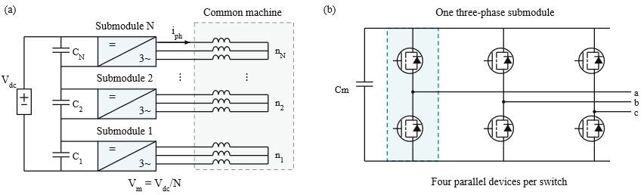

Fig. 1. (a) SPB topology and isolated winding sets for a multiphase machine; (b) three-phase submodule; each symbol represents four parallel GaN devices, with the diode indicating reverse conduction.
Voltage partitioning enables each SPB submodule to use a lower semiconductor voltage class, creating an opportunity to exploit the favorable on-state resistance and switching characteristics of low-voltage gallium nitride (GaN) devices in high-voltage truck propulsion systems [4]. Increasing the submodule count reduces the voltage across each bridge but leaves the phase-current requirement unchanged for fixed total power, dc-link voltage, modulation index, and power factor. Several devices may therefore be required in parallel, making current sharing, gate-drive impedance, and commutation paths central to realizing the expected device benefits.
Previous studies address SPB modulation and losses [3], dc-link stability [5], and comparisons with alternative GaN converter systems [6]. Research on paralleled GaN stages identifies complementary implementation constraints, including commutation inductance, source coupling, and unequal gate impedances [7]–[9]. These findings indicate that device-level comparisons must be complemented by an assessment of the routed building block: a favorable device figure of merit alone does not establish sufficient drain- and gate-voltage margins at the required phase current. Accordingly, this paper evaluates low-voltage GaN utilization by linking device selection, single-cell characterization, and parallel-count selection to a symmetric phase-leg implementation. A KiCad–Ansys Q3D–LTspice workflow connects the prototype layout to its parasitic network and switching response. The contribution is a quantitative assessment of how the power network and gate-drive settings jointly constrain the submodule voltage and the design of the SPB building block. Current-range and bus-voltage checks expose constraints that a peak-current sizing screen alone does not capture. The introduction part will be extended in the final paper; the reduced version is given in the digest due to the page limitation.

Truck Propulsion Requirements and Low Voltage Device Selection

Truck Propulsion Requirements
The building block is designed for the truck propulsion operating point and constraints summarized in Table I. For balanced operation with equal submodule voltages, the total active power is expressed as
$P = \frac{3 M V_{dc} I_{ph,rms} cos φ}{2\sqrt{2}}$ (1)
Here, V_{dc} is the total dc-link voltage, I_{ph,rms} is the rms phase current, and cosφ is the power factor. The modulation index M is defined such that the fundamental phase-to-neutral voltage peak of each submodule is M V_{m}/2. Space-vector modulation is assumed, with M below 2/√3. The specified operating point requires approximately 228 A rms and 322 A peak phase current.
TABLE I DESIGN OPERATING POINT AND PRELIMINARY CONSTRAINTS
Quantity | Symbol | Value
Total active power | P | 300 kW
Total dc-link voltage | V_{dc} | 1200 V
Modulation index | M | 1.15
Power factor | cosφ | 0.9
Phase current | I_{ph} | 228 A rms
Switching frequency | f_{sw} | 50 kHz
Junction-temperature limit | T_{j,max} | 125 °C
Ambient temperature | T_{a} | 40 °C

Semiconductor Voltage Class Comparison
Voltage partitioning allows the semiconductor voltage class to be selected together with the submodule count. The comparison considers conduction and switching characteristics rather than on-state resistance alone. Fig. 2 compares the typical on-state resistance R_{DS(on)} at 25 °C and charge-equivalent output capacitance C_{oss,Q} of the surveyed GaN devices. Here, C_{oss,Q} = Qoss(Vtest)/Vtest. For EPC2361, 90 nC at 50 V gives 1800 pF, distinct from its differential Coss of 1019 pF [10].
Following the charge-based screening criterion in [4], the device figure of merit is defined as
$D-FOM = \frac{1}{\sqrt{R_{DS(on)} C_{oss,Q}}}$ (2)
A higher D-FOM indicates a more favorable combination of conduction resistance and output charge. In the simplified hard-switching model underlying this criterion, optimizing semiconductor area gives minimum losses proportional to the square root of the resistance–capacitance product. Fig. 2 therefore uses constant-product contours, with lower τ = R_{DS(on)} C_{oss,Q} corresponding to higher D-FOM. Because of the digest page limit, detailed screening limits will be given in the full paper.

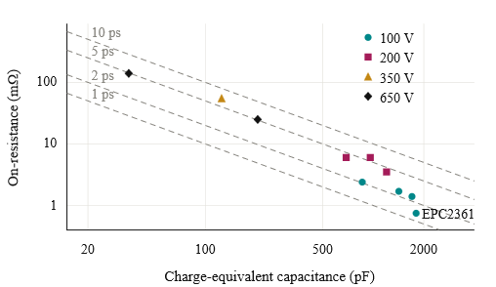
Fig. 2. On-state resistance versus charge-equivalent output capacitance for the surveyed GaN voltage classes.

Initial Submodule Voltage
For equal voltage partitioning, the nominal submodule voltage is
$V_{m} = \frac{V_{dc}}{N}$ (3)
where N is the number of series-connected modules. For the considered 100 V device, the initial submodule dc-link voltage is set to 75 V to allow for switching overshoot and submodule-voltage variation. This choice requires 16 series-connected submodules for the specified 1200 V dc link voltage. The feasibility of this operating point is assessed through iterative layout design, parasitic extraction, and switching simulations. If adequate voltage margin cannot be achieved, the submodule operating voltage should be revised. However, lowering this voltage increases the required submodule count. The design therefore seeks to use the device-voltage capability effectively while maintaining adequate switching margin.

Single Cell Characterization and Selection of the Parallel Count

A. Single Cell Switching Characterization
The selected EPC2361 is evaluated in a half-bridge model with one device per switch position. Inductive-load switching (unidirectional current) simulations are performed at a submodule voltage of 75 V over a device-current sweep. Gate-loop inductances of 10 nH and 20 nH represent the preliminary range of interest, while commutation-loop inductances of 0.5 nH and 1 nH represent a compact power path and a higher-inductance sensitivity case, respectively. Turn-on and turn-off gate resistances are fixed at 3 Ω and 1 Ω. The manufacturer’s device model [10] uses 27 °C, −1/5-V gate commands, 0.85/0.35-Ω driver pull-up/down resistances, and 0.03-nH common-source inductance. Gate-loop values are assumed bounds, not extracted measurements. The aim is to retain fast switching and low switching energy so that the device’s switching capability can be used effectively.
Fig. 3 separates the low-side drain–source voltage peak at turn-off from the high-side peak during low-side turn-on and reports both low-side switching energies. Voltage peaks cover the complete off interval and subsequent on interval. Near 80 A per device, the compact power path meets the drain-voltage target for both events, but the higher-inductance path does not. At lower current, the high-side peak can exceed the target even with the compact path, so the peak-current screen does not establish full-current-range feasibility. Increasing gate resistance can slow the relevant transition and reduce overshoot, but increases switching energy. Minimizing commutation inductance is therefore important for retaining voltage margin and the device’s switching-loss advantage. Because of the digest page limit, the full paper will expand the current-range assessment and simulation details.
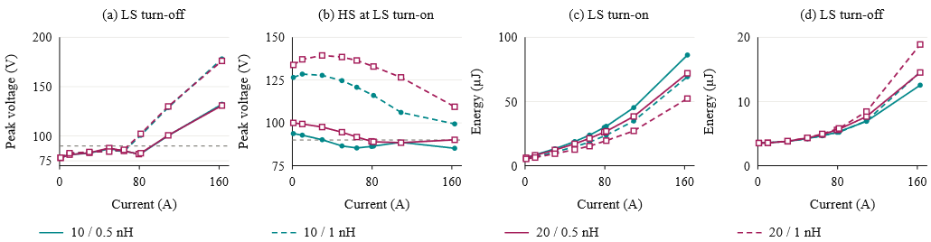
Fig. 3. Single-cell results at 75 V: (a) low-side voltage peak at turn-off; (b) high-side voltage peak during low-side turn-on; (c) low-side turn-on energy; (d) low-side turn-off energy. Legend: gate-loop / commutation-loop inductance. Grey lines: 90 V target.

Loss and Thermal Assessment
For n parallel devices and ideal current sharing, the peak current per device is
$I_{dev,pk} = \frac{I_{ph,pk}}{n}$ (4)
The single-cell switching-energy maps are evaluated over the sinusoidal phase-current waveform to estimate average switching losses. Turn-on energy is integrated over 150 ns and turn-off energy over the full 1-µs off interval to capture slow low-current capacitance charging. The first-pass cooling estimate assumes 7.62 K/W per device from junction to sink and 0.65 K/W from the shared phase-leg sink to 40 °C ambient. Loss accounting includes 10-ns dead time. The detailed model will be given in the full paper because of the digest page limit. Fig. 4(a) shows the loss distribution for the nominal gate-loop case and compact commutation path. Additional parallel devices reduce conduction loss, while switching charge, gate loading, and layout complexity limit the benefit of further paralleling. Fig. 4(b) compares only the low-side drain–source voltage peak at turn-off, evaluated at the peak current per device. The high-side peak is assessed separately in Fig. 3(b); both transitions must satisfy the voltage constraint before a parallel count can be accepted.
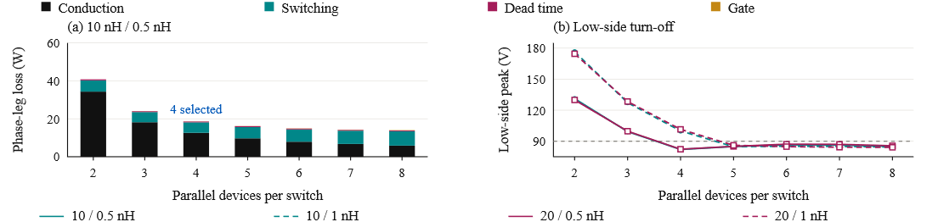
Fig. 4. (a) Phase-leg losses and (b) low-side voltage peak at turn-off versus parallel count at 75 V and 50 kHz.

Selection of Four Parallel Devices
Four parallel devices are retained as an initial implementation choice: this count meets the preliminary peak-current voltage screen with the compact commutation path. The 10-nH/0.5-nH case estimates 18.6 W per phase leg and 70 °C junction temperature under the assumed cooling conditions. It is not the minimum-loss count in the sweep. Its suitability is therefore checked in the routed prototype board rather than inferred from the single-cell model alone. Because of the digest page limit, the selection will be detailed in the full paper.

Gate Drive Configuration and Cell Arrangement

A. Current Sharing Sensitivity
The preliminary parallel-count choice assumes equal current sharing. Fig. 5(a) compares two parallel devices at 75 V and 120 A nominal total current, using 0/5 V gate commands, 3 Ω gate resistors, and nominal 10 nH gate loops. A power-loop mismatch of 0.1 nH produces approximately 2% peak-current imbalance; 10/15 nH gate loops produce approximately 17%; and removing the Kelvin return with a 0.05 nH source-inductance mismatch produces approximately 9%. Imbalance is 100|Ipk,1 − Ipk,2|/(Ipk,1 + Ipk,2), using each branch’s turn-on maximum. These different perturbations motivate matched gate paths and dedicated Kelvin returns, without establishing a universal sensitivity ranking. Because of the digest page limit, the sensitivity analysis will be detailed in the full paper.

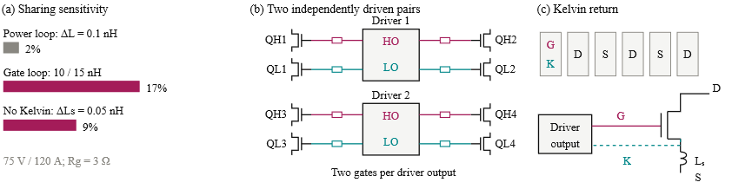
Fig. 5. (a) Peak-current imbalance with a nominal 10 nH gate loop; (b) paired gate drive; (c) device pads and Kelvin return. HO/LO denote high-/low-side driver outputs. S denotes the power-source terminal, K the Kelvin-source return, and Lₛ the power-source inductance.

Paired Gate Drive Configuration
Connecting all four devices to one gate-driver output increases the total gate charge and the current required to establish the intended switching transition. The turn-off path must also sink the displacement current coupled through the gate–drain capacitance during drain-voltage transients. Excessive impedance in this path can cause a positive gate-voltage disturbance and reduce the margin against unintended turn-on. The four-device arrangement is divided into two device pairs per switch position. As illustrated in Fig. 5(b), each pair of switching cells is served by one dual-channel 2EDF7275K driver [11]. One channel drives two high-side devices and the other drives two low-side devices. The phase leg uses two drivers, with an individual gate resistor for each device.

Kelvin Source Connection and Cell Layout
Because of the digest page limit, the full paper will detail layout symmetry, Kelvin returns, and driver loading.

Verification of the Physical Arrangement
Because of the digest page limit, inter-driver timing and additional routed-network checks will be presented in the full paper.

Low Voltage GaN Utilization in the Routed Prototype Board

Layout and Parasitic Extraction
Initial sizing identifies a voltage class and parallel-count candidate. The prototype board must then show whether this device arrangement can retain sufficient switching margin at the required phase current. Fig. 6 links KiCad placement and routing to Ansys Q3D extraction and LTspice assessment. Drain stress, gate disturbance, and branch behavior guide changes to the layout or drive settings. If sufficient margin cannot be recovered, the submodule voltage or device class must be reconsidered. The workflow thus checks the selected SPB operating point against the intended building-block implementation.
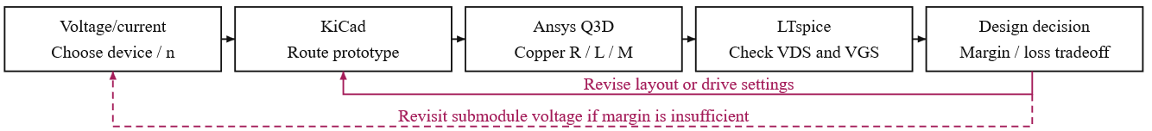
Fig. 6. Prototype board design loop linking voltage choice, routing, parasitic extraction, and the joint drain- and gate-voltage assessment.

Prototype Board Layout and Extracted Network
Fig. 7 shows a CAD rendering of the KiCad prototype board assembly and the Q3D conductor geometry. The estimated local commutation loop inductance is approximately 0.41 nH per cell, including capacitor equivalent series inductance (ESL). The coupled power network contains 29 branches and 406 mutual terms, using dc resistance and partial inductances at 100 MHz. The scalar comprises 0.347 nH of copper and 0.062 nH of capacitor ESL at device/capacitor ports under equal branch excitation. Gate loops remain under assumed 20-nH bounds. This supports the compact-path assumption used for initial sizing. Because of the digest page limit, the full paper will detail layout and Q3D results.
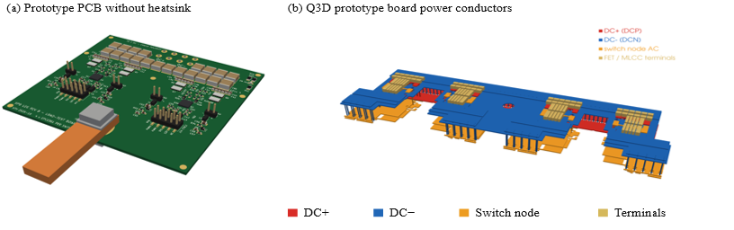
Fig. 7. (a) Prototype PCB CAD rendering without heatsink. (b) Q3D prototype board power conductors; colours identify the dc rails, switch node and device/capacitor terminals.

Prototype Board Switching Assessment
Fig. 8 compares prototype board responses using the same extracted power network. The local bus is 75 V; controlled-current commutations sample 1, 40, 80, 160, 240, and 322 A total positive current. A check near 316 A agrees with the inductive-load case within 2% in peak voltage and summed switching energy. The device model temperature is 27 °C. A 5-V on-state command, 1-Ω external turn-off resistance, and 0.85-Ω/0.35-Ω driver pull-up/pull-down resistances are used. External turn-on resistance and off-state bias are varied to assess the drain and gate constraints together. Settings A/B/C use a 20-nH gate loop with turn-on resistance/off bias of 2 Ω/0 V, 3 Ω/0 V, and 3 Ω/−1 V; D uses 10 nH and 3 Ω/−1 V. The maximum time step is 0.2 ns. Because of the digest page limit, the full paper will detail prototype board simulation results.
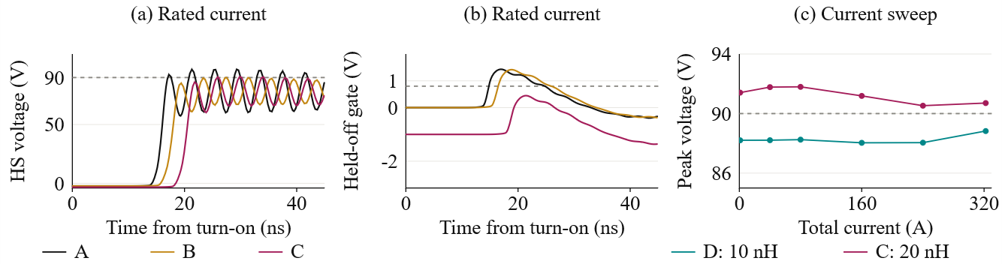
Fig. 8. Prototype board waveforms at 75 V: (a) high-side drain voltage and (b) held-off gate response for A–C at 322 A; (c) maximum drain stress over both transitions across the sampled current range. Grey references mark 90 V and 0.8 V.

Implications for Low Voltage GaN Utilization
The prototype board results show that a compact power loop is necessary but does not by itself establish usable switching margin. Parallel count, branch symmetry, and gate-drive settings determine whether the selected voltage class remains practical. The higher gate-inductance case leaves no useful drain-voltage margin for tolerances or operating-point variation. If layout and drive changes cannot provide that margin, reducing the submodule voltage feeds back into the SPB series count. With revised drive settings, the 10-nH case gives 88.0–88.8-V drain peaks at sampled nominal-current points; the 20-nH case reaches 91.8 V at lower current. At rated current, the 10-nH case has a 5.9-ns voltage fall time and 38.7-µJ summed low-side switching energy per device. Because of the digest page limit, the details will be presented in the full paper.

Experimental Validation and Scope of the Full Paper

A. Testing of One Building Block
Because of the digest page limit, experimental validation is reserved for the full paper. One prototype board building block will be tested to validate simulation predictions. Measurements will include Kelvin-referenced gate voltage, branch currents, and deskewed switching energy. Negative-bias implementation and driver compatibility will also be checked.

System Integration Boundary
Because of the digest page limit, system integration and insulation details will be presented in the full paper.

Conclusion
The SPB voltage partition enables low-voltage GaN to be considered for a high-voltage truck propulsion system, but its utilization depends on a realizable high-current building block. The device comparison, single-cell study, and parallel-count assessment lead to a symmetric four-device candidate. Prototype board extraction and switching simulations then expose the remaining joint drain- and gate-voltage constraints. These results connect device-level selection to implementation feasibility; they do not establish a final loss optimum or full-drive efficiency. Conclusion will be updated in the full paper. Testing one building block in the full paper will assess the simulation predictions and remaining switching margin.
ACKNOWLEDGMENT
OpenAI Codex assisted with drafting and language editing throughout this manuscript, preparation of figures, scripting simulations and result processing. The authors retain responsibility for the technical content and its verification.
REFERENCES
[1] J. Schneider et al., “The novel megawatt charging system standard: Impact on battery size and cell requirements for battery-electric long-haul trucks,” eTransportation, vol. 17, Jul. 2023, Art. no. 100253.
[2] S. Norrga et al., "A novel inverter topology for compact EV and HEV drive systems," IECON 2013 - 39th Annual Conference of the IEEE Industrial Electronics Society, Vienna, Austria, 2013, pp. 6590-6595.
[3] L. Jin et al., "Modulation and Power Losses of a Stacked Polyphase Bridge Converter," in IEEE Journal of Emerging and Selected Topics in Power Electronics, vol. 5, no. 1, pp. 409-418, March 2017.
[4] J. Azurza Anderson et al., "New Figure-of-Merit Combining Semiconductor and Multi-Level Converter Properties," in IEEE Open Journal of Power Electronics, vol. 1, pp. 322-338, 2020, doi: 10.1109/OJPEL.2020.3018220.
[5] M. Nikouie et al., "DC-Link Stability Analysis and Controller Design for the Stacked Polyphase Bridges Converter," in IEEE Transactions on Power Electronics, vol. 32, no. 2, pp. 1666-1674, Feb. 2017, doi: 10.1109/TPEL.2016.2553129.
[6] G. Rohner et al., “Comparative evaluation of three-phase three-level flying capacitor and stacked polyphase bridge GaN inverter systems for integrated motor drives,” Electronics, vol. 13, Art. 1259, 2024.
[7] J. A. Brothers et al., "GaN Module Design Recommendations Based on the Analysis of a Commercial 3-Phase GaN Module," 2019 IEEE Energy Conversion Congress and Exposition (ECCE), Baltimore, MD, USA, 2019, pp. 4109-4116.
[8] J. L. Lu and D. Chen, "Paralleling GaN E-HEMTs in 10kW–100kW systems," 2017 IEEE Applied Power Electronics Conference and Exposition (APEC), Tampa, FL, USA, 2017, pp. 3049-3056.
[9] M. Tuan Tran et al., "A High-Performance GaN Power Module With Parallel Packaging for High-Current and Low- Voltage Traction Inverter Applications," in IEEE Journal of Emerging and Selected Topics in Power Electronics, vol. 13, no. 1, pp. 1188-1209, Feb. 2025.
[10] Efficient Power Conversion, “EPC2361 eGaN FET datasheet,” July 20, 2026.
[11] Infineon Technologies, “2EDF7275K data sheet,” rev. 2.8, August 8, 2022.

