Low-Voltage GaN Utilization in High-Voltage Stacked Polyphase Bridge Inverters for Truck Propulsion
Topic 17 — Power Electronics for Transportation Electrification
Abstract—The stacked polyphase bridge (SPB) partitions a high-voltage dc link for truck propulsion among series-connected submodules, enabling the use of low-voltage gallium nitride (GaN) devices. Retaining their loss advantages at the required phase current requires sufficient drain- and gate-voltage margins in the physical building block. This paper evaluates a phase leg for a 300-kW, 1200-V truck propulsion system, starting with a charge-based device comparison and a preliminary four-device parallel arrangement using the 100-V EPC2361. A KiCad–Ansys Q3D–LTspice workflow connects the routed prototype to a coupled parasitic network. Despite an estimated local commutation-loop inductance of 0.41 nH, the simulated voltage margin depends on gate-loop inductance, drive settings, and operating current. With a 10-nH gate loop and revised drive settings, the rated operating point remains below the 90-V drain–source target at a 75-V local bus. The contribution is a quantified assessment of how implementation constraints feed back into SPB voltage partitioning. Experimental validation of one building block is planned for the full paper.
Index Terms—Electrification of transportation, Gallium nitride, stacked polyphase bridge, truck propulsion.

I. INTRODUCTION
High dc-link voltages support truck propulsion power levels of several hundred kilowatts while requiring substantial phase current [1]. In a conventional two-level bridge, the switches block the full dc-link voltage. The stacked polyphase bridge (SPB) instead connects three-phase bridges in series on the dc side, each supplying an isolated winding set of a common machine [2], [3]. With suitable bypass hardware and winding control, its modular structure can support operation after a submodule fault at reduced capability. This benefit is conditional on the remaining submodules’ voltage and current margins; bypass operation is not evaluated here. Fig. 1 shows the topology and the building block considered.

Fig. 1. (a) SPB and isolated winding sets of a common multiphase machine. (b) Three-phase submodule; each switch represents four parallel GaN devices. The diode denotes reverse conduction, not an intrinsic p–n body diode.
Voltage partitioning enables each SPB submodule to use a lower semiconductor voltage class, creating an opportunity to exploit the favorable on-state resistance and switching characteristics of low-voltage gallium nitride (GaN) devices in high-voltage truck propulsion systems [4]. Increasing the submodule count reduces the voltage across each bridge but leaves the phase-current requirement unchanged for fixed total power, dc-link voltage, modulation index, and power factor. Several devices may therefore be required in parallel, making current sharing, gate-drive impedance, and commutation paths central to realizing the expected device benefits.
Previous work establishes SPB modulation and losses [3], dc-link stability [5], and comparisons with alternative GaN converters [6]. Studies of paralleled GaN stages identify commutation inductance, source coupling, and unequal gate impedance as important constraints [7]–[9]. The contribution here is to connect these implementation constraints to the SPB voltage choice quantitatively. A peak-current sizing screen is followed by a routed-network current sweep and voltage/temperature sensitivities. The resulting margins show why a favorable device figure of merit and a small local power loop do not alone establish a usable submodule voltage. The current-range and voltage-variation checks close the gap between preliminary sizing and the routed implementation.

II. TRUCK PROPULSION REQUIREMENTS AND DEVICE SELECTION

A. Truck Propulsion Requirements
The building block is designed for the truck propulsion operating point and constraints summarized in Table I. For balanced operation with equal submodule voltages, the total active power is expressed as
$P = \frac{3 M V_{dc} I_{ph,rms} cos φ}{2\sqrt{2}}$ (1)
Here, Vdc is the total dc-link voltage, Iph,rms is the rms phase current, and cosφ is the power factor. The modulation index M defines the fundamental phase-voltage peak as M Vm/2. Space-vector modulation is assumed, for which M = 1.15 is below 2/√3. These specifications establish the phase-current requirement for device selection and parallel-count assessment.
TABLE I. DESIGN OPERATING POINT AND PRELIMINARY CONSTRAINTS
Quantity | Symbol | Value
Active power / dc-link voltage | P / Vdc | 300 kW / 1200 V
Modulation index / power factor | M / cosφ | 1.15 / 0.9
Phase current, rms / peak | Iph | 227.7 A / 322.1 A
Switching frequency | fsw | 50 kHz
Junction limit / ambient | Tj,max / Ta | 125 °C / 40 °C
Initial submodules / local bus | N / Vm | 16 / 75 V
Drain–source peak target | VDS,target | 90 V

B. Semiconductor Voltage-Class Comparison
Fig. 2 screens the surveyed devices using typical 25 °C on-resistance and charge-equivalent output capacitance, Coss,Q = Qoss(Vtest)/Vtest. Following [4], the charge-based device figure of merit is
$D-FOM = \frac{1}{\sqrt{R_{DS(on)} C_{oss,Q}}}$ (2)
Lower τ = RDS(on) Coss,Q gives higher D-FOM. Quoted test voltages differ between classes and are not a common fraction of rating, so this comparison is a screening tool. The EPC2361 has the lowest product in this set, 1.35 ps. Its 90-nC output charge at 50 V gives 1800 pF, distinct from its 1019-pF differential Coss [10]. Subsequent switching assessment uses nonlinear device models.
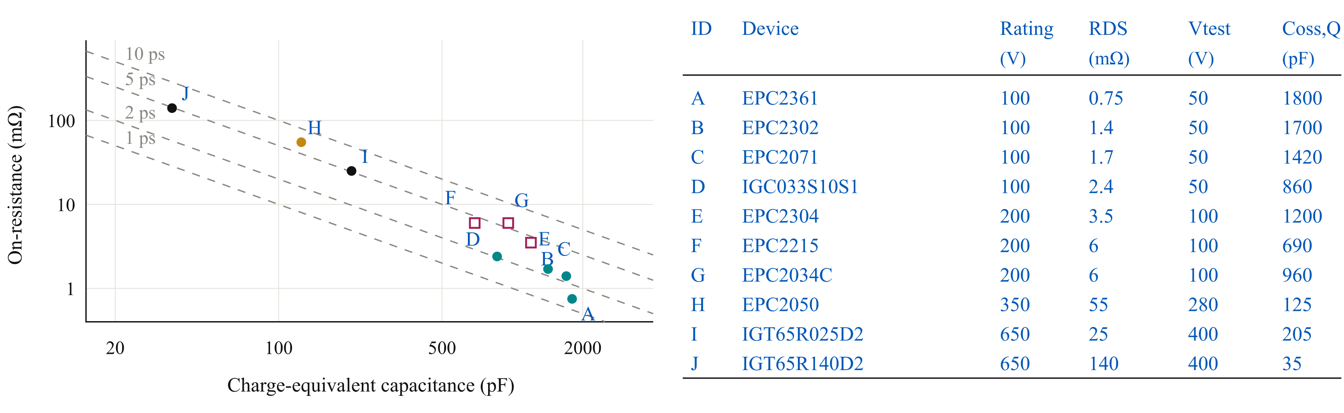
Fig. 2. Device screening basis and quoted capacitance test voltages. Dashed contours denote constant RDS(on) Coss,Q; device IDs link the plot to the data.

C. Initial Submodule Voltage
For equal voltage partitioning, the nominal submodule voltage is
$V_{m} = \frac{V_{dc}}{N}$ (3)
The 100-V candidate starts at Vm = 75 V and N = 16. The 90-V peak target reserves 15 V above nominal and 10 V below the device rating. Layout and switching assessment must establish these allowances. Inadequate margin requires a lower Vm and higher N. Bypassing one of sixteen submodules at unchanged total voltage would raise the remaining local buses to 80 V, requiring a separate fault-operation assessment.

III. SINGLE-CELL CHARACTERIZATION AND PARALLEL COUNT

A. Single-Cell Switching Characterization
The manufacturer’s EPC2361 model [10] is assessed at 27 °C and 75 V with one device per switch and positive inductive-load current. Gate/power-loop combinations are 10/20 nH and 0.5/1 nH, respectively. Gate commands are −1/5 V; external turn-on/off and driver pull-up/down resistances are 3/1 Ω and 0.85/0.35 Ω. Common-source inductance is 0.03 nH and the maximum time step is 0.5 ns. Gate-loop values are assumed bounds, not extracted measurements.
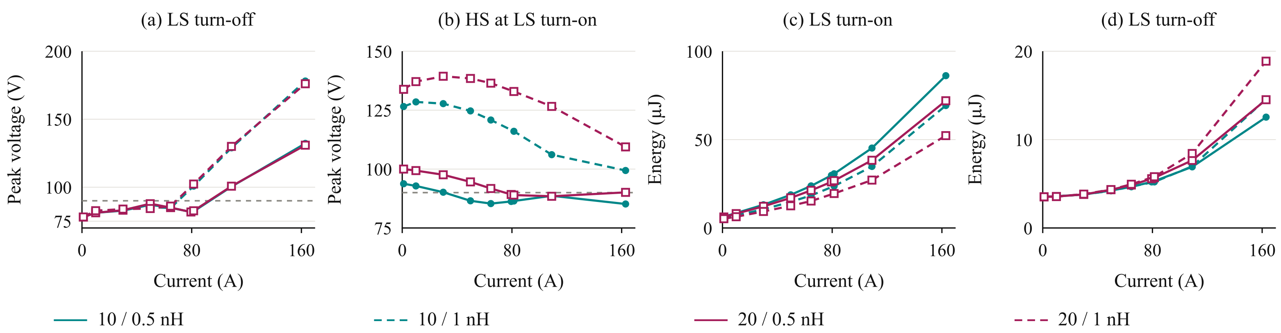
Fig. 3. Single-cell voltage peaks and low-side switching energies at 75 V. Legend: gate/power-loop inductance. LS/HS denote low/high side; the 90-V target is shown in (a) and (b).
Fig. 3 separates low-side turn-off stress from high-side stress during low-side turn-on. Voltage peaks cover the complete 1-µs off interval and the following 0.5-µs on interval. Signed terminal-energy integrals use 150 ns for turn-on and the complete off interval, ending 1 ns before turn-on, for turn-off. The longer window captures slow output-capacitance charging at low current. The compact path passes the 90-V screen near 80 A per device, but high-side stress can exceed the target at lower current. Thus, peak-current compliance alone is insufficient. Increasing gate resistance can reduce overshoot at the cost of switching energy.

B. Loss and Thermal Assessment
For n parallel devices and ideal current sharing, the peak current per device is
$I_{dev,pk} = \frac{I_{ph,pk}}{n}$ (4)
Fig. 4 uses the energy maps averaged over a sinusoidal phase-current magnitude for a first-pass loss estimate at 50 kHz. Conduction uses 0.75 mΩ at 25 °C with the datasheet temperature factor; the model also includes 10-ns dead time, gate charge of 28 nC, a 6-V gate swing, and a provisional 2.9-µJ capacitive freewheeling term per device per cycle. Cooling is assumed to provide 0.65 K/W from the shared phase-leg sink to ambient and 7.62 K/W from each junction to the sink, including a provisional interface/spreader contribution. These assumed resistances are not validated thermal measurements.
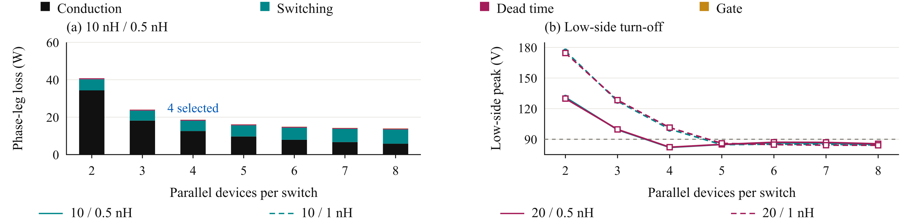
Fig. 4. First-pass (a) phase-leg loss and (b) low-side turn-off peak at the peak current per device. Legend in (b): gate/power-loop inductance. Grey line: 90 V.

C. Selection of Four Parallel Devices
At 10 nH/0.5 nH, four devices give an estimated 18.6-W phase-leg loss and 70 °C junction temperature at 40 °C ambient under the assumed cooling model. Two devices exceed the 125 °C limit (approximately 144 °C), while three exceed the peak-current voltage screen (approximately 99 V). Four is therefore the smallest count passing this preliminary screen, not the minimum-loss count or proof of full-cycle feasibility. The routed-network assessment must resolve the remaining current-range constraint.

IV. GATE-DRIVE CONFIGURATION AND CELL ARRANGEMENT

A. Current-Sharing Sensitivity
The two-device comparison in Fig. 5 uses 75 V, 120 A nominal total current, 0/5-V commands, 3-Ω gate resistors, and nominal 10-nH gate loops. Imbalance is defined as 100|Ipk,1 − Ipk,2|/(Ipk,1 + Ipk,2), using each branch’s turn-on maximum. A 0.1-nH power-path mismatch gives 2%; 10/15-nH gate loops give 17%; and a 0.05-nH source mismatch without Kelvin returns gives 9%. These are responses to different perturbations, not a universal ranking of sensitivities.
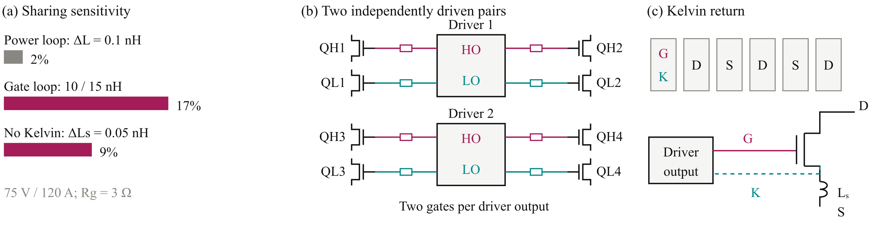
Fig. 5. (a) Recomputed peak-current imbalance. (b) Paired gate drive. (c) Gate and Kelvin-source connections. HO/LO denote high-/low-side driver outputs. S denotes the power-source terminal, K the Kelvin-source return, and Lₛ the power-source inductance.

B. Paired Gate Drive and Kelvin Returns
Four devices per switch position are arranged as two symmetric pairs. Each 2EDF7275K dual-channel driver [11] drives two high-side devices and two low-side devices, with an individual gate resistor per device. Two drivers serve the phase leg. Dedicated Kelvin returns separate gate and power-current paths; matched gate impedances and symmetric copper paths limit transient inequality. Present simulations assume synchronous driver commands; timing skew and physical realization of the negative gate bias remain validation items.

V. LOW-VOLTAGE GaN UTILIZATION IN THE ROUTED PROTOTYPE

A. Layout and Parasitic Extraction
The initial voltage and parallel count are checked using the routed prototype phase leg. Fig. 6 connects KiCad placement and routing, Ansys Q3D extraction, and LTspice assessment. Drain stress, gate disturbance, and branch currents guide layout and drive changes; insufficient margin feeds back into the submodule voltage rather than being hidden by the nominal device rating.
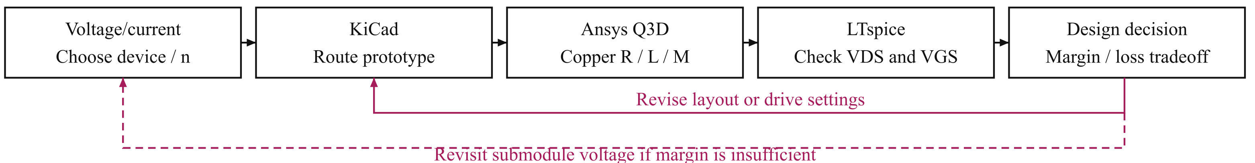
Fig. 6. Design feedback from routed switching margins to the SPB voltage partition.
Fig. 7 shows the printed circuit board (PCB) as a computer-aided design (CAD) rendering and the extracted conductor geometry.
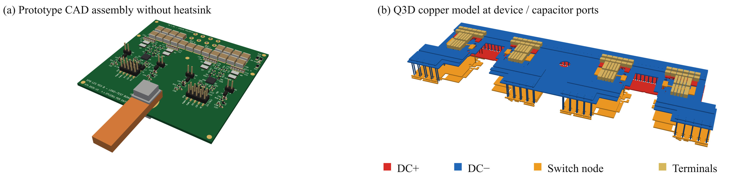
Fig. 7. (a) Prototype CAD rendering without heatsink. (b) Q3D copper model; colours identify rails, switch node, and terminals.
The extracted power network contains 29 branches and 406 mutual-inductance terms, using dc resistance and partial inductances at 100 MHz. The approximately 0.41-nH local loop comprises 0.347 nH of copper and 0.062 nH of capacitor equivalent series inductance (ESL) under equal branch excitation at the device/capacitor ports. This scalar covers the PCB/capacitor contribution; device-package and gate-path inductances were not separately extracted. Switching simulations retain the coupled network, not only this scalar value. Gate-loop bounds remain 10/20 nH, split 70% in the forward path and 30% in the return.

B. Prototype Switching Assessment
A controlled-current commutation model evaluates the same eight-device power network at 1, 40, 80, 160, 240, and 322.1 A total positive current. The current source approximates a large load inductance during the transition. At approximately 316 A, its peak voltage and summed switching energy agree within 2% with the inductive-load case. Unless stated otherwise, Vm = 75 V and model temperature is 27 °C; all settings use a 5-V on command, 1-Ω turn-off resistance, and 0.85/0.35-Ω driver pull-up/down resistance. The maximum time step is 0.2 ns. Table II compares the drive settings on this common basis.
TABLE II. MATCHED DRIVE COMPARISON AT 322.1 A AND 75 V
Setting | Lg / Rgon / Voff | VDS,pk | VGS,off,pk | Eon / Eoff
A | 20 nH / 2 Ω / 0 V | 97.2 V | 1.43 V | 25.6 / 7.3 µJ
B | 20 nH / 3 Ω / 0 V | 90.1 V | 1.42 V | 30.9 / 7.3 µJ
C | 20 nH / 3 Ω / −1 V | 90.7 V | 0.45 V | 30.5 / 6.2 µJ
D | 10 nH / 3 Ω / −1 V | 88.8 V | 0.43 V | 32.9 / 5.8 µJ
VDS,pk is the largest device peak across both assessed transitions; VGS,off,pk is the largest held-off high-side gate peak. Energies are mean low-side per-device terminal integrals, not total phase-leg losses.
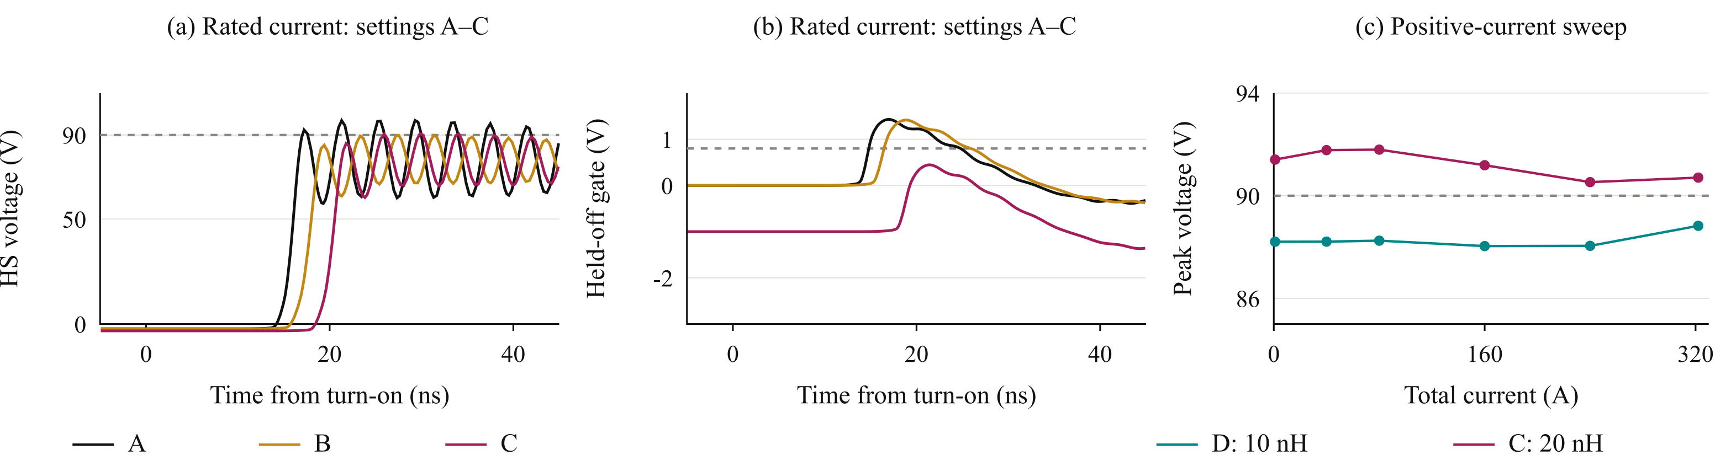
Fig. 8. (a), (b) High-side drain and held-off gate waveforms for settings A–C at rated current. (c) Maximum device drain stress over both transitions for C and D. References: 90 V and 0.8 V.

C. Switching Margins and Feedback to Voltage Partitioning
Table II shows that increasing turn-on resistance reduces rated-current drain stress at an energy cost. Negative off-state bias suppresses the held-off gate disturbance but does not independently recover the drain margin. Setting D reduces the rated-current peak to 88.8 V, with a mean low-side 90%–10% voltage fall time of 5.9 ns and a 38.7-µJ sum of turn-on/off energies. Its simulated positive branch-current peak spread is 1.15%, using (Ipk,max − Ipk,min)/(Ipk,max + Ipk,min). These values quantify the switching-speed/energy tradeoff rather than establish a global optimum.
For setting D, sampled nominal-current points remain between 88.0 and 88.8 V, whereas setting C reaches 91.8 V near 80 A total current (Fig. 8(c)). The low-current high-side transient therefore remains relevant even when the rated-current result is close to target. The 0.8-V reference is the minimum static threshold at 25 °C [10], not an absolute gate-voltage rating or proof against dynamic turn-on. The revised cases reach approximately −2.4 V minimum gate voltage, within the stated −4/+6-V ratings, but driver compatibility and dynamic behavior require measurement.
At rated current, raising the local bus by 5% to 78.75 V increases setting D’s drain peak to 92.2 V at 27 °C, exceeding the design target. Forced 125 °C device-model cases give 84.6 V at 75 V and 88.4 V at 78.75 V; the extracted copper network is held fixed. Thus, the nominal sixteen-submodule result does not demonstrate the proposed voltage-variation allowance. An illustrative seventeen-submodule allocation gives 74.12 V per module at +5% total bus and 88.1/83.8-V rated-current peaks at 27/125 °C. This is an electrical headroom comparison, not validation of a seventeen-winding machine or its full current range. It demonstrates the architectural consequence of unresolved switching margin: either the network/drive must improve or the voltage partition must change.

VI. EXPERIMENTAL VALIDATION AND FULL-PAPER SCOPE
One building block will be tested at controlled bus voltage, current, and temperature. Drain and Kelvin-referenced gate transients, individual branch currents, and deskewed switching-energy measurements will be compared with predictions. The planned voltage acquisition bandwidth is at least 500 MHz; current-sensor bandwidth, probe loading, and timing uncertainty will be reported. Negative-bias implementation and driver compatibility will be verified before operation. Because of the digest page limit, the detailed experimental procedure and resulting comparisons are reserved for the full paper; no experimental result is claimed here. Regenerative current, inter-driver skew, parasitic tolerances, insulation, and temperature-dependent dynamic losses remain outside the present simulation evidence.

VII. CONCLUSION
The study links low-voltage GaN selection to the switching margins of an SPB phase leg. A four-device candidate and a 0.41-nH local loop do not by themselves establish feasibility. The routed model identifies a 10-nH gate-loop candidate meeting the sampled nominal 90-V target, but its +5% bus case requires further design change or voltage repartitioning. This quantified feedback, rather than device figure of merit alone, governs the proposed low-voltage GaN utilization.

ACKNOWLEDGMENT
OpenAI Codex assisted with drafting and language editing throughout this manuscript, preparation of Figs. 1–8 from project data, and scripting for LTspice runs and result processing in Sections III–V. The authors retain responsibility for the technical content and its verification.

REFERENCES
[1] J. Schneider et al., “The novel megawatt charging system standard: Impact on battery size and cell requirements for battery-electric long-haul trucks,” eTransportation, vol. 17, Art. no. 100253, Jul. 2023.
[2] S. Norrga et al., “A novel inverter topology for compact EV and HEV drive systems,” in Proc. IECON, 2013, pp. 6590–6595.
[3] L. Jin et al., “Modulation and power losses of a stacked polyphase bridge converter,” IEEE J. Emerg. Sel. Topics Power Electron., vol. 5, no. 1, pp. 409–418, Mar. 2017.
[4] J. Azurza Anderson et al., “New figure-of-merit combining semiconductor and multi-level converter properties,” IEEE Open J. Power Electron., vol. 1, pp. 322–338, 2020, doi: 10.1109/OJPEL.2020.3018220.
[5] M. Nikouie et al., “DC-link stability analysis and controller design for the stacked polyphase bridges converter,” IEEE Trans. Power Electron., vol. 32, no. 2, pp. 1666–1674, Feb. 2017.
[6] G. Rohner et al., “Comparative evaluation of three-phase three-level flying capacitor and stacked polyphase bridge GaN inverter systems for integrated motor drives,” Electronics, vol. 13, Art. no. 1259, 2024.
[7] J. A. Brothers et al., “GaN module design recommendations based on the analysis of a commercial 3-phase GaN module,” in Proc. IEEE ECCE, 2019, pp. 4109–4116.
[8] J. L. Lu and D. Chen, “Paralleling GaN E-HEMTs in 10kW–100kW systems,” in Proc. IEEE APEC, 2017, pp. 3049–3056.
[9] M. Tuan Tran et al., “A high-performance GaN power module with parallel packaging for high-current and low-voltage traction inverter applications,” IEEE J. Emerg. Sel. Topics Power Electron., vol. 13, no. 1, pp. 1188–1209, Feb. 2025.
[10] Efficient Power Conversion, “EPC2361 eGaN FET datasheet,” Jul. 20, 2026.
[11] Infineon Technologies, “2EDF7275K data sheet,” rev. 2.8, Aug. 8, 2022.

