Topic 17 — Power Electronics for Transportation Electrification

Parasitic Aware Building Block Design for Stacked Polyphase Bridge Traction Inverters
Abstract—The stacked polyphase bridge (SPB) introduces a voltage-partitioning degree of freedom into high-voltage traction inverters: the number of series-connected submodules determines the semiconductor voltage class, while the phase-current requirement remains high. This paper presents a hardware-constrained design procedure for an SPB phase-leg building block. A charge-based device figure of merit identifies the 100 V EPC2361 as the preferred candidate among the surveyed devices. Single-cell pre-simulations use gate-loop inductances of 10 nH and 20 nH and commutation-loop inductances of 0.5 nH and 1 nH. A peak-current voltage screen and electrothermal comparison identify four parallel transistors per switch position as an initial candidate for sixteen submodules. Current-sharing sensitivity motivates symmetric transistor pairs and dedicated Kelvin returns. An iterative KiCad–Ansys Q3D–LTspice workflow replaces the assumed paths with routed networks. The extracted double-pulse test (DPT) network requires a joint assessment of resistance, gate disturbance, and switching energy. Low-current resonance and the remaining gap to the 90 V drain-voltage target require further drive refinement. The contribution is to connect SPB cell/voltage selection to the physical switching constraints governing low-voltage devices at traction-current levels.
Index Terms—Gallium nitride, gate drive, parallel transistors, parasitic inductance, stacked polyphase bridge, traction inverter.

I. Introduction
Electrification is driving traction and fast-charging power levels toward several hundred kilowatts, while demands for efficiency and power density continue to increase. Raising the dc-link voltage is a key design choice for meeting these requirements; however, in a conventional two-level traction inverter, each switch must block the full dc-link voltage and conduct the phase current, making semiconductor losses a central design constraint.
The stacked polyphase bridge (SPB) introduces an additional design degree of freedom by connecting three-phase bridges in series on the dc side, with each bridge feeding an isolated winding set of a multiphase machine [1], [2]. Fig. 1 illustrates the SPB topology and the phase-leg building block considered in this work. Distributing the dc-link voltage among submodules allows each bridge to use a lower semiconductor voltage class and apply smaller voltage steps to its winding set. Voltage partitioning therefore becomes an active design choice that links the converter architecture to device selection.
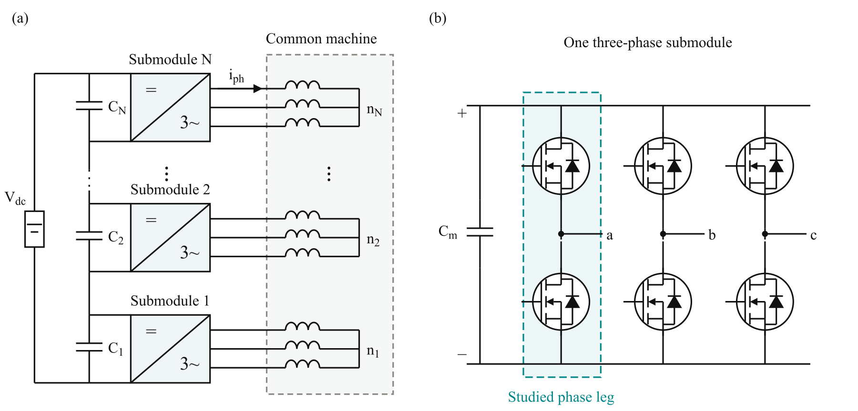
Fig. 1. (a) SPB traction-drive topology with N series-connected submodules, each supplying an isolated three-phase winding set of a common machine. (b) Three-phase submodule with the studied phase leg highlighted. Each switch symbol represents four parallel GaN transistors; the diode denotes the equivalent reverse-conduction path.
The benefit of voltage partitioning depends on realizing a practical high-current submodule. Increasing the number of submodules reduces the voltage across each bridge but does not reduce the phase current for a given total drive power and dc-link voltage. Low-voltage gallium nitride (GaN) devices can offer favorable on-state resistance and switching performance, but meeting the traction-current requirement may require several devices in parallel. Current sharing, gate-drive impedance, and commutation-loop parasitics then determine how much of the expected loss benefit can be retained. Increasing the submodule count also increases the number of gate-drive circuits, auxiliary supplies, and interconnections throughout the converter.
Previous studies establish SPB modulation and loss characteristics [2], dc-link stability [3], and comparisons with alternative GaN converter systems [4]. These studies provide the system-level basis for selecting a submodule voltage. Research on paralleled GaN stages identifies complementary implementation constraints, including commutation-loop inductance, common-source coupling, and unequal gate impedances [5]–[7]. Together, these findings motivate a design procedure that considers voltage partitioning and high-current hardware implementation jointly.
The central challenge is the feedback between the selected submodule voltage and the physical building block. A lower device voltage class may offer favorable loss characteristics, but the available voltage margin must accommodate switching overshoot at the required current. Excessive commutation-loop inductance can require slower switching or a lower submodule operating voltage, potentially changing the initial loss comparison or the required submodule count. Gate-loop impedance and symmetry further constrain switching speed by affecting gate-voltage disturbances and dynamic current sharing. The practical benefits of SPB voltage partitioning therefore depend on optimizing the power and gate networks together.
This paper presents a hardware-constrained design procedure for an SPB phase-leg building block. Single-cell switching simulations establish an initial current range using representative gate-loop and commutation-loop inductances. Losses, junction temperature, and the voltage stress of both switches then determine the parallel-count candidate. Current-sharing sensitivity guides the symmetric cell arrangement and paired gate drive. An iterative layout, parasitic extraction, and circuit-simulation workflow evaluates whether the assumed switching conditions can be maintained in the routed building block. Separate operating and double-pulse test (DPT) boards distinguish the intended converter layout from measurement-related parasitics. The contribution is to connect SPB voltage partitioning and device selection to the physical constraints governing high-current implementation.

II. Traction Requirements and Initial Device Selection

A. Traction Drive Requirements
The building block is designed for the traction operating point and constraints summarized in Table I. For balanced operation with equal submodule voltages, the total active power is expressed as
$P = \frac{3 M V_{dc} I_{ph,rms} cos φ}{2\sqrt{2}}$ (1)
Here, V_{dc} is the total dc-link voltage, I_{ph,rms} is the rms phase current, and cosφ is the power factor. The modulation index M is defined such that the fundamental phase-to-neutral voltage peak of each submodule is M V_{m}/2. The specified operating point requires approximately 228 A rms and 322 A peak phase current.
TABLE I DESIGN OPERATING POINT AND PRELIMINARY CONSTRAINTS
Quantity | Symbol | Value
Total active power | P | 300 kW
Total dc-link voltage | V_{dc} | 1200 V
Modulation index | M | 1.15
Power factor | cosφ | 0.9
Phase current | I_{ph} | 228 A rms
Switching frequency | f_{sw} | 50 kHz
Candidate submodule count | N | 16
Nominal submodule voltage | V_{m} | 75 V
Peak drain–source voltage target | V_{DS,pk} | 90 V
Junction-temperature limit | T_{j,max} | 125 °C
Ambient temperature | T_{a} | 40 °C
The submodule count does not appear explicitly in (1).
The full paper will expand the relationship between voltage partitioning, winding-set voltage, and the phase-current requirement.

B. Semiconductor Voltage Class Comparison
Voltage partitioning allows the semiconductor voltage class to be selected together with the submodule count. This choice requires a comparison of conduction and switching characteristics rather than on-state resistance alone. Fig. 2 compares the typical on-state resistance R_{DS(on)} at 25 °C and the charge-equivalent output capacitance C_{oss,Q} of the surveyed GaN devices.
Following the charge-based screening criterion in [8], the device figure of merit is defined as
$D-FOM = \frac{1}{\sqrt{R_{DS(on)} C_{oss,Q}}}$ (2)
A higher D-FOM indicates a more favorable combination of conduction resistance and output charge. In the simplified hard-switching model underlying this criterion, optimizing semiconductor area gives minimum losses proportional to the square root of the resistance–capacitance product. Fig. 2 therefore uses constant-product contours, with lower τ = R_{DS(on)} C_{oss,Q} corresponding to higher D-FOM.
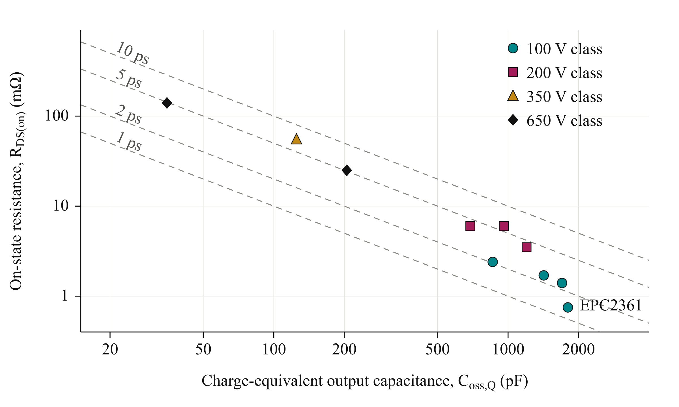
Fig. 2. Typical on-state resistance at 25 °C versus charge-equivalent output capacitance of the surveyed GaN devices, distinguished by voltage class.
The full paper will document the device-data comparison underlying the EPC2361 selection, including charge-equivalent capacitance, datasheet test conditions, and the limits of the screening criterion.

C. Initial Submodule Voltage
For equal voltage partitioning, the nominal submodule voltage is
$V_{m} = \frac{V_{dc}}{N}$ (3)
The candidate arrangement in Table I permits 100 V devices to be considered. The available margin must accommodate submodule-voltage variation and switching overshoot. The peak drain–source voltage target leaves a 15 V allowance above the nominal submodule voltage and a further margin below the device rating. The candidate operating point is therefore assessed through switching simulations and parasitic extraction rather than accepted from the nominal rating alone.

III. Single Cell Characterization and Selection of the Parallel Count

A. Single Cell Switching Characterization
The selected EPC2361 is evaluated in a half-bridge model with one device per switch position. Double-pulse simulations are performed at a submodule voltage of 75 V over a device-current sweep. Gate-loop inductances of 10 nH and 20 nH represent the preliminary range of interest. Commutation-loop inductances of 0.5 nH and 1 nH separately represent a compact power path and a higher-inductance sensitivity case.
The full paper will specify the gate-drive model and the complete simulation parameters used for these switching sweeps.
Fig. 3 compares the voltage-stress and turn-on-energy results for the four combinations of power- and gate-loop inductance. Voltage stress is evaluated as the larger of the low-side drain-voltage peak at turn-off and the high-side peak during low-side turn-on. This avoids selecting the device current from only one switching transition. With the compact commutation path, operation near 80 A per device satisfies the drain-voltage target for both gate-loop cases. The larger power-loop case exceeds the target and cannot be accepted solely by increasing the parallel count.
The single-cell results establish approximately 80 A as a preliminary current scale for the compact-loop case, rather than an absolute device-current limit. Dividing the required phase-current peak by this value suggests four parallel transistors per switch position. Neighboring counts are compared on the same drive and thermal basis. This is a peak-current screen: Fig. 3 also shows resonant overshoot at low current, so compliance over the full sinusoidal current range still requires drive refinement. Held-off gate disturbance is checked separately against the minimum threshold; a passing drain-voltage result alone does not establish gate-drive margin.
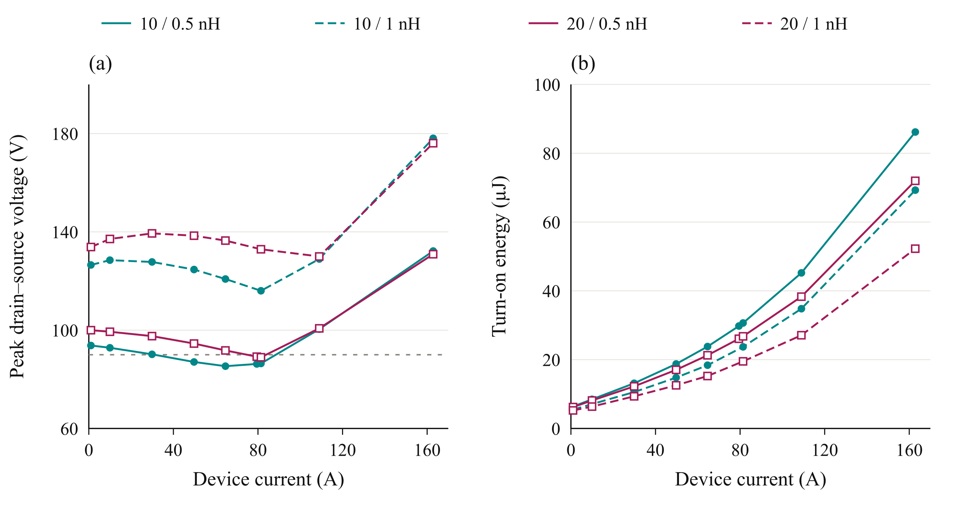
Fig. 3. Simulated single-cell characteristics at 75 V: (a) the larger drain–source voltage peak across the two evaluated switching transitions and (b) turn-on energy. Legend entries give gate-loop / commutation-loop inductance.

B. Loss and Thermal Assessment
For n parallel transistors and ideal current sharing, the peak current per device is
$I_{dev,pk} = \frac{I_{ph,pk}}{n}$ (4)
The single-cell switching-energy maps are evaluated over the sinusoidal phase-current waveform to estimate average switching losses.
The full paper will detail the switching-energy integration and electrothermal model, including cooling assumptions and temperature-dependent conduction losses.
Fig. 4(a) shows the loss distribution for the nominal gate-loop case and compact commutation path. Additional parallel devices reduce conduction loss, while switching charge, gate loading, and layout complexity limit the benefit of further paralleling. The corresponding voltage-stress comparison in Fig. 4(b) shows that overshoot is not necessarily monotonic with parallel count. Gate-network dynamics therefore have to be checked alongside the reduction in current per device.
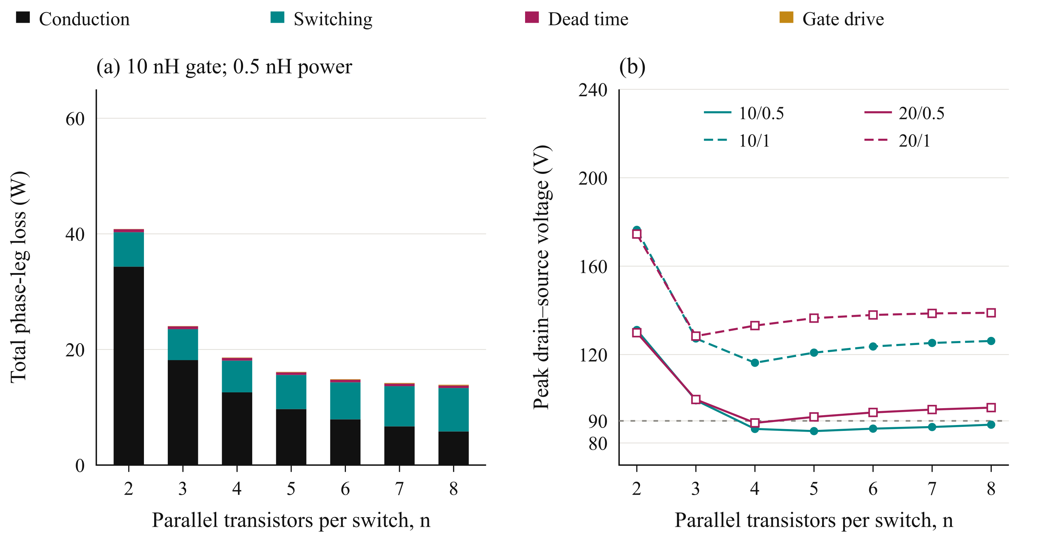
Fig. 4. Parallel-count comparison at 75 V, 228 A rms phase current, and 50 kHz: (a) phase-leg loss distribution for a 10 nH gate loop and 0.5 nH commutation loop; (b) the larger drain-voltage peak across the two switching transitions at the required phase-current peak.

C. Selection of Four Parallel Devices
The full paper will present the detailed loss, temperature, and voltage-stress comparison supporting the four-device candidate, together with its sensitivity to gate drive and commutation-loop inductance.

IV. Gate Drive Configuration and Cell Arrangement

A. Current Sharing Sensitivity
The preliminary parallel-count selection assumes equal current sharing among the four transistors in each switch position. Maintaining this condition during switching requires control of the gate and power-path impedances. Differences in gate-loop inductance, common-source inductance, and driver timing can produce unequal transient currents and switching energies, even when the devices have similar on-state resistance. Fig. 5(a) summarizes sensitivity simulations for two parallel devices at 75 V and 120 A total current. A power-loop inductance mismatch of 0.3 nH produces approximately 2% switching-energy imbalance in the evaluated case. A gate-loop inductance difference of 2 nH versus 8 nH increases the imbalance to approximately 19%. Without a Kelvin-source return, a common-source inductance mismatch of 0.2 nH produces approximately 29% imbalance.
The full paper will detail the current-sharing perturbation cases and their relationship to the routed gate network.
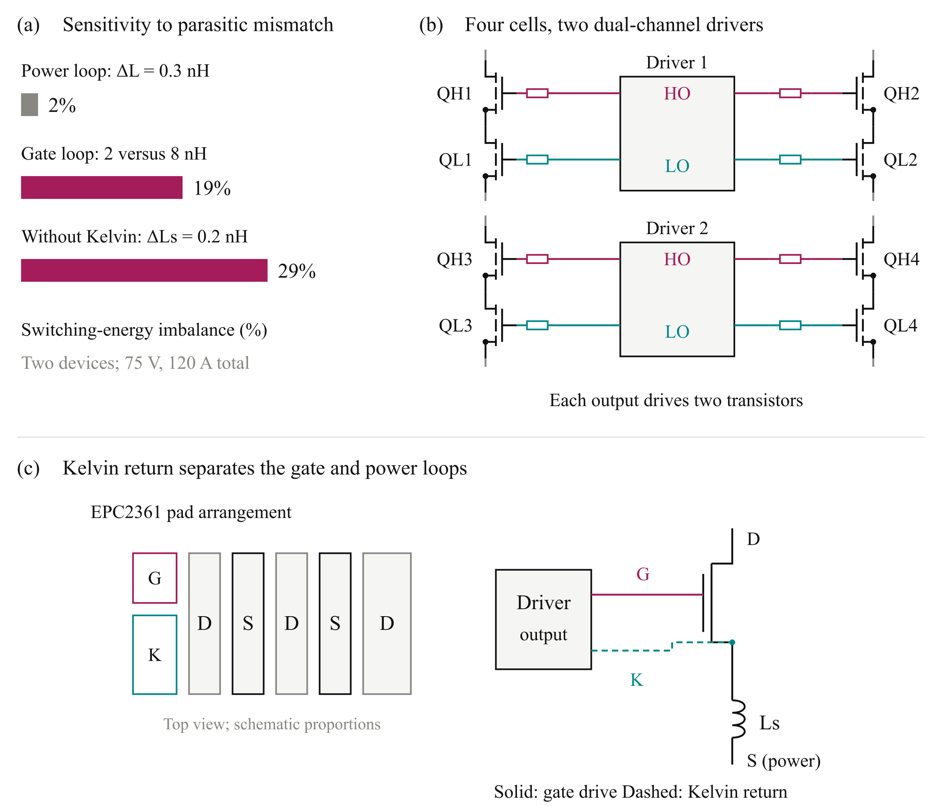
Fig. 5. Gate-drive design considerations: (a) simulated switching-energy imbalance under the investigated parasitic mismatches; (b) four switching cells grouped into two pairs, each served by a dual-channel driver with individual gate resistors; and (c) schematic EPC2361 pad arrangement and Kelvin-source connection, illustrating separation of the gate return from the power-source inductance. Driver supply and return connections are omitted in (b) for clarity. High-side (HS) and low-side (LS) outputs are denoted HO and LO.

B. Paired Gate Drive Configuration
Connecting all four transistors to one gate-driver output increases the total gate charge and the current required to establish the intended switching transition. The turn-off path must also sink the displacement current coupled through the gate–drain capacitance during drain-voltage transients. Excessive impedance in this path can cause a positive gate-voltage disturbance and reduce the margin against unintended turn-on.
The four-device arrangement is therefore divided into two transistor pairs per switch position. As illustrated in Fig. 5(b), each pair of switching cells is served by one dual-channel 2EDF7275K driver IC. One channel drives the two high-side transistors, while the other drives the two low-side transistors. The complete phase leg consequently uses two driver ICs, with two transistor gates connected to each output channel through individual gate resistors.
The full paper will assess gate-driver loading, sink-current requirements, and the resulting gate-voltage margins.

C. Kelvin Source Connection and Cell Layout
The full paper will detail the symmetric cell layout, individual gate resistors, and Kelvin-source returns illustrated in Fig. 5(c). It will explain the matching of the power and gate paths within each transistor pair.

D. Verification of the Physical Arrangement
The full paper will assess inter-driver timing and current sharing using the routed networks. Extracted parasitics will be used to revisit the initial current and switching-margin assumptions.

V. Closing the Design Loop with the Routed Building Block

A. Layout and Parasitic Extraction
Initial sizing establishes a candidate voltage and parallel count using the two gate-loop and two commutation-loop cases. The routed building block must then be assessed to determine whether the associated voltage and gate-drive margins can be retained. Fig. 6 connects the KiCad layout, Ansys Q3D parasitic extraction, and LTspice switching assessment. Its feedback is used to revise placement, routing, or drive settings when the complete network changes the switching response.
The power devices, local decoupling capacitors, and paired gate drivers are placed and routed in KiCad. The conductor geometry is evaluated in Ansys Q3D to obtain resistive and inductive networks, including mutual coupling between branches. These networks are incorporated into LTspice to assess voltage overshoot, gate disturbance, transient current sharing, and switching-energy distribution. Placement, routing, or drive settings are revised where necessary.
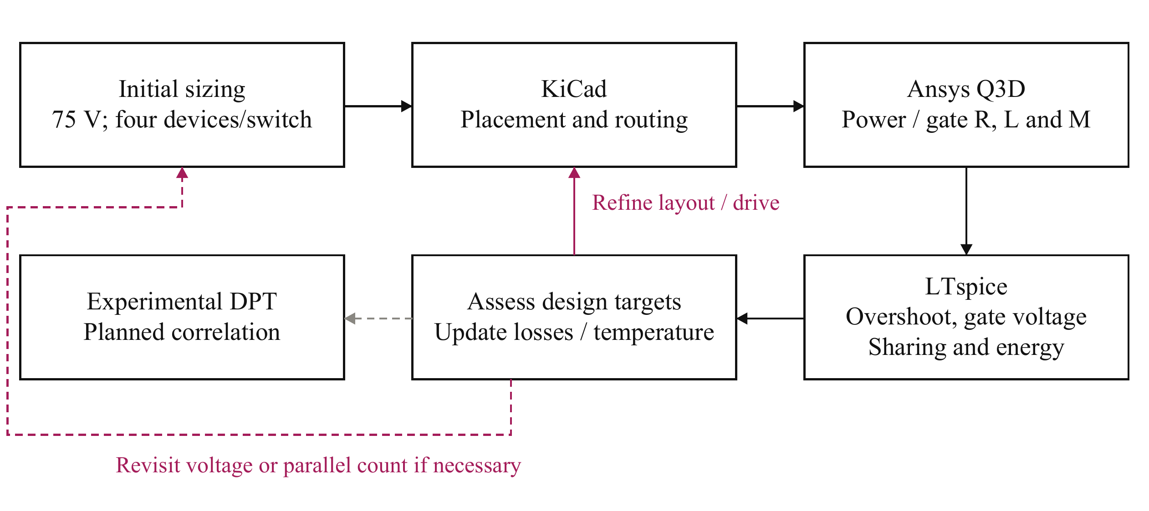
Fig. 6. Iterative design and verification workflow. Extracted power and gate networks connect the routed geometry to switching simulations. The results inform revisions to layout, drive settings, and, where necessary, voltage partition or parallel count. Experimental double-pulse test (DPT) correlation is planned.
Two board variants are considered: an operating board representing the intended converter building block and an instrumented DPT board. The latter includes current-measurement provisions that introduce additional commutation-path parasitics. Figs. 7(a) and 7(b) distinguish these implementations, preventing measurement-related inductance from being treated as an unavoidable feature of the operating converter.

B. Extracted Power and Gate Networks
Fig. 7(c) separates the commutation-loop contributions. The operating-board loop is approximately 0.41 nH per cell, supporting the feasibility of the compact-loop assumption used in preliminary sizing. The additional conductor length and shunt contribution increase the DPT loop to approximately 0.65 nH. The capacitor contribution is included through its equivalent series inductance (ESL).
The full paper will compare the lumped and extracted gate networks, including shared-path inductance and mutual coupling.
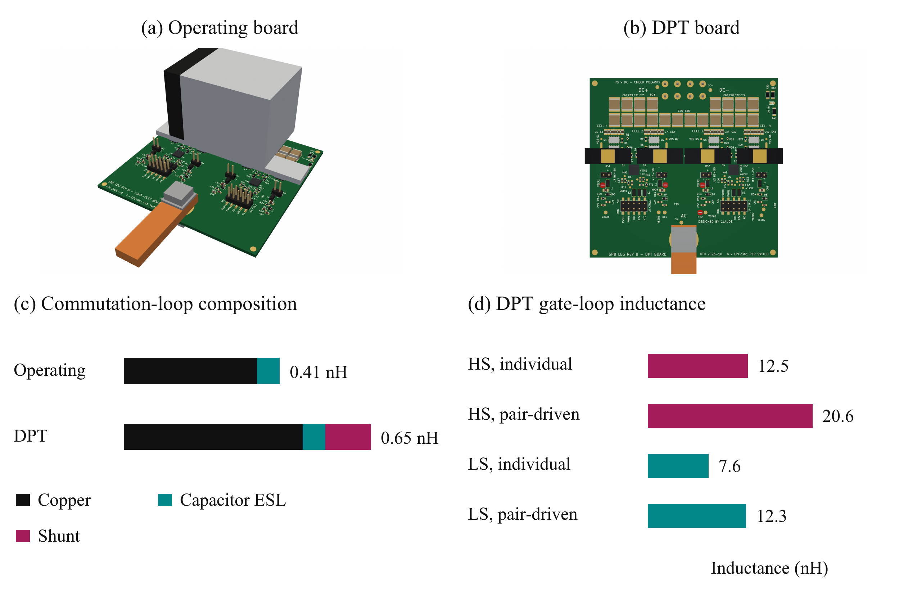
Fig. 7. Building-block variants and evaluated parasitics: (a) operating-board rendering; (b) instrumented DPT-board rendering; (c) commutation-loop inductance including conductor, capacitor ESL, and shunt contributions; and (d) individual and pair-driven DPT gate-loop inductances. Gate-network extraction in this study applies to the DPT board.
Fig. 8 shows the Q3D conductor models underlying the extraction. The operating-board view is compared with the DPT-board network, which includes the additional low-side source-to-shunt path. The cell-pair detail shows the overlapping conductors, interlayer connections, and device and capacitor terminals used to define the local power network. These are geometry views rather than field-distribution plots.
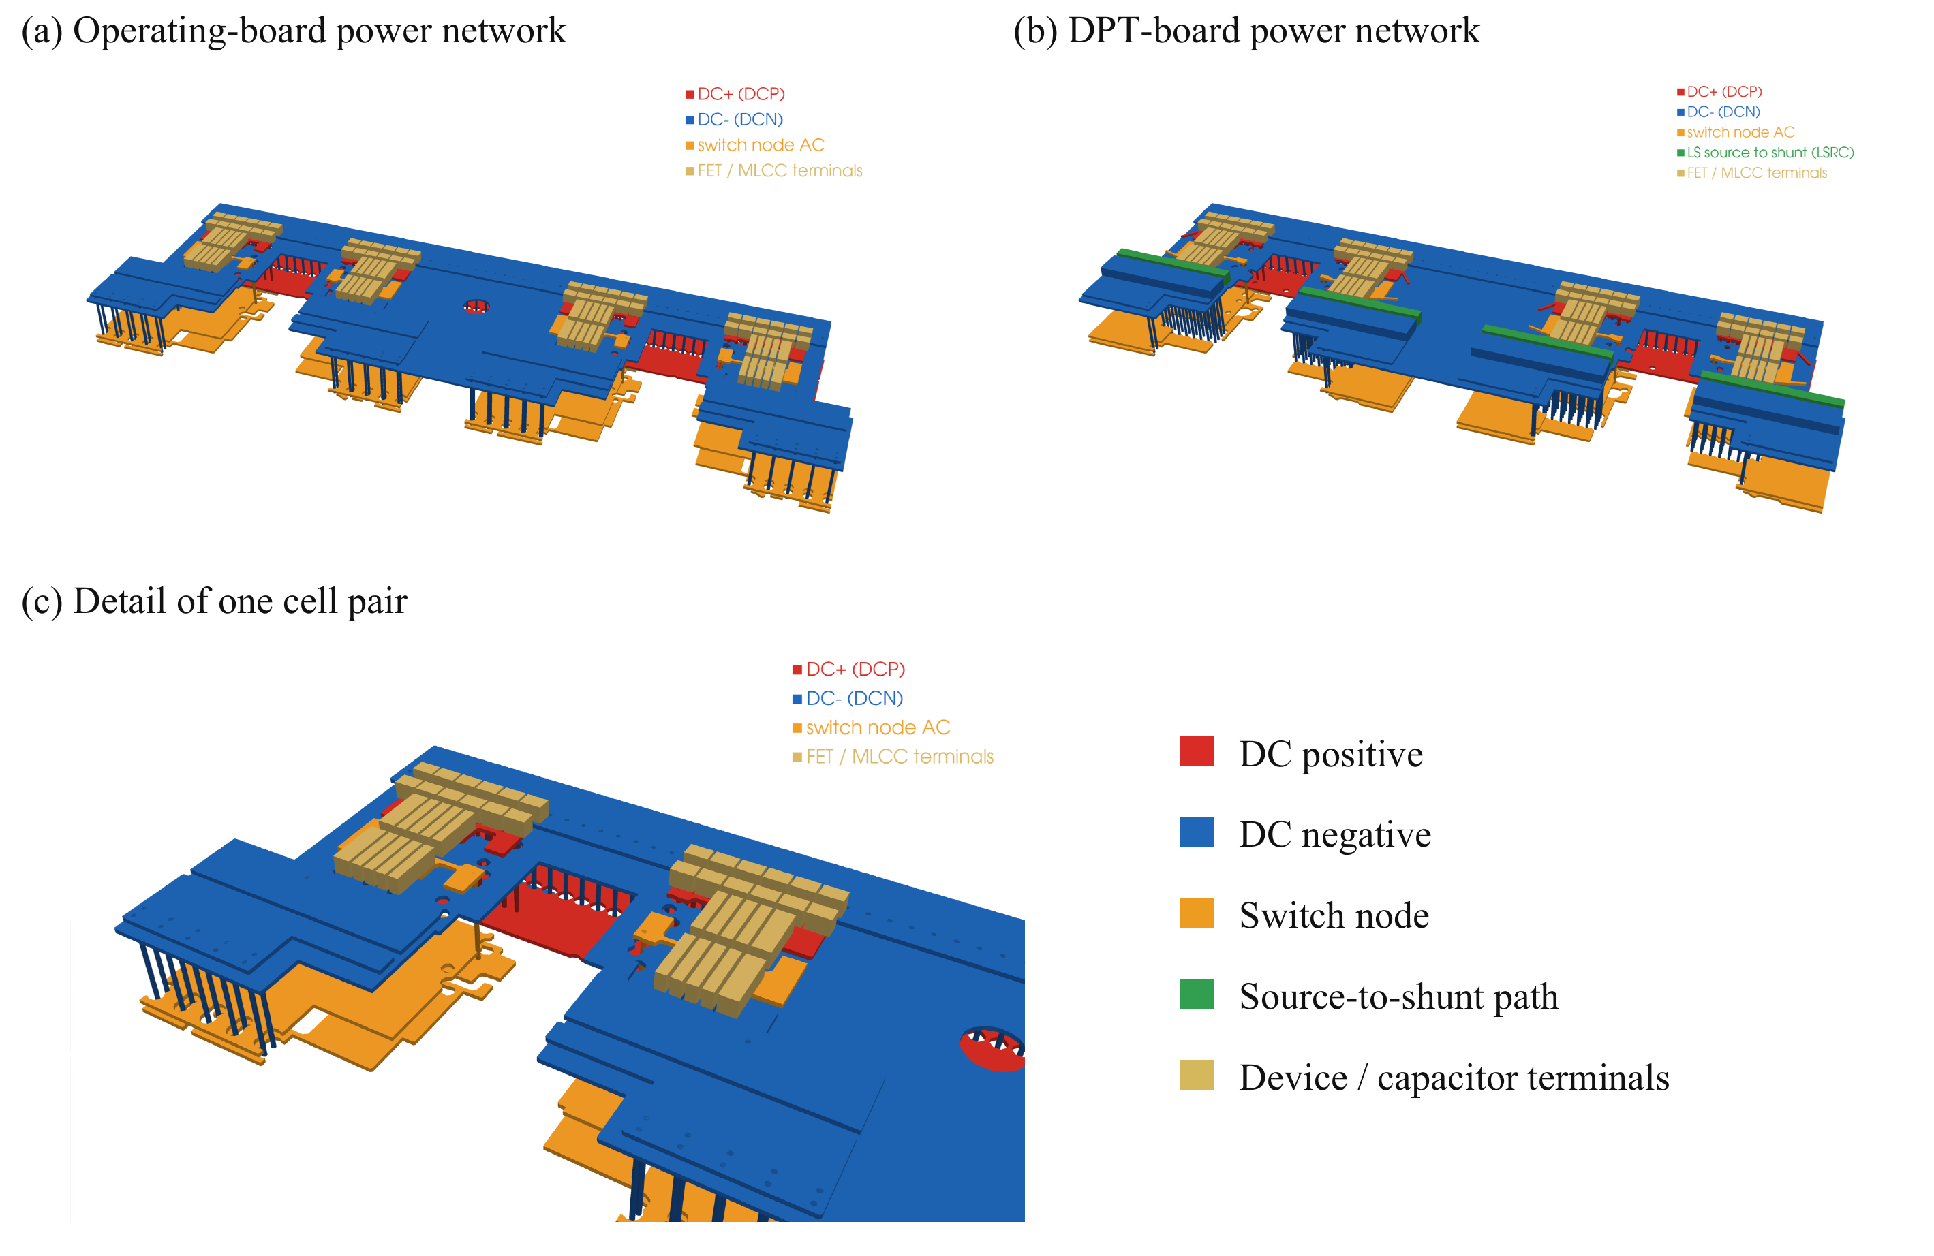
Fig. 8. Ansys Q3D conductor models used for parasitic extraction: (a) operating-board power network; (b) instrumented DPT-board power network, including the additional source-to-shunt conductors; and (c) detail of one cell pair showing the local conductor stack, interlayer connections, and device and capacitor terminals. Colors identify electrical nets and terminals, not field magnitude.

C. Switching Assessment and Design Feedback
The full paper will detail the simulation configurations underlying Table II, including the assumed operating-board gate paths and the extracted DPT gate network.
TABLE II SWITCHING SIMULATION COMPARISON NEAR 316 A
Board / gate model | R_{g,on} / R_{g,off} (Ω) | Off bias (V) | Peak V_{DS} (V) | Mean E_{on} per device (µJ) | Minimum V_{GS} (V)
Operating / 10 nH | 3 / 1 | -1 | 88 | 31.6 | -2.4
Operating / 20 nH | 3 / 1 | -1 | 90 | 29.4 | -2.5
Operating / 20 nH | 3 / 0 | 0 | 89 | 29.7 | -3.0
DPT / 10 nH | 3.5 / 0 | -1.9 | 91 | 32.5 | -4.8
DPT / 20 nH | 3.5 / 0 | -1.9 | 94 | 29.9 | -6.0
DPT / extracted | 2.5 / 0.5 | -1.9 | 105 | 24.3 | -3.5
DPT / extracted | 3.5 / 0.5 | -1.9 | 93 | 31.2 | -3.5
Table II reports the maximum high-side drain–source voltage across the four cells during low-side turn-on and the mean turn-on energy per transistor for that event. These event energies are not fundamental-period average losses. The revised operating-board drive uses the preliminary sizing settings; the zero-bias case shows the gate-disturbance problem. In the extracted DPT gate network, a shared turn-on resistor of 1 Ω or 1.5 Ω feeds two individual 0.5 Ω gate resistors. The listed turn-on values are the corresponding effective per-device resistances under equal pair currents; the individual resistors also remain in the turn-off path. The lumped DPT comparison uses zero external turn-off resistance. Extracted power paths are used in all cases; gate-network extraction applies only to the cases identified in the table.
The full paper will expand the voltage-stress and switching-energy tradeoff in Fig. 9 and assess gate-bias and resistance settings across the evaluated networks.
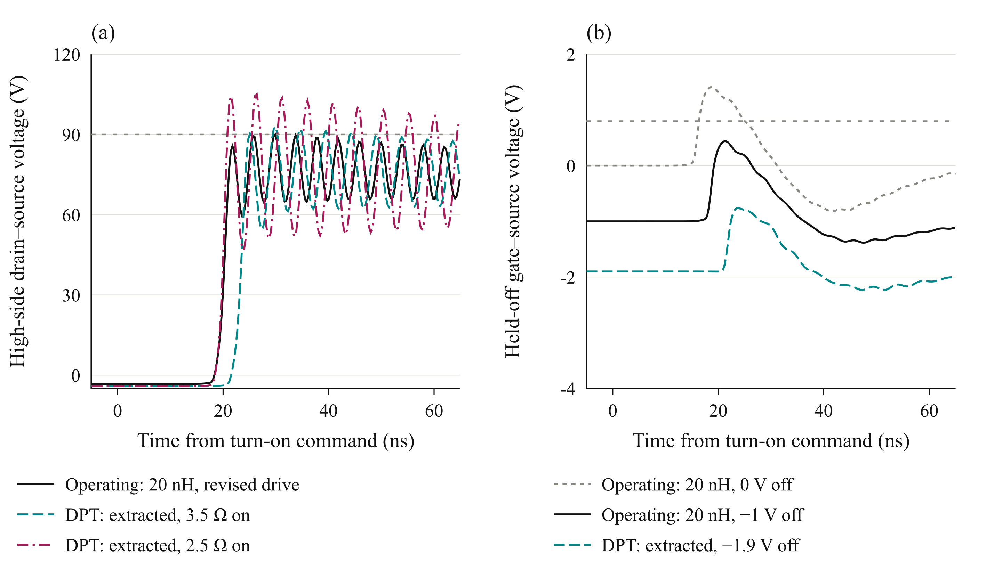
Fig. 9. Switching simulations at 75 V and approximately 316 A: (a) worst-cell high-side drain–source voltage during low-side turn-on and (b) cell-1 held-off high-side gate voltage. The revised operating-board drive uses a 20 nH lumped gate branch, 3 Ω turn-on resistance, 1 Ω turn-off resistance, and −1 V bias. Its zero-bias reference uses zero external turn-off resistance. DPT curves use the extracted gate network with individual 0.5 Ω gate resistors and −1.9 V bias; legend turn-on values are effective per-device resistances. Grey lines denote the 90 V drain-voltage target and the 0.8 V minimum gate threshold.
The extracted-network DPT case with the larger turn-on resistance has a maximum held-off gate excursion of approximately -0.5 V and a minimum gate voltage of approximately -3.5 V across the saved transitions and cells. Both positive and negative gate excursions must be checked against the device ratings of −4 V and +6 V [9]. These waveform checks remain conditional on the modeled network and do not replace experimental correlation.

D. Implications for the Building Block
The full paper will use the routed-network results to refine the shared gate paths and drive settings. The corresponding switching energies will update the loss and thermal assessment.

VI. Experimental Validation and Scope of the Full Paper

A. Planned Double Pulse Measurements
Experimental DPT measurements are planned for the full paper to validate the parasitic model and switching-loss estimates, including voltage overshoot, gate disturbance, and current sharing.

B. System Integration Boundary
The full paper will discuss integration constraints, including inter-driver timing, submodule balancing, auxiliary power, and insulation across the series stack.

VII. Conclusion
This digest links SPB voltage selection to the current-sharing and parasitic constraints of a high-current phase-leg building block. The full paper will refine the gate network and validate the resulting switching and loss estimates experimentally.

References
[1] S. Norrga et al., “A novel inverter topology for compact EV and HEV drive systems,” Proc. IECON, 2013, pp. 6590–6595.
[2] L. Jin et al., “Modulation and power losses of a stacked polyphase bridge converter,” IEEE J. Emerg. Sel. Topics Power Electron., vol. 5, no. 1, pp. 409–418, 2017.
[3] M. Nikouie et al., “DC-link stability analysis and controller design for the stacked polyphase bridges converter,” IEEE Trans. Power Electron., vol. 32, no. 2, pp. 1666–1674, 2017.
[4] G. Rohner et al., “Comparative evaluation of three-phase three-level flying capacitor and stacked polyphase bridge GaN inverter systems for integrated motor drives,” Electronics, vol. 13, Art. 1259, 2024.
[5] J. A. Brothers and T. Beechner, “GaN module design recommendations based on the analysis of a commercial 3-phase GaN module,” Proc. IEEE ECCE, 2019, pp. 4109–4116.
[6] J. Lu and D. Chen, “Paralleling GaN E-HEMTs in 10 kW–100 kW systems,” Proc. IEEE APEC, 2017, pp. 3049–3056.
[7] M. T. Tran et al., “A high-performance GaN power module with parallel packaging for high-current and low-voltage traction inverter applications,” IEEE J. Emerg. Sel. Topics Power Electron., vol. 13, no. 1, pp. 1188–1209, 2025.
[8] J. Azurza Anderson et al., “New figure-of-merit combining semiconductor and multi-level converter properties,” IEEE Open J. Power Electron., vol. 1, pp. 322–338, 2020, doi: 10.1109/OJPEL.2020.3018220.
[9] Efficient Power Conversion, “EPC2361 eGaN FET datasheet,” July 20, 2026.
[10] Infineon Technologies, “2EDF7275K data sheet,” rev. 2.8.

