Joint Selection of GaN SPB Cells and Pole-Changing
Windings for Truck Propulsion
Abstract—Stacked polyphase bridges (SPBs) enable low-voltage power devices to supply high-voltage truck propulsion systems while independently controlling multiple stator winding groups. This paper presents a device–winding co-design method that exploits these groups for electronic pole changing. Discrete GaN voltage ratings, cell-voltage stress, coil allocation, three-phase balance, and pole ratio are treated as coupled constraints. A constructive winding analysis compares 2:1, 3:1, and 5:2 pole ratios. For a 1.2-kV link, the investigated design space includes a 150-V, 16-cell, 48-slot 8/4-pole configuration and a 200-V, 12-cell, 36-slot 12/6-pole configuration. An explicit 36-slot construction gives a winding factor of 0.866 in both 12- and 6-pole modes while cancelling the alternate selected stator order. The resulting candidates establish selected-order winding and voltage compatibility within the investigated family. A preliminary two-dimensional magnetostatic model illustrates two rotor-field settings. Loss analysis and machine-based HE-IPM torque–speed and power–speed characteristics will be developed in the full paper.
Index Terms—Electric truck propulsion, gallium nitride, hybrid excitation, pole changing, stacked polyphase bridge.

Introduction
Megawatt-level charging of battery-electric trucks motivates higher battery and dc-link voltages to limit current and cable loss at a given power [1]. In a conventional two-level truck propulsion inverter, each switch must block the full dc-link voltage together with switching overshoot. Increasing the blocking-voltage requirement introduces conduction- and switching-loss trade-offs that constrain the simultaneous improvement of efficiency and switching frequency. Limited switching frequency increases current-ripple-related machine losses, while common-mode voltage (CMV), high dv/dt, and associated insulation and bearing stress must also be addressed.
Multilevel inverters provide an alternative to full-link-voltage switching. Three-, five-, and seven-level neutral-point-clamped (NPC) or flying-capacitor (FC) implementations can employ lower-blocking-voltage devices and generate smaller output-voltage steps. With appropriate modulation, these steps can reduce current distortion and CMV [2]. However, the additional switches, clamping or flying-capacitor networks, and balancing functions introduce further failure mechanisms and implementation complexity. Fault-tolerant operation requires explicit redundancy, fault isolation, or reconfiguration; it does not follow inherently from the number of voltage levels.
The SPB offers a modular route to voltage partitioning: series-connected dc cells supply separate polyphase winding groups [2]. Low cell voltages permit suitable low-voltage GaN devices, while the machine is implemented with multiple three-phase winding sets whose neutral points remain isolated. The resulting independently controlled inverter units are already required by the voltage architecture. Their current phase and sequence can therefore be used as additional machine-control degrees of freedom.
Pole changing can exploit this flexibility to trade low-speed torque against high-speed capability and operating-point losses. Variable-pole induction drives have demonstrated partial-load and high-speed loss benefits [3], and pole-changing electric-vehicle drives have been investigated for wide-speed propulsion requirements [4]. Such benefits motivate drive-cycle-dependent pole selection, although net cycle savings must include converter and excitation losses. Conventional implementations use Dahlander-type stator reconnection or multiple inverter units to reverse selected coil-group currents. Purpose-designed synchronous and hybrid-excited rotors can change their field polarity accordingly [5]. An SPB can reuse its inverter units for this stator rephasing without adding dedicated stator converters, provided the winding is admissible in both modes.
Prior SPB voltage partitioning [2] and electronic pole changing [3]–[5] do not alone determine compatible cell and winding counts. This paper adds a construction-specific selection method: balanced isolated three-phase groups and alternate-order stator-MMF cancellation are checked jointly with discrete device ratings and coil allocation. The analytical result is a reproducible admissibility frontier, rather than a manufactured machine or an efficiency optimum.
The introduction is abbreviated for the digest. The full paper will expand the comparison with prior SPB and synchronous pole-changing drives and relate the design objectives to truck propulsion duty.

SPB Drive Architecture and Design Constraints
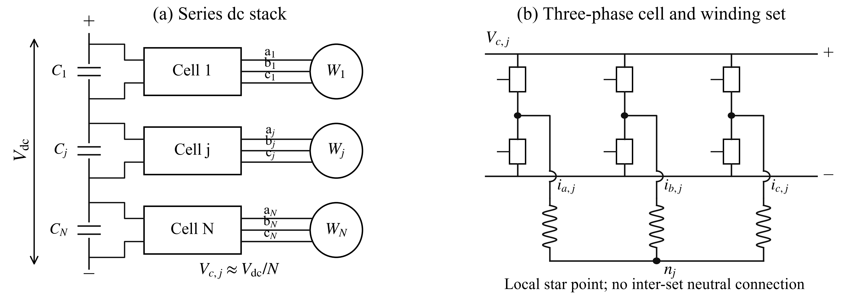
Fig. 1. SPB truck-propulsion architecture. (a) Series dc cells supply separate winding sets. (b) Each cell contains a three-phase bridge and supplies a winding set with a local floating star point.
The considered drive contains N series-connected dc cells, each supplying a three-phase winding group through a two-level bridge. The nominal cell voltage is Vdc/N. The star point of one winding set is not connected to another set or to the dc link. Consequently, each group satisfies
$i_{a,j} + i_{b,j} + i_{c,j} = 0$ (1)
The 3N controlled phase branches therefore provide 2N independent instantaneous current coordinates. Balanced current commands are insufficient by themselves: the phase back-EMF magnitudes, phase displacement, and impedance must also be compatible with balanced operation at both selected pole counts. Equal modal gain and current amplitude, with a common current angle relative to each selected modal EMF, give equal ideal electromagnetic conversion power. This does not establish balance under additional rotor harmonics, regeneration, or transitions; capacitor sizing and active balance control remain design tasks.

A. Device voltage and coil allocation
Let Vr be the device blocking-voltage rating, u its allowable utilization, and kimb and kov the assumed imbalance and overshoot factors. The voltage-dependent lower bound is
$N_{V} = ⌈\frac{V_{dc,max}k_{imb}k_{ov}}{uV_{r}}⌉$ (2)
A 1200-V nominal link and a 1320-V maximum link are considered with kimb = kov = 1.10 and u = 0.80. Table I gives the resulting lower bounds for four verified device classes [6]. The selected parts illustrate discrete voltage and resistance trade-offs; their current, package, thermal, and switching characteristics are not interchangeable.
TABLE I
DEVICE CLASSES AND CELL-COUNT LOWER BOUNDS
Rating | Device [6] | Minimum N | Phase branches | RDS(on), max
100 V | EPC2361 | 20 | 60 | 1 mΩ
150 V | EPC2305 | 14 | 42 | 3 mΩ
200 V | EPC2304 | 10 | 30 | 5 mΩ
350 V | EPC2050 | 6 | 18 | 80 mΩ
For Q conventional double-layer coil positions, the assumed one-coil-per-position construction gives C = Q independently connected coils. At least one coil per phase branch requires 3N ≤ C; equal allocation additionally requires integer c = C/(3N). A conventional single-layer arrangement instead gives C = Q/2. Additional independently fed conductor subdivisions can change these bounds, but require separate lead, insulation, and manufacturing analysis. The slot bounds used here are therefore construction specific.
The full paper will expand this section with truck operating requirements, sensitivity to voltage margins, winding insulation and lead constraints, and dc-cell power-balance control. The present bounds are preliminary selection constraints.

Winding Admissibility for Pole Changing
Let PH and PL denote total pole counts, with pH = PH/2 and pL = PL/2. Define g = gcd(pH,pL), a = pH/g, and b = pL/g. In the investigated family, the three phase-coil axes are displaced by 120°/g mechanically. Their electrical phase displacements are therefore 120a and 120b degrees. The uniform phase-axis triple has balanced selected-order induced-voltage phasors when
$a, b ∉ 3ℤ; Q/(3g) ∈ ℕ; Q/(3N) ∈ ℕ$ (3)
Equation (3) is a phase-axis and allocation screen, not a sufficient machine-feasibility theorem. Define d = Q/(3g). Primitive triples have start slots 1 + q + 3dt + kd for q = 0, …, d − 1, t = 0, …, g − 1, and k = 0, 1, 2. Order triples by q, then t; consecutive blocks of c = Q/(3N) triples form each cell, with identical coil polarity and modulo-Q return slots at pitch y. Equal modal magnitudes across phases and cells and alternate-order rejection are checked to 10⁻⁸ relative tolerance. Current commands align with the selected-order coil phasors. Balanced impedance, mutual coupling, and rotor-harmonic back-EMF are not established by this check.

A. Pole ratio and coil span
The reduced orders of a 2:1 combination are 2 and 1, yielding opposite phase sequences. The 5:2 combination also satisfies (3), with equal sequences. A 3:1 combination gives a zero-sequence spatial order within this uniform-triple family and is excluded by the three-wire connection. This result applies to the stated construction; it does not exclude alternative distributed, reconfigurable, or nonuniform winding families.
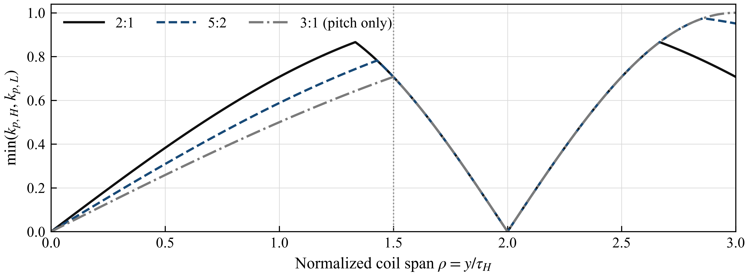
Fig. 2. Minimum pitch factor of the two pole modes versus normalized coil span. The vertical line denotes 1.5 high-pole pitches. The 3:1 curve describes pitch utilization only; it does not satisfy the balanced-cell condition of this construction.
For coil pitch y in slots, spatial pole-pair order ν, and high-pole pitch τH = Q/PH, the pitch factor is
$k_{p,ν} = |sin(\frac{πνy}{Q})|$ (4)
The continuous 2:1 case maximizes the smaller modal pitch factor at 0.866 at y/τH = 4/3. The unrestricted 5:2 case reaches approximately 0.975 at y/τH = 20/7; imposing y/τH ≤ 1.5 reduces its optimum to approximately 0.782. Thus, the highest pitch factor can require a substantially longer end winding. Slot discretization, leakage, resistance, and manufacturability must be included before a pitch optimum is selected.
The full paper will expand the ratio comparison with discrete coil-span choices, end-winding length, leakage, and harmonic MMF. The digest presents only the analytical pitch trade-off.

B. Reproducible 12 Cell Winding
For Q = 36, N = 12, and coil pitch y = 4, define q = 0, …, 3, t = 0, …, 2, and phase index k = 0, 1, 2. Cell j = 3q + t + 1 has start slot s = 1 + q + 12t + 4k and return slot 1 + [(s + 3) mod 36], with identical coil polarity. Relative current phases are 60q + 240k degrees for 12 poles and 30q + 120k degrees for 6 poles; a common torque-angle offset is allowed. Table II checks this construction.
With θs = 2π(s − 1)/36, define Gν = Σs Is[exp(−iνθs) − exp(−iνθreturn)]/72 and Is = exp(ipθs). Thus |Gp| is the winding factor and max(|Gother|, |G−other|)/|Gp| is the alternate-order residual. The same grouping procedure gives a two-cell 36-slot example with factors 0.750/0.837; its one-cell counterpart fails alternate-order rejection. This is construction specific, not a universal cell-count minimum.
The full paper will add winding diagrams, complete connections, impedance matrices, and rotor-harmonic checks for this example.

Cell and Winding Selection Results
The search uses N = 1–32, Q = 18, 24, …, 96, and pole counts H/L = 8/4, 12/6, 16/8, 24/12, 32/16, 12/4, 24/8, 10/4, and 20/8. The frontier uses unrestricted integer pitches 1–Q/2, maximizing the smaller winding factor; the 1.5-pitch cap is a separate sensitivity. For each rating and pole pair, accepted candidates are ranked by lowest N, then Q. Passenger-car examples (48 slots/8 poles [7], [8]; 72/12 [9]) motivate a sensitivity range, not truck design limits. Q ≤ 60 and Q ≤ 72 are study constraints.
TABLE II
DIRECT COIL-SIDE FOURIER CHECK FOR THE 12-CELL WINDING
Total poles | Complex desired gain Gp | Winding factor | Alternate-order residual
12 | 0.750 − i0.433 | 0.866 | < 10⁻¹²
6 | 0.750 + i0.433 | 0.866 | < 10⁻¹²
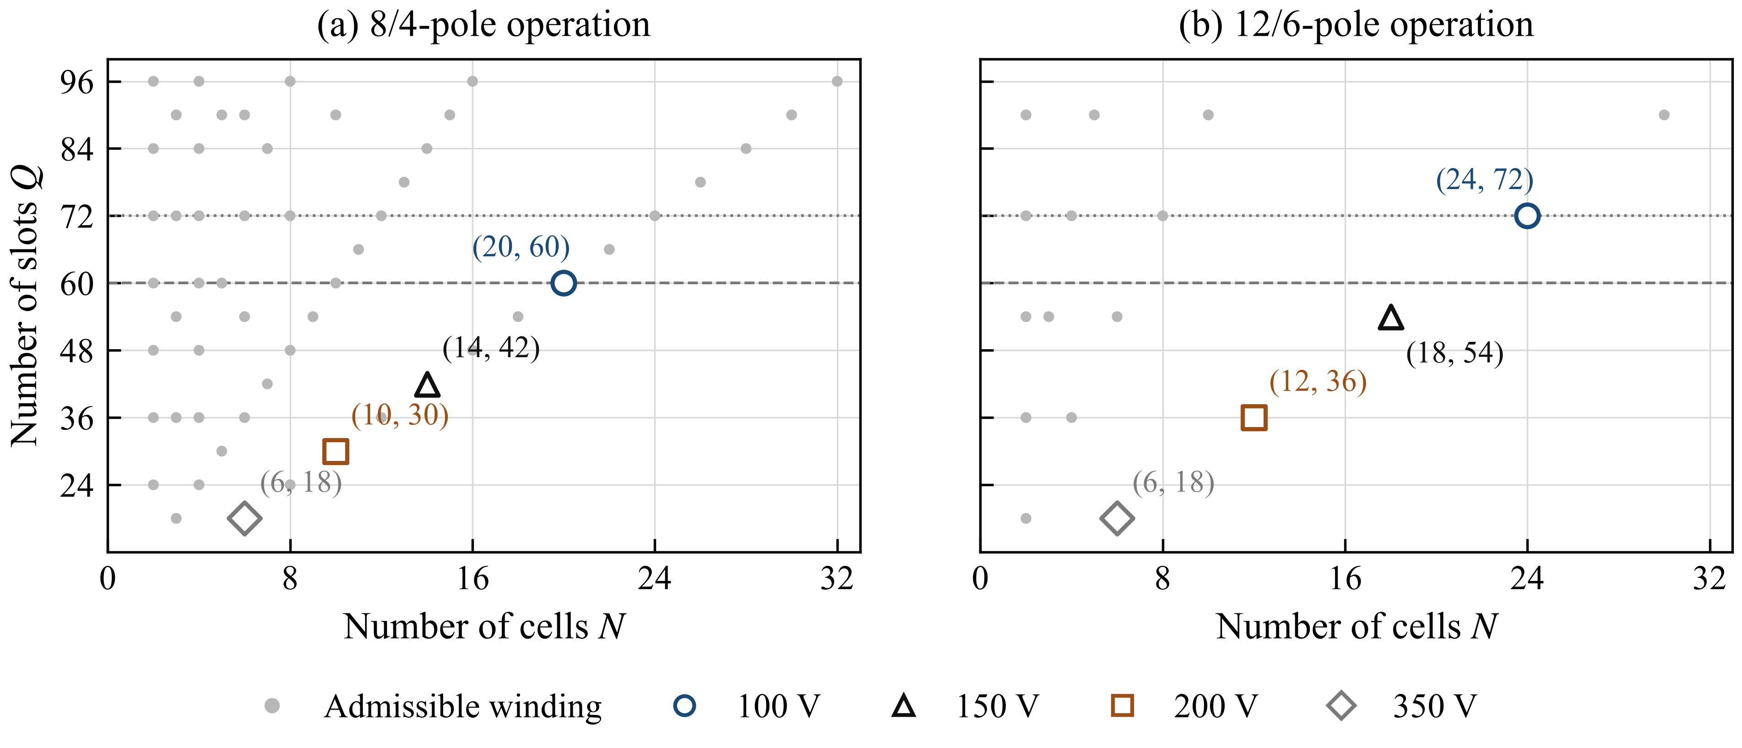
Fig. 3. Admissible cell/slot combinations within the investigated winding family: (a) 8/4-pole and (b) 12/6-pole operation. Dashed and dotted lines denote the 60- and 72-slot constraints, respectively. Marker labels give (N, Q).
With Q ≤ 60, the 100-V class admits 20 cells/60 slots for 8/4 poles but no 12/6-pole layout in this family. For 12/6 poles, 150-V devices admit 18 cells/54 slots and 200-V devices admit 12 cells/36 slots. Q ≤ 72 additionally admits the 100-V, 24-cell/72-slot case. Thus, cell count follows joint voltage and winding constraints.
TABLE III
REPRESENTATIVE DEVICE–WINDING COMBINATIONS
Device class | N | Q | Total poles H/L | Design characteristic
100 V | 20 | 60 | 8/4 | Low channel resistance
150 V | 16 | 48 | 8/4 | 48-slot winding basis
200 V | 12 | 36 | 12/6 | Reduced group count
350 V | 6 | 18 | 12/6 | Higher tabulated resistance
Table III gives N RDS(on) indices of 20, 48, 60, and 480 mΩ at equal group current and paralleling. These are preliminary arithmetic comparisons, not equal-output-power losses or voltage-class optima.
The full paper will expand the shortlist with temperature-dependent converter and winding losses, parallel-device area, and cooling. The 200-V/12-cell case is preliminary.

Converter and Machine Design to Be Expanded

A. 200 V GaN Building Block
A new full-paper section will detail the three-phase 200-V cell, including paralleling, gate driving, capacitance, voltage balancing, and electrothermal feasibility.

B. Hybrid Excited Machine Design and FEA
The full paper will expand the basic model with measured material data, optimized geometry, loaded FEA, torque ripple, losses, and inductance maps. Motor manufacture is not assumed.

Preliminary HE IPM Model and Propulsion Concept
The 36-slot model uses 110 160 triangles, a 1-mm gap, 0.7-T PMs, and synthetic nonlinear steel. Figure 4 shows no-load fields for two excitation settings. Angular refinement changes selected harmonics by <1%; alternate selected rotor harmonics remain at 8.4–9.0%.
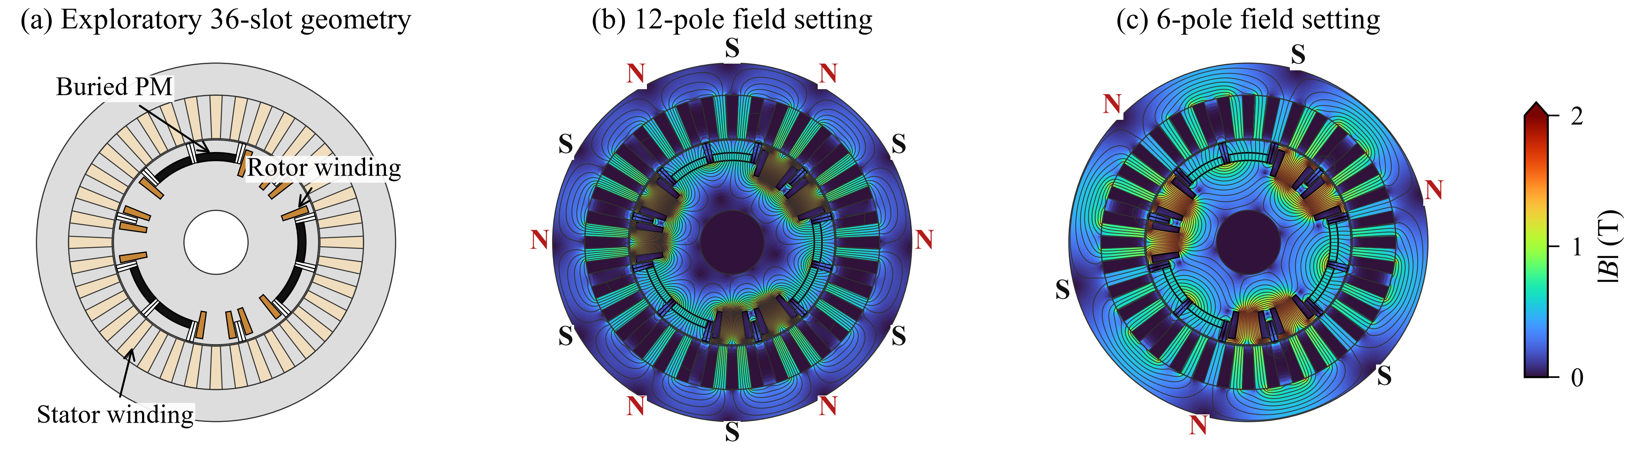
Fig. 4. HE-IPM geometry and no-load FEA fields; colors clipped above 2 T (computed local peak: 2.95 T).
Figure 5 is a conceptual mode trade-off, not a prediction from the FEA geometry.
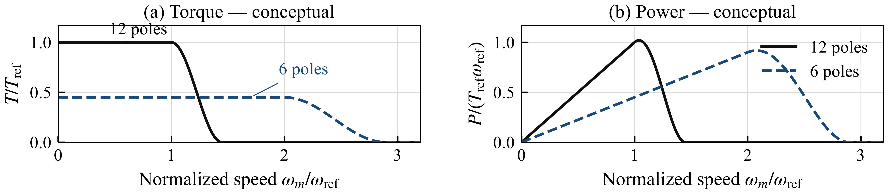
Fig. 5. Conceptual mode curves: P = Tωm; arbitrary reference scales, not FEA performance predictions.
The full paper will report HE-IPM loss analysis and FEA-based torque–speed/power–speed curves, including excitation, inverter losses, current/voltage and thermal limits, truck duty, and pole transitions.

Conclusion
The preliminary winding and field results motivate coupled converter–machine optimization in the full paper.
The conclusion will be updated with the full-paper results.

References
[1] CharIN, "Megawatt Charging System—Recommendations and Requirements," white paper, ver. 2.0, May 2025.
[2] G. Rohner, J. Huber, S. Miric, and J. W. Kolar, "Comparative Evaluation of Three-Phase Three-Level Flying Capacitor and Stacked Polyphase Bridge GaN Inverter Systems for Integrated Motor Drives," Electronics, vol. 13, art. 1259, 2024, doi: 10.3390/electronics13071259.
[3] E. Libbos, E. Krause, A. Banerjee, and P. T. Krein, "Inverter Design Considerations for Variable-Pole Induction Machines in Electric Vehicles," IEEE Trans. Power Electron., vol. 37, no. 11, pp. 13554–13565, 2022, doi: 10.1109/TPEL.2022.3177082.
[4] Rohith, L. Umanand, and B. Subba Reddy, "Pole Changing Wide Speed Range Induction Motor Drive for Electric Vehicles," in Proc. IEEE PEDES, 2018, pp. 1–5, doi: 10.1109/PEDES.2018.8707677.
[5] C. Conto and N. Bianchi, "On the Possibility to Achieve a Pole Change in Synchronous Motors," in Proc. IEEE ECCE, 2022, doi: 10.1109/ECCE50734.2022.9947754.
[6] Efficient Power Conversion, EPC2361, EPC2305, EPC2304, and EPC2050 datasheets, 2025–2026, epc-co.com.
[7] T. Burress, "Electrical Performance, Reliability Analysis, and Characterization," ORNL, DOE Vehicle Technologies Annual Merit Review, project EDT087, 2017, slide 18.
[8] S. Oki and Y. Sato, "Nissan LEAF and e-POWER: Evolution of Motors and Inverters," IEEJ J. Ind. Appl., vol. 13, no. 1, pp. 8–16, 2024, doi: 10.1541/ieejjia.23006552.
[9] U.S. DOE, FY 2016 Annual Progress Report for Electric Drive Technologies, pp. 200–202, 2017.

