Joint Selection of GaN SPB Cells and Pole-Changing
Windings for Truck Propulsion
Abstract—Stacked polyphase bridges (SPBs) enable low-voltage power devices to supply high-voltage truck propulsion systems while independently controlling multiple stator winding groups. This paper presents a device–winding co-design method that exploits these groups for electronic pole changing. Discrete GaN voltage ratings, cell-voltage stress, coil allocation, three-phase balance, and pole ratio are treated as coupled constraints. A constructive winding analysis compares 2:1, 3:1, and 5:2 pole ratios. For a 1.2-kV link, the investigated design space includes 200-V/12-cell and 650-V/4-cell configurations sharing a 36-slot 12/6-pole winding basis. An explicit 36-slot construction gives a winding factor of 0.866 in both 12- and 6-pole modes while cancelling the alternate selected stator order. The resulting candidates establish selected-order winding and voltage compatibility within the investigated family. A preliminary two-dimensional magnetostatic model illustrates two rotor-field settings. Loss analysis and machine-based HE-IPM torque–speed and power–speed characteristics will be developed in the full paper.
Index Terms—Electric truck propulsion, gallium nitride, hybrid excitation, pole changing, stacked polyphase bridge.

Introduction
Megawatt-level charging of battery-electric trucks motivates higher battery and dc-link voltages to limit current and cable loss at a given power [1]. In a conventional two-level truck propulsion inverter, each switch must block the full dc-link voltage together with switching overshoot. Increasing the blocking-voltage requirement introduces conduction- and switching-loss trade-offs that constrain the simultaneous improvement of efficiency and switching frequency. Limited switching frequency increases current-ripple-related machine losses, while common-mode voltage (CMV), high dv/dt, and associated insulation and bearing stress must also be addressed.
Multilevel inverters provide an alternative to full-link-voltage switching. Three-, five-, and seven-level neutral-point-clamped (NPC) or flying-capacitor (FC) implementations can employ lower-blocking-voltage devices and generate smaller output-voltage steps. With appropriate modulation, these steps can reduce current distortion and CMV [2]. However, the additional switches, clamping or flying-capacitor networks, and balancing functions introduce further failure mechanisms and implementation complexity. Fault-tolerant operation requires explicit redundancy, fault isolation, or reconfiguration; it does not follow inherently from the number of voltage levels.
The SPB offers a modular route to voltage partitioning: series-connected dc cells supply separate polyphase winding groups [2]. Low cell voltages permit suitable low-voltage GaN devices, while the machine is implemented with multiple three-phase winding sets whose neutral points remain isolated. The resulting independently controlled inverter units are already required by the voltage architecture. Their current phase and sequence can therefore be used as additional machine-control degrees of freedom.
Pole changing can exploit this flexibility to trade low-speed torque against high-speed capability and operating-point losses. Variable-pole induction drives have demonstrated partial-load and high-speed loss benefits [3], and pole-changing electric-vehicle drives have been investigated for wide-speed propulsion requirements [4]. Such benefits motivate drive-cycle-dependent pole selection, although net cycle savings must include converter and excitation losses. Conventional implementations use Dahlander-type stator reconnection or multiple inverter units to reverse selected coil-group currents. Purpose-designed synchronous and hybrid-excited rotors can change their field polarity accordingly [5]. An SPB can reuse its inverter units for this stator rephasing without adding dedicated stator converters, provided the winding is admissible in both modes.
Prior SPB voltage partitioning [2] and electronic pole changing [3]–[5] do not alone determine compatible cell and winding counts. This paper adds a construction-specific selection method: balanced isolated three-phase groups and alternate-order stator-MMF cancellation are checked jointly with discrete device ratings and coil allocation. The analytical result is a reproducible admissibility frontier, rather than a manufactured machine or an efficiency optimum.
The introduction is abbreviated for the digest. The full paper will expand the comparison with prior SPB and synchronous pole-changing drives and relate the design objectives to truck propulsion duty.

SPB Drive Architecture and Design Constraints
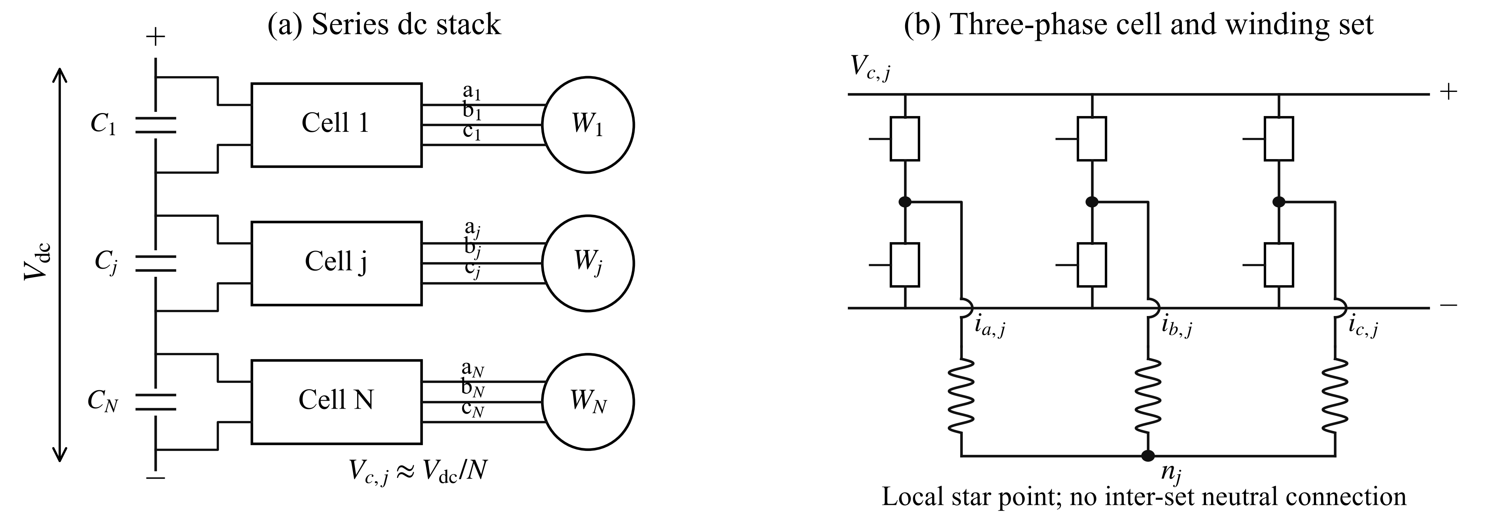
Fig. 1. SPB truck-propulsion architecture. (a) Series dc cells supply separate winding sets. (b) Each cell contains a three-phase bridge and supplies a winding set with a local floating star point.
Each of the N series dc cells supplies an isolated three-phase winding set. Its nominal voltage and three-wire current constraint are
$V_{c,j} = \frac{V_{dc}}{N}, i_{a,j} + i_{b,j} + i_{c,j} = 0$ (1)
The 3N controlled phase branches therefore provide 2N independent instantaneous current coordinates. Balanced current commands are insufficient by themselves: the phase back-EMF magnitudes, phase displacement, and impedance must also be compatible with balanced operation at both selected pole counts. Equal modal gain and current amplitude, with a common current angle relative to each selected modal EMF, give equal ideal electromagnetic conversion power. This does not establish balance under additional rotor harmonics, regeneration, or transitions; capacitor sizing and active balance control remain design tasks.

A. Device voltage and coil allocation
Let the device rating be Vr, its allowed utilization u, and the imbalance and overshoot multipliers kimb and kov. The switch-stress estimate and minimum voltage-driven cell count are
$V_{stress} = \frac{V_{dc,max}k_{imb}k_{ov}}{N}, N_{V} = \left\lceil \frac{V_{dc,max}k_{imb}k_{ov}}{uV_{r}}\right\rceil$ (2)
The study uses a 1200-V nominal link, 1320-V maximum, 10% imbalance, 10% overshoot, and 80% device-rating utilization. Table I gives the resulting bounds [6]; current, package, thermal, and gate-drive requirements differ between parts.
TABLE I
DEVICE CLASSES AND CELL-COUNT LOWER BOUNDS
Rating | Device [6] | Minimum N | Phase branches | RDS(on), max
100 V | EPC2361 | 20 | 60 | 1 mΩ
150 V | EPC2305 | 14 | 42 | 3 mΩ
200 V | EPC2304 | 10 | 30 | 5 mΩ
650 V | IGLT65R025D2 | 4 | 12 | 30 mΩ
For the assumed conventional winding, the independent coil count C and equal allocation c obey (3). Additional conductor subdivisions can change these construction-specific bounds, subject to lead and insulation constraints.
$C = Q \text{(double layer)}; C = \frac{Q}{2} \text{(single layer)}; c = \frac{C}{3N} ∈ ℕ; 3N ≤ C$ (3)
The full paper will expand this section with truck operating requirements, sensitivity to voltage margins, winding insulation and lead constraints, and dc-cell power-balance control. The present bounds are preliminary selection constraints.

Winding Admissibility for Pole Changing
The total high/low pole counts and electrical pole-pair orders are related by
$p_{H} = \frac{P_{H}}{2}, p_{L} = \frac{P_{L}}{2}, g = \text{gcd}\left(p_{H}, p_{L}\right), a = \frac{p_{H}}{g}, b = \frac{p_{L}}{g}$ (4)
For uniform phase-axis triples, the mechanical displacement and selected-order balance/allocation conditions are
$Δθ = \frac{2π}{3g}, a,b ∉ 3ℤ, d = \frac{Q}{3g} ∈ ℕ, c = \frac{Q}{3N} ∈ ℕ$ (5)
These conditions screen the stated family; they do not prove physical-machine feasibility. With zero-based slot offset q, repeated sector t, and phase index k, the start slot s, return slot r(s), and cell index j are
$\begin{aligned}s = 1 + q + 3dt + kd, r(s) = 1 + [(s − 1 + y) \text{mod} Q] \\ j = 1 + \left\lfloor \frac{gq + t}{c}\right\rfloor ; q = 0,…,d − 1; t = 0,…,g − 1; k = 0,1,2\end{aligned}$ (6)
Consecutive blocks of c triples form each cell. Equal phase/cell modal gain and the alternate-order residual are checked to the relative tolerance in (10). The 2:1 ratio gives opposite phase sequences, while 5:2 gives equal sequences. A 3:1 ratio fails this uniform-triple family, without excluding other winding constructions.

A. Choosing a Common Coil Span
A single coil span must serve both pole counts. For span y in slots and spatial pole-pair order ν, define the pitch factor and the smaller of its two modal values as
$τ_{H} = \frac{Q}{P_{H}}, ρ = \frac{y}{τ_{H}}, k_{p,ν} = \left|\text{sin}\left(\frac{πνy}{Q}\right)\right|, η = \text{min}\left(k_{p,H}, k_{p,L}\right)$ (7)
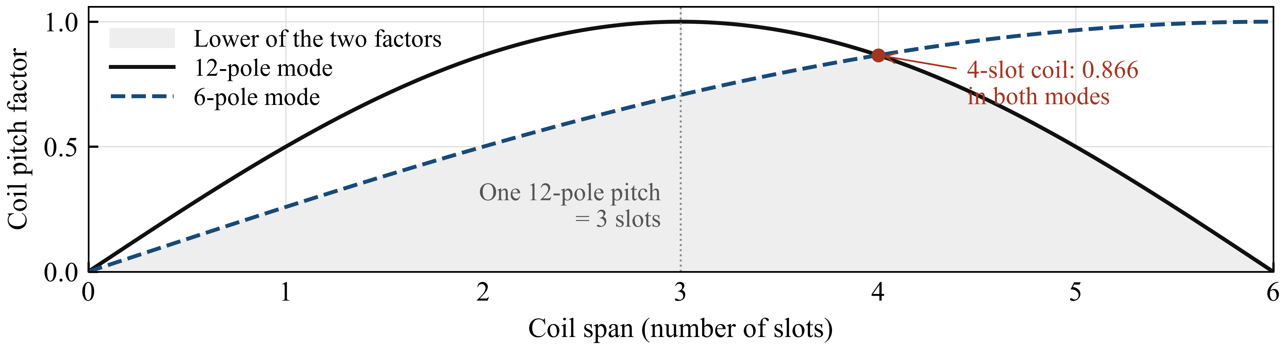
Fig. 2. Common coil-span choice for the 36-slot 12/6-pole example. The shaded region follows the lower pitch-factor curve; a four-slot coil gives 0.866 in both modes.
Three slots give pitch factors of 1 and 0.707; four slots give 0.866 in both modes. For 5:2, the continuous optimum is 0.975 at 2.857 high-pole pitches, falling to 0.782 with a 1.5-pitch cap. Pitch factors do not establish torque or loss.
The full paper will expand this comparison with discrete coil spans, end-winding length, leakage, and harmonic MMF.

B. Reproducible Winding and Fourier Check
For 36 slots, 12 cells, and a four-slot span, (8) gives the coil angles and current commands; i is the imaginary unit. A common current-angle offset sets torque angle.
$θ_{s} = \frac{2π(s − 1)}{Q}, θ_{r(s)} = \frac{2π[r(s) − 1]}{Q}, I_{s} = e^{ipθ_{s}}$ (8)
The normalized full-stator coefficient sums the outgoing and return sides of every coil:
$G_{ν} = \frac{1}{2Q}\sum_{s = 1}^{Q}{I_{s}\left[e^{−iνθ_{s}} − e^{−iνθ_{r(s)}}\right]}$ (9)
The desired-order winding factor and alternate-order residual are then (10), where p′ is the unselected pole-pair order.
$k_{w,p} = \left|G_{p}\right|, ε_{p} = \frac{\text{max}\left(\left|G_{p′}\right|, \left|G_{−p′}\right|\right)}{\left|G_{p}\right|} ≤ {10}^{−8}$ (10)
Series-connecting the three t-indexed coils for each (q,k) gives four cells with unchanged 0.866 factors. Two-cell control fails the selected 650-V voltage bound (Table II); this is not a universal minimum-cell theorem.
The full paper will add winding diagrams, complete connections, impedance matrices, and rotor-harmonic checks.

Cell and Winding Selection Results
The search spans one to 32 cells and 18 through 96 slots in steps of six. Pole combinations are 8/4, 12/6, 16/8, 24/12, 32/16, 12/4, 24/8, 10/4, and 20/8. Integer pitches extend to half the slot count; the 1.5-pitch cap is a separate sensitivity. Accepted candidates are ranked by cell count, then slot count. Passenger-car examples (48 slots/8 poles [7], [8]; 72/12 [9]) motivate the 60/72-slot sensitivity caps, not truck design limits.
TABLE II
DIRECT COIL-SIDE FOURIER CHECK FOR THE 36-SLOT CONSTRUCTION
Total poles | Complex desired gain | Winding factor | Alternate-order residual
12 | 0.750 − i0.433 | 0.866 | < 10⁻¹²
6 | 0.750 + i0.433 | 0.866 | < 10⁻¹²
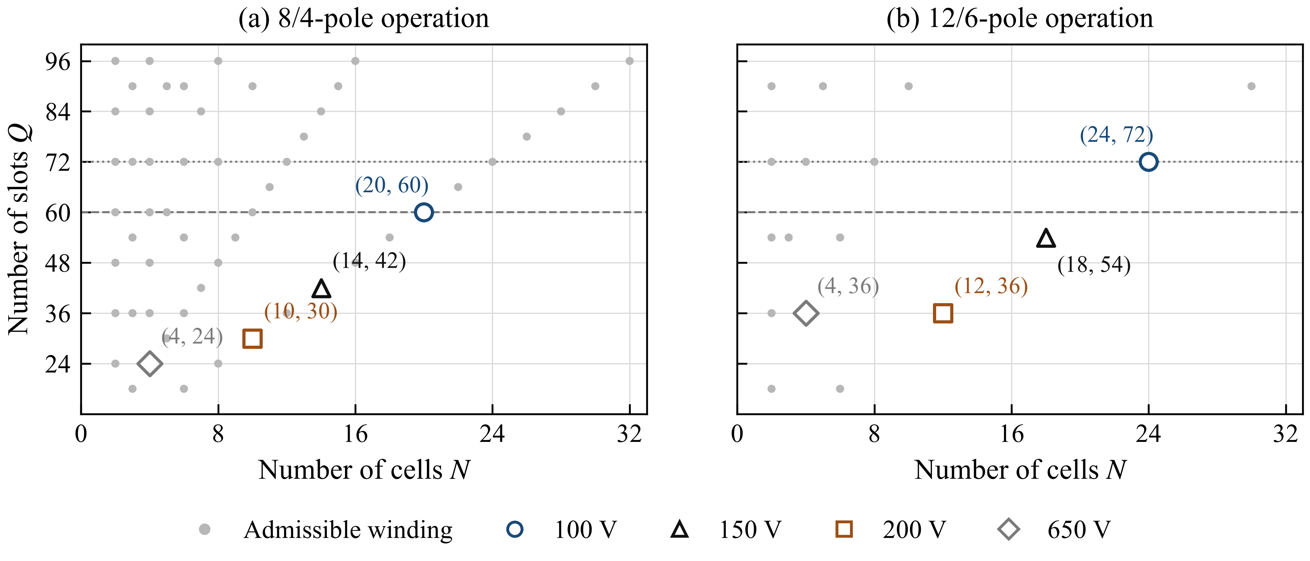
Fig. 3. Screened windings in the investigated family: (a) 8/4 and (b) 12/6 poles. Labels give (N, Q); dashed/dotted lines mark 60/72 slots.
For 650-V devices, (2) gives stresses of 798.6, 532.4, and 399.3 V for two, three, and four cells. Two exceed the continuous rating; three remain below it but exceed the chosen 520-V allowance at 80% utilization. Four pass this voltage screen and admit a 36-slot 12/6-pole winding.
TABLE III
REPRESENTATIVE DEVICE–WINDING COMBINATIONS
Device class | N | Q | Total poles H/L | Design status
200 V | 12 | 36 | 12/6 | Reference candidate
650 V | 2 | 36 | 12/6 | Exceeds continuous rating
650 V | 3 | 54 | 12/6 | Exceeds chosen 80% allowance
650 V | 4 | 36 | 12/6 | Passes voltage screen
The static index (11) gives 60 and 120 mΩ for the accepted 200-V/12-cell and 650-V/4-cell cases at equal group current and paralleling. This is not an equal-output-power loss ranking.
$R_{ind} = NR_{DS(on)}$ (11)
The full paper will expand the shortlist with temperature-dependent converter and winding losses, parallel-device area, and cooling. Both the 200-V/12-cell and 650-V/4-cell cases remain preliminary.

Converter and Machine Design to Be Expanded

A. GaN Building Block Comparison
The full paper will compare 200-V and 650-V building blocks, including paralleling, gate driving, dc capacitance, voltage balancing, and cooling.

B. Hybrid Excited Machine Design and FEA
The full paper will balance PM/wound-pole flux and add geometry optimization with measured material data, loaded FEA, and loss maps.

Preliminary HE IPM Model and Propulsion Concept
The 36-slot model uses a 17.5-mm stator yoke, 1-mm gap, 0.7-T PMs, and synthetic nonlinear steel. Its 6-pole yoke peak is 1.70 T; the selected air-gap harmonic is 0.55% below the 25-mm-yoke baseline. Residual rotor harmonics and unequal PM/wound-pole flux remain optimization targets.
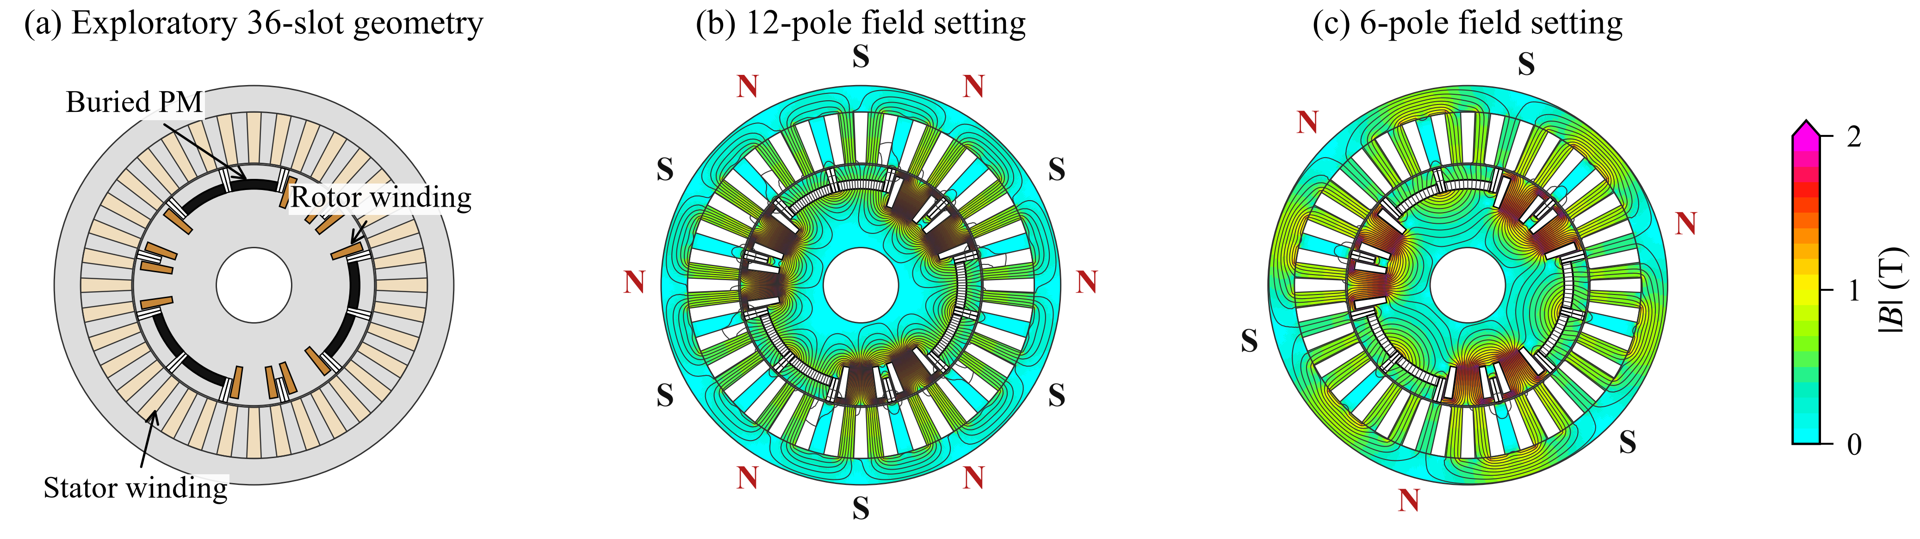
Fig. 4. HE-IPM geometry and no-load FEA fields; colors clipped above 2 T (computed local peak: 2.95 T).
Figure 5 is a conceptual mode trade-off governed by (12), not a prediction from the FEA geometry.
$P = T_{e}ω_{m}$ (12)
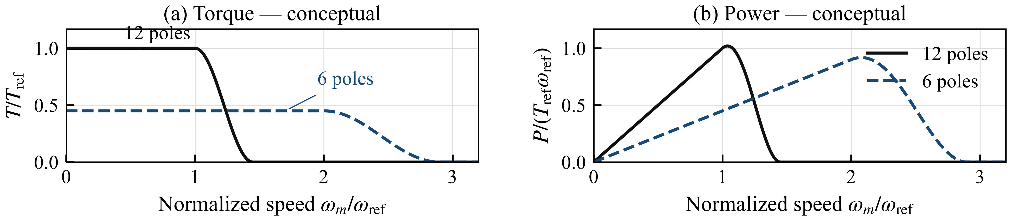
Fig. 5. Conceptual torque/power curves with arbitrary reference scales; not FEA performance predictions.
The full paper will report HE-IPM loss analysis and FEA-based torque–speed/power–speed curves, including excitation, inverter losses, current/voltage and thermal limits, truck duty, and pole transitions.

Conclusion
The preliminary winding and field results motivate coupled converter–machine optimization in the full paper.
The conclusion will be updated with the full-paper results.

References
[1] CharIN, "Megawatt Charging System—Recommendations and Requirements," white paper, ver. 2.0, May 2025.
[2] G. Rohner, J. Huber, S. Miric, and J. W. Kolar, "Comparative Evaluation of Three-Phase Three-Level Flying Capacitor and Stacked Polyphase Bridge GaN Inverter Systems for Integrated Motor Drives," Electronics, vol. 13, art. 1259, 2024, doi: 10.3390/electronics13071259.
[3] E. Libbos, E. Krause, A. Banerjee, and P. T. Krein, "Inverter Design Considerations for Variable-Pole Induction Machines in Electric Vehicles," IEEE Trans. Power Electron., vol. 37, no. 11, pp. 13554–13565, 2022, doi: 10.1109/TPEL.2022.3177082.
[4] Rohith, L. Umanand, and B. Subba Reddy, "Pole Changing Wide Speed Range Induction Motor Drive for Electric Vehicles," in Proc. IEEE PEDES, 2018, pp. 1–5, doi: 10.1109/PEDES.2018.8707677.
[5] C. Conto and N. Bianchi, "On the Possibility to Achieve a Pole Change in Synchronous Motors," in Proc. IEEE ECCE, 2022, doi: 10.1109/ECCE50734.2022.9947754.
[6] Efficient Power Conversion, EPC2361/EPC2305/EPC2304 datasheets; Infineon, IGLT65R025D2 datasheet, rev. 1.1, 2026.
[7] T. Burress, "Electrical Performance, Reliability Analysis, and Characterization," ORNL, DOE Vehicle Technologies Annual Merit Review, project EDT087, 2017, slide 18.
[8] S. Oki and Y. Sato, "Nissan LEAF and e-POWER: Evolution of Motors and Inverters," IEEJ J. Ind. Appl., vol. 13, no. 1, pp. 8–16, 2024, doi: 10.1541/ieejjia.23006552.
[9] U.S. DOE, FY 2016 Annual Progress Report for Electric Drive Technologies, pp. 200–202, 2017.

