Three Phase Stacked Bridge Drives
for Pole Changing Hybrid Excited Machines
Abstract - A stacked polyphase bridge can reuse independently controlled three-phase winding groups for pole changing while distributing a high traction DC voltage among low-voltage converter cells. We investigate the joint choice of cell count, stator winding and pole ratio for hybrid-excited synchronous machines. All groups are three wire, with no neutral conductor. A constructive winding screen covers higher pole counts, including a 12/6-pole example with 24 cells and 72 coil positions. Its two pitch factors are both 0.866. A linear desired-order dq model compares a pole-changing hybrid machine against a matched 12-pole IPMSM reference and a stronger-field-weakening IPMSM sensitivity. In the illustrative case, selecting six poles extends the 150 kW electrical envelope from 4450 rpm to the 9000 rpm study ceiling, while the 300 kW range is unchanged. The result is conditional on rotor flux, back-iron capacity and modal inductances; it is not a general superiority claim.

Introduction
Megawatt charging for heavy-duty electric vehicles motivates interest in high-voltage vehicle architectures [1]. For a given power, a higher DC voltage reduces current. Conventional two-level traction inverters expose each switch to the full DC-link voltage plus transients, which constrains device selection, switching energy, cooling and electromagnetic compatibility. The feasible switching frequency also affects current ripple, machine harmonic loss and common-mode excitation.
Multilevel converters, including neutral-point-clamped and flying-capacitor implementations, can reduce device voltage stress and output-voltage steps. Their common-mode and loss benefits depend on the topology and modulation [2]. Additional balancing, control and protection are required; component count alone is insufficient to rank reliability. Likewise, fault tolerance requires explicit detection, isolation and reconfiguration provisions.
The stacked polyphase bridge (SPB) distributes the link voltage among series DC cells. Each cell supplies a separate three-phase, three-wire winding group, with no neutral connection between cells or to the DC link. This structure permits lower-voltage devices, including suitable GaN devices, and independent group-current commands. It can therefore supply the stator rephasing needed for pole changing without stator contactors, provided the winding and rotor are compatible.
The research question is which combinations of stacked-cell count and pole-changing ratio are usable. A 4/2-pole example is not sufficient for higher-pole traction machines: absolute pole count, slot layout and rotor geometry must also be specified. This digest develops an explicit 12/6-pole winding and compares hybrid-excited and IPMSM torque and power envelopes. Phase count is held at three throughout; other phase counts are reserved for later work.

Three Wire Winding Configuration
Each inverter has only A, B and C machine leads. The calculations impose iA + iB + iC = 0 and do not use zero-sequence current. No accessible or interconnected neutral is assumed. The dq voltage and current limits use a floating-wye phase basis; a delta implementation requires the corresponding line-to-phase conversion. Figure 1 illustrates the electrical interface and a concrete double-layer winding arrangement.
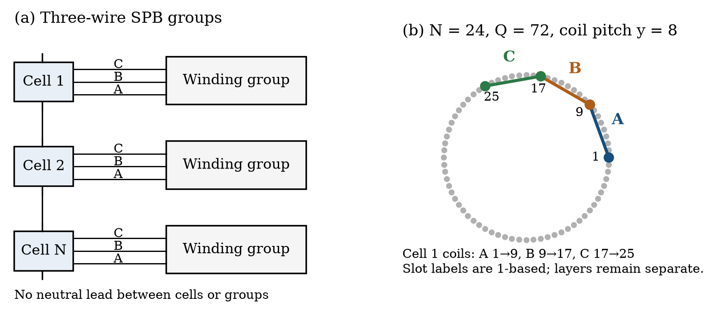
Fig. 1. Three-wire SPB interface and one cell of the 12/6-pole winding. Arrows in the slot labels identify coil start and return positions, not connections between different coils.

A. A constructive family for integer pole ratios
Let PH and PL be total poles, pH = PH/2 and pL = PL/2. In the selected family, the three phase-coil axes are spaced by 120°/pL mechanically. The low-pole phase displacement is 120°; the high-pole displacement is r times this value, where r = pH/pL. An integer ratio r not divisible by three preserves balanced three-phase operation. A 2:1 change reverses phase sequence; the commands are adjusted to preserve mechanical rotation direction. Thus 12/6 poles is supported, whereas 12/4 poles requires another winding family [4].
$Q = lcm(3N, 3p_{L}), c = Q/(3N)$ (1)
Here Q counts coil positions and c is the number of series coils per inverter phase leg. Identical sector triples are combined to obtain c coils per leg. For N = 24 and 12/6 poles, Q = 72, c = 1 and y = 8. The pitch factor |sin(πpy/Q)| is 0.866 in both modes. Coil-side Fourier summation independently reproduces these values.
TABLE I Example cells in the 72 coil winding
Cell | Phase A coil | Phase B coil | Phase C coil
1 | 1 to 9 | 9 to 17 | 17 to 25
2 | 25 to 33 | 33 to 41 | 41 to 49
3 | 49 to 57 | 57 to 65 | 65 to 1
Slot indices are 1-based. Each listed coil occupies separate outgoing and return layers; a shared slot number is not an electrical junction. The complete coil assignment, phase angles and connection polarities are supplied in the numerical study.

Stacked Cell Count and Rotor Compatibility
Figure 2 gives the minimum Q within this exact balanced construction. It is not a universal minimum-slot theorem. The 12/6-pole design admits N = 12 with Q = 36, N = 16 with Q = 144, or N = 24 with Q = 72. The familiar 16-cell choice therefore need not give the simplest winding for a 12-pole machine. Other belt or fractional-slot windings may produce different trade-offs.
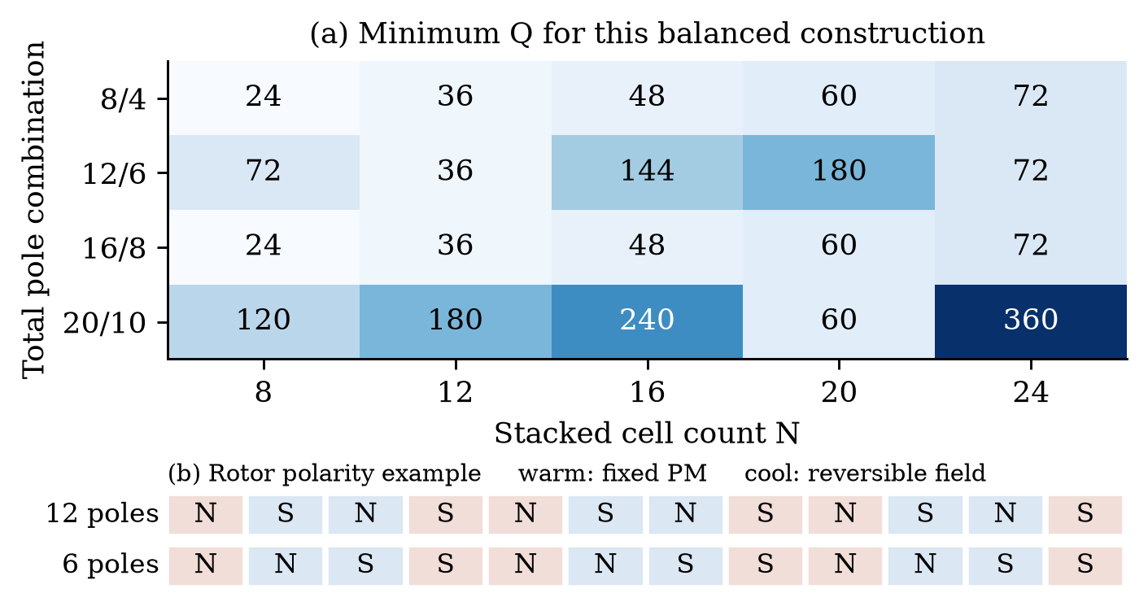
Fig. 2. Cell count and pole combination determine the winding layout. The rotor sketch generalizes the reference hybrid concept to 12/6 poles: one set retains PM polarity and the other reverses field polarity.
TABLE II Illustrative voltage and winding screen for 12/6 poles
N | Nominal Vcell | Q | Coils per leg | Device rating example
8 | 150 V | 72 | 3 | 250 V
12 | 100 V | 36 | 1 | 200 V
16 | 75 V | 144 | 3 | 150 V
20 | 60 V | 180 | 3 | 100 V
24 | 50 V | 72 | 1 | 100 V
The device examples assume a 1320 V maximum bus, factors of 1.10 each for imbalance and overshoot, and operation below 80% of device rating. They are voltage screens, not commercial part selections or a loss optimization. At N = 24, the scenario produces 66.55 V per cell; a 100 V rating passes the assumed 80 V working ceiling. More cells add legs, drivers and interfaces, so the lowest cell voltage is not automatically optimal.
A synchronous rotor must change its spatial field with the stator. The supplied study demonstrates this principle for specialized hybrid-excited rotors [3]. In the 12-segment example, the high-pole pattern alternates N and S; the low-pole pattern repeats NNSS. Six PM segments retain polarity and six field segments reverse. This is a magnetic concept, not a completed excitation circuit or mechanical rotor design.
For a 0.70 pole-arc ratio and equal pole-face field, the ideal Fourier model gives a low-to-high flux-linkage ratio of 1.659. The back iron must carry the corresponding increase in flux: a 1.5 T low-mode yoke limit requires the high-mode yoke flux density to remain below approximately 0.90 T. Saturation can therefore invalidate the apparent speed benefit.

Hybrid Excited and IPMSM Speed Envelopes
A linear desired-order dq calculation uses N = 24, a 1200 V nominal link, 27.42 V peak phase-voltage limit, 376.31 A peak current limit and a 300 kW electromagnetic output ceiling. Negative d-axis current is allowed for field weakening in every model. The hybrid machine uses fixed endpoint fluxes for the two rotor polarities; an independently adjustable total hybrid flux is not assumed. Parameters are selected for a transparent feasibility example and are not identified from a manufactured motor.
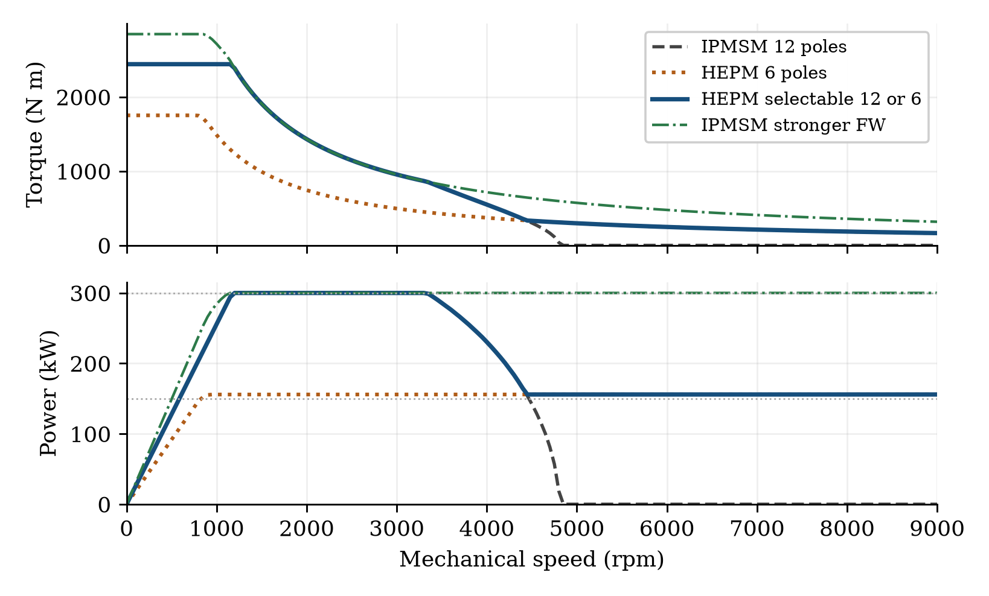
Fig. 3. Conditional electrical envelopes. The hybrid high-pole mode matches the 12-pole IPMSM reference. The green curve is an IPMSM field-weakening sensitivity, not the same optimized machine. The 9000 rpm endpoint is a study limit.
TABLE III Per phase peak dq model parameters
Parameter | 12 pole reference and HEPM | 6 pole HEPM
Field flux linkage | 0.0260 Wb | 0.0431 Wb
Ld | 45 µH | 270 µH
Lq | 90 µH | 270 µH
Phase resistance | 2 mΩ | 2 mΩ
The lower-mode inductance is four times the mean high-mode inductance, reflecting the squared pole-ratio scaling of a simplified magnetic model. Equal low-mode d and q inductances are an explicit round-mode approximation; actual saliency may differ substantially. Both omitted-harmonic EMFs and saturation require a field model.
$T = (3N/2)p[ψ_{f} + (L_{d} − L_{q})I_{d}]I_{q}, P = Tω_{m}$ (2)
For each speed, the solver searches d-axis current and solves the voltage constraint analytically for feasible q-axis current. Selected points are checked against a direct two-dimensional current grid. The resulting envelope is an upper bound on selectable steady operating modes: transition torque, cell-energy balancing, field-reversal time and mechanical stress are not modeled.

Interpretation and Design Limits
TABLE IV Speed ranges under explicit power criteria
Model | End speed at 150 kW | End speed at 300 kW
12 pole IPMSM reference | 4450 rpm | 3300 rpm
Selectable 12/6 pole HEPM | 9000 rpm or higher* | 3300 rpm
IPMSM stronger FW sensitivity | 9000 rpm or higher* | 9000 rpm or higher*
*The study stops at 9000 rpm; no maximum mechanical speed is established. The speed grid is 50 rpm. The hybrid low-pole mode delivers approximately 155.85 kW at the study ceiling.
For the selected reference, changing rotor and stator polarity extends operation at 150 kW beyond the fixed 12-pole envelope. It does not extend the 300 kW range. A stronger-field-weakening IPMSM also reaches the study ceiling, so the result cannot establish a general advantage over optimized IPMSMs. Its characteristic-current ratio ψPM/(Ld Imax) is 0.90, compared with 1.54 for the reference; its inductances and peak torque differ. An equal-volume and thermally constrained optimization is still required.
The nominal advantage is especially sensitive to lower-mode inductance and yoke capacity. A lower-mode inductance sweep of 135, 270 and 405 µH gives approximately 300, 156 and 104 kW at 9000 rpm. About 140 µH is therefore a candidate full-power design target, not a freely selectable parameter. Reducing pole count alone does not multiply mechanical speed: linked flux and reactance change. The rotor Fourier scaling assumes adequate back iron. Unused spatial rotor harmonics can induce additional winding voltage and cell-power ripple, even in a steady selected mode. These effects, PM demagnetization, excitation-supply losses and rotor stress are absent from the desired-order model.
The hybrid model records an assumed 3 kW field loss, excluded from the electromagnetic curves; no shaft-efficiency gain is claimed. Iron loss, thermal duty and transitions are omitted. A practical design needs a bipolar field supply and DC-stack insulation and balancing. Other phase counts remain future work.

Conclusion
The proposed contribution is a co-design map from cell voltage and cell count to a usable winding and pole ratio, followed by rotor and speed-envelope checks. A concrete 24-cell, 72-coil 12/6-pole candidate demonstrates that three-phase groups without a neutral lead can support higher-pole traction concepts. In the illustrative hybrid case, pole changing extends the reduced-power electrical range while leaving the full-power range unchanged. The outcome supports further winding and rotor optimization; it does not yet select a universally superior machine or an optimal cell count.

References
[1] CharIN, Whitepaper Ruggedized Megawatt Charging System, version 1.3, 2024. Available at charin.global, Technology and Knowledge Base.
[2] G. Rohner, J. Huber, S. Miric, and J. W. Kolar, "Comparative Evaluation of Three-Phase Three-Level Flying Capacitor and Stacked Polyphase Bridge GaN Inverter Systems for Integrated Motor Drives," Electronics, vol. 13, no. 7, art. 1259, 2024, doi: 10.3390/electronics13071259.
[3] C. Conto and N. Bianchi, "On the Possibility to Achieve a Pole Change in Synchronous Motors," IEEE ECCE, 2022, doi: 10.1109/ECCE50734.2022.9947754.
[4] B. Ge, D. Sun, W. Wu, and F. Z. Peng, "Winding Design, Modeling, and Control for Pole-Phase Modulation Induction Motors," IEEE Trans. Magn., vol. 49, no. 2, pp. 898-911, 2013, doi: 10.1109/TMAG.2012.2208652.

