Topic 17 — Power Electronics for Transportation Electrification

Parasitic Aware Building Block Design for Stacked Polyphase Bridge Traction Inverters
Abstract—The stacked polyphase bridge (SPB) introduces a voltage-partitioning degree of freedom into a high voltage traction inverter: the number of series-connected submodules determines the semiconductor voltage class, while the required phase current is unchanged. Exploiting this freedom requires the submodule voltage, parallel transistor count, and realizable parasitic impedances to be selected together. This paper presents a hardware-constrained design procedure for the phase-leg building block of an SPB traction inverter. A device figure of merit based on on-resistance and output charge identifies the 100 V EPC2361 as the preferred candidate in the surveyed set. Loss and voltage-stress studies motivate four parallel transistors per switch and a candidate arrangement of sixteen submodules. Current-sharing sensitivity then determines a symmetric cell arrangement with one gate-driver channel per transistor pair. An iterative KiCad–Ansys Q3D–LTspice workflow evaluates the routed power and gate networks. The results show that matched current paths alone do not establish sufficient voltage margin: shared gate inductance and the measurement shunts change the required drive settings and the associated switching loss. The contribution is to connect SPB voltage selection to these physical constraints, establishing the conditions under which low voltage devices can be used in a high voltage traction drive. Experimental double-pulse validation is planned for the full paper.
Index Terms—Gallium nitride, gate drive, parallel transistors, parasitic inductance, stacked polyphase bridge, traction inverter.

I. Introduction
A high voltage traction inverter must deliver substantial phase current while limiting semiconductor loss and switching stress. In a conventional two-level bridge, the dc-link voltage largely determines the required semiconductor voltage class. The stacked polyphase bridge (SPB) changes this relationship by connecting three-phase bridges in series on the dc side, with each bridge feeding an isolated winding set of a multiphase machine [1], [2]. The traction voltage is distributed among submodules, allowing each bridge to use a lower device voltage class and apply a smaller voltage step to its winding set. This makes the allocation of voltage across the drive an active design choice.
That freedom is valuable only if it leads to a practical high-current submodule. Increasing the number of submodules reduces the voltage across each bridge, but it does not reduce the phase current required for a given total drive power, modulation index, and power factor. Low voltage gallium nitride (GaN) transistors can offer favorable on-resistance and switching charge, yet several devices may be needed in parallel. Their current sharing, gate drive, and commutation paths then determine how much of the expected loss benefit can be retained. The additional submodules also repeat the gate-drive, auxiliary-supply, and interconnection requirements throughout the converter.
The literature establishes SPB modulation and loss characteristics [2], [3], dc-link stability [4], and comparisons with alternative GaN converter systems [5]. These studies provide the system context for selecting a submodule voltage. Work on paralleled GaN stages identifies complementary hardware constraints, including commutation-loop inductance, source coupling, and unequal gate impedances [6]–[8]. Taken together, these results indicate that the voltage partition cannot be selected from device data alone: the chosen low voltage bridge must also be realizable at the required traction current.
The problem addressed here is therefore the coupling between SPB voltage partition and building-block implementation. A larger number of lower-voltage submodules may improve the device-level loss comparison, but insufficient switching margin can force slower commutation or a further reduction of submodule voltage. Conversely, reducing the commutation inductance may allow the selected voltage partition to be retained. Gate-loop impedance determines whether that low-inductance power stage can be driven without excessive gate disturbance or unequal transient loading. The hardware constraints feed back into the converter architecture.
This paper develops a phase-leg building block through that feedback. Its contribution is a linked design procedure that translates the traction specification into a voltage-class and parallel-count choice, derives the required symmetry and gate-drive arrangement from current-sharing sensitivity, and checks the resulting choice using extraction of the routed power and gate networks. An instrumented double-pulse test (DPT) board and an operating board separate the parasitics required for measurement from those of the intended converter. The study connects the architecture-level voltage choice to the switching quantities that determine hardware feasibility.

II. From Traction Requirements to the SPB Voltage Partition

A. Voltage partition and phase current
Fig. 1 relates the system voltage partition to the repeated phase-leg building block. With N equally loaded submodules, the nominal submodule voltage is V_{m} = V_{dc}/N, where V_{dc} is the total dc-link voltage. Each submodule supplies one three-phase winding set, and each phase leg must carry the phase current required by the total drive. For sinusoidal phase current, the active power is
$P = \frac{3 M V_{dc} I_{ph,rms} cos φ}{2\sqrt{2}}$ (1)
Here, P is the total active power, M is the modulation index, I_{ph,rms} is the phase rms current, and φ is the displacement angle. Equation (1) shows why voltage partitioning and current capability must be treated separately. Increasing N lowers the voltage handled by each bridge without reducing the current in its phase legs. It also increases the number of repeated semiconductor and driver stages. An attractive local device must therefore be assessed as part of the complete stack.
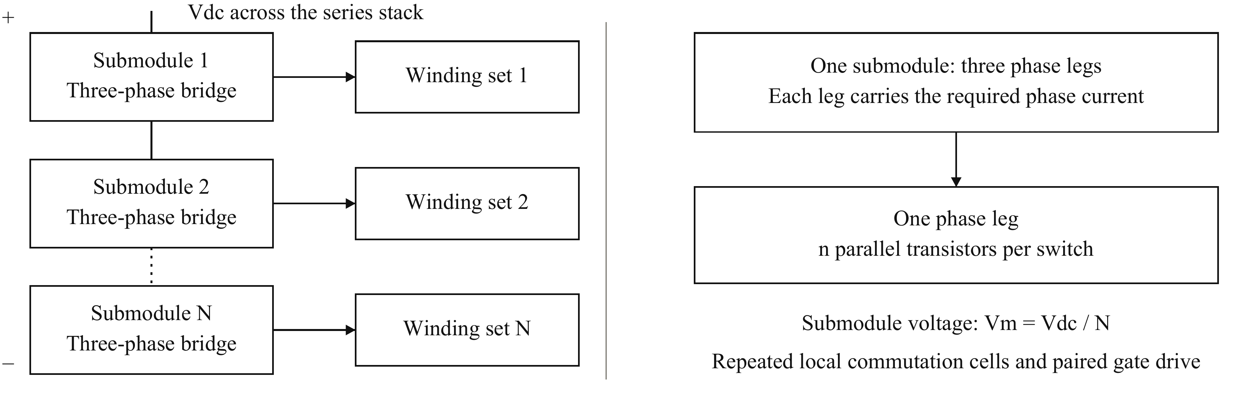
Fig. 1. SPB voltage partition and building-block hierarchy. Series-connected dc inputs distribute the traction voltage among N three-phase submodules. Each submodule supplies an isolated winding set. Each phase leg uses n parallel transistors per switch to carry the required phase current. The parallel count is an implementation choice, whereas N also determines the converter voltage partition.
Table I gives the traction design point and the candidate operating conditions used in the hardware study. The candidate partition is evaluated together with a conservative drain-voltage target for the selected device class. It is not treated as a fixed input that the layout must accept regardless of switching stress.
TABLE I
TRACTION DESIGN POINT AND CANDIDATE OPERATING CONDITIONS
Parameter | Value | Parameter | Value
V_{dc} / P | 1200 V / 300 kW | Switching frequency | 50 kHz
M / cos φ | 1.15 / 0.90 | Phase rms / peak current | 228 A / 322 A
Candidate N / V_{m} | 16 / 75 V | Drain-voltage target | 90 V

B. Device comparison at the converter level
The device comparison must account for the way the number of submodules changes with voltage class. For n parallel transistors per switch, the stack conduction loss scales with N I_{ph,rms}² R_{DS(on)}/n, while output-charge loss scales with N n f_{sw} C_{oss,tr} V_{m}². The on-resistance is R_{DS(on)}, f_{sw} is the switching frequency, and C_{oss,tr} = Q_{oss}/V_{test} is the charge-equivalent output capacitance obtained from datasheet output charge Q_{oss} at test voltage V_{test}. A device figure of merit (D-FoM) is defined as R_{DS(on)} C_{oss,tr}. Minimizing this simplified loss sum over a continuous parallel count gives
$P_{min} ∝ V_{dc} I_{ph,rms} \sqrt{f_{sw} D-FoM}, D-FoM = R_{DS(on)} C_{oss,tr}$ (2)
The explicit dependence on voltage partition cancels in this first-order screening model. Lowering the device voltage class is therefore not, by itself, an optimization result. The benefit depends on the on-resistance and output-charge characteristics of the available devices, as well as the parallel count that can be implemented. Equation (2) provides a basis for comparing the surveyed candidates before detailed switching and thermal calculations.
Fig. 2(a) compares the best surveyed candidate in each voltage class: EPC2361, EPC2215, EPC2050, and IGT65R140D2, respectively. EPC2361 gives the lowest D-FoM in this set and provides a Kelvin source connection [9]. It is selected for the detailed study. The ranking uses typical room-temperature on-resistance and charge-equivalent capacitance at the respective datasheet test voltages. Nonlinear charge, temperature dependence, and the realizable integer parallel count are addressed in the subsequent design. Driver, auxiliary-supply, and machine costs are not included in this screening metric.

C. Parallel count and usable submodule voltage
Selecting the device does not establish the switch current capability. Increasing n reduces conduction loss and the current assigned to each transistor, but it increases the switched charge, gate-charge demand, and layout complexity. Fig. 2(b) evaluates this tradeoff using device-level DPT switching energies averaged over the fundamental current waveform. The thermal calculation iterates junction temperature and on-resistance for the assumed cooling arrangement.
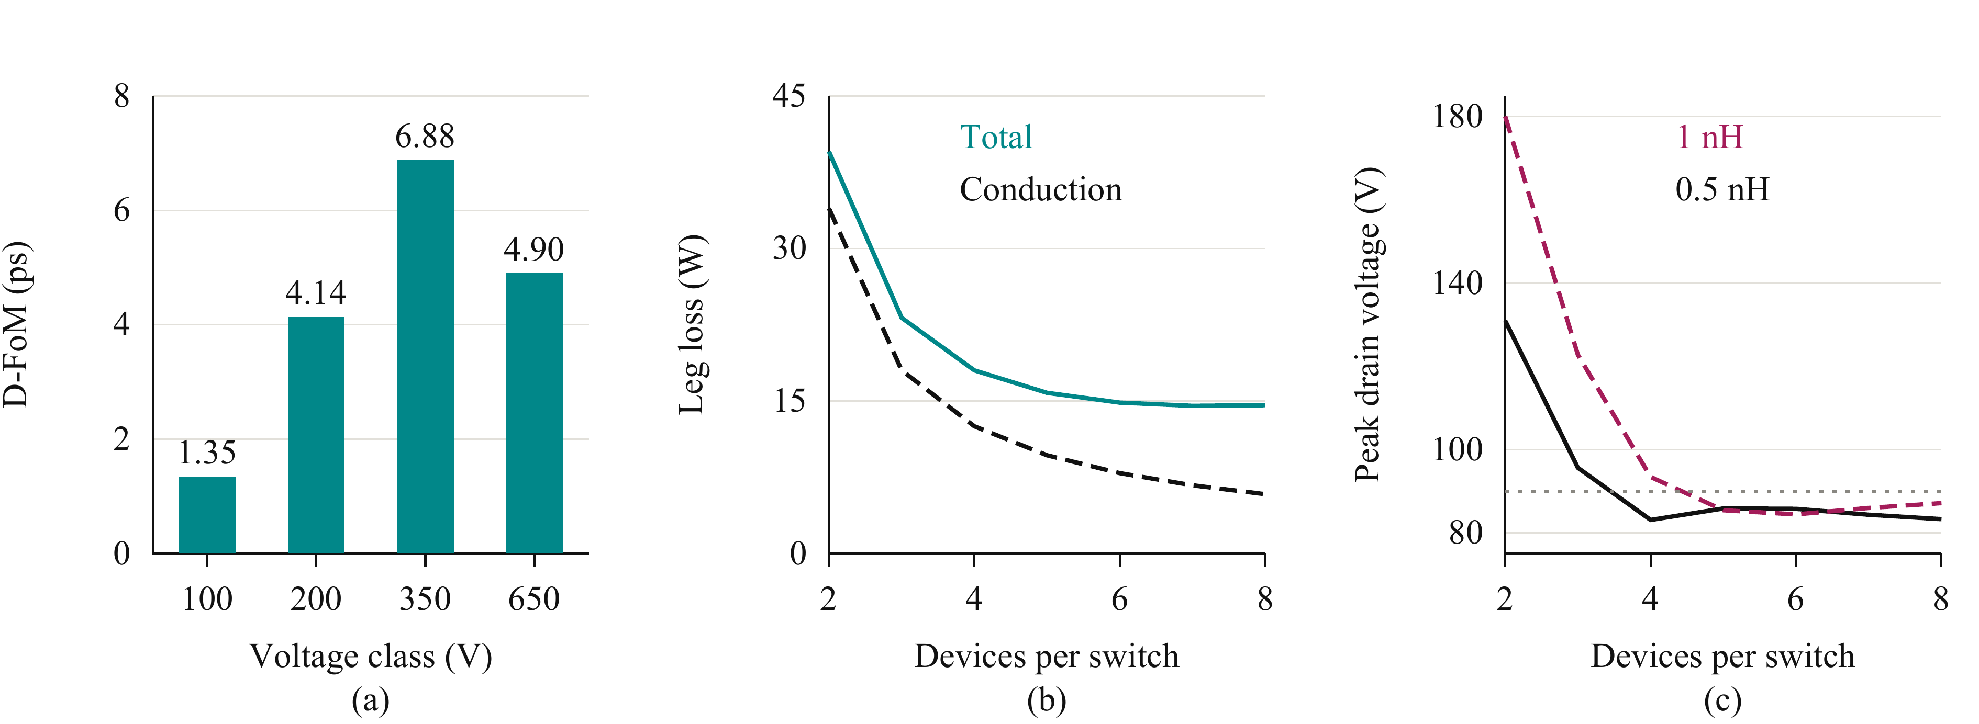
Fig. 2. Coupled device and parallel-count selection. (a) Minimum surveyed D-FoM in each voltage class. (b) Total semiconductor loss (teal solid) and conduction loss (black dashed) per leg with 0.5 nH per cell. (c) Peak drain voltage with 0.5 nH (black solid) and 1 nH (wine dashed); the grey dotted line denotes the design target. The parallel-count studies use Table I and identical device-level drive assumptions.
The same candidate must satisfy a voltage constraint. The peak drain-to-source voltage V_{DS,pk} is screened using V_{DS,pk} ≈ V_{m} + L_{loop} |di/dt|, where L_{loop} and di/dt are the inductance and current slew rate of the same cell commutation path. The assumed inductance range covers a compact local loop and a less favorable instrumented implementation. As Fig. 2(c) shows, a parallel count that appears adequate from temperature alone can still leave insufficient drain-voltage margin.
Four parallel transistors per switch are selected because they provide a practical balance between conduction loss, switching stress, and drive complexity in the lower-inductance case. Fewer devices do not satisfy the preliminary voltage target, while the incremental loss reduction from additional devices diminishes. The selected count also permits two identical gate-drive pairs. This is a constrained design choice, rather than the minimum of semiconductor loss considered in isolation.
For this selection, the preliminary fundamental-period loss is approximately 18 W per leg, of which conduction and switching account for approximately 12.5 W and 5.0 W, respectively. Conduction loss therefore remains the main motivation for a low-resistance device and sufficient paralleling. The corresponding junction estimate is 69 °C with a 40 °C ambient, a 0.65 K/W heatsink, and a 7.6 K/W junction-to-heatsink path per device. These estimates apply to the preliminary drive settings and the stated thermal boundary; the final gate adjustment requires the operating loss to be reevaluated.
The candidate voltage partition in Table I is retained for layout development because it is compatible with the preliminary compact-loop result. The higher-inductance result does not provide the same margin. This conditional selection is the connection between SPB optimization and the physical building block: if the routed power or gate network cannot meet the required stress limits at acceptable loss, the submodule voltage or parallel count must be revisited.

III. Translating the Parallel Count into a Gate Drive and Cell Layout

A. Dynamic sharing as a design constraint
The parallel-count calculation assumes that each transistor carries an appropriate share of the phase current. During switching, that assumption depends on gate and source impedances, not only on the number of devices. Unequal transient loading can increase the loss and stress of one transistor even when the average current is acceptable. The nominal current capability obtained by dividing the total current by n is therefore useful only if the hardware supports balanced commutation.
Table II summarizes the two-device sensitivity study at the candidate submodule voltage and a total current of 120 A. Gate-loop and common-source mismatch produce the largest switching-energy imbalance. The power-path perturbation has a much smaller effect in this particular comparison. The design implication is to preserve individual Kelvin returns and equalize the complete gate branches, while repeating the local power cells. These results motivate the layout arrangement; they do not eliminate device-parameter or driver-timing spread.
TABLE II
SENSITIVITY OF SWITCHING-ENERGY SHARING
Perturbation | Energy imbalance | Layout implication
Power-path inductance +0.3 nH | Negligible | Repeated commutation cells
Gate loops 2 and 8 nH | 19% | Equal gate branches
No Kelvin return; source mismatch +0.2 nH | 29% | Individual Kelvin returns

B. Gate drive in symmetric pairs
The phase leg is implemented as four local commutation cells. Each cell contains one high-side and one low-side transistor with nearby bypass capacitors. Two cells form a driver block, arranged with point symmetry around the driver. One dual-channel 2EDF7275K serves each block: one output channel drives its high-side transistor pair and the other drives its low-side pair. Two driver integrated circuits therefore serve the complete eight-transistor phase leg. Individual gate resistors and individual Kelvin returns preserve the symmetry within each pair.
The selected driver provides 4 A source and 8 A sink capability per channel [10]. Dividing the transistors into pairs limits the gate charge presented to one output and keeps the routing local. A strong sink path is particularly important when the opposite switch commutates, because Miller current can raise the gate voltage of a transistor that should remain off. The sink-current rating is only one part of that path: shared inductance between the driver and the star point can still allow a substantial gate excursion.
The resulting design must satisfy two distinct requirements. Branch symmetry limits dynamic imbalance between parallel devices, while low absolute gate-loop impedance limits delay, ringing, and held-off gate rise. A geometrically balanced network can satisfy the first requirement and still fail the second. This distinction determines why extraction of the gate network is needed in addition to extraction of the commutation loop.

IV. Closing the Design Loop with the Routed Building Block

A. Layout and extraction procedure
Fig. 3 shows how the hardware implementation feeds back into the SPB selection. The initial voltage class, N, and n define the current and voltage stress that each cell must support. KiCad establishes the component placement, current paths, and gate returns. Ansys Q3D extracts the resulting impedances, which are then inserted into LTspice switching simulations. Local violations lead to layout or drive changes. If those changes cannot recover the margin without an unacceptable loss penalty, the outer iteration returns to the submodule voltage or parallel count.
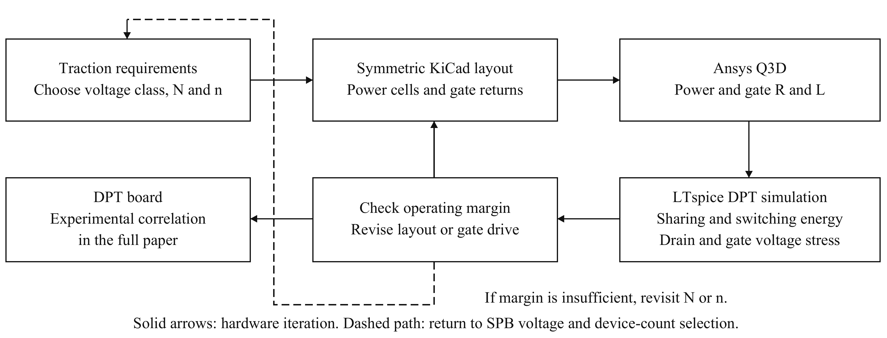
Fig. 3. Design iteration linking SPB voltage selection to physical implementation. R and L denote the extracted resistance and inductance, including mutual terms. Solid arrows denote hardware development and local revision. The dashed path denotes feedback to the voltage partition or parallel count when the required operating margin cannot be recovered locally. Experimental DPT correlation is planned for the full paper.
Fig. 4 shows the two phase-leg variants and the extraction geometry. Both use four copper layers, closely adjacent power planes, and repeated local commutation cells. Distributed bypass capacitors close the fast current paths, while the larger capacitor bank supplies switching-frequency charge. The DPT board adds a coaxial shunt in each cell to resolve individual currents. The operating board removes the shunts and incorporates the intended cooling arrangement. The measurement circuit is thus an explicit variant of the power stage, rather than an electrically transparent attachment.
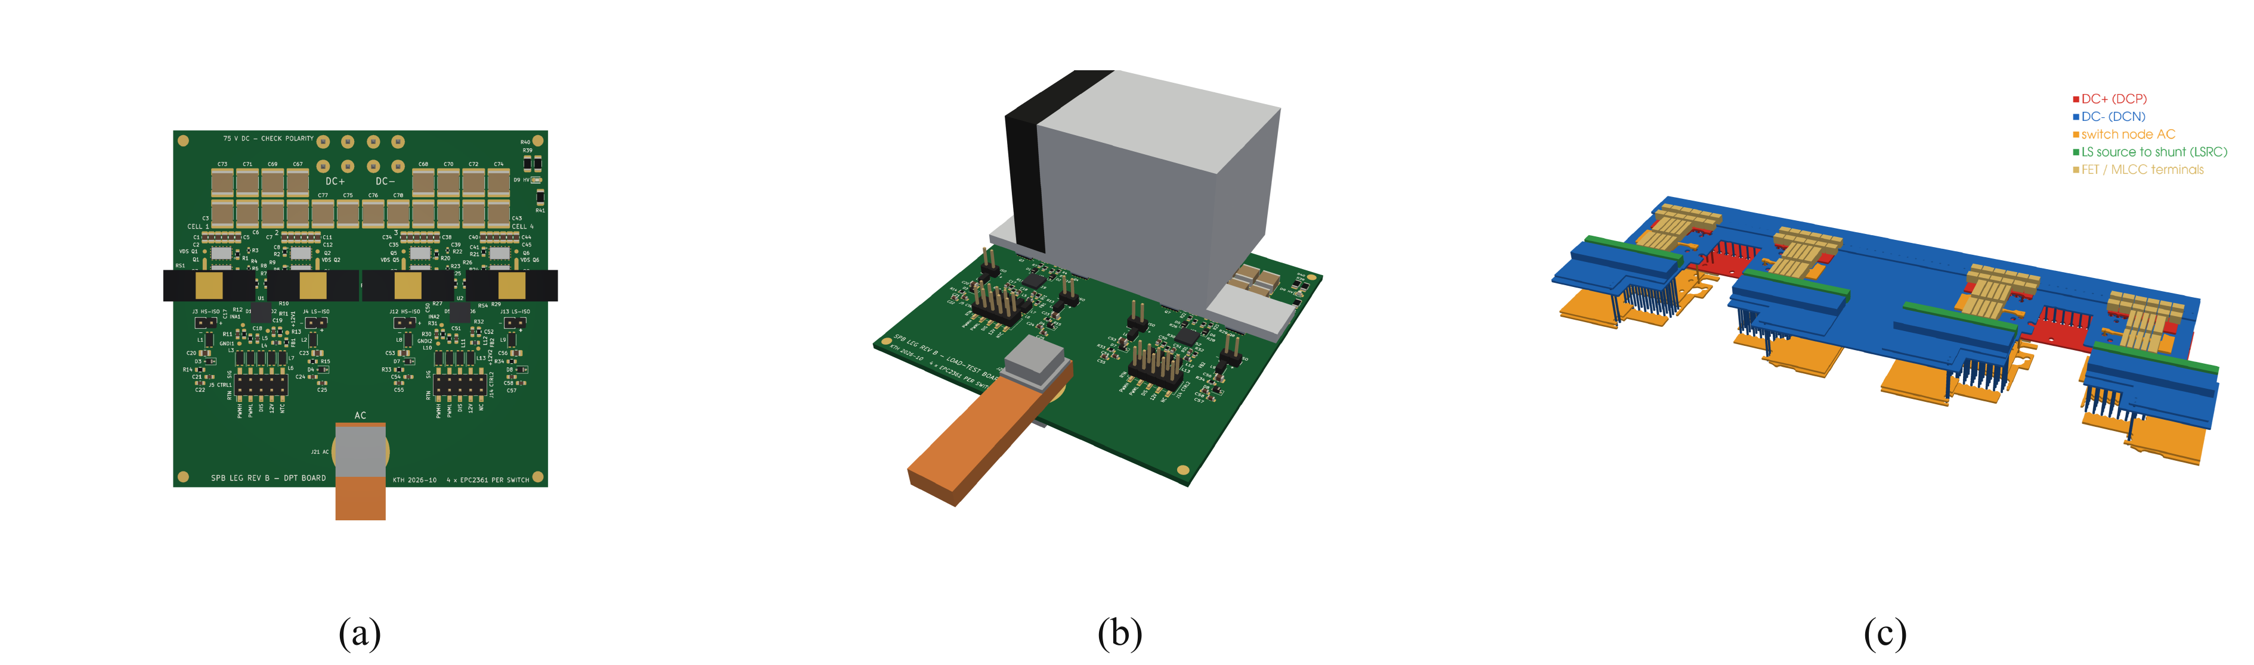
Fig. 4. Building-block implementation. (a) DPT board with individual cell-current sensing. (b) Operating board with heatsink. (c) Q3D geometry of the instrumented cells; vertical dimensions are exaggerated for visibility. The panels show board designs and extraction geometry, not experimental switching operation.
The commutation-cell region is extracted at 100 MHz for the power-loop inductance, and the full board at dc for the resistance matrix. Mutual inductances are retained. Capacitor equivalent series inductance and shunt inductance are added consistently to the copper network. The effective loop of one cell is evaluated with all parallel cells commutating. The repeated geometry gives symmetric cell loops at the reporting precision, while the shunts and their connections increase the instrumented-board loop.

B. Separating gate symmetry from gate inductance
The gate extraction separates the common driver-to-star path from the individual gate and Kelvin branches. For simultaneous pair switching, the effective high-side and low-side gate-loop inductances are 20.6 and 12.3 nH. The substantial common portions explain how matched branches can coexist with an appreciable effective loop. They also show why replacing the routed gate network by an assumed small lumped inductance can give the wrong drive setting even when current sharing appears satisfactory.
The extraction therefore tests the assumptions used in the initial selection, rather than merely assigning a final inductance to a completed layout. A small power loop supports the selected submodule voltage, but the gate network determines the switching trajectory through that loop. Both networks must be represented before the overshoot and gate-bump constraints can be used to judge the chosen SPB building block.

V. Switching Results and Feedback to the SPB Design

A. Simulation conditions
The extracted copper networks are combined with eight manufacturer transistor models, bias-dependent bypass capacitance, component inductances, and source/sink drive networks representing the selected driver output impedances. The operating-board comparisons retain the preliminary 1.7 nH lumped gate model. The DPT-board comparisons include the extracted gate network and its component interconnects. The distinction limits what can be concluded from each case: the operating-board results assess its extracted power network, while the DPT results also test the routed gate-drive assumption.
All cases use the candidate submodule voltage in Table I. The simulated current at the first turn-off is approximately 316 A, close to the nominal design peak. The effective turn-on resistance is denoted R_{g,on}; for the DPT pair it includes the contribution of the common resistor during simultaneous switching. Turn-on energy E_{on} is integrated over the commutation interval and averaged over the four active devices. These peak-current energies are used to compare switching configurations and are distinct from the fundamental-period operating loss.

B. Current sharing and drain stress
Fig. 5(a) shows the DPT cell currents at the second turn-on. The nominal symmetric model produces equal switching-energy sharing at the reporting precision. This supports the repeated-cell and paired-drive arrangement under matched device and timing assumptions. It does not establish sharing under manufacturing spread. The current rise also illustrates why the voltage screen must be closed with a switching model: the current trajectory is affected by the drive and coupled parasitic network.
Fig. 5(b) compares the most highly stressed high-side transistor in each configuration, and Table III gives the corresponding energy and peak-voltage results. The critical event is low-side turn-on, during which the held-off high-side transistor is charged. Thus the relevant voltage margin cannot be assessed only from the active transistor turn-off waveform. The commutation model must include both switches and their local capacitor path.
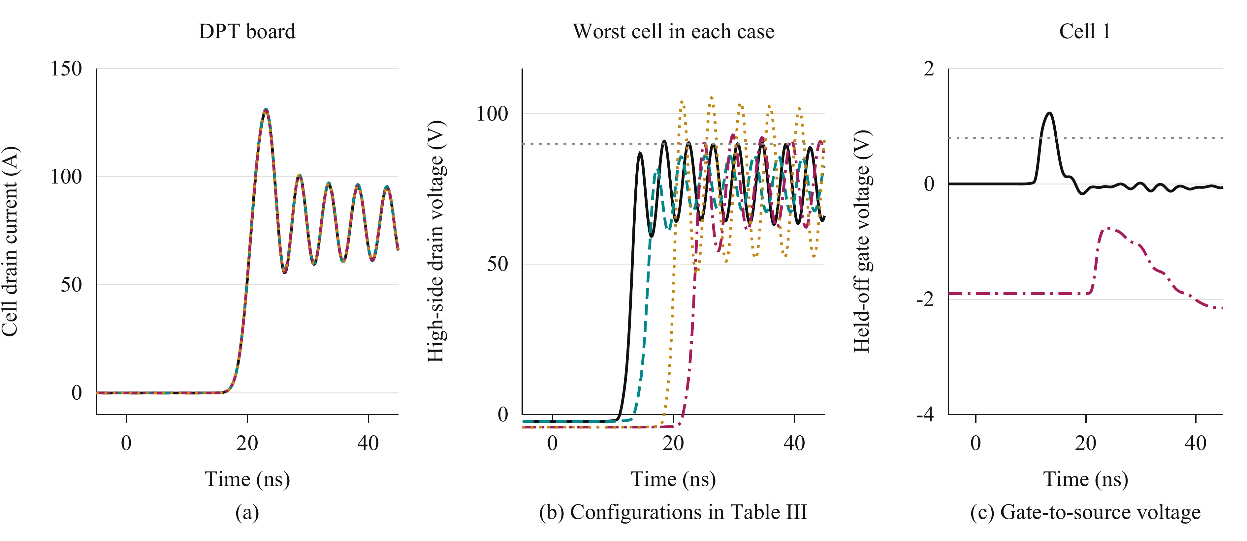
Fig. 5. Extracted-network DPT simulations. (a) DPT cell currents; cells 1–4 use solid, dashed, dash-dot, and dotted lines. (b) Worst-cell high-side drain voltage: operating board at 2 Ω (black solid) and 3 Ω (teal dashed), DPT board at 3.5 Ω (wine dash-dot) and 2.5 Ω (ochre dotted). (c) High-side gate-to-source voltage of cell 1 for the baseline operating board and adjusted DPT board, with the same case styles. Grey dotted lines mark the drain-voltage target and minimum gate threshold. Time is relative to the second turn-on command.
TABLE III
EXTRACTED-NETWORK SIMULATION RESULTS
Board and gate model | Effective loop (nH) | R_{g,on} (Ω) | Peak V_{DS} (V) | Mean E_{on} (µJ)
Operating, lumped gate | 0.41 | 2.0 | 91 | 27.3
Operating, lumped gate | 0.41 | 3.0 | 86 | 32.8
DPT, extracted gate | 0.65 | 2.5 | 105 | 24.3
DPT, extracted gate | 0.65 | 3.5 | 93 | 31.2
Increasing turn-on resistance reduces the drain stress of the operating-board power network, at the cost of higher turn-on energy. Including the extracted DPT gate network shows that the preliminary gate assumption is insufficient for the instrumented stage. The slower setting reduces its peak below the device blocking rating, but it still exceeds the design target in Table I. The result therefore distinguishes a useful hardware candidate from a fully closed voltage-margin design.

C. Held-off gate disturbance
Fig. 5(c) shows the complementary gate constraint. With zero off-state bias, the simulated gate rise can exceed the minimum threshold specified in [9]. Slowing turn-on reduces the drain overshoot, but it does not by itself establish that the opposite transistor remains off. A low-impedance sink path and controlled gate return are needed in addition to the turn-on adjustment.
The instrumented-board configuration uses −1.9 V off-state bias to keep the held-off gate below threshold. Its approximately −3.4 V negative ringing remains within the −4 V gate limit. This is a response to the extracted gate network, rather than an assumed requirement of the selected transistor. Shortening the shared gate path addresses the physical cause directly and may reduce reliance on negative bias. Any further slowing or bias change must be included in the loss assessment because switching energy and reverse-conduction loss are also affected.

VI. Importance for SPB Traction Optimization and Experimental Validation
The results connect the building-block design to the main SPB optimization decision. The voltage partition determines which devices can be considered, but the realizable commutation and gate networks determine the usable fraction of their blocking capability. A partition selected only from the device figure of merit may require drive settings that erode its expected switching-loss benefit. Conversely, reducing the local parasitics can preserve voltage margin without increasing the number of submodules or further slowing the transition.
This connection is particularly important in a traction SPB because the same phase-leg design is repeated across the three phases of every submodule. A local loss penalty is repeated throughout the converter. Increasing N to reduce submodule voltage also adds repeated semiconductor and driver stages. The value of layout optimization is therefore broader than reducing an isolated overshoot peak: it can determine whether a favorable low voltage device class can be used with the intended stack partition and current capability. The present study quantifies the local semiconductor and switching constraints; a complete drive optimum would additionally include auxiliary power, insulation, machine winding arrangements, and cooling.
The two board variants also clarify how the design should be evaluated. The instrumented loop must be represented when comparing DPT measurements with simulation, because its shunts alter the switching stress. That additional stress should not be attributed unchanged to the intended operating stage. At the same time, the operating-board result cannot substitute for validation of its routed gate network. Keeping the two cases explicit allows the measurement model to be correlated without overstating the operating margin of the final converter.
The full paper will include DPT measurements of the individual cell currents, switching energies, drain overshoot, and held-off gate voltage. Measurements will be compared with simulation at identical voltage, current, and drive settings, with the shunts and probe connections retained in the test model. Experimental correlation will determine whether the remaining voltage margin requires a further gate-drive or layout revision.

VII. Conclusion
The voltage-partitioning freedom of an SPB becomes useful for traction conversion only when the selected low voltage bridge is realizable at the required phase current. This paper links device-voltage and parallel-count selection to dynamic sharing, gate-drive capability, and extraction of the routed building block. The surveyed device characteristics motivate EPC2361, while the loss and voltage-stress study selects four parallel transistors per switch for the candidate stack partition. Symmetric commutation cells and paired gate drive support balanced nominal switching, but extraction shows that shared gate inductance and measurement parasitics still determine the drive settings and available voltage margin. The contribution is this hardware-constrained connection between SPB architecture and phase-leg implementation. It provides a basis for refining the submodule voltage and layout together, with experimental DPT correlation planned for the full paper.

References
[1] S. Norrga, L. Jin, O. Wallmark, A. Mayer, and K. Ilves, “A novel inverter topology for compact EV and HEV drive systems,” in Proc. IECON, 2013, pp. 6590–6595.
[2] L. Jin, S. Norrga, O. Wallmark, and M. Nikouei Harnefors, “Control and modulation of the stacked polyphase bridges inverter,” in Proc. IEEE ECCE, 2014.
[3] L. Jin, S. Norrga, O. Wallmark, and N. Apostolopoulos, “Modulation and power losses of a stacked polyphase bridge converter,” IEEE J. Emerg. Sel. Topics Power Electron., vol. 5, no. 1, pp. 409–418, Mar. 2017.
[4] M. Nikouie, O. Wallmark, L. Jin, L. Harnefors, and H.-P. Nee, “DC-link stability analysis and controller design for the stacked polyphase bridges converter,” IEEE Trans. Power Electron., vol. 32, no. 2, pp. 1666–1674, Feb. 2017.
[5] G. Rohner, J. Huber, S. Mirić, and J. W. Kolar, “Comparative evaluation of three-phase three-level flying capacitor and stacked polyphase bridge GaN inverter systems for integrated motor drives,” Electronics, vol. 13, no. 7, Art. no. 1259, 2024, doi: 10.3390/electronics13071259.
[6] J. A. Brothers and T. Beechner, “GaN module design recommendations based on the analysis of a commercial 3-phase GaN module,” in Proc. IEEE ECCE, 2019, pp. 4109–4116.
[7] J. Lu and D. Chen, “Paralleling GaN E-HEMTs in 10 kW–100 kW systems,” in Proc. IEEE APEC, 2017, pp. 3049–3056.
[8] M. T. Tran et al., “A high-performance GaN power module with parallel packaging for high-current and low-voltage traction inverter applications,” IEEE J. Emerg. Sel. Topics Power Electron., vol. 13, no. 1, pp. 1188–1209, Feb. 2025.
[9] Efficient Power Conversion, “EPC2361 eGaN FET datasheet,” Feb. 20, 2026. [Online]. Available: https://epc-co.com/epc/Portals/0/epc/documents/datasheets/EPC2361_datasheet.pdf
[10] Infineon Technologies, “2EDF7275K data sheet,” rev. 2.8. [Online]. Available: https://www.infineon.com/part/2EDF7275K

