Topic 17 — Power Electronics for Transportation Electrification

Parasitic Aware Building Block Design for Stacked Polyphase Bridge Traction Inverters
Abstract—The stacked polyphase bridge (SPB) introduces a voltage-partitioning degree of freedom into a high voltage traction inverter: the number of series-connected submodules determines the semiconductor voltage class, while the required phase current is unchanged. Exploiting this freedom requires the submodule voltage, parallel transistor count, and realizable parasitic impedances to be selected together. This paper presents a hardware-constrained design procedure for the phase-leg building block of an SPB traction inverter. A device figure of merit based on on-resistance and output charge identifies the 100 V EPC2361 as the preferred candidate in the surveyed set. Single-cell switching simulations establish a usable current range. A short comparison of loss, temperature, and drain stress then selects four parallel transistors per switch for a candidate arrangement of sixteen submodules. Current-sharing sensitivity then determines a symmetric cell arrangement with one gate-driver channel per transistor pair. An iterative KiCad–Ansys Q3D–LTspice workflow evaluates the routed power and gate networks. The results show that matched current paths alone do not establish sufficient voltage margin: shared gate inductance and the measurement shunts change the required drive settings and the associated switching loss. The contribution is to connect SPB voltage selection to these physical constraints, establishing the conditions under which low voltage devices can be used in a high voltage traction drive. Experimental double-pulse validation is planned for the full paper.
Index Terms—Gallium nitride, gate drive, parallel transistors, parasitic inductance, stacked polyphase bridge, traction inverter.

I. Introduction
A high voltage traction inverter must deliver substantial phase current while limiting semiconductor loss and switching stress. In a conventional two-level bridge, the dc-link voltage largely determines the required semiconductor voltage class. The stacked polyphase bridge (SPB) changes this relationship by connecting three-phase bridges in series on the dc side, with each bridge feeding an isolated winding set of a multiphase machine [1], [2]. The traction voltage is distributed among submodules, allowing each bridge to use a lower device voltage class and apply a smaller voltage step to its winding set. This makes the allocation of voltage across the drive an active design choice.
That freedom is valuable only if it leads to a practical high-current submodule. Increasing the number of submodules reduces the voltage across each bridge, but it does not reduce the phase current required for a given total drive power, modulation index, and power factor. Low voltage gallium nitride (GaN) transistors can offer favorable on-resistance and switching charge, yet several devices may be needed in parallel. Their current sharing, gate drive, and commutation paths then determine how much of the expected loss benefit can be retained. The additional submodules also repeat the gate-drive, auxiliary-supply, and interconnection requirements throughout the converter.
The literature establishes SPB modulation and loss characteristics [2], [3], dc-link stability [4], and comparisons with alternative GaN converter systems [5]. These studies provide the system context for selecting a submodule voltage. Work on paralleled GaN stages identifies complementary hardware constraints, including commutation-loop inductance, source coupling, and unequal gate impedances [6]–[8]. Taken together, these results indicate that the voltage partition cannot be selected from device data alone: the chosen low voltage bridge must also be realizable at the required traction current.
The problem addressed here is therefore the coupling between SPB voltage partition and building-block implementation. A larger number of lower-voltage submodules may improve the device-level loss comparison, but insufficient switching margin can force slower commutation or a further reduction of submodule voltage. Conversely, reducing the commutation inductance may allow the selected voltage partition to be retained. Gate-loop impedance determines whether that low-inductance power stage can be driven without excessive gate disturbance or unequal transient loading. The hardware constraints feed back into the converter architecture.
This paper develops a phase-leg building block through that feedback. Its contribution is a design sequence that turns the traction-current requirement into a single-cell switching study and a small parallel-count comparison, then translates the selected count into a paired gate drive and a routed board. Extraction of the power and gate networks closes the assumptions made during this first-pass sizing. An instrumented double-pulse test (DPT) board and an operating board separate the parasitics required for measurement from those of the intended converter. The study connects the architecture-level voltage choice to the switching quantities that determine hardware feasibility.

II. Traction Requirements and the Initial Device and Voltage Choice

A. Phase current before the device count
Fig. 1 relates the SPB voltage partition to the phase-leg building block. With N equally loaded submodules, the nominal submodule voltage is V_{m} = V_{dc}/N, where V_{dc} is the total dc-link voltage. Each submodule supplies one three-phase winding set. For sinusoidal phase current, the active power is
$P = \frac{3 M V_{dc} I_{ph,rms} cos φ}{2\sqrt{2}}$ (1)
Here, P is the total active power, M is the modulation index, I_{ph,rms} is the phase rms current, and φ is the displacement angle. The phase-current requirement follows from (1) before selecting the semiconductor or the parallel count. Increasing N lowers the voltage across a bridge but does not reduce this current. The device selection must therefore provide a high-current switch at the chosen submodule voltage.
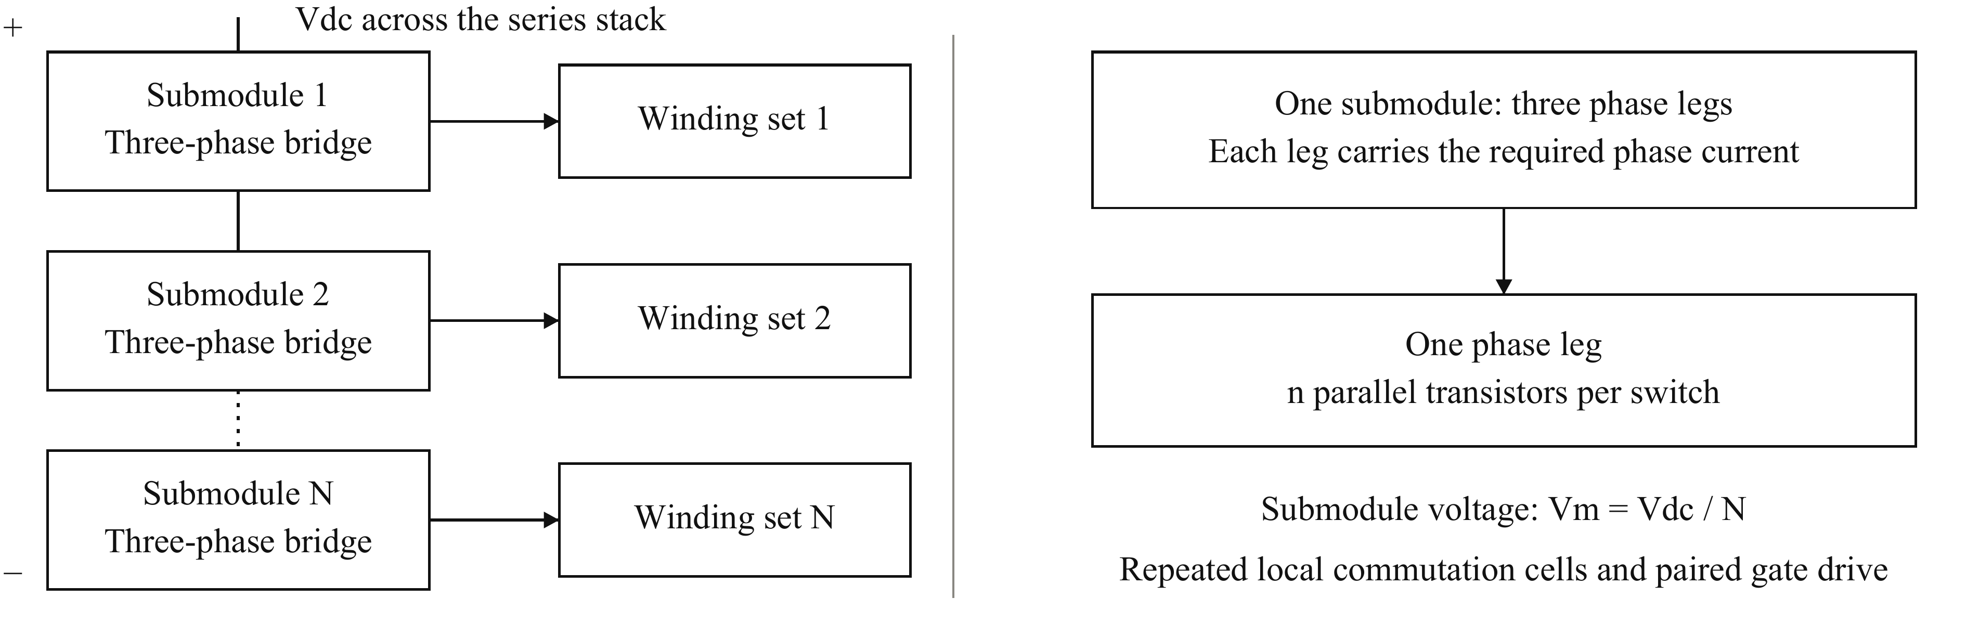
Fig. 1. SPB voltage partition and building-block hierarchy. Series-connected dc inputs distribute the traction voltage among N three-phase submodules. Each submodule supplies an isolated winding set. Each phase leg uses n parallel transistors per switch to carry the required phase current. The parallel count is an implementation choice, whereas N also determines the converter voltage partition.
Table I gives the drive specification and the provisional voltage partition used for the switching study. The latter is a candidate to be tested, not a conclusion that the selected device can already withstand all commutation events.
TABLE I
DRIVE SPECIFICATION AND CANDIDATE VOLTAGE PARTITION
Parameter | Value | Parameter | Value
V_{dc} / P | 1200 V / 300 kW | Switching frequency | 50 kHz
M / cos φ | 1.15 / 0.90 | Phase rms / peak current | 228 A / 322 A
Candidate N / V_{m} | 16 / 75 V | Drain-voltage target | 90 V
Junction-temperature limit | 125 °C | Ambient temperature | 40 °C

B. Voltage class and device screening
For n parallel transistors per switch, stack conduction loss scales with N I_{ph,rms}² R_{DS(on)}/n, while output-charge loss scales with N n f_{sw} C_{oss,tr} V_{m}². The on-resistance is R_{DS(on)}, f_{sw} is the switching frequency, and C_{oss,tr} = Q_{oss}/V_{test} is the charge-equivalent output capacitance obtained from datasheet charge Q_{oss} at test voltage V_{test}. Defining the device figure of merit (D-FoM) as R_{DS(on)} C_{oss,tr}, minimization of this simplified sum over a continuous parallel count gives
$P_{min} ∝ V_{dc} I_{ph,rms} \sqrt{f_{sw} D-FoM}, D-FoM = R_{DS(on)} C_{oss,tr}$ (2)
This screening step compares device technologies at the stack level before committing to an integer device count. Fig. 2(a) shows the best surveyed candidate in each voltage class: EPC2361, EPC2215, EPC2050, and IGT65R140D2, respectively. EPC2361 gives the lowest D-FoM in the surveyed set and includes a Kelvin source connection [9]. It is selected for the single-cell switching study. Typical room-temperature on-resistance and charge-equivalent capacitance at the respective datasheet test voltages are used; temperature dependence and nonlinear switching behavior are evaluated subsequently.
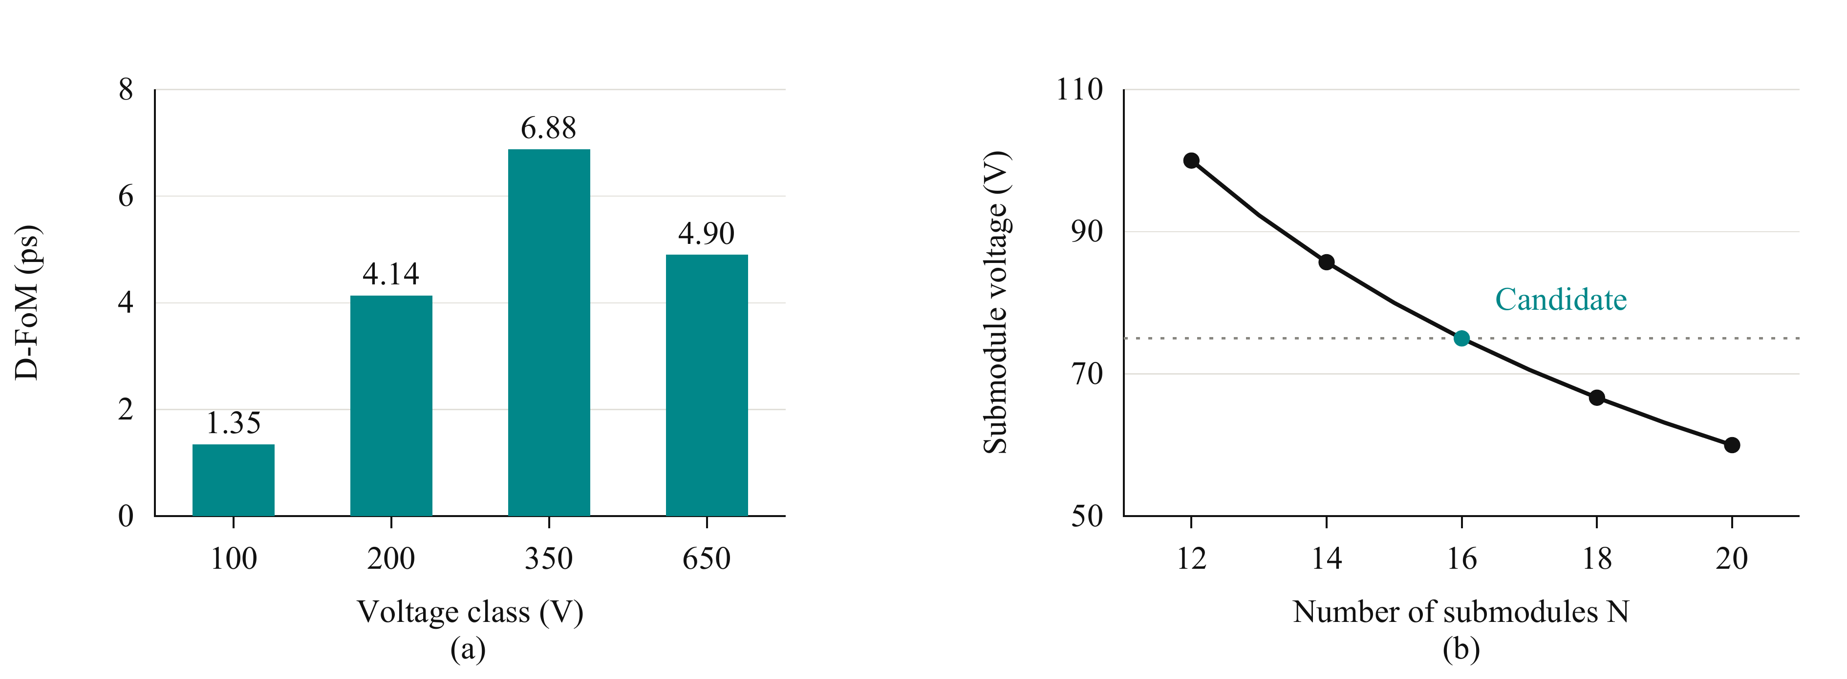
Fig. 2. Initial device and voltage-partition screens. (a) Minimum surveyed D-FoM in each voltage class. (b) Submodule voltage for a fixed traction dc bus; the highlighted point is the provisional partition in Table I. The grey dotted line marks the candidate submodule voltage. Neither screen establishes the final switching margin.

C. A candidate voltage with an explicit inductance target
The candidate submodule voltage is chosen with switching headroom, rather than by applying a fixed fraction of the device rating alone. The peak drain-to-source voltage V_{DS,pk} is screened using V_{DS,pk} ≈ V_{m} + L_{loop} |di/dt|, where L_{loop} and di/dt refer to the inductance and current slew rate of the same cell path. A compact loop of 0.5 nH is used as the initial layout target, with 1 nH as a pessimistic comparison. The candidate partition is retained as a practical starting point that avoids adding further complete submodules.
The analytical screen is not a proof of compliance. For example, the gate-charge estimate around 80 A per device gives a submodule ceiling near 73 V at the smaller assumed inductance, slightly below the candidate voltage. The difference makes switching speed an explicit design variable. Detailed single-cell simulation must therefore determine the usable current range, and the routed-board model must ultimately confirm or revise the voltage and drive choice. Even N is retained for the intended symmetric winding arrangement; it is not a general requirement of every SPB implementation.

III. Single Cell Characterization and Selection of the Parallel Count

A. A single-cell model establishes the current scale
One EPC2361 is first modeled in each position of a half bridge at the candidate submodule voltage. This model uses the selected driver output impedances, a preliminary 1.7 nH gate loop, and 2 Ω turn-on resistance with a low-impedance turn-off path. The two assumed commutation inductances are evaluated over device current. Switching energies from these runs provide the loss map used in the parallel-count comparison. The model intentionally precedes the detailed multi-device layout, so the initial count can be selected without first building and extracting every candidate board.
Fig. 3(a) shows the resulting voltage stress. The compact-loop case supports operation in the vicinity of 80 A per device, whereas a higher device current loses the intended margin. This establishes a useful current scale rather than a hard current rating. Dividing the required phase-current peak by that scale points to approximately four transistors per switch. The neighboring counts are then checked instead of accepting this division as sufficient justification.
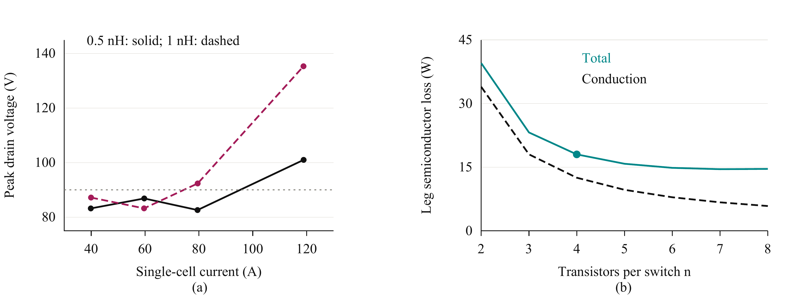
Fig. 3. Selection of the parallel count from single-cell data. (a) Simulated single-cell peak drain voltage for 0.5 nH (black solid) and 1 nH (wine dashed); markers denote simulated operating points and the grey dotted line is the voltage target. (b) Fundamental-period total semiconductor loss (teal solid) and conduction loss (black dashed) versus n at 0.5 nH, with the selected count marked. Losses use the design point in Table I and the preliminary drive model.

B. A short electrical and thermal comparison
Table II compares the relevant parallel counts using equal phase current, switching frequency, and single-cell drive assumptions. Conduction loss is calculated with temperature-dependent on-resistance. Switching energies are averaged over the fundamental current waveform, and junction temperature and on-resistance are solved together. The thermal boundary uses the ambient and temperature limit in Table I, a 0.65 K/W heatsink for the complete leg, and a 7.6 K/W junction-to-heatsink path per device. The same per-device path is assumed for the count comparison.
TABLE II
PARALLEL-COUNT COMPARISON FROM THE PRELIMINARY SINGLE-CELL MODEL
n | Peak current per device (A) | Leg loss (W) | Estimated T_{j} (°C) | Peak V_{DS} at 0.5 / 1 nH (V)
2 | 161 | 39.5 | 141 | 131 / 180
3 | 107 | 23.2 | 84 | 96 / 123
4 | 80.5 | 18.0 | 69 | 83 / 93
5 | 64.4 | 15.8 | 62 | 86 / 85
6 | 53.7 | 14.8 | 59 | 86 / 84
Two devices fail both the thermal and voltage screens. Three reduce temperature sufficiently but still exceed the drain-voltage target even with the compact loop. Four are the smallest tested count satisfying the preliminary electrical and thermal requirements in that case. Additional devices reduce loss further, as Fig. 3(b) shows, but are not needed to pass the initial screens. The choice of four is therefore the smallest adequate candidate under the stated assumptions, not the absolute minimum of semiconductor loss.
This decision also has a straightforward implementation: four devices can be divided into two identical driver pairs. Pairing does not replace the electrical check; it provides a practical arrangement for the count already indicated by that check. The higher-inductance result remains outside the target for the selected count, so a low commutation inductance and controlled switching speed become requirements for the detailed board. Current sharing and gate-drive loading are evaluated next to determine whether the assumed single-device behavior can be retained when the devices operate together.

C. Switching frequency and local energy storage
Before routing the cells, the switching frequency and capacitor arrangement establish the remaining local current paths. The study uses a design frequency of 50 kHz, balancing semiconductor loss against dc-link charge ripple and winding-current ripple. The final allowable frequency depends on the machine leakage inductance and operating point. The capacitor bank is sized for the three-phase submodule, because its three leg banks share the switching-frequency ripple through the common dc bus.
A 3% peak-to-peak voltage-ripple target requires approximately 127 µF effective bank capacitance per leg board in the switching-function calculation. The selected bank uses twenty nominal 22 µF, 100 V multilayer ceramic capacitors, with their dc-bias derating included. A separate set of ten nominal 1 µF bypass capacitors per cell supplies the fast commutation edge. Bank charge capacity and local loop inductance are therefore addressed separately. These capacitor placements are carried into the routed geometry and the extracted switching model; detailed ripple-sharing and capacitor comparisons can be reported in the full paper.

IV. Translating the Parallel Count into a Gate Drive and Cell Layout

A. Dynamic sharing as a design constraint
The parallel-count calculation assumes that each transistor carries an appropriate share of the phase current. During switching, that assumption depends on gate and source impedances, not only on the number of devices. Unequal transient loading can increase the loss and stress of one transistor even when the average current is acceptable. The nominal current capability obtained by dividing the total current by n is therefore useful only if the hardware supports balanced commutation.
Table III summarizes the two-device sensitivity study at the candidate submodule voltage and a total current of 120 A. Gate-loop and common-source mismatch produce the largest switching-energy imbalance. The power-path perturbation has a much smaller effect in this particular comparison. The design implication is to preserve individual Kelvin returns and equalize the complete gate branches, while repeating the local power cells. These results motivate the layout arrangement; they do not eliminate device-parameter or driver-timing spread.
TABLE III
SENSITIVITY OF SWITCHING-ENERGY SHARING
Perturbation | Energy imbalance | Layout implication
Power-path inductance +0.3 nH | Negligible | Repeated commutation cells
Gate loops 2 and 8 nH | 19% | Equal gate branches
No Kelvin return; source mismatch +0.2 nH | 29% | Individual Kelvin returns

B. Gate drive in symmetric pairs
The phase leg is implemented as four local commutation cells. Each cell contains one high-side and one low-side transistor with nearby bypass capacitors. Two cells form a driver block, arranged with point symmetry around the driver. One dual-channel 2EDF7275K serves each block: one output channel drives its high-side transistor pair and the other drives its low-side pair. Two driver integrated circuits therefore serve the complete eight-transistor phase leg. Individual gate resistors and individual Kelvin returns preserve the symmetry within each pair.
The selected driver provides 4 A source and 8 A sink capability per channel [10]. The driver-loading study gives a quantitative reason to divide the selected count into pairs: driving four devices from one channel increases turn-on energy by approximately 31% relative to two, and the predicted sink-current demand exceeds the channel rating. One channel per device avoids the common gate-charge load but increases driver and supply count. One channel per pair is therefore the intermediate arrangement that retains a short, symmetric gate network without assigning all four gates to one output.
A strong sink path is particularly important when the opposite switch commutates, because Miller current can raise the held-off gate voltage. The sink-current rating is only one part of that path. The common driver-to-star inductance must also be limited; it is checked by extraction after the branch geometry has been made symmetric.
The resulting design must satisfy two distinct requirements. Branch symmetry limits dynamic imbalance between parallel devices, while low absolute gate-loop impedance limits delay, ringing, and held-off gate rise. A geometrically balanced network can satisfy the first requirement and still fail the second. This distinction determines why extraction of the gate network is needed in addition to extraction of the commutation loop.

C. Timing between the two driver pairs
Pairing introduces a second sharing question: the two driver blocks must commutate together. Symmetry within one pair does not remove a delay between the blocks. For a delay Δt, a reduced model gives a current redistribution ΔI ≈ V_{m} Δt/L_{x}, where L_{x} is the inductance between the two pair switch nodes. The extracted load-board path predicts a low-side current change of order 14 A per nanosecond of skew in this model. The actual imbalance depends on the switching trajectory and the driver delays.
Both blocks consequently use a common pulse-width modulation source and matched input paths. The DPT arrangement measures the individual cell currents and the gate voltages of both blocks, allowing the inter-pair timing to be checked. Timing mismatch remains a validation requirement; equal nominal gate branches alone are not presented as proof of robust four-device sharing.

V. Closing the Design Loop with the Routed Building Block

A. Layout and extraction procedure
Fig. 4 summarizes the resulting sequence. The first pass selects the device and candidate submodule voltage, characterizes one cell, and compares a small number of parallel counts. The capacitor arrangement and paired gate drive then translate that candidate into a KiCad layout. Only at this stage are the routed power and gate networks extracted in Ansys Q3D and inserted into LTspice. Extraction verifies the initial assumptions and supplies the revision loop; it is not required to justify the first parallel-count estimate. A failed stress or sharing check first leads to gate-drive or layout changes, and returns to V_{m} or n if the required margin cannot be recovered locally.
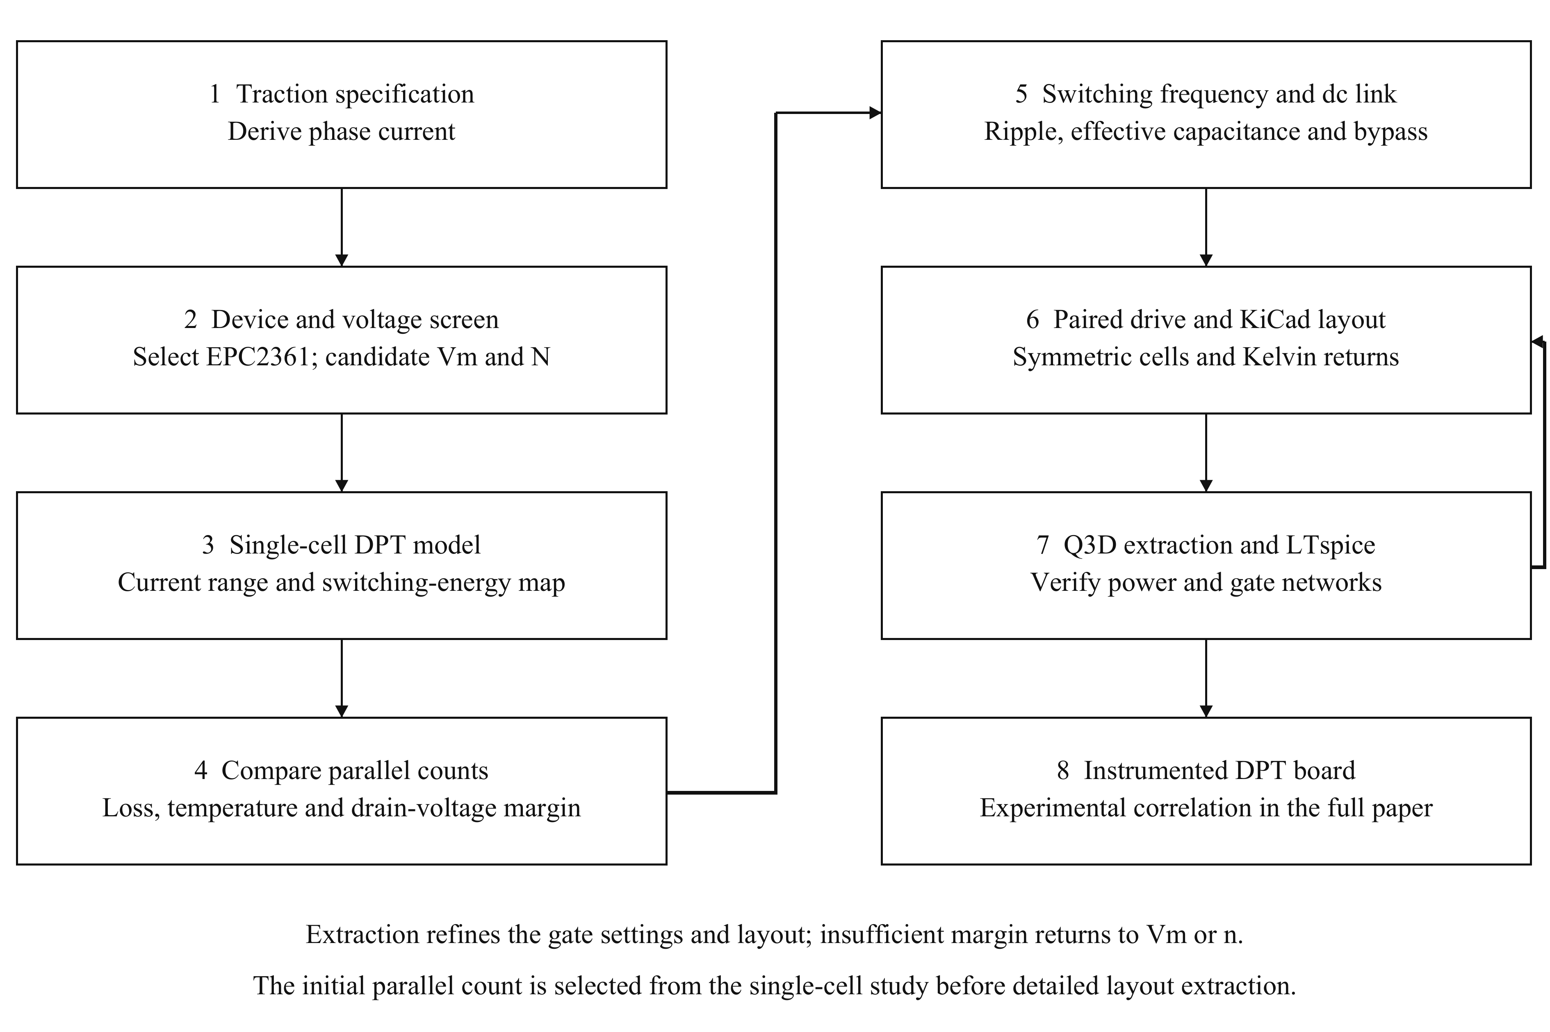
Fig. 4. Sequential first-pass design and subsequent extraction-based refinement. A single-cell model supplies the current range and switching-energy data for the initial parallel-count comparison. Frequency, capacitance, and paired drive define the geometry to be routed. Extracted-network switching simulations then refine the layout and gate settings, with feedback to the candidate voltage or count if needed. DPT measurements are planned for the full paper.
Fig. 5 shows the two phase-leg variants and the extraction geometry. Both use four copper layers, closely adjacent power planes, and repeated local commutation cells. Distributed bypass capacitors close the fast current paths, while the larger capacitor bank supplies switching-frequency charge. The DPT board adds a coaxial shunt in each cell to resolve individual currents. The operating board removes the shunts and incorporates the intended cooling arrangement. The measurement circuit is thus an explicit variant of the power stage, rather than an electrically transparent attachment.
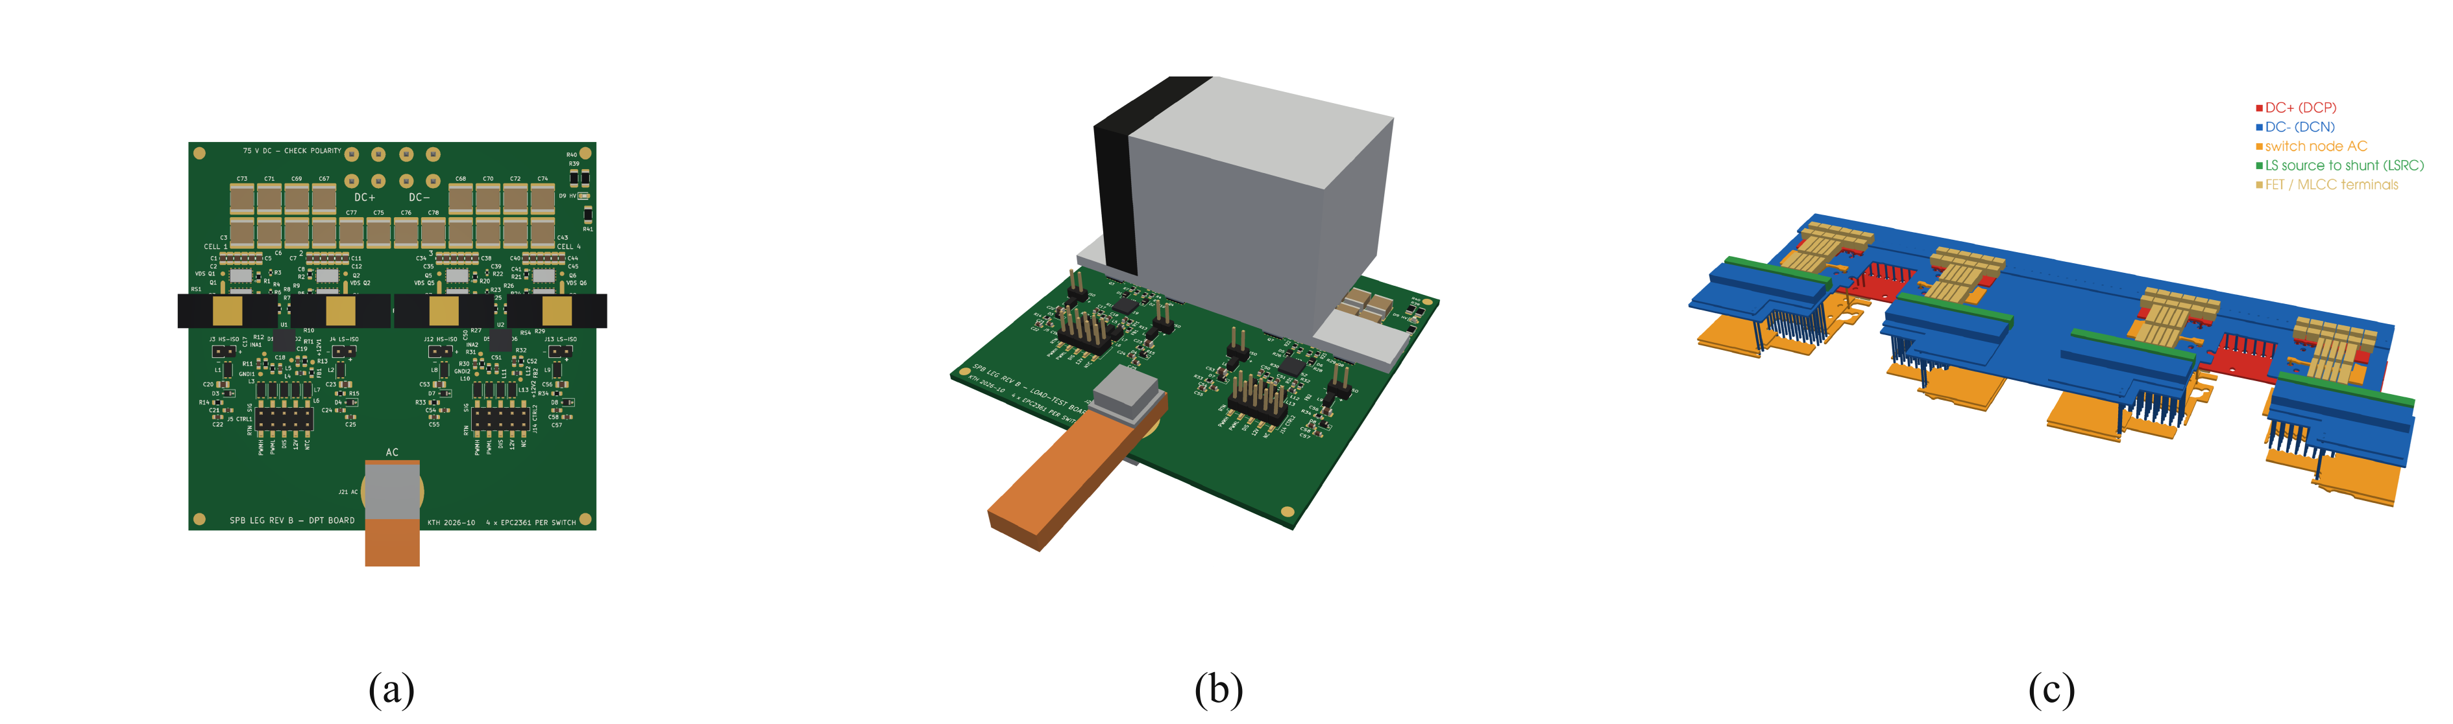
Fig. 5. Building-block implementation. (a) DPT board with individual cell-current sensing. (b) Operating board with heatsink. (c) Q3D geometry of the instrumented cells; vertical dimensions are exaggerated for visibility. The panels show board designs and extraction geometry, not experimental switching operation.
The commutation-cell region is extracted at 100 MHz for the power-loop inductance, and the full board at dc for the resistance matrix. Mutual inductances are retained. Capacitor equivalent series inductance and shunt inductance are added consistently to the copper network. The effective loop of one cell is evaluated with all parallel cells commutating. The repeated geometry gives symmetric cell loops at the reporting precision, while the shunts and their connections increase the instrumented-board loop.

B. Separating gate symmetry from gate inductance
The gate extraction separates the common driver-to-star path from the individual gate and Kelvin branches. For simultaneous pair switching, the effective high-side and low-side gate-loop inductances are 20.6 and 12.3 nH. The substantial common portions explain how matched branches can coexist with an appreciable effective loop. They also show why replacing the routed gate network by an assumed small lumped inductance can give the wrong drive setting even when current sharing appears satisfactory.
The extraction therefore tests the assumptions used in the initial selection, rather than merely assigning a final inductance to a completed layout. A small power loop supports the selected submodule voltage, but the gate network determines the switching trajectory through that loop. Both networks must be represented before the overshoot and gate-bump constraints can be used to judge the chosen SPB building block.

VI. Switching Results and Feedback to the SPB Design

A. Simulation conditions
The extracted copper networks are combined with eight manufacturer transistor models, bias-dependent bypass capacitance, component inductances, and source/sink drive networks representing the selected driver output impedances. The operating-board comparisons retain the preliminary 1.7 nH lumped gate model. The DPT-board comparisons include the extracted gate network and its component interconnects. The distinction limits what can be concluded from each case: the operating-board results assess its extracted power network, while the DPT results also test the routed gate-drive assumption.
All cases use the candidate submodule voltage in Table I. The simulated current at the first turn-off is approximately 316 A, close to the nominal design peak. The effective turn-on resistance is denoted R_{g,on}; for the DPT pair it includes the contribution of the common resistor during simultaneous switching. Turn-on energy E_{on} is integrated over the commutation interval and averaged over the four active devices. These peak-current energies are used to compare switching configurations and are distinct from the fundamental-period operating loss.

B. Current sharing and drain stress
Fig. 6(a) shows the DPT cell currents at the second turn-on. The nominal symmetric model produces equal switching-energy sharing at the reporting precision. This supports the repeated-cell and paired-drive arrangement under matched device and timing assumptions. It does not establish sharing under manufacturing spread. The current rise also illustrates why the voltage screen must be closed with a switching model: the current trajectory is affected by the drive and coupled parasitic network.
Fig. 6(b) compares the most highly stressed high-side transistor in each configuration, and Table IV gives the corresponding energy and peak-voltage results. The critical event is low-side turn-on, during which the held-off high-side transistor is charged. Thus the relevant voltage margin cannot be assessed only from the active transistor turn-off waveform. The commutation model must include both switches and their local capacitor path.
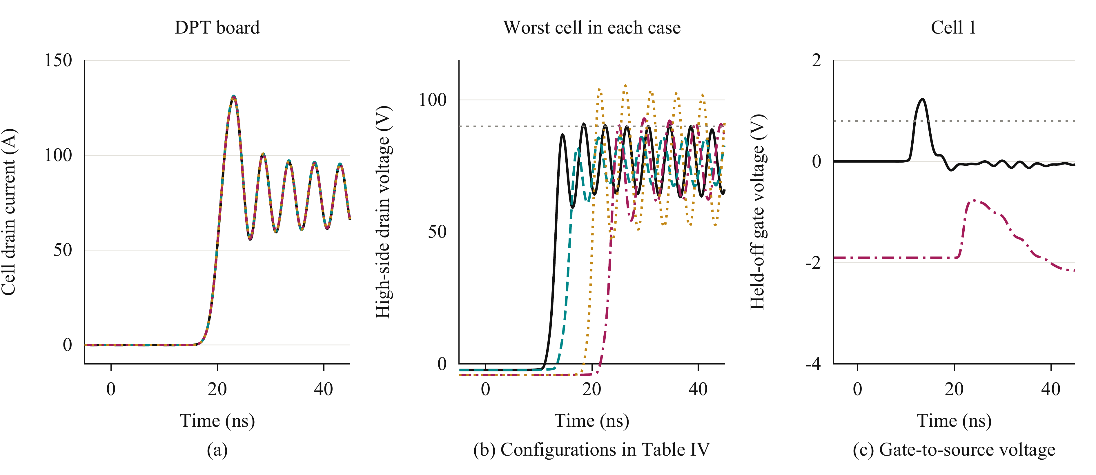
Fig. 6. Extracted-network DPT simulations. (a) DPT cell currents; cells 1–4 use solid, dashed, dash-dot, and dotted lines. (b) Worst-cell high-side drain voltage: operating board at 2 Ω (black solid) and 3 Ω (teal dashed), DPT board at 3.5 Ω (wine dash-dot) and 2.5 Ω (ochre dotted). (c) High-side gate-to-source voltage of cell 1 for the baseline operating board and adjusted DPT board, with the same case styles. Grey dotted lines mark the drain-voltage target and minimum gate threshold. Time is relative to the second turn-on command.
TABLE IV
EXTRACTED-NETWORK SIMULATION RESULTS
Board and gate model | Effective loop (nH) | R_{g,on} (Ω) | Peak V_{DS} (V) | Mean E_{on} per device (µJ)
Operating, lumped gate | 0.41 | 2.0 | 91 | 27.3
Operating, lumped gate | 0.41 | 3.0 | 86 | 32.8
DPT, lumped gate | 0.65 | 3.5 | 90 | 34.1
DPT, extracted gate | 0.65 | 2.5 | 105 | 24.3
DPT, extracted gate | 0.65 | 3.5 | 93 | 31.2
Table IV first shows the loss-versus-stress tradeoff when the operating-board turn-on resistance is increased. The DPT rows then isolate the importance of the gate model: at equal effective resistance, replacing the lumped gate loop by the extracted network raises the peak stress. The lower-resistance extracted case exceeds the device blocking rating, while the implemented slower setting brings the peak below that rating but not below the target in Table I. The initial choice of four devices remains supported, but the routed DPT board requires further voltage-margin refinement. These are distinct conclusions: selecting the parallel count is an initial sizing decision, whereas closing the switching margin requires the extracted network.

C. Held-off gate disturbance
Fig. 6(c) shows the complementary gate constraint. With zero off-state bias, the simulated gate rise can exceed the minimum threshold specified in [9]. Slowing turn-on reduces the drain overshoot, but it does not by itself establish that the opposite transistor remains off. A low-impedance sink path and controlled gate return are needed in addition to the turn-on adjustment.
The instrumented-board configuration uses −1.9 V off-state bias to keep the held-off gate below threshold. Its approximately −3.4 V negative ringing remains within the −4 V gate limit. This is a response to the extracted gate network, rather than an assumed requirement of the selected transistor. Shortening the shared gate path addresses the physical cause directly and may reduce reliance on negative bias. Any further slowing or bias change must be included in the loss assessment because switching energy and reverse-conduction loss are also affected.

VII. Implications for SPB Traction Optimization and Experimental Validation
The results connect the building-block design to the main SPB optimization decision. The voltage partition determines which devices can be considered, but the realizable commutation and gate networks determine the usable fraction of their blocking capability. A partition selected only from the device figure of merit may require drive settings that erode its expected switching-loss benefit. Conversely, reducing the local parasitics can preserve voltage margin without increasing the number of submodules or further slowing the transition.
This connection is particularly important in a traction SPB because the same phase-leg design is repeated across the three phases of every submodule. A local loss penalty is repeated throughout the converter. Increasing N to reduce submodule voltage also adds repeated semiconductor and driver stages. The value of layout optimization is therefore broader than reducing an isolated overshoot peak: it can determine whether a favorable low voltage device class can be used with the intended stack partition and current capability. The present study quantifies the local semiconductor and switching constraints; a complete drive optimum would additionally include auxiliary power, insulation, machine winding arrangements, and cooling.
The two board variants also clarify how the design should be evaluated. The instrumented loop must be represented when comparing DPT measurements with simulation, because its shunts alter the switching stress. That additional stress should not be attributed unchanged to the intended operating stage. At the same time, the operating-board result cannot substitute for validation of its routed gate network. Keeping the two cases explicit allows the measurement model to be correlated without overstating the operating margin of the final converter.
The full paper will include DPT measurements of the individual cell currents, switching energies, drain overshoot, and held-off gate voltage. Measurements will be compared with simulation at identical voltage, current, and drive settings, with the shunts and probe connections retained in the test model. Experimental correlation will determine whether the remaining voltage margin requires a further gate-drive or layout revision.

VIII. Conclusion
The voltage-partitioning freedom of an SPB becomes useful for traction conversion only when the selected low voltage bridge is realizable at the required phase current. This paper links device-voltage and parallel-count selection to dynamic sharing, gate-drive capability, and extraction of the routed building block. The surveyed device characteristics motivate EPC2361, while the loss and voltage-stress study selects four parallel transistors per switch for the candidate stack partition. Symmetric commutation cells and paired gate drive support balanced nominal switching, but extraction shows that shared gate inductance and measurement parasitics still determine the drive settings and available voltage margin. The contribution is this hardware-constrained connection between SPB architecture and phase-leg implementation. It provides a basis for refining the submodule voltage and layout together, with experimental DPT correlation planned for the full paper.

References
[1] S. Norrga, L. Jin, O. Wallmark, A. Mayer, and K. Ilves, “A novel inverter topology for compact EV and HEV drive systems,” in Proc. IECON, 2013, pp. 6590–6595.
[2] L. Jin, S. Norrga, O. Wallmark, and M. Nikouei Harnefors, “Control and modulation of the stacked polyphase bridges inverter,” in Proc. IEEE ECCE, 2014.
[3] L. Jin, S. Norrga, O. Wallmark, and N. Apostolopoulos, “Modulation and power losses of a stacked polyphase bridge converter,” IEEE J. Emerg. Sel. Topics Power Electron., vol. 5, no. 1, pp. 409–418, Mar. 2017.
[4] M. Nikouie, O. Wallmark, L. Jin, L. Harnefors, and H.-P. Nee, “DC-link stability analysis and controller design for the stacked polyphase bridges converter,” IEEE Trans. Power Electron., vol. 32, no. 2, pp. 1666–1674, Feb. 2017.
[5] G. Rohner, J. Huber, S. Mirić, and J. W. Kolar, “Comparative evaluation of three-phase three-level flying capacitor and stacked polyphase bridge GaN inverter systems for integrated motor drives,” Electronics, vol. 13, no. 7, Art. no. 1259, 2024, doi: 10.3390/electronics13071259.
[6] J. A. Brothers and T. Beechner, “GaN module design recommendations based on the analysis of a commercial 3-phase GaN module,” in Proc. IEEE ECCE, 2019, pp. 4109–4116.
[7] J. Lu and D. Chen, “Paralleling GaN E-HEMTs in 10 kW–100 kW systems,” in Proc. IEEE APEC, 2017, pp. 3049–3056.
[8] M. T. Tran et al., “A high-performance GaN power module with parallel packaging for high-current and low-voltage traction inverter applications,” IEEE J. Emerg. Sel. Topics Power Electron., vol. 13, no. 1, pp. 1188–1209, Feb. 2025.
[9] Efficient Power Conversion, “EPC2361 eGaN FET datasheet,” Feb. 20, 2026. [Online]. Available: https://epc-co.com/epc/Portals/0/epc/documents/datasheets/EPC2361_datasheet.pdf
[10] Infineon Technologies, “2EDF7275K data sheet,” rev. 2.8. [Online]. Available: https://www.infineon.com/part/2EDF7275K

