Parasitic Aware Building Block Design for Stacked Polyphase Bridge Traction Inverters
17. Power Electronics for Transportation Electrification
Abstract— The stacked polyphase bridge (SPB) introduces a voltage-partitioning degree of freedom into high-voltage traction inverters: the number of series-connected submodules determines the required semiconductor voltage class. However, increasing the number of submodules does not reduce the phase current, making switches paralleling necessary and introducing dynamic current-sharing challenges associated with unequal parasitic impedances. This paper presents a hardware-constrained design procedure for the phase-leg building block of an SPB traction inverter. A device figure of merit based on on-state resistance and output charge identifies the 100 V EPC2361 as the preferred candidate among the surveyed devices. Single-cell switching simulations establish a usable current range per single switch. A subsequent comparison of losses, junction temperature, and drain–source voltage stress supports the selection of four parallel devices per switch position for a candidate configuration with sixteen submodules. Current-sharing sensitivity informs a symmetric cell arrangement with one gate-driver channel per device pair. An iterative KiCad–Ansys Q3D–LTspice workflow then evaluates and refines the routed power and gate networks. The contribution lies in linking SPB voltage partitioning and device selection to the physical constraints of a realizable building block, identifying the conditions required to exploit low-voltage devices in high-voltage traction drives. Experimental double-pulse tests are planned for the full paper to assess the predicted switching losses and parasitic effects.

Introduction
Electrification is driving traction and fast-charging power levels toward several hundred kilowatts, while demands for efficiency and power density continue to increase. Raising the dc-link voltage is a key design choice for meeting these requirements, although traction inverters must still deliver substantial phase current. In a conventional two-level traction inverter, each switch must block the full dc-link voltage and conduct the phase current, making semiconductor losses a central design constraint. The stacked polyphase bridge (SPB) introduces an additional design degree of freedom by connecting three-phase bridges in series on the dc side, with each bridge feeding an isolated winding set of a multiphase machine [1], [2]. Distributing the dc-link voltage among submodules allows each bridge to use a lower semiconductor voltage class and apply smaller voltage steps to its winding set. Consequently, voltage partitioning becomes an active design choice that links the converter architecture to device selection. The benefit of this freedom depends on realizing a practical high-current submodule. Increasing the number of submodules reduces the voltage across each bridge but does not reduce the phase current for a given total drive power, dc-link voltage, modulation index, and power factor. The design must therefore combine the potential loss advantages of low-voltage devices with the current-handling capability, current sharing, and parasitic constraints of the physical building block.

Low-voltage gallium nitride (GaN) devices can offer favorable on-resistance and switching charge, yet several devices may be needed in parallel. Their current sharing, gate drive, and commutation paths then determine how much of the expected loss benefit can be retained. The additional submodules also repeat the gate-drive, auxiliary-supply, and interconnection requirements throughout the converter.
The literature establishes SPB modulation and loss characteristics [2], [3], dc-link stability [4], and comparisons with alternative GaN converter systems [5]. These studies provide the system context for selecting a submodule voltage. Work on paralleled GaN stages identifies complementary hardware constraints, including commutation-loop inductance, source coupling, and unequal gate impedances [6]–[8]. Taken together, these results indicate that the voltage partition cannot be selected from device data alone: the chosen low-voltage bridge must also be realizable at the required traction current.
The problem addressed here is therefore the coupling between SPB voltage partition and building-block implementation. A larger number of lower-voltage submodules may improve the device-level loss comparison, but insufficient switching margin can force slower commutation or a further reduction of submodule voltage. Conversely, reducing the commutation inductance may allow the selected voltage partition to be retained. Gate-loop impedance determines whether that low-inductance power stage can be driven without excessive gate disturbance or unequal transient loading. The hardware constraints feed back into the converter architecture.
This paper develops a phase-leg building block through that feedback. Its contribution is a design sequence that turns the traction-current requirement into a single-cell switching study and a small parallel-count comparison, then translates the selected count into a paired gate drive and a routed board. Extraction of the power and gate networks closes the assumptions made during this first-pass sizing. An instrumented double-pulse test (DPT) board and an operating board separate the parasitics required for measurement from those of the intended converter. The study connects the architecture-level voltage choice to the switching quantities that determine hardware feasibility.

Here is a subsection
Here is a subsection. Here is a subsection. Here is a subsection. Here is a subsection. Here is a subsection. Here is a subsection. Here is a subsection. Here is a subsection.

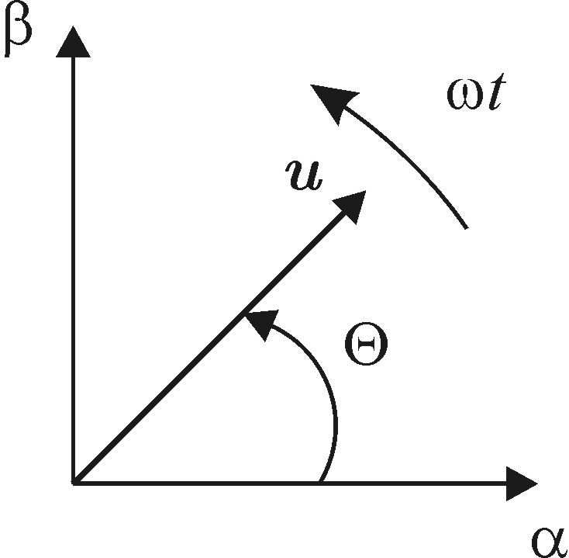
Fig. 1: Figure in a two columns paper

Next Section Text
Next section text. Next section text. Next section text. Next section text. Next section text. Next section text. Next section text. Next section text. Next section text. Next section text. Next section text. Next section text. Next section text. Next section text. Next section text. Next section text. Next section text. Next section text. Next section text. Next section text. Next section text.

A. Your subsection text
Your subsection text. Your subsection text. Your subsection text. Your subsection text. Your subsection text. Your subsection text. Your subsection text. Your subsection text. Your subsection text. Your subsection text. Your subsection text. Your subsection text. Your subsection text. Your subsection text. Your subsection text. Your subsection text. Your subsection text. Your subsection text. Your subsection text. Your subsection text. Your subsection text. Your subsection text.
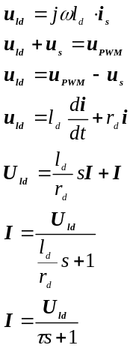
(2)
(1)
B. Subsubsection Heading Here
Subsection is here. Subsection is here. Subsection is here. Subsection is here. Subsection is here. Subsection is here. Subsection is here. Subsection is here. Subsection is here. Subsection is here. Subsection is here. Subsection is here. Subsection is here. Subsection is here. Subsection is here. Subsection is here. Subsection is here. Subsection is here. Subsection is here. Subsection is here. Subsection is here. Subsection is here. Subsection is here. Subsection is here. Subsection is here. Subsection is here. Subsection is here. Subsection is here. Subsection is here. Subsection is here. Subsection is here. Subsection is here. Subsection is here. Subsection is here. Subsection is here. Subsection is here. Subsection is here. Subsection is here. Subsection is here

Conclusion
Here goes conclusion. Here goes conclusion. Here goes conclusion. Here goes conclusion. Here goes conclusion. Here goes conclusion. Here goes conclusion. Here goes conclusion. Here goes conclusion. Here goes conclusion. Here goes conclusion. Here goes conclusion. Here goes conclusion. Here goes conclusion. Here goes conclusion. Here goes conclusion. Here goes conclusion. Here goes conclusion. Here goes conclusion. Here goes conclusion. Here goes conclusion. Here goes conclusion. Here goes conclusion. Here goes conclusion. Here goes conclusion. Here goes conclusion. Here goes conclusion. Here goes conclusion. Here goes conclusion. Here goes conclusion. Here goes conclusion. Here goes conclusion. Here goes conclusion. Here goes conclusion. Here goes conclusion. Here goes conclusion. Here goes conclusion. Here goes conclusion. Here goes conclusion. Here goes conclusion. Here goes conclusion. Here goes conclusion. Here goes conclusion. Here goes conclusion. Here goes conclusion. Here goes conclusion. Here goes conclusion.

References
[1] And here is reference. And here is reference. And here is reference. And here is reference. And here is reference. [2] And here is reference. And here is reference. And here is reference. And here is reference. And here is reference. [3] And here is reference. And here is reference. And here is reference. And here is reference. And here is reference. [4] And here is reference. And here is reference. And here is reference. And here is reference. And here is reference.
[5] And here is reference. And here is reference. And here is reference. And here is reference. And here is reference. [6] And here is reference. And here is reference. And here is reference. And here is reference. And here is reference. [7] And here is reference. And here is reference. And here is reference. And here is reference. And here is reference. [8] And here is reference. And here is reference. And here is reference. And here is reference. And here is reference. [9] And here is reference. And here is reference. And here is reference. And here is reference. And here is reference.

Guideline for Digest Submission

- Papers presented at ICPE 2027-ECCE Asia must be original material and must not have been presented or published previously. All digests must comply with the export control laws of the country or countries in which the author(s) reside. A statement of compliance will be required as part of the submission process. All authors should obtain company and governmental clearance prior to submission of Digests. Digests marked or labeled as “Confidential”, “Proprietary” or with similar wording will not be accepted.
- The digest should give a clear and concise statement of the purpose and contribution of the work, specific results and the methods used. Include key equations, figures and tables. ICPE 2027-ECCE Asia reviewers highly value evidence of completed experimental work such as oscillograms and photos of equipment under test.
- Digest should be written in 5 pages or less, single column, and single-space on A4 sized format including figures and tables. Line space can be adjusted upto 1.5. Number all Digest pages. Digests should be submitted as the Adobe Acrobat PDF file (*.pdf).
- Please do not write authors' names and affiliations on the digest for peer review.
- CRITICAL: When submitting the digest, the corresponding author must ensure that the percentage of self-citations in the final paper does not exceed 25%.

