Integrated Auxiliary Power Supply Using Switching Harmonics in an Open-End Winding Traction Drive
Abstract
Electric vehicle powertrains conventionally employ a dedicated high-voltage to low-voltage DC/DC converter to supply auxiliary loads such as control electronics, cooling systems, and low-voltage buses. Although the auxiliary power demand is small compared with the traction power, the additional converter requires semiconductor devices, magnetic components, cooling, protection, and packaging. This paper proposes an integrated auxiliary power supply concept for an open-end winding traction drive. The modulation redundancy provided by the two traction inverters is utilized to control the high-frequency differential voltage across the machine winding while maintaining the required fundamental voltage for torque production. A parallel resonant branch, tuned close to a selected switching-frequency component, presents high impedance at the machine fundamental frequency and low impedance at the targeted harmonic. The resulting high-frequency power is rectified to supply a DC auxiliary load. The concept is evaluated in terms of obtainable auxiliary power, interaction with traction operation, and additional converter losses.

Introduction
Battery electric vehicle (BEV) drivetrains contain several power-electronic converters with different power and voltage ratings. The highest-power converters are traction inverters that energize and control the electric machine from the high-voltage battery [1], [2]. In addition, there are several auxiliary converters which are commonly utilized to supply low-voltage loads such as lighting, electronic control units, pumps, cooling systems, etc. [1].
These auxiliary converters require considerably smaller power compared to traction inverters. However, they usually need a high-voltage high-step-down converter where the design may be tricky regarding the selection of semiconductor devices, magnetic components, gate drivers, and cooling systems. Therefore, a system-level perspective shows that these converters increase the component count, volume, weight, and cost.
One smart idea here to mitigate these is to combine some of the converters to utilize the components more [3], [4]. For example, it is possible to put a pre-scaling stage, then a regulation stage can drive multiple ports. At the same time, the traction inverter continuously generates high-frequency voltage components as a consequence of pulse-width modulation (PWM). These components are normally treated as undesirable harmonics because they contribute to current ripple, additional losses, and electromagnetic interference [5], [6]. However, they also constitute a controllable high-frequency excitation that can potentially be used for another power-conversion function. An open-end winding (OEW) machine provides additional flexibility for controlling these components because both terminals of each phase winding are supplied by independent inverter legs [7],[8]. Different switching-state combinations can synthesize the same fundamental machine voltage while producing different high-frequency differential voltages.
This paper utilizes that modulation redundancy to generate auxiliary power from the traction drive. A resonant branch is connected in parallel with the machine winding and tuned near a selected switching-frequency component. The branch is designed to have high impedance at the machine fundamental frequency and low impedance at the selected harmonic.

The main contribution is an integrated auxiliary power supply concept in which the traction inverters simultaneously synthesize the fundamental machine voltage and a controllable high-frequency excitation for a resonant auxiliary branch. The approach therefore offers a possible method for reducing or simplifying the conventional dedicated high-voltage auxiliary converter.
PROPOSED SYSTEM CONFIGURATION
The proposed system is based on an OEW electric machine supplied by two voltage-source inverters, as shown in Fig.1. Considering phase A, the instantaneous winding voltage is determined by the difference between the two inverter terminal voltages:
V_{AA} (t) = V_{A+}(t) - V_{A-} (t) | (1)
The winding voltage can be separated conceptually into a fundamental component responsible for machine operation and high-frequency components introduced by PWM:
V_{AA}(t) = V_{AA,1}(t) + V_{AA,h}(t) | (2)
For normal traction operation, the fundamental component is selected according to the required machine torque and flux. The high-frequency component, however, depends strongly on the switching sequence and relative carrier phase shift of the two inverters. The proposed method uses this degree of freedom to control the high-frequency differential voltage without intentionally changing the fundamental voltage.
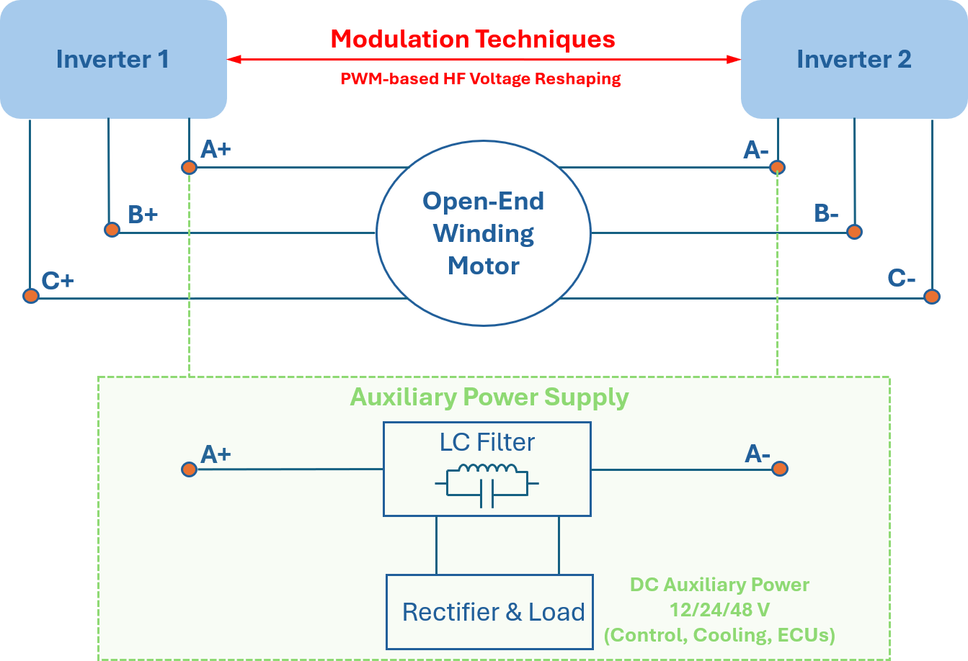
Figure 1: Proposed open-end winding traction drive with parallel resonant auxiliary power extraction branch.

A high-frequency resonant branch is connected in parallel with the machine phase, followed by a rectifier and a DC-side filter or auxiliary load. Its impedance is selected such that the branch draws only limited current at the fundamental frequency while providing a low-impedance path around the selected switching-frequency component.
|Z_{aux(f1)}| >> |Z_{aux(fs)}| | (3)
For a simplified LC resonant network, the nominal resonant frequency is
f_{r} = 1 / (2π√ (L_{aux} C_{aux})) | (4)
where L_{aux} and C_{aux} are selected so that the resonance is close to the targeted switching-frequency component. The resulting high-frequency current is subsequently rectified to obtain a DC auxiliary output.

MODULATION-BASED AUXILIARY POWER CONTROL
This section will be added to the final version.
RESONANT AUXILIARY POWER EXTRACTION AND DRIVE INTERACTION
This section will be added to the final version.
SYSTEM DESIGN AND RESULTS
This section will be added to the final version.
Conclusions and Future Work
This paper proposes an integrated auxiliary power supply for an open-end winding traction drive using modulation-controlled switching-frequency excitation. The two traction inverters synthesize the required fundamental machine voltage, while their carrier phase shift between them is used to control the high-frequency differential voltage across the winding. A parallel resonant branch selectively extracts this high-frequency power, and a rectifier converts it to a DC auxiliary supply. Compared with a conventional EV architecture, the proposed approach uses the existing traction switching stage as part of the auxiliary power-conversion process, potentially reducing dedicated semiconductor hardware and converter volume.
Future work will quantify auxiliary power capability, resonant-network stresses, additional losses, and operating-point dependence, followed by experimental validation.
References
[1] Kotb, R.; Chakraborty, S.; Tran, D.-D.; Abramushkina, E.; El Baghdadi, M.; Hegazy, O. Power Electronics Converters for Electric Vehicle Auxiliaries: State of the Art and Future Trends. Energies 2023, 16, 1753. https://doi.org/10.3390/en16041753

[2] Tu, CC., Hung, CL., Hong, KB. et al. Industry perspective on power electronics for electric vehicles. Nat Rev Electr Eng 1, 435–452 (2024). https://doi.org/10.1038/s44287-024-00055-4

[3] S. Mukherjee, V. Sujan, S. Chowdhury and O. Onar, "Multiport Converter based Auxiliary Power Supply for Heavy Duty Fuel Cell Power Train," 2024 IEEE Transportation Electrification Conference and Expo (ITEC), Chicago, IL, USA, 2024, pp. 1-6, doi: 10.1109/ITEC60657.2024.10598972

[4] I. Subotic, N. Bodo, E. Levi and M. Jones, "Onboard Integrated Battery Charger for EVs Using an Asymmetrical Nine-Phase Machine," in IEEE Transactions on Industrial Electronics, vol. 62, no. 5, pp. 3285-3295, May 2015, doi: 10.1109/TIE.2014.2345341.

[5] H. Matsumori, T. Kosaka, N. Matsui and S. Saha, "Alternative PWM Switching Strategy Implementation for a Dual Inverter Fed Open Winding Motor Drive System for an Electric Vehicle Application," in IEEE Transactions on Industry Applications, vol. 59, no. 5, pp. 5957-5970, Sept.-Oct. 2023, doi: 10.1109/TIA.2023.3291340.

[6] M. Khayamy and H. Chaoui, "Efficient PMSM-Inverter-Based Drive for Vehicular Transportation Systems," in IEEE Transactions on Vehicular Technology, vol. 67, no. 6, pp. 4783-4792, June 2018, doi: 10.1109/TVT.2018.2798359.

[7] Y. -F. Jia et al., "Power Flow Control Strategy Based on the Voltage Vector Distribution for a Dual Power Electric Vehicle With an Open-End Winding Motor Drive System," in IEEE Access, vol. 6, pp. 54910-54926, 2018, doi: 10.1109/ACCESS.2018.2872697.

[8] Q. An, J. Liu, Z. Peng, L. Sun and L. Sun, "Dual-Space Vector Control of Open-End Winding Permanent Magnet Synchronous Motor Drive Fed by Dual Inverter," in IEEE Transactions on Power Electronics, vol. 31, no. 12, pp. 8329-8342, Dec. 2016, doi: 10.1109/TPEL.2016.2520999.

