Topic 17 — Power Electronics for Transportation Electrification

Parasitic Aware Building Block Design for Stacked Polyphase Bridge Traction Inverters
Abstract—The stacked polyphase bridge (SPB) introduces a voltage-partitioning degree of freedom into high-voltage traction inverters: the number of series-connected submodules determines the required semiconductor voltage class. However, voltage partitioning does not reduce the phase current for a fixed drive operating point, making device paralleling and dynamic current sharing central implementation constraints. This paper presents a hardware-constrained design procedure for an SPB phase-leg building block. A device figure of merit based on on-state resistance and output charge identifies the 100 V EPC2361 as the preferred candidate among the surveyed devices. Single-cell simulations and an electrical and thermal comparison support four parallel transistors per switch position for a candidate arrangement of sixteen submodules. Current-sharing sensitivity informs a symmetric cell arrangement with one driver output channel per transistor pair. An iterative KiCad–Ansys Q3D–LTspice workflow evaluates the routed power and gate networks. The operating and instrumented double-pulse test boards have evaluated commutation-loop inductances of 0.41 nH and 0.65 nH, respectively. The extracted test-board gate network requires revised drive settings; the evaluated peak drain–source voltage remains approximately 93 V, above the 90 V design target. The study connects SPB voltage partitioning to the physical constraints governing the use of low-voltage devices at traction-current levels. Experimental double-pulse tests are planned for the full paper.
Index Terms—Gallium nitride, gate drive, parallel transistors, parasitic inductance, stacked polyphase bridge, traction inverter.

I. Introduction
Electrification is driving traction and fast-charging power levels toward several hundred kilowatts, while demands for efficiency and power density continue to increase. Raising the dc-link voltage is a key design choice for meeting these requirements, although traction inverters must still deliver substantial phase current. In a conventional two-level traction inverter, each switch must block the full dc-link voltage and conduct the phase current, making semiconductor losses a central design constraint. The stacked polyphase bridge (SPB) introduces an additional design degree of freedom by connecting three-phase bridges in series on the dc side, with each bridge feeding an isolated winding set of a multiphase machine [1], [2]. Fig. 1 illustrates the SPB topology and the phase-leg building block considered in this work. Distributing the dc-link voltage among submodules allows each bridge to use a lower semiconductor voltage class and apply smaller voltage steps to its winding set. Voltage partitioning therefore becomes an active design choice that links the converter architecture to device selection.
The benefit of voltage partitioning depends on realizing a practical high-current submodule. Increasing the number of submodules reduces the voltage across each bridge but does not reduce the phase current for a given total drive power, dc-link voltage, modulation index, and power factor. Low-voltage gallium nitride (GaN) devices can offer favorable on-state resistance and switching performance, but meeting the traction-current requirement may require several devices in parallel. Current sharing, gate-drive impedance, and commutation-loop parasitics then determine how much of the expected loss benefit can be retained. Increasing the submodule count also increases the number of gate-drive circuits, auxiliary supplies, and interconnections throughout the converter.
Previous studies establish SPB modulation and loss characteristics [2], [3], dc-link stability [4], and comparisons with alternative GaN converter systems [5]. These studies provide the system-level basis for selecting a submodule voltage. Research on paralleled GaN stages identifies complementary implementation constraints, including commutation-loop inductance, common-source coupling, and unequal gate impedances [6]–[8]. Together, these findings motivate a design procedure that considers voltage partitioning and high-current hardware implementation jointly.
The central challenge is the feedback between the selected submodule voltage and the physical building block. A lower device voltage class may offer favorable loss characteristics, but the available voltage margin must accommodate switching overshoot at the required current. Excessive commutation-loop inductance can require slower switching or a lower submodule operating voltage, potentially changing the initial loss comparison or the required submodule count. Gate-loop impedance and symmetry further constrain switching speed by affecting gate-voltage disturbances and dynamic current sharing. The practical benefits of SPB voltage partitioning therefore depend on optimizing the power and gate networks together.
This paper presents a hardware-constrained design procedure for an SPB phase-leg building block. Single-cell switching simulations establish a usable current range per device, and a comparison of losses, junction temperature, and voltage stress supports the selection of the parallel-device count. Current-sharing sensitivity then guides the cell arrangement and paired gate-drive configuration. An iterative layout, parasitic-extraction, and circuit-simulation workflow evaluates the routed power and gate networks and revisits the assumptions used during initial sizing. Separate operating and double-pulse test (DPT) boards distinguish the intended converter layout from the additional parasitics introduced by measurement provisions. The contribution is to connect SPB voltage partitioning and device selection to the physical constraints that determine whether the expected advantages of low-voltage devices can be realized at traction-current levels.
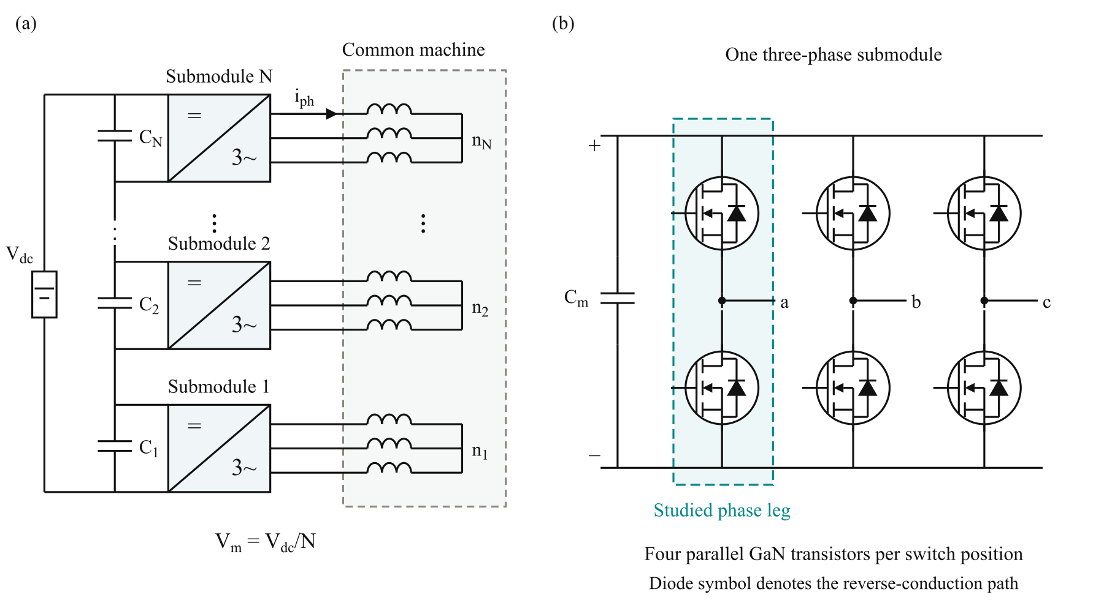
Fig. 1. (a) SPB traction-drive topology with N series-connected submodules, each supplying an isolated three-phase winding set of a common machine. (b) Three-phase submodule with the studied phase leg highlighted. Each switch symbol represents four parallel GaN transistors; the diode denotes the equivalent reverse-conduction path.

II. Traction Requirements and Initial Device Selection

A. Traction Drive Requirements
The building block is designed for the traction operating point and constraints summarized in Table I. For balanced operation with equal submodule voltages, the total active power is expressed as
$P = \frac{3 M V_{dc} I_{ph,rms} cos φ}{2\sqrt{2}}$ (1)
Here, V_{dc} is the total dc-link voltage, I_{ph,rms} is the rms phase current, and cosφ is the power factor. The modulation index M is defined such that the fundamental phase-to-neutral voltage peak of each submodule is M V_{m}/2. The specified operating point requires approximately 228 A rms and 322 A peak phase current.
TABLE I
DESIGN OPERATING POINT AND PRELIMINARY CONSTRAINTS
Quantity | Symbol | Value
Total active power | P | 300 kW
Total dc-link voltage | V_{dc} | 1200 V
Modulation index | M | 1.15
Power factor | cosφ | 0.9
Switching frequency | f_{sw} | 50 kHz
Candidate submodule count | N | 16
Nominal submodule voltage | V_{m} | 75 V
Peak drain–source voltage target | V_{DS,pk} | 90 V
Junction-temperature limit | T_{j,max} | 125 °C
Ambient temperature | T_{a} | 40 °C
The submodule count does not appear explicitly in (1). Increasing the number of series-connected submodules reduces the voltage supplied to each winding set while increasing the number of winding sets contributing to the total power. Consequently, voltage partitioning does not reduce the phase-current requirement under the stated operating conditions. The selected devices must therefore provide both an appropriate blocking-voltage rating and sufficient current-handling capability.

B. Semiconductor Voltage Class Comparison
Voltage partitioning allows the semiconductor voltage class to be selected together with the submodule count. This choice requires a comparison of conduction and switching characteristics rather than on-state resistance alone. Fig. 2 compares the typical on-state resistance R_{DS(on)} at 25 °C and the charge-equivalent output capacitance C_{oss,Q} of the surveyed GaN devices. The latter is calculated as
$C_{oss,Q} = \frac{Q_{oss}}{V_{test}}$ (2)
where Q_{oss} is the output charge at the datasheet test voltage V_{test}. This quantity accounts for the charge accumulated over the voltage excursion, whereas differential output capacitance describes the capacitance at a particular voltage. Following the charge-based screening criterion in [9], the device figure of merit is defined as
$D-FOM = \frac{1}{\sqrt{R_{DS(on)} C_{oss,Q}}}$ (3)
A higher D-FOM indicates a more favorable combination of conduction resistance and output charge. In the simplified hard-switching model underlying this criterion, optimizing semiconductor area gives minimum losses proportional to the square root of the resistance–capacitance product. Fig. 2 therefore uses constant-product contours, with lower τ = R_{DS(on)} C_{oss,Q} corresponding to higher D-FOM.
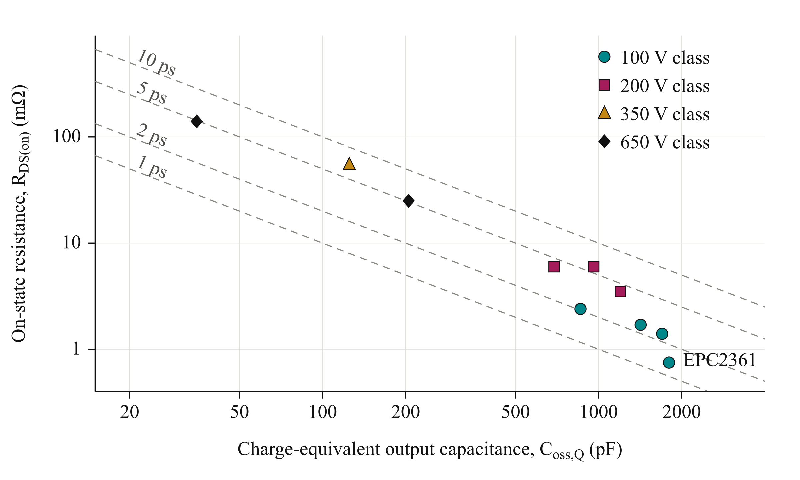
Fig. 2. Typical on-state resistance at 25 °C versus charge-equivalent output capacitance of the surveyed GaN devices, distinguished by voltage class. Dashed lines indicate constant resistance–capacitance products τ = R_{DS(on)} C_{oss,Q}. Lower τ corresponds to higher D-FOM. Charge-equivalent capacitance is calculated at the respective datasheet test voltage.
Among the surveyed devices, EPC2361 has the highest D-FOM and is selected for further investigation. Its typical on-state resistance is 0.75 mΩ [10]. The quotient of the rounded output charge of 90 nC and its 50 V test voltage gives 1800 pF, consistent with the datasheet time-related capacitance of 1796 pF. This is distinct from the differential output capacitance of 1019 pF at the same voltage.
The comparison is an initial screening rather than a direct prediction of converter efficiency. Output-charge values are specified at different test voltages, and the simplified criterion does not capture temperature, gate-drive, parasitic, and current-sharing effects. The candidate is subsequently evaluated at the intended submodule voltage and traction current.

C. Initial Submodule Voltage
For equal voltage partitioning, the nominal submodule voltage is
$V_{m} = \frac{V_{dc}}{N}$ (4)
The candidate arrangement in Table I permits 100 V devices to be considered. The available margin must accommodate submodule-voltage variation and switching overshoot. The peak drain–source voltage target leaves a 15 V allowance above the nominal submodule voltage and a further margin below the device rating. The candidate operating point is therefore assessed through switching simulations and parasitic extraction rather than accepted from the nominal rating alone.

III. Single Cell Characterization and Selection of the Parallel Count

A. Single Cell Switching Characterization
The selected EPC2361 is first evaluated in a half-bridge model with one device per switch position. Double-pulse simulations are performed at a submodule voltage of 75 V over a range of device currents. Two assumed commutation-loop inductances, 0.5 nH and 1 nH, represent a compact layout target and a higher-inductance sensitivity case, respectively. The preliminary gate-drive model uses a gate-loop inductance of 1.7 nH, an external turn-on resistance of 2 Ω and a low-impedance turn-off path. These lumped assumptions provide an initial basis for sizing before the detailed board geometry is available.
Fig. 3 shows the simulated peak drain–source voltage and turn-on energy. For the 0.5 nH case, operation near 80 A per transistor remains below the 90 V design target. Increasing the device current to approximately 120 A raises the peak voltage above 100 V. The higher-inductance case exceeds the design target already near 80 A, demonstrating the sensitivity of the usable current range to the commutation path.
The results identify approximately 80 A as a useful current scale for preliminary sizing, rather than an absolute device-current limit. Dividing the required phase-current peak of 322 A by this value suggests approximately four parallel transistors per switch position. Neighboring parallel counts are then compared to determine whether this initial estimate satisfies the electrical and thermal requirements.
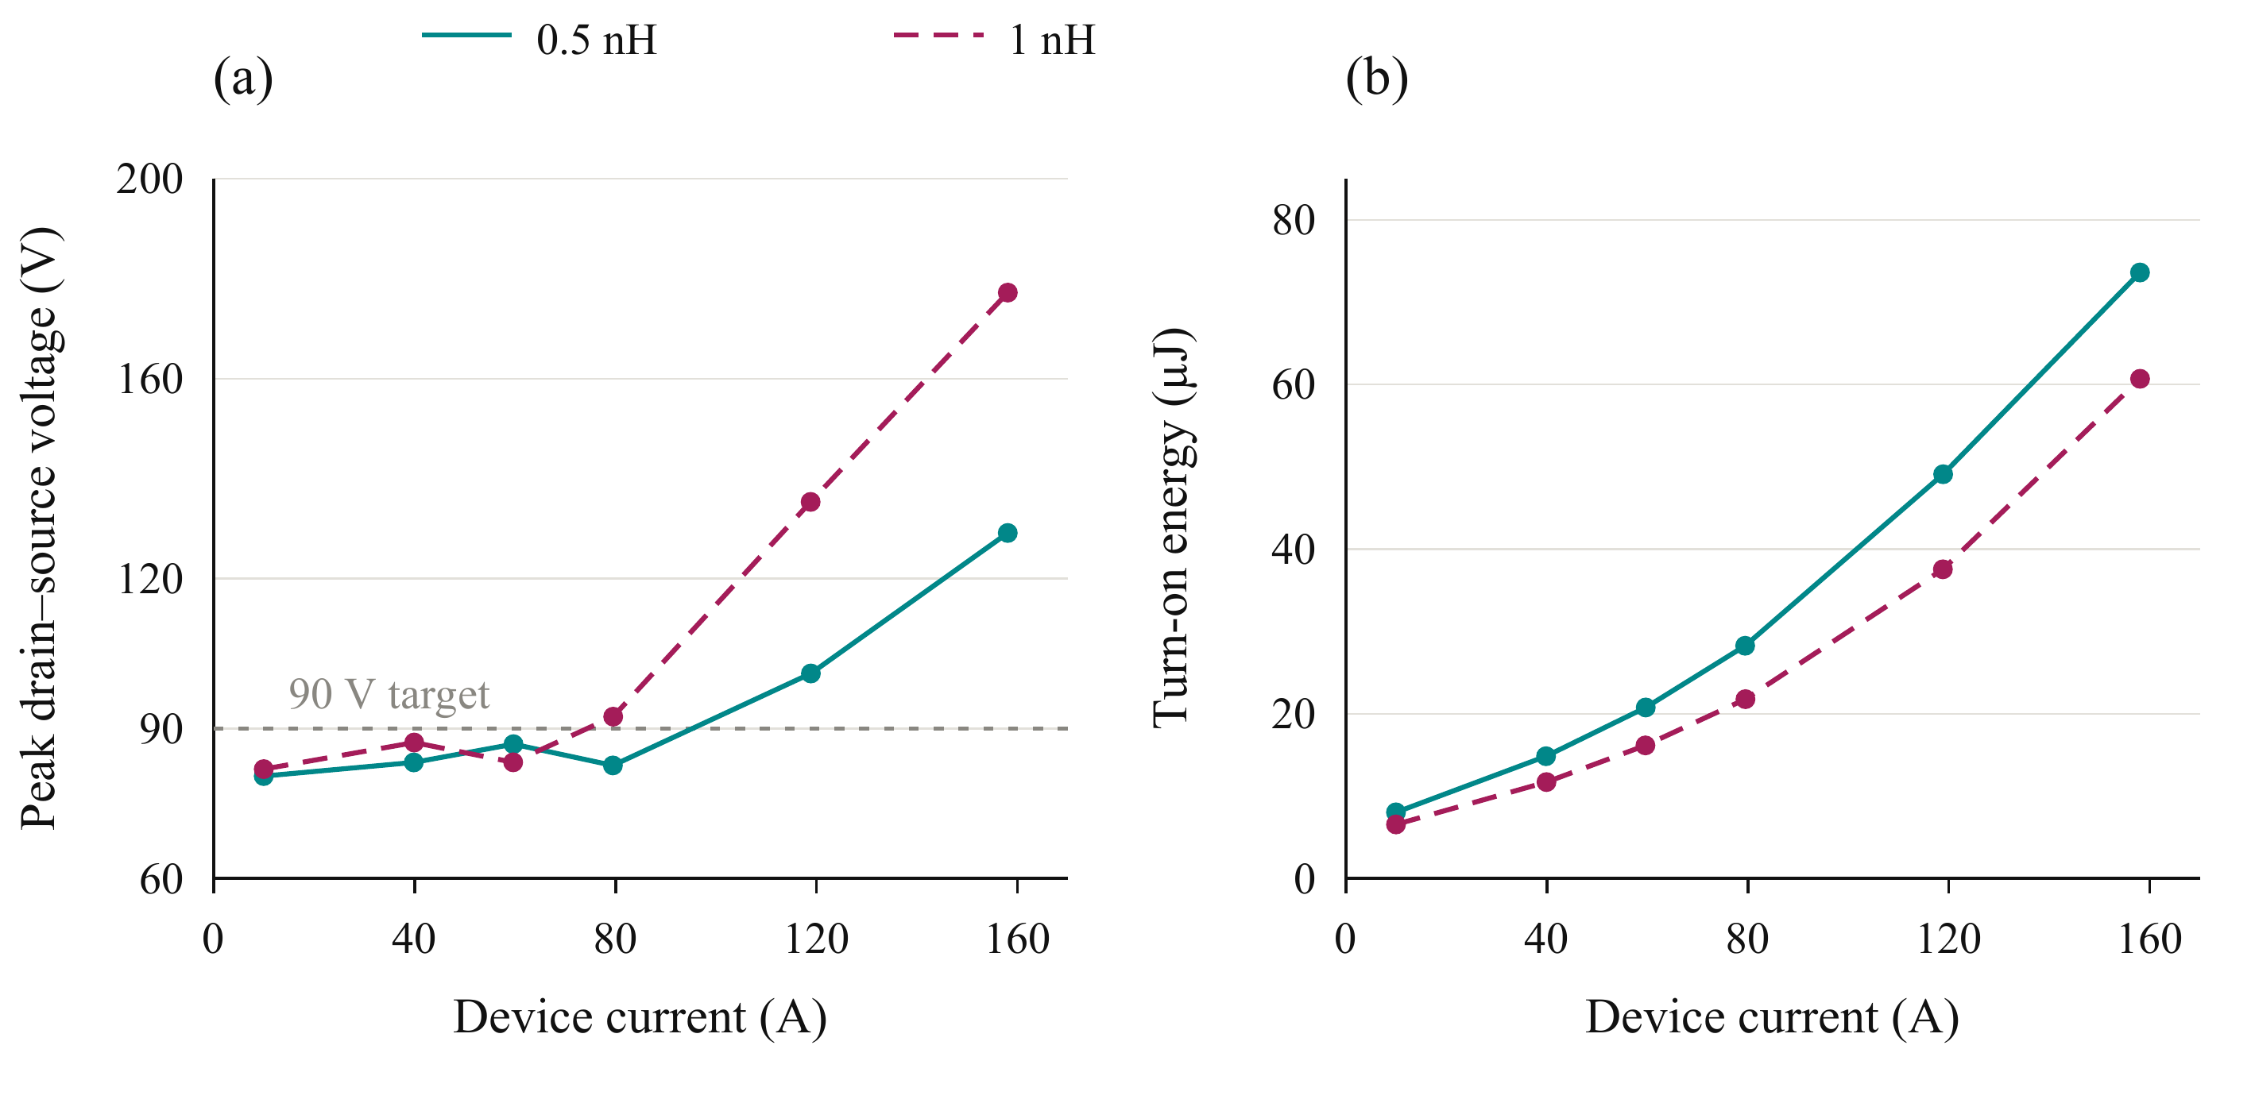
Fig. 3. Simulated single-cell switching characteristics of EPC2361 at a submodule voltage of 75 V: (a) peak drain–source voltage and (b) turn-on energy versus device current for assumed commutation-loop inductances of 0.5 nH and 1 nH. Markers indicate simulated operating points; connecting lines guide the eye. The horizontal dashed line in (a) denotes the 90 V design target.

B. Loss and Thermal Assessment
For n parallel transistors and ideal current sharing, the peak current per device is
$I_{dev,pk} = \frac{I_{ph,pk}}{n}$ (5)
The single-cell switching-energy data are evaluated over the sinusoidal phase-current waveform to estimate the average switching losses. Turn-on energy at the phase-current peak is therefore not applied uniformly throughout the fundamental period. Conduction losses are calculated using temperature-dependent on-state resistance, and the junction temperature and resistance are solved iteratively.
The thermal assessment assumes an ambient temperature of 40 °C, a heatsink-to-ambient thermal resistance of 0.65 K/W for the complete phase leg, and a junction-to-heatsink thermal resistance of 7.6 K/W per transistor. The same per-device thermal path is used for each parallel-count candidate. The resulting junction temperatures are estimates conditional on these cooling assumptions.
Fig. 4(a) shows the phase-leg loss distribution. Increasing the parallel count reduces conduction losses, while the additional devices increase the switching-charge and gate-drive contributions. Four devices provide a substantial reduction in total loss compared with two or three devices. Further paralleling initially reduces the calculated loss, which approaches a plateau at the higher counts.
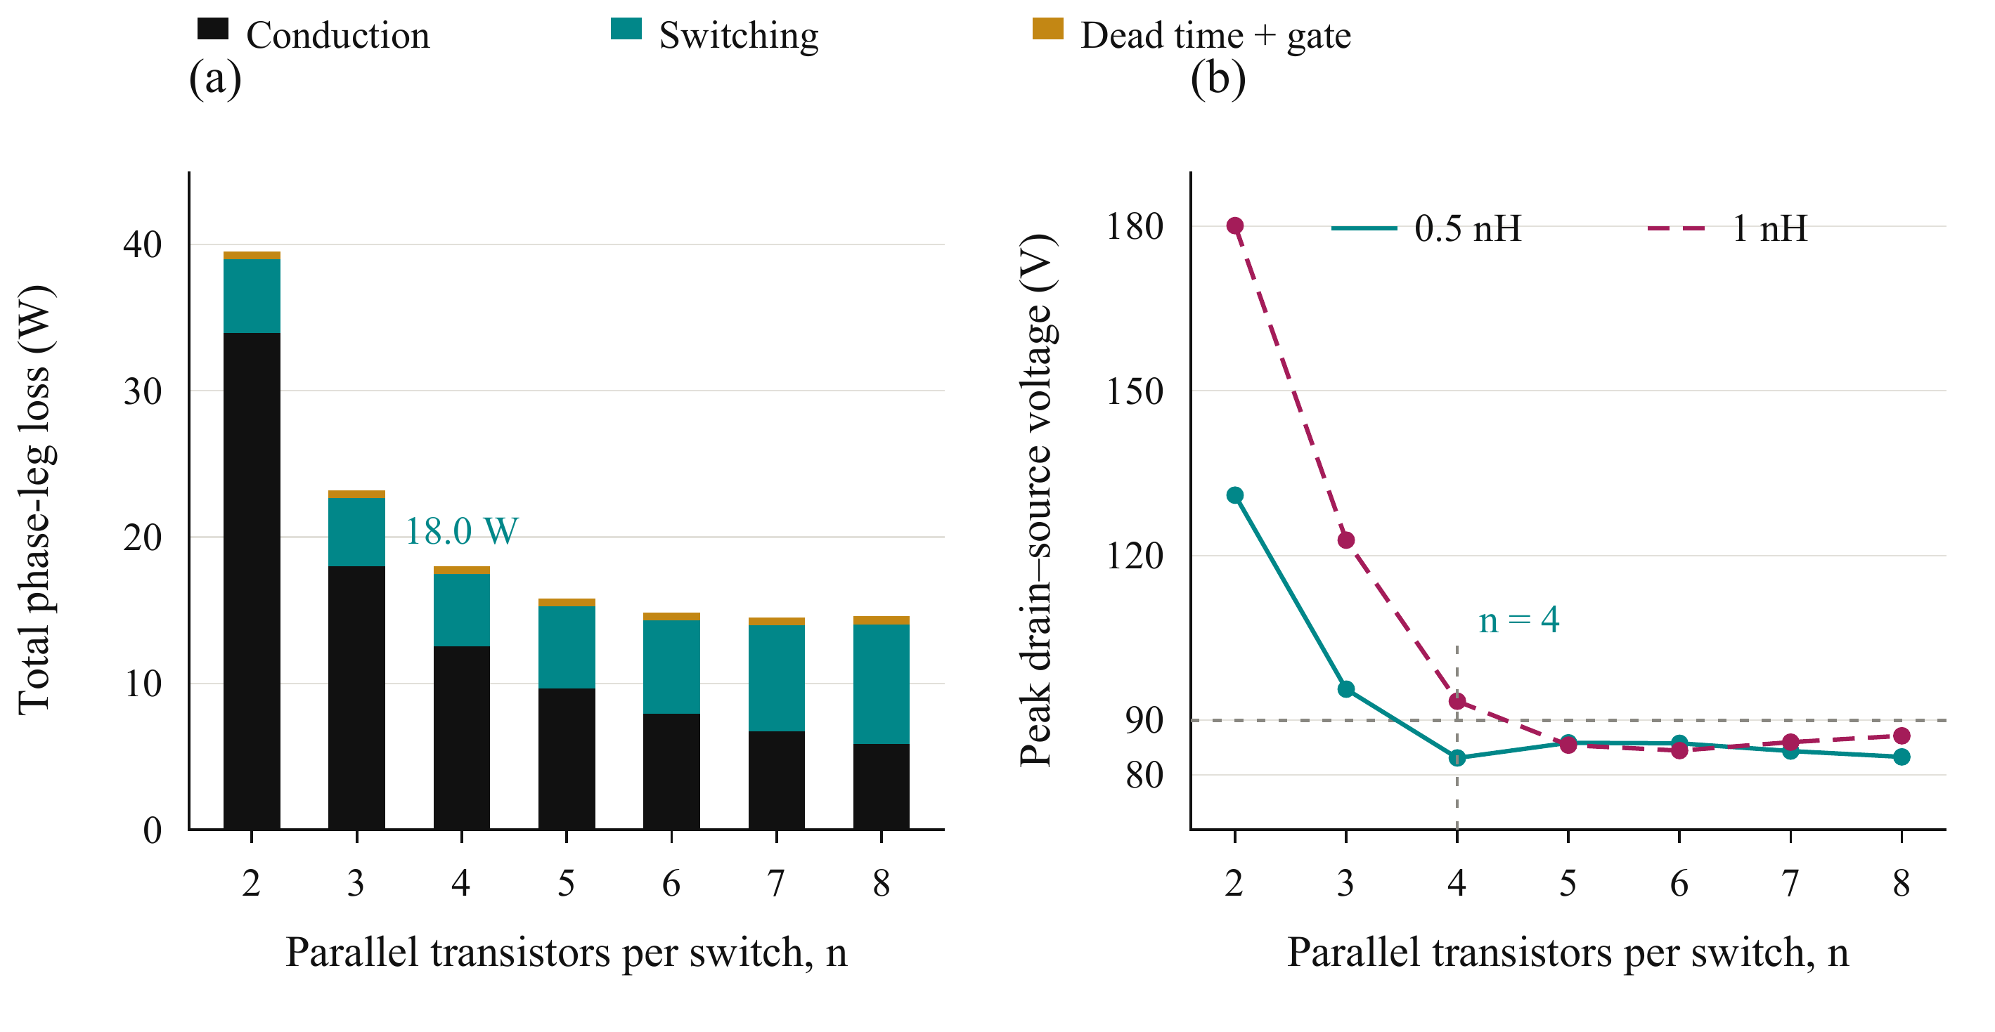
Fig. 4. Preliminary parallel-count comparison at 75 V, 228 A rms phase current, and 50 kHz: (a) calculated phase-leg loss distribution for a commutation-loop inductance of 0.5 nH and (b) predicted peak drain–source voltage for 0.5 nH and 1 nH. The horizontal dashed line denotes the 90 V design target. Four devices are the smallest tested count satisfying the preliminary voltage and thermal constraints at 0.5 nH.

C. Selection of Four Parallel Devices
Table II summarizes the preliminary comparison. Two devices exceed both the thermal and voltage limits. Three satisfy the thermal constraint but still exceed the voltage target at the compact-loop assumption. Four are the smallest tested count satisfying both constraints in that case.
TABLE II
PRELIMINARY PARALLEL COUNT COMPARISON
Parallel count n | Peak device current (A) | Leg loss (W) | Junction temperature (°C) | Peak V_{DS} at 0.5 nH (V) | Peak V_{DS} at 1 nH (V)
2 | 161 | 39.5 | 141 | 131 | 180
3 | 107 | 23.2 | 84 | 96 | 123
4 | 80.5 | 18.0 | 69 | 83 | 93
5 | 64.4 | 15.8 | 62 | 86 | 85
6 | 53.7 | 14.8 | 59 | 86 | 84
Loss and junction-temperature estimates in Table II use the 0.5 nH case and the preliminary gate-drive and cooling assumptions.
The selected count is not the absolute minimum-loss solution. Additional devices reduce the calculated losses further, but increase the device count and the gate-drive and layout requirements. Four devices are therefore retained as the initial implementation candidate and can subsequently be arranged as two identical transistor pairs.
Fig. 4(b) also shows that the four-device arrangement reaches approximately 93 V when the assumed commutation inductance increases to 1 nH. Consequently, the selection depends on achieving a sufficiently low-inductance commutation path and suitable switching speed. The preliminary calculation also assumes equal current sharing. The following design stage therefore evaluates the cell symmetry, gate-drive arrangement, and extracted power and gate networks to determine whether these assumptions can be maintained in the physical building block.

IV. Gate Drive Configuration and Cell Arrangement

A. Current Sharing Sensitivity
The preliminary parallel-count selection assumes equal current sharing among the four transistors in each switch position. Maintaining this condition during switching requires control of the gate and power-path impedances. Differences in gate-loop inductance, common-source inductance, and driver timing can produce unequal transient currents and switching energies, even when the devices have similar on-state resistance. Fig. 5(a) summarizes sensitivity simulations for two parallel devices at 75 V and 120 A total current. A power-loop inductance mismatch of 0.3 nH produces approximately 2% switching-energy imbalance in the evaluated case. A gate-loop inductance difference of 2 nH versus 8 nH increases the imbalance to approximately 19%. Without a Kelvin-source return, a common-source inductance mismatch of 0.2 nH produces approximately 29% imbalance. Although these results depend on the investigated operating point and perturbations, they demonstrate that matching the power paths alone is insufficient. The gate branches and source-reference connections must also be considered when translating the selected parallel count into a physical layout.
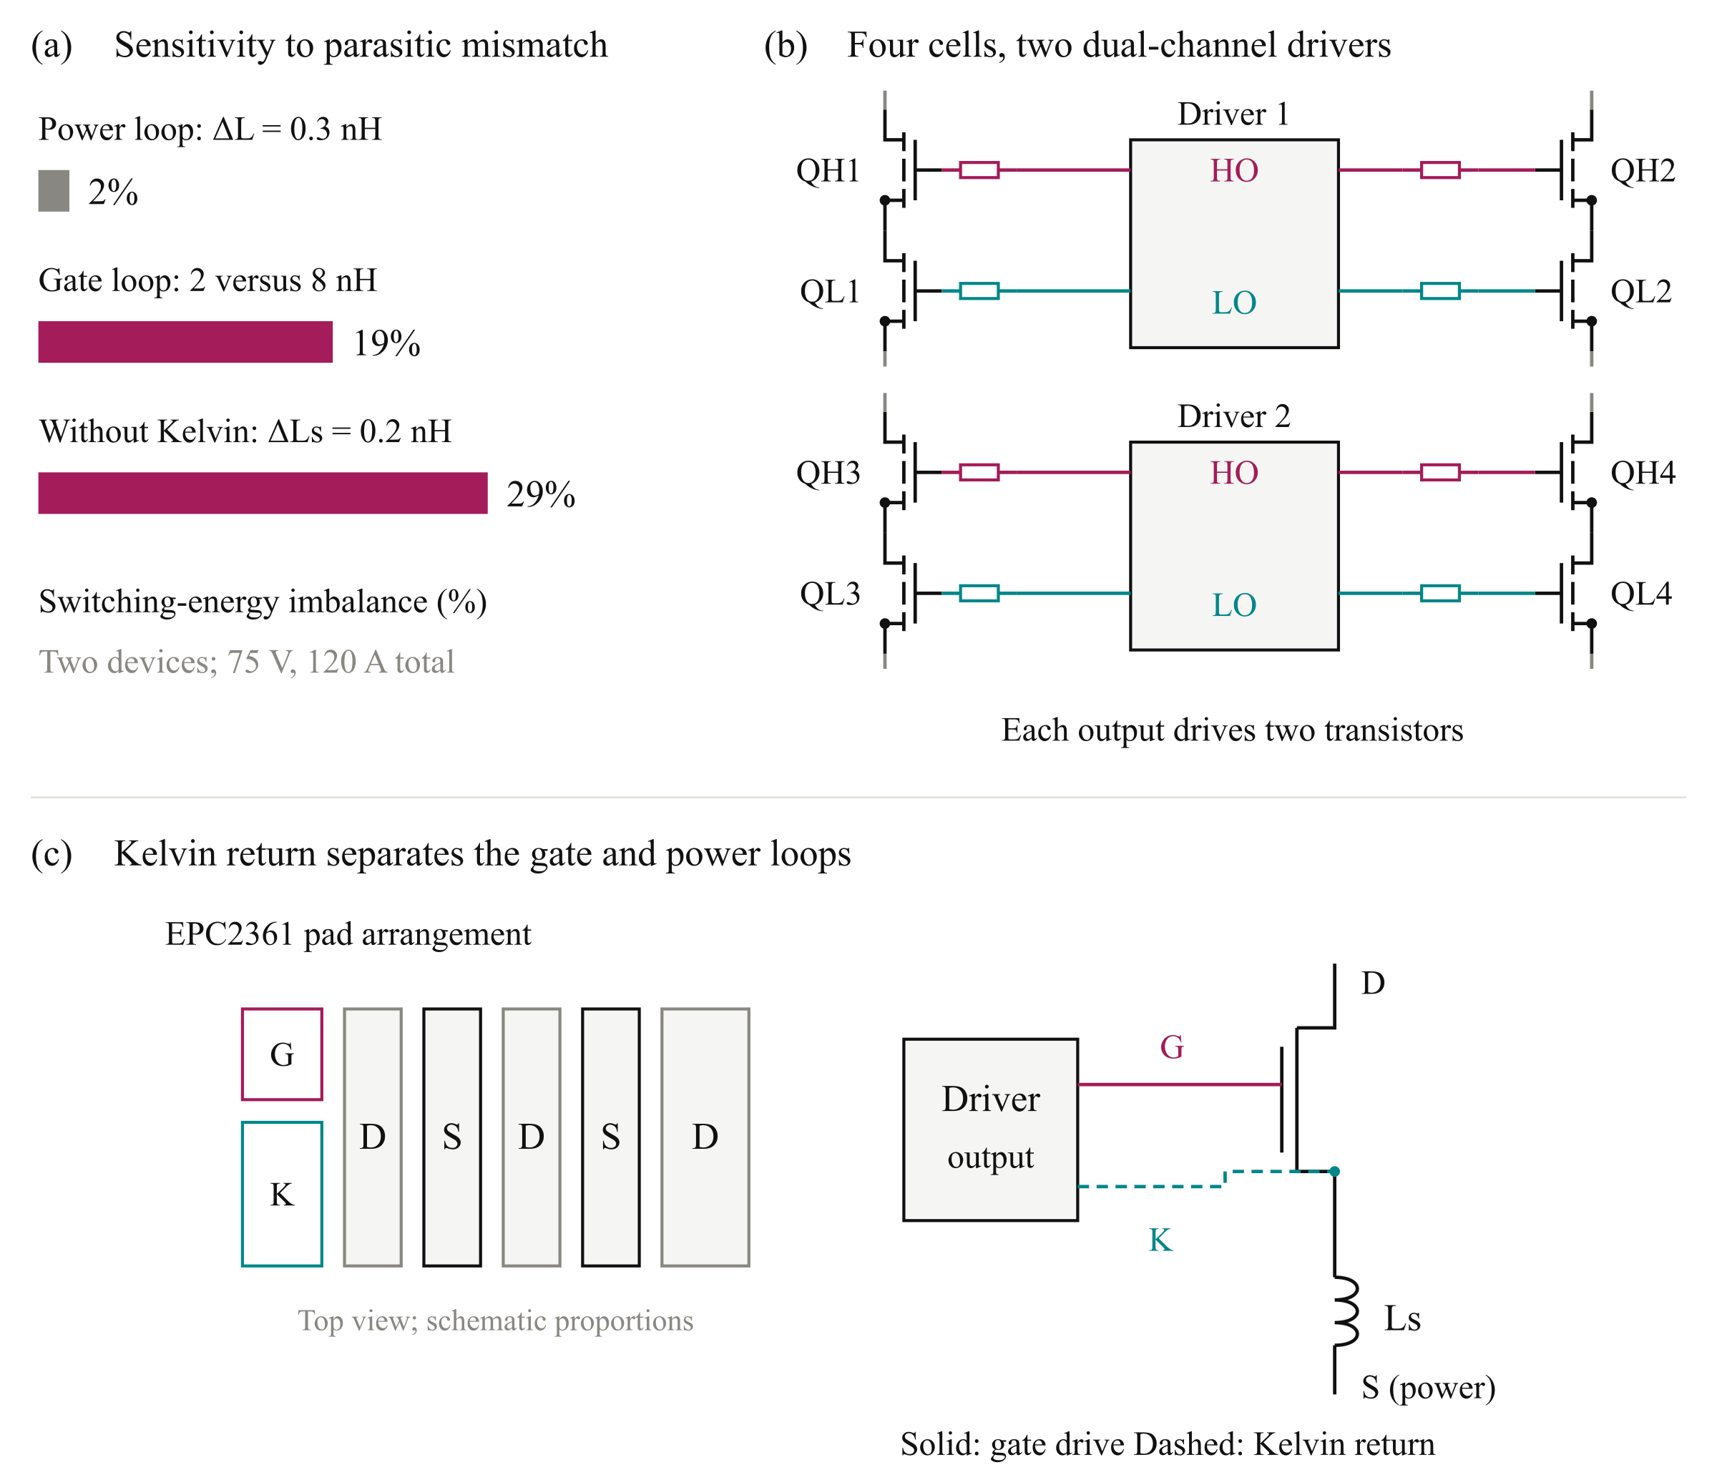
Fig. 5. Gate-drive design considerations: (a) simulated switching-energy imbalance under the investigated parasitic mismatches; (b) four switching cells grouped into two pairs, each served by a dual-channel driver with individual gate resistors; and (c) schematic EPC2361 pad arrangement and Kelvin-source connection, illustrating separation of the gate return from the power-source inductance. Driver supply and return connections are omitted in (b) for clarity. High-side (HS) and low-side (LS) outputs are denoted HO and LO.

B. Paired Gate Drive Configuration
Connecting all four transistors to one gate-driver output increases the total gate charge and the current required to establish the intended switching transition. The turn-off path must also sink the displacement current coupled through the gate–drain capacitance during drain-voltage transients. Excessive impedance in this path can cause a positive gate-voltage disturbance and reduce the margin against unintended turn-on.
The four-device arrangement is therefore divided into two transistor pairs per switch position. As illustrated in Fig. 5(b), each pair of switching cells is served by one dual-channel 2EDF7275K driver IC. One channel drives the two high-side transistors, while the other drives the two low-side transistors. The complete phase leg consequently uses two driver ICs, with two transistor gates connected to each output channel through individual gate resistors.
The selected driver provides a peak sink-current capability of 8 A per channel [11]. In the preliminary gate-drive comparison, connecting four gates to one channel produces an estimated peak sink-current demand of approximately 12–14 A and increases turn-on energy by approximately 31% relative to the two-gate configuration. These results support the paired arrangement as a practical compromise between driver count, gate loading, and routing complexity. The nominal driver-current capability alone, however, does not establish the available gate-voltage margin; the complete gate network must be evaluated during switching.

C. Kelvin Source Connection and Cell Layout
Each local switching cell contains one high-side transistor, one low-side transistor, and local dc-link decoupling capacitors. Four cells form the phase leg and are arranged as two identical pairs. Within each pair, symmetric device placement and matched gate branches are used to reduce differences in transient loading. Local decoupling limits the extent of the high-frequency commutation path, while symmetric connections to the shared power terminals reduce differences between the parallel branches.
Fig. 5(c) illustrates the role of the dedicated Kelvin-source connection. The gate-drive return is taken from the Kelvin pad rather than through the power-source conductors. This separates the gate-reference path from the inductance carrying the main source current and reduces the associated inductive feedback into the gate voltage. The Kelvin connection does not eliminate gate-loop inductance; both the outgoing gate branch and its return must remain short and closely coupled.
Individual gate resistors and separate Kelvin-return branches are retained for each transistor. The branches are connected to the corresponding driver channel in a star arrangement, avoiding unnecessary shared impedance between the devices. The layout objective is therefore to minimize both the magnitude and mismatch of the relevant loop impedances.

D. Verification of the Physical Arrangement
Symmetry within each transistor pair does not eliminate timing differences between the two driver ICs. Input routing and inter-driver propagation-delay differences must therefore be assessed separately from the matching of the local gate branches. The paired configuration establishes the intended circuit arrangement, while its current-sharing performance remains subject to verification with the routed geometry.
The paired configuration is translated into a routed board and evaluated through the extraction-based workflow in Section V. The assessment determines whether the current capability and switching margin assumed during initial sizing can be retained in the physical building block.

V. Closing the Design Loop with the Routed Building Block

A. Layout and Parasitic Extraction
The initial sizing establishes a candidate voltage, parallel count, and drive configuration using assumed loop inductances. The routed building block must then be assessed to determine whether these assumptions are physically achievable. Fig. 6 shows the iterative KiCad–Ansys Q3D–LTspice workflow connecting conductor geometry to switching behavior.
The power devices, local decoupling capacitors, and paired gate drivers are placed and routed in KiCad. The conductor geometry is evaluated in Ansys Q3D to obtain resistive and inductive networks, including mutual coupling between branches. These networks are incorporated into LTspice to assess voltage overshoot, gate disturbance, transient current sharing, and switching-energy distribution. Placement, routing, or drive settings are revised where necessary.
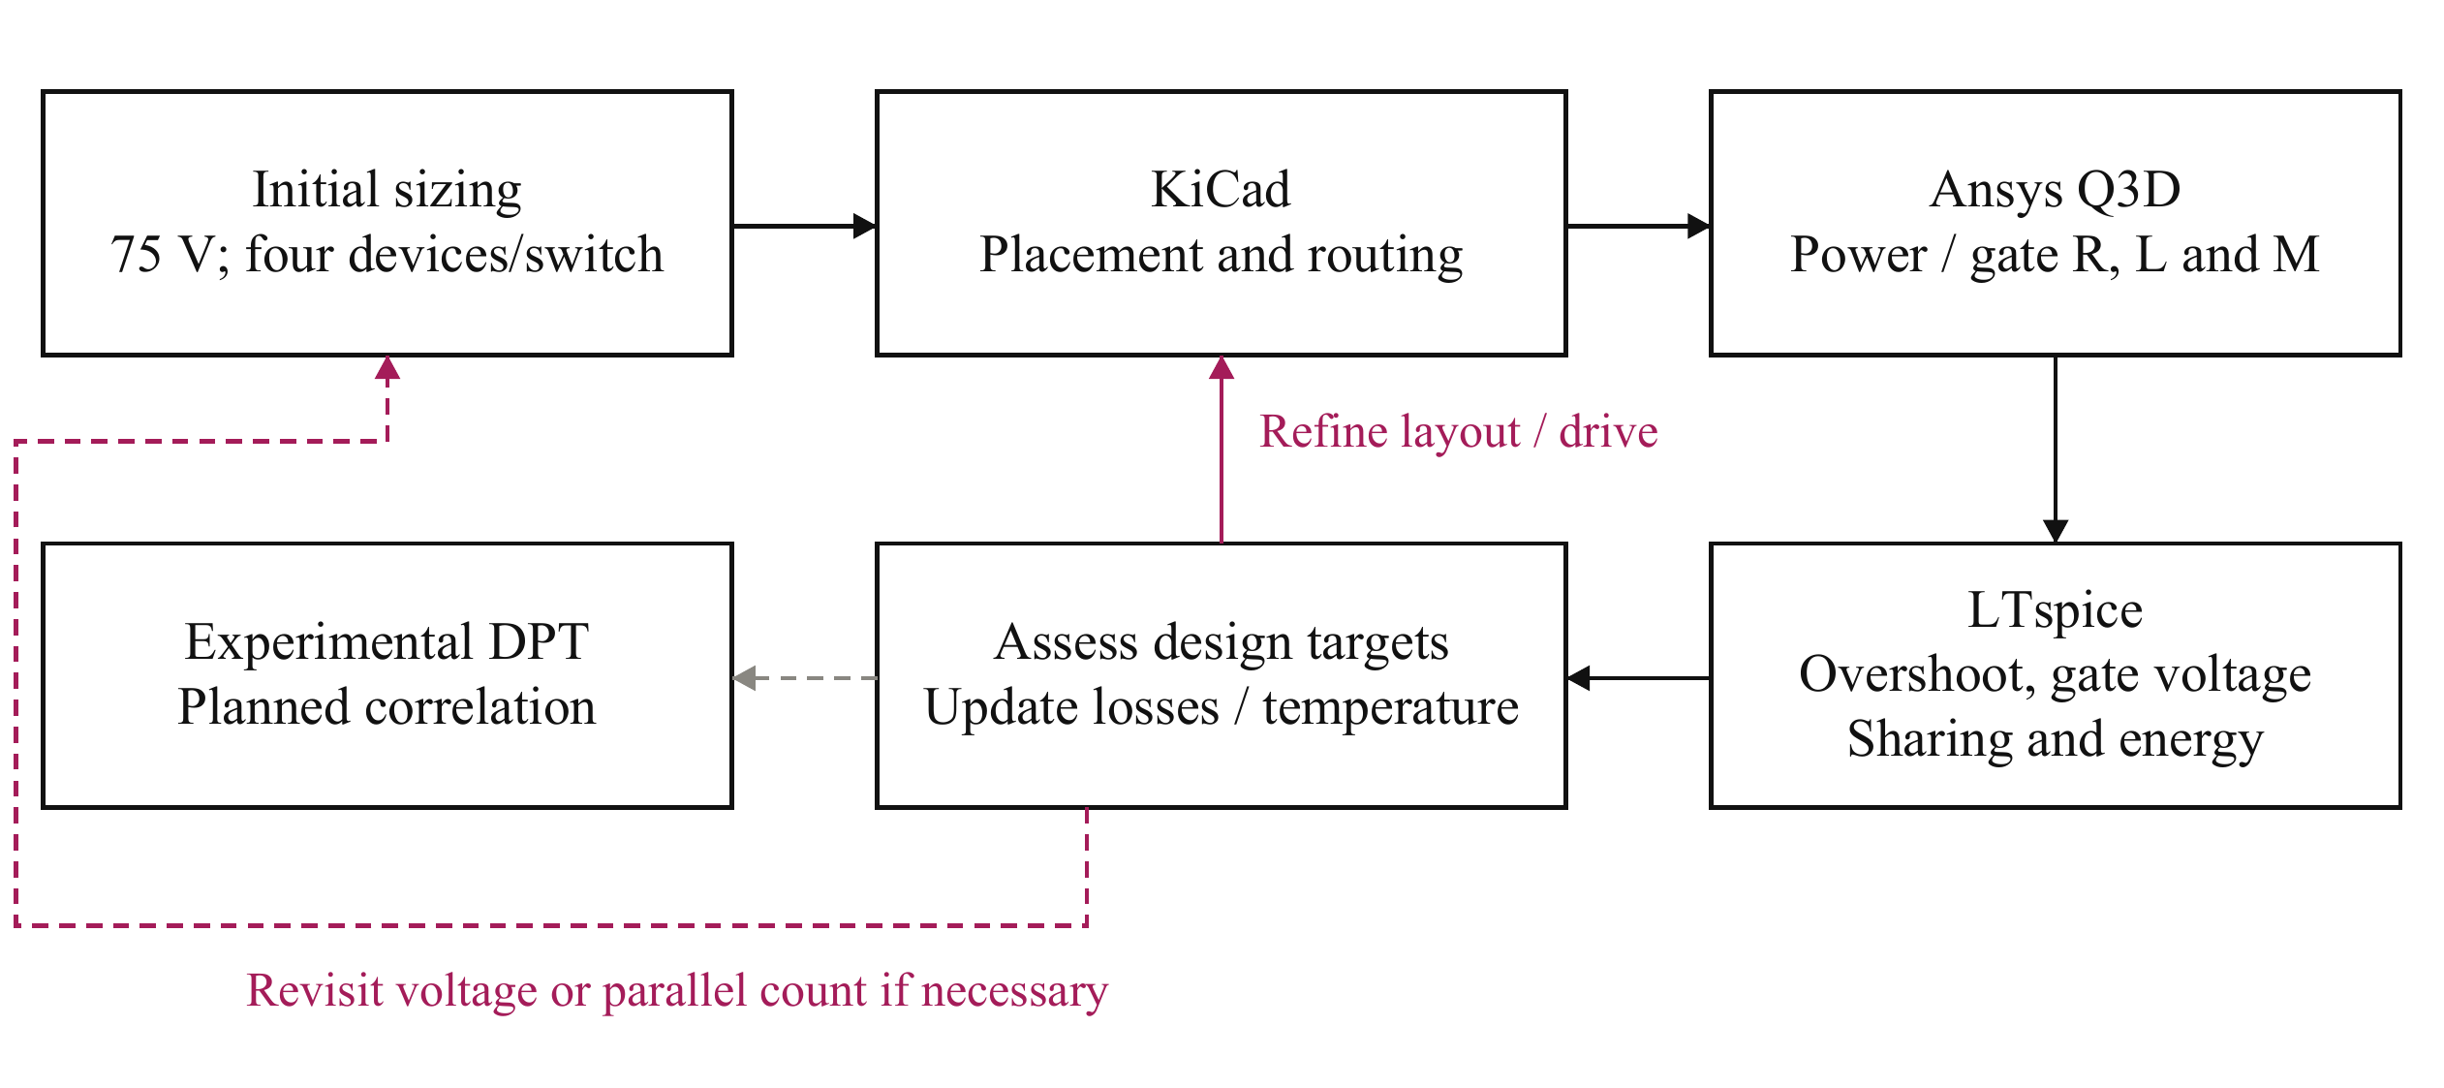
Fig. 6. Iterative design and verification workflow. Extracted power and gate networks connect the routed geometry to switching simulations. The results inform revisions to layout, drive settings, and, where necessary, voltage partition or parallel count. Experimental double-pulse test (DPT) correlation is planned.
Two board variants are considered: an operating board representing the intended converter building block and an instrumented DPT board. The latter includes current-measurement provisions that introduce additional commutation-path parasitics. Figs. 7(a) and 7(b) distinguish these implementations, preventing measurement-related inductance from being treated as an unavoidable feature of the operating converter.

B. Extracted Power and Gate Networks
Fig. 7(c) separates the commutation-loop contributions. The operating-board loop is approximately 0.41 nH per cell, supporting the feasibility of the compact-loop assumption used in preliminary sizing. The additional conductor length and shunt contribution increase the DPT loop to approximately 0.65 nH. The capacitor contribution is included through its equivalent series inductance (ESL).
The DPT gate network departs more substantially from the preliminary assumptions. Fig. 7(d) compares the individual loops with the pair-driven loops, which include the effect of the shared gate path. Symmetric branches can therefore retain substantial shared inductance. Matching alone does not establish a sufficiently low gate-loop impedance.
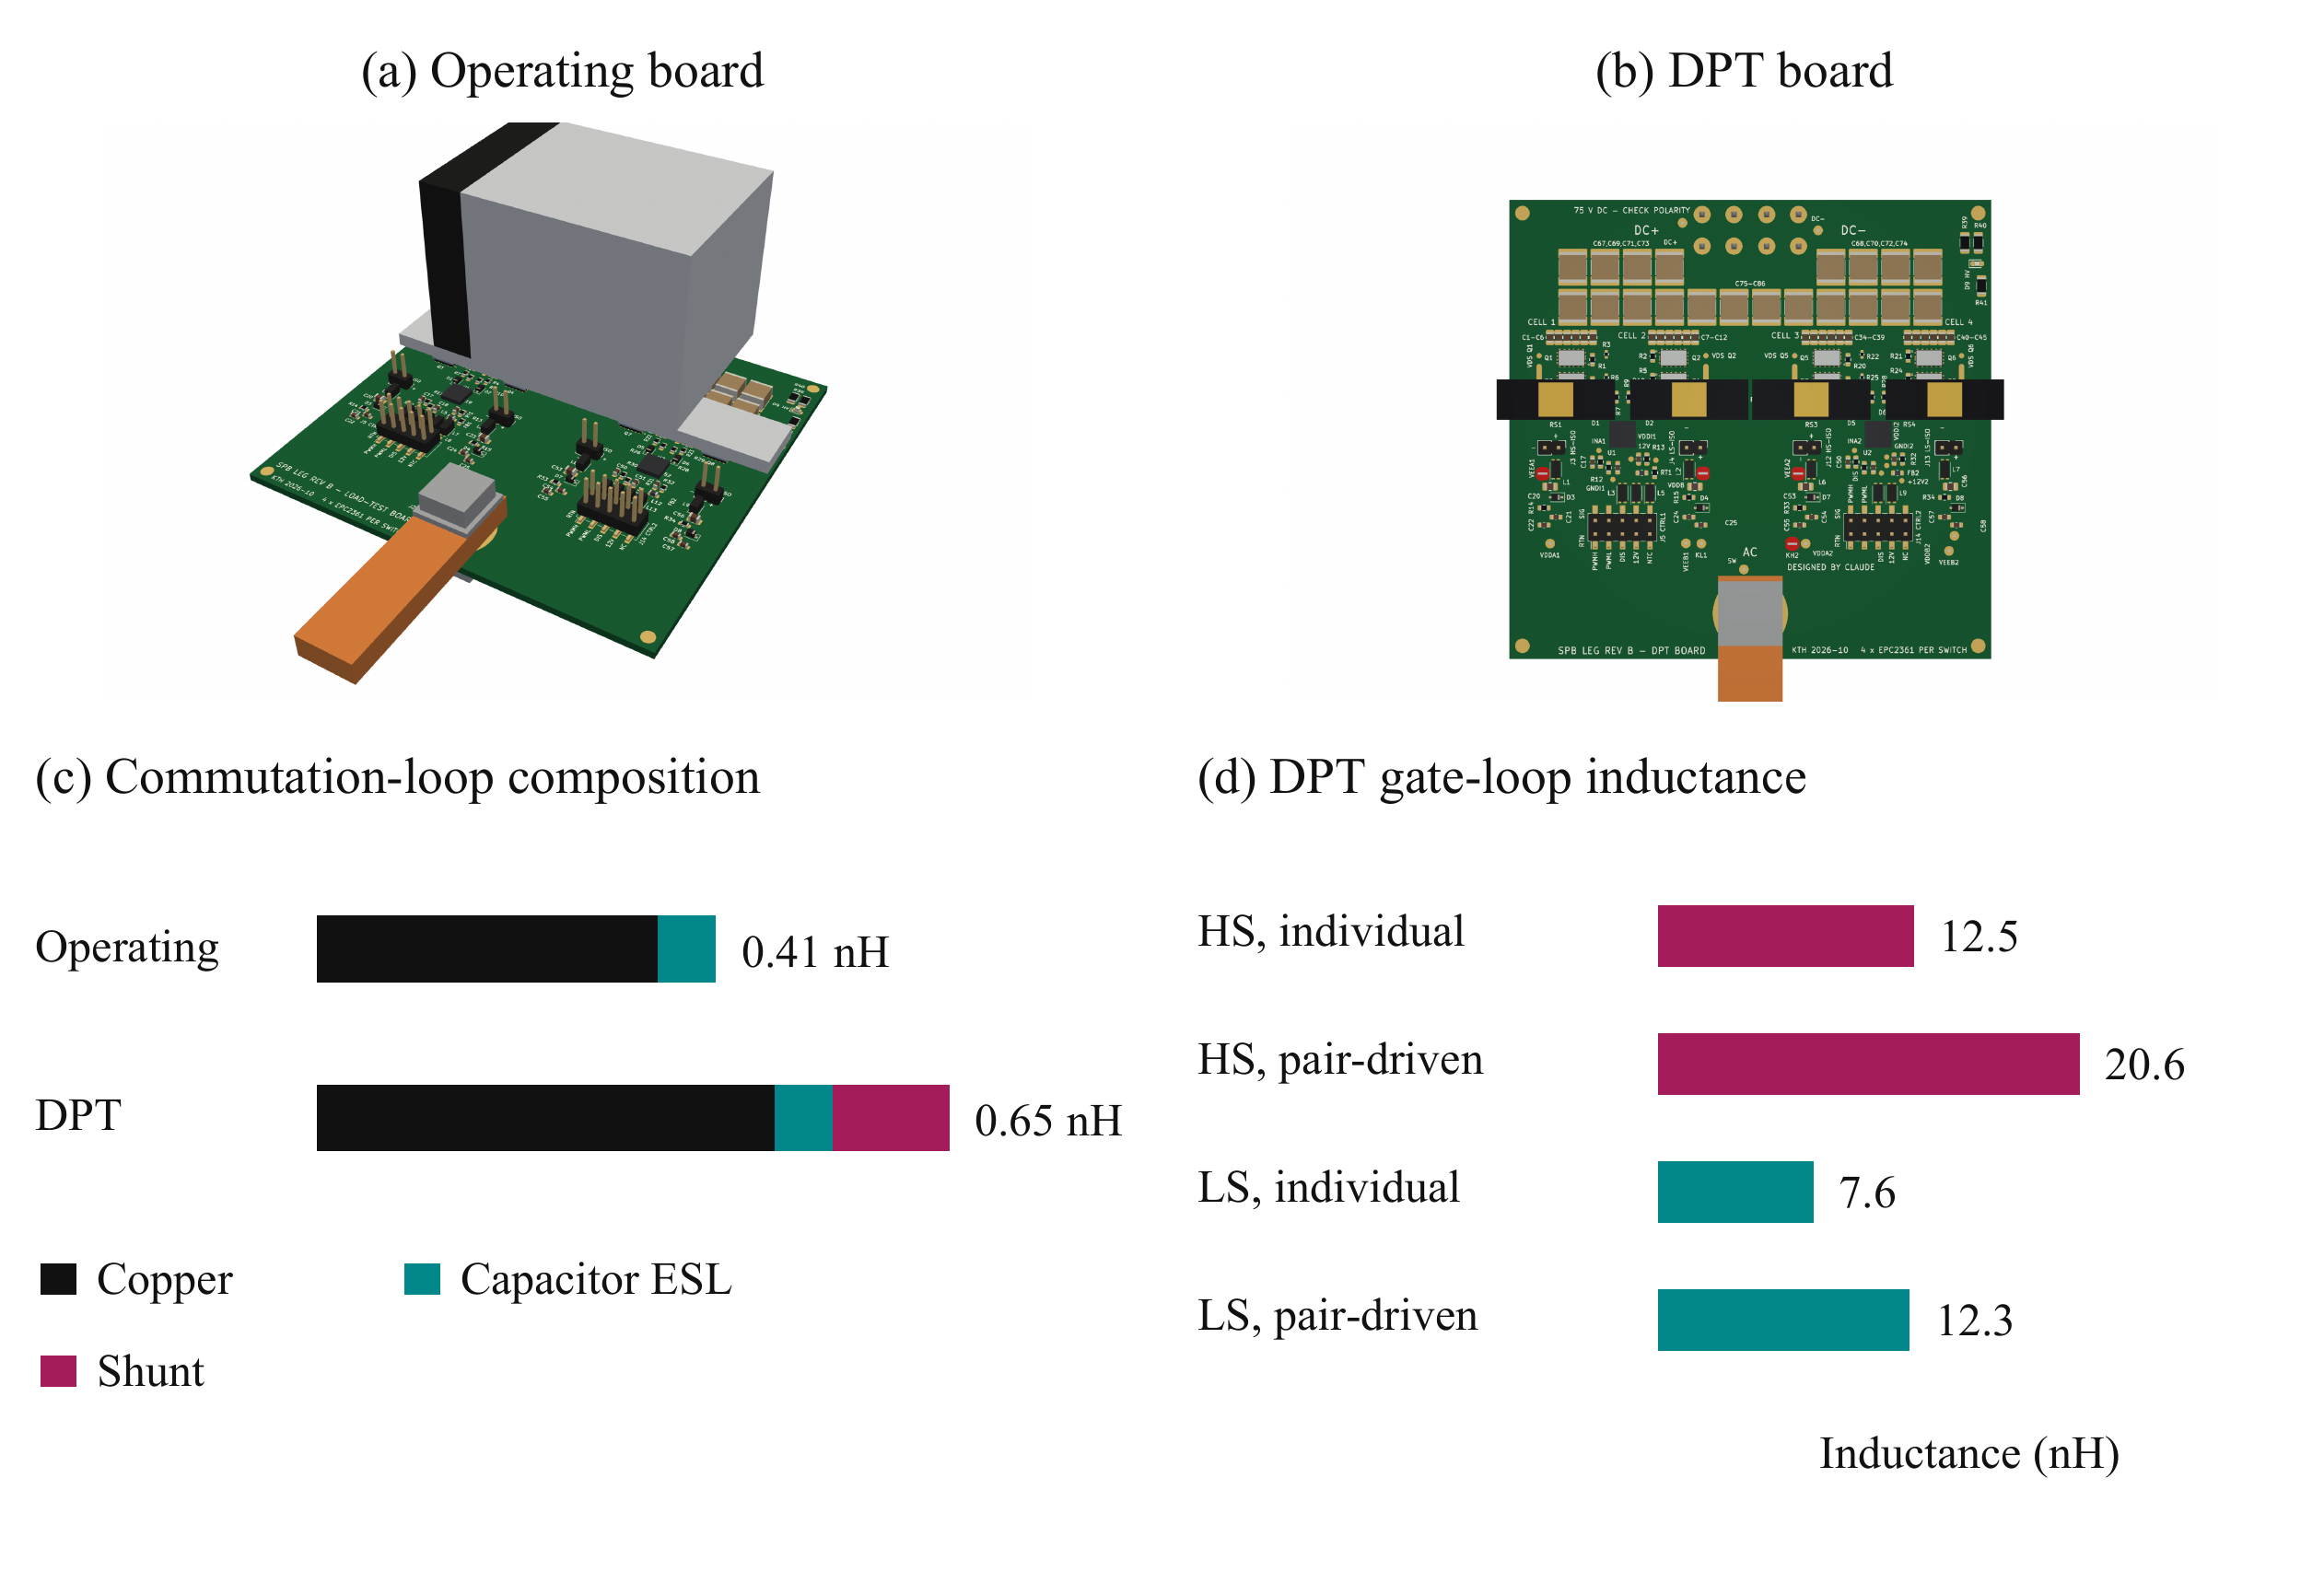
Fig. 7. Building-block variants and evaluated parasitics: (a) operating-board rendering; (b) instrumented DPT-board rendering; (c) commutation-loop inductance including conductor, capacitor ESL, and shunt contributions; and (d) individual and pair-driven DPT gate-loop inductances. Gate-network extraction in this study applies to the DPT board.
Fig. 8 shows the Q3D conductor models underlying the extraction. The operating-board view is compared with the DPT-board network, which includes the additional low-side source-to-shunt path. The cell-pair detail shows the overlapping conductors, interlayer connections, and device and capacitor terminals used to define the local power network. These are geometry views rather than field-distribution plots.
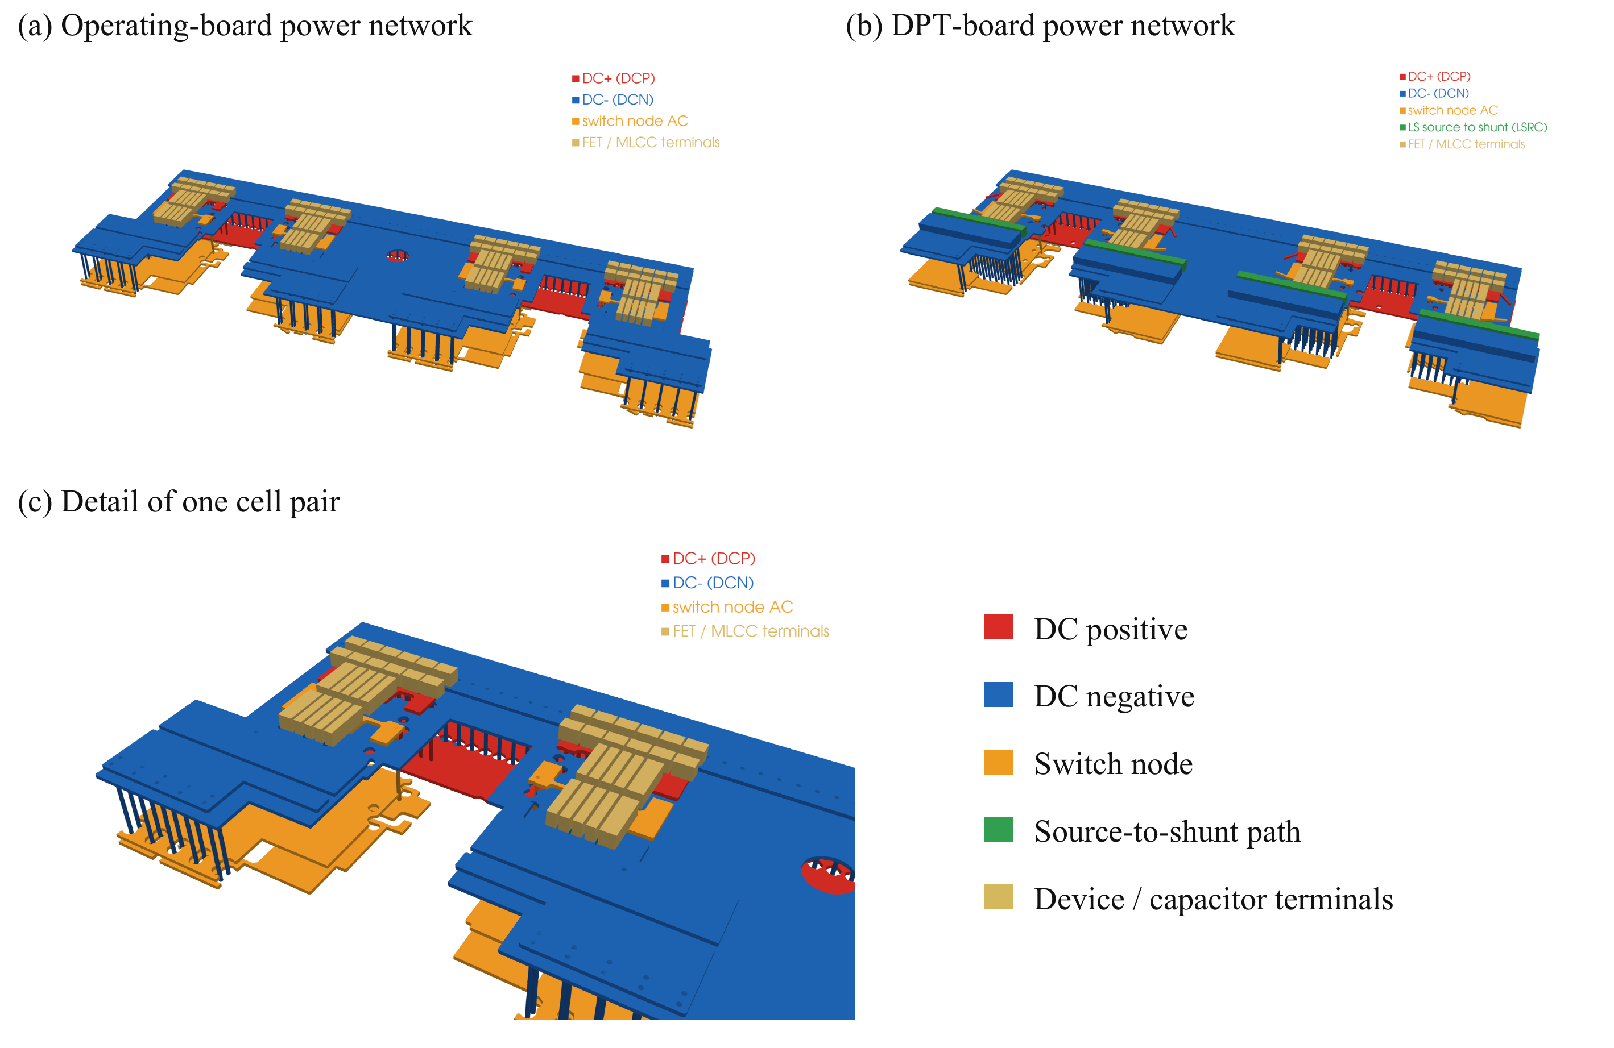
Fig. 8. Ansys Q3D conductor models used for parasitic extraction: (a) operating-board power network; (b) instrumented DPT-board power network, including the additional source-to-shunt conductors; and (c) detail of one cell pair showing the local conductor stack, interlayer connections, and device and capacitor terminals. Colors identify electrical nets and terminals, not field magnitude.

C. Switching Assessment and Design Feedback
Switching simulations are performed near the required phase-current peak, with approximately 316 A achieved in the evaluated DPT cases. Table III compares the saved configurations. At equal DPT turn-on resistance, replacing the preliminary lumped gate model with the extracted gate network increases the peak drain–source voltage. Reducing the resistance in the extracted-network case increases voltage stress further, demonstrating that the gate network materially changes the available switching margin.
TABLE III
SWITCHING SIMULATION COMPARISON NEAR 316 A
Board | Gate model | R_{g,on} (Ω) | Off bias (V) | Peak V_{DS} (V) | Mean E_{on} per device (µJ)
Operating | Preliminary | 2.0 | 0 | 91 | 27.3
Operating | Preliminary | 3.0 | 0 | 86 | 32.8
DPT | Preliminary | 3.5 | −1.9 | 90 | 34.1
DPT | Extracted | 2.5 | −1.9 | 105 | 24.3
DPT | Extracted | 3.5 | −1.9 | 93 | 31.2
The operating-board cases include the evaluated power path but retain the preliminary gate model. The DPT extracted cases include both power and gate networks. Switching-energy values are device averages for the evaluated turn-on event, not fundamental-period average losses.
Fig. 9(a) illustrates the associated drain-voltage transients. Slower turn-on reduces stress at the cost of greater switching energy, so drive resistance must be selected through a combined voltage and loss assessment. The evaluated DPT configuration remains below the nominal device rating but above the project voltage target.
Fig. 9(b) compares the held-off high-side gate voltage for two board and drive configurations. The zero-bias operating-board case rises above the minimum specified gate threshold, indicating insufficient margin against unintended turn-on. Negative turn-off bias suppresses the positive excursion in the extracted-network DPT case. Because both the board network and bias differ, the comparison illustrates complete configurations rather than isolating the effect of bias alone.
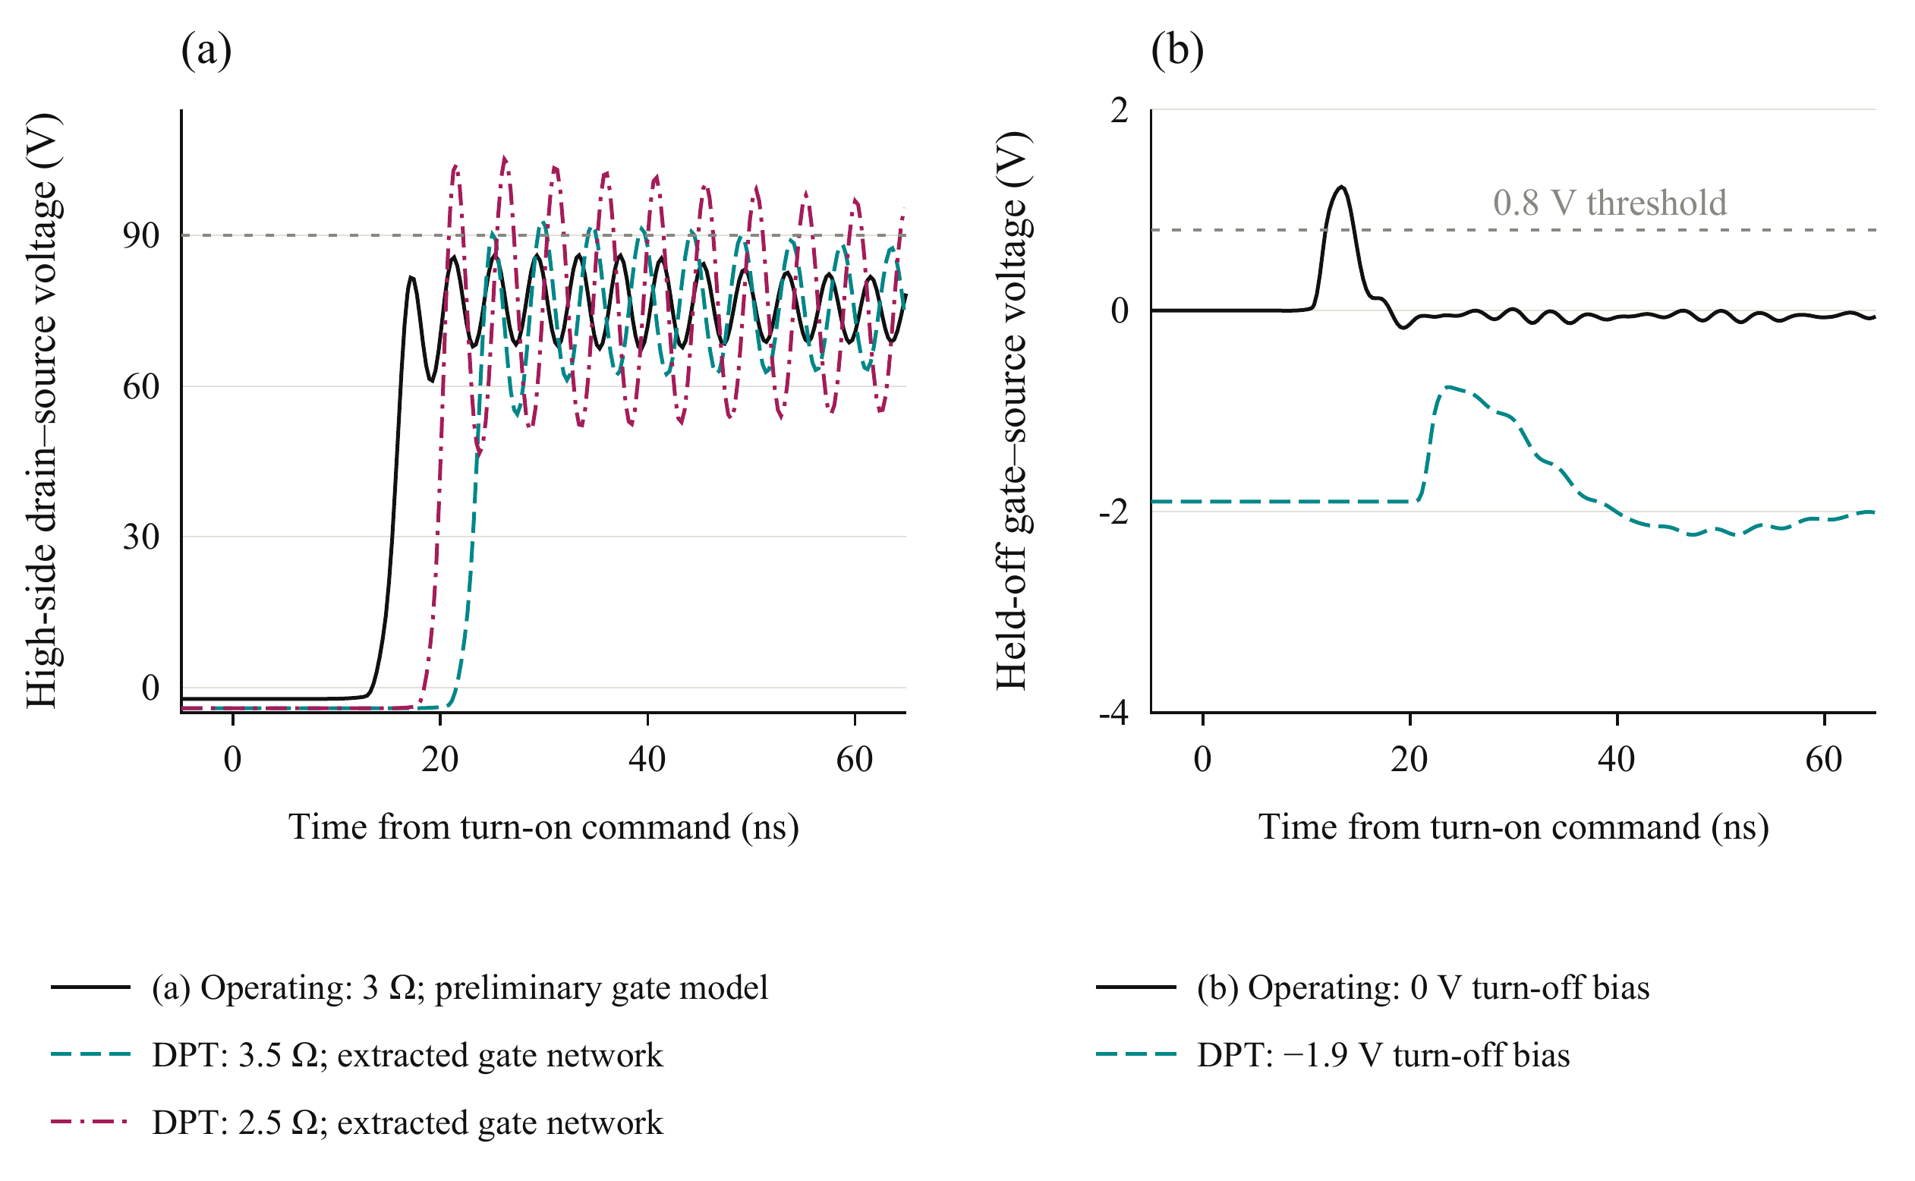
Fig. 9. Simulated switching at 75 V and approximately 316 A: (a) worst-cell high-side drain–source voltage during low-side turn-on for the indicated board, gate-network, and resistance configurations; and (b) cell-1 held-off high-side gate voltage. Reference lines denote the 90 V drain-voltage target and the 0.8 V minimum gate threshold. Operating-board cases retain the preliminary gate model; DPT cases include the extracted gate network.
The evaluated negative-bias DPT case has a maximum held-off gate excursion of approximately −0.5 V and negative ringing reaching approximately −3.4 V over the assessed transitions. Both positive and negative gate excursions must be checked against the device limits; the minimum gate rating is −4 V [10].

D. Implications for the Building Block
The power-network results support a compact commutation path, while the gate-network results identify shared routing inductance as a remaining constraint. The evaluated extracted-network DPT case is therefore a candidate requiring refinement rather than a completed validation against all targets. Shorter shared gate paths and driver output stages closer to each pair are the next layout objectives.
Updated switching energies must be used to revise the preliminary loss and thermal estimates. The operating-board simulations must also be repeated with their corresponding extracted gate network before its switching margin can be established. This feedback connects the physical building block to the initial SPB voltage choice: the expected benefit of low-voltage devices depends on the power and gate networks together.

VI. Experimental Validation and Scope of the Full Paper

A. Planned Double Pulse Measurements
The instrumented board provides the basis for experimental DPT correlation. The planned assessment starts at reduced voltage and current before progressing toward the candidate submodule operating point. Measurements will include drain–source voltage, gate–source voltage referenced to the Kelvin terminal, total commutating current, and individual branch currents where the sensing arrangement permits.
The measured voltage and current waveforms will be used to assess overshoot, ringing, transient current sharing, and switching energy. Probe delay and channel skew must be accounted for before voltage–current integration. The effects of the shunts, connections, and probe loading will be considered when comparing measurements with the instrumented-board model. Turn-on resistance and turn-off bias will be varied to examine the voltage-stress and loss tradeoff identified by simulation.
Experimental results are not available in this manuscript. The full paper is intended to report correlation of the DPT model and measurements, including whether the voltage and gate-drive margins predicted by the revised layout are retained in hardware. Operating-board loss and temperature validation will require a subsequent continuous-current assessment under a defined cooling condition.

B. System Integration Boundary
The present study addresses one phase-leg building block. It does not establish a globally optimum SPB submodule count or a complete traction-drive efficiency advantage. Submodule-voltage balancing, winding design, common-mode behavior, auxiliary-power overhead, and insulation across the series stack remain system-level constraints. The voltage-class comparison and preliminary loss model do not replace those evaluations.
Inter-driver timing and the common interconnections between cell pairs must also be evaluated. The gate driver provides functional isolation [11]; it does not by itself establish the insulation architecture required for a submodule positioned within the full dc-link stack. These integration requirements bound the conclusions that can be drawn from the local DPT model.

VII. Conclusion
A hardware-constrained procedure has been presented for a phase-leg building block of an SPB traction inverter. Charge-based device screening selects the 100 V EPC2361 from the surveyed candidates. Single-cell characterization and an electrical and thermal comparison support four parallel devices per switch position as the smallest tested count meeting the preliminary constraints for the compact-loop assumption. Current-sharing sensitivity motivates paired gate drive, matched gate branches, and dedicated Kelvin returns.
The routed-network assessment shows why device selection and voltage partitioning cannot be finalized independently of implementation. A compact power loop is achievable in the evaluated operating-board geometry, but the extracted DPT gate network changes the required switching settings. The remaining gap to the project voltage target requires further gate-network refinement and updated loss estimates. Experimental DPT correlation is planned for the full paper. The contribution is the traceable connection between SPB voltage choice and the physical switching constraints that determine the usefulness of low-voltage devices at traction-current levels.

References
[1] S. Norrga, L. Jin, O. Wallmark, A. Mayer, and K. Ilves, “A novel inverter topology for compact EV and HEV drive systems,” in Proc. IECON, 2013, pp. 6590–6595.
[2] L. Jin, S. Norrga, O. Wallmark, and M. Nikouei Harnefors, “Control and modulation of the stacked polyphase bridges inverter,” in Proc. IEEE ECCE, 2014.
[3] L. Jin, S. Norrga, O. Wallmark, and N. Apostolopoulos, “Modulation and power losses of a stacked polyphase bridge converter,” IEEE J. Emerg. Sel. Topics Power Electron., vol. 5, no. 1, pp. 409–418, Mar. 2017.
[4] M. Nikouie, O. Wallmark, L. Jin, L. Harnefors, and H.-P. Nee, “DC-link stability analysis and controller design for the stacked polyphase bridges converter,” IEEE Trans. Power Electron., vol. 32, no. 2, pp. 1666–1674, Feb. 2017.
[5] G. Rohner, J. Huber, S. Mirić, and J. W. Kolar, “Comparative evaluation of three-phase three-level flying capacitor and stacked polyphase bridge GaN inverter systems for integrated motor drives,” Electronics, vol. 13, no. 7, Art. no. 1259, 2024, doi: 10.3390/electronics13071259.
[6] J. A. Brothers and T. Beechner, “GaN module design recommendations based on the analysis of a commercial 3-phase GaN module,” in Proc. IEEE ECCE, 2019, pp. 4109–4116.
[7] J. Lu and D. Chen, “Paralleling GaN E-HEMTs in 10 kW–100 kW systems,” in Proc. IEEE APEC, 2017, pp. 3049–3056.
[8] M. T. Tran et al., “A high-performance GaN power module with parallel packaging for high-current and low-voltage traction inverter applications,” IEEE J. Emerg. Sel. Topics Power Electron., vol. 13, no. 1, pp. 1188–1209, Feb. 2025.
[9] J. Azurza Anderson, G. Zulauf, J. W. Kolar, and G. Deboy, “New figure-of-merit combining semiconductor and multi-level converter properties,” IEEE Open J. Power Electron., vol. 1, pp. 322–338, 2020, doi: 10.1109/OJPEL.2020.3018220.
[10] Efficient Power Conversion, “EPC2361 eGaN FET datasheet,” rev. July 20, 2026. [Online]. Available: https://epc-co.com/epc/Portals/0/epc/documents/datasheets/EPC2361_datasheet.pdf
[11] Infineon Technologies, “2EDF7275K data sheet,” rev. 2.8. [Online]. Available: https://www.infineon.com/part/2EDF7275K

