**State-Space Modelling of the Gallium-Nitride Based Power Transistors**

# Abstract

Nowadays, Gallium Nitride which is kind of high electron mobility transistor become more popular than its rivals such as SiC and IGBT in power applications. GaN provides some advantageous such as high switching frequency, reverse current capability and high efficiency to other counterparts. However, electrical and mathematical modelling of GaN for simulation environments are insufficient because it is bleeding-edge technology. Also, the electrical model of GaN takes much time while using the simulation because of the complexity of dynamic behaviours. In this study, the electrical model of GaN is converted to mathematical model to minimize the simulation time and to reach the same resolution and accuracy at electrical model. The mathematical model is created by using State Space Realization.

# GaN HEMT Physical Structure

Gallium Nitride is kind of high electron mobility transistors. The main advantageous of the HEMTs over the MOSFETs are high electron velocity and high breakdown electric field.

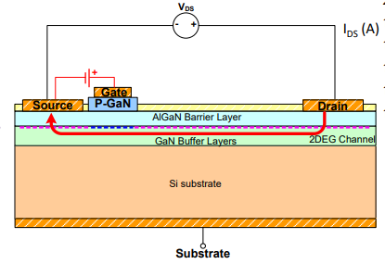

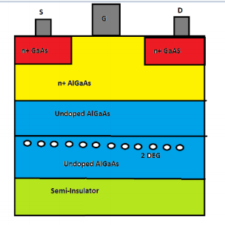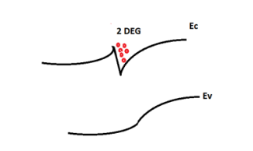

The device physical structure and energy band diagram are illustrated basically at Figure X and X+1.

A quantum well is formed at contact between large band gap material and low band gap material and it can be named as two-dimensional electron gas (2DEG) cloud. Thus, the electrons are apart from impurity and mobility of electrons increase.

# Operational Points

GaN has no body diodes externally, but 2DEG provide 3rd quadrant. It can conduct in forward current during positive gate- source voltage. Also, it can conduct in reverse current at both gate-source voltage positive and negative. However, the more negative gate-source voltage increases the drain-source voltage and increases the power loss.

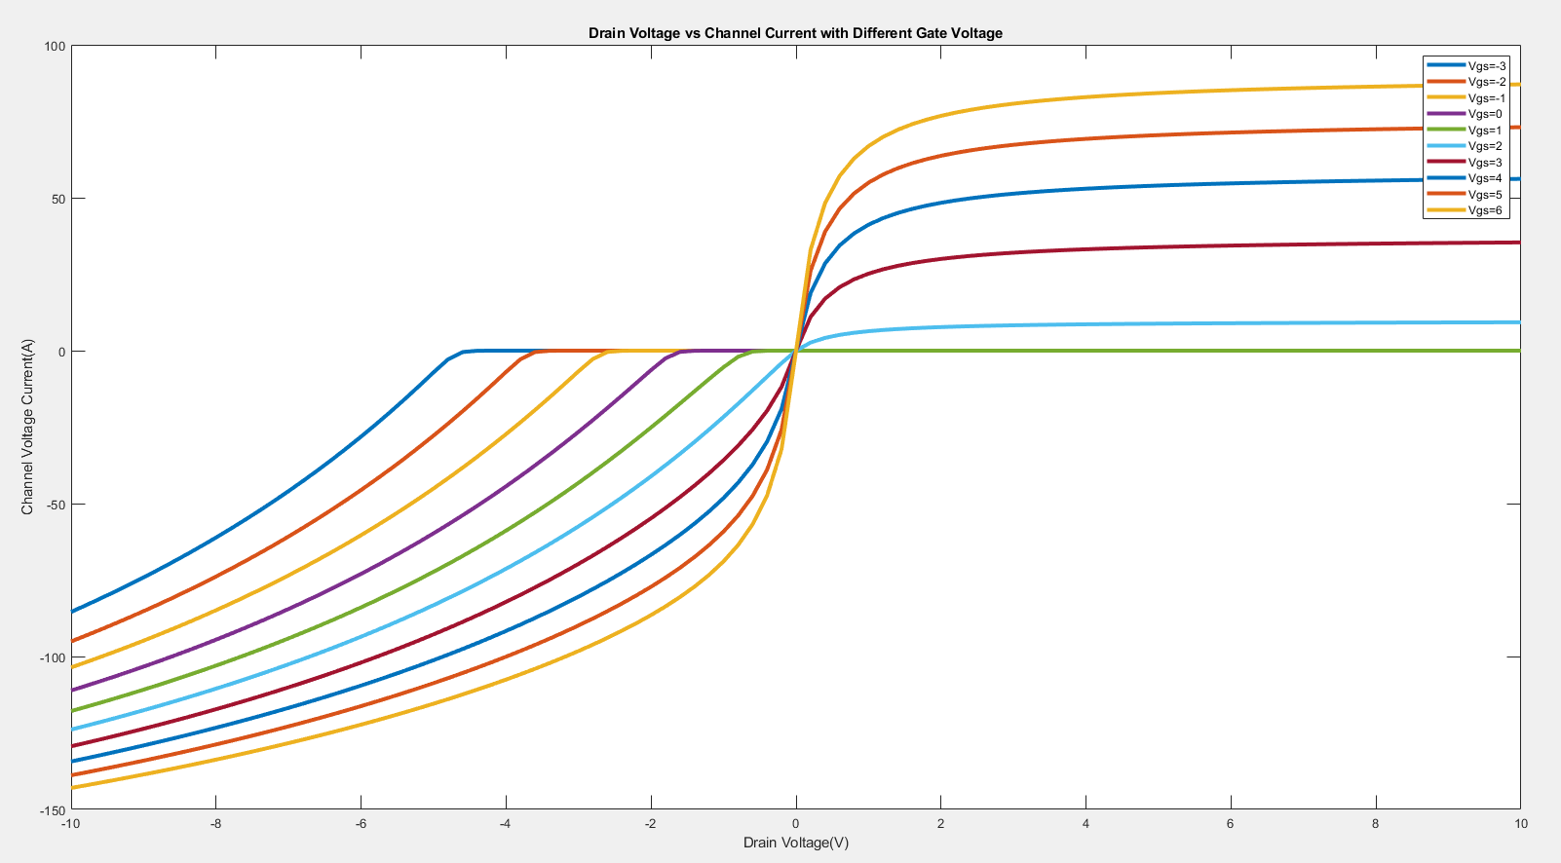

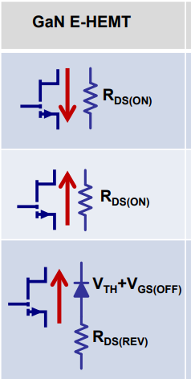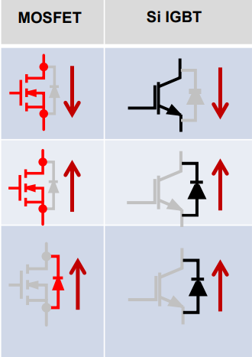

# Comparison GaN with other semiconductor devices

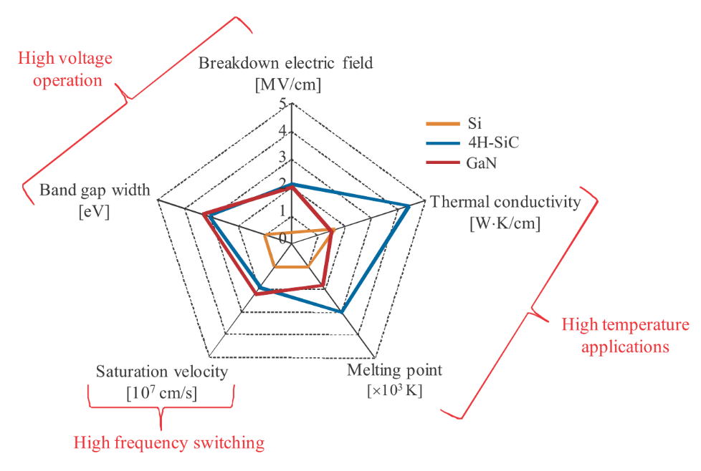

* High Electron Mobility
* Higher Gain
* Small Package, Lower Parasitic Elements and Lower Noise
* Higher Switching Frequency
* Higher efficiency
* Small on resistance, Lower Conduction Loss
* Higher Transconductance

# Electrical Model of GaN

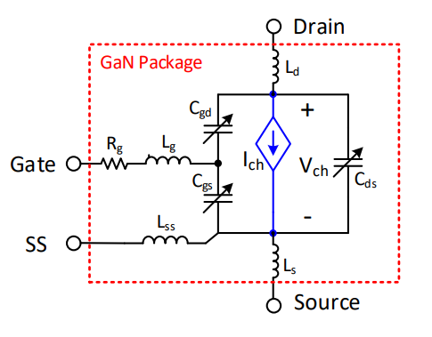

The electrical model of GaN can be thought as two level. One of them is inner side, it reflects the channel voltages and channel currents. The applying gate-source and drain-source voltage creates a constant channel current. Other one reflects the dynamic behaviour of the GaN. The model consists of stray inductances and inner capacitance of GaN. Also, the capacitances change with respect to drain-source voltages. The changes can not be ignored when transient behaviours are investigated.

The electrical model of GaN consist of voltage dependent current source, capacitance, inductances and resistance. The voltage dependent current source reflects the main occurrence of current at channel with respect to inner gate-source and drain-source voltages. The capacitances are important at transient state, it determines the dynamic behaviour of the GaN. The inductances represent unintended inductances which disrupt the current flow.

# State Space Model of GaN

The State-Space model is created from electrical modelling of GaN. The state space model can be stated as:



Next state is determined by using current state and current input. Inputs, states and output can be chosen in different combination. We create two state space model and differences of the models are basically stated as excitation. One of them is excited by current and other one is excited by voltages. Also, state and input matrices are function of the capacitance, inductance and resistance at electrical model. The capacitance and channel current are calculated with respect to channel voltage and inner gate-source voltage at every step of solution.

Voltage Biasing

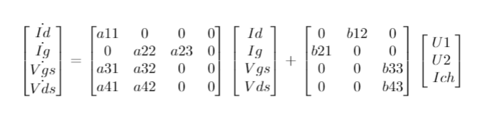,

Current Biasing

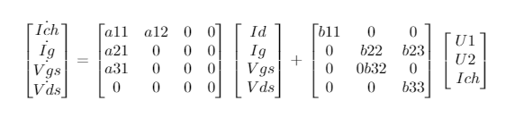

# Simulation Results

# Conclusion

J. Kovac, R.Szobolovszky, A.Kosa, A.Chavala, J.Marek, L.Stuchlikova , GaN/SiC based High Electron Mobility Transistors for integrated microwave and power circuits, Institute of Electronics and Photonics, Ilkovičova 3, 812 19, Bratislava, 2015